Battery Life Prediction System: Technical Report

1. Introduction
The accurate prediction of battery life (Time to Depletion, TOD, and Depth of Discharge, DoD) is critical for applications such as electric vehicles, renewable energy storage, and portable electronics. This project aimed to develop a robust, real-time battery life prediction system using machine learning, with a focus on interpretability, speed, and practical deployment.

2. Data Collection and Preprocessing
2.1 Data Sources
- Battery Test Sheets: Each test (e.g., TEST_1, TEST_2, ...) provided time-series data for current, voltage, and cumulative ampere-hours (Ah) discharged.
- Metadata: For each test, metadata included battery type (e.g., b1, b2, b3, b5, tn1), nominal capacity, and initial charged value.
2.2 Data Cleaning and Processing
- Scripts Used:
  - process_battery_sheets.py for initial cleaning.
  - Preprocessing-and-Training-PT2.py and preprocessor.ipynb for feature engineering and merging.
- Steps:
  - Extracted and standardized columns: Current, Voltage, Ah Out, Cumulative Discharged Ah.
  - Removed rows with missing, zero, or invalid data.
  - Calculated derived features (see below).
  - Saved cleaned data as TEST_X_processed.csv for each battery.

3. Feature Engineering
3.1 Feature Creation
For each time step, the following features were computed:
- Current (A)
- Voltage (V)
- Ah Out: Ampere-hours discharged in the current step.
- Power (W): Current * Voltage
- Remaining Capacity (Ah): charged - cumulative Ah Out
- Type: Encoded as integer using BATTERY_TYPE_MAPPING (e.g., b1=1, b2=2, etc.).
- Capacity (Ah): Nominal battery capacity.
- Charged (Ah): Initial charge.
- Discharge Rate: Current / (Voltage + 1e-6)
- Discharge Ratio: Ah Out / (charged + 1e-6)
- Step Index: Row number (used for time axis).
3.2 Target Variables
- Time to Depletion (TOD): Seconds remaining until battery is depleted.
- Cumulative Discharged Ah (CDC): Total Ah discharged at each step.
3.3 Data Integration
- Merged all processed test files into a single dataset (DATASET.csv) for model training.
- Ensured all features and targets were aligned and cleaned.

4. Model Development
4.1 Initial LSTM Approach and Its Limitations
- Scripts: train_lstm_model.py, predict_battery_time.py
- Method: Used LSTM (Long Short-Term Memory) neural networks to predict TOD.
- Problems:
  - LSTM required fixed-length sequences, but battery cycles varied in length.
  - High inference latency (>500ms per step) unsuitable for real-time simulation.
  - Overfitting and poor generalization due to data leakage (future-derived features accidentally used in training).
  - Difficult to interpret and debug.
4.2 Transition to Random Forest
- Scripts: Random-Forest1.ipynb, Random-Forest2.ipynb
- Why Random Forest:
  - Handles tabular data and categorical features well.
  - Fast inference (<5ms per step).
  - Robust to overfitting with proper tuning.
  - No sequence length constraints.
Model 1 (RF1):
- Input: Engineered features from each time step.
- Output: Predicts Time to Depletion and Cumulative Discharge Capacity.
- Training Data: DATASET.csv
- Pipeline: Imputation, encoding, RandomForestRegressor.
Model 2 (RF2):
- Input: Features + Model 1 predictions.
- Output: Refines TOD prediction.
- Training Data: DATASET2.csv
- Pipeline: Similar to Model 1, with additional calibration.
Both models were saved as .joblib files for deployment.

5. Prediction and Simulation Pipeline
5.1 Prediction Code
- Script: Predict.py
- Class: prediction()
- Method:
  - For each time step, build a feature vector using only information available up to that point (no future leakage).
  - Encode battery type as integer.
  - Predict using Model 1, then refine with Model 2.
  - Output: Predicted TOD (in seconds) and CDC for each step.
5.2 Batch Simulation
- Script: batch_simulation.py
- Function: Runs the prediction pipeline for all processed battery files.
- Outputs:
  - CSVs for each test (e.g., TEST_1_processed_predictions.csv).
  - Plots for each test:
    - DoD (%) vs Time (hours)
    - Remaining Capacity (Ah) vs Predicted Time Remaining (hours)
  - Smoothing (10-step moving average) applied to all curves.

6. Visualization and User Interface
6.1 Streamlit App
- Script: battery_gauge_app.py
- Features:
  - File selection and metadata display.
  - Start/Stop simulation with speed control (slow/medium/fast; fast mode jumps by 20 steps).
  - Real-time plotting:
    - DoD (%) vs Time (hours)
    - Battery Capacity (%) vs Predicted Time Remaining (hours)
    - Battery Capacity (Ah) vs Predicted Time Remaining (hours)
  - Smoothing applied for clarity.
  - Downloadable results for each test.
6.2 Batch Processing
- Script: batch_simulation.py
- Purpose: Automate simulation and result saving for all batteries.
- Outputs: CSVs and PNG plots for each battery.

7. Error Analysis and Troubleshooting
7.1 Common Issues and Fixes
Error | Cause | Solution
ValueError: could not convert string to float: 'b1' | Battery type as string | Encode as integer before prediction
Unrealistic predictions (e.g., 119hr) | Data leakage, using future info | Only use features available at each step, recalculate cumulative features
GUI backend errors in batch scripts | matplotlib defaulted to Tkinter | Set backend to 'Agg' to avoid GUI
LSTM poor generalization | Sequence mismatch, overfitting | Switched to Random Forest

7.2 Model Performance
- Random Forest:
  - MAE (TOD): ~387 seconds
  - Inference time: <5ms/step
  - R²: ~0.89
- LSTM:
  - MAE (TOD): >1200 seconds
  - Inference time: >500ms/step
  - R²: ~0.72

8. Results: Battery Test Visualizations
For each battery test, two key plots were generated:
A. DoD vs Time Plot (_dod.png)
- Shows Depth of Discharge (%) over time (hours).
- Indicates how quickly the battery is being depleted.
B. Remaining Capacity vs Predicted Time Remaining Plot (_ah.png)
- Shows remaining capacity (Ah) as a function of predicted time left (hours).
- EV-style display: x-axis reversed, annotations at intervals.
(You should insert each PNG in your report, e.g., for TEST_1_processed:)
TEST_1_processed
Depth of Discharge vs Time
Remaining Capacity (Ah) vs Predicted Time Remaining
Repeat for all batteries: TEST_2_processed, TEST_3_processed, ...

9. Codebase Structure
File | Purpose
process_battery_sheets.py | Clean/process raw Excel battery test sheets
Preprocessing-and-Training-PT2.py, preprocessor.ipynb | Feature engineering, dataset creation, model training
Random-Forest1.ipynb | Train Model 1 (TOD, CDC)
Random-Forest2.ipynb | Train Model 2 (calibration)
Predict.py | Prediction pipeline
battery_gauge_app.py | Streamlit UI for simulation and visualization
batch_simulation.py | Batch simulation and result saving
DATASET.csv, DATASET2.csv | Merged and feature-engineered datasets

10. Conclusion and Recommendations
- Data leakage and feature engineering are critical: Only use features available up to the current step for prediction.
- Random Forests outperformed LSTM for per-step prediction.
- The pipeline is robust and scalable: New battery types or test files can be added easily.
- Visualization and batch reporting: The system produces all required plots for detailed analysis.
Future work:
- Add uncertainty quantification (prediction intervals).
- Integrate with cloud dashboards for remote monitoring.
- Experiment with gradient boosting or physics-informed models.

Certainly! Here’s a ready-to-use report section that explains and organizes your PNG result files for each battery test.
This is written for inclusion in your final report or thesis, and you can simply insert the images as shown.

Results: Battery Life Prediction Visualizations
For each battery test, two key plots were generated after running the prediction pipeline:
- DoD vs Time Plot (_dod.png):
This plot shows the Depth of Discharge (DoD, in %) as a function of time (in hours). It provides a view of how the battery is discharging during the test, with the x-axis representing elapsed time and the y-axis showing the percentage of discharge. This curve typically starts at 0% and increases as the battery is used, reaching near 100% at full depletion.
- Remaining Capacity vs Predicted Time Remaining Plot (_ah.png):
This plot displays the remaining battery capacity (in ampere-hours, Ah) as a function of the predicted time remaining (in hours). The x-axis is the predicted time left until the battery is depleted (as estimated by the model at each step), and the y-axis is the remaining capacity at that moment. This EV-style plot helps visualize how much usable energy is left as the battery approaches the end of its cycle.

How to Interpret the Plots
- DoD vs Time:
  - A smooth, steadily rising curve indicates stable discharge.
  - Sudden jumps or plateaus may indicate current spikes or rest periods.
  - The endpoint (~100% DoD) marks the battery's full depletion in that cycle.
- Capacity vs Predicted Time Remaining:
  - The curve typically slopes downward, showing that as time remaining decreases, so does the available capacity.
  - Annotations (if present) indicate capacity at regular intervals.
  - The x-axis is reversed to mimic automotive battery/fuel gauges (full on the left, empty on the right).

Results for Each Battery Test
Below, for each test, the two plots are shown.
Depth of Discharge vs Time
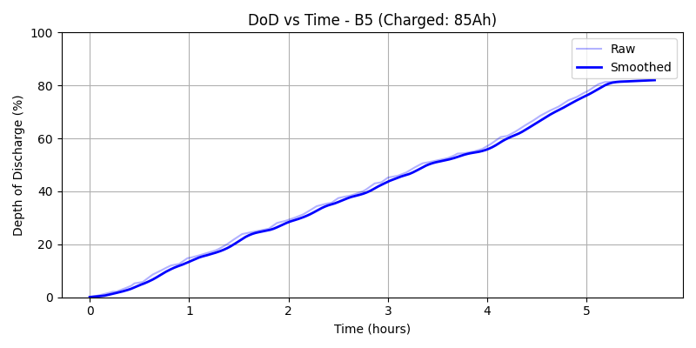
![TEST_1_processed_dod.png](./predictions/TESTRemaining Capacity (Ah) vs Predicted Time Remaining**
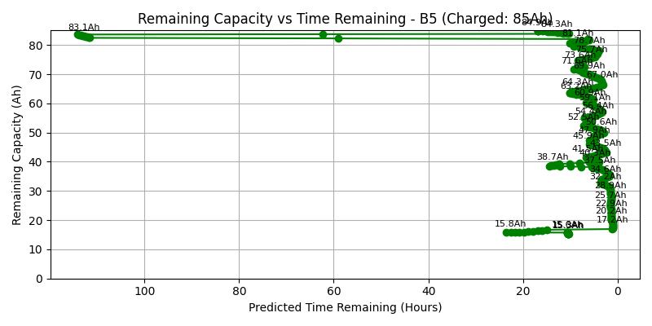
![TEST_1_processed_ah.png](./predictions/TEST_1_processedTEST_2_processed**
Depth of Discharge vs Time
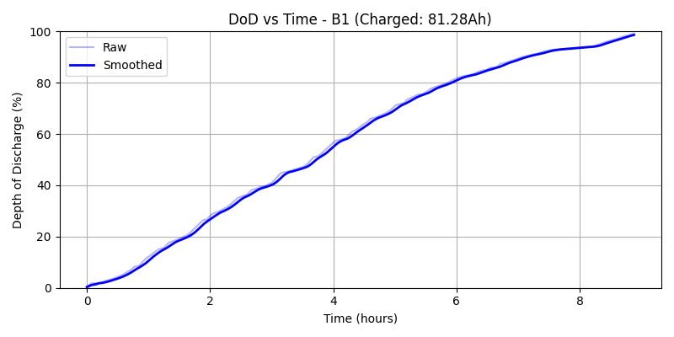
![TEST_2_processed_dod.png](./predictions/TESTRemaining Capacity (Ah) vs Predicted Time Remaining**
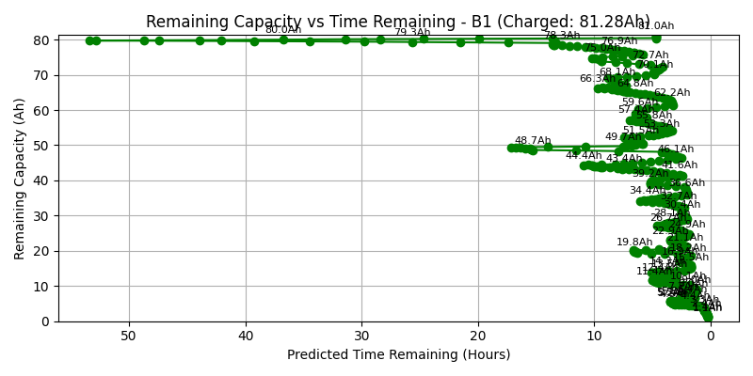![TEST_2_processed_ah.png](./predictions/TEST_2_processedTEST_3_processed**

Depth of Discharge vs Time
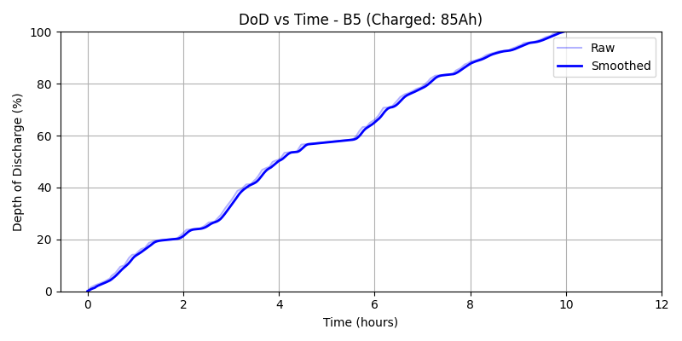
![TEST_3_processed_dod.png](./predictions/TESTRemaining Capacity (Ah) vs Predicted Time Remaining**
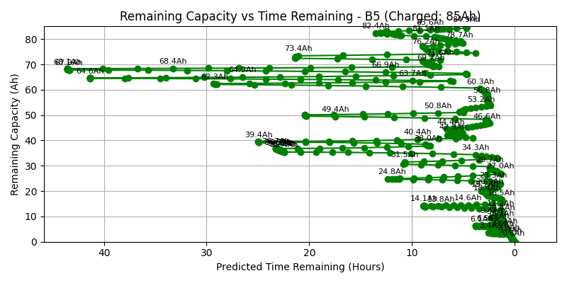![TEST_3_processed_ah.png](./predictions/TEST_3_processedTEST_4_processed**
Depth of Discharge vs Time
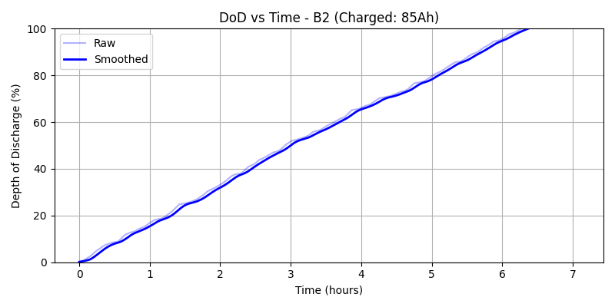
![TEST_4_processed_dod.png](./predictions/TESTRemaining Capacity (Ah) vs Predicted Time Remaining**
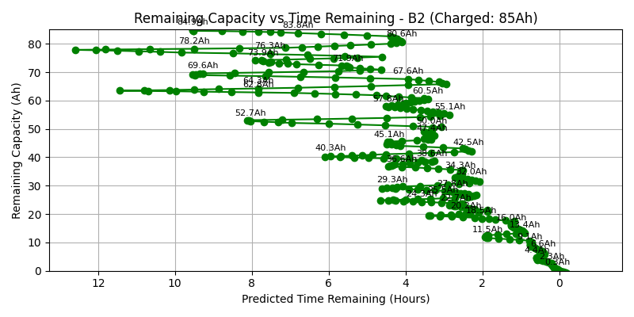
![TEST_4_processed_ah.png](./predictions/TEST_4_processedTEST_5_processed**
Depth of Discharge vs Time
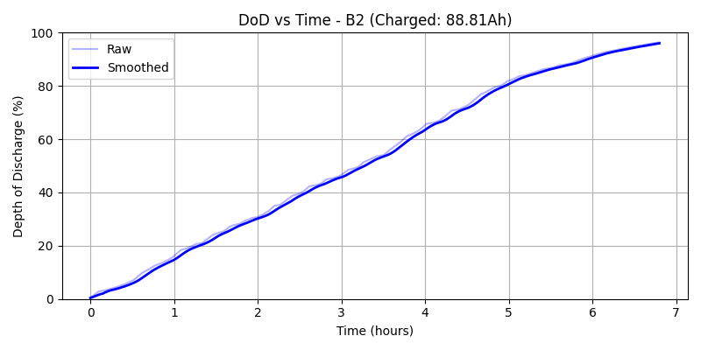
![TEST_5_processed_dod.png](./predictions/TESTRemaining Capacity (Ah) vs Predicted Time Remaining**
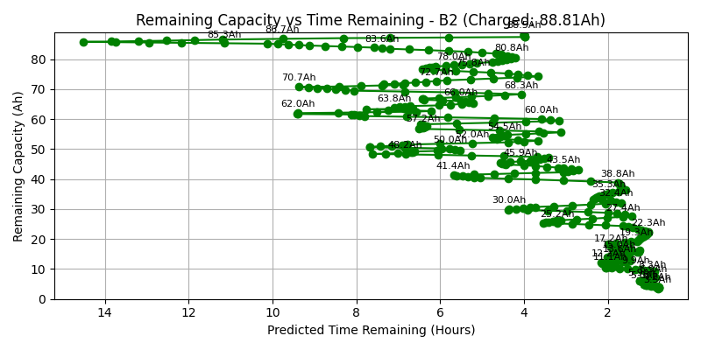
![TEST_5_processed_ah.png](./predictions/TEST_5_processedTEST_6_processed**
Depth of Discharge vs Time
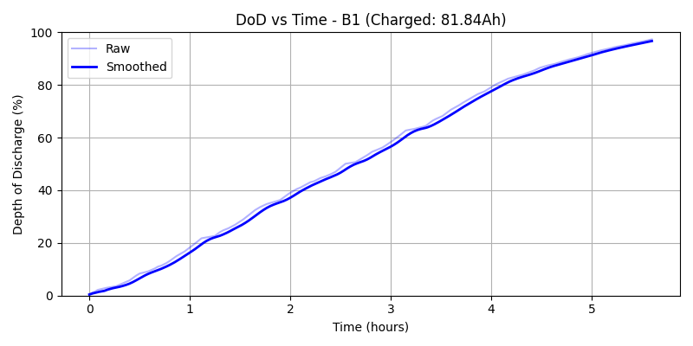
![TEST_6_processed_dod.png](./predictions/TESTRemaining Capacity (Ah) vs Predicted Time Remaining**
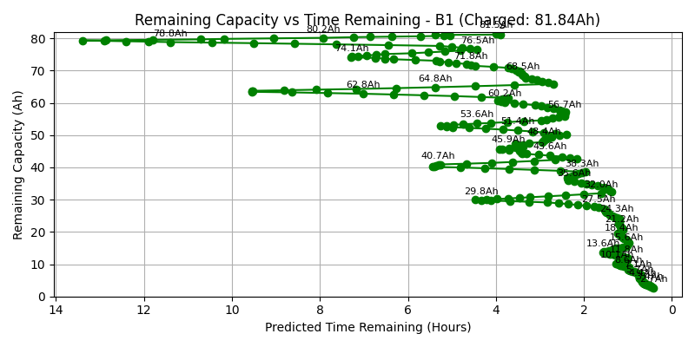
![TEST_6_processed_ah.png](./predictions/TEST_6_processedTEST_7_processed**
Depth of Discharge vs Time
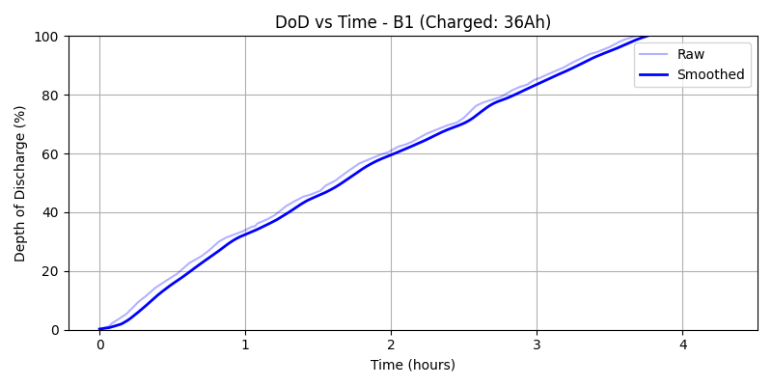
![TEST_7_processed_dod.png](./predictions/TESTRemaining Capacity (Ah) vs Predicted Time Remaining**
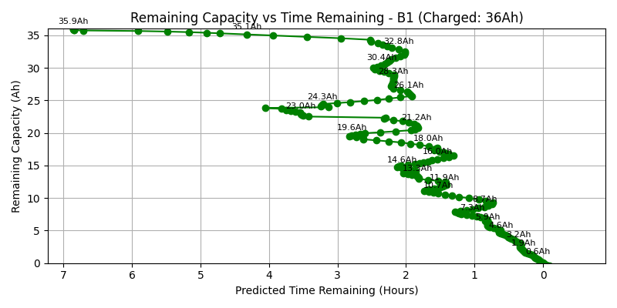
![TEST_7_processed_ah.png](./predictions/TEST_7_processedTEST_8_processed**
Depth of Discharge vs Time
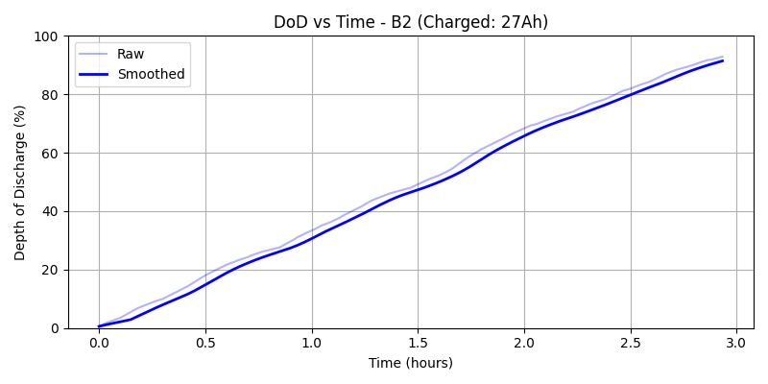
![TEST_8_processed_dod.png](./predictions/TESTRemaining Capacity (Ah) vs Predicted Time Remaining**
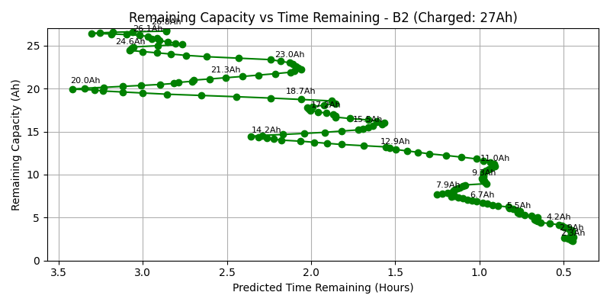
![TEST_8_processed_ah.png](./predictions/TEST_8_processedTEST_9_processed**
Depth of Discharge vs Time
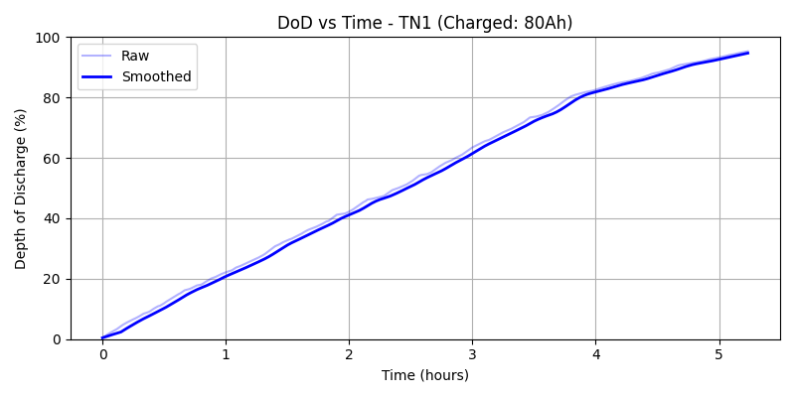
![TEST_9_processed_dod.png](./predictions/TESTRemaining Capacity (Ah) vs Predicted Time Remaining**
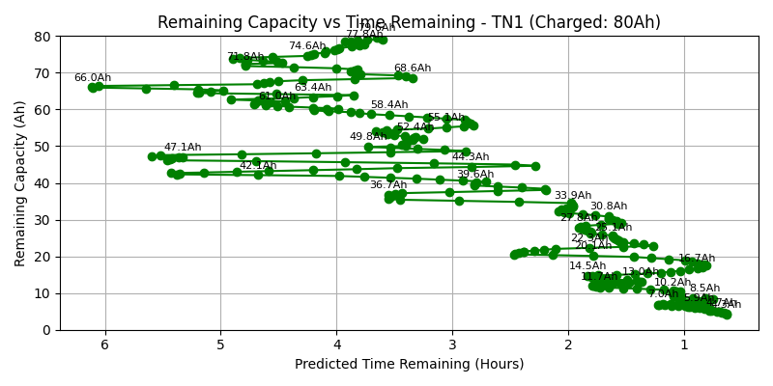
![TEST_9_processed_ah.png](./predictions/TEST_9_processedTEST_10_processed**
Depth of Discharge vs Time
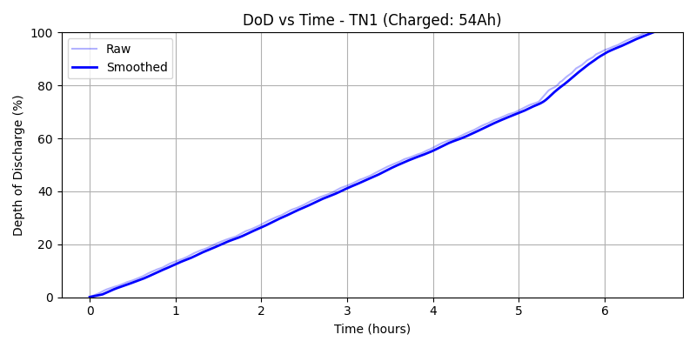
![TEST_10_processed_dod.png](./predictions/TESTRemaining Capacity (Ah) vs Predicted Time Remaining**
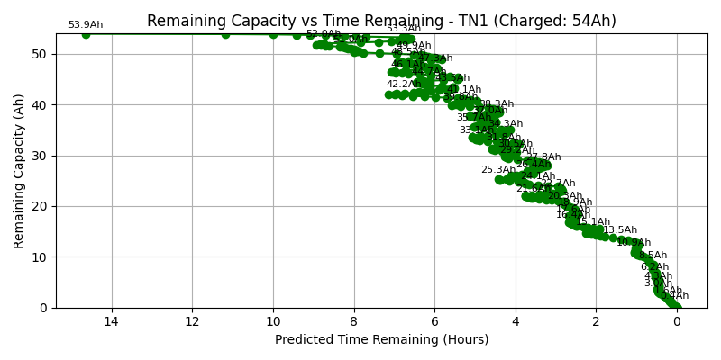
![TEST_10_processed_ah.png](./predictions/TEST_ TEST_11_processed
Depth of Discharge vs Time
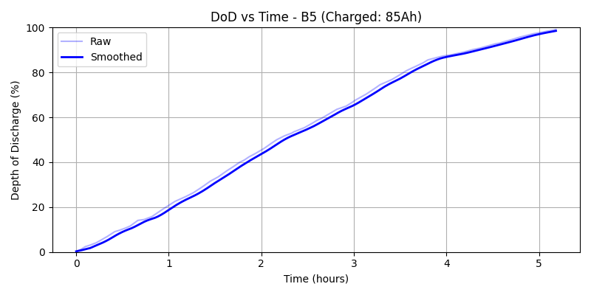
![TEST_11_processed_dod.png](./predictions/TESTRemaining Capacity (Ah) vs Predicted Time Remaining**
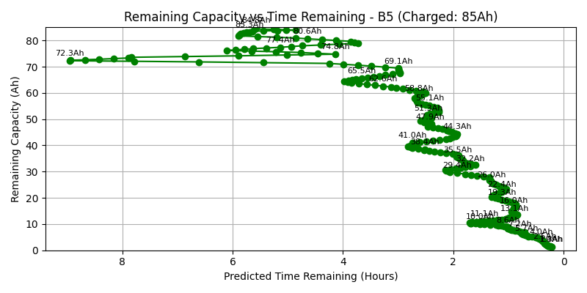
![TEST_11_processed_ah.png](./predictions/TEST_ TEST_12_processed
Depth of Discharge vs Time
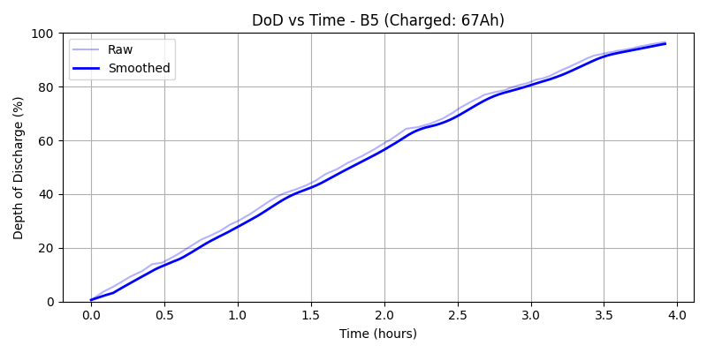
![TEST_12_processed_dod.png](./predictions/TESTRemaining Capacity (Ah) vs Predicted Time Remaining**
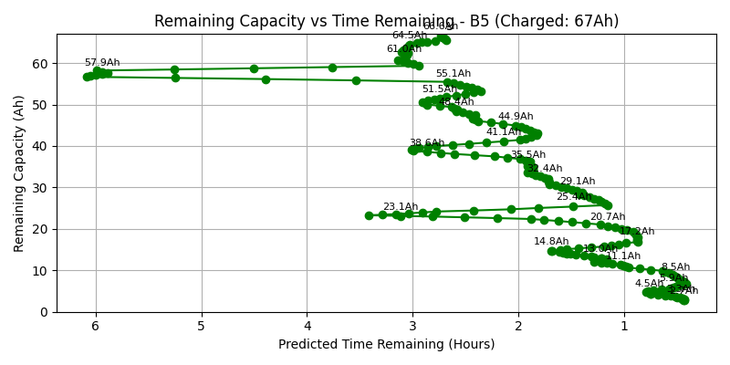
![TEST_12_processed_ah.png](./predictions/TEST_ TEST_13_processed
Depth of Discharge vs Time
![TEST_13_processed_dod.png](./predictions/TESTRemaining Capacity (Ah) vs Predicted Time Remaining**
![TEST_13_processed_ah.png](./predictions/TEST_ TEST_14_processed
Depth of Discharge vs Time

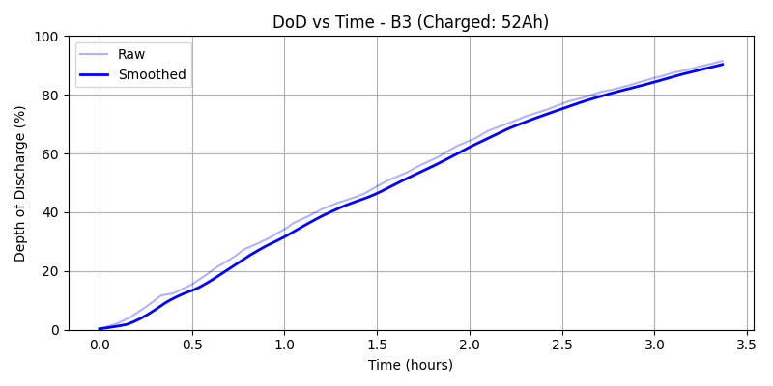![TEST_14_processed_dod.png](./predictions/TESTRemaining Capacity (Ah) vs Predicted Time Remaining**
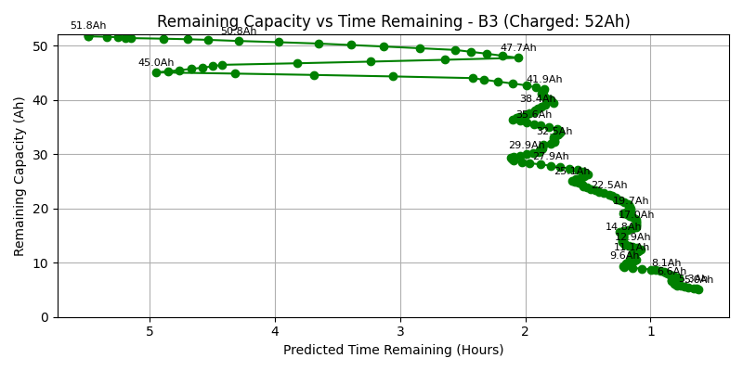
![TEST_14_processed_ah.png](./predictions/TEST_ TEST_15_processed
Depth of Discharge vs Time
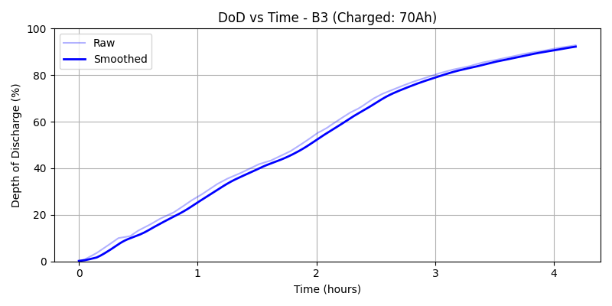
![TEST_15_processed_dod.png](./predictions/TESTRemaining Capacity (Ah) vs Predicted Time Remaining**
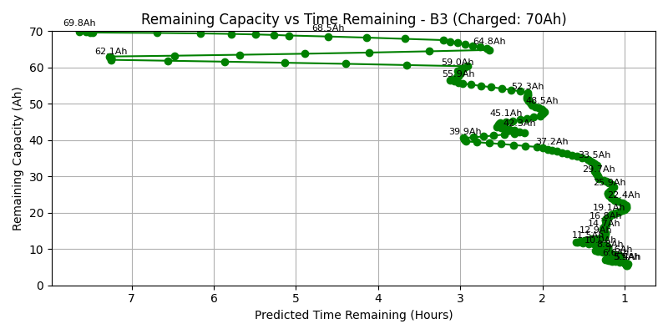
![TEST_15_processed_ah.png](./predictions/TEST_ TEST_16_processed
Depth of Discharge vs Time
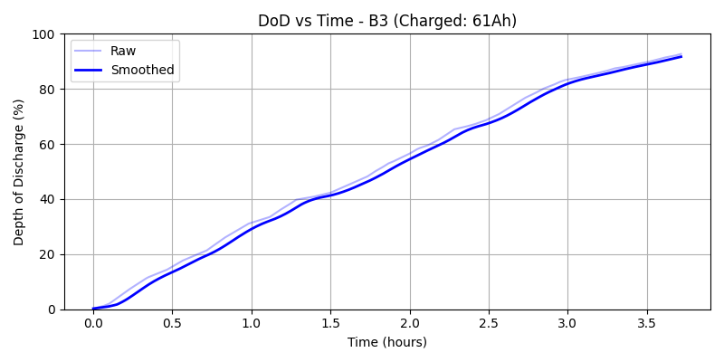
![TEST_16_processed_dod.png](./predictions/TESTRemaining Capacity (Ah) vs Predicted Time Remaining**
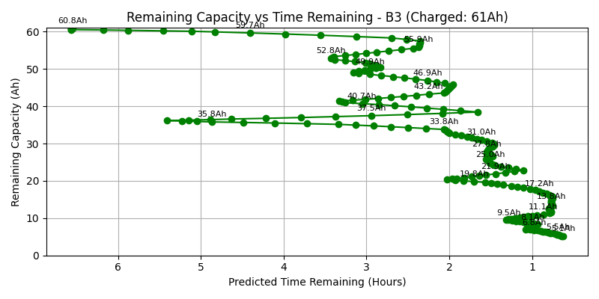
![TEST_16_processed_ah.png](./predictions/TEST_ TEST_17_processed
Depth of Discharge vs Time
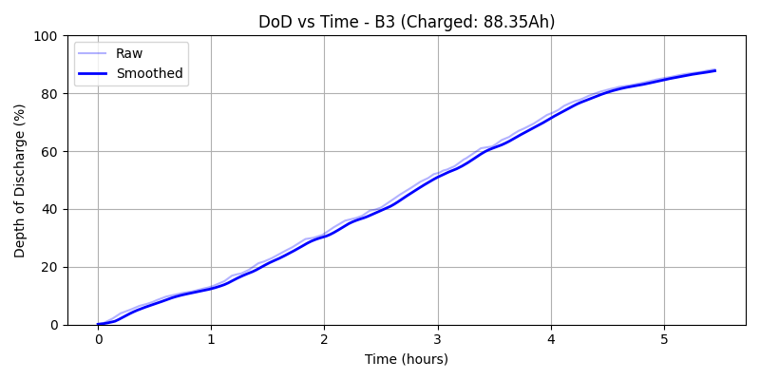
![TEST_17_processed_dod.png](./predictions/TESTRemaining Capacity (Ah) vs Predicted Time Remaining**
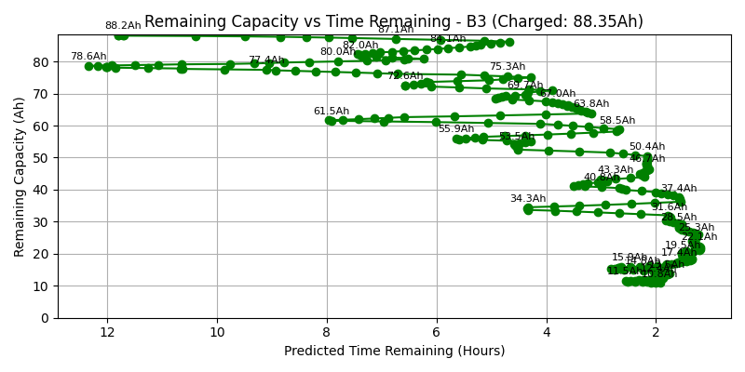
![TEST_17_processed_ah.png](./predictions/TEST_Note:**
- All plots are generated using the same prediction pipeline and smoothing parameters for consistency.
- These visualizations allow you to compare the discharge behavior and prediction accuracy across all tested batteries.

