Instruction

1. Check Regional Settings (details are in the Appendix 1)
2. Create a folder with all needed raw data:

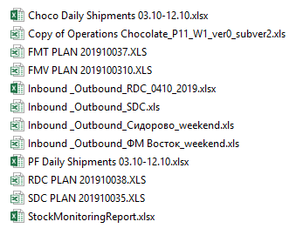

1. Check key phrases and names (details are in the Appendix 2)
2. Close all EXCEL files
3. Run the 
4. Set params: 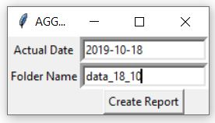
5. If there is a problem pop-up message appears
6. If mapping should be updated, code update it in mapping file with default values colored in red and inform user.
7. If 'inbound _outbound' files consist row with not filled storage name, code update it in this file with default values colored in red and inform user.
8. Then user may change this colored values in proper and get new report with not default values

**Appendix 1. Regional Settings**

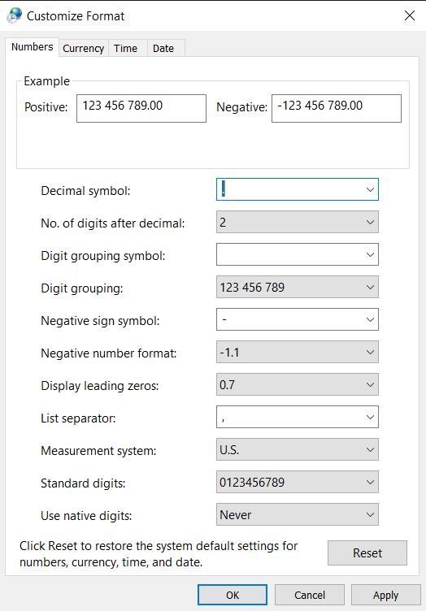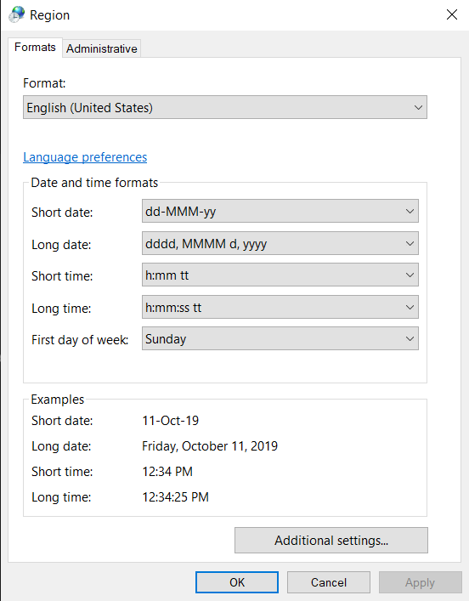

**Appendix 2. Key Phrases and Names**

* Key: 'choco daily shipments'

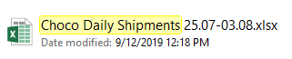

Names of sheets:



* Key: 'pf daily shipments'



Names of sheets:



* Key: 'operations'



Names of sheets:



* Key: 'plan'

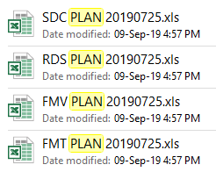

Should be 1 sheet with a random name

* Key: 'inbound _outbound'

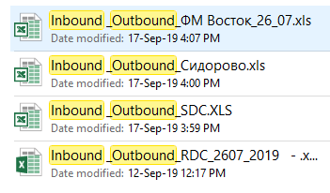

Names of sheets:

