Untitled

Dara Abb

2025-04-10

library(tidyverse)

## ── Attaching core tidyverse packages ──────────────────────── tidyverse 2.0.0 ──  
## ✔ dplyr 1.1.4 ✔ readr 2.1.5  
## ✔ forcats 1.0.0 ✔ stringr 1.5.1  
## ✔ ggplot2 3.5.1 ✔ tibble 3.2.1  
## ✔ lubridate 1.9.3 ✔ tidyr 1.3.1  
## ✔ purrr 1.0.2   
## ── Conflicts ────────────────────────────────────────── tidyverse_conflicts() ──  
## ✖ dplyr::filter() masks stats::filter()  
## ✖ dplyr::lag() masks stats::lag()  
## ℹ Use the conflicted package (<http://conflicted.r-lib.org/>) to force all conflicts to become errors

library(ggplot2)

Import datasets

cars <- read.csv("cars.csv")  
  
retail_clean <- read.csv("retail_clean.csv")

Scatterplots:are used to examine the relationship between two continuous variables

1st Scatterplot: examines the relation between horsepower an city miler per gallon

cars %>% ggplot(aes(x= horsepower, y=city_miles_per_galloon, color=Price))+geom_point()

## Warning: Removed 14 rows containing missing values or values outside the scale range  
## (`geom_point()`).

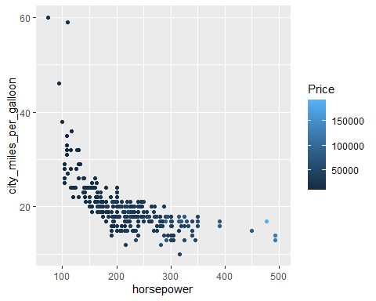

2nd Scatterplot: Weight vs. Price with Size and Color Modifications

cars %>% ggplot(aes(x=weight, y= Price, color=sports_car, size=horsepower))+geom_point()

## Warning: Removed 2 rows containing missing values or values outside the scale range  
## (`geom_point()`).

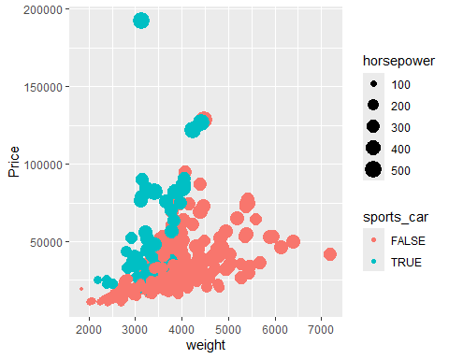

3rd Scatterplot: Scatterplot with Different Shape

cars %>% ggplot(aes(x=weight, y= Price, shape=sports_car))+geom_point()+theme_classic()

## Warning: Removed 2 rows containing missing values or values outside the scale range  
## (`geom_point()`).

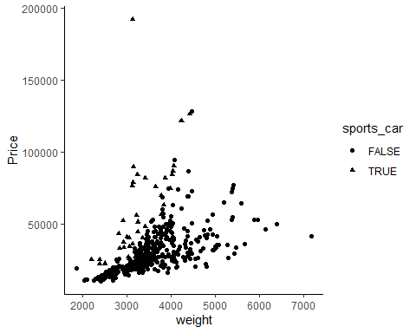

4th Scatterplot: Price vs. Horsepower with Cylinders Factor

cars %>% ggplot(aes(x=Price, y= horsepower, color=factor(cylenders)))+geom_point()

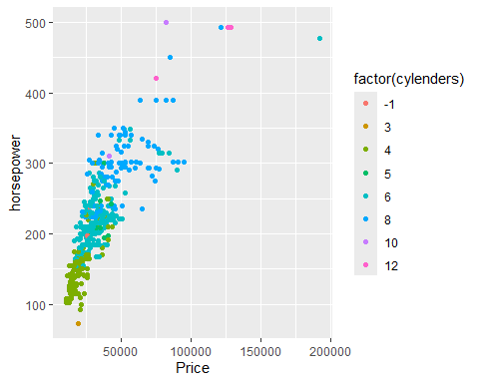

Bar plots help to visualize categorical data by representing the frequency of each category.

Top 9 Countries with Highest Appearances

top9_international <- retail_clean %>% group_by(Country) %>% summarise(appearnece = n()) %>% arrange(desc(appearnece))%>%   
 slice(2:10)   
  
top9 <- as.vector(top9_international[["Country"]])  
  
retail_clean %>% filter(Country %in% top9) %>% ggplot(aes(x= Country))+geom_bar(fill= "darkred")

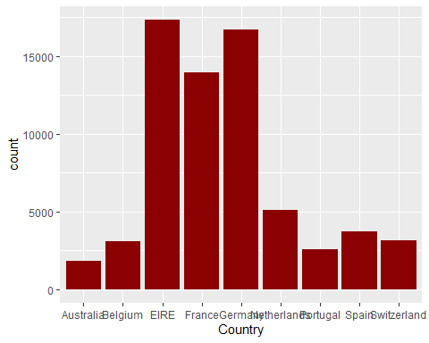

Weekday Distribution Plot

retail_clean<- retail_clean %>% separate(col = InvoiceDate,  
 into = c("date","time"),  
 sep = " ")

## Warning: Expected 2 pieces. Missing pieces filled with `NA` in 1042721 rows [1, 2, 3, 4,  
## 5, 6, 7, 8, 9, 10, 11, 12, 13, 14, 15, 16, 17, 18, 19, 20, ...].

head(retail_clean)

## Invoice StockCode Description Quantity  
## 1 489434 85048 15CM CHRISTMAS GLASS BALL 20 LIGHTS 12  
## 2 489434 79323P PINK CHERRY LIGHTS 12  
## 3 489434 79323W WHITE CHERRY LIGHTS 12  
## 4 489434 22041 RECORD FRAME 7" SINGLE SIZE 48  
## 5 489434 21232 STRAWBERRY CERAMIC TRINKET BOX 24  
## 6 489434 22064 PINK DOUGHNUT TRINKET POT 24  
## date time Price Customer.ID Country  
## 1 2009-12-01T07:45:00Z <NA> 6.95 13085 United Kingdom  
## 2 2009-12-01T07:45:00Z <NA> 6.75 13085 United Kingdom  
## 3 2009-12-01T07:45:00Z <NA> 6.75 13085 United Kingdom  
## 4 2009-12-01T07:45:00Z <NA> 2.10 13085 United Kingdom  
## 5 2009-12-01T07:45:00Z <NA> 1.25 13085 United Kingdom  
## 6 2009-12-01T07:45:00Z <NA> 1.65 13085 United Kingdom

#####weekday analysis  
retail_clean$date <- as.Date(retail_clean$date)  
  
retail_clean$week <- weekdays(retail_clean$date)  
  
retail_clean %>% ggplot(aes(x=week))+geom_bar()

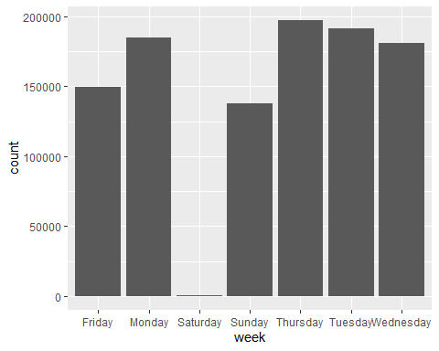

Bar Plot for Top 9 Countries Reordered

top9_international %>%   
 ggplot(aes(x=reorder(Country, appearnece), y=appearnece))+geom_col()+coord_flip()+xlab("Top 9 International")

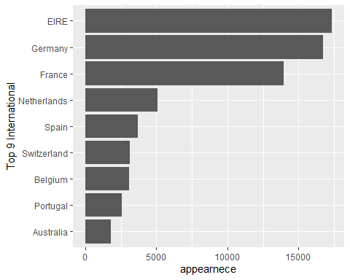

Density Plot: Horsepower by Cylinders

cars %>% ggplot(aes(x=horsepower, fill = factor(cylenders)))+ geom_density(alpha=0.3)

## Warning: Groups with fewer than two data points have been dropped.

## Warning in max(ids, na.rm = TRUE): no non-missing arguments to max; returning  
## -Inf

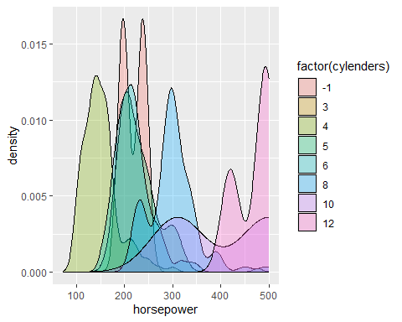

Box plots: Box plots are used to visualize the distribution of a continuous variable and identify outliers.

##Box Plot: Horsepower by Cylinders  
table(cars$cylenders)

##   
## -1 3 4 5 6 8 10 12   
## 2 1 136 7 190 87 2 3

cars %>% filter(cylenders %in% c(4,6,8)) %>% ggplot(aes(x=factor(cylenders), y=horsepower))+geom_boxplot()

