

Football Player Market Valuation: Identifying Key Performance Drivers Across the Big 5 European Leagues Using Predictive Modelling

Daragh Brady
D00255640

Final Year Project
Bachelor of Science (Hons) in Computing Science and Mathematics

© Daragh Brady, 2025

Supervisor: Damian Loughran

Dundalk Institute of Technology
School of Informatics and Creative Arts
Department of Computing Science and Mathematics

2024 / 2025

Abbreviations

AI Artificial Intelligence
EFL English Football League
GK Goalkeeper
MLS Major League Soccer
OLS Ordinary Least Squares
PSG Paris Saint-Germain
R² Coefficient of Determination
RF Random Forest
RMSE Root Mean Squared Error
UEFA Union of European Football Associations
xA Expected Assists
xG Expected Goals

Acknowledgements
I would like to thank my supervisor, Damian Loughran, for his guidance and support throughout this project. I would also like to thank Siobhan Connolly Kernan, for her advice and assistance in the development of this project.

Declaration

I hereby declare that the work described in this project is, except where otherwise stated, entirely my own work and has not been submitted as part of any degree at this or any other Institute/University.

Name: Daragh Brady

Signature: ___________________________

Date: ___________________________

Abstract
In football, a player’s market value is difficult to understand and without valuation data from the past is almost impossible to predict. For this study, the approach taken to this is with three regression models created from the ground up, with performance data from the English Premier League, La Liga, Bundesliga, Ligue 1, and Serie A, collectively known as Europe’s top five leagues, from 2020 until 2025. Based on the results from this, the best model was found to be Random Forest, as it had the strongest predictive ability, with an R² value of 0.637. After feature importance analysis, it was found that the most influential predictors of market value were minutes played, team finishing position, and age. Separate league and year on year comparisons were conducted to see the difference between leagues as well as possible trends across seasons. An interactive dashboard was created to showcase these findings through visualisations, with the ability to search for any player, and look at past changes of players market value, through risers and fallers from each year of each league.

Contents
Abbreviations 2
Acknowledgements 3
Declaration 4
Abstract 5
List of Figures 7
1. Introduction 8
2. Literature Review 10
2.1 Player Valuation in Football 10
2.2 Performance Metrics and Expected Goals 11
2.3 Machine Learning in Sports Analytics 12
2.4 Limitations of Existing Research 13
3. Data & Methods 14
3.1 Research Design and Data Sources 14
3.2 Data Preprocessing and Feature Engineering 14
3.3 Model Implementation 15
3.4 Evaluation 16
4. Results and Analysis 17
4.1 Overall Model Performance 17
4.2 Per-League Analysis 18
4.3 Per-Position Analysis 18
4.4 Feature Importance 20
4.5 Year-on-Year Trends 21
5. Discussion 22
5.1 Interpretation of Findings 22
5.2 Limitations 23
6. Conclusion 25
6.1 Summary 25
6.2 Future Work 26
Bibliography 28
Appendix A: Artificial Intelligence Interaction Log 30
Appendix B: Source Code 30

List of Figures

Figure 1: Distribution of player market values by position, 2024-25 season
Figure 2: Actual vs. predicted log market value for all three models on the holdout test set
Figure 3: Random Forest actual vs. predicted market value by league
Figure 4: Random Forest permutation feature importance heatmap across playing positions
Figure 5: Feature importance for all three models on the overall dataset
Figure 6: Year-on-year Random Forest and OLS R² by league across five seasons

Introduction
Over the past decade, transfer fees of football players have escalated dramatically, with new record-breaking deals becoming much more common. Simultaneous with this financial growth, the use of data analytics in football has expanded quickly, as clubs invest in performance analysis to identify talent and give grounds to recruitment decisions. However, clubs and agents both lack clear, data-driven valuation tools to determine how much a player is worth, and if there are cheaper alternatives to a player deemed to expensive for them to warrant allocating so much resources and expenditure to.
The use of data from Europe’s top five leagues was used to develop a predictive model more suited to the big spenders in the footballing world. The most expensive transfers that occur every year worldwide are always from one of these top five leagues, and with the commonness of the transfers happening within each league and across these top five leagues, it is an area that can be explored to see how players’ market values from a certain league compare to another. Importantly, prior market value was purposefully not included as a feature, to ensure the models predict value from only performance sooner than bolster existing valuations.
Football analytics is one of the most data-rich and commercially compelling uses of data science, which makes this project very aligned with the subject of Data Analytics. The objective determination of player value has relevance towards club recruitment, financial planning, and competitive strategy.
Upon creating this project, the following research questions were made to try to guide how the project was being conducted.
- Which performance statistics are the strongest at predicting player market value across Europe’s top five leagues?
- Do the main predictors of market value change substantially by league or position?
- How does market value unfold year on year and what pushes those changes?
- Can a model without prior market values be trained on performance and produce effective predictions?
Each of these research questions were made to ask a range of expectations of the project, as the goal of the project was to create something that could showcase lots of different, informative material.
This report is organised as follows: Section 2 surveys literature on player valuation and predictive modelling in sport. The sources of data, preprocessing approach, and modelling methodology are all explained in Section 3. Results are presented and discussed in Section 4. Section 5 concludes the report and outlines directions for future work.

Literature Review

Player Valuation in Football
Player value in the market has become one of the fastest growing and economically significant indicators for professional football. As transfer activity has increased, clubs have grown increasingly reliant on structured player assessment measures to drive their recruitment and financial plans and a conception of market value has risen to the status of not only a 'scholarly subject', but an essential knowledge for clubs within financial fair play regulations and budget constraints.

The early work in academic discussions of player valuation rested on labour economics. According to (Frick, 2013) the Bosman ruling of 1995 was the single most momentous transformation in structural terms of the European football labour market, opening up player mobility to more than a few and fostering substantial wage inflation. Pre Bosman clubs kept wages cheap as compared to player productivity according to contract control but liberalisation introduced more accurate market measurements of productivity. (Torgler & Schmidt, 2007) built on this based on a panel data analysis of European football, revealing that individual statistics were influenced by wage levels, contract security, team quality, etc. The findings emphasize a feedback loop complicating fundamental performance-to-value models: The performance of these teams depends on economic incentives for the business; the market derives value from each player's performance; and the market cannot factor in missing team context, so no one predictive model can truly capture the value.

Individual statistics have also been consistently associated with premium values, (Bryson, et al., 2013) that scarcity of certain player attributes creates wage premiums in the market and (Lucifora & Simmons, 2003) that observed superstar effects in Italian football, where elite players brought valuations that were above those that positional peers commanded.

(Herm, et al., 2014) tested the reliability of crowd-sourced valuation platforms, who found that collective evaluations at sites like Transfermarkt tracked professional valuations relatively well but experienced systematic annual inflation of 12 percent or so. (Müller, et al., 2017) went further in this regard by claiming that crowd-source values also exhibit implicit biases and offering a data-driven alternative based upon quantified performance measurements. (Peeters, 2018) also tested Transfermarkt valuations as a prediction benchmark, finding adequate predictive accuracy but also concluded that league-specific biases are hard to manage.

Performance Metrics and Expected Goals
When moving from the traditional counting statistics about a player to performance measures that are now sophisticated, there has been a significant shift in the way that a player’s abilities are evaluated and assessed in football. Simply putting it raw data such as goals and assists have historically been used as proxies to suggest the quality of players yet do not capture the environment in which scores are awarded or the totality of a player’s contribution in any given match in which his or her actions and experiences are observed.

(Fernández, et al., 2019) introduced the idea of expected goal scoring. The probability score on each shot was assigned to be between zero and one, taking into account such background factors as distance, angle where shots were taken, and body part utilized. This metric solves one problem of goal counts: When a player consistently puts out high-quality chances he is rewarded whether or not those chances lead to goals, a less volatile and repeatable metric for contribution to attacker. Expected goals also allow for comparisons between players that exceed or fail to meet their expected output, exposing clinical finishing or wastefulness in a way that raw goals cannot.

(Sulimov, 2024) extended this by leveraging CatBoost over possession-chain expected goals measures, producing a mean absolute error of €4.26 million for the prediction of market value and confirming expectations continue to be better able to predict the market value than simple statistics used in year-over-year comparisons in transfer value. (McHale & Holmes, 2023) looked at performance measurement through plus-minus, a measure of a player's effect on team play performance when they are on-field. The Random Forest resulted in a root mean square error of about €10 million, proving that sophisticated metrics are possible for applying an advanced benchmark to transfer fee computation on other leagues but also highlighting that metrics that depend on team level data are more difficult to apply to other leagues than individual measures, including expected goals.

This is consistent with the current study, which finds that expected goals and associated per-90-minute metrics are necessary inclusion features in valuation models.

Machine Learning in Sports Analytics
The application of machine learning to sports prediction has risen significantly over the last ten years, and it is interesting to note that the sport of football has attracted particular attention, due to the large economic impact of the transfer market. Regression-based solutions have traditionally been used as a reference group in predicting market value, when ordinary least squares are understood as an interpretation starting point for predicting market values and, consequently, more sophisticated machine learning models have been developed.

(Hoerl & Kennard, 1970) introduced Ridge regression, targeting a limitation of ordinary least squares by subjecting coefficient estimates to a penalty to regularise results, limiting overfitting in datasets with correlated predictor variables. Ridge regression provides better generalisation without diminishing interpretability in football data, which inherently comprises statistics like goals and expected goals. (He, et al., 2015) used machine learning on player performance data from major European leagues and discovered that there was a strong prediction signal of market value for objective statistical features, providing an initial proof of concept for data-based valuation algorithms.

Ensemble algorithms were then generalised to linear baselines. The Random Forest program (Breiman, 2001) constructs a number of decision trees from bootstrapped subsets of training data, and averages their results, and is particularly well-suited for capturing non-linear associations, such as the age-value peak that characterizes player career. For transfer fee estimation, (McHale & Holmes, 2023) indicated that it was effective, and (Patnaik, et al., 2019) demonstrated that statistical and economic attributes combining in various types of models increased the accuracy over single features.

This more recent work also covered graph-based and gradient boosting methods. (Veliz & Dimopoulos, 2025) used GraphSAGE for Premier League transfer data modelling career trajectory through clubs as a network, (Sulimov, 2024) predicted transfer fees from possession-chain statistics using CatBoost. While powerful, these techniques are not applicable for research because they still use private or complex tracking data not typically accessible to industry, leading to the use of interpretable regression and Random Forest models in the current research.

Limitations of Existing Research
Notwithstanding the wide literature on the prediction of player market value by the existing player market, several limitations remain, and this present work intends to overcome them. The most noticeable is a single-league approach. Publications such as (McHale & Holmes, 2023) and (Veliz & Dimopoulos, 2025) studies were focused exclusively on the English Premier League only and (Lucifora & Simmons, 2003) focused specifically on Italian football only. The models trained on only one league have league-specific biases on value distribution across positions and age, and their conclusions cannot be easily extended. None of the research reported in this review studied but instead modelled and compared all five major European leagues over a variety of seasons.
Another limitation is the use of complex or proprietary measures. Plus-minus, implemented by (McHale & Holmes, 2023), depends on event-level tracking data that is not available at scale in the public domain, and the GraphSAGE approach employed by (Veliz & Dimopoulos, 2025) relies on transfer network data not accessible to most researchers. This inhibits reproducibility and restricts the relevance of use cases of such models for clubs that lack access to commercial data providers.
In addition, there is very little position-specific modelling in the prevailing literature. Although the value of a goalkeeper is significantly different from the value of a forward, most studies only consider position as a single categorical variable when modelling a general model. Viewing position as a control rather than structural variable in a model can obscure the separate relationship between performance metrics and value in different roles.
Finally, while (Herm, et al., 2014) reported an annual inflation in market values, few studies also consider this systematic drift during training across several seasons. To fill each of these gaps we present an approach by training individual models only on different leagues, each league and position in different leagues, including five seasons of data and also year by year analysis, and use solely publicly accessible performance data (FBref and Transfermarkt).

Data & Methods

Research Design and Data Sources
This study uses a quantitative research methodology, using player market value prediction as a supervised regression task, over the top five European football leagues and the previous five seasons of those leagues, from 2020 to 2025. The final modelling database was created using four datasets. The (Transfermarkt, n.d.) dataset published on Kaggle by (Cariboo, 2023) provided market value data of players, biographical information, as well as club details across the required European leagues. Performance statistics like goals, assists, games started, appearances, club league finishing position, the definitive statistics, were all collected using (FBref, n.d.), which is a free football statistics website covering all the top five European leagues in one webpage. The in depth statistics such as, expected goals, expected assists, expected goals chain, and expected goals buildup were all sourced from (Understat, n.d.). Player scores were sourced from (FotMob, n.d.) provides average match performance scores across a full season was used as the average player rating in the completed dataset.

Upon merging these four sources of data, using player name, age, and season, the final dataset returned almost 13,600 individuals player-season records from the top five leagues across Europe. There were some records omitted from the dataset as there were missing market value data from that player, which left 12,938 usable rows. The limitations found in the literature review were resolved with this multi-source approach undertaken, as it was found that the majority of the prior research were reliant on one league from one data source.

Data Preprocessing and Feature Engineering
The market value was log-transformed using the natural logarithm of one plus the raw value before modelling, creating a distribution that was more aligned to normality and also reducing the influence of large outliers. The change is consistent with practice across the entire valuation literature, and includes residuals that can be interpreted on a proportional basis. Goals and assists were divided by the number of 90 minute intervals that each player played to find the goals and assists per 90 minutes. The clean sheet percentage, win rate, and goals conceded per 90 minutes were created as a proxy by using the team statistics with the number of 90 minute intervals that defenders and goalkeepers featured in, this accompanied with the other preprocessing created a level playing field for all players in the dataset. The square value of player age was used with age to include the non-linear peak and decline, a pattern that was noticed across player careers.
Position was already stored as goalkeeper, defender, midfielder, and forward, with league encoded numerically so it allowed for the inclusion as a continuous feature inside linear models. Player rating was set at a position level where missing in an attempt to reduce multiple positions bias.

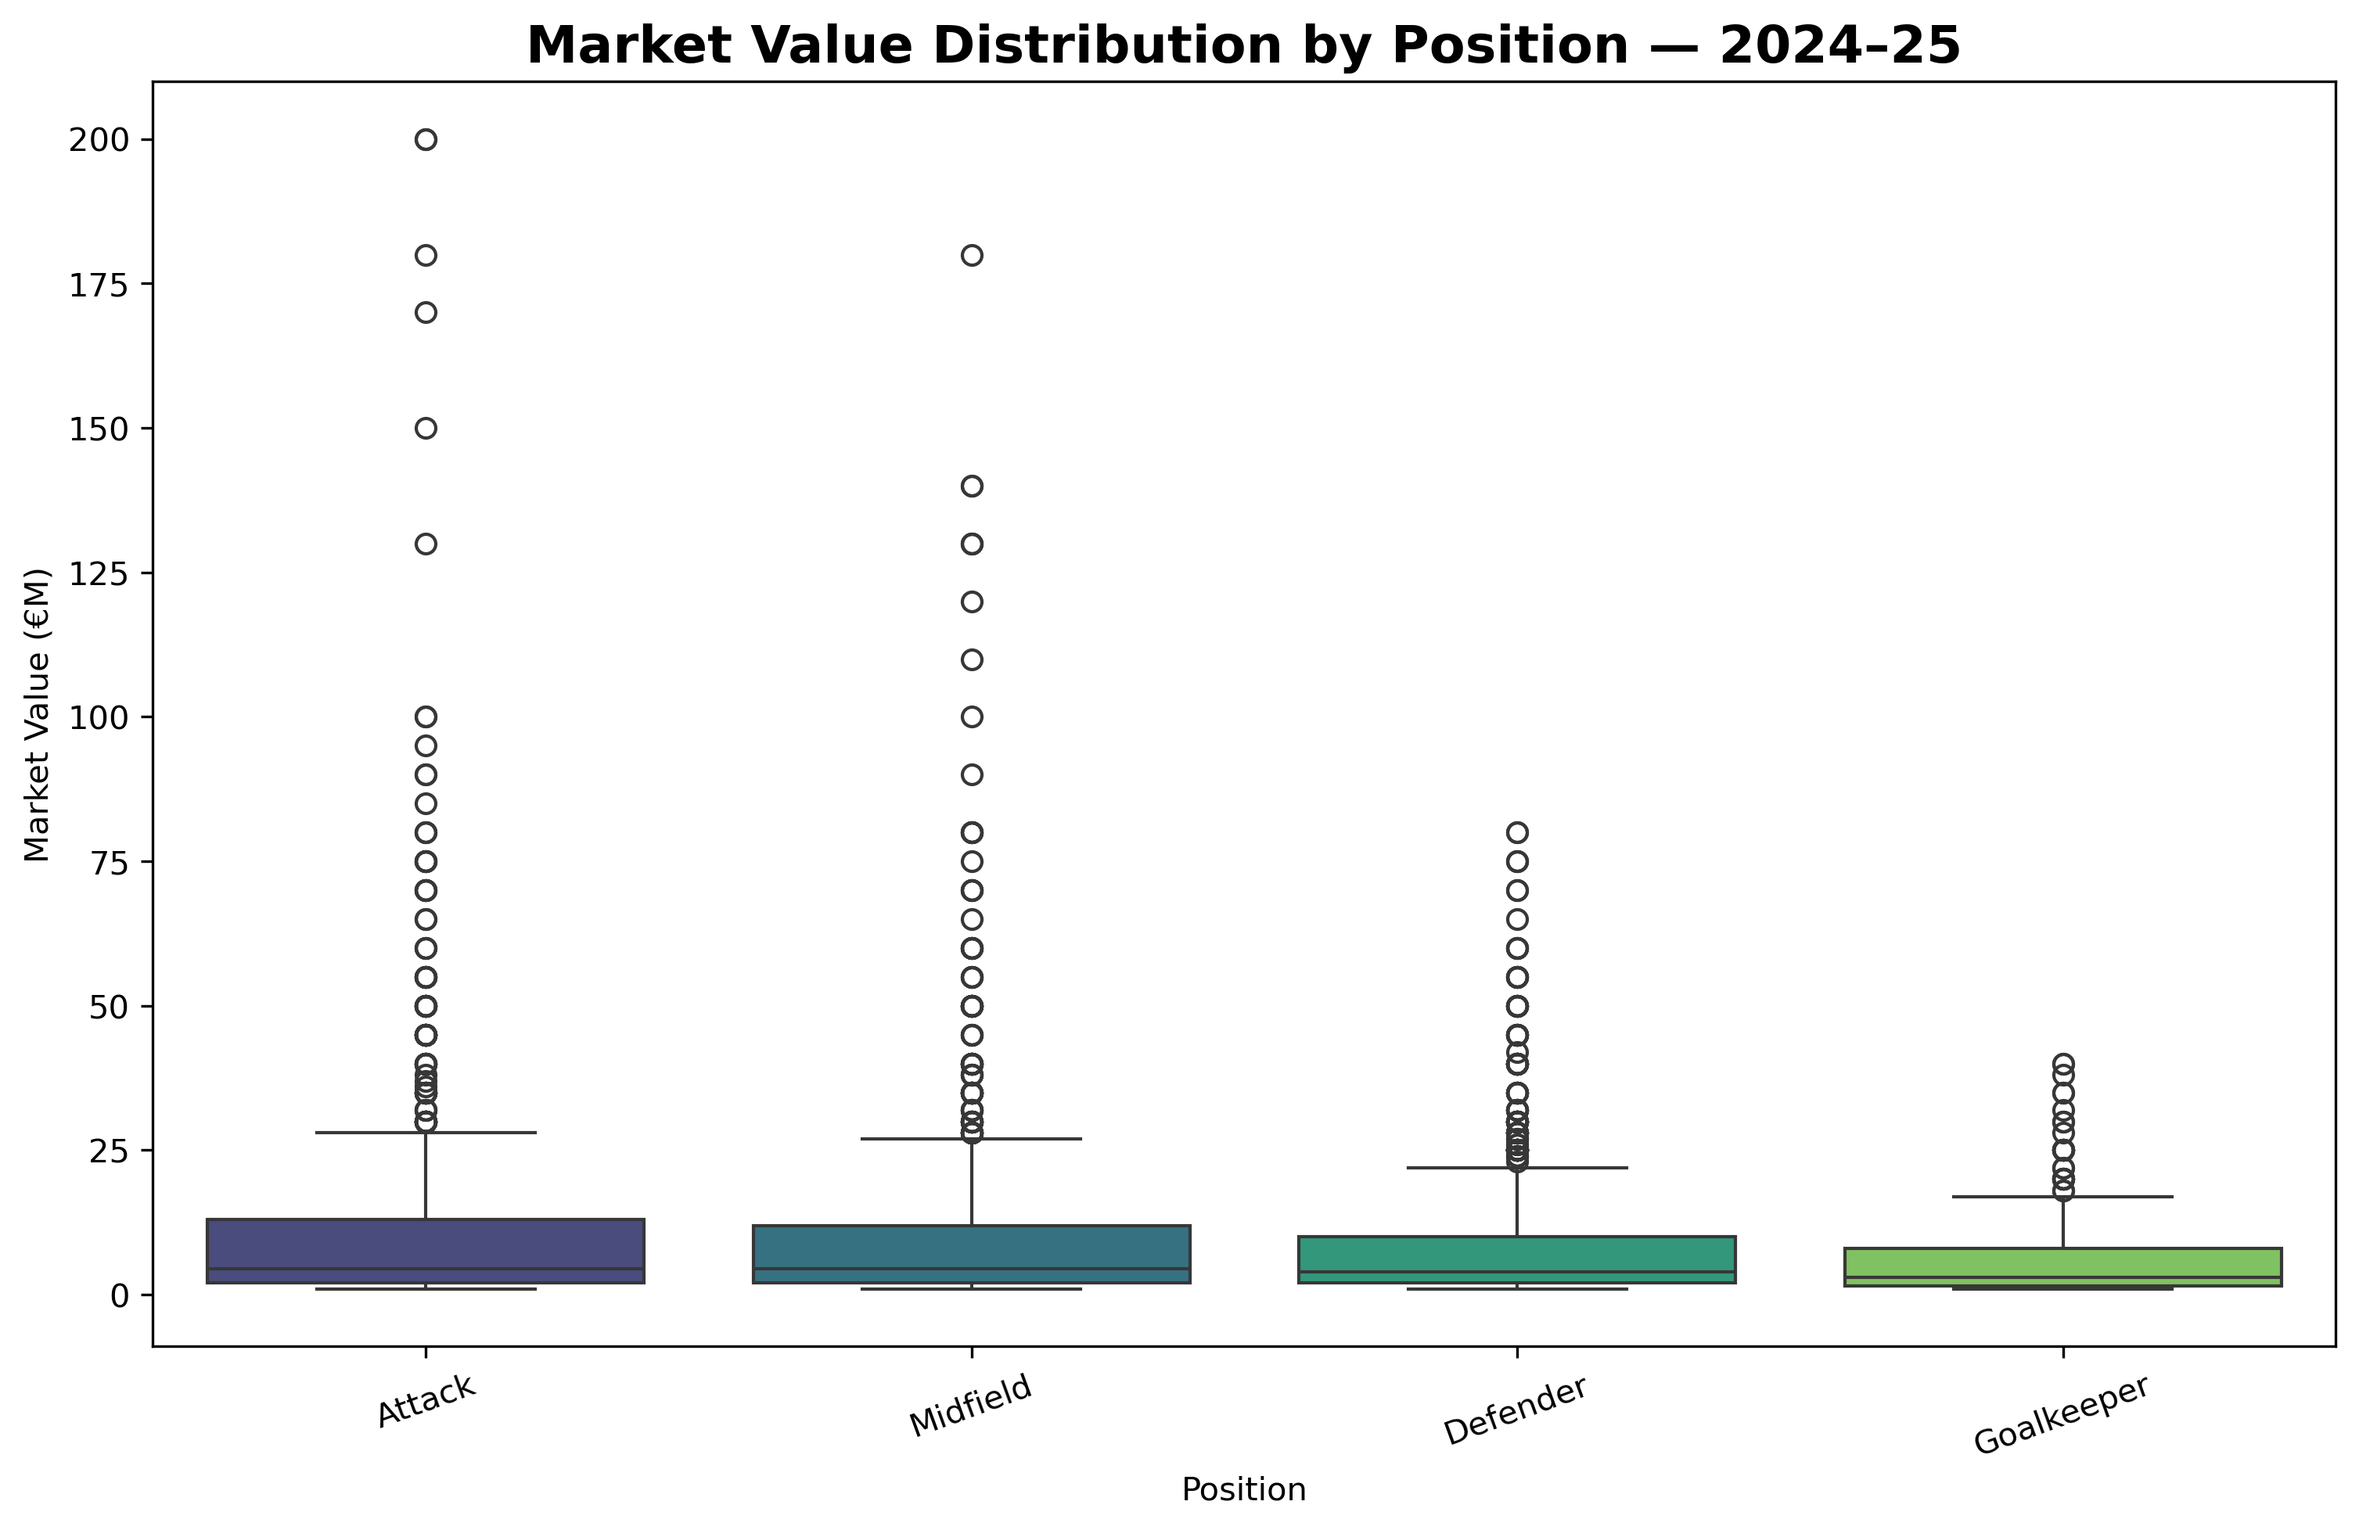
Figure 1: Distribution of player market values (EUR millions) by position, 2024-25 season. The right-skewed distribution motivates log-transformation of the target variable.

Model Implementation
Using NumPy, three regression models were used, not relying on machine learning libraries, demonstrating understanding of the fundamental mathematics behind the way it works. The different models were fitted for ten separate variations. One model covered all leagues and positions in the dataset, five per-league models, and four per-position models with adjusted feature sets were created.
Basic least squares regression was used for the normal equation through numpy.linalg.lstsq, with an intercept column added to the design matrix. This model was used as an understandable guideline to compare with alternative approaches.
Ridge regression was performed by fitting a regularisation matrix augmented by a lambda penalty parameter of ten by multiplying the normal equation with the penalty parameter. The intercept variable was not included in regularisation by setting the diagonal entry of the penalty matrix to zero for the intercept term, as per common practice. This use minimises overfitting where predictors like goals and expected goals exist, which are clearly connected, within the dataset.
Using fifty different decision trees, a custom Random Forest was created, each developed on a bootstrapped subsample of 85 percent of the training data with 60 percent of features chosen on a random basis for each split. Trees were grown to a maximum depth of seven, and twelve samples as the minimum threshold needed for each leaf node. Variance reduction was used as the splitting criterion. Predictions across all the trees were averaged to yield the final estimate. The use of this also showcased non-linear relationships such as the relationship between age and league connection which are unrepresentable in linear models.

Evaluation
The evaluation of all models were based on a set out test set, using 20 percent of each dataset, accompanied with the left over 80 percent being used for training. The split of the data was enforced by using a set random seed ensuring reproducibility. The first evaluation metric used was the coefficient of determination, known as R², measures the proportion of variance in log market value explained using the model. The second evaluation method was the root mean square error on the log scale, which reflects average prediction error in a way that punishes large differences. Each model type was assessed in a separate way for the feature importance. For the basic least squares and Ridge regression, the absolute values of standardised coefficients were normalised to sum to one, creating a comparable importance ranking. For Random Forest, both impurity-based importance obtained during training and permutation importance calculated on the test set were computed and compared, with permutation importance taken as the primary measure owing to its lower susceptibility to bias toward high-cardinality features.

Results and Analysis

Overall Model Performance
Three regression models were evaluated at a 80/20 holdout test set, using Ordinary Least Squares (OLS), Ridge regression where lambda is equal to 10, and a Random Forest of 50 trees with max depth of 7. The performance of these models was measured using R² and root mean squared error (RMSE) on market values that are log transformed.
Overall test R² was highest for Random Forest at 0.637, substantially outperforming linear models at 0.540 for OLS and 0.539 for Ridge. In addition, the near-identical scores of OLS and Ridge indicate that multicollinearity was not a severe problem in the final feature set, and that the penalty applied by Ridge had little effect on generalisation at the regularisation strength chosen. The Random Forest advantage is evident in its suitability to capture non-linear relationships. For example, the non-monotonic influence of age on market value, with players peaking in their mid to late twenties and then declining, which cannot be described through a linear decision boundary.
All three models significantly outperform a simple baseline through predicting the training mean for every observation, R² = 0, confirming that the chosen in-season features and contextual features convey authentic predictive information. R² values below 0.65, however, also emphasize the inherent difficulty of this task: player valuations are affected by factors absent from the model, including transfer market liquidity, contract length, injury history, and speculative demand driven by media attention. These sources of residual variability are explained in more detail in Section 5.2.

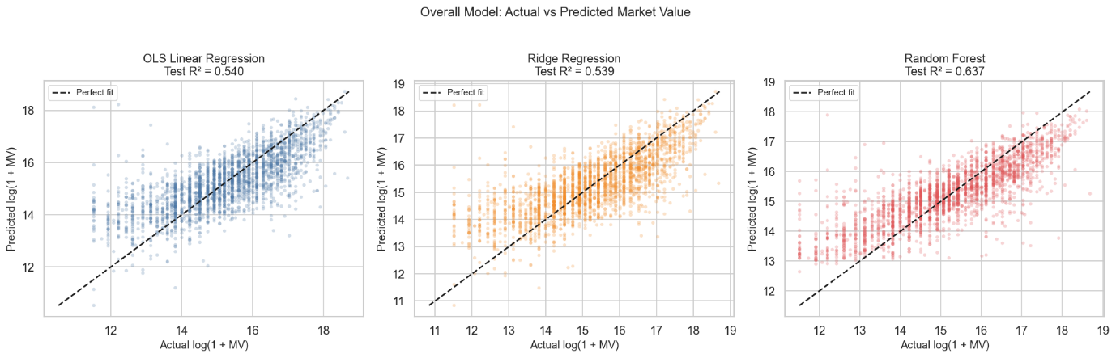
Figure 2: Actual vs. predicted log market value for all three models on the holdout test set (OLS R² = 0.540, Ridge R² = 0.539, RF R² = 0.637).

Per-League Analysis
Disaggregating league outcome results shows substantial variance in model fit according to the competition setting, implying valuation dynamics differ across footballing contexts.

The Bundesliga had the highest quality results of the three models with OLS=0.562, Ridge=0.552 and RF=0.619. This may also be because the transfer market for German football is relatively transparent; player wages and club finances are reported publicly via league licensing rules, making it possible for performance statistics to be found consistent with observable values. The Premier League and Ligue 1 generated average overall R² scores, Premier League RF: 0.620, and Ligue 1 RF: 0.593, while La Liga RF: 0.607 sat in a comparable range.

Serie A was the lowest linear model performing with OLS: 0.261 and Ridge: 0.288, but the RF, however, was an impressive 0.596. This incongruence implies that Serie A valuation has a more non-linear structure that OLS cannot accommodate, possibly because in Italy a greater combination of ageing established stars and developmental signings respond differently to the same stats. This is further supported by the higher robustness observed in the RF across leagues; the RF test R² across the board achieved greater performance than, or comparable to, the best linear model in competition, thus proving the utility of ensemble methods in this area.

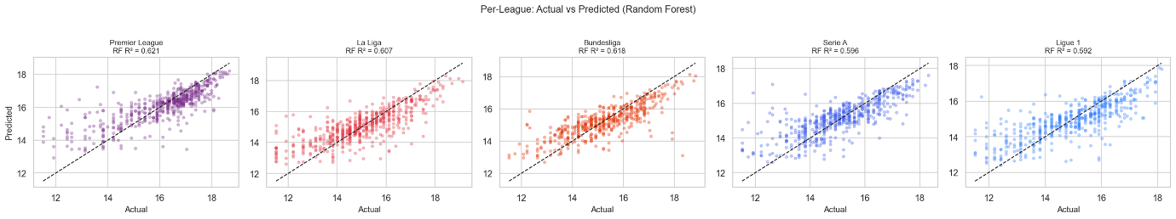
Figure 3: Random Forest actual vs. predicted log market value split by league, with individual R² values shown per competition.

Per-Position Analysis
Splitting the test set by playing position reveals yet more diversity. Goalkeepers had the highest R² for all three models with OLS = 0.716, Ridge = 0.717, RF = 0.708, and notably the linear approaches performed on par with the RF. This is in line with the notion that GK valuation is the case based on a more straightforward set of interpretable factors, save percentage, clean sheets, experience, rather than complex combinatorial signals that distinguish outfield players.

Defenders also demonstrated good linear performance of OLS: 0.626, Ridge: 0.623 with a modest change for the RF of 0.616 which is within margin of variation. The RF also outperformed linear baselines for midfielders and forwards, again showing that there lies a wide distribution of roles in these positions: a deep-lying playmaker and an attacking winger have the label ‘midfielder’ in common, but they are not motivated by the same valuation drivers as sources of variance the trees can partition more smoothly than a single linear plane.

Forwards resulted in the least significant RF improvement from 0.575 to 0.535 over OLS, and this is likely because goals, the main forward-specific measure, are relatively straightforward to capture, even in a linear model, though their high variance across a single season introduces noise.

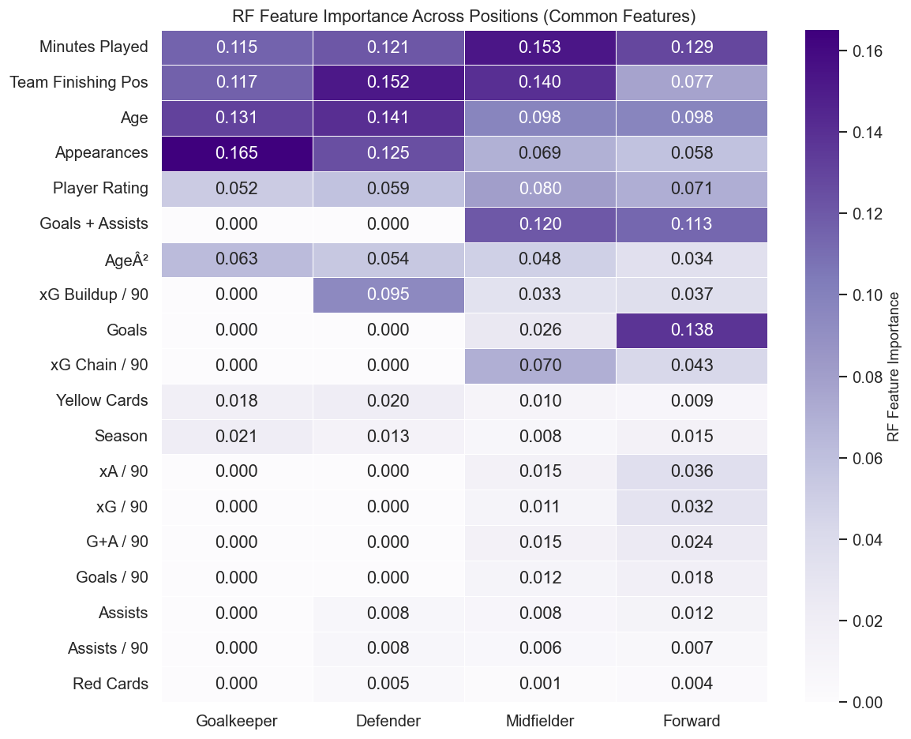
Figure 4: Random Forest permutation feature importance heatmap across playing positions. Colour intensity indicates relative importance.

Feature Importance
Feature importance was estimated using three complementary approaches: OLS and Ridge with absolute standardised coefficients, and permutation-based importance with Random Forest, averaged across five repeated permutations to reduce variance.

Minutes Played and Age were the two most important features over the various methods. Minutes Played is a basic understanding for player fitness, trust in a manager and consistent contributions in seasons, all signals towards transfer market value. The age component captures valuation in terms of career trajectory: prime-age players, say 23 to 28, command elevated prices, all else being equal, reflecting future resale value.

Appearances were most important permutants in their rank, which was similar to but different from minutes, numbers of games played, rather than time played in. Team League Position was the fourth most important permutation feature, consistent with the idea that contextual performance of playing for a top team influences individual player valuation beyond raw statistics.

Player Rating sourced from FotMob, came in fifth, not surprising as this metric is an aggregate. This could suggest that the combined signal that is encoded into a match rating accounts for some performance effects not fully captured by the other individual statistics.

Goals and assists were statistically significant in linear models but lower in permutation importance which is probably because their within-season variance is high for individual players, rendering them noisy signals at the single-season level. Position-specific features such as xG Buildup per 90 for defenders and Win Rate for goalkeepers, surfaced as important features in position-stratified models, thus confirming we chose to analyse positions independently from each other.
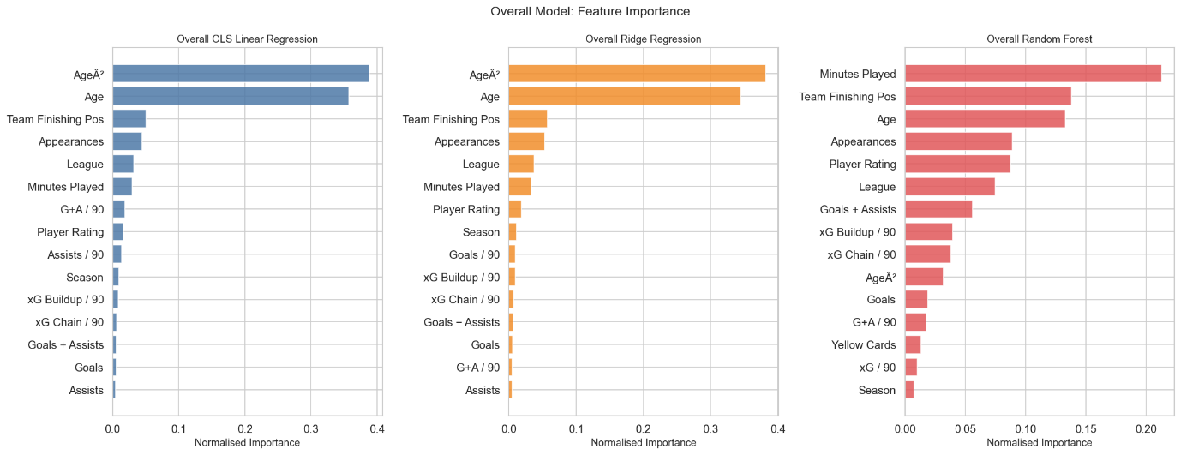
Figure 5: Normalised feature importance for OLS, Ridge, and Random Forest models on the overall dataset.

Year-on-Year Trends
Random Forest models were used to judge model stability over time, these were retrained and separately tested on each season from 2020/21 to 2024/25. The results were generally consistent across seasons for most leagues, which indicates that model-modelled valuation relationships appear structurally stable and not period-specific artefacts.
The Bundesliga performed especially well at all 5 seasons with a RF R² of between 0.60 and 0.68, indicating that model generalization was good and robust from one season to the next. Premier League results were relatively stable about 0.57 to 0.65.
The most notable anomaly was Ligue 1 in 2024/25, where the RF R² dropped as low as 0.341 shows it as substantially lower compared to both other seasons and leagues. This mirrors the financial and sporting upheaval that Paris Saint-Germain has faced after the departures of multiple elite figures in the league, particularly the departure of Kylian Mbappé, which has dramatically reshaped its market architecture in that time span. In particular, a few extreme valuations in a single club can disproportionately distort predictions when the model has not been tested with similar cases before training.
In summary, through analysing yearly data, the framework is robust across seasons, whereas with the Ligue 1 2024/25 result a well-recognized limitation of data-driven models comes into play: the model is unable to predict structural breaks in market dynamics due to extraordinary outliers beyond the training distribution. This is explored further in Section 5.2.

Discussion
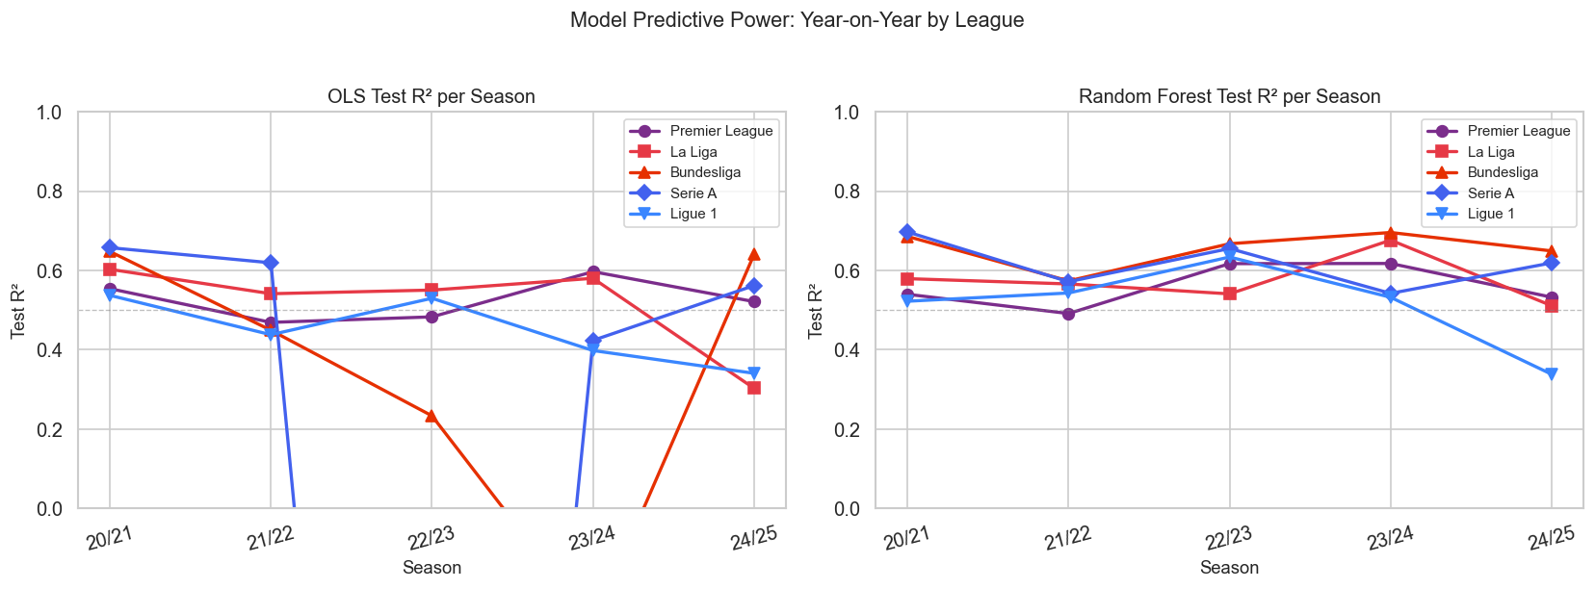
Figure 6: Year-on-year OLS and Random Forest R² by league across five seasons (2020/21 to 2024/25). The Ligue 1 2024/25 drop is clearly visible.

Interpretation of Findings
The drivers of football player valuation and the extent to which they can be understood from in-season data alone in Section 4 results provide some interesting perspectives.
The fact that such Random Forest performance is consistently superior across leagues and positions indicates what much of prior research has been about, the association between player performance and market value is not linear. The most obvious illustration of this is Age. A player's value does not increase linearly with experience; it rises during the early stages of their career, reaches a high point in their mid-to-late 20s, and begins to decrease as the market factors in future resale potential. This curve cannot be reduced to a straight regression line, and the RF can understand the space to such a degree with no guaranteed functional form, giving it a substantial advantage over OLS and Ridge.
The influence of minutes played and appearances within the feature importance ranks is an interesting finding in and of itself. Someone may be of the opinion that the main drivers of valuation should be goals, assists, or expected goals metrics, since these are the statistics of most interest when it comes to discussions of transfers. The results, meanwhile, show that availability and consistency are valued more highly by the market than peak output. A consistent player who features in 35 games at a desired level is valued more consistently than a player scoring 10 goals in 20 matches and does not play more due to an injury or rotation.
The fact that the goalkeeper model performed better, with an R² of roughly 0.71, than other positions means that the GK valuation process is a more formal procedure. There are fewer goalkeepers at the top level, their role is much more standardised and their performance metrics such as, save rate, clean sheets, distribution, these are more of a direct match to what markets decide. Outfield roles, particularly midfielders and forwards, contain a broader range of roles and stylistic characteristics, resulting in variability that the model faces difficultly in accommodating completely.
The value of the Team League Position as the fourth-most valuable dimension supports the argument made by (Peeters, 2018) and others that make the claim of contextual performance. The quality of a player's environment is therefore perceived by the market to influence a player's value beyond what their individual statistics suggest. An example of this is a central midfielder with a high pass completion percentage for a dominant team has a different position in the market than one making as many passes in a relegation battle.

Limitations
Limitations should be noted in interpreting these results, even though a decent predictive capability was attained.
The variety of features used is the most basic limitation that could be interpreted. Player market values are not determined purely by on-field performance but are determined by many hard to quantify, or publicly inaccessible factors. Contract length, off pitch drama, agent status, and remaining sell-on value are important factors, but were omitted entirely because the data were not available. Likewise, record of injury in terms of the seriousness and frequency of former injuries, has been shown to influence transfer fees, but it was not possible to create robust injury records from the open-access literature in the current study. Both media images and economic attractions that were vital factors in transfers, for example Neymar’s move to PSG in 2017, fall well beneath what performance statistics could measure (Müller et al., 2017), and Mason Greenwood’s controversy at Manchester United in 2022, resulting in his market value collapsing when there was no on-field evidence of declining performance.
The second limitation is to do with the data sources themselves. Valuations derived from Transfermarkt are community-driven rather than official values. Although earlier studies have found that Transfermarkt fees are closely matched to the actual transfer fees (Peeters, 2018; He et al., 2015), the estimates are not always the same as the real amounts, and the crowd-sourced nature of the estimates introduces some noise, more specifically to smaller leagues and players not seen from the media.
The models were trained following five seasons of data from five major European leagues and thus limits their generalisability to other competitions, where transfer fees are not as large. MLS, EFL Championship, Eredivisie or Liga MX valuations operate in different economic markets, squad structures, and media environments. Using that model in those scenarios would return a worse performance, without re-training on league-specific data.
The Ligue 1 2024/25 abnormality noted in Section 4.5 highlights a wider weakness of all supervised learning approaches; models trained on historical data do not predict structural breaks. Kylian Mbappé departure concentrated extreme valuations in a way the model had never encountered during training, leaving it with no mechanism to compensate. This is not an issue unique to the methods used here, it is rather an unavoidable property of data-driven modelling under the conditions of a dramatic change in real-world market conditions, but is well worth noting as a limitation on deployment in the live transfer market application.
Finally, all three models were evaluated on a single 80/20 split. Although results were implicitly cross-validated by the year-on-year comparison in Section 4.5, more robust k-fold cross-validation across seasons would provide stronger evidence of generalisation and is a possibility for future work.

Conclusion

Summary
This study had the goal to investigate if machine learning models trained on the publicly available in-season performance statistics can be useful to forecasts of players market valuations in the top 5 European professional football leagues. The results show that this can be reasonably done to a reasonable extent, as the Random Forest model generates an overall test R² of 0.637, better than OLS of 0.540 and Ridge regression of 0.539 as well, all while leaving out the input feature of prior market value.
The results confirm certain hypotheses inferred from previous research. First, that the relationship between performance and value is non-linear, between performance and value and that ensemble methods are more capable of fitting than regression. Second, availability and consistency, as measured in Minutes Played and Appearances. These are stronger and more consistent signals of value than the peak output metrics, goals and assists. Thirdly, contextual variables, especially a player’s team league position, play an important role in the market value of players, further than basic statistics and contribute to the idea that the market adjusts a player's value based on the environment in which they perform.
Position-level analysis showed that the valuation of the goalkeeper was most predictable of all groups with an R² value of around 0.71, showing the more formalised nature of this market. Residual variance throughout outfield positions, and midfielders more specifically, was relatively higher, in line with the diversity of roles and stylistic profiles in those fields.
The five-year analysis showed the model has achieved stability in performance over the five periods examined, leading to higher confidence in the robustness of the model. The sole exception, Ligue 1 in 2024/25, where performance dropped sharply after Kylian Mbappé departed, is a tangible example of a broader limitation: data-driven models are unable to predict structural breaks from extraordinary events outside the training distribution.
From these results the evidence shows that a data driven approach for player valuation is actually useful in practice and as benchmarking material in providing clubs with objective reference points against which one can benchmark asking prices of markets. It also allows clubs to identify players whose statistics indicate that their current estimate is likely to be below what is currently calculated on the market.

Future Work
While the framework proposed in this paper is deemed feasible, there are several avenues for future exploration that could greatly improve its predictive capability and practical applicability.
The most impactful extension would be to include extra features which are not included in the model currently. Contract length and any possible clauses are especially significant omissions, as these elements have a direct impact on how much a club may charge in negotiations. Injury history, the number, severity and recovery time of injuries, is another well-documented driver of transfer fees that was not possible to include here because of data availability limitations. Bringing these variables into the model would possibly explain much of the remaining unexplained variance.
The second avenue is use of career trajectory modelling as opposed to single-season snapshots. The existing technique treats all seasons of a player as a stand‑alone one, so it cannot tell if a player is growing, plateauing or declining against their own past numbers. Including how well the figures improve with each year as a result of those seasons, so the variation in Goals + Assists per 90 or minutes played through consecutive seasons, for instance, may help the model capture the momentum of the forward-looking nature of the transfer valuations. This was identified as a priority during the design phase, and would be a logical next step.
Thirdly, a stronger validation framework would improve the confidence of the results. The present study was based on single holdout split at 80/20 in addition to the year-forward comparison. A rolling time-series, cross-validation strategy meaning training on seasons 1 to 3 and testing on season 4, then training on seasons 1 to 4, and testing on season 5, would better replicate the kind of data that's typically simulated in real use cases, where a model that is trained on previous seasons could be applied to any potential transfer window.
Lastly, the model could be extended to other leagues or lower divisions so that it is broadly applicable. Including European competition data, such as the UEFA Champions League, would provide additional observations for players who appear in both domestic and continental fixtures within the same season. The chance to find some of the most impactful signings, being some who are signing from the EFL Championship, Eredivisie or Liga Portugal, to make a real difference at the top. A model that has the potential to value players from a broad variety of competitive contexts would be much more beneficial for clubs operating across various tiers of the football pyramid.

Bibliography
Breiman, L., 2001. Random forests. Machine Learning, 45(1), pp. 5-32.
Bryson, A., Frick, B. & Simmons, R., 2013. The returns to scarce talent: Footedness and player remuneration in European soccer. Journal of Sports Economics, 14(6), pp. 606-628.
Cariboo, D., 2023. Football data from Transfermarkt. [Online]
Available at: https://www.kaggle.com/datasets/davidcariboo/player-scores
[Accessed 17 October 2025].
FBref, n.d. FBref: Football statistics and history. [Online]
Available at: https://fbref.com/en/
[Accessed 12 November 2025].
Fernández, J., Bornn, L. & Cervone, D., 2019. Decomposing the immeasurable sport: A deep learning expected possession value framework for soccer. Boston, s.n.
FotMob, n.d. FotMob: Live football scores. [Online]
Available at: https://www.fotmob.com/en-GB
[Accessed 12 November 2025].
Frick, B., 2013. The labor market in professional team sport: The case of football players in Europe. In: L. Trenberth & D. Hassan, eds. Routledge Handbook of Sport Management. London: Routledge.
He, M., Cachucho, R. & Knobbe, A. J., 2015. Football player's performance and market value. Porto, s.n.
Herm, S., Callsen-Bracker, H.-M. & Kreis, H., 2014. When the crowd evaluates soccer players' market values: Accuracy and evaluation attributes of an online community. Sport Management Review, 17(4), pp. 484-492.
Hoerl, A. E. & Kennard, R. W., 1970. Ridge regression: Biased estimation for nonorthogonal problems. Technometrics, 12(1), pp. 55-67.
Lucifora, C. & Simmons, R., 2003. Superstar Effects in Sport: Evidence From Italian Soccer. Journal of Sports Economics, 4(1), pp. 35-55.
McHale, I. G. & Holmes, B., 2023. Estimating transfer fees of professional footballers using advanced performance metrics and machine learning. European Journal of Operational Research, 306(1), pp. 389-399.
Müller, O., Simons, A. & Weinmann, M., 2017. Beyond crowd judgments: Data-driven estimation of market value in association football. European Journal of Operational Research, 263(2), pp. 611-624.
Patnaik, D., Praharaj, H., Prakash, K. & Samdani, K., 2019. A study of prediction models for football player valuations by quantifying statistical and economic attributes for the global transfer market. Pondicherry, s.n.
Peeters, T., 2018. Testing the wisdom of crowds in the field: Transfermarkt valuations and international soccer results. International Journal of Forecasting, 34(1), pp. 17-30.
Sulimov, A., 2024. Performance insights-based AI-driven football transfer fee prediction, s.l.: s.n.
Torgler, B. & Schmidt, S. L., 2007. What shapes player performance in soccer? Empirical findings from a panel analysis. Applied Economics, 39(18), pp. 2355-2369.
Transfermarkt, n.d. Transfermarkt: Football transfers, rumours, market values and news. [Online]
Available at: https://www.transfermarkt.com/
[Accessed 17 October 2025].
Understat, n.d. Understat: Expected goals statistics for football. [Online]
Available at: https://understat.com/
[Accessed 29 November 2025].
Veliz, E. & Dimopoulos, G. R., 2025. Here we go! Predicting transfer market valuations of Premier League footballers. [Online]
Available at: https://medium.com/stanford-cs224w/here-we-go-predicting-transfer-market-valuations-of-premier-league-footballers-1774131946ff
[Accessed October 2025].

Appendix A: Artificial Intelligence Interaction Log

The following prompts were submitted to Claude (Anthropic) as part of the development and writing process for this project. All outputs were reviewed, verified, and substantially rewritten by the author.

Prompt 1:
Help me find more Literature than what I currently have for my dissertation on football player market valuation. My subsections are: Player Valuation in Football, Performance Metrics and Expected Goals, Machine Learning in Sports Analytics, and Limitations of Existing Research.
Prompt 2:
Review my methodology section and give feedback on whether it adequately describes the OLS, Ridge, and Random Forest models I implemented from scratch in NumPy.
Prompt 3:
The Value Estimator in my Streamlit dashboard is giving incorrect predictions. The intercept is missing from the Ridge regression prediction code. How can I fix it?
Prompt 4:
Write a draft for Section 4 (Results and Analysis) using the following test R² values: OLS=0.540, Ridge=0.539, RF=0.637 overall, with per-league and per-position breakdowns.
Prompt 5:
What figures should I include in my dissertation report and where should they go? I have plots in my outputs folder including actual vs. predicted charts, feature importance, and year-on-year trends.

Appendix B: Source Code

The complete source code for this project, including the machine learning pipeline, data preprocessing scripts, and Streamlit dashboard, is available in the project folder. https://gitlab.comp.dkit.ie/D00255640/player-market-prediction/-/tree/00db20a800d89ae6e92b0e091f993c189aaa8679/
Key files include:
• notebooks/market_value_prediction.ipynb - Full model training and evaluation pipeline
• streamlit_app/app.py - Interactive dashboard application
• data/ - Processed datasets from Transfermarkt, FBref, Understat, and FotMob
• outputs/model_results/ - Model outputs, feature importance plots, and evaluation figures

