**CODM-CHANNEL OF DISTRIBUTION AND MARKETING**

- A product trip from manufacturer to the buyer.

**Background-**

* **Problem statement :** Buying fake products happens at consumer’s volition, when he wants meet his esteem needs, but not pay the price(counterfeited luxury goods).

**ISSUES:**

1. Production slow down.
2. Reduce Consumer spending.
3. Damage the reputation of brand names.

* **Existing tools**: Regular Database , ‘ BONAFI ‘ is a company which allows only leaf entity to ownership the product.
* But the problem with the existing tool is that the manipulation of the records can be done easily , chain of ownership is not determined and chance of counterfeiting the goods.
* Though the current tool is updated , we can update the records with the regular database.

**Solution:**

Overlapping point :authenticating the supply chain using blockchain technology.

**Difference:**

During manufacturing, products are embedded with an unique key(hash key) , which acts as key to the distributed ledger.

This unique key is used to scan the number of products for quality checking and transparency of that particular product.

**Gains/wins from creating this solution:**

* Transfer of ownership will be done by the current owner.
* It stores complete history of transactions in shared database.
* We can track the price.
* Customer trust and satisfaction.

**Definitions/acronyms, and abbreviations:**

Blockchain : continuously growing list of records, called blocks. Which are linked and secured using cryptography

Hash key : it is an unique key , function that converts input of letters and numbers into an encrypted output of fixed length.

**Design overview:**

Project requirements : 1.ETHEREUM PLATFORM(SOLIDITY LANG.)

2.PRIVATE SERVER(LITE SERVER)

3.FRONT END

Requirements needed from customer/partners : Revenue.

**Minimal viable product** : A company should register in to the site and enter the details of product , then each product is assigned with an unique key. If the company scan the product id the ownership of the product is displayed.

If the company want to sell the product to buyer ,again the buyer details are recorded and generated with an unique id. Now if we scan the product id then it shows the chain of ownership from manufacturer to the buyer(transfer of ownership from one to one).

**Stretch goals and Future goals** : Adding transactions and displaying the cost of the product at each stage in the supply chain.

Application Programming Interface : Command line prompt for running test-rpc.

User Interface : 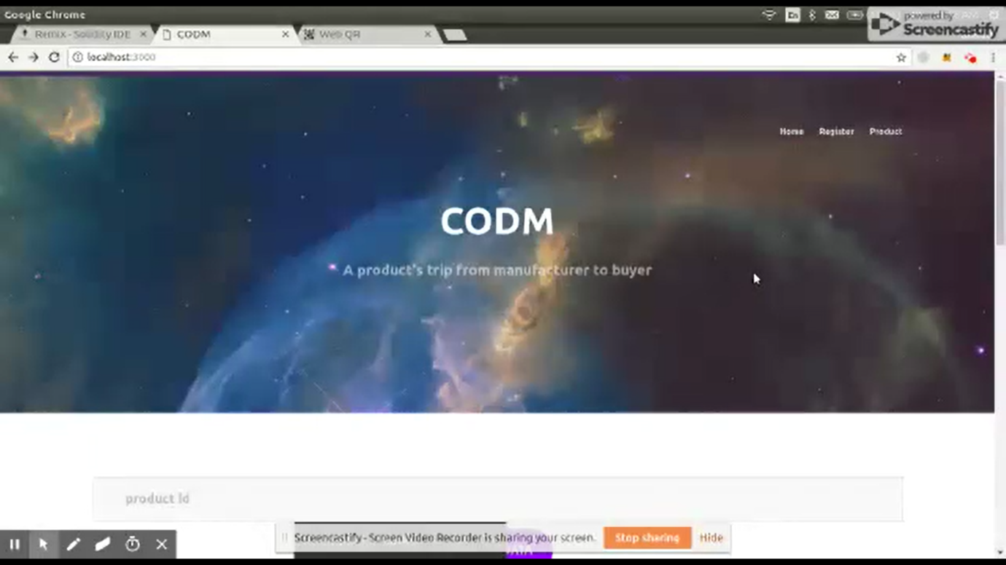

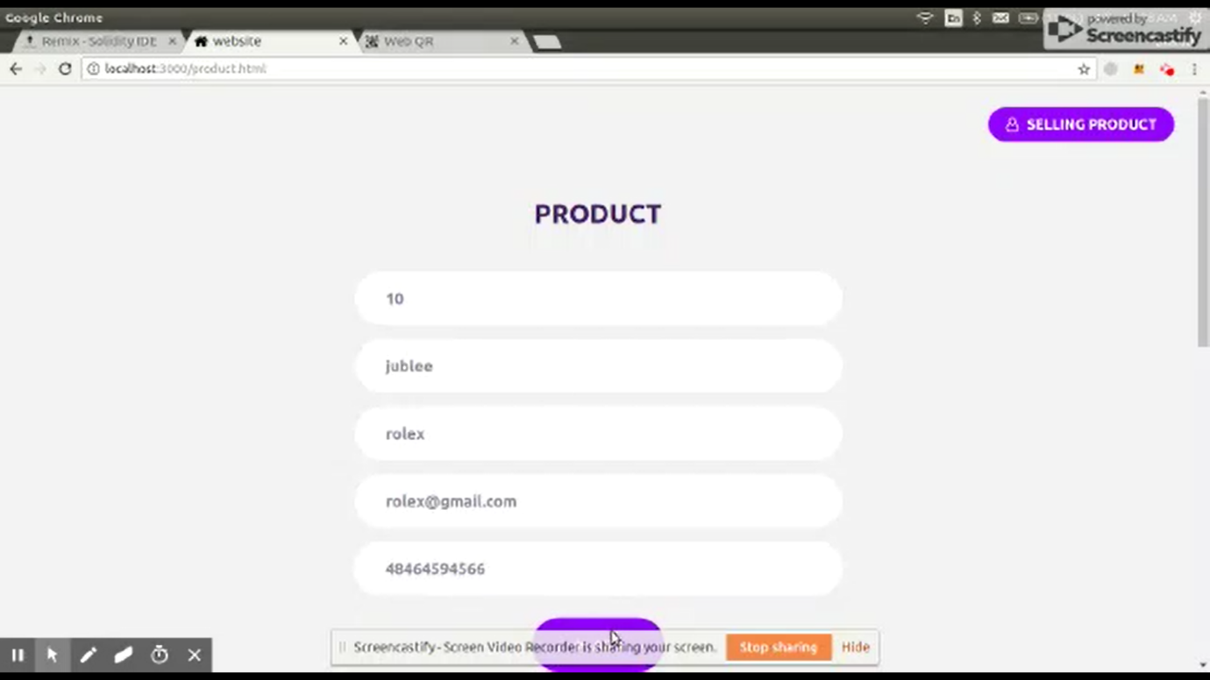

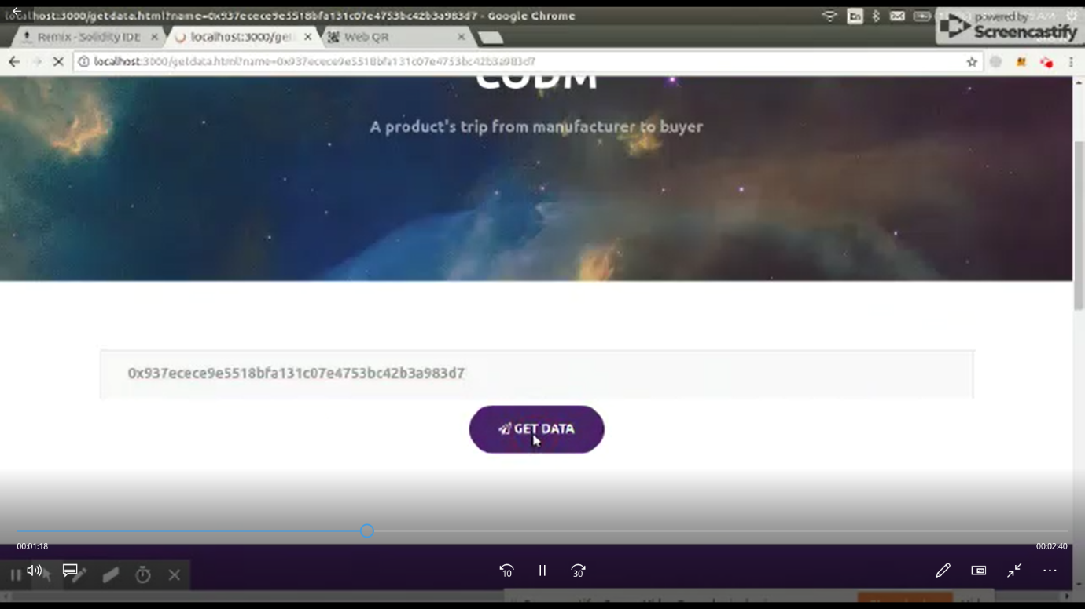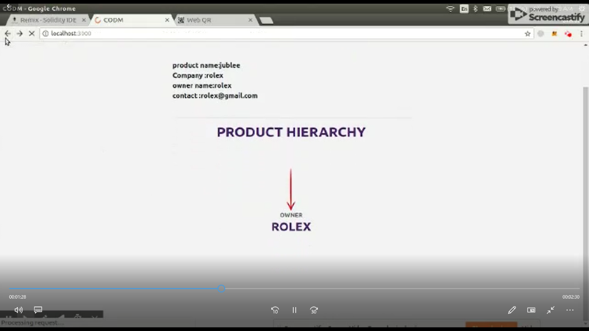

USECASE DIAGRAM :UML DIAGRAM FOR OUR PROJECT

