Design Doc Template

*Author(s): TEAM CREATIVE BRAINIACS*

*Date: 22/05/2019*

Revision: 0

Document Status: Draft [Draft, Completed, Submitted, Reviewed, Final]

Project Status: In-Progress [In Review, Approved, In-Progress, Completed]

Revision History

|  |  |  |  |
| --- | --- | --- | --- |
| Date | Revision | Description | Author |
| 22/05/2019 | 0 | Initial draft of the design doc template | xyz |
|  |  |  |  |
|  |  |  |  |
|  |  |  |  |
|  |  |  |  |
|  |  |  |  |
|  |  |  |  |
|  |  |  |  |
|  |  |  |  |
|  |  |  |  |

Table of Contents

TOC \o "1-3" \h \z \u Introduction4

Summary4

Background4

Definitions, Acronyms, and Abbreviations4

Design Overview4

Requirements4

Documentation4

Minimum Viable Product5

Stretch goals5

Future work5

Architectural Diagrams5

System Diagrams5

Application Programming Interface5

Recommendations5

User Interface6

Data Models and Storage6

Service Operability6

Key Performance Indicators6

Service Level Objectives6

Project Overview7

Communication and Tracking7

Risks7

Milestones7

Project Phases7

Cost7

Frequently Asked Question7

References7

Addendum8

# Introduction

## Summary

Most of the senior citizens deaths are due to negligence of their health and also due to falling down.If we could prevent old people from falling down then we can stop 95% of their deaths. By calculating the gait speed of old person using a wearable device( a SMART BAND) and sensors on different parts of the body enables a safety protection before the elderly fall down.In this way can prevent them from falling down according to a research. There is an immediate need of this technology in today’s life.

Also elderly people ,bedridden people feel difficulty in communicating with their family for the basic needs such as asking for food, water etc., My solution is about developing a gesture based messaging system along with a remainder system that helps to convey message to the caregiver immediately and he would be able to assist the senior citizens within seconds.

## Background

## PROBLEM STATEMENT

Most of the senior citizens feel difficult to communicate with their family for the basic needs and frequently forget their daily medical schedule. Most of the senior citizens deaths are due to falling down.

**1.Fall Detection and Prediction**

According to a research, it was found that a gait speed decline of 5 cm/s was associated with a 86.3% probability of falling within the next 3 weeks. So by calculating the speed and number of steps taken by an old person thereby we can prevent him from falling down in near future. Further we would store the walking speed in an SD card and compare the data of 2 weeks. If the difference in the avg. walking speed is greater than 0.5 cm/s then we would report them to take care.

This is just a part of our research through which we can predict.

**2.Gesture based Messaging System**

As soon as the senior citizens or bedridden people make some particular fixed gesture an SMS is sent to the family members.The accelerometer takes the specific gesture readings and message is sent through a GSM module to the family members phones.All this would be integrated into a SMART BAND.

**Other competitors**

Our only competitor is Apple Band.Apple bands give us information only about **Fall detection**.We have the feature of **fall prevention** which gives us an upper hand and this way we are different from it.The unique feature of our band is gesture based messaging system which doesn’t exist in any device.

By designing and developing this prototype we can prevent elderly people from falling down and hence save many lives. Also we can make the lives of bedridden people healthier and simpler.

## Definitions, Acronyms, and Abbreviations

SBSC – Smart Band for Senior Citizens

GSM Module – Global System for Mobile communication

MPU6050-Accelerometer

Design Overview

## Requirements

Project requirements, this can include requirements from customers, partners, or overseeing teams. The requirements for the project, this may include subsections for various types or sources of requirements

### Documentation

If the project requires any wiki pages, code comments, presentations, etc. that information should be included here

## Minimum Viable Product

The gesture enabled system should work perfectly, also fall prediction and detection should be done to such an extent that all the investors, customers along with myself should be satisfied that this would work for sure.

## Stretch goals

Optimizing the cost of the product. Further development of the project in fall prevention category.

## Future work

In the future we would further like to work on fall prevention thereby making it more simplified and preventing the fall in a more efficient way. Further I would work on the project to help the people of different ages along with Senior Citizens making it a universal product.

# Architectural Diagrams

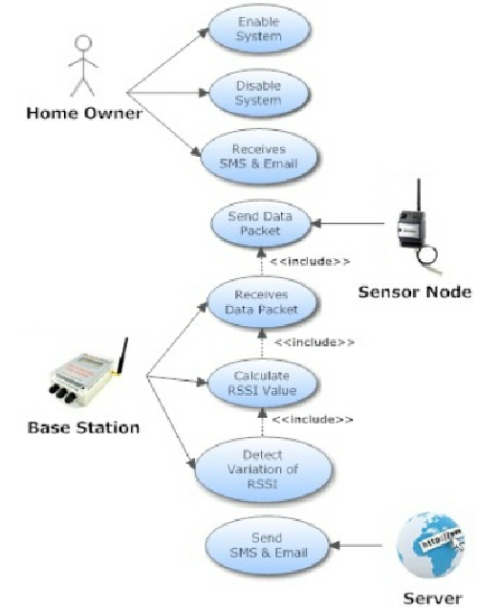

Use case diagram

# System Diagrams

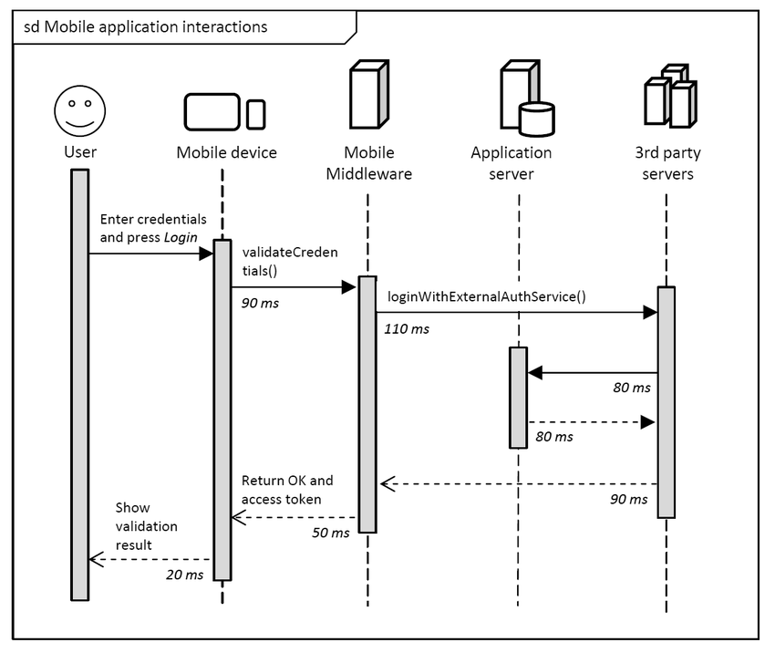

Sequence diagram

# Application Programming Interface

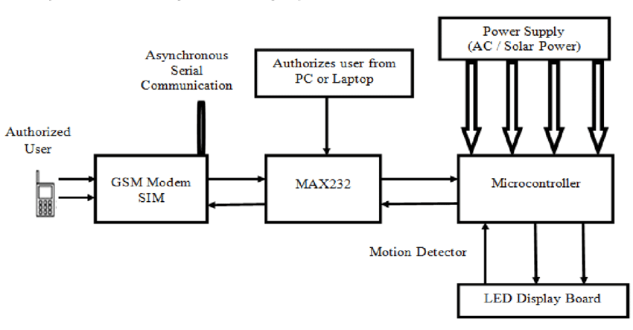

# Service Operability

## Key Performance Indicators

Acceptance of customers: Will the product trigger their esteem needs.

Accuracy of band: working of band accurately without failure.

## Service Level Objectives

Notification to care taker: The needs of elder people is notified to care taker.

Alarm to senior citizen: The alarm is set for proper medication.

# Project Overview

## Risks

**1**.Gestures not working at the right time.

**2.**Power Source

**3**. Will not be able to predict and detect falls in all cases.

## Milestones

**14th June**

Completion of working on Gesture based messaging System, Fall detection and prediction and making it possible.

**18th June**

Testing the prototype along with developing and making all the required changes.

## Project Phases

**Phase-1:**

Working on fall prediction and prevention.

**Phase 2:**

Testing the prototype.

**Phase 3:**

Using embedded systems making its compact , cost-effective and robust product.

## Cost

Level of effort, number of resources, number of hours or weeks, unlike milestones which tracks project time cost should only include engaged time.

1) For the all tasks which are deliverables/visible on user-end side needs to be documented as stories.

2) Need to guess/estimate the time required in number of hours for the completing that stories which can be captured in taiga.

3) Assign that task to the right person and document the actual time taken for completing that task.

# Frequently Asked Question

**Is Fall Prevention really possible?**

Yes, fall prevention is possible taking the right care and perfect use of technology. Many researches have been done on fall prevention and prediction. With the help of these researches I would want to design a product that could help the elderly from falling and getting injured.

**How can the care taker set the alarm for medicine?**

There is a keypad on the band with which we can set the alarm. The alarm rings for the time we have set and elder people are asked to have their medicine.

**How does the message sent to concerned people?**

Based on the gestures shown by the old people the angle is set and appropriate message is sent to concerned people by using GSM module.

# References

**Fallsloop**

<https://www.fallsloop.com/services/webinars/archived-webinars>

**Predicting and preventing fall using technology**

<https://youtu.be/PVeEJrejOW4>

**Sensoria Smart Socks**

**How IOT can help prevent falls**

<https://www.expresscomputer.in/news/how-iot-can-help-in-preventing-falls-for-senior-citizens/18926/>

# Addendum

