Smart Scheme App

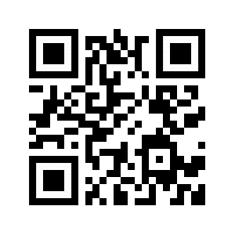

M.G.M Ali, Indu Konduru, Likhita Kasa, Akaanksh Pemmaraju

Progress:

* Week1 - Initially we just had an idea.
* Week2 - In this week we are done with the layouts of the app.
* Week3 - We connected database to the app.
* Week4 - We did the market research regarding app.
* Week5 - According to that we planned our revenue model.
* Week6 - Working app given to users for their feedback.

Contributors:

As it might be difficult for an uneducated person to search for something so our mentor Praful sir suggested to provide contact details in the app and we also got suggestion regarding revenue model, as our app is a service based it is free of cost. So we can provide something like private schemes regarding bank loans and all we can make money of it.

Initial Prototype:

Initially we just had an idea of building the app.

Business:

It is a service based app free of cost, but for the development of the app we can use advertising to generate revenue.

Customer Stories:

Few of our customers said that before they used to know about the information through newspapers and it was difficult for them to search but now this app made it easy for them.

Technology:

We used android studio to build the app and firebase database to store the user information and Schemes information.

Problem: The Govt. has put forward many schemes for the welfare of people but we are not able to use service.

Product: We are building an app that links schemes to the user, Connecting Govt. and people.

Product: We are building an app that links all the schemes to the people, Connecting Govt and people.