Design Doc Template

*Author(s): xyz*

*Date: 22/05/2019*

Revision: 0

Document Status: Draft [Draft, Completed, Submitted, Reviewed, Final]

Project Status: In-Progress [In Review, Approved, In-Progress, Completed]

Revision History

|  |  |  |  |
| --- | --- | --- | --- |
| Date | Revision | Description | Author |
| 22/05/2019 | 0 | Initial draft of the design doc template | xyz |
| 30/05/2019 | 1 | Market Survey |  |
| 06/06/2109 | 2 | Design overview |  |
|  |  |  |  |
|  |  |  |  |
|  |  |  |  |
|  |  |  |  |
|  |  |  |  |
|  |  |  |  |
|  |  |  |  |

Table of Contents

TOC \o "1-3" \h \z \u Introduction4

Summary4

Background4

Definitions, Acronyms, and Abbreviations4

Design Overview4

Requirements4

Documentation4

Minimum Viable Product5

Stretch goals5

Future work5

Architectural Diagrams5

System Diagrams5

Application Programming Interface5

Recommendations5

User Interface6

Data Models and Storage6

Service Operability6

Key Performance Indicators6

Service Level Objectives6

Project Overview7

Communication and Tracking7

Risks7

Milestones7

Project Phases7

Cost7

Frequently Asked Question7

References7

Addendum8

# Introduction

SparCar is a mobile android application which lets the user to know the nearby parking slots by showing the slots on google maps. It covers the concept of utilizing the domestic houses and apartments parking places as rental parking slots to the customers.

SparCar has two types of Clients namely

a. Customer

blot-Owner

* • *Customer* is the person who requires the parking slot to park his car.
* • *Slot-Owner* is the person who provides parking slot area to customer.

Thus, Spar Car act as an interface between Customer and Slot Owner which provides a platform to digitally find the parking areas.

## Summary

* India is the world’s fourth largest automobile market with limited parking spots. Ever-growing number of vehicles causes traffic congestion on most streets and roads.
* Availability of a low cost connected ecosystem will help identify the nearest parking spot when sought
* The ecosystem provided is SparCar which by name means **S**mart **Par**king for **Car-**SparCar which is both environment and economical friendly

## Background

* Parking Spot of Vicinty is the problem statement which describes the problem of scarcity of parking areas and providing a platform to efficiently use the limited and existing parkin areas instead of creating it.

What are the existing tools that address these issues or gaps, and why do they not satisfy this problem?

* Parking Places or Zones in Malls and Special Parking Areas only confined to that purpose.
* HOW ARE YOU DIFFERENT
* We’re different by using the existing resources but not constructing or creating the new resources.

Why can’t the existing tools be updated to solve this problem.

* They can’t solve because they are not providing common gateway or interface to the users directly to communicate and enquire about the parking spaces, their status and place of existence.

What overlaps will your solution have and how is it differentiated from the existing tooling.

* Parking places are common to us and existing platforms and we’re different from existing as the usage of existing parking places which are semi-utilized or under-utilized into a proper purposeful usage by maintaining environmental sustainability and adaptability without creating and constructing a new parking place.

What are the gains / wins from creating this tool / solution?

* It aware the people to solve the “society problem as their problem” by motivating them to offer slots for parking which are not utilised up to the mark.
* It clears the unsolved puzzle of parking issues without even creating or constructing new things.
* It saves the time, energy and fuel of citizens ultimately saving the resources of nation.
* SparCar solves the problem of traffic congestion and parking issues removing the social anomalies.
* Minimising the botherance to vehicle owners regarding where to park, is that parking at that place is legal or not.
* Provide the Customer with a Safe and Secure parking slot within his vicinity.
* *SparCar* is budget friendly to customer as well as easy to use.
* Major benefit to Slot Owner is SparCar is going to earn for them.
* Apartments can incur the monthly maintenance cost as an income from SparCar.

## Definitions, Acronyms, and Abbreviations

Definition of terms that will help readers understand the documents, or acronyms common in your project area

* *Customer* is the person who requires the parking slot to park his car.
* *Slot-Owner* is the person who provides parking slot area to customer.

# Design Overview

## Requirements

* Requirements for car owner are a car, mobile phone with SparCar application (provided with internet and GPS services).
* Requirements for slot owner are a parking slot and application Sparcar (provided with internet and GPS services).
* Requirements of SparCar are the necessity of parking slot to park a car,parking slot and a car.

### Documentation

If the project requires any wiki pages, code comments, presentations, etc. that information should be included here:

The requirement of intelligent parking system is published in the following site:

<https://www.sciencedirect.com/science/article/pii/S1665642313715803>

The parking problems and their types are published in following site and how much parking solution would reduce the problems:

<https://hackernoon.com/how-much-will-smart-parking-solutions-improve-in-2019-fa1bac32cb77>

## Minimum Viable Product

As a minimum viable Product, SparCar provides with potential features to be used by the users as following:

* SparCar provides the major functionality as finding the nearest empty parking slot
* It helps customer search some other place and view parking slots at that place as well as users custom location.
* It also provides slots based on economy,car model and primarily based on distance.
* It also provides customers route to the parking slot .
* It provides the House owners with a way of income by earning amount for each parking
* It provides the House owners with the addition of location and so on.

## Stretch goals

* SparCar would be extended with the addition of payment gateway to the car owner while booking the slot, address search bar like searching the address where we need to find parking slots and so on, providing hardware and security devices in the parking areas.

## Future work

* Extending SparCar to iOS platform
* Extending to all types of Vehicles
* Few Security Enhancements

# Architectural Diagrams

UML diagrams describing the project. You can look for any open source diagramming tool for the same. 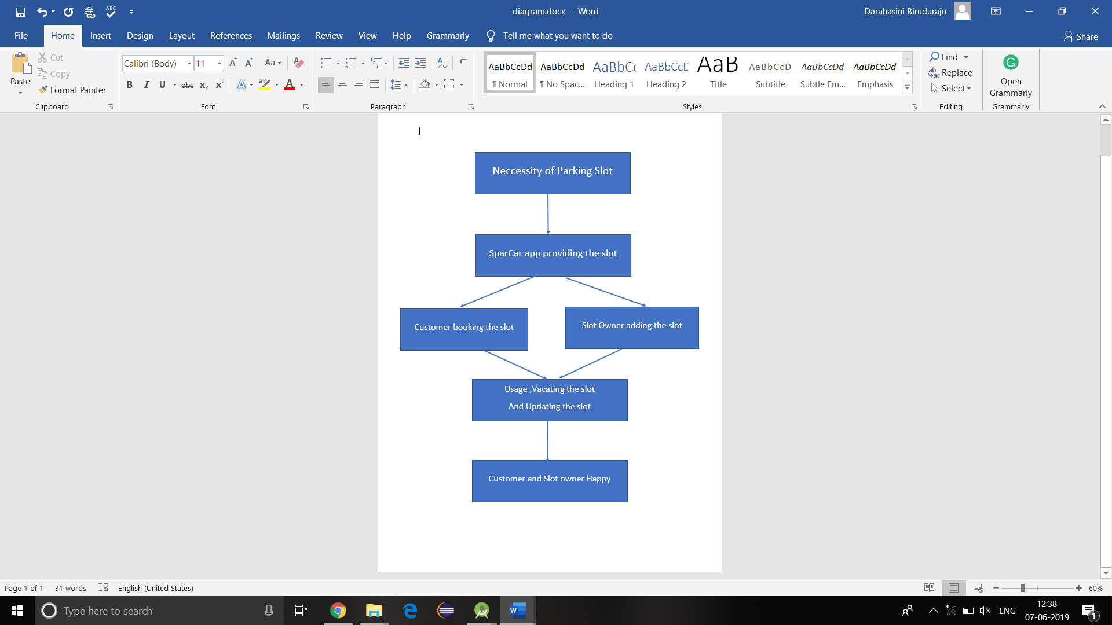

Figure 1: Describing the flow of Usage of SparCar

# System Diagrams

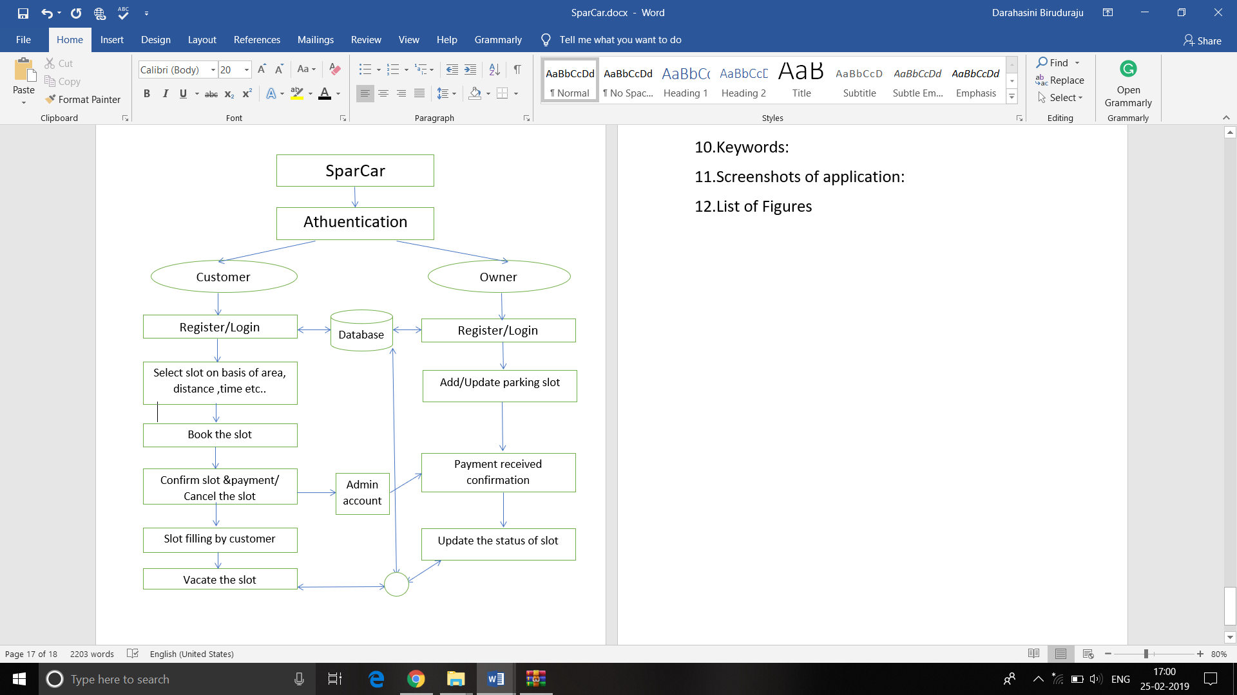

Figure 2:Describing the flow of whole process in both customer and slot owner perspectives

# Application Programming Interface

For services, libraries, and command line interfaces that present an interface which can be wrapped

* Google Maps API
* Firebase

## Recommendations

Using a versioned endpoint simplifies the process of making future backwards incompatible API changes;

/api/v0

# User Interface

For frontends, a mockup can be attached to illustrate the user interface. Command line interfaces may include a list of subcommands and their options.

* User interface is created by XML.

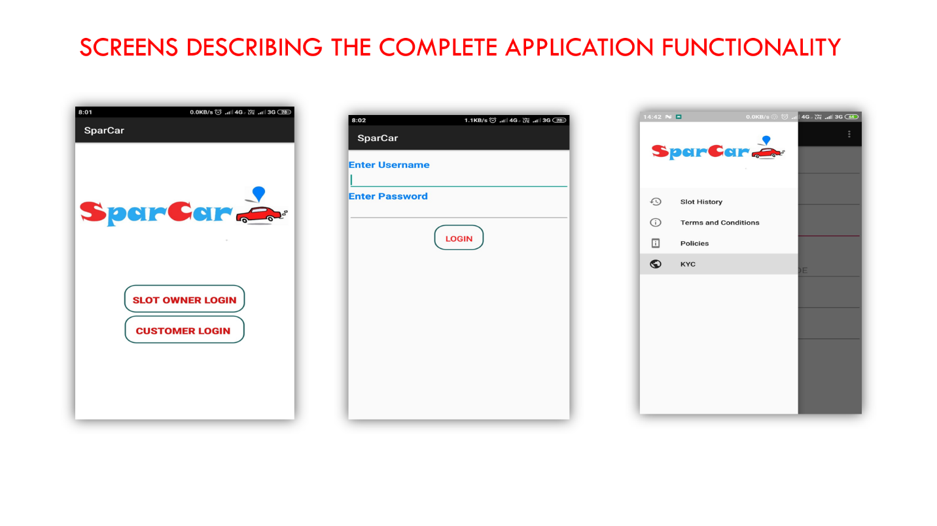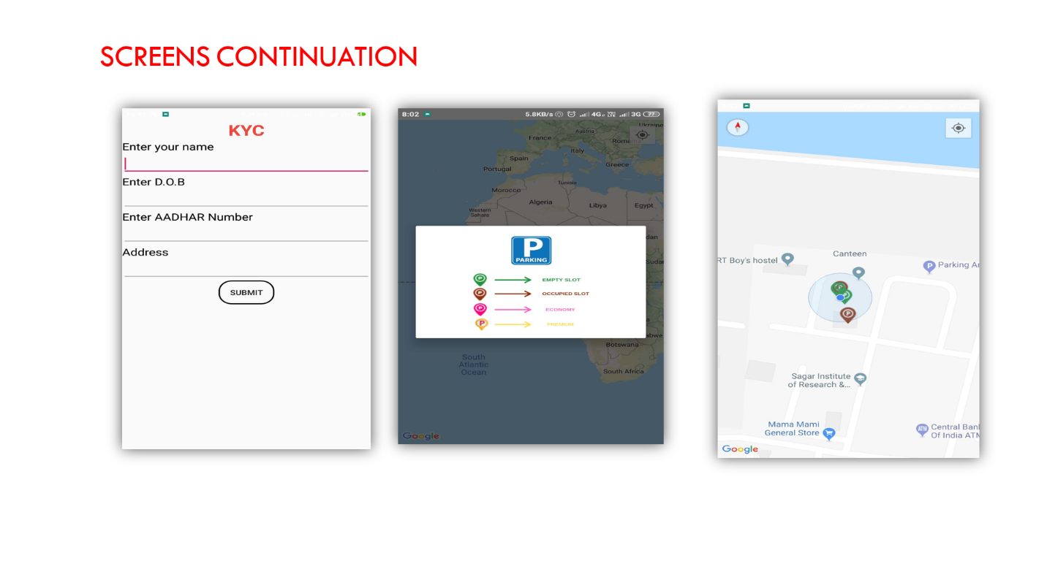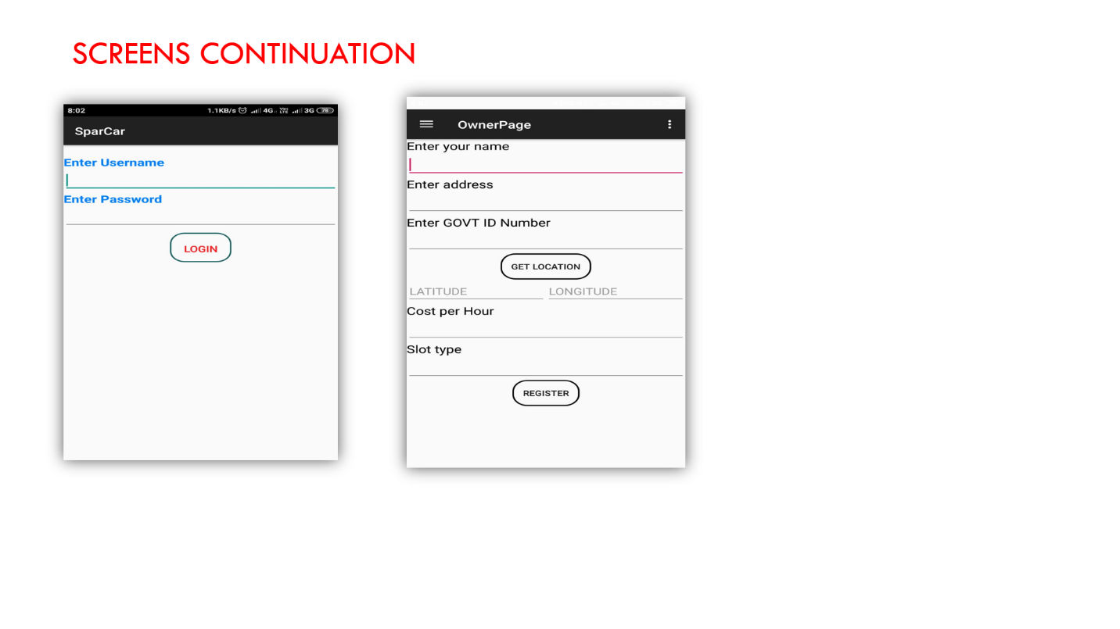

# Data Models and Storage

Firebase

* Firebase is providing both server and database services.
* In firebase, two objects exist one for car owner and one for slot owner.
* Car owner details and KYC along with car number and type are stored in Car owner partition of firebase.
* Details of Slot owner with KYC along with slot type, slot address is stored in Slot owner partition of Firebase.

# Service Operability

## Key Performance Indicators

* Good User ratings
* Customer satisfaction
* Number of Users
* Less error rate and crashes.

## Service Level Objectives

* Sending alert messages, mails or alert calls during situations which might service interruption
* For example, if car owner has booked car for 2 hours and by the end of second hour, he’ll sent with alert message to empty the slot within next 10 minutes as reserved time is going to end.
* Sending the service information messages which has details of car owner to slot owner for re-verification purpose by the slot owner.
* To aim at removing of a social problem traffic congestion which implies the discipline of the nation.
* To provide a digital and technical platform which can create a smart parking strategy in the society.
* To reduce the vehicles that are being parked in No-Parking areas and in between/on the roads.
* To maximize the utilization of resources which are prone to be wasted or under-utilized like spaces in houses.
* Minimization of the precious time, energy and fuel of the citizens of the country.
* Maximize the customers and Government’s satisfaction by effective utilization of available resources.

# Project Overview

## Communication and Tracking

* Communication between our clients and application management would be done through discussion forum and comments section of play store.
* Clients can post their opinions, bugs, and recommendations or suggestions in the comment section as well as the report section provided within the application.

## Risks

1.Legal risks:

a. Ownership rights of Parking slot

b. Customer and owner identity verification.

c. Security concerns of Slot Owners offering Parking.

2. Hardware device failures

3. Database breach

## Milestones

* Aim to reach ten thousand customers within first six months from deployment.
* Easy usability and maintainability of the application by the users.
* Gathering and filtering reviews of users and implementing accorded to reviews.

## Project Phases

* Requirement Analysis
* Designing and Implementing phase
* Development Phase
* Debugging phase
* Deployment phase
* User survey while using the Sparcar
* Reviews Gathering Phase
* Changes according to user reviews and improving standards

## Cost

Six hours are dedicated to work on the SparCar for six weeks in which

* Three hours for User analysis and Market Survey
* Three hours for technical development of applications.

# Frequently Asked Question

**Is this Pragmatic?**

Yes. It is 100% possible and it can get into people easily as similar kind of apps like OLA and UBER are ruling out the market.

**Is this customer friendly?**

Yes, it is. Customers can use it Very easily and find their parking spot within no time in a reasonable cost. Similarly, House owner can get earning with no effort.

# References

Links to any supporting documentation, other projects, or reference material

<https://www.sciencedirect.com/science/article/pii/S1665642313715803>

<https://hackernoon.com/how-much-will-smart-parking-solutions-improve-in-2019-fa1bac32cb77>

# Addendum

TECHNOLOGY STACK:

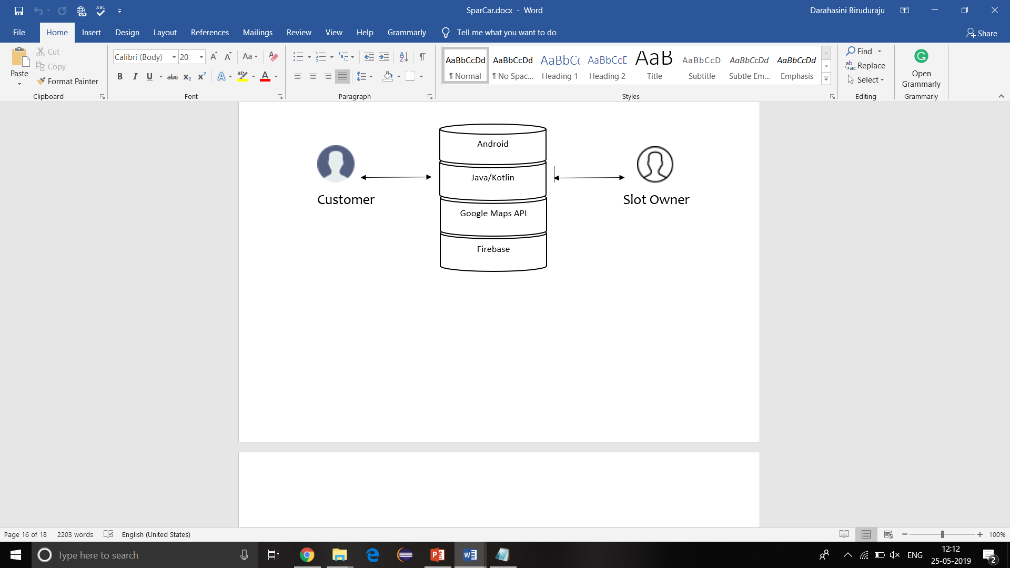

**Materials Used & Fabrication Work:**

Android Studio

Firebase

Google Maps API

Mobile

Internet Connection