Smart Scheme App

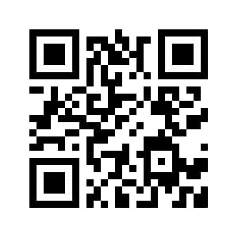

M.G.M Ali, Indu Konduru

Progress:

* Week1 – Planning the way of approach to final project.
* Week2 – UI and layouts of the app were collaborated.
* Week3 – Linking database to the application.
* Week4 – We did market research on services via social media.
* Week5 – Revenue model identification and planning.
* Week6 – User experience and their feedback.

Contributors:

As it might be difficult for an uneducated person to search for something so our mentor Praful sir suggested to provide contact details in the app and we also got suggestion regarding revenue model, as our app is a service based it is free of cost. So we can provide something like private schemes regarding bank loan and all we can make a money of it.

Initial Prototype:

We had a preliminary app before.

Business:

It is a service based app free of cost.

We use social media to spread awareness about the app and we can also give some premium features like guidance from people to attract the market.

Customer Stories:

Student feedback: “I am able to know that govt has taken major steps in education sector and I am able to apply for it. This app made my work simple.”

Technology:

* Android studio.
* Firebase Console.

Problem: The lack of awareness of government implemented schemes among people.

Product: Mobile Application that links schemes to the beneficiary, Connecting govt. to the people.