EXCEL:
Total Column = 11
Total Rows = 50
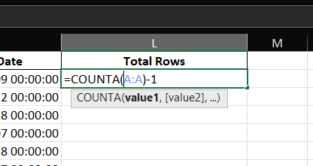

Data Types:
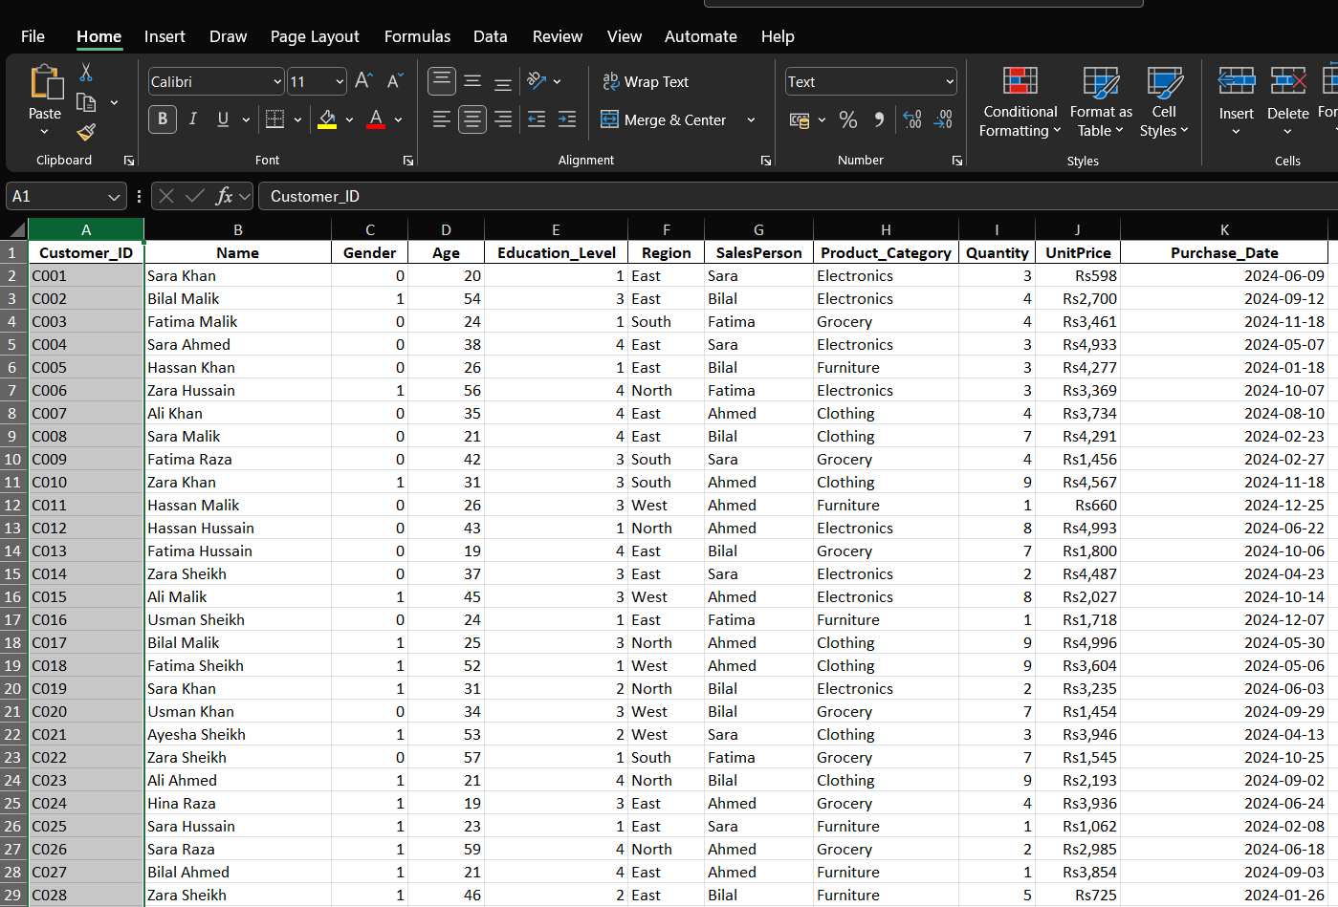
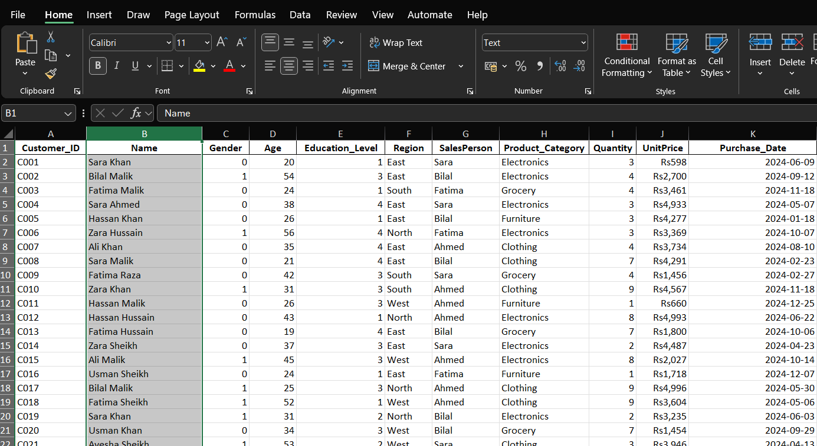
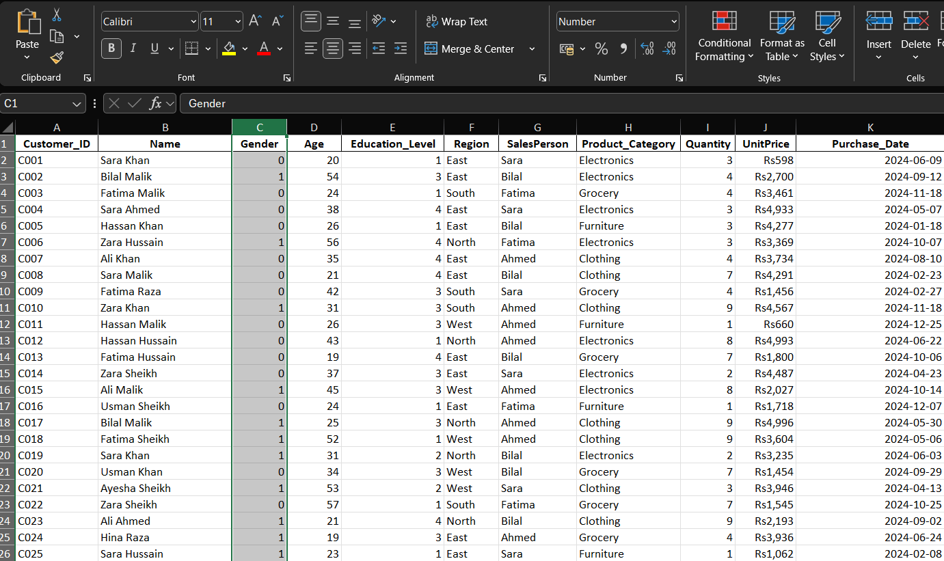
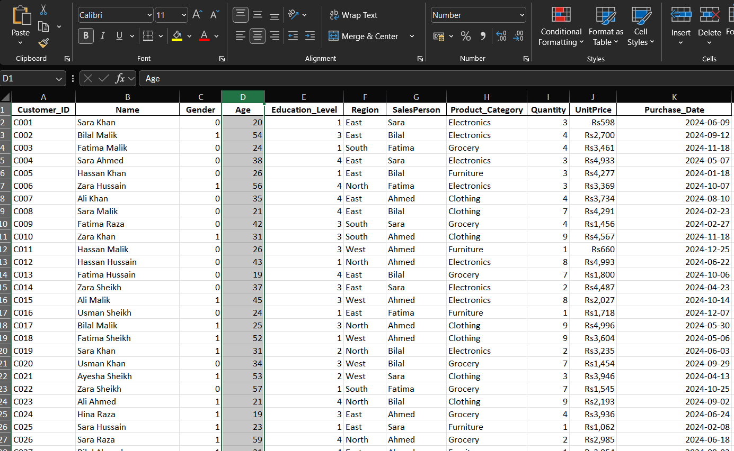
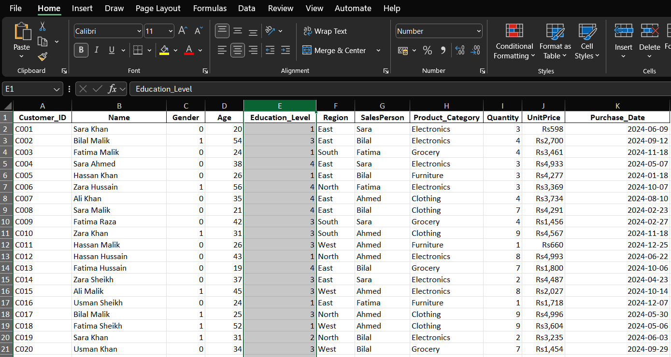
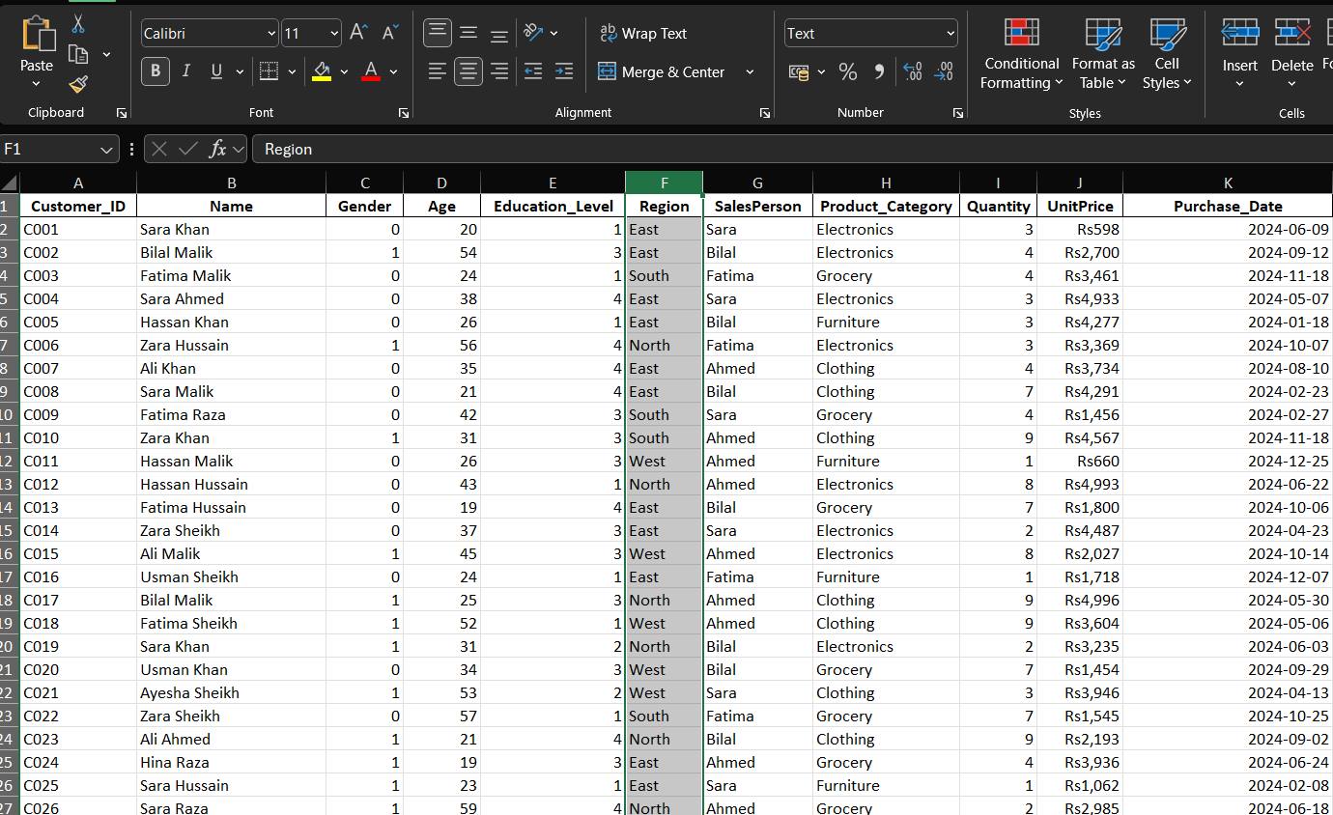

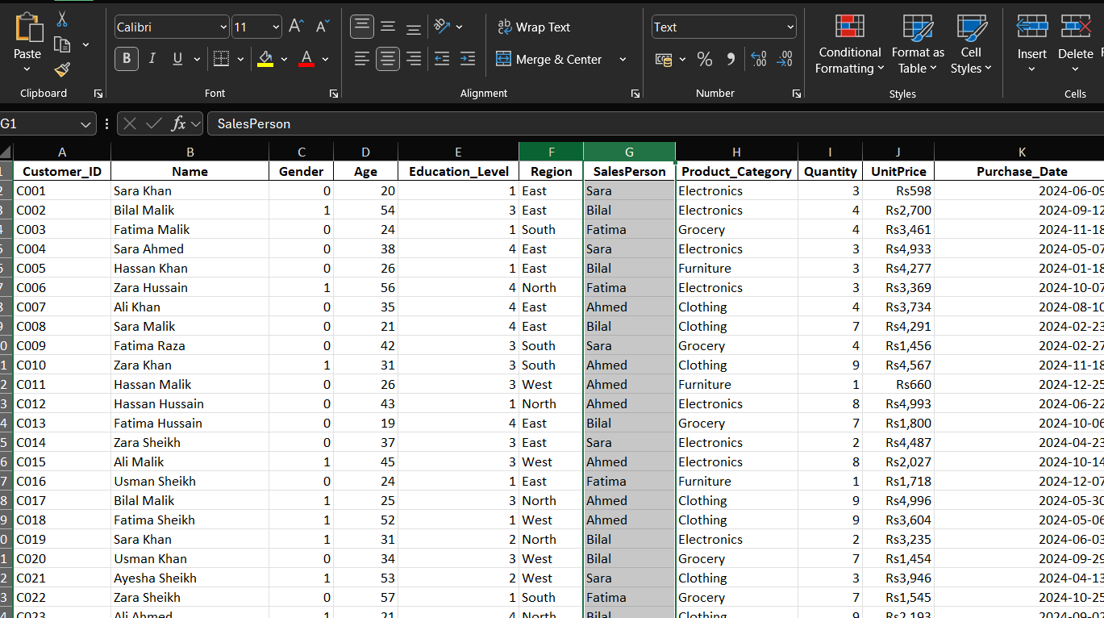
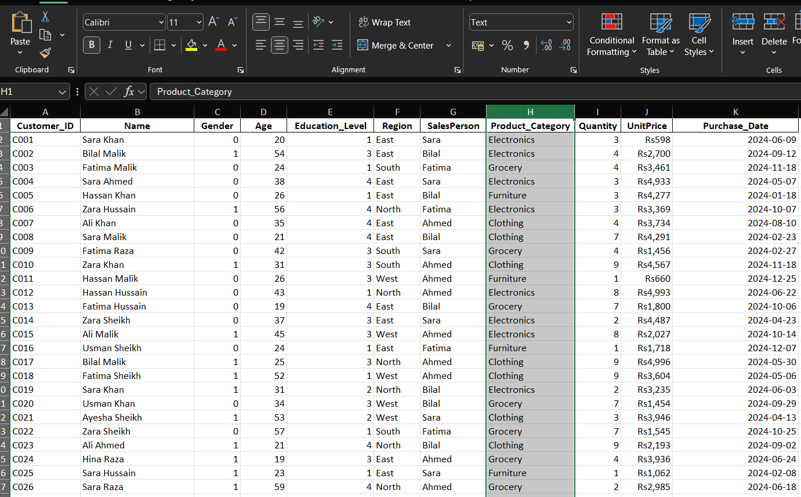
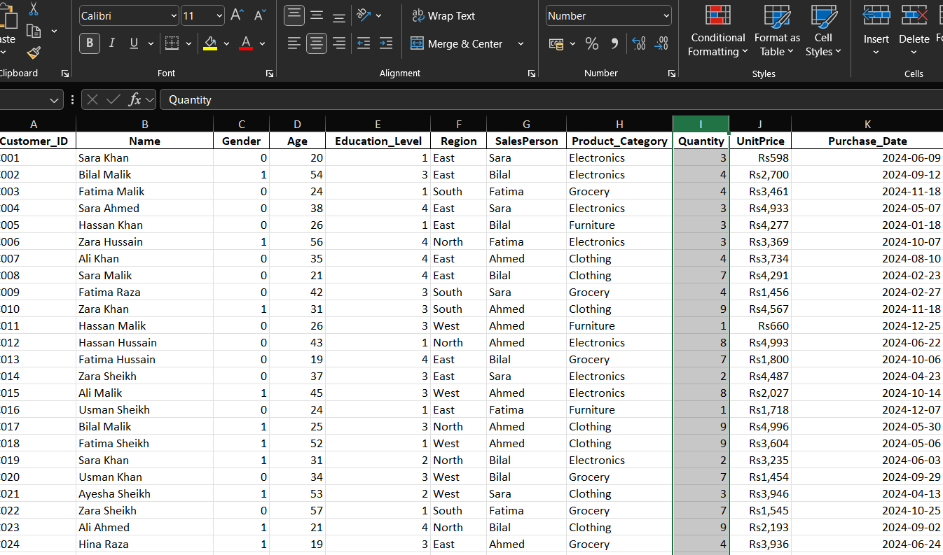
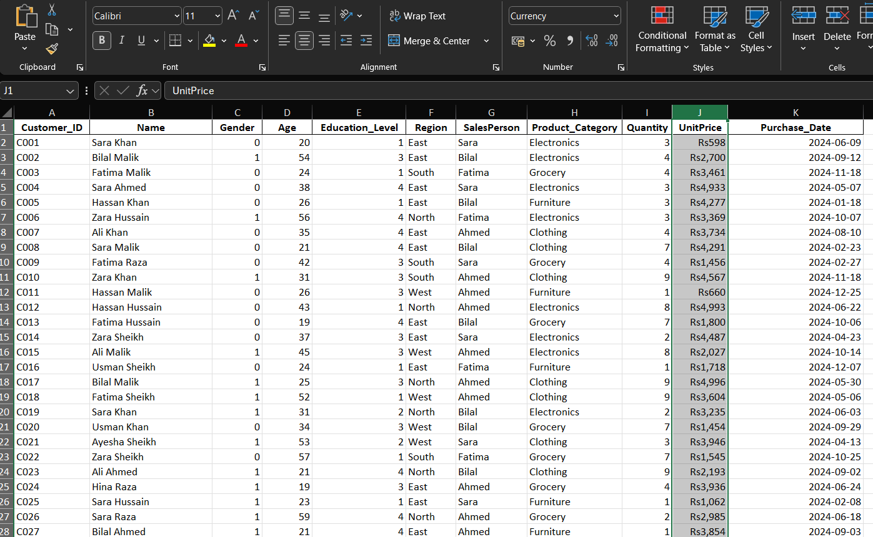
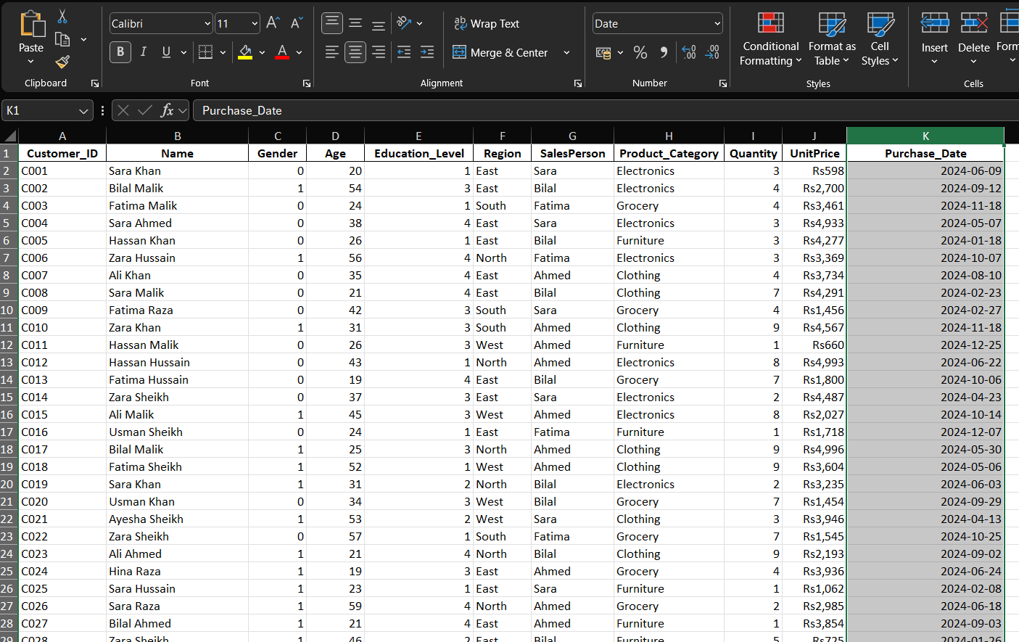
Total Customer:
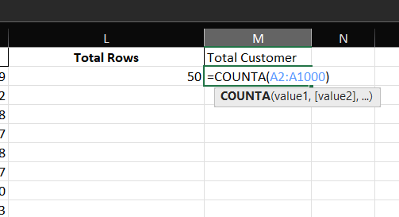
Average Age of Customer:
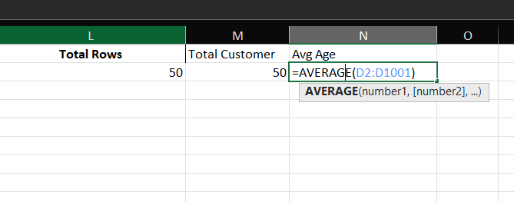
Result:
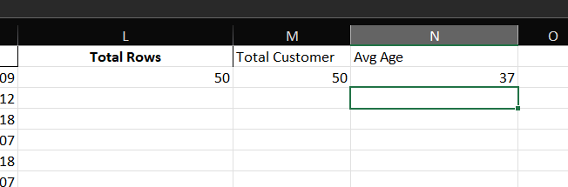

Max Education Level:
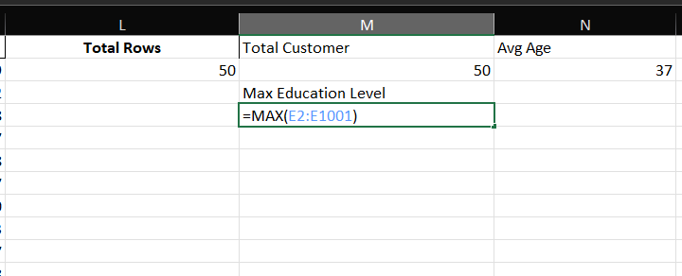
Min Education Level:
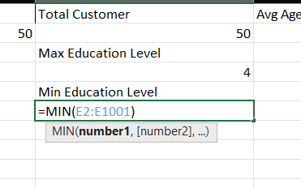
Result:
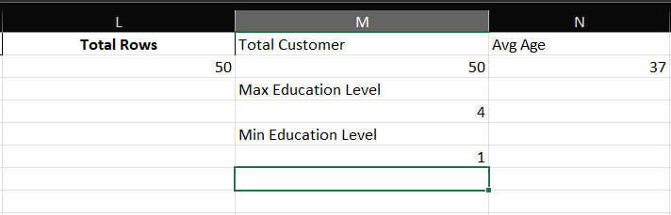
Total Sales:
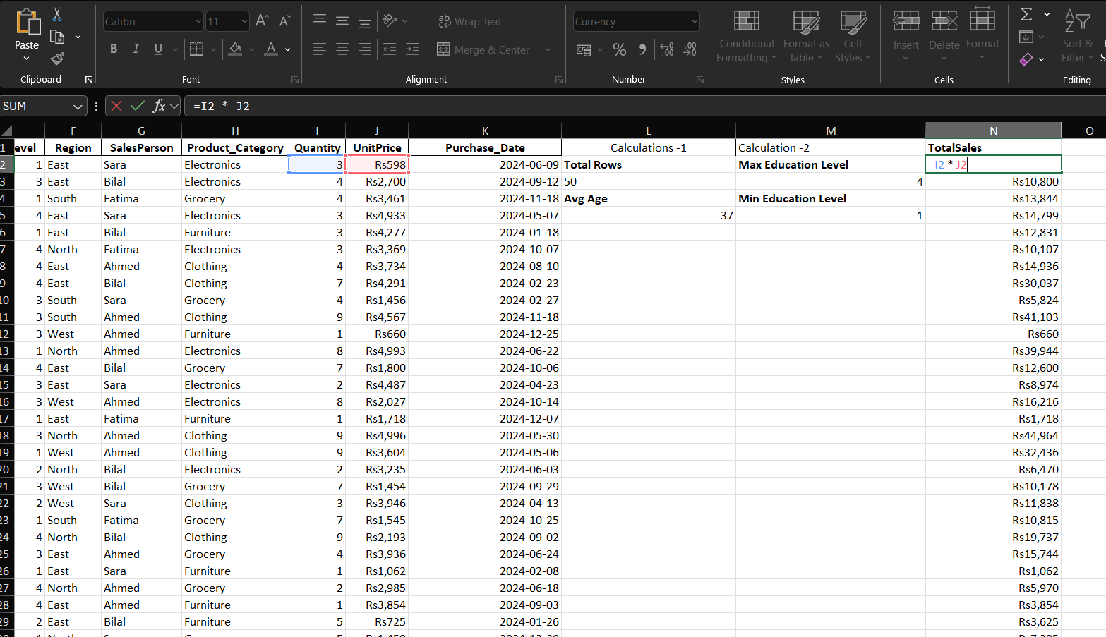

Unique Products:
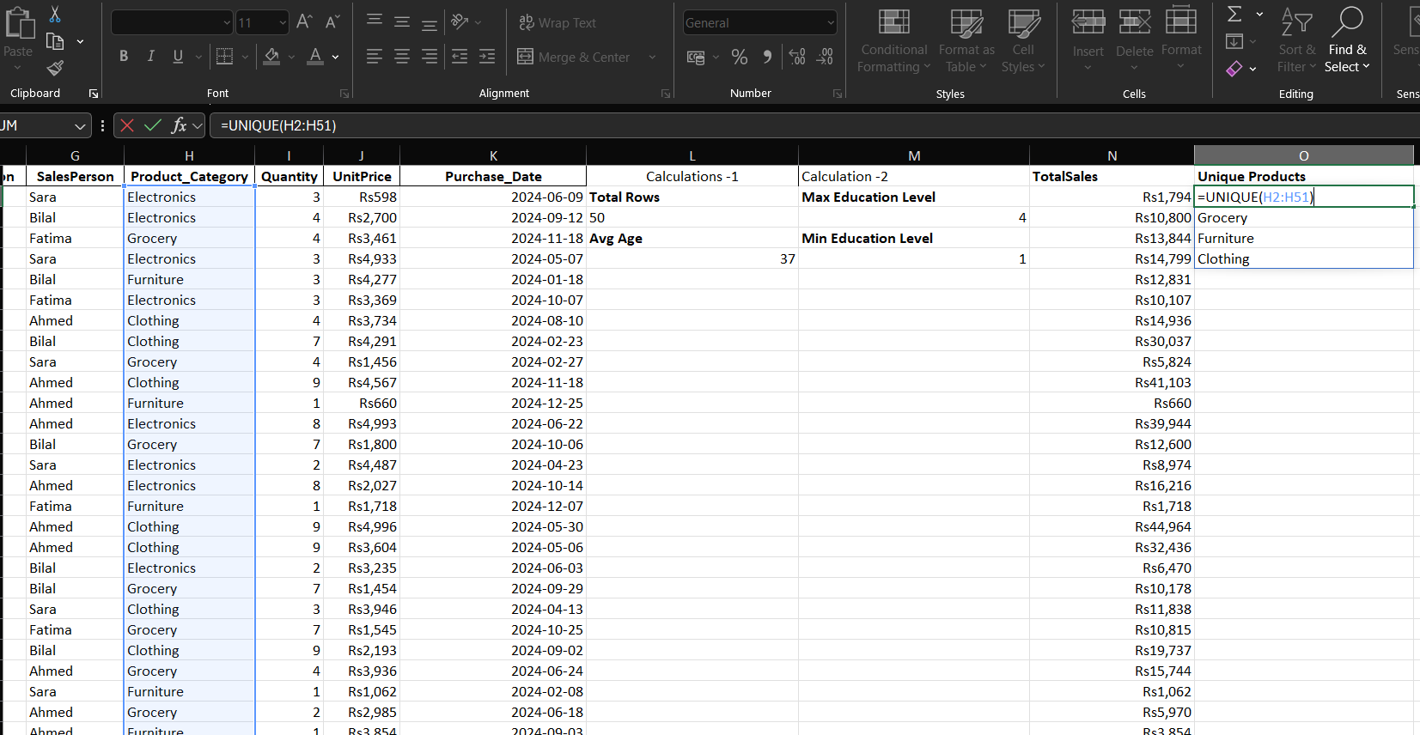
Result:
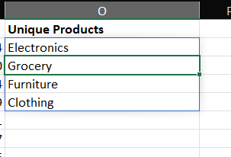
Frequency of Each Product:
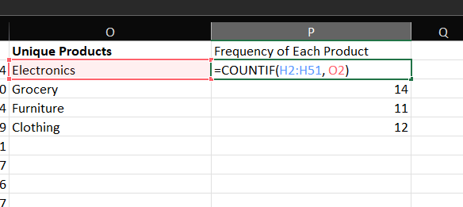
Result:
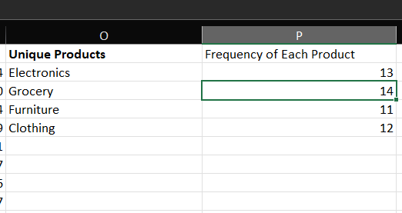
Unique Regions:
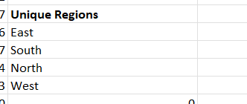
Frequency by Regions:
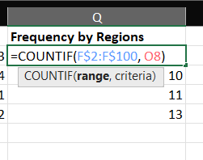
Result:
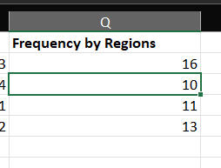

Frequency Distribution of Quantity:
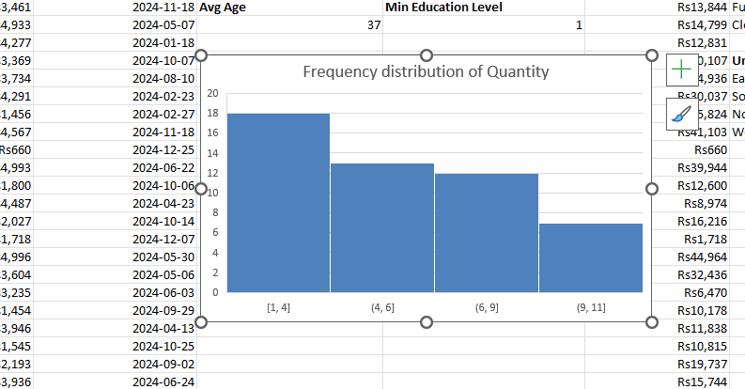
Pivot Tables:
Sales by Product Category:
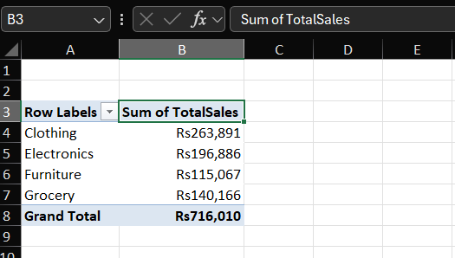
Largest to Smallest Order:
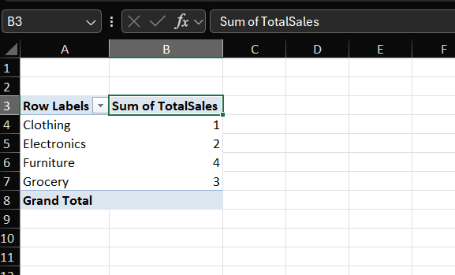

Sales by Region and SalesPerson:
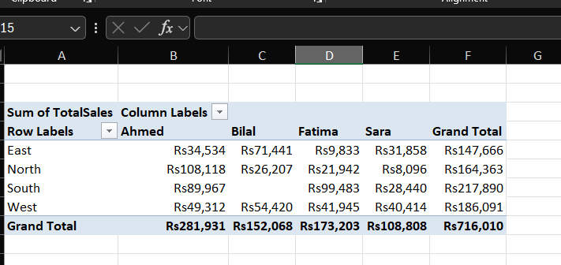
Top Performing Region:
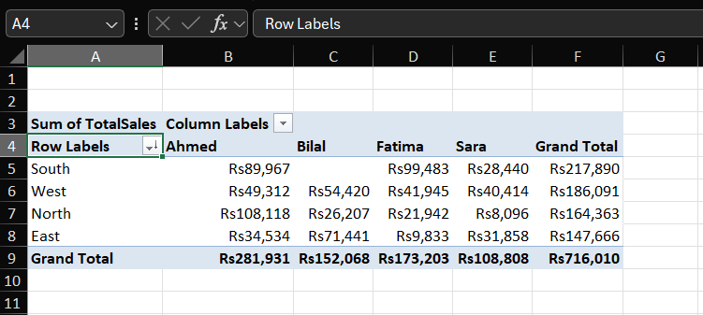

Descriptive Analysis:
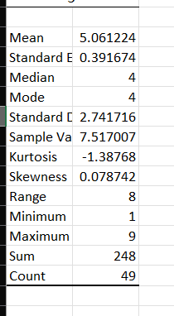
The skewness value is 0.0787, which is approximately zero. This indicates that the data distribution is nearly symmetric, meaning there is no significant skewness toward either side.

CONCLUSION:
The Excel analysis of customer_sales_data revealed key sales insights. The PivotTable by Product Category showed that [Clothing] had the highest total sales, while the Region-wise PivotTable identified [South] as the best-performing area. Descriptive statistics for Quantity Sold summarized the data’s spread and central tendency, and skewness helped determine whether the mean or median better represented typical sales. Overall, Excel effectively transformed raw data into clear insights for decision-making.

R:
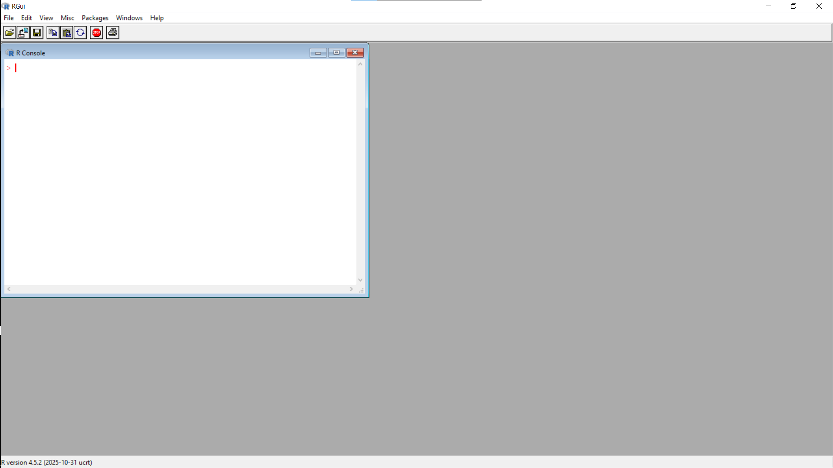

View:
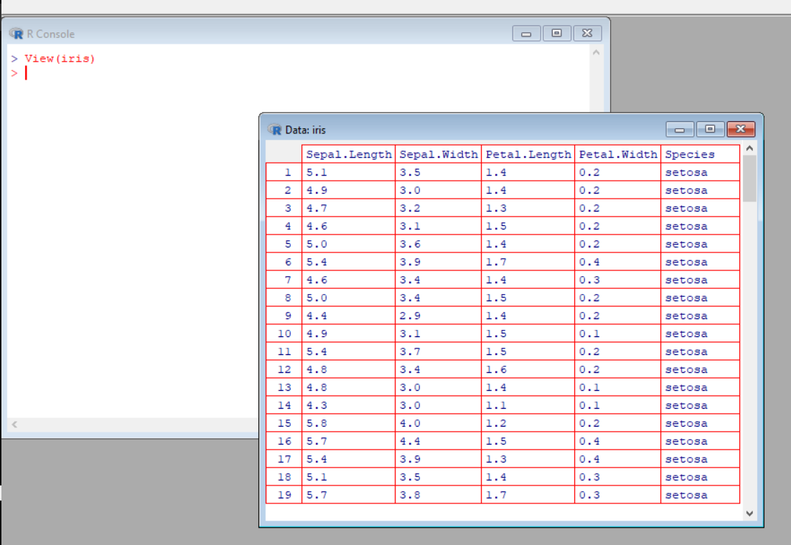
The View(iris) command displays the built-in Iris dataset as a spreadsheet-like table with 150 rows and 5 columns. It contains measurements for sepal length, sepal width, petal length, and petal width across three flower species — setosa, versicolor, and virginica.

Summary:
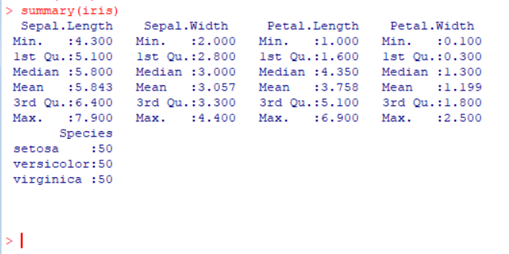
The summary(iris) command gives quick statistics for each variable. It shows that Sepal.Length ranges from 4.3 to 7.9 (mean ≈ 5.84), Sepal.Width from 2.0 to 4.4 (mean ≈ 3.06), Petal.Length from 1.0 to 6.9, and Petal.Width from 0.1 to 2.5. Species is evenly distributed with 50 samples each.

Mean of Sepal Length and Width:
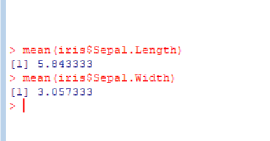
Using mean(iris$Sepal.Length) and mean(iris$Sepal.Width) gives mean values of 5.843 and 3.057 respectively. These averages describe the typical size of the sepals in the dataset and help compare floral dimensions across species.

Box Plot:
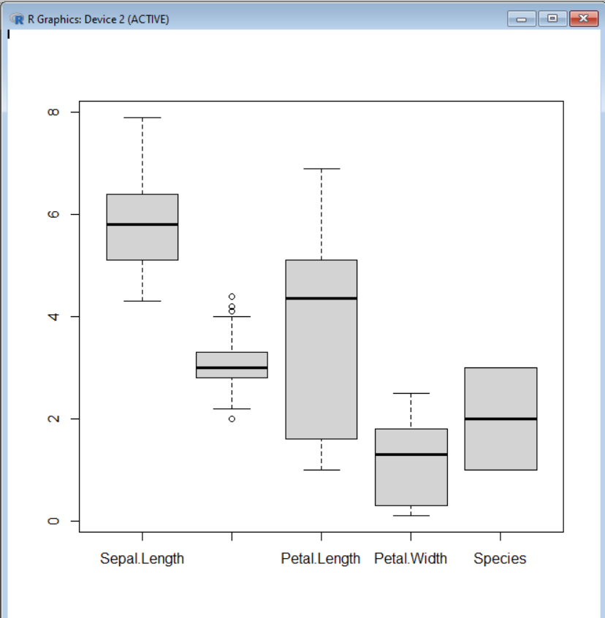
The boxplot displays the spread and central values of all numeric variables. It shows that petal measurements have wider variation than sepal measurements, and Petal.Width has several outliers, especially for versicolor and virginica species.
Pairs Plot:
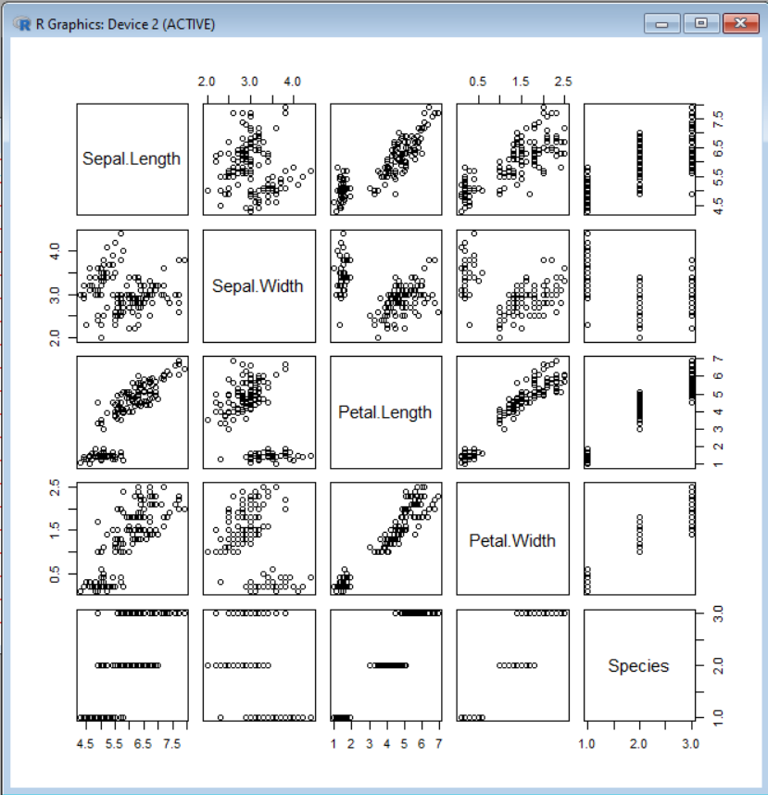
The pairs plot visualizes pairwise relationships between all numeric variables. A clear positive correlation appears between Petal.Length and Petal.Width, while Sepal.Width shows weaker relationships with the others. Clusters for the three species are visible, indicating strong separation between flower types.

