Inbox Triage Assistant — Screenshots
Visual proof of the n8n Inbox Triage Assistant workflow in action — automatic Gmail labeling and AI-generated draft replies.

1. Automatic Labeling
Incoming emails are automatically classified and labeled as AI/Urgent, AI/Spam, or AI/NeedsReply based on LLM analysis of sender, subject, and content.
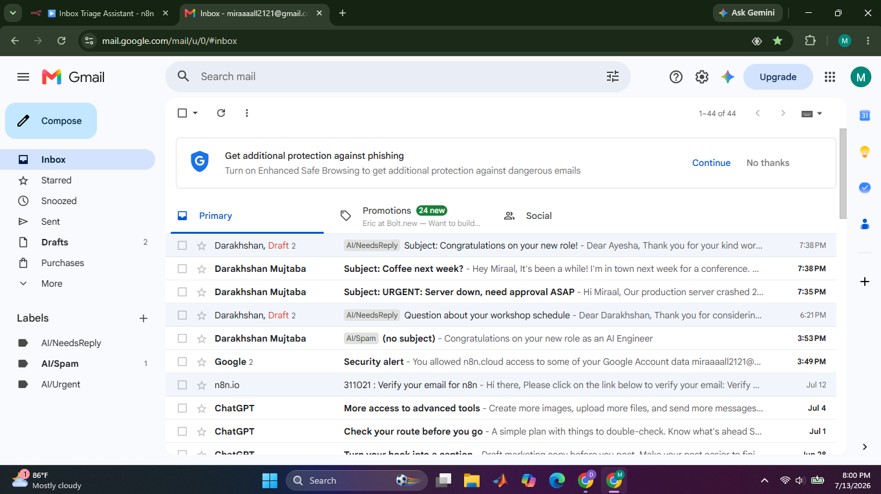

2. AI-Generated Draft Reply
For emails classified as needs-reply, the workflow fetches the full message, generates a context-aware reply via Groq/Llama 3.3, and saves it as a draft in the same email thread — ready for human review before sending.
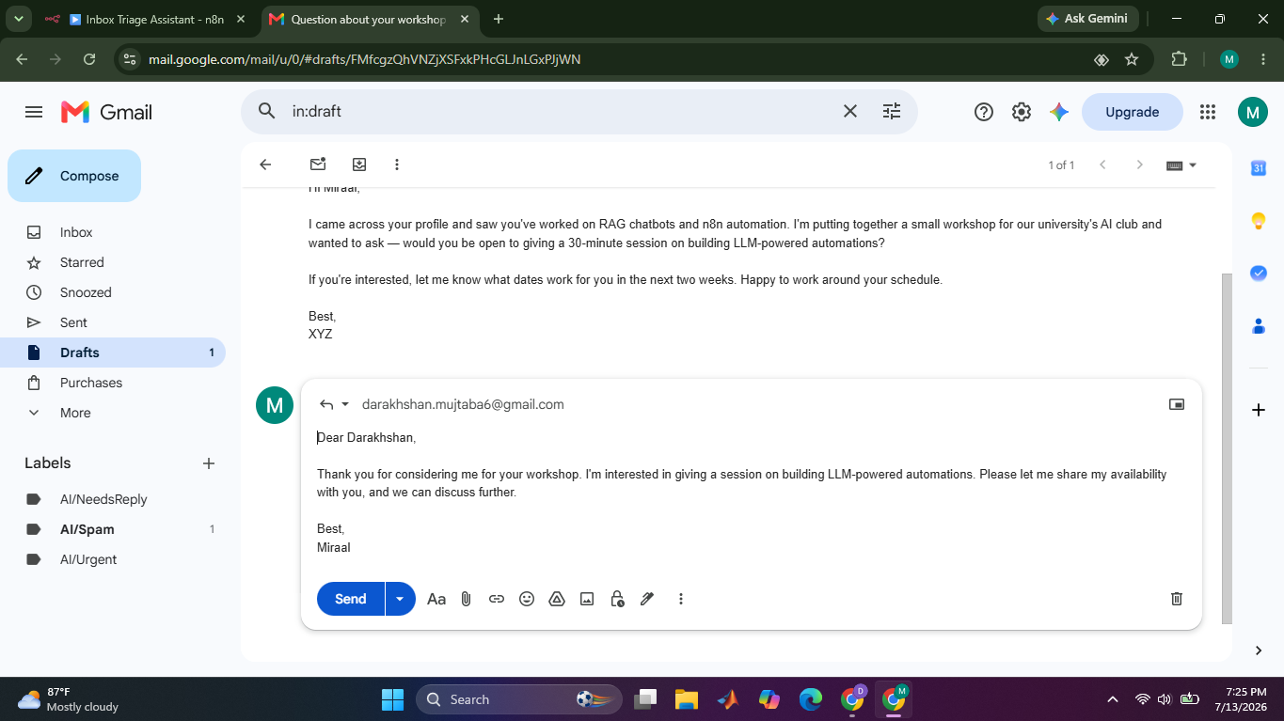

3. Workflow Canvas
The full n8n workflow: Gmail Trigger to Groq classification to Switch routing to per-category labeling, with the NeedsReply branch continuing on to fetch the full message, generate a reply, and create a draft.
