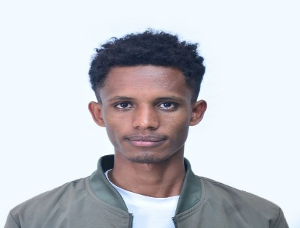

C:\xampp\htdocs\dashboard\OnlineShopping\image\icons8-address-22.png Adama , Ethiopia

+251919466744



+251715555044

C:\xampp\htdocs\dashboard\OnlineShopping\image\icons8-email-22.png [dararatasfaye](mailto:dararatasfaye@gmail.com)

**DARARA**

**TESFAYE**

Web Developer

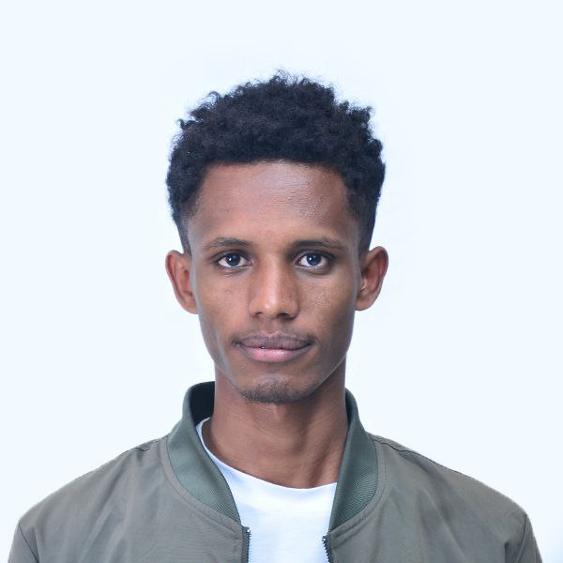ABOUT ME

I’am web developer with expertize in HTML, CSS, JavaScript, and PHP, I create engaging and user-friendly websites that provide seamless experiences across devices. Explore my work and let's bring your online presence to the next level!"

**SOCIAL MEDIA**

[**darara.tesfaye1**](https://www.facebook.com/darara.tesfaye1)



[**@Darara_Ta**](https://www.x.com/Darara_Ta)

[Darara Tesfaye](https://www.linkedin.com/in/darara-tasfaye-41a2b3216)

[DararaTesfaye](https://github.com/DararaTasfaye/DararaTasfaye)

WORK EXPERIENCE

Backos Technology

PLC C:\xampp\htdocs\dashboard\OnlineShopping\image\icons8-address-22.png Adama

October 2023

Visit Oromia

* Finfinnee

July – Aug/ 2024

Internship, Web Developer

Successfully launched the e-commerce platform, resulting in a 100 % increase in user engagement

Internship, Web Developer

* Front-End and Back-End Development
* Data base Management
* UI/UX Collaboration

EDUCATION

Adama Science &

Technology University

* Adama

2020/21 – 2024/25

Department: Computer Science and Engineering

Relevant Coursework: Web Development, Database Management, Software Engineering, Data Structures and Algorithms