Summary Report: Exploratory Data Analysis of UNICEF Survey Data

Prepared for: Decision-Makers at UNICEF

Prepared by: [Darbin Rawal]

Date: [12/01/2024]

Focus Area: [e.g., Health, Education, Nutrition]

1. Introduction

The analysis examines UNICEF survey data to identify key trends, disparities, and areas for improvement in health, education, and nutrition across regions in Nepal. The goal is to provide actionable insights that support UNICEF’s efforts to enhance child welfare and community development.

2. Key Findings

1. **Immunization Coverage**

* Insight: Bagmati and Province 2 have higher immunization rates (78%+), while Gandaki has the lowest at 72.2%.
* Recommendation: Focus immunization efforts on Gandaki.

1. **Child Nutrition**

* Insight: Karnali has the highest underweight rate (24.2%), and Gandaki has a high stunting rate (33.9%).
* Recommendation: Launch nutrition programs in Karnali and Gandaki.

1. **Maternal Health**

* Insight: Province 1 has a higher maternal health checkup rate (69.6%) compared to Bagmati (64.8%).
* Recommendation: Improve maternal health services in Bagmati.

1. **Infant Mortality**

* Insight: Gandaki has the highest infant mortality rate (32.8 per 1,000), while Karnali has the lowest (28.1).
* Recommendation: Target healthcare improvements in Gandaki.

1. **Disease Prevention**

* Insight: Gandaki leads in disease prevention (81.6%), while Bagmati lags behind at 75.8%.
* Recommendation: Strengthen disease prevention efforts in Bagmati.

3. Supporting Evidence (Visualizations)

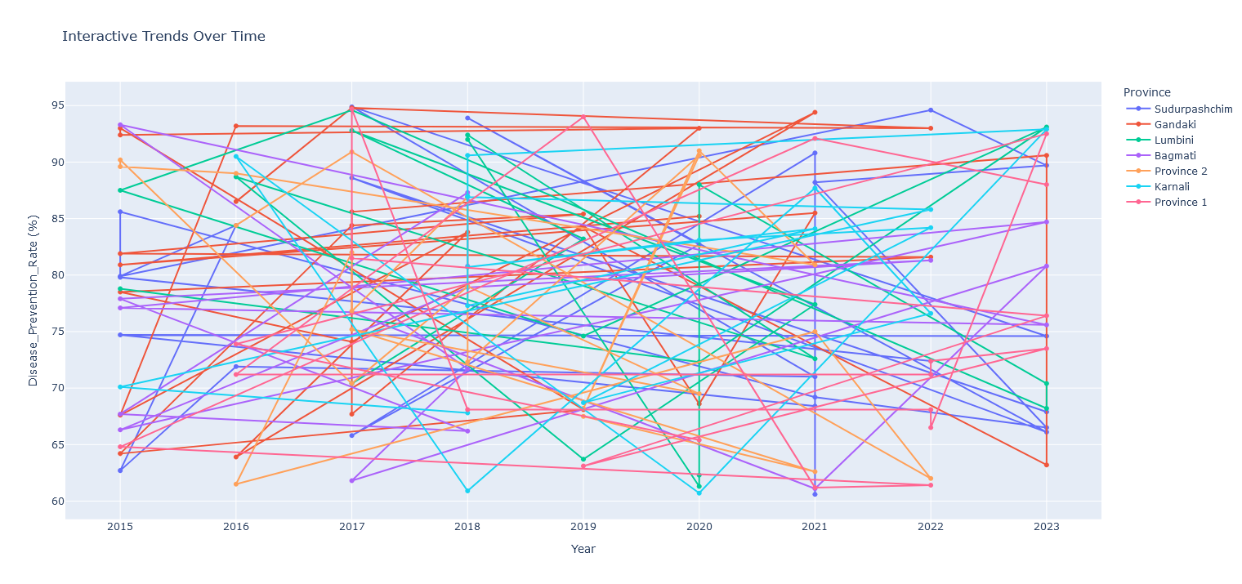

Fig. 1: Interactive Trends Over Time

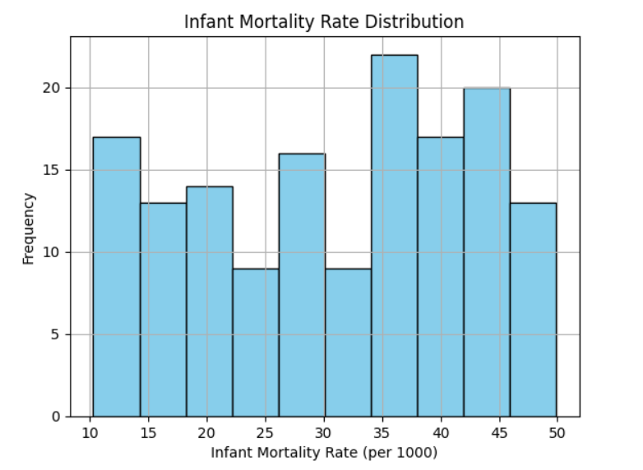

Fig. 2: Infant Mortality Rate Distribution

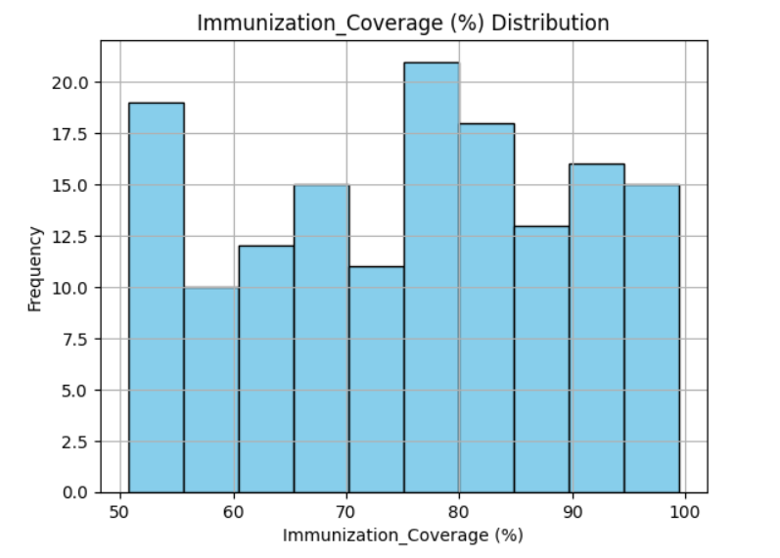

Fig. 3: Immunization Coverage (%) Distribution

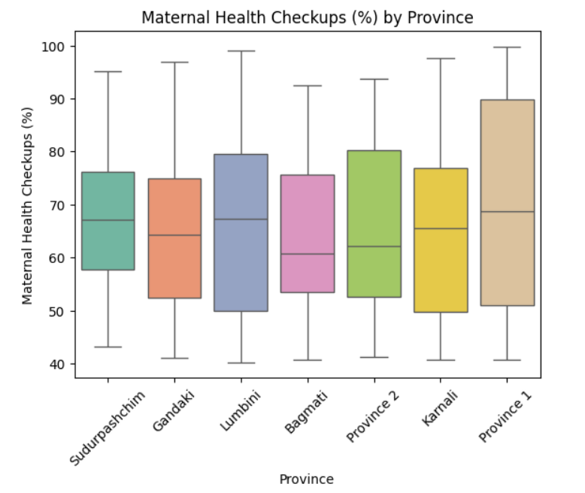

Fig. 4: Maternal Health Checkups (%) by Province

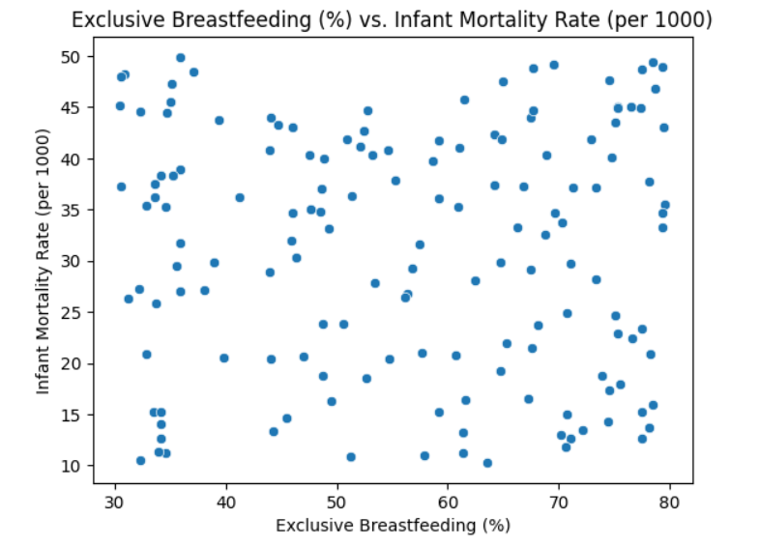

Fig. 5: Exclusive Breastfeeding (%) vs. Infant Mortality Rate (per 1,000)

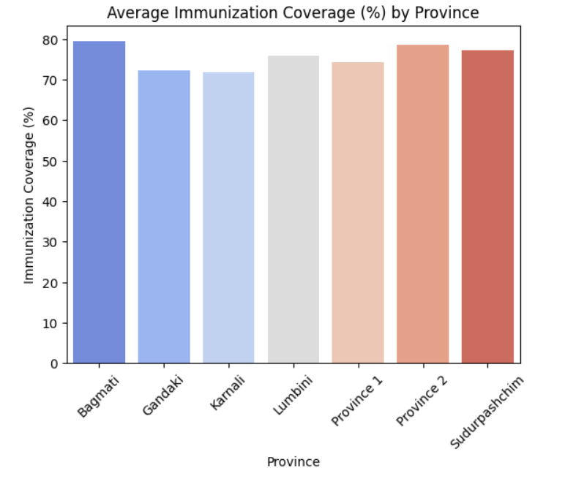

Fig. 6: Average Immunization Coverage (%) by Province

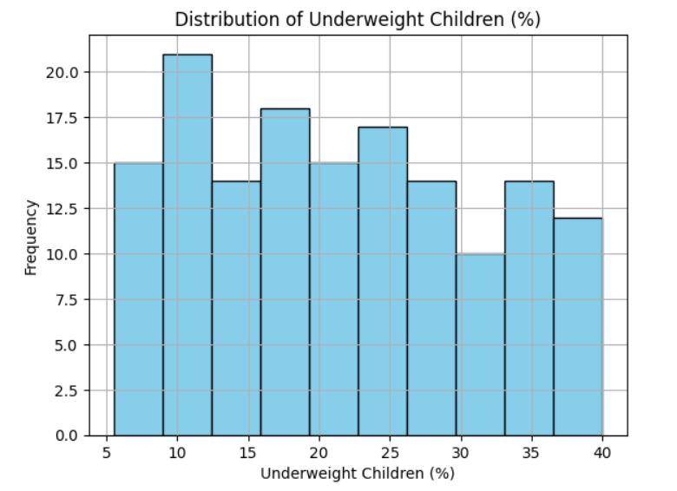

Fig. 7: Distribution of Underweight Children (%)

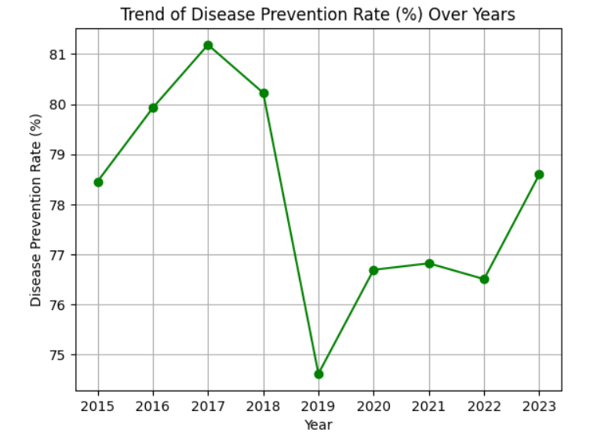

Fig. 8: Trend of Disease Prevention Rate (%) Over Years

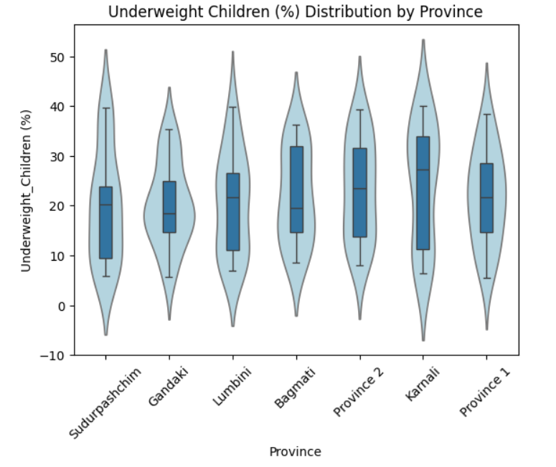

Fig. 9: Underweight Children (%) Distribution by Province

4. Actionable Insights

1. **Boost Immunization in Low-Rate Areas**

* Insight: Immunization rates are lower in Gandaki (72.2%) compared to other provinces (Bagmati: 78%+).
* Action:
  + Launch mobile vaccination clinics and community health education in Gandaki and other low-performing areas.
  + Improve local healthcare infrastructure to increase access to vaccinations.

1. **Tackle Malnutrition in Rural Areas**

* Insight: High underweight rates in Karnali (24.2%) and stunting in Gandaki (33.9%).
* Action:
  + Introduce nutrition awareness programs and distribute micronutrient-rich food in rural areas.
  + Partner with local organizations to improve food security and nutritional access.

1. **Improve Maternal Health Services**

* Insight: Maternal health checkups are lower in Bagmati (64.8%) than in Province 1 (69.6%).
* Action:
  + Train community health workers for home visits and establish mobile clinics to increase prenatal care access.
  + Run health campaigns on the importance of maternal checkups.

1. **Reduce Infant Mortality**

* Insight: Higher infant mortality in Gandaki (32.8 per 1,000 live births).
* Action:
  + Strengthen neonatal care and expand access to skilled birth attendants.
  + Educate mothers on infant care and provide vaccines to prevent infant deaths.

1. **Improve Disease Prevention**

* Insight: Disease prevention rates are lower in Bagmati (75.8%).
* Action:
  + Launch disease prevention awareness campaigns in Bagmati.
  + Equip local clinics with necessary health resources and conduct regular health checkups.

5. Conclusion

The data reveals key disparities in health, nutrition, and education across Nepal, especially in provinces like Gandaki, Karnali, and Bagmati. To address these challenges, UNICEF can implement targeted programs to improve immunization rates, tackle malnutrition, enhance maternal health, reduce infant mortality, and strengthen disease prevention efforts.

By acting on these insights, UNICEF can improve outcomes for children and communities in Nepal, ensuring that interventions are impactful and aligned with local needs.

6. Next Steps

1. Validate Findings: Confirm with local experts and stakeholders.
2. Regional Planning: Tailor recommendations to each province’s specific needs.
3. Implementation: Create an action plan with timelines, budgets, and necessary resources.