# ****SumaTask – Your Modern Task Management System****

## ****Project Documentation****

**Student Name:** Muhammed Darboe  
**Date:** June 18, 2025  
**Course:** INTERNET AND WEB PROGRAMMING II,  
**Project Type:** MEAN Stack Application

## ****Table of Contents****

1. Project Description
2. Technical Overview
3. Features List
4. System Architecture
5. User Roles and Permissions
6. Screenshots
7. Installation Guide
8. API Documentation
9. Conclusion

## ****1. Project Description****

### ****Overview****

SumaTask is a comprehensive, modern task management system built with the MEAN stack (MongoDB, Express.js, Angular, Node.js) to streamline workflow processes and improve team productivity.

### ****Problem Statement****

Many organizations face challenges with project coordination and task tracking. Existing tools often lack intuitive UIs or strong role-based access. SumaTask solves this by offering a unified, powerful platform for project and task management.

### ****Solution Highlights****

* Role-based Access (Admin, Project Manager, Team Member)
* One-click task completion with smart permission checks
* Real-time collaboration and team directory
* Responsive design using Tailwind CSS
* Full project lifecycle management

### ****Target Audience****

* Software Development Teams
* Schools and Academic Projects
* Freelancers and Consultants

## ****2. Technical Overview****

### ****Backend****

* **Node.js**, **Express.js**, **MongoDB**, **Mongoose**
* **JWT** for auth
* **bcrypt** for password hashing
* **Multer** for file uploads

### ****Frontend****

* **Angular 18**, **Tailwind CSS**, **RxJS**, **Angular Router**, **HTTP Client**

### ****Dev Tools****

* **TypeScript**, **Angular CLI**, **Nodemon**, **CORS**

### ****Database Collections****

* Users
* Projects
* Tasks
* Categories

## ****3. Features List****

### 🔐 ****Authentication & Security****

* JWT login, bcrypt password hashing
* Role-based route protection
* Session and token management

### 📋 ****Task Management****

* CRUD for tasks
* Task assignment, priority, due dates
* Smart permission-based task completion
* Comments, file uploads, status tracking

### 🎯 ****Project Management****

* Full project lifecycle tracking
* Assign project managers, team members
* Budget & timeline tracking
* Milestone & progress indicators

### 👥 ****Team Collaboration****

* Team directory
* User profiles & departments
* Real-time availability status

### 🎨 ****UI/UX Features****

* Responsive design with Tailwind
* Accessible and keyboard-friendly
* Loading states, modals, toast alerts

### 🏷️ ****Category Management****

* Custom color-coded categories
* Icon support
* Filter tasks by category

### 📊 ****Analytics & Reports****

* Dashboard stats
* Project & task metrics
* Exportable reports
* Gantt-style timelines

## ****4. System Architecture****

### ****Three-Tier Architecture****

1. **Frontend (Angular)** – Component-based with RxJS
2. **Backend (Express.js)** – RESTful API, middleware
3. **Database (MongoDB)** – Mongoose schema validation

### ****Security****

* JWT tokens
* Role-based middleware
* Sanitization & validation
* bcrypt-hashed passwords
* CORS setup

## ****5. User Roles and Permissions****

### ****Admin****

* Full access to users, projects, tasks, settings
* Manage categories and analytics

### ****Project Manager****

* Manage own projects
* Assign tasks and manage teams
* View project-specific analytics

### ****Team Member****

* View and complete assigned tasks
* Update progress, comment, and view profiles

## ****6. Screenshots (Descriptions Only)****

**1. Login Page** – Clean form, branding, Tailwind styling

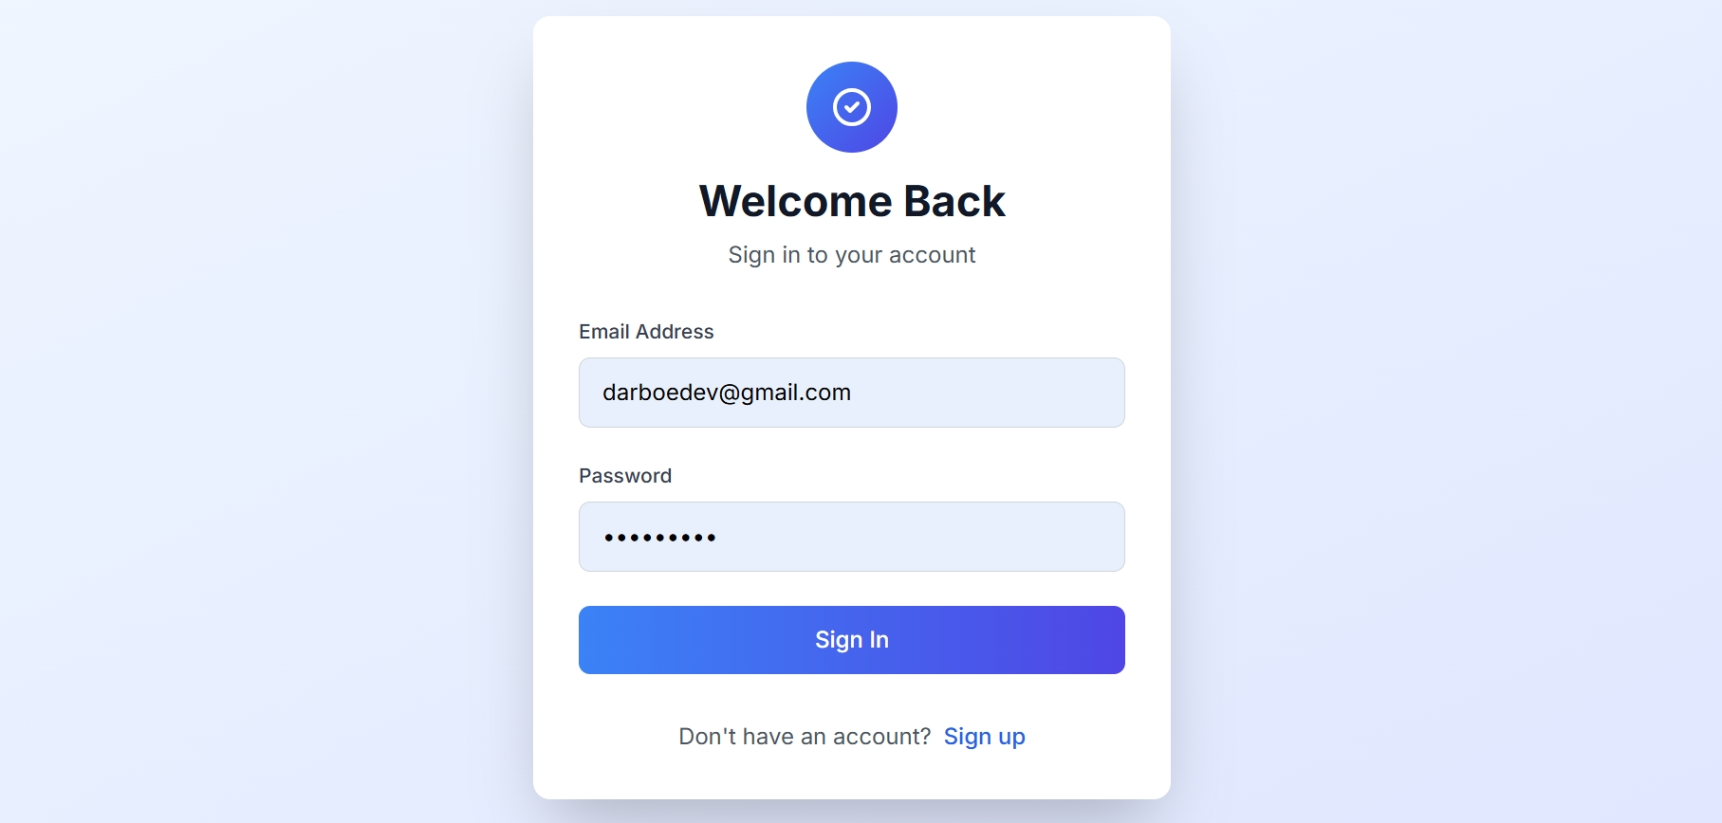

**2. Dashboard** – Stats cards, recent tasks, sidebar nav

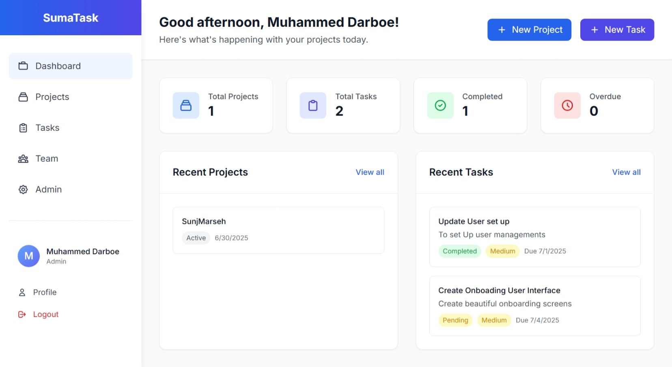

**3. Project Management Page** – Project cards, progress, team

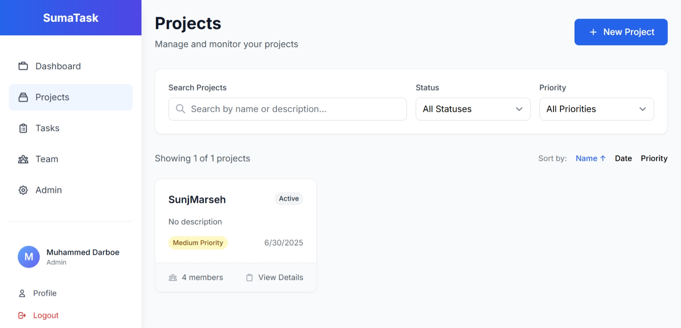

**4. Task List** – Status badges, priority colors, one-click complete

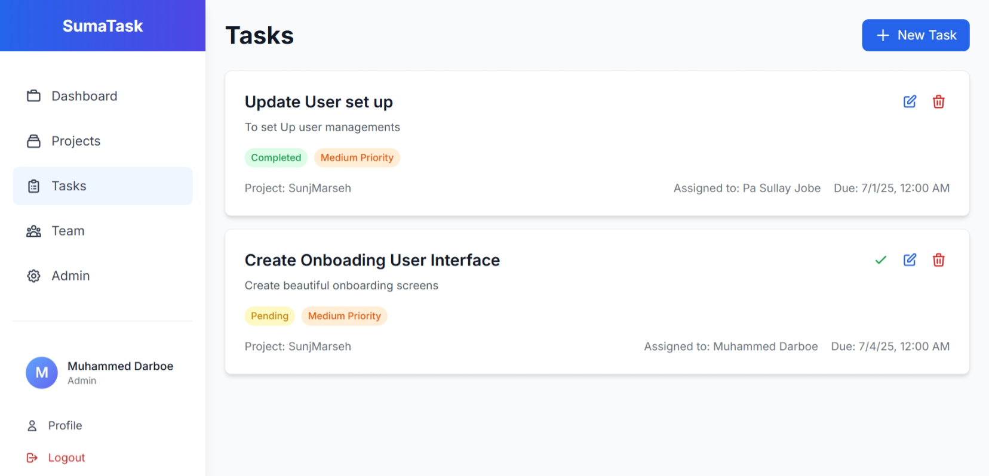

**5. Task Details** – Comments, file uploads, permissions

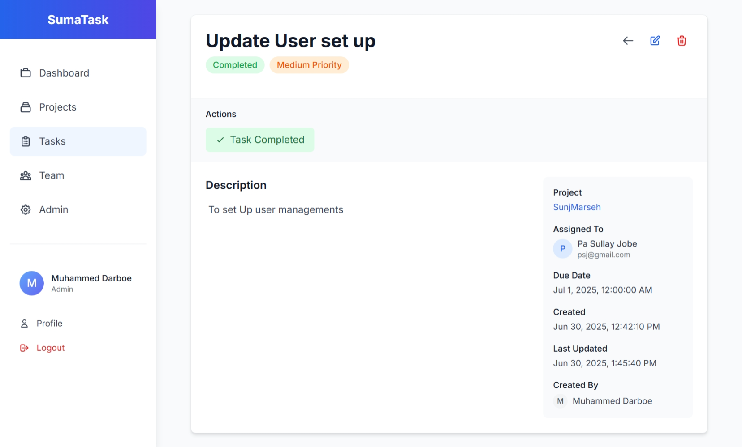

**6. Team Directory** – Cards, status, assignments

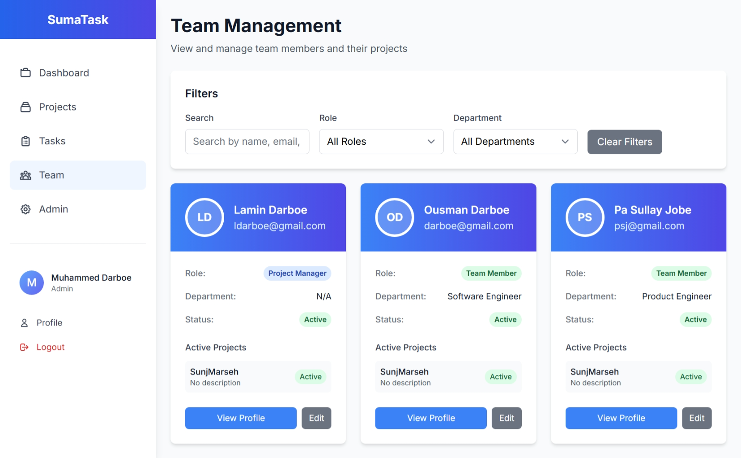

**7. Profile Page** – Editable details, role-based access

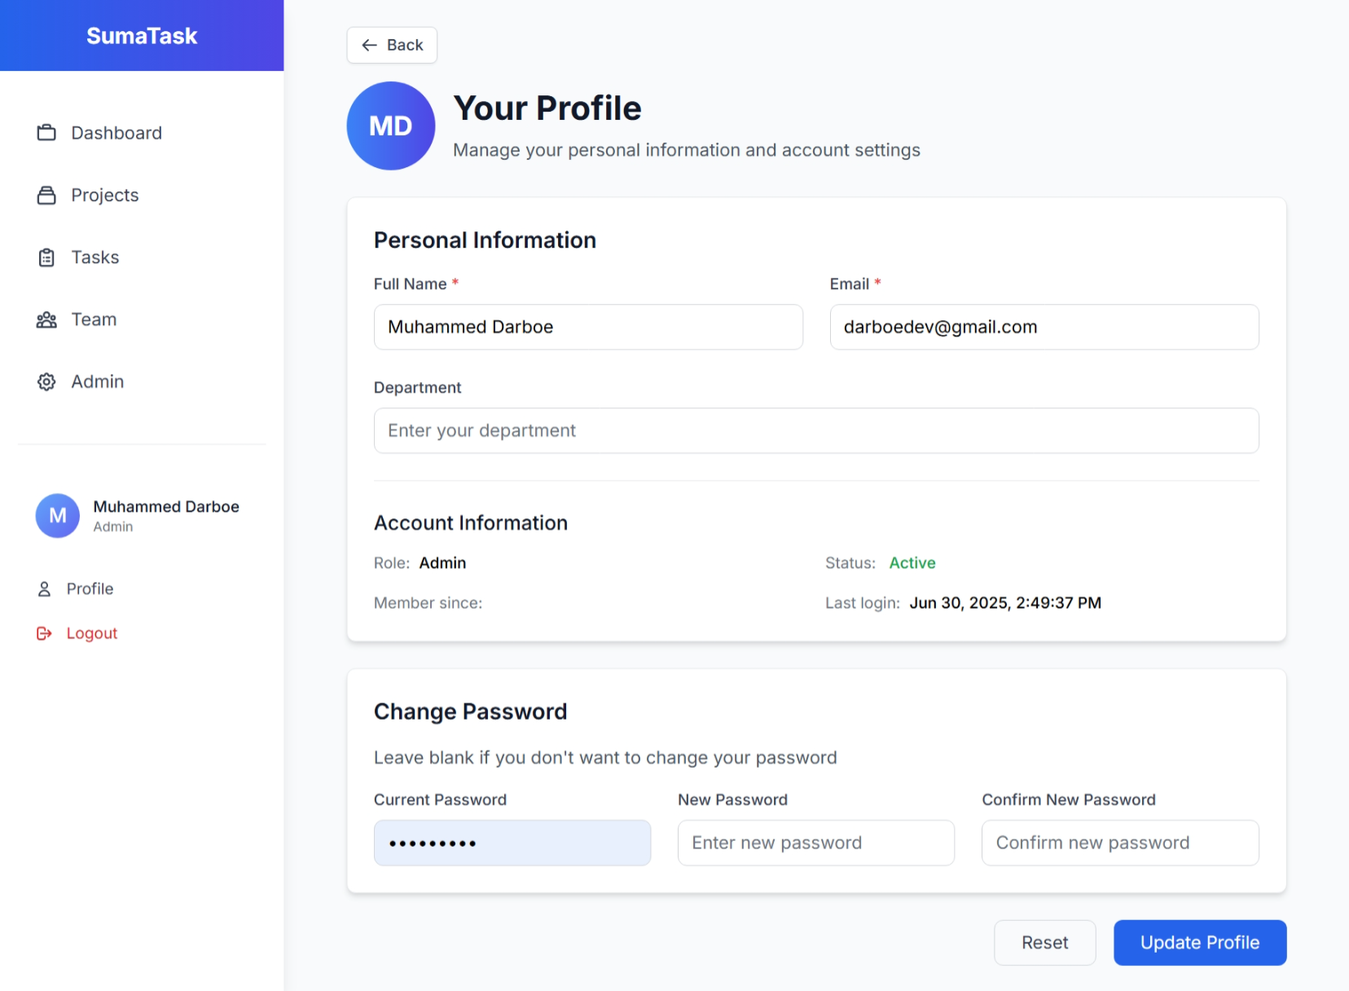

**8. Project Creation Form** – Validated fields, member selection

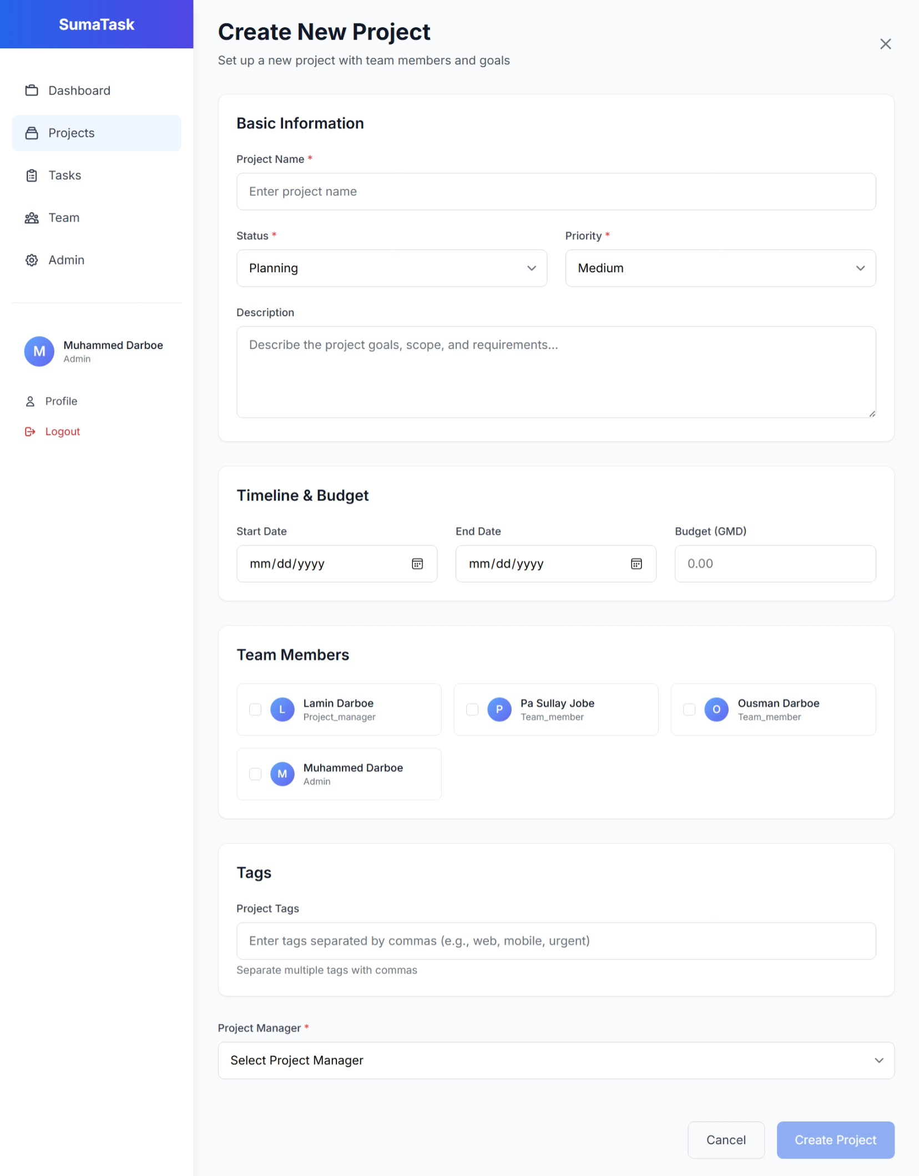

**9. Mobile View** – Responsive layout, mobile-friendly

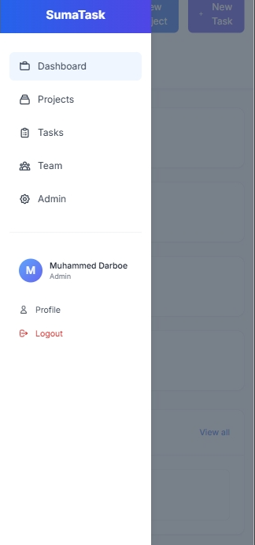

**10. Admin Panel** – User table, role assignment, system config

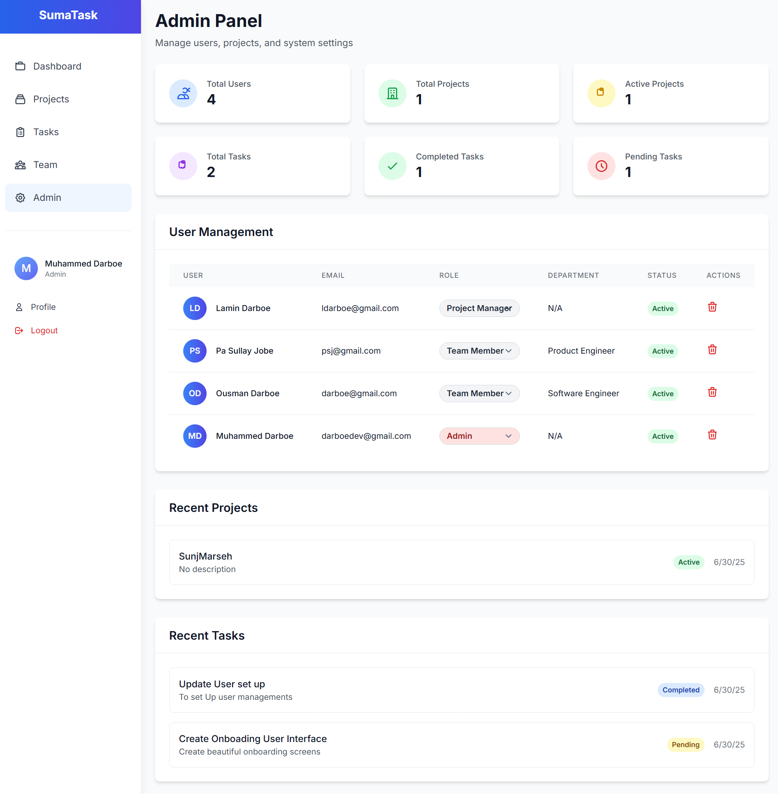

## ****7. Installation Guide****

### ****Prerequisites****

* Node.js v16+, MongoDB, Angular CLI, Git

### ****Backend Setup****

bash

CopyEdit

git clone <repo>

cd backend

npm install

Create .env:

env

CopyEdit

PORT=5000

MONGODB_URI=mongodb://localhost:27017/sumatask

JWT_SECRET=your-secret

JWT_EXPIRE=7d

NODE_ENV=development

Run server:

bash

CopyEdit

npm start

### ****Frontend Setup****

bash

CopyEdit

cd frontend

npm install

Update environment.ts:

ts

CopyEdit

export const environment = {

production: false,

apiUrl: "http://localhost:5000/api",

};

Run frontend:

bash

CopyEdit

npm start

### ****Initial Setup****

* Register admin user
* Update role in DB
* Create sample data for testing

## ****8. API Documentation****

### ****Auth****

* **POST /api/auth/register** – { fullName, email, password }
* **POST /api/auth/login** – { email, password }
* **GET /api/auth/me** – Auth header required

### ****Projects****

* **GET /api/projects** – Query filters supported
* **POST /api/projects** – Create new project
* **PUT /api/projects/:id** – Update project

### ****Tasks****

* **GET /api/tasks** – Query by project, status, etc
* **POST /api/tasks** – Create task
* **PUT /api/tasks/:id** – Update task

### ****Users****

* **GET /api/users/team-members** – Get list
* **PUT /api/users/:id** – Update user

## ****9. Conclusion****

### ****Achievements****

* Full MEAN stack app
* Role-based authentication
* Responsive UI/UX
* Scalable codebase

### ****Tech Skills Gained****

* API design
* MongoDB schemas
* JWT security
* Tailwind UI
* Full-stack deploy

**Prepared by:** Muhammed Darboe  
**Date:** June 18, 2025  
**Course:** INTERNET AND WEB PROGRAMMING II,  
**Institution:** University of The Gambia