1. 结构的赋值
   1. 点.运算符

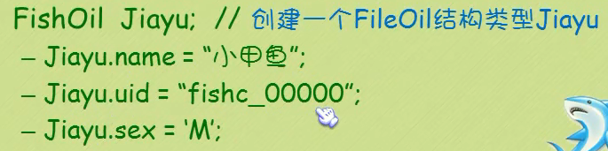

* 1. 直接赋值：FishOil Jiayu = {“小甲鱼”,”fishc_00000”,”M”};

1. 结构与指针

FishOil *pJiayu = &Jiayu;

(*pJiayu).name = ‘小威威’;

pJiayu->name=”小威威”;