# 新建一个服务id，规定它的主题，如“jinlin”

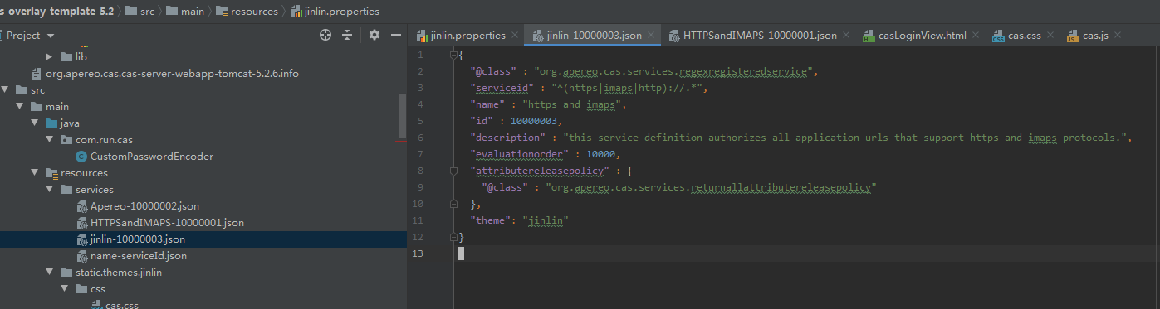

{  
 "@class" : "org.apereo.cas.services.regexregisteredservice",  
 "serviceid" : "^(https|imaps|http)://.*",  
 "name" : "https and imaps",  
 "id" : 10000003,  
 "description" : "this service definition authorizes all application urls that support https and imaps protocols.",  
 "evaluationorder" : 10000,  
 "attributereleasepolicy" : {  
 "@class" : "org.apereo.cas.services.returnallattributereleasepolicy"  
 },  
 "theme": "jinlin"  
}

# 修改application.properties ，指定默认主题

# 默认主题  
cas.theme.defaultThemeName=jinlin

# 添加登录页html文件，根据规范创建文件

<https://apereo.github.io/cas/5.2.x/installation/User-Interface-Customization-Themes.html>

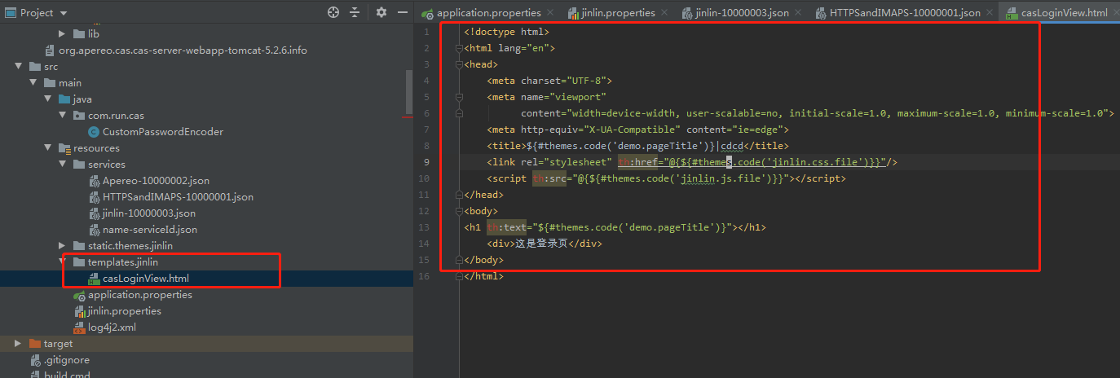

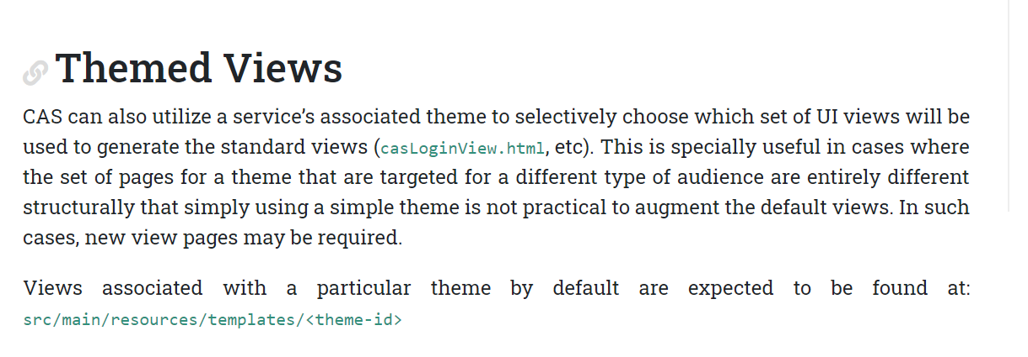

# 创建文件[theme_name].properties 指定主题属性信息

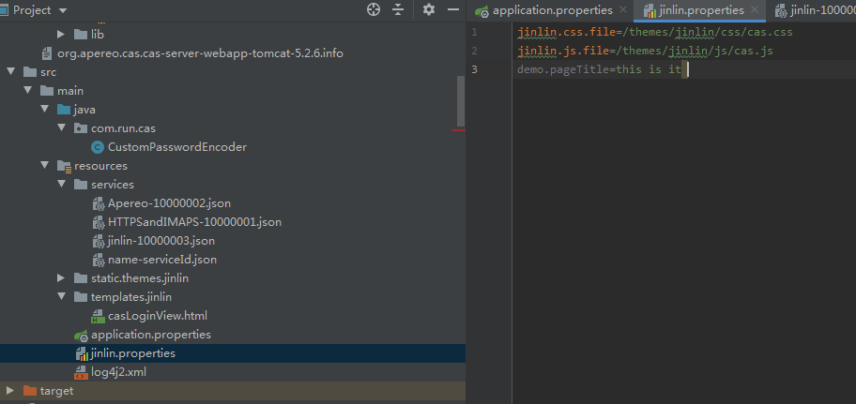

jinlin.css.file=/themes/jinlin/css/cas.css  
jinlin.js.file=/themes/jinlin/js/cas.js  
demo.pageTitle=this is it

# 创建css/js文件

