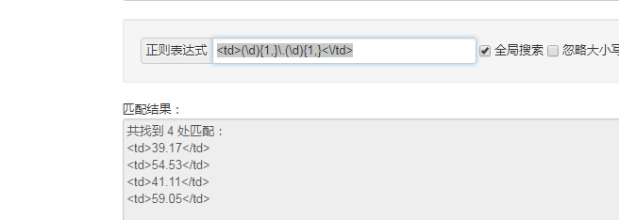

<td>(\d){1,}\.(\d){1,}<\/td>

<div class="data-view">

<div class="market">

<div class="market-info">

<div class="row">

<div class="col-md-6">

<div class="market-title market-title-for-index">

<h1>全部A股等权重市盈率 中位数市盈率</h1>

<div class="full-name">A Market P/E Ratio Chart</div>

</div>

</div>

<div class="col-md-4 market-title-data-for-index">

<div style="color: #BB554E">动态市盈率(TTM)中位数: 38.98</div>

<div style="color: #374856">动态市盈率(TTM)等权平均: 54.04</div>

<div style="color: #77A4AC">静态市盈率(LYR)中位数: 41.27</div>

<div style="color: #CA876D">静态市盈率(LYR)等权平均: 59.19</div>

</div>

<div class="col-md-2 market-title-data-for-index-time">

2020年10月29日

</div>

</div>

</div>

</div>

<div class="echarts-for-wider echarts-style">

<div id="main" class="chart-back"></div>

左边：<div style="color: #[A-Z0-9]{6}">.+:

时间获取

<div class="col-md-2 market-title-data-for-index-time">