IMG_256IMG_256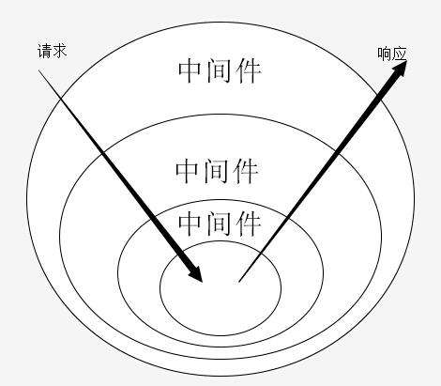

const Koa = require('Koa')

const app = new Koa()

app.use(async(ctx,next)=>{

ctx.body = "1"

next()

ctx.body += "2"

})

app.use(async(ctx,next)=>{

ctx.body += "3"

next()

ctx.body += "4"

})

app.use(async(ctx,next)=>{

ctx.body += "5"

next()

ctx.body += "6"

})

app.listen(3000)

