如php72安装opcache

# cd /usr/local/src/php-7.2.5/ext/opcache

# phpize

# ./configure --with-php-config=/usr/local/php/php72/bin/php-config

# make && make install

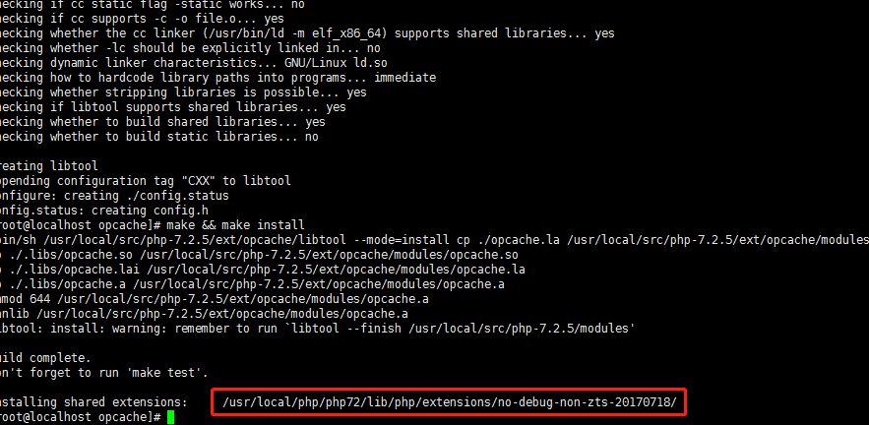

/usr/local/php/php72/lib/php/extensions/no-debug-non-zts-20170718/

修改php.ini

zend_extension=/usr/local/php/php72/lib/php/extensions/no-debug-non-zts-20170718/opcache.so