# dist /outputPath

# MOCK忽略

mock.exclude

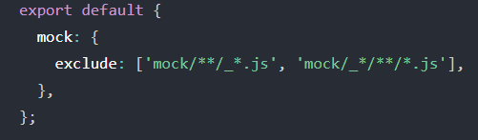

# History

history: 'hash', // 配置哈希路由