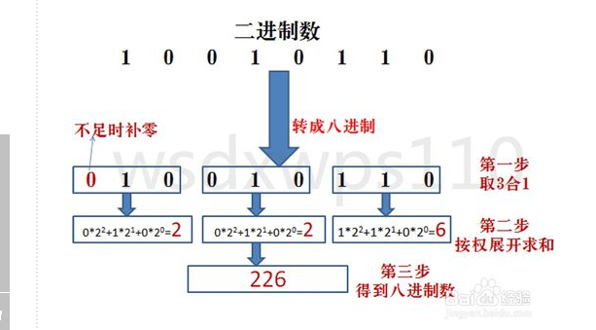

//二进制转八进制 时间复杂度O(n),No3

#include <stdio.h>
#include <stdlib.h>
#include <math.h>

#define STACK_INIT_SIZE 20
#define STACKINCREMENT 10
#define OK 1
#define ERROR 0
#define SOVERFLOW -1

typedef int Status;
typedef char ElemType;

typedef struct
{
ElemType *base;
ElemType *top;
int stacksize;
}sqStack;

Status InitStack(sqStack *s)
{
s->base = (ElemType *)malloc(STACK_INIT_SIZE * sizeof(ElemType));
if(!s->base)
{
return ERROR;
}
s->top = s->base;
s->stacksize = STACK_INIT_SIZE;
return OK;
}

Status Push(sqStack *s,ElemType e)
{
if(s->top - s->base >=s->stacksize)
{
s->base = (ElemType *)realloc(s->base,(s->stacksize + STACKINCREMENT)*sizeof(ElemType));
if(!s->base)
{
return ERROR;
}
s->top = s->base + s->stacksize;
s->stacksize = s->stacksize + STACKINCREMENT;
}
*(s->top++)=e;
return OK;
}
Status Pop(sqStack *s,ElemType *e)
{
if(s->top == s->base) return ERROR;
*e = *(--s->top);
return OK;
}
int StackLen(sqStack s)
{
return (s.top - s.base);
}

int main()
{
sqStack s1,s2;
int len1,len2,d,y,i,j,sum=0;
ElemType c;

InitStack(&s1);
InitStack(&s2);

printf("Please enter a number by Bin and end by # :\n");
scanf("%c",&c);
while( c != '#')
{
Push(&s1,c);
scanf("%c",&c);
}
getchar();

len1 = StackLen(s1);
printf("The length of s1 is : %d \n",len1);
d = len1/3;//d==2
y = len1%3;//y==2
for(i=0;i<d;i++)
{
for(j=0;j<3;j++)
{
Pop(&s1,&c);
sum = sum + (c-48)*pow(2,j);
}
//printf("%d",sum);
Push(&s2,sum+48);
sum = 0;
}
for(i=0;i<y;i++)
{
Pop(&s1,&c);
sum = sum + (c-48)*pow(2,i);
}
//printf("%d",sum);
Push(&s2,sum+48);
len2 = StackLen(s2);
printf("The Oct is :");
for(i=0;i<len2;i++)
{
Pop(&s2,&c);
printf("%c",c);
}
printf("\n");
return 0;
}

- 利用栈处理这些左右右左来回操作的东西，是非常方便的。
- 嵌套的设计不会难，懂得复杂变简单就OK
- 单个阿拉伯数字 c-48=本身数值

#include <stdio.h>
#include <stdlib.h>
#include <math.h>

#define Stack_Init_Size 20
#define Stack_Increasement 10

typedef char Elemtype;

typedef struct{
Elemtype *base;
Elemtype *top;
int stackSize;
}sqStack;

void InitStack(sqStack *s){
s->base=(Elemtype *)malloc(Stack_Init_Size*sizeof(Elemtype));
if(!s->base)
exit(0);
s->top=s->base;
s->stackSize=Stack_Init_Size;
}

int stackLen(sqStack s){
return (s.top-s.base);
}

void push(sqStack *s,Elemtype e){
if(s->top-s->base>=s->stackSize){
s->base=(Elemtype *)realloc(s->base,(Stack_Increasement+s->stackSize)*sizeof(Elemtype));
if(!s->base)
exit(0);
}
*(s->top)=e;
s->top++;
}

void pop(sqStack *s,Elemtype *e){
if(s->top==s->base){
return;
}
s->top--;
*e=*(s->top);
}

int isEmpty(sqStack *s){
return s->top==s->base;
}

int main(){
sqStack s,t;
Elemtype c;

InitStack(&s);
InitStack(&t);

scanf("%c",&c);
while(c!='#'){ //当输入# 输入结束 以字符读入
push(&s,c);
scanf("%c",&c);
}
getchar();
int sum;
int i,j;
int slen=stackLen(s);
for(i=0;i<slen;i+=3){
sum=0;
for(j=0;j<3;j++){
if(!isEmpty(&s))
{
pop(&s,&c);
sum+=(c-48)*(int)pow(2,j);
}
}
push(&t,sum+48);
}
int tlen=stackLen(t);
for(i=0;i<tlen;i++){
pop(&t,&c);
printf("%c",c);
}
return 0;
}
https://blog.csdn.net/MDreamlove/article/details/48207905?locationNum=14&fps=1

时间复杂度也是O(n),但是空间复杂度比我的小。
- 思路：重复动作变化尽量小，能通过其他方式妥协应付特殊情况，就尽量妥协
- 我的：特殊情况特殊对待->容易产生空间复杂度
- 他的：特殊情况能一致对待尽量一致对待
4.以后在设计算法的时候，面对“特殊情况”，我们就得考虑下通过某种妥协应付且不影响结果的情况下能不能一致对待，这样就能节省空间复杂度。

