【根目录配置】
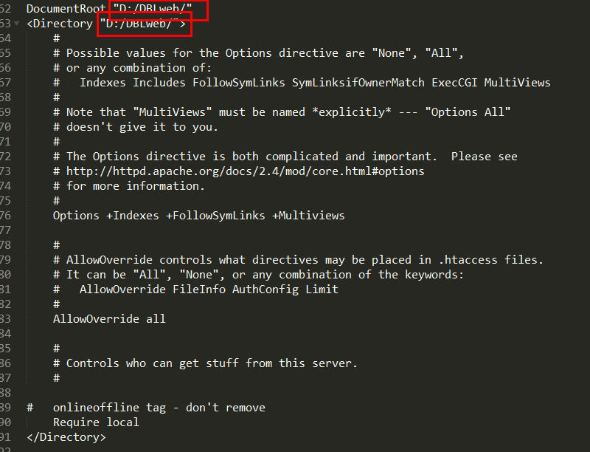

【主机配置】
<VirtualHost 127.0.0.1:80>
DocumentRoot "D:/DBLweb/TP"
ServerName www.wwj449214.com
ServerAlias www.wwj449214.com
</VirtualHost>
<Directory "D:/DBLweb/">
Allow from all
</Directory>

<VirtualHost 127.0.0.2:80>
DocumentRoot "D:/DBLweb/shopex"
ServerName www.wwj449214.com
ServerAlias www.wwj449214.com
</VirtualHost>

<VirtualHost 127.0.0.3:80>
DocumentRoot "D:/DBLweb/lvyecms"
ServerName www.wwj449214.com
ServerAlias www.wwj449214.com
</VirtualHost>
<VirtualHost 127.0.0.4:80>
DocumentRoot "D:/DBLweb/dblcms"
ServerName www.wwj449214.com
ServerAlias www.wwj449214.com
</VirtualHost>

