因缺乏语言包导致安装不了东西

Failed to set locale, defaulting to C.UTF-8

Last metadata expiration check: 0:05:28 ago on Mon Dec 28 06:55:32 2020.

Error:

Problem: conflicting requests

- nothing provides libpsl.so.5()(64bit) needed by wget-1.19.5-10.el8.x86_64

(try to add '--skip-broken' to skip uninstallable packages or '--nobest' to use not only best candidate packages)

检测语言包

locale

发现语言包缺失

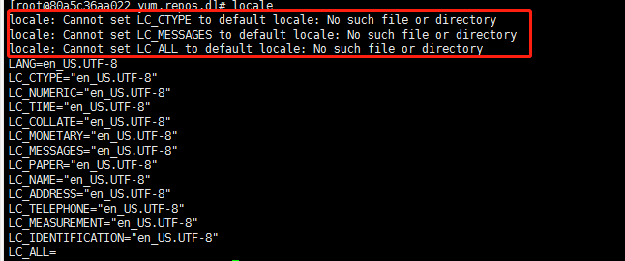

该报错提示说明不存在相关文件，则使用命令locale -a查看目前系统已安装的语言包

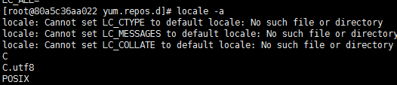

由上图可知，当前系统并没有安装en_US.UTF-8语言，则使用命令 dnf install glibc-langpack-en 或 dnf install langpacks-en glibc-all-langpacks -y进行语言包安装