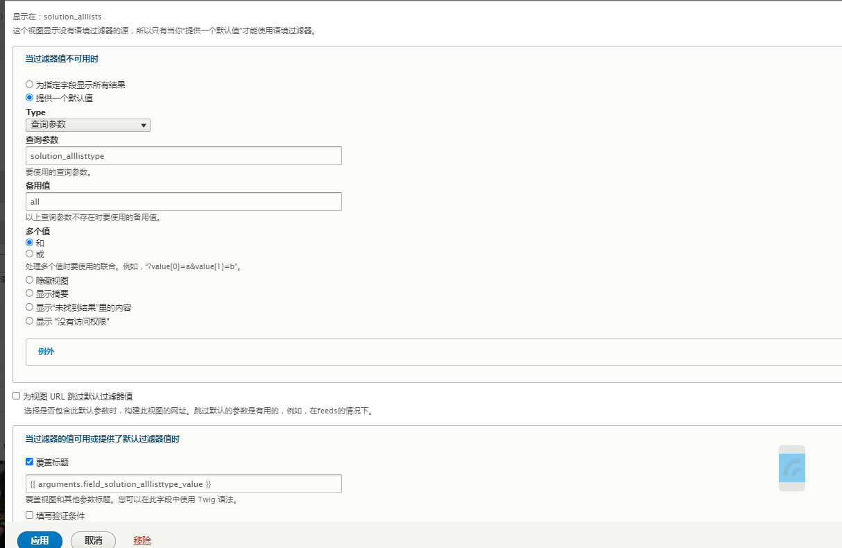

[solution_tags](http://www.ruuuun.com/drupal/admin/structure/views/nojs/handler/jiejuefanganchaoshiliebiao/block_1/argument/field_solution_tags_target_id)

http://www.ruuuun.com/drupal/solution?solution_tags=1