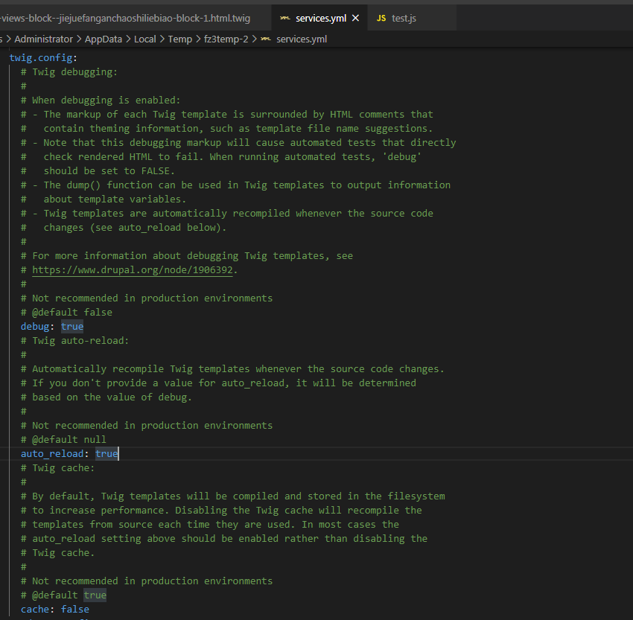

在setting.php



$config['system.logging']['error_level'] = 'verbose';

在 setting.local.php

