# 安装xdebug

wget <https://xdebug.org/files/xdebug-2.7.1.tgz>

tar xzf xdebug-2.7.1.tgz

cd xdebug-2.7.1.tgz

phpize

./configure

make && make install

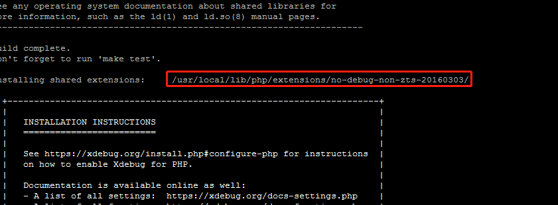

/usr/local/lib/php/extensions/no-debug-non-zts-20160303/

/usr/local/lib/php/extensions/no-debug-non-zts-20160303/xdebug.so

修改php.ini 加上配置：

zend_extension=/usr/local/lib/php/extensions/no-debug-non-zts-20160303/xdebug.so

xdebug.profiler_enable=on

xdebug.trace_output_dir="/home/logs/php/xdebug_trace"

xdebug.profiler_output_dir="/home/logs/php/xdebug_profiler"

xdebug.remote_handler = "dbgp"

xdebug.remote_port = "9001" #端口号

xdebug.remote_host = "192.168.99.1" #远程调试的ip地址，即你自己的本机ip

## vscode插件库搜索安装php debug插件

