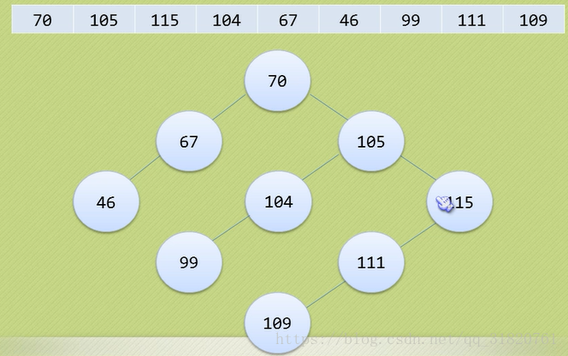

## 实现代码

/**

* BiTreeOrderCreate.c 二叉排序树的建立了

*

* @author darbuly

* @copyright 2018-2019

*/

#include <stdio.h>

#include <stdlib.h>

typedef struct BiNode

{

int data;

struct BiNode *lchild,*rchild;

}BiNode,*BiTree;

void insertChild(BiTree *T,int num);

void CreateBiTreeOrder(BiTree *T)

{

*T = (BiNode*)malloc(sizeof(BiNode));

(*T)->lchild = NULL;

(*T)->rchild = NULL;

int num;

scanf("%d",&num);

if((*T)!=NULL && 65535 != num)

(*T)->data = num;

while(65535!= num)

{

scanf("%d",&num);

if((*T)!=NULL && 65535 !=num)

insertChild(T,num);

}

}

void insertChild(BiTree *T,int num)

{

if(num<(*T)->data)

{

if((*T)->lchild == NULL)

{

(*T)->lchild = (BiNode*)malloc(sizeof(BiNode));

(*T)->lchild->lchild=NULL;

(*T)->lchild->rchild=NULL;

(*T)->lchild->data = num;

}

else

{

insertChild(&((*T)->lchild),num);

}

}

else

{

if((*T)->rchild==NULL)

{

(*T)->rchild = (BiNode*)malloc(sizeof(BiNode));

(*T)->rchild->lchild = NULL;

(*T)->rchild->rchild = NULL;

(*T)->rchild->data = num;

}

else

{

insertChild(&((*T)->rchild),num);

}

}

}

void visit(int c,int level)

{

printf("%d located in %d layer\n",c,level);

}

void MidOrderTraverse(BiTree T,int level)

{

if(T)

{

MidOrderTraverse(T->lchild,level+1);

visit(T->data,level+1);

MidOrderTraverse(T->rchild,level+1);

}

}

int main()

{

printf("BiTreeOrder Test\n");

BiTree T;

int level=1;

CreateBiTreeOrder(&T);

MidOrderTraverse(T,level);

return 0;

}

