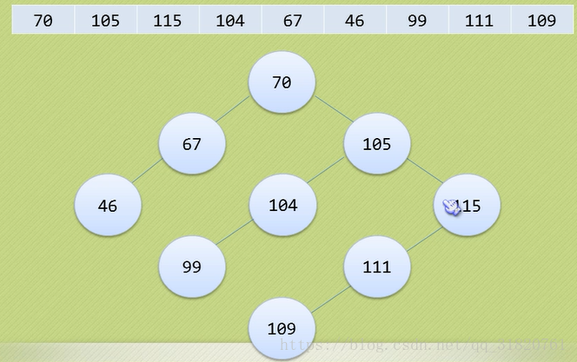

## 实现代码

/**

* InsertBST.c 二叉排序树的插入

*

* @author Darbuly 970073804@qq.com

*

* @copyright 2018-2019 Darbulys

*/

#include <stdio.h>

#include <stdlib.h>

typedef struct BiNode

{

int data;

struct BiNode *lchild,*rchild;

}BiNode,*BiTree;

int str[] = {70,105,115,104,67,46,99,111,109,65535};

int top=0;

void insertChild(BiTree *T,int num);

void CreateBT(BiTree *T)

{

*T = (BiNode*)malloc(sizeof(BiNode));

(*T)->lchild = NULL;

(*T)->rchild = NULL;

int num;

//scanf("%d",&num);

num = str[top++];

if((*T)!=NULL && 65535 !=num)

(*T)->data = num;

while(65535!=num)

{

//scanf("%d",&num);

num = str[top++];

if((*T) !=NULL && 65535 !=num)

insertChild(T,num);

}

}

void insertChild(BiTree *T,int num)

{

if(num<(*T)->data)

{

if((*T)->lchild==NULL)

{

(*T)->lchild = (BiNode*)malloc(sizeof(BiNode));

(*T)->lchild->lchild=NULL;

(*T)->lchild->rchild=NULL;

(*T)->lchild->data = num;

}

else

{

insertChild(&((*T)->lchild),num);

}

}

else

{

if((*T)->rchild==NULL)

{

(*T)->rchild = (BiNode*)malloc(sizeof(BiNode));

(*T)->rchild->rchild=NULL;

(*T)->rchild->lchild=NULL;

(*T)->rchild->data = num;

}

else

{

insertChild(&((*T)->rchild),num);

}

}

}

void visit(int c,int level)

{

printf(" %d located in %d layer\n",c,level);

}

void MidOrderTraverse(BiTree T,int level)

{

if(T)

{

MidOrderTraverse(T->lchild,level+1);

visit(T->data,level+1);

MidOrderTraverse(T->rchild,level+1);

}

}

int SearchBST(BiTree T,int key,BiTree f,BiTree *p)

{

if(!T)

{

*p = f;

return 0;

}

else if(key==T->data)

{

*p = T;

return 1;

}

else if(key<T->data)

{

return SearchBST(T->lchild,key,T,p);

}

else

{

return SearchBST(T->rchild,key,T,p);

}

}

int InsertBST(BiTree *T,int key)

{

BiTree p,s;

if(!SearchBST(*T,key,NULL,&p))

{

s = (BiNode*)malloc(sizeof(BiNode));

s->data = key;

s->lchild = s->rchild = NULL;

if(!p)

{

*T=s;

}

else if (key<p->data)

{

p->lchild = s;

}

else

{

p->rchild = s;

}

return 1;

}

else

{

return 0;

}

}

int main()

{

printf("InsertBST.c Test\n");

BiTree T,p;

int level=0;

int key;

CreateBT(&T);

MidOrderTraverse(T,level);

printf("Please enter what you want to insert:\n");

scanf("%d",&key);

if(InsertBST(&T,key))

{

level = 0;

MidOrderTraverse(T,level);

}

else

{

printf("Insert error!Maybe it is exited!\n");

}

return 0;

}

