**QR codes for image tracking / detection in AR**

The goal is to have a quizz attached to an image that shows up when found by AR tracking.

For now, images are represented by QR codes but they can be anything else (car or animal images for example).

You can find tracked image defined in the unity editor game object list :

AR > AR Session Origin 🡪 (script attached) « AR Tracked Image Manager » 🡪 ReferenceImageLibrary (double click and you should see the list of qr code images defined below)

You can add more images to it or change them. The detection is done in ImageRecognitionExemple script (Gameobject AR > ARFindQrCode)

Actually, the name of the image (« 1 », « 2 », « 3 », « 4 ») represents the quizz id. This is static and was only done for testing

TODO : Add tracked images (attached to each quizz) to API and retrieve them. Add dynamically the images to track at runtime after downloading images from API data.

<https://docs.unity3d.com/Packages/com.unity.xr.arfoundation@3.0/manual/tracked-image-manager.html>

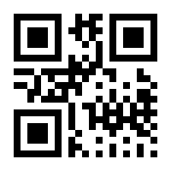

1

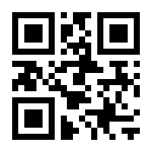

2

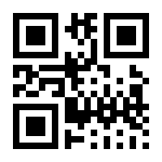

3

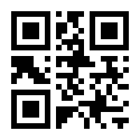

4