Name | Adwait S Purao
UID no. | 2021300101
Experiment No. | 6

AIM: | Demonstrate the use of two-dimensional arrays to solve a given problem.
Program 1
PROBLEM STATEMENT : | Write a program to perform Matrix Addition, Subtraction, Multiplication, Transpose of Matrix and Norm of Matrix. Dimensions of matrices will be decided by user.
ALGORITHM: | - START  - Define void function zero with a float 2D array mat[m][n] as parameter  - Initialize all elements to 0  - Define void function print with a float 2D array mat[m][n] as parameter  - I=0  - J=0  - Print mat[i][j]  - J++  - Repeat 7,8 till j<n  - I++  - Repeat 6,7,8,9 and 10 till i<m  - Define void function add with 2 2D float array mat1[m][n] and mat2[a][b] as parameters  - I=0  - J=0  - Print mat1[i][j]+mat2[i][j]  - J++  - Repeat 15,16 till j<n  - I++  - Repeat 14,15,16,17 and 18 till i<m  - Define void function sub with 2 2D float array mat1[m][n] and mat2[a][b] as parameters  - I=0  - J=0  - Print mat1[i][j]-mat2[i][j]  - J++  - Repeat 23,24 till j  - I++  - Repeat 22,23,24,25 and 26 till i  - Define void function multiply with 2 2D float array mat1[m][n] and mat2[a][b] as parameters  - Initialize 2D array mat3  - Call function zero(m,b,mat3)  - I=0  - J=0  - K=0  - mat3[i][j] += mat1[i][k]*mat2[k][j]  - k++  - repeat 34 and 35 till k  - j++  - repeat 33, 34, 35, 36 and 37 till j<b  - i++  - repeat 32, 33, 34, 35, 36, 37, 38 and 39 till i<m  - call function print(m,b,mat3)  - Define void function transpose with a 2D float array mat[m][n] as parameter  - Initialize 2D array newmat of dimension n x m  - I=0  - J=0  - Newmat[i][j]=mat[j][i]  - J++  - Repeat 46 and 47 till j  - I++  - Repeat 45, 46, 47, 48 and 49 till i<n  - Call function print(m,b,newmat)  - Define int function matrixnorm with a 2D float array mat[m][n]  - Initialize sum = 0.00  - I=0  - J=0  - Sum += square of mat[i][j]  - J++  - Repeat 54 and 55 till j<n  - I++  - Repeat 55, 56, 57 ,58 and 59 till i<m  - Sum = square root of sum  - Return sum  - Define integer main function  - Input dimensions of matrix 1 m and n  - Input matrix 1 [m][n]  - Input dimensions of matrix 2 a and b  - Input matrix 2 [a][b]  - If (m=a and b=n)  call function matrixadditon(m,n,mat1,a,b,mat2)  else  print Addition not possible  - If (m=a and b=n)  call function matrixsubtraction(m,n,mat1,a,b,mat2)  else  print subtraction not possible  - If(n=a)  call function matrixmultiplication(m,n,mat1,a,b,mat2)  else  print multiplication not possible  - Call function transpose(m,n,mat1)  - Call function norm(a,b,mat2)  - Print value of function matrixnorm(m,n,mat1)  - Print value of function matrixnorm(a,b,mat2)  - STOP
FLOWCHART:
PROGRAM: | #include<stdio.h>  #include<math.h>  void zero(int m,int n,float mat[m][n])  {  for(int i=0;i<m;i++)  for(int j=0;j<n;j++)  mat[i][j]=0.0;  }  void print(int m,int n,float mat[m][n])  {  for(int i=0;i<m;i++)  {  for(int j=0;j<n;j++)  printf("%.2f\t",mat[i][j]);  printf("\n");  }  }  void matrixaddition(int m,int n,float mat1[m][n],int a,int b,float mat2[a][b])  {  for(int i=0;i<m;i++)  {  for(int j=0;j<n;j++)  printf("%.2f\t",mat1[i][j]+mat2[i][j]);  printf("\n");  }  }  void matrixsubtraction(int m,int n,float mat1[m][n],int a,int b,float mat2[a][b])  {  for(int i=0;i<m;i++)  {  for(int j=0;j<n;j++)  printf("%.2f\t",mat1[i][j]-mat2[i][j]);  printf("\n");  }  }  void matrixmultiplication(int m,int n,float mat1[m][n],int a,int b,float mat2[a][b])  {  float mat3[m][b];  zero(m,b,mat3);  for(int i=0;i<m;i++)  for(int j=0;j<b;j++)  for(int k=0;k<n;k++)  mat3[i][j] += mat1[i][k]*mat2[k][j];  print(m,b,mat3);  }  void matrixtranspose(int m,int n,float mat[m][n])  {  float newmat[n][m];  for(int i=0;i<n;i++)  for(int j=0;j<m;j++)  newmat[i][j]=mat[j][i];  print(n,m,newmat);  }  double matrixnorm(int m,int n,float mat[m][n])  {  double sum=0.0;  for(int i=0;i<m;i++)  {  for(int j=0;j<n;j++)  {  sum += pow(mat[i][j],2);  }  }  sum = sqrt(sum);  return sum;  }  int main()  {  int m,n,a,b;  printf("Enter dimensions of Matrix 1:\n");  scanf("%d %d",&m,&n);  float mat1[m][n];  printf("Enter elements of Matrix 1:\n");  for(int i=0;i<m;i++)  for(int j=0;j<n;j++)  scanf("%f",&mat1[i][j]);  print(m,n,mat1);  printf("Enter dimensions of Matrix 2:\n");  scanf("%d %d",&a,&b);  float mat2[a][b];  printf("Enter elements of Matrix 2:\n");  for(int i=0;i<a;i++)  for(int j=0;j<b;j++)  scanf("%f",&mat2[i][j]);  print(a,b,mat2);  printf("\n Addition of Matrices:\n");  if(m==a && n==b)  matrixaddition (m,n,mat1,a,b,mat2);  else  printf("Addition of matrices is not possible");  printf("\n Subtraction of Matrices:\n");  if(m==a && n==b)  matrixsubtraction(m,n,mat1,a,b,mat2);  else  printf("Subtraction of matrices is not possible");  printf("\n Multiplication of Matrices:\n");  if(n==a)  matrixmultiplication(m,n,mat1,a,b,mat2);  else  printf("Multiplication of matrices is not possible");  printf("\nTranspose of the 2 Matrices:\n");  matrixtranspose(m,n,mat1);  printf("\n");  matrixtranspose(a,b,mat2);  printf("Norm of Matrix 1 : %.2f\n",matrixnorm(m,n,mat1));  printf("Norm of Matrix 2 : %.2f",matrixnorm(a,b,mat2));  return 0;  }
RESULT:
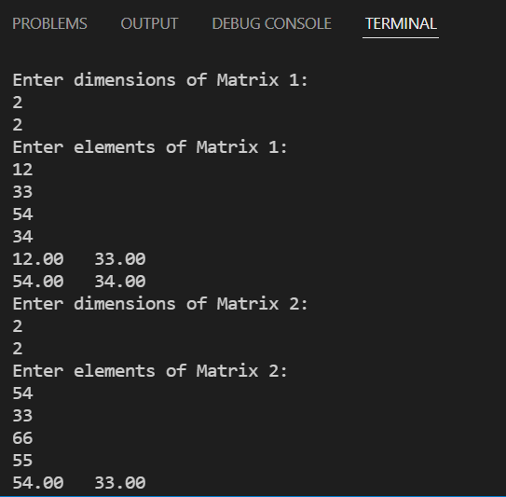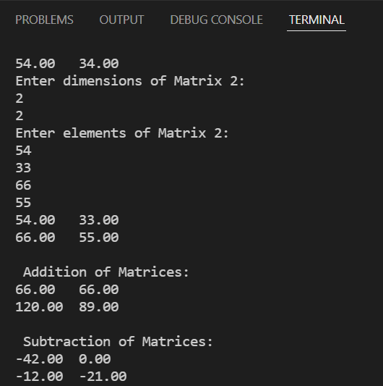
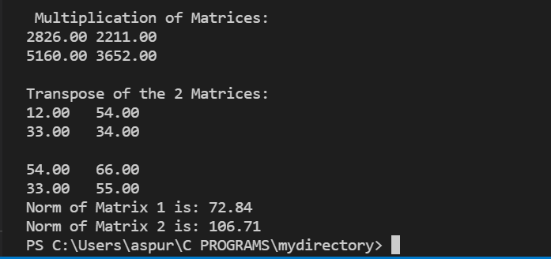
Program 2
PROBLEM STATEMENT : | Write a program which reads the current year followed by N followed by a list of N employee numbers and their current ages. Produce a list showing the years in which the employees retire (become 65 years old). If more than one employee retires in a given year then include them all under the same heading. For example: Year Number 1986 896743 1988 674501 450926
ALGORITHM: | - START  - Define void function selection sort with an 2D integer array mat[n][2]  - Define integer variables min, ind  - I=0  - Ind = i  - J=I+1  - If(mat[j][0] < mat[index][0]) ,index = j  - J++  - Repeat 7 and 8 till j  - Initialize temp1 to mat[ind][0]  - Mat[ind][0] = mat[i][0]  - Mat[i][0] = temp1  - Initialize temp2 to mat[index][1]  - Mat[ind][1] = mat[i][1]  - Mat[i][1] = temp1  - I++  - Repeat steps 5 to 16 till i  - Define integer main function  - Input current year year  - Input the number of employees n  - I=0  - Input current age mat[i][0] and employee number mat[i][1]  - Mat[i][0] = year + 65 – mat[i][0]  - Call function selection sort(n,mat)  - I=0  - If(I not equal to 0 and mat[i][0]=mat[i-1][0])  print Tabspace mat[i][1]  else  print mat[i][0] Tabspace mat[i][1]  - STOP
FLOWCHART:
PROGRAM: | #include<stdio.h>  void selectionsort(int n,int mat[n][2])  {  int min,ind;  for(int i=0;i<n-1;i++)  {  ind=i;  for(int j=i+1;j<n;j++)  {  if(mat[j][0]<mat[ind][0])  {  ind=j;  }  }  int temp1=mat[ind][0];  mat[ind][0]=mat[i][0];  mat[i][0]=temp1;  int temp2=mat[ind][1];  mat[ind][1]=mat[i][1];  mat[i][1]=temp2;  }  }  int main()  {  int year,n;  printf("Enter current year: ");  scanf("%d",&year);  printf("Enter the number of employees: ");  scanf("%d",&n);  int mat[n][2];  for(int i=0;i<n;i++)  {  printf("Enter Employee Number and current age: ");  scanf("%d %d",&mat[i][1],&mat[i][0]);  mat[i][0] = year + 65 - mat[i][0];  }  selectionsort(n,mat);  printf("Retiring Year\tEmployee Number\n");  for(int i=0;i<n;i++)  {  if(i!=0 && mat[i][0]==mat[i-1][0])  printf("\t\t%d\n",mat[i][1]);  else  printf("%d\t\t%d\n",mat[i][0],mat[i][1]);  }  return 0;  }
RESULT:
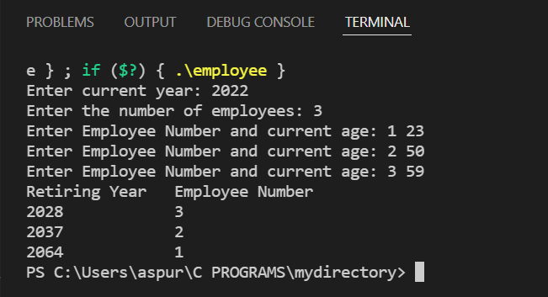
Program 3
PROBLEM STATEMENT: | Given a nxn matrix, find whether it is an upper triangular matrix or not. Also print the upper triangle of the matrix.
ALGORITHM: | - START  - Declare function as void matread with integer parameters m, n and mat[][n])  - For(int i=0;i<m ;i++)  For(int j=0;j<n;j++)  Read mat[i][j]  - Declare function as void matprint with integer parameters m, n andint mat[][n])  - For(int i=0;i<m ;i++)  For(int j=0;j<n;j++)  Print mat[i][j]  - Declare function void matcheck with integer parameters n, arr[][n]  - Declare int row,col, up=1  - for (row = 0; row < n; row++)  for (col = 0; col < n; col++)  if (col < row && arr[row][col] != 0)  up=0  - if(up=1)  - Print The entered matrix is a upper triangular matrix  - Print The matrix is  - Call function as Matprint(n,n,arr)  - Else  Print This is Not a Upper triangular matrix  - Define function main  - Initialize integer variables m and n  - Input number of rows and columns i.e m and n  - Declare int arr[m][n]  - Input elements of array  - Call function matread(m,n,arr)  - Call function matcheck(n,arr)  - STOP
FLOWCHART: | 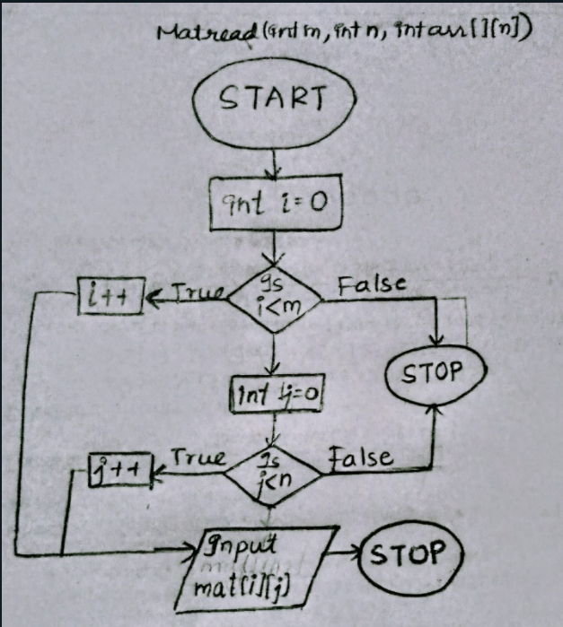  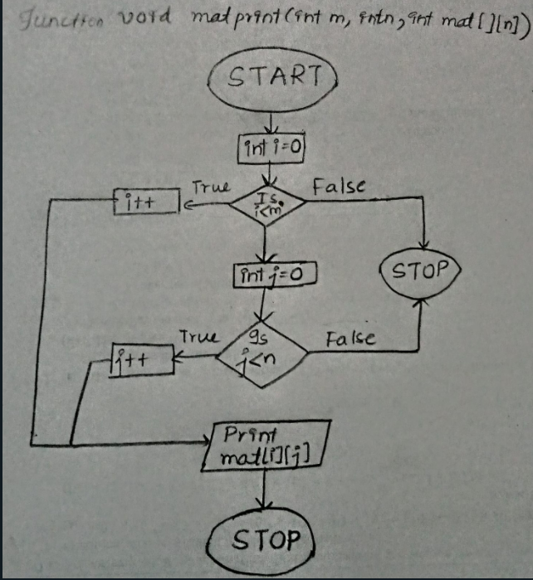  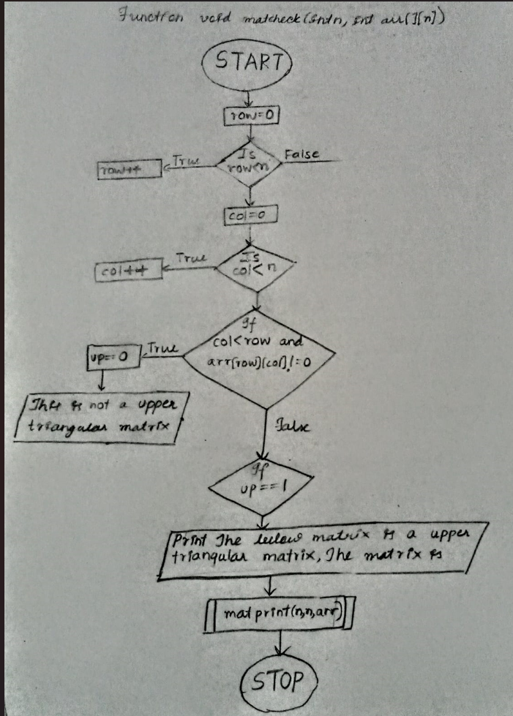  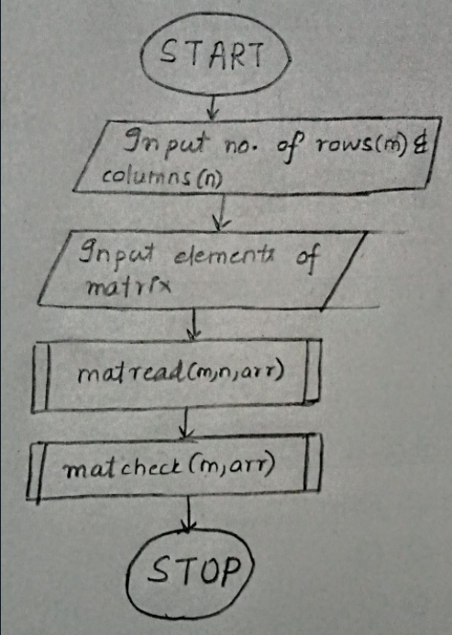
PROGRAM: | #include <stdio.h>  void matread(int m, int n, int mat[][n])  {  for (int i = 0; i < m; i++)  for (int j = 0; j < n; j++)  scanf("%d", &mat[i][j]);  }  void matprint(int m, int n, int mat[][n])  {  for (int i = 0; i < m; i++)  {  for (int j = 0; j < n; j++)  printf("%d ", mat[i][j]);  printf("\n");  }  }  void matcheck(int n, int arr[][n])  {  int row, col, up;  up = 1;  for (row = 0; row < n; row++)  {  for (col = 0; col < n; col++)  {  if (col < row && arr[row][col] != 0)  {  up = 0;  }  }  }  if (up == 1)  {  printf("\nThe entered matrix is a Upper triangular matrix.\n");  printf("The matrix is printed below \n");  matprint(n,n,arr);  }  else  {  printf("\nThis is Not a Upper triangular matrix.");  }  }  int main()  {  int m, n;  printf("Enter the number of rows and columns \n");  scanf("%d %d", &m, &n);  int arr[m][n];  printf("Enter elements of matrix\n");  matread(m, n, arr);  matcheck(m, arr);  return 0;  }
RESULT:
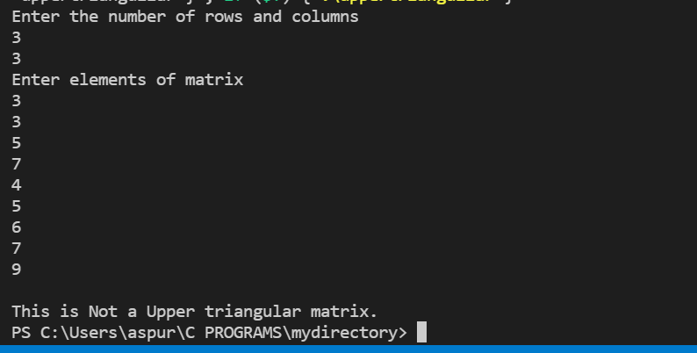
CONCLUSION: | We learnt about the 2-D arrays in the above experiment, we learnt about their functions and operations on matrix like matrix addition, subtraction, multiplication etc. and we learnt to use them in various problems.

