+
Name | Adwait S Purao
UID no. | 2021300101
Experiment No. | 7

AIM: | Implement various text processing problems.
Program 1
PROBLEM STATEMENT : | Write a program to count the number of vowels, consonants, total characters and words in the given string.
ALGORITHM: | - START  - Define function void findvowelconsonants with character input str  - Set integer variables vow_count, count, consonants to zero  - while (str[count] != '\0')  if (str[count] == 'a' || str[count] == 'e' || str[count] == 'i'  || str[count] == 'o' || str[count] == 'u' || str[count] == 'A'  || str[count] == 'E' || str[count] == 'I' || str[count] == 'O'  || str[count] == 'U')  vow_count++  - else  consonants++  - count++  - Print the number of vowels and consonants  - Define function int string length with char input str  - Initialize len to zero  - while (str[len] != '\0')  - len++  - Return len  - Define function int word_num with character input str  - Define two integer variables i and count=0  - for (i = 0; str[i] != '\0'; i++)  - if (str[i] == ' ' && str[i + 1] != ' ')  count++  - Return count+1  - Define function int main  - Initialize character variable str[100]  - Initialize integer variables count=0 and i  - Input the string  - Call functions findvowelconsonants , string_length, word_num  - Print number of vowels, consonants,string length,number of words  - STOP
PROGRAM: | #include<stdio.h>  void  findvowelconsonants (char str[])  {  int vow_count = 0;  int count = 0;  int consonants = 0;  while (str[count] != '\0')  {  if (str[count] == 'a' || str[count] == 'e' || str[count] == 'i'  || str[count] == 'o' || str[count] == 'u' || str[count] == 'A'  || str[count] == 'E' || str[count] == 'I' || str[count] == 'O'  || str[count] == 'U')  {  vow_count++;  }  else  {  consonants++;  }  count++;  }  printf ("\nThe string has %d vowels\n", vow_count);  printf ("\nThe string has %d consonants\n ", consonants);  }  int  string_length (char str[])  {  int len = 0;  while (str[len] != '\0')  {  len++;  }  return len;  }  int  word_num (char str[])  {  int count = 0, i;  for (i = 0; str[i] != '\0'; i++)  {  if (str[i] == ' ' && str[i + 1] != ' ')  count++;  }  return count + 1;  }  int  main ()  {  char str[100];  int count = 0, i;  printf ("Enter the string:\n");  scanf (" %[^\n]s ", str);  findvowelconsonants (str);  string_length (str);  printf ("\nLength of string:%d\n", string_length (str));  word_num (str);  printf ("\nNumber of words in given string are: %d\n", word_num (str));  }
RESULT:
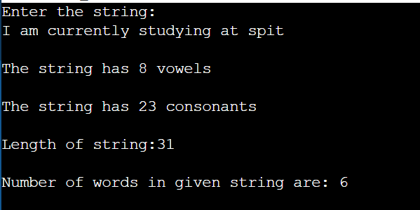
Program 2
PROBLEM STATEMENT : | Write a Menu driven Program to  i)copy one string to another one by one character.  ii) Find the string length  iii) compare two strings  iv) reverse the string  v) Concatenate one string to another string.  vi) lower case to upper
ALGORITHM: | - START  - Define function void cop with two string inputs str 1 and str 2  - Initialize integer variable i  - for(i=0; str1[i]!='\0'; ++i)  store the value of str 1 in str 2  - Put null character at the end of string 2  - Define function int len with character input str1  - Initialize integer variable len to zero  - for(int i=0; str1[i]!='\0'; ++i)  length++  - return length  - Define function int com with two string inputs str 1 and str 2  - Initialize integer variable dif to zero  - for(int i=0; str1[i]!='\0' || str2[i]!='\0'; ++i)  - dif = str1[i] - str2[i]  - return dif  - Define function char rev with string input str1  - Initialize integer variables i,j  - Call function len, int l = len(str1)  - Initialize string char tempstr[l]  - j=l-1  - for(i=0; i<l; i++)  - Store str1 in tempstr  - j—  - End tempstr with null character  - Call function cop(tempstr, str1)  - Define function void cat with two string input str1 and str2  - Initialize integer variables i,j  - Call function len, int l = len(str1)  - for(i=0, j=l; str2[i]!='\0'; ++i, ++j)  - str1[j] = str2[i]  - End str1 with null character  - Define function void up with two string inputs str and strn  - Initialize integer variable i  - for(i=0;str[i]!='\0';i++)  - if(str[i] >= 97 && str[i] <= 122)  strn[i] = str[i] – 32  - else  strn[i] = str[i]  - End strn with null character  - Define function int main  - Initialize integer variables ch and trash  - Initialize strings str 1,str 2,strn1,strn2  - Read two strings  - Do while(ch!=7)  - Print Copy first string to second\n2) Length of string\n3) Compare two strings\n4) Reverse string\n5) Concatenate second string to first string\n6) Convert string to upper case\nEnter choice:  - Define switch case statement  - Case 1  - Read string  - Call function cop  - Print copied string  - break  - Case 2  - Read string  - Call function len(str)  - Break  - Case 3  - Read two strings  - Call function com(str 1,str 2)  - Break  - Case 4  - Read string  - Call function rev(str 1)  - Print reversed string  - Break  - Case 5  - Read two strings  - Call function  - cat(str 1,str2)  - print catenated string  - break  - Case 6  - Read two strings  - Call function  up(str1,strn1)  up(str2,strn2)  - Print strn1 and strn2  - Break  - If input is not between 1 to 6 then print default statement Invalid input  - STOP
PROGRAM: | #include <stdio.h>  void cop(char str1[], char str2[])  {  int i;  for(i=0; str1[i]!='\0'; ++i)  {  str2[i] = str1[i];  }  str2[i] = '\0';  }  int len(char str1[])  {  int length=0;  for(int i=0; str1[i]!='\0'; ++i)  {  ++length;  }  return length;  }  int com(char str1[], char str2[])  {  int dif = 0;  for(int i=0; str1[i]!='\0' || str2[i]!='\0'; ++i)  {  dif = str1[i] - str2[i];  }  return dif;  }  char rev(char str1[])  {  int l = len(str1), i, j;  char tempstr[l];  j=l-1;  for(i=0; i<l; i++)  {  tempstr[i] = str1[j];  j--;  }  tempstr[i] = '\0';  cop(tempstr, str1);  }  void cat(char str1[], char str2[])  {  int l = len(str1), i, j;  for(i=0, j=l; str2[i]!='\0'; ++i, ++j)  {  str1[j] = str2[i];  }  str1[j] = '\0';  }  void up(char str[],char strn[])  {  int i;  for(i=0;str[i]!='\0';i++)  {  if(str[i] >= 97 && str[i] <= 122)  strn[i] = str[i] - 32;  else  strn[i] = str[i];  }  strn[i]='\0';  }  int main()  {  int ch;  int trash;  char str1[1024];  char str2[1024];  char strn1[100],strn2[100];  printf("Enter string 1: ");  scanf("%[^\n]",str1);  printf("Enter string 2: ");  scanf(" %[^\n]",str2);  do{  printf("1) Copy first string to second\n2) Length of string\n3) Compare two strings\n4) Reverse string\n5) Concatenate second string to first string\n6) Convert string to upper case\nEnter choice: ");  scanf("%d", &ch);  switch (ch)  {  case 1:  printf("Enter string: ");  scanf(" %[^\n]s ", str1);  cop(str1, str2);  printf("Copied string: %s", str2);  break;  case 2:  printf("Enter string: ");  scanf(" %[^\n]s ", str1);  printf("Length: %d", len(str1));  break;  case 3:  printf("Enter string 1: ");  scanf(" %[^\n]s ", str1);  printf("Enter string 2: ");  scanf(" %[^\n]s ", str2);  printf("%d", com(str1, str2));  break;  case 4:  printf("Enter string: ");  scanf(" %[^\n]s ", str1);  rev(str1);  printf("%s", str1);  break;  case 5:  printf("Enter string 1: ");  scanf(" %[^\n]s ", str1);  printf("Enter string 2: ");  scanf(" %[^\n]s ", str2);  cat(str1, str2);  printf("%s", str1);  break;  case 6:  {  scanf("%[^\n]", str1);  scanf("%[^\n]", str2);  up(str1,strn1);  up(str2,strn2);  printf("%s\n",strn1);  printf("%s\n\n",strn2);  break;  }  default: printf("Invalid input");  break;  }  } while(ch!=7);  return 0;  }
RESULT:
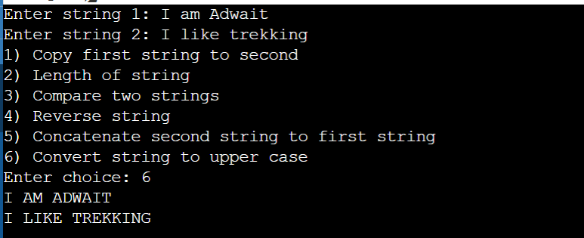
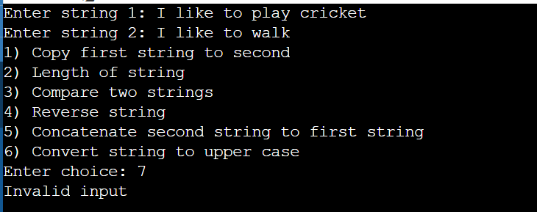

Program 3
PROBLEM STATEMENT: | Write a program to delete all repeated words in string. Input: welcome to C programming class , welcome again to C class ! Output: welcome to C programming class , again !
ALGORITHM: | 1. START  2. Define integer function comp with two character arrays str1[] and  str2[] as parameters  3. Ctr = 0, I=0  4. If (str1[i]>str2[i] or str1[i]<str2[i])  count = 1  Go to step 7  5. i++  6. Repeat 4 and 5 till str1[i] = 0 or str2[i] =0  7. Return count  8. Define void function delrepeated_words with a character array as parameters  9. char mat[100][100], words[100]  10.int i=0,j=0,k=0,l=0  11.If (str[i]==32)  mat[k][j]=0  k++  j=0  Else  mat[k][j]=str[i]  j++  12.i++  13.Repeat 11 and 12 till str[i]!=0  14.mat[k][j]=0  j=0  i=0  15.temp=0  l=1  16.If(mat[i][j]==0 or l==1)  Check if (comp(mat[i],mat[l])==0)  mat[i][j] = 0  temp++  17.l++  18.Repeat 16 and 17 till l<k+1\  19.i++  20.Repeat 15,16,17,18 and 19 till i<k  21.i=0  j=0  22.Is mat[i][j]!=0?  Print mat[i]  23.i++  24.Repeat 22 and 23 till i<k+1  25.STOP
FLOWCHART: | 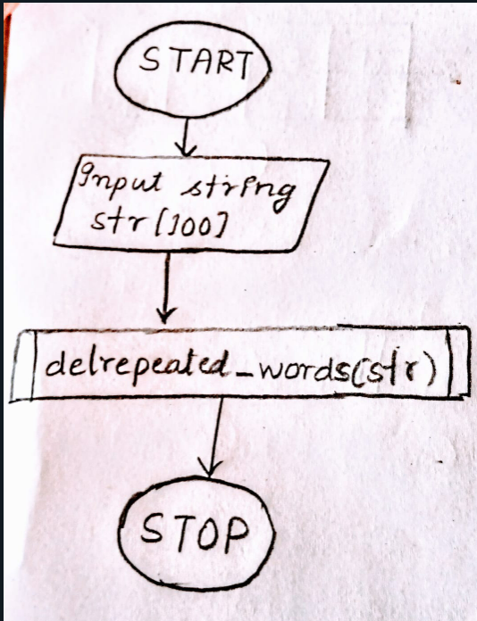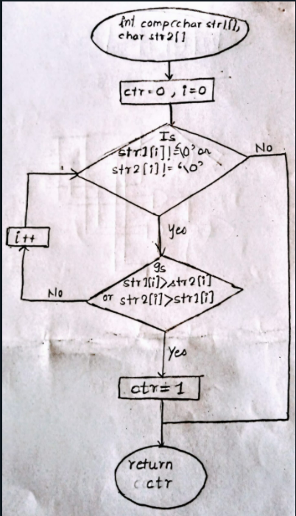  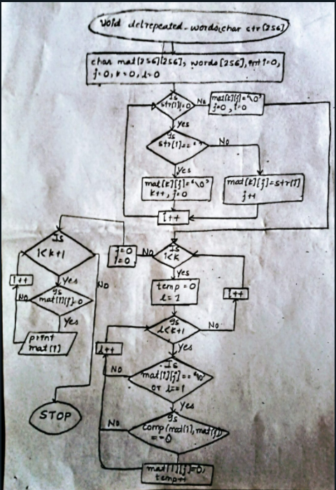
PROGRAM: | #include<stdio.h>  int comp(char str1[256],char str2[256])  {  int ctr=0;  for(int i=0;(str1[i]!='\0' || str2[i]!='\0');i++)  {  if((str1[i]>str2[i]) || (str1[i]<str2[i]))  {  ctr=1;  break;  }  }  return ctr;  }  void delrepeated_words(char str[256])  {  char mat[256][256], words[256];  int i=0,j=0,k=0,l=0;  for(i=0;str[i]!='\0';i++)  {  if(str[i]==' ')  {  mat[k][j] = '\0';  k++;  j=0;  }  else  {  mat[k][j] = str[i];  j++;  }  }  mat[k][j]='\0';  j=0;  for(i=0;i<k;i++)  {  int temp=0;  for(l=1;l<k + 1;l++)  {  if(mat[l][j] == '\0' || l == i)  {  continue;  }  if(comp(mat[i],mat[l])==0)  {  mat[l][j] = '\0';  temp++;  }  }  }  j=0;  for(i=0;i<k + 1;i++)  {  if(mat[i][j] == '\0')  continue;  else  printf("%s ",mat[i]);  }  }  int main()  {  char str[256];  printf("Enter a string: ");  scanf(" %[^\n]",str);  delrepeated_words(str);  return 0;  }
RESULT:
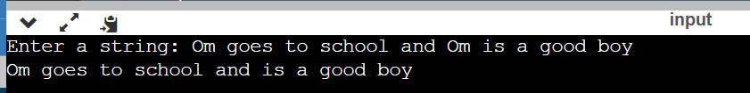
CONCLUSION: | In the above experiment we learned about the basic syntax of strings and how to initialize them and how to read and print them. We learnt how we can pass them to arrays and functions. We learned about some functions like reversing, concatenating, finding the length of strings etc.

