Name | Adwait S Purao
UID no. | 2021300101
Experiment No. | 9

AIM: | Demonstrate the use of pointers to solve a given problem.
Program 1
PROBLEM STATEMENT : | Write a program to swap smallest and largest element in an array using pointers
ALGORITHM: | - START  - Define function void swap with integer pointer parameters a and b  - Define a temporary variable temp  - Store the value of *a in temp  - Store the value of *b in *a  - Store the value of temp in *b  - Define function void sort with integer parameters array and size  - for(int i=0;i<size;i++)  for(int j=i+1;j<size;j++)  if(*(arr+i)>*(arr+j))  - swap(&arr[i],&arr[j])  - Define function int main  - Define integer parameters n,ar[100],h  - Take input of the number of elements  - Take input of the elements of the array  - Call function sort  - Call function swap to swap the first and last element of the sorted array  - Print the array after swapping  - STOP
PROGRAM: | #include<stdio.h>  void sort(int arr[],int size);  void swap(int*a,int*b);  int main(){  int n,ar[100],h;  printf("Enter the number of elements:\n");  scanf("%d",&n);  printf("Enter the elements of array:\n");  for(h=0;h<n;h++){  scanf("%d",(ar+h));  }  sort(ar,n);  swap(&ar[0],&ar[n-1]);  printf("After swapping the smallest and largest elements:\n");  for(int s=0;s<n;s++){  printf("%d,",*(ar+s));  }  }  void sort(int arr[],int size){  for(int i=0;i<size;i++){  for(int j=i+1;j<size;j++){  if(*(arr+i)>*(arr+j)){  swap(&arr[i],&arr[j]);  }  }  }  }  void swap(int*a,int*b){  int temp;  temp=*a;  *a=*b;  *b=temp;  }
RESULT:
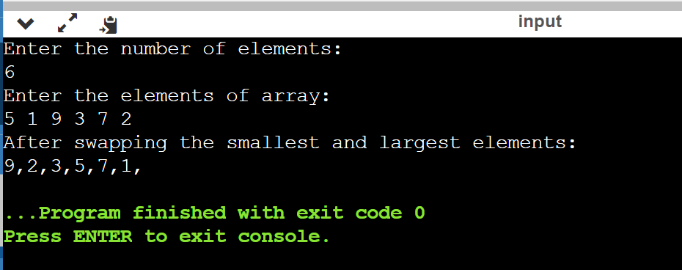
Program 2
PROBLEM STATEMENT : | Write a program to reverse the position of all elements in the array using pointers.
ALGORITHM: | - START  - Define function void ar_reverse with integer parameters arr,start,end  - if(start<end)  - Declare a integer variable temp  temp=*(arr+start);  *(arr+start)=*(arr+end);  *(arr+end)=temp;  - Call the function recursively ar_reverse(arr,start+1,end-1)  - In function main declare integer variables ar[100],k,st=0,ed  - Take the number of elements as input  - Take the elements of the array as input  Call function ar_reverse(ar,st,ed)  - Print Reversed array  - STOP
PROGRAM: | #include<stdio.h>  void ar_reverse(int arr[],int start,int end);  int main(){  int ar[100],k,st=0,ed;  printf("Enter the number of elements:\n");  scanf("%d",&k);  ed=k-1;  printf("Enter the elements of array:\n");  for(int r=0;r<k;r++){  scanf("%d",(ar+r));  }  ar_reverse(ar,st,ed);  printf("Reversed array:\n");  for(int g=0;g<k;g++){  printf("%d,",*(ar+g));  }  }  void ar_reverse(int arr[],int start,int end){  if(start<end){  int temp;  temp=*(arr+start);  *(arr+start)=*(arr+end);  *(arr+end)=temp;  ar_reverse(arr,start+1,end-1);  }  }
RESULT:
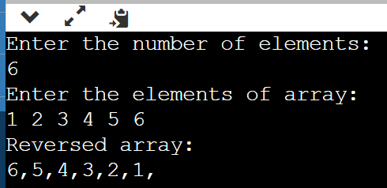
Program 3
PROBLEM STATEMENT: | Write a program to perfor m matrix multiplication using pointers. Dimensions of matrices will be decided by the user.
ALGORITHM: | 1. START  2. Define void function multiply with 4 integers m, n, a, b and three 2-D integer arrays arr1[m][n], arr2[a][b], arr3[m][b]  3. If n is equal to a  A. Loop from I = 0 to m-1  I. Loop from J = 0 to b-1  a. sum = 0  b. Loop from k = 1 to n-1  sum += (*(*(arr1 + i) + k)) * (*(*(arr2 + k) + j))  4. Define main function  5. Input dimensions of first matrix m and n  6. Input first matrix arr1[m][n]  7. Input dimensions of second matrix a and b  8. Input second matrix arr2[a][b]  9. Define arr3[m][b]  10. Call function multiply(m, n, a, b, arr1, arr2, arr3)  11. Print 2-D array arr3  12. STOP
PROGRAM: | #include<stdio.h>  void multiply(int m,int n ,int arr1[m][n],int a, int b, int arr2[a][b],int  arr3[m][b])  {  if(n==a)  for(int i=0;i<m;i++)  for(int j=0;j<b;j++)  {  int sum = 0;  for(int k=0;k<n;k++)  sum += (*(*(arr1 + i) + k)) * (*(*(arr2 + k) + j));  *(*(arr3 + i) + j) = sum;  }  }  int main()  {  int m,n,a,b;  printf("Enter dimensions of matrix:\n");  scanf("%d %d",&m,&n);  printf("Enter elements of the matrix:\n");  int arr1[m][n];  for(int i=0;i<m;i++)  for(int j=0;j<n;j++)  scanf("%d",(*(arr1 + i) + j));  printf("Enter dimensions of matrix:\n");  scanf("%d %d",&a,&b);  printf("Enter elements of the matrix:\n");  int arr2[a][b];  for(int i=0;i<a;i++)  for(int j=0;j<b;j++)  scanf("%d",(*(arr2 + i) + j));  int arr3[m][b];  multiply(m,n,arr1,a,b,arr2,arr3);  printf("The matrix after multiplying is:\n");  for(int i=0;i<m;i++)  for(int j=0;j<b;j++)  printf("%d ", *(*(arr3 + i) + j));  return 0;  }
RESULT:
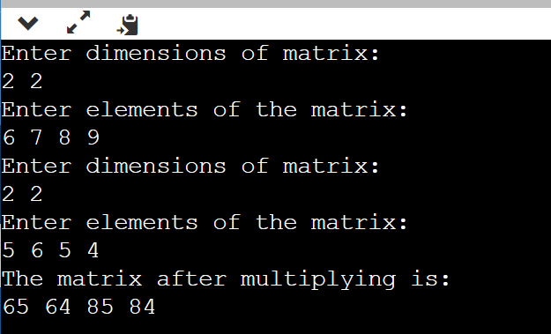
CONCLUSION: | In the above experiment we learnt how to take inputs and print outputs using pointers and we also learned how to access the elements of the array using pointers.

