**NAME: ADWAIT S PURAO**

**BATCH: B2**

**UID: 2021300101**

**EXP NO.:1**

**16 BIT ADDITION**

data segment

n1 dw 0210h

n2 dw 0410h

result dw 01 dup(?)

data ends

code segment

assume cs:code,ds:data

start:

mov ax,data

mov ds,ax

mov ax,n1

mov bx,n2

mov cx,0000

add ax,bx

jnc xyz

inc cx

xyz: mov result,ax

mov [result+2],cx

int 3

code ends

end start

**OUTPUT**

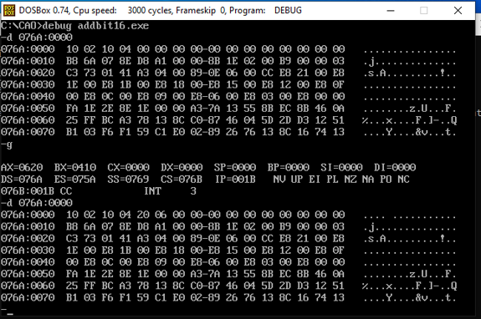

**16 BIT SUBTRACTION**

data segment

n1 dw 0210h

n2 dw 0410h

result dw 01 dup(?)

data ends

code segment

assume cs:code,ds:data

start:

mov ax,data

mov ds,ax

mov ax,n1

mov bx,n2

mov cx,0000

sub ax,bx

jnc xyz

inc cx

xyz: mov result,ax

mov [result+2],cx

int 3

code ends

end start

**OUTPUT**

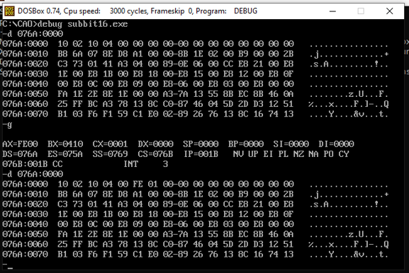

**8 BIT ADDITION**

data segment

num1 dw 12h

num2 dw 24h

result dw 01 dup(?)

data ends

assume cs:code,ds:data

code segment

start:

mov ax,data

mov ds,ax

mov ax,num1

mov bx,num2

add ax,bx

mov result,ax

mov ah,4ch

int 21h

code ends

end start

**OUTPUT**

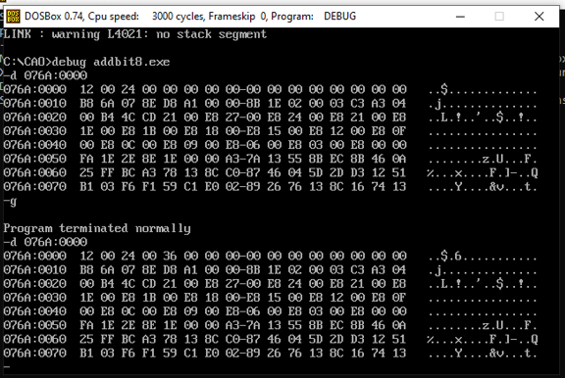

**8 BIT SUBTRACTION**

data segment

num1 dw 12h

num2 dw 24h

result dw 01 dup(?)

data ends

assume cs:code,ds:data

code segment

start:

mov ax,data

mov ds,ax

mov ax,num1

mov bx,num2

sub ax,bx

mov result,ax

mov ah,4ch

int 21h

code ends

end start

**OUTPUT**

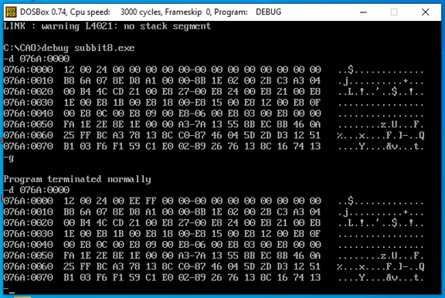

**CONCLUSION:**

In the above experiment we learnt to add and subtract two 8 bit numbers and two 16 bit numbers in 8086 microprocessor.

We also learnt to use the dosbox software. We learnt to use the various instruction like edit to open the .asm file , masm , link and debug.