**NAME : ADWAIT S PURAO**

**UID:2021300101**

**BATCH: B2**

**CODE 1:**

**COPYING 10 NO.S FROM ONE LOCATION TO OTHER IN THE SAME DATA SEGMENT**

data segment

data ends

assume cs:code,ds:data

code segment

start:

mov ax,1000h

mov ds,ax

mov si,0000h

mov di,2000h

mov cl,0ah

again:

mov ax,[si]

mov [di],ax

add si,02

add di,02

dec cl

jnz again

mov ah,4ch

int 21h

code ends

end start

**OUTPUT:**

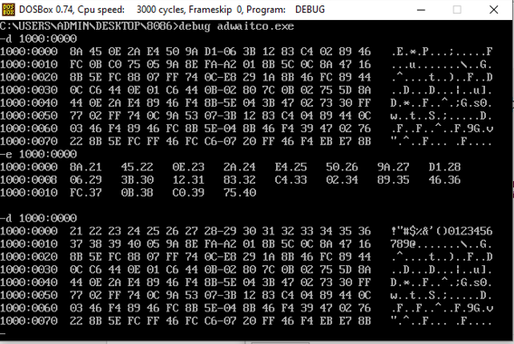

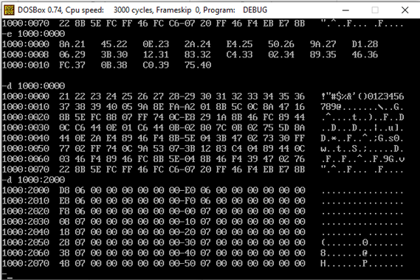

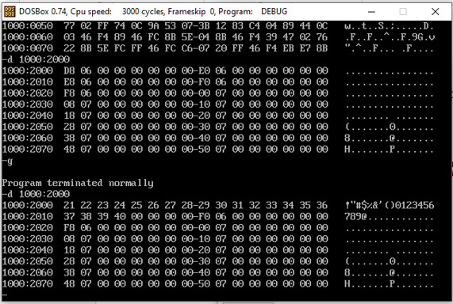

**CODE 2:**

**2) COPYING 10 NO.S FROM ONE LOCATION TO OTHER IN DIFFERENT DATA SEGMENT**

data segment

data ends

code segment

assume cs:code,ds:data

start:

mov ax,1000h

mov ds,ax

mov ax,2000h

mov es,ax

mov ax,0000h

mov si,ax

mov ax,0000h

mov di,ax

mov cl,0Ah

again:

mov ax,[si]

mov es:[di],ax

add si,02

add di,02

dec cl

jnz again

mov ah,4ch

int 21h

code ends

end start

**OUTPUT:**

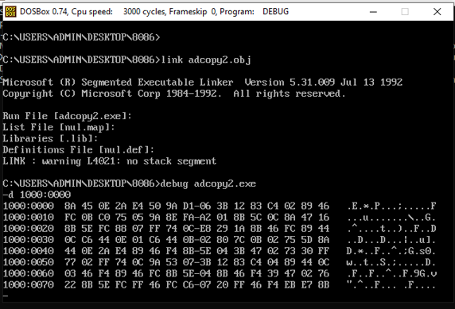

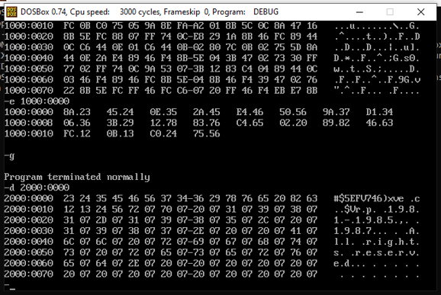

**CONCLUSION:**

In the above experiment we learnt to move data from one memory location to other in same data and different data segment using source and destination indexes.