**CAO EXP:3**

**NAME : ADWAIT S PURAO**

**UID : 2021300101**

**BATCH: B2**

**DIVISION: B**

**FE COMPS B**

**AIM: Checking whether two string are equal or not using 8086**

**CONDITION 1: STRINGS ARE NOT EQUAL**

data segment

string1 db "Adwait","$"

equal db "string is equal","$"

notequal db "string is not equal","$"

data ends

extra segment

string2 db "welcome","$"

extra ends

code segment

assume cs:code,ds:data,es:extra

start:

mov ax,data

mov ds,ax

mov ax,extra

mov es,ax

lea si,string1

lea di,string2

cld

mov cx,07h

repe cmpsb

jnz noteq

lea dx,equal

mov ah,09h

int 21h

jmp endp1

noteq:

lea dx,notequal

mov ah,09h

int 21h

endp1:

mov ah,4ch

int 21h

code ends

end start

**OUTPUT:**

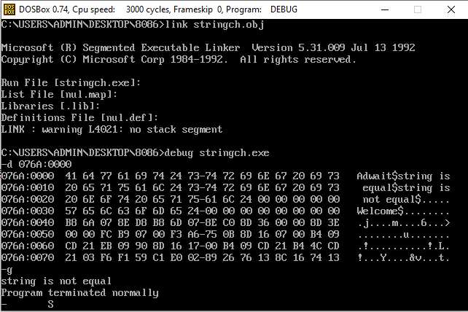

**CONDITION 2: STRINGS ARE EQUAL**

data segment

string1 db "Adwait","$"

equal db "string is equal","$"

notequal db "string is not equal","$"

data ends

extra segment

string2 db "Adwait","$"

extra ends

code segment

assume cs:code,ds:data,es:extra

start:

mov ax,data

mov ds,ax

mov ax,extra

mov es,ax

lea si,string1

lea di,string2

cld

mov cx,07h

repe cmpsb

jnz noteq

lea dx,equal

mov ah,09h

int 21h

jmp endp1

noteq:

lea dx,notequal

mov ah,09h

int 21h

endp1:

mov ah,4ch

int 21h

code ends

end start

OUTPUT:

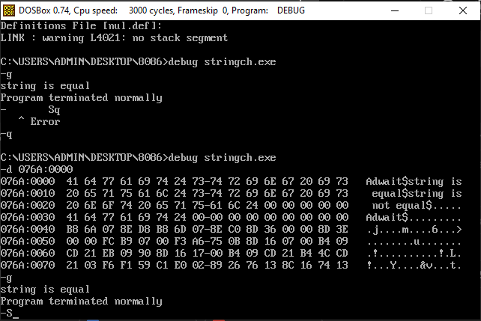

**Conclusion:**

We understood the process of storing and processing strings in 8086 and displaying the desired output using suitable interrupt. We also learned about process of comparing two string types using ‘REPE CMPSB’ command line, and was thus able to get desired output.