NAME : ADWAIT S PURAO

UID : 2021300101

BATCH : B2

RESTORING DIVISION FLOWCHART:

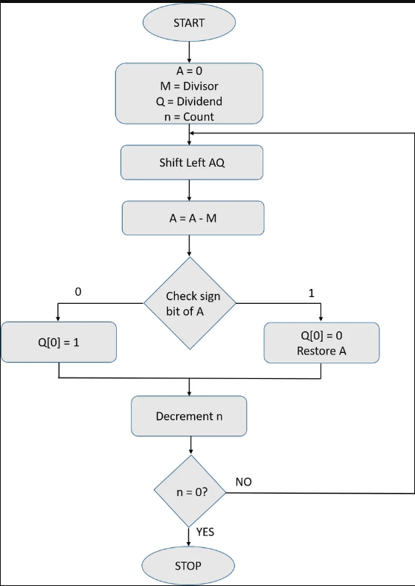

CODE:

def deci_to_bin(n):

    return bin(n).replace("0b", "")

def shift_left(C,AC,Q):

    C=AC[0]

    temp_AC=list(AC)

    for i in range(1,len(AC)):

        temp_AC[i-1]=temp_AC[i]

    temp_AC[len(AC)-1]=Q[0]

    AC=''

    AC=AC.join(temp_AC)

    temp_Q=list(Q)

    for i in range(1,len(Q)):

        temp_Q[i-1]=temp_Q[i]

    temp_Q[len(Q)-1]='_'

    Q=''

    Q=Q.join(temp_Q)

    return(C,AC,Q)

def operation(C,AC,M):

    temp=C+AC

    temp=bin(int(temp,2)+int(M,2))

    temp=temp.replace("0b","")

    # discard the carry while operation is done

    if(len(temp)>len(M)):

        temp=temp[1::]

    return(temp[0],temp[1::])

# Main function

AC=''

C='0'

Q=input("Enter the dividend(Q)  :  ")

Q=deci_to_bin(int(Q))

M=input("Enter the divisor(M)   :  ")

M=deci_to_bin(int(M))

if(len(Q)>len(M)):

    for i in range(len(Q)):

        AC=AC+'0'

else:

    for i in range(len(M)):

        AC=AC+'0'

print("Initial C value is     : ",C)

print("Initial AC value is    : ",AC)

print("Initial Q value is     : ",Q)

for i in range(len(Q)-len(M)):

    M='0'+M

# adding one bit extra

M='0'+M

print("Value of M is          : ",M)

# two's complement

M_array=list(M)

for i in range(len(M)):

    if(M[i]=='0'):

        M_array[i]='1'

    if(M[i]=='1'):

        M_array[i]='0'

M_negative=''

M_negative=M_negative.join(M_array)

M_negative=bin(int(M_negative,2)+int('1',2))

M_negative=M_negative.replace("0b","")

print("Two's complement of M  : ",M_negative)

print()

print("---------------------------------------------------------------------------------------------------------------------")

print("\t C "," "*int(len(AC)/2),"AC"," "*int(len(AC)/2)," "*int(len(Q)/2),"Q"," "*int(len(Q)/2),"     Operation done")

print("---------------------------------------------------------------------------------------------------------------------")

print("\t",C,"  ",AC,"  ",Q,"   ","Initial values")

print()

for i in range(len(Q)):

    print("step",(i+1),":  ")

    C,AC,Q=shift_left(C,AC,Q)

    print("\t",C,"  ",AC,"  ",Q,"   ","After shift left operation")

    C,AC=operation(C,AC,M_negative)

    print("\t",C,"  ",AC,"  ",Q,"   ","AC_equals_AC_minus_M operation")

    if(C=='1'):

        temp_Q=list(Q)

        temp_Q[len(Q)-1]='0'

        Q=''

        Q=Q.join(temp_Q)

        C,AC=operation(C,AC,M)

        print("\t",C,"  ",AC,"  ",Q,"   ","AC_equals_AC_plus_M operation")

    else:

        temp_Q=list(Q)

        temp_Q[len(Q)-1]='1'

        Q=''

        Q=Q.join(temp_Q)

    print()

print('\nFinal values')

print("\t",C,"  ",AC,"  ",Q)

print()

print("Remainder=(C,AC)       : ",int(C+AC,2))

print("Quotient=(Q)           : ",int(Q,2))

Output:

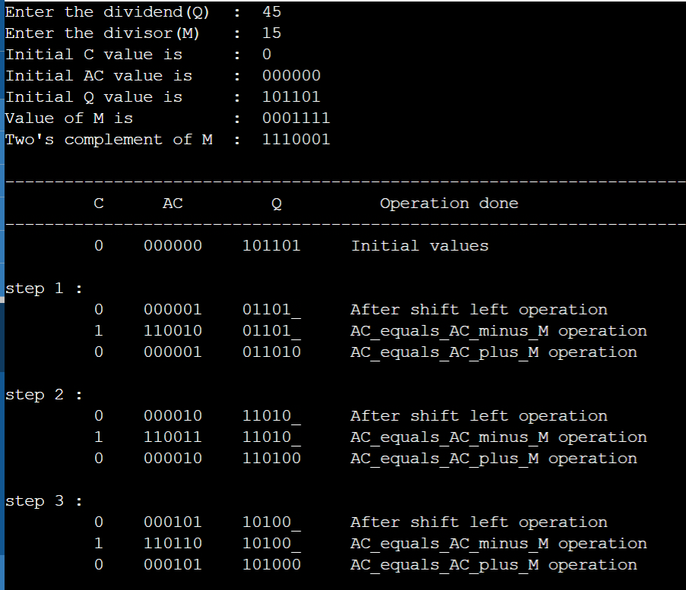

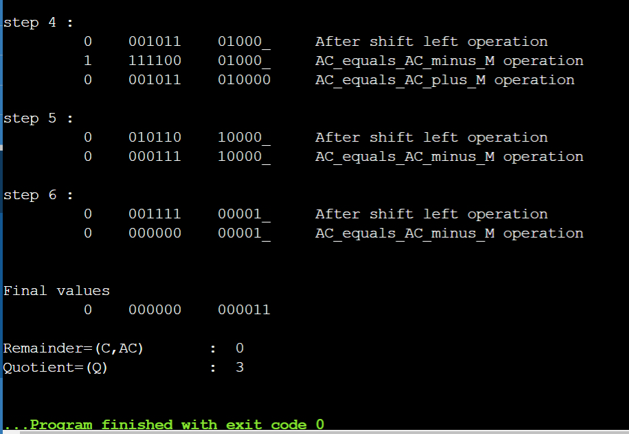

Input 2:

67/23

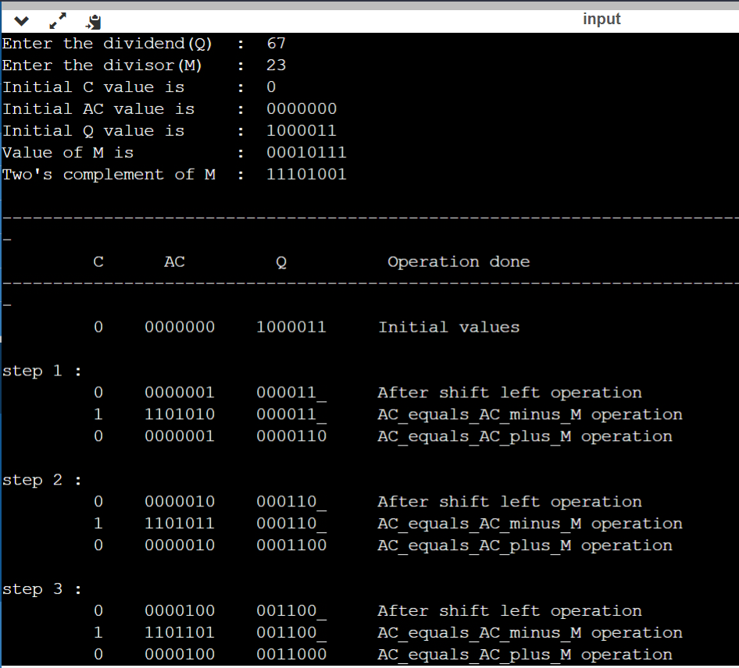

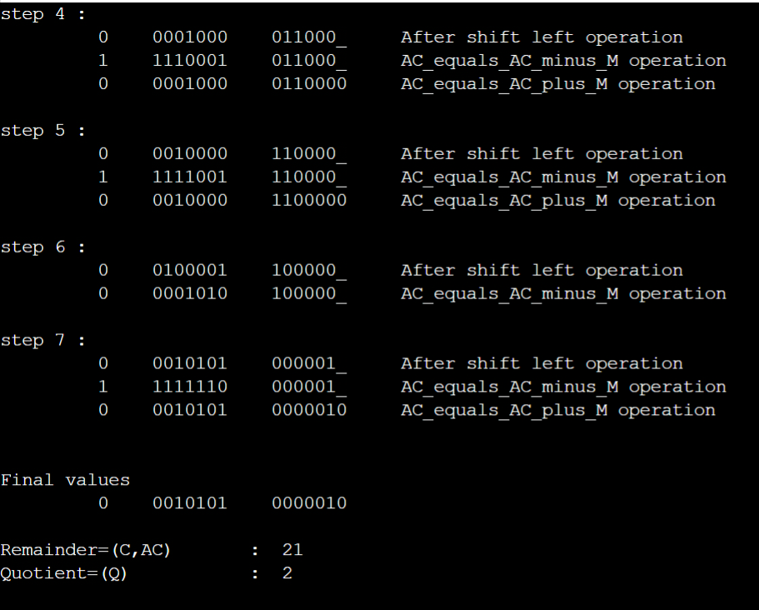

Conclusion:

We learnt about the restoring division algorithm with the help of flowchart and implemented it with the help of python.