**Name: Adwait S Purao**

**UID : 2021300101**

**Batch : B2**

**Direct Mapping**

**Code:**

import math as math

print("Enter size of Main Memory : ",end="")

Main_size = int(input())

print("Enter size of each Block : ",end="")

Block_size = int(input())

nu_blocks = int(Main_size/Block_size)

print("Number of blocks: %s"%nu_blocks)

print("Enter the size of Cache Memory : ",end="")

Cache_size = int(input())

numboflines = int(Cache_size/Block_size)

print("The number of lines in cache block is %s "%numboflines)

blockindex = math.log(nu_blocks,2)

print("Block index is %s"%blockindex)

cacheindex = math.log(numboflines,2)

print("Index of Cache memory is %s"%cacheindex)

print("Enter a number you want to check : ",end="")

numb = int(input())

numb = bin(numb).replace("0b","")

while(len(numb)!=blockindex):

numb = '0' + numb

print("The Number converted to binary",numb)

lsb = numb[2:]

print("Index where it would be mapped",int(lsb,2))

**Output:**

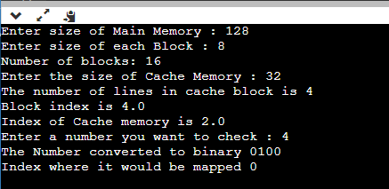

**Conclusion:**

In the above experiment we learnt about direct mapping technique of cache memory . In the end we implented the logic in python.