**NAME: ADWAIT S PURAO**

**UID: 2021300101**

**EXP NO. :2**

**AIM:** **To implement the circular queue functions**

**THEORY:** A Circular Queue is a special version of queue where the last element of the queue is connected to the first element of the queue forming a circle. The circular queue solves the major limitation of the normal queue. In a normal queue, after a bit of insertion and deletion, there will be non-usable empty space.

 It is also known as a **Ring Buffer**.

Operations on circular queue

* **Front:** It is used to get the front element from the Queue.
* **Rear:** It is used to get the rear element from the Queue.
* **enQueue(value):** This function is used to insert the new value in the Queue. The new element is always inserted from the rear end.
* **deQueue():** This function deletes an element from the Queue. The deletion in a Queue always takes place from the front end.

Applications on circular queue

* **Memory management:** The circular queue provides memory management. As we have already seen that in linear queue, the memory is not managed very efficiently. But in case of a circular queue, the memory is managed efficiently by placing the elements in a location which is unused.
* **CPU Scheduling:** The operating system also uses the circular queue to insert the processes and then execute them.
* **Traffic system:** In a computer-control traffic system, traffic light is one of the best examples of the circular queue. Each light of traffic light gets ON one by one after every jinterval of time. Like red light gets ON for one minute then yellow light for one minute and then green light. After green light, the red light gets ON.

**Initial condition , now queue is empty:**

Front =0, Rear=0

Front==Rear

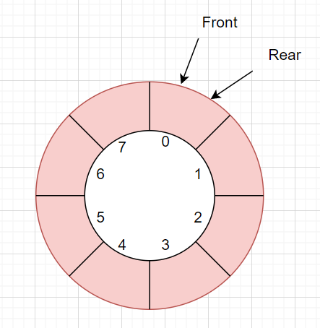

**Enqueue operation**

Check whether queue is Full or not

Increment rear by one

Insert element at index=rear

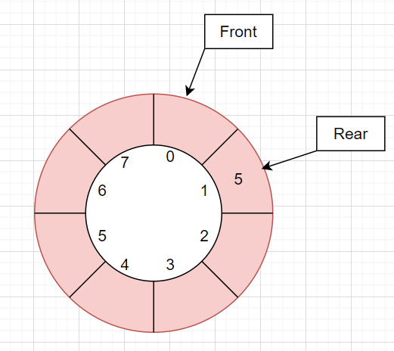

**Dequeue operation**

Check whether queue is empty or not

Increment front by one

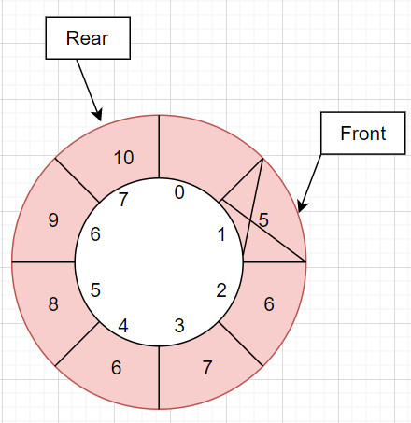

**Queue is Full:**

When (rear+1)%size==front

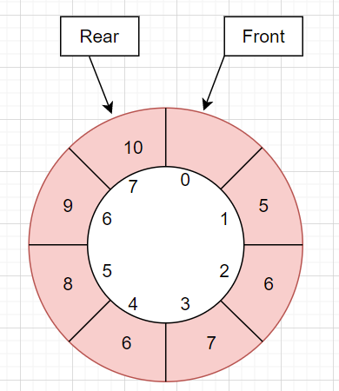

**ALGORITHM:**

**Class Queue:**

Data members:

Size, front, top

1) Queue constructor

Initialize size, array

And set front=rear=0

2) Boolean isEmpty() method

Return true if front==rear

3) Boolean isFull() method

Return true if (rear+1)%size == front

4) Void getRear() method

If Queue is not empty

print a[rear]

Else

Print Queue is empty

5) Void getFront() method

If Queue is not empty

Print a[(front+1)%size]

Else

Print Queue is empty

6) Void display() method

Initialize a new variable f to front

If Queue is not empty

While f is not equal to rear

f=(f+1)%size

print a[f]

Else

Print queue is empty

7) Void Enq(int element) method

If Queue is Full

Print Overflow State

Else

rear=(rear+1)%size

Insert element at index rear

Print Enqueued element

8) Void Deq() method

If Queue is empty

Print Underflow state

Else

Print Dequeued a[(front+1)%size]

front=(front+1)%size

**Class DSA_EXP_2:**

1)Main method

Take input n the size of the Queue

Create an object q of class queue

Initialize flag to zero

Do while flag is not equal to 1

Print the menu

Take the choice as input in variable ch

Switch(ch)

Case 1:

Take input the element you want to enqueuer

Call the Enq method from queue class

Show the current status of Queue

Call the display method of the queue

Case 2:

Call the Dequeue method of the queue class

Show the current status of Queue

Call the display method of the queue

Case 3:

Show the current status of Queue

Call the display method of the queue

Call the getFront method to show the Front-most element

Case 4:

Show the current status of Queue

Call the display method of the queue

Call the getRear method to show the Rear-most element

Case 5:

Print program finished

Set flag to 1

Default case:

Print invalid choice

**PROBLEM SOLVING ON CONCEPT:**

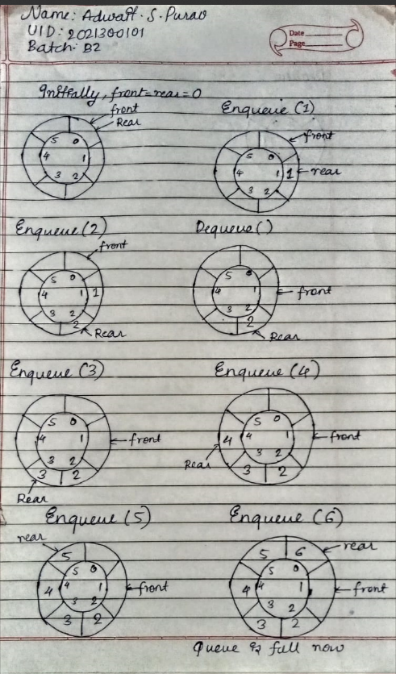

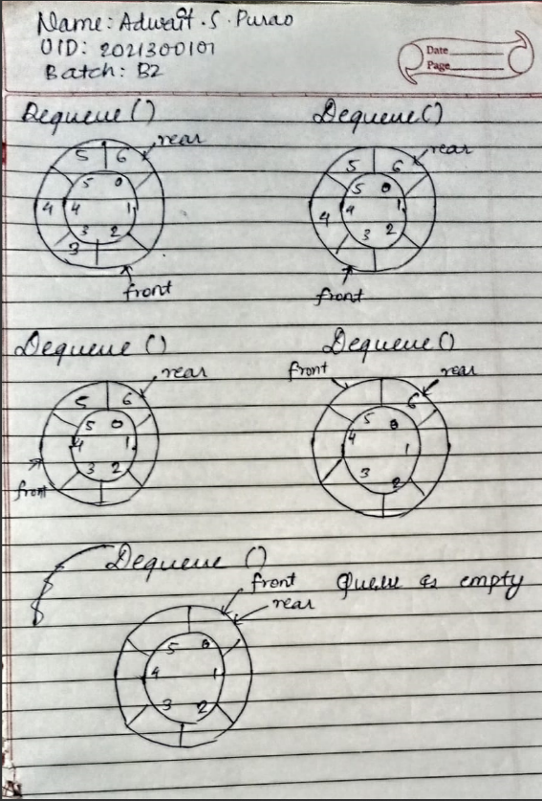

**CODE:**

import java.util.\***;**

import java.util.\***;**class Queue{  
 int rear**;** int front**;** int [] a**;** int size**;** Queue(int size){  
 this.size=size**;** this.front=**0;** this.rear=**0;** this.a=new int[size]**;** }  
 void Deq(){  
 if(isEmpty()){  
 System.*out*.println("Underflow State")**;** }  
 else {  
 System.*out*.println("Dequeued:" + a[(front+**1**)%size])**;** front=(front+**1**)%size**;** //%size is done to avoid going beyond the length of queue  
 }  
 }  
  
  
 void Enq(int element){ //Enqueue operation  
 if(isFull()){  
 System.*out*.println("Overflow state")**;** }  
 else {  
 rear=(rear+**1**)%size**;** //%size is done to avoid going beyond the length of queue  
 a[rear] = element**;** System.*out*.println("Enqueued:" + element)**;** }  
 }  
  
 void getFront(){  
 if(!isEmpty()){  
 System.*out*.println(a[(front+**1**)%size])**;** }  
 else if(isEmpty()){  
 System.*out*.println("Queue is Empty")**;** }  
 }  
  
 void display(){  
 int f=front**;** if(!isEmpty()){  
 while(f!=rear){  
 f=(f+**1**)%size**;** System.*out*.print(a[f]+" ")**;** }  
 }  
 else{  
 System.*out*.println("Queue is empty")**;** }  
 }  
  
 void getRear(){  
 if(!isEmpty()){  
 System.*out*.println(a[rear])**;** }  
 else if(isEmpty()){  
 System.*out*.println("Queue is Empty")**;** }  
  
 }  
  
 boolean isEmpty(){  
 return front==rear**;** }  
  
 boolean isFull(){  
 return (rear+**1**)%size==front**;** }  
}  
public class DSA_EXP_2{  
 public static void main(String [] args){  
  
 Scanner sc=new Scanner(System.*in*)**;** System.*out*.println("Enter the size of the Queue")**;** int n=sc.nextInt()**;** Queue q=new Queue(n)**;** int flag=**0;** do{  
 System.*out*.println()**;** System.*out*.println("Menu")**;** System.*out*.println("1)Enqueue")**;** System.*out*.println("2)Dequeue")**;** System.*out*.println("3)Tell the Front-most element")**;** System.*out*.println("4)Tell the Rearmost element")**;** System.*out*.println("5)Exit")**;** int ch=sc.nextInt()**;** switch (ch) {  
 case **1** -> {  
 System.*out*.println("Enter the element you want to enqueue")**;** int element = sc.nextInt()**;** q.Enq(element)**;** System.*out*.println("Status after performing Enqueue operation")**;** q.display()**;** }  
 case **2** -> {  
 q.Deq()**;** System.*out*.println("Status after performing Dequeue operation")**;** q.display()**;** }  
 case **3** -> {  
 System.*out*.println("Current Status")**;** q.display()**;** System.*out*.println()**;** System.*out*.println("The Front most element is ")**;** q.getFront()**;** }  
 case **4** -> {  
 System.*out*.println("Current Status")**;** q.display()**;** System.*out*.println()**;** System.*out*.println("The Rear most element")**;** q.getRear()**;** }  
 case **5** -> {  
 System.*out*.println("Program finished")**;** flag = **1;** }  
 default -> System.*out*.println("Invalid choice")**;** }  
  
 }while(flag!=**1**)**;** }  
}

**OUTPUT SCREENSHOT:** 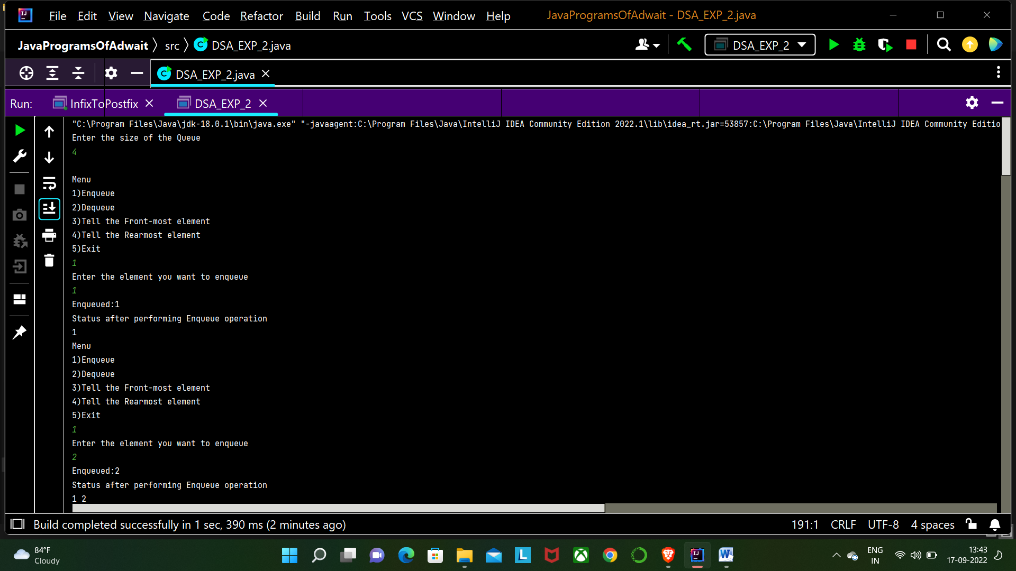 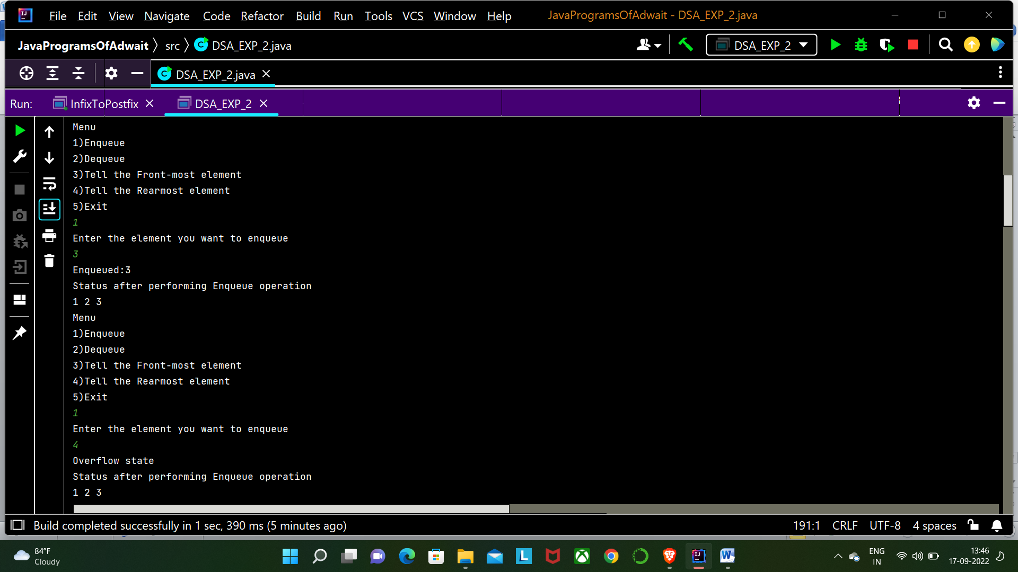 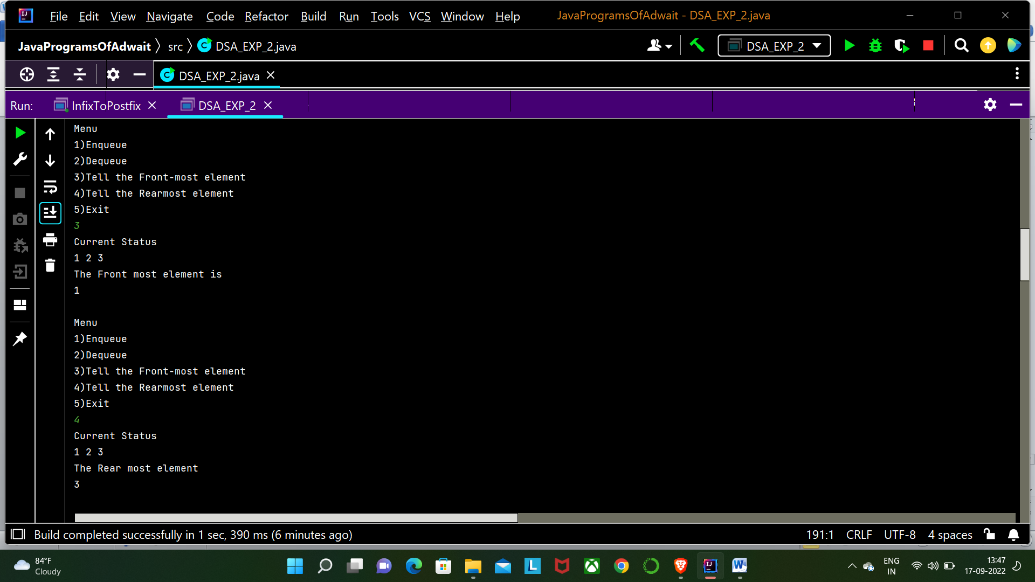 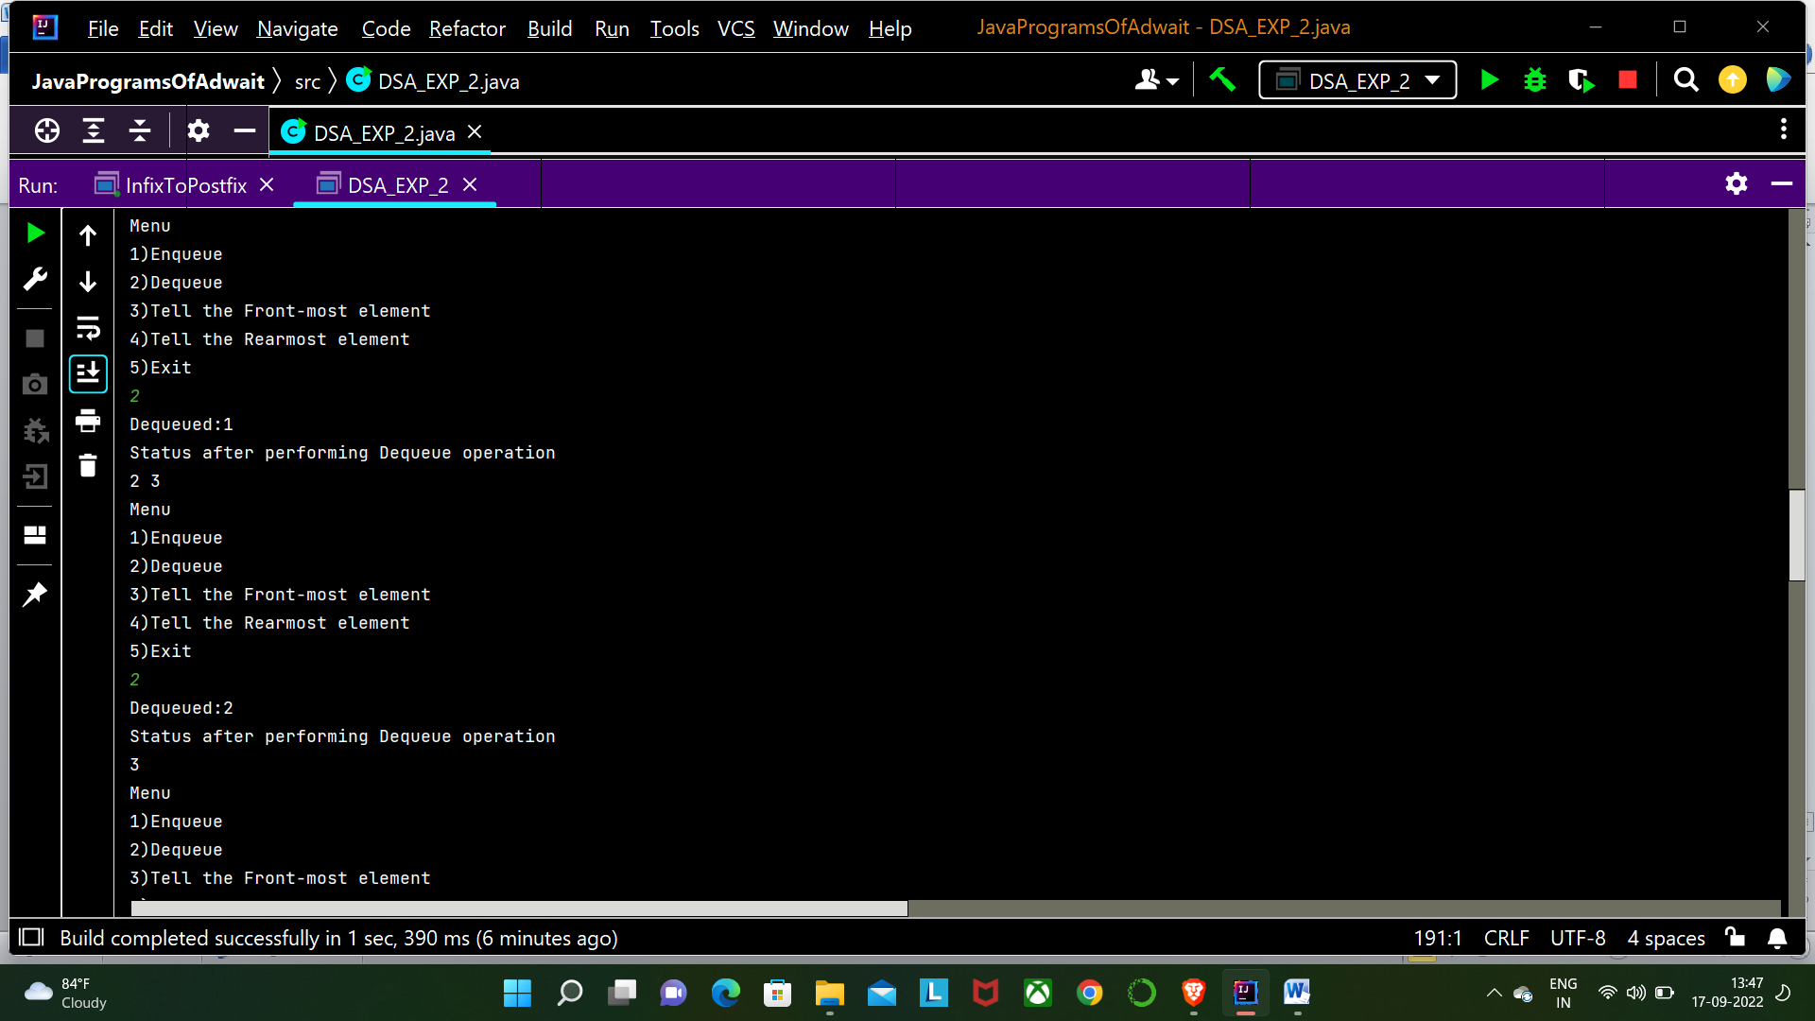 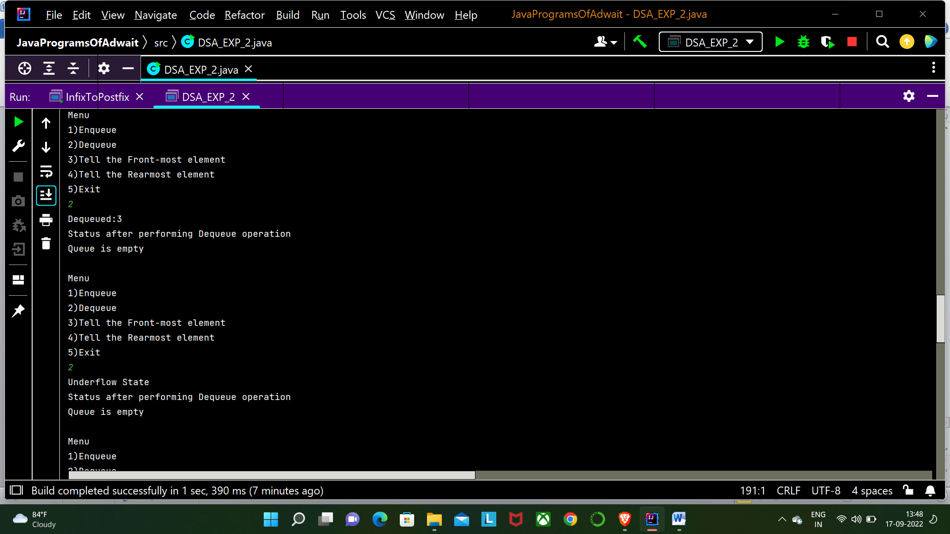 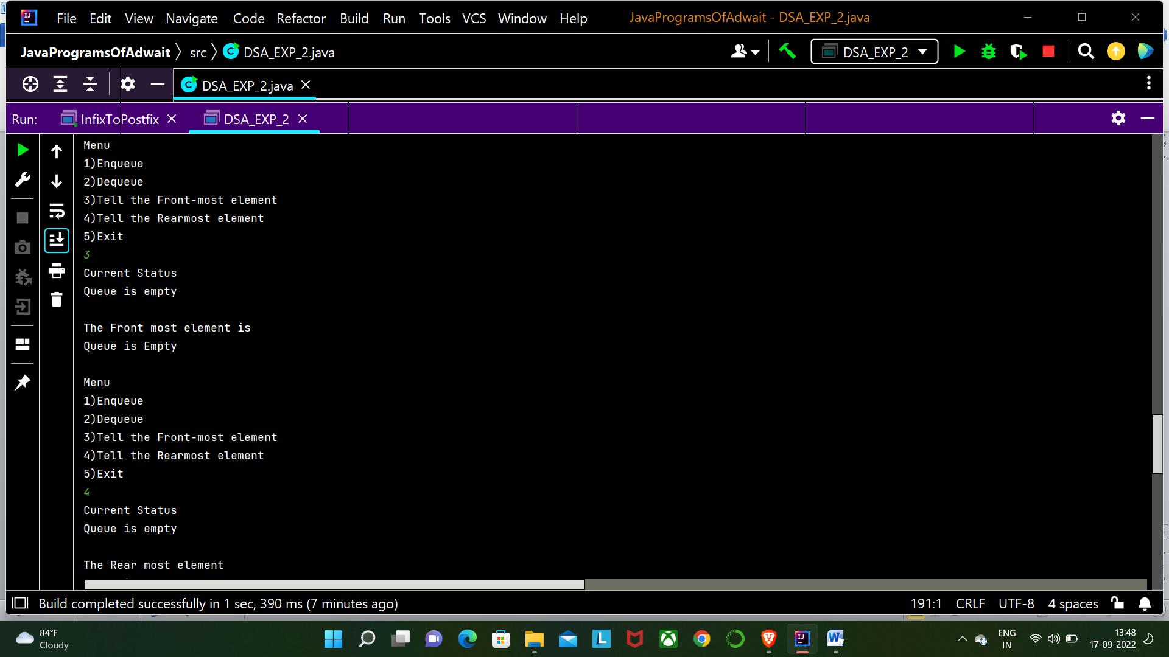 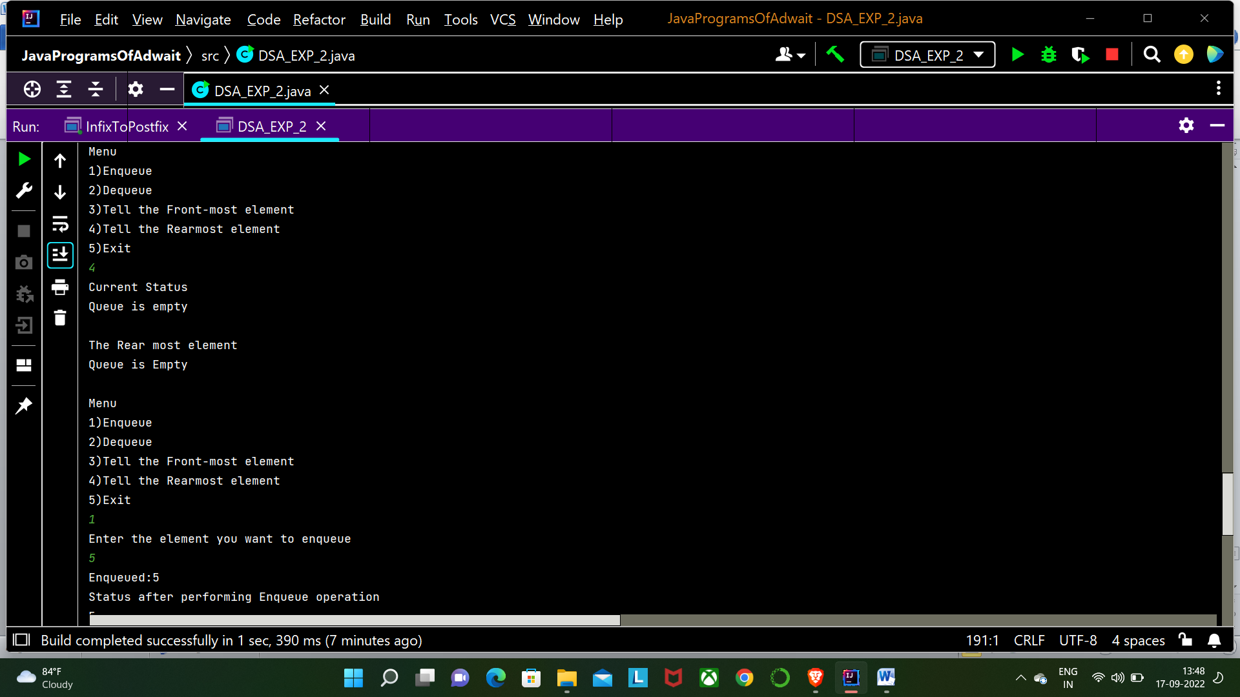 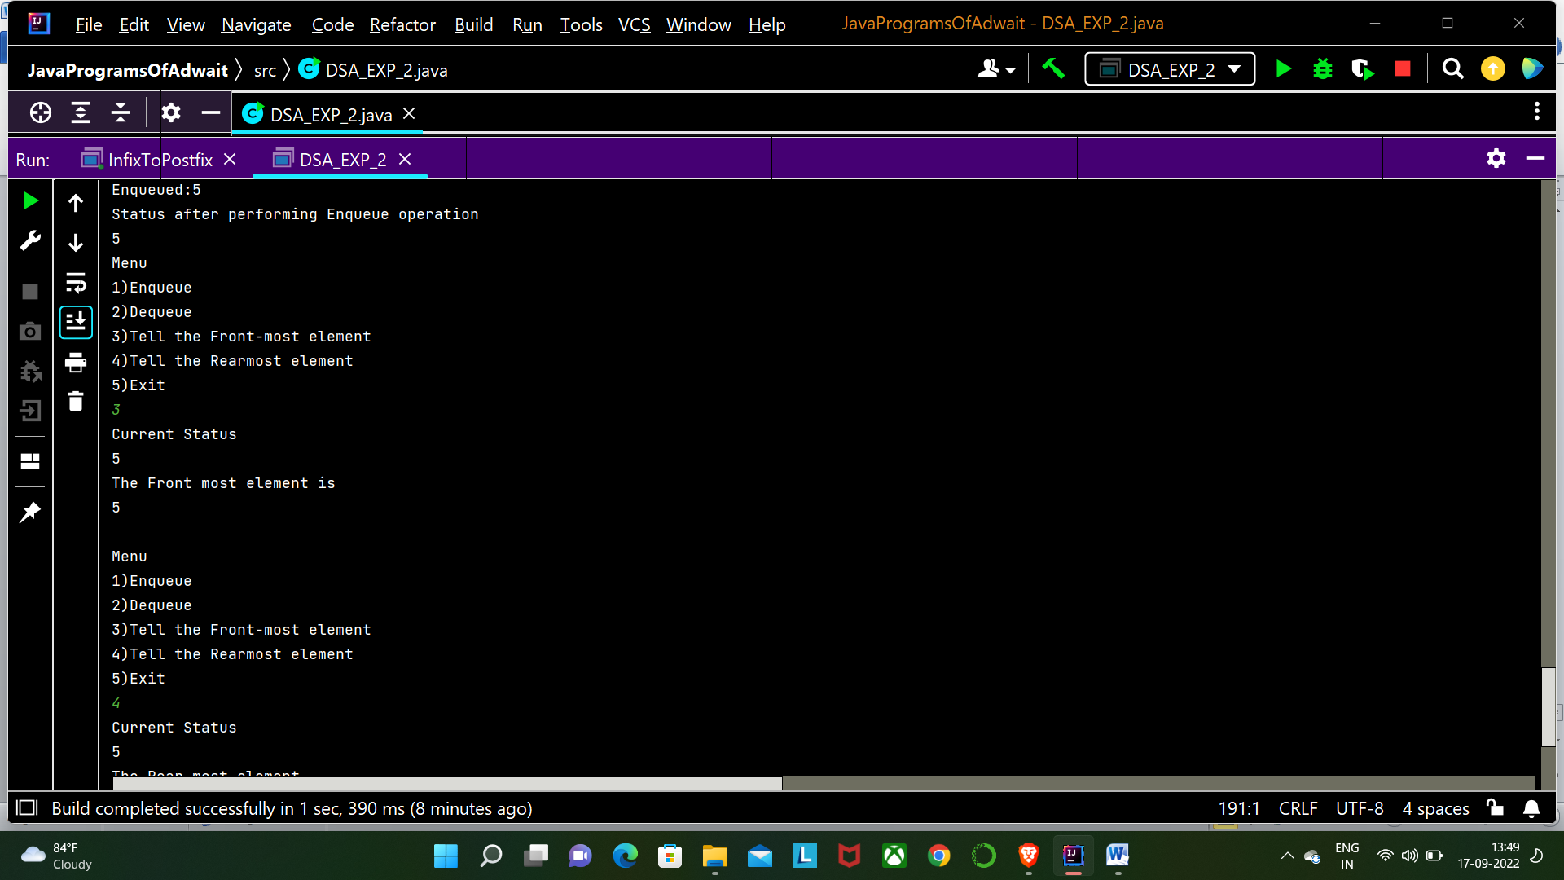 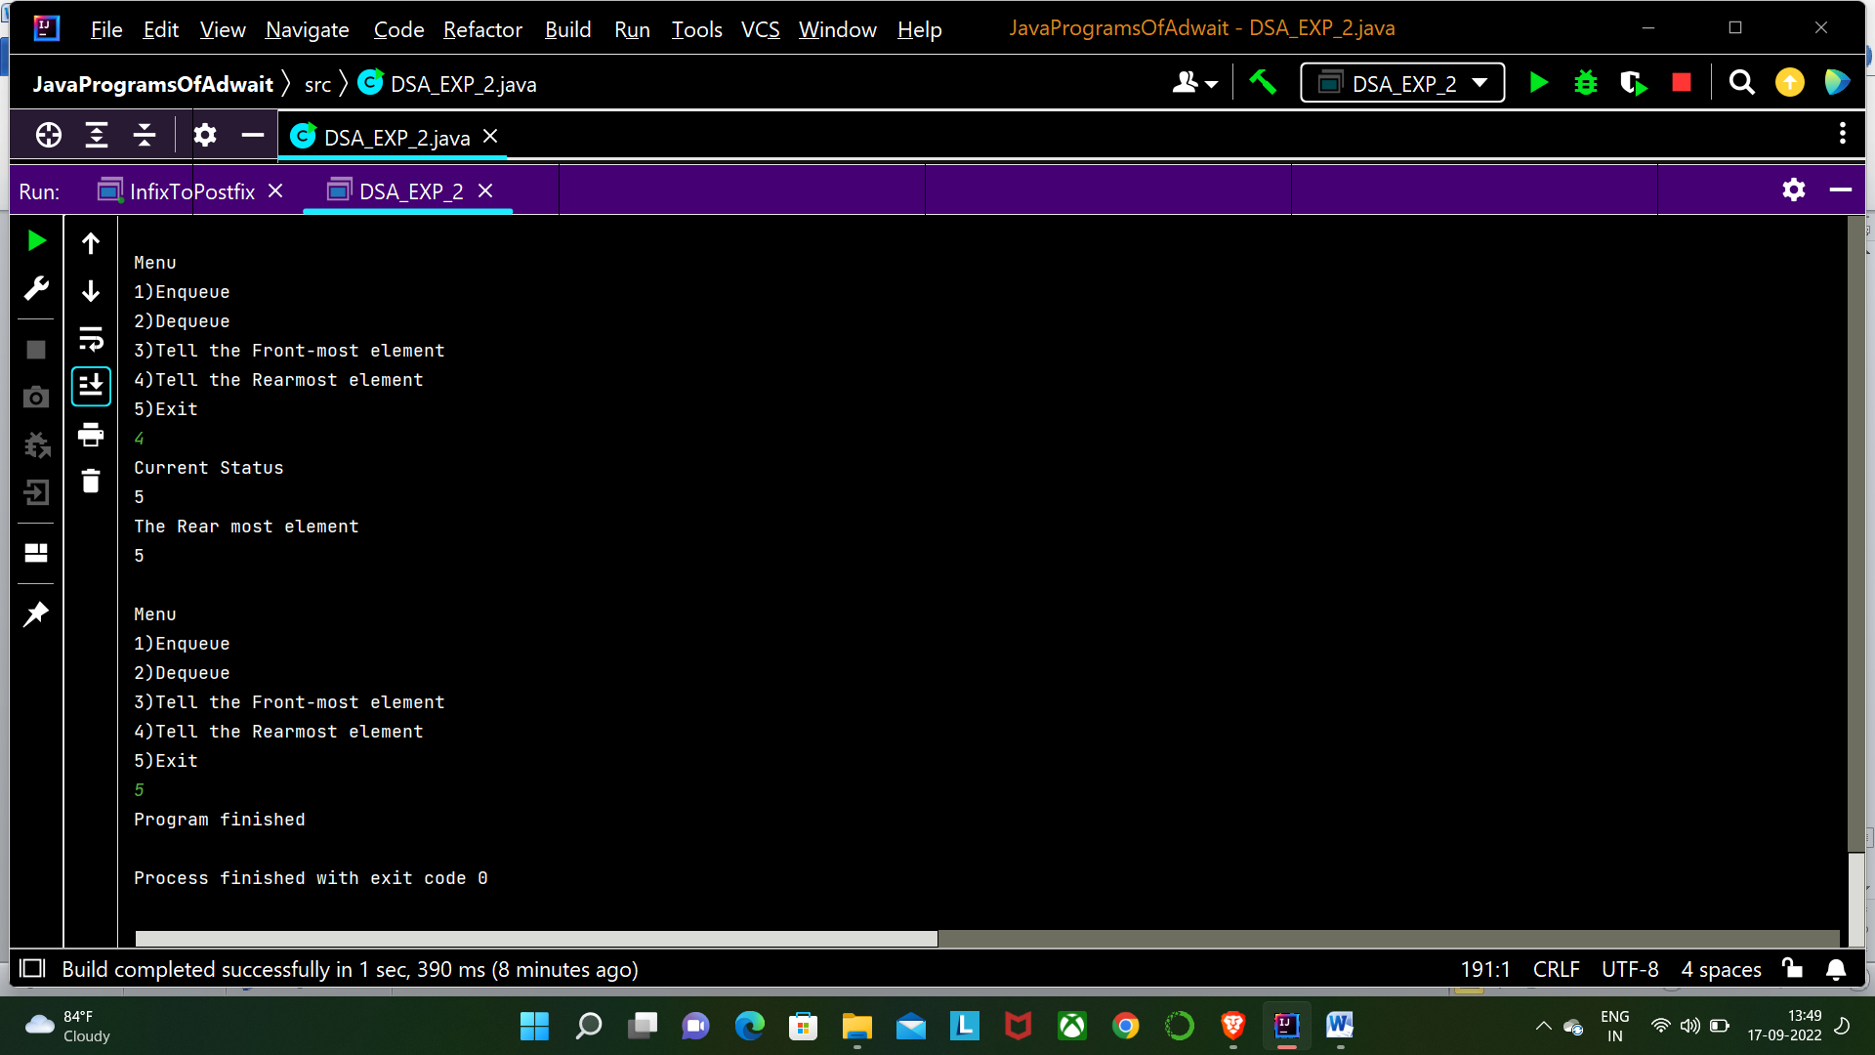

**CONCLUSION:** In this experiment we learnt about the circular queues. We learnt their advantages over the normal queues i.e. they save space and are reusable. We performed the Enqueue, Dequeue , getFront and getRear operations on the queue with a menu driven program. But in circular queue one space is always wasted which is more preferred than wasting a lot of memory using normal queues.