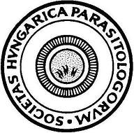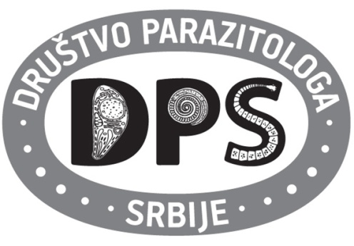

**SECOND BILATERAL HUNGARIAN AND SERBIAN PARASITOLOGY SOCIETIES**

**MEETING**

October 14, 2016

Venue: **Szeged Zoo, Learning Center**

**PROGRAM:**

10:00-11:30 Get together and refreshment

11:30-13:30 Round table

**Introductory presentations and moderators:**

**Róbert Farkas and Olgica Djurković-Djaković**

1. **Róbert Farkas,** President of the Hungarian Society for Parasitology: **Current information about teaching and research in veterinary parasitology in Hungary**
2. **István Kucsera,** member of the board of theHungarian Society for Parasitology: **Some information about human parasitology in Hungary**
3. **Olgica Djurković-Djaković*,*** President of the Serbian Society for Parasitology: **Parasitology teaching and research in Serbia. SWOT analysis**

**Scientific lectures**

1. **Snežana Tomanović***, Institute for Medical Research, University of Belgrade, Serbia:* **Medical entomology in Serbia. Wild animals as hosts for anthropophilic tick species**
2. **Sándor Szekeres***, University of Veterinary Medicine Budapest, Hungary:* **Tick-borne pathogens in Hungary: Rural vs urban habitats**

13:30 Lunch and visit of the ZOO

18:00 End of meeting