Q1)

Q2)

Accepted = 1) ab

2) abb

3) abbb

Not Accepted = 1) ac

2) ca

3) bc

Q3) Epsilon is not accepted as the initial state is not an accepting state (not the final state) and it needs to read letters to reach the final state.

Q4) By following the subset contradiction, i will create the transition table for A and then the new transition table which will help construct the DFA.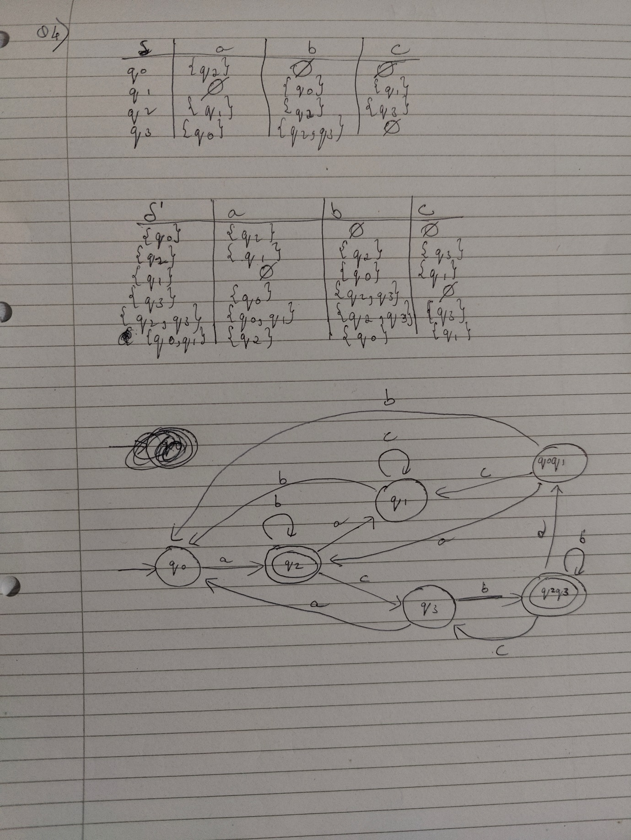

Q5)

By following the marking table construction, there are no dead states, and all pairs were marked so the DFA A is already minimal.

Q6)

The CFG for FSA A is:

Q7)

A language L is considered regular if it can be defined by a finite state automation or an regular expression. In this case since w belongs to L(A) and L(A) is regular so all the elements in L are also regular. Even though L can have at most a length of 42 it is regular as L is essentially a subset of L(A) with an additional rule.

Q8)

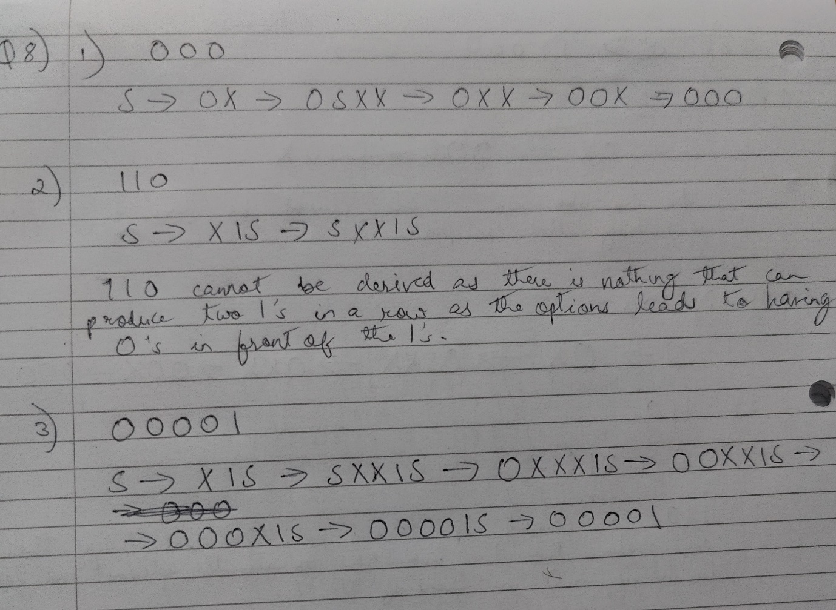

Q9)

Q10)

The grammar G is not in Chomsky normal form (CNF) because it contains a rule of the form S → X1S. This rule expands a nonterminal (S) to a sequence of a nonterminal (X), a terminal (1), and another nonterminal (S). This structure doesn't conform to any of the three allowed forms in CNF.

Q11)

