# **Parents and Heirloom**

Fin grew up mostly with his father. Didn’t see his mom that much, but he loved her nonetheless. Knew that she was busy with the work that she did in the army and that was enough to inspire him. For as long as he remembers, he has had a necklace (initiative one), gifted by his parents, with the following symbol etched into it.

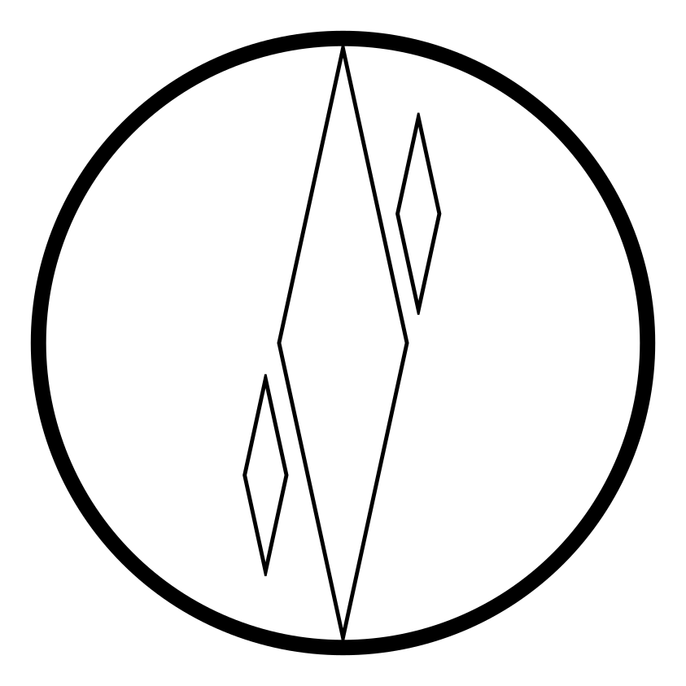

He knew there was something behind that necklace. Each morning he got up and put it on, he felt a bit more aware of his surroundings. Felt like he could react faster. Sense danger to a degree. The only thing he was told was to not flash it in public that much.

# Valgrum

He was born and spent his life in the city of Valgrum, the capital of the **United Empire**, spanning the whole **Valgrum Continent**, mostly the Earth District (see image below), but occasionally visiting the Outer Settlements. He knew the city well, but did not spend that much time in the Sky and Water Districts. They were for the richest humans after all… The Holy District was off-limits to anyone but the higher-ups.

Valgrum layout (from left to right) – Earth, Outer Settlements, Sky, Water, Holy District

The **Earth District** was the poorest. This does not necessarily mean that life was bad, but compared to the other districts, it looked a bit malnurished. All of the entrances are in the Earth District. Common for all districts is the very frequent temples, establishments of the **Church of the Eternal**. Speaking of which, the church’s guards and priests constantly patrol the streets, making sure no crime goes unpunished.

The fun stuff, is in the **Outer Walls District**, or the **Outer Settlements**, as some call them. People gather around the huge walls of Valgrum city so that they can receive even a little bit of the convenience and safety it offers, hoping that one day, they will step into the city as citizens themselves. It is here, in the Outer Walls, that fin started his little adventure, getting stoned in the **Pretty Bog** tavern.

The **Sky District** is where the richest people in Valgrum live. This part is built at the root of the Valgrum Mountains. Rising upwards, the farther from the center, the higher the houses are.

The **Water District** is also a rich district. The only difference between this and the Sky district is that this one is flat and has water canals.

The **Holy District** is at the center of the city. Nobody is allowed here and the only information available to the public is that the emperor, his family and the highest members of the church live and work here. They operate in secrecy and as far as everyone knows, nobody has seen their faces, or exchanged words with them.

# Church of the Eternal

The faith in the so called Eternal, brings with it some restrictions to the people who practice it.

* All races are considered inferior to humans, as the Eternal was human themself.

* Chicken meat is forbidden for consumption.

* Tobacco (and cigarettes) is not allowed.

* All non-believers are to be saved, preached on and if ultimately do not convert, will suffer the Eternal’s wrath.

There may be more restrictions, but Finn is not aware of them.

# **Passing of his mother**

When Finn was around 20 years old, approximately 15 years before today, his father received the grim news of his mother’s passing. It was his father that had a talk with him about these news before losing himself to alcohol due to not being able to cope with that loss. All he told Finn, was that his mother was a hero of war and that they should be proud of her.

# The War

Not much is known to the commonfolk about the war. It has been a topic since Finn was a little boy. Still is. Troops are regularly being sent through the Earth District outside, most probably on missions. Sometimes returning with less, sometimes with the same number of members and sometimes with new faces, people, soldiers.

# The Temple in the Forest

During Finn’s adventure time (heh), the temple he rebuilt he remembers to this day. During it’s reconstruction / cleaning, he has noticed the following symbol on multiple places, including above the front door.

