**Table of Contents**

Intro 2

Rules of Nature 2

The Balance 3

What each Eidolon stands for 4

The Eidolon-touched 5

The Arcanists 5

# Intro

After being taken in by the Arcanists, Norren learned quite a lot under their tutelage. In parallel, he continued his search for any survivors from the tragic day, but to no avail. What his feelings are about the things he learns in his future years are up to you to decide…

# Rules of Nature

**Disclaimer**: This is not D&D canon and differs from the source materials. Read – homebrewed as part of the custom world.

One of the first things he learns is how the strongest forces of nature in the world work. He learns about spells and what fuels them. The surrounding energy, borrowed and returned in full to beings that represent concepts and elements.

To put it simply, these few supreme creatures are the ones that grant magic.

A bit more complicated explanation would that their energy lingers in the world, gets borrowed by spellcasters and once used, it returns to the being, making it more powerful.

## The Balance

There is a total of 11 such known beings, called Eidolons. Most of them, form a complex system, called the Balance, keeping each other in check and retaining the millennial status quo, “allowing” people to live in peace.

The Balance was formed around 1000 years ago, after a bloody and nearly cataclysmic war that lasted for centuries.

The following picture represents the Balance.

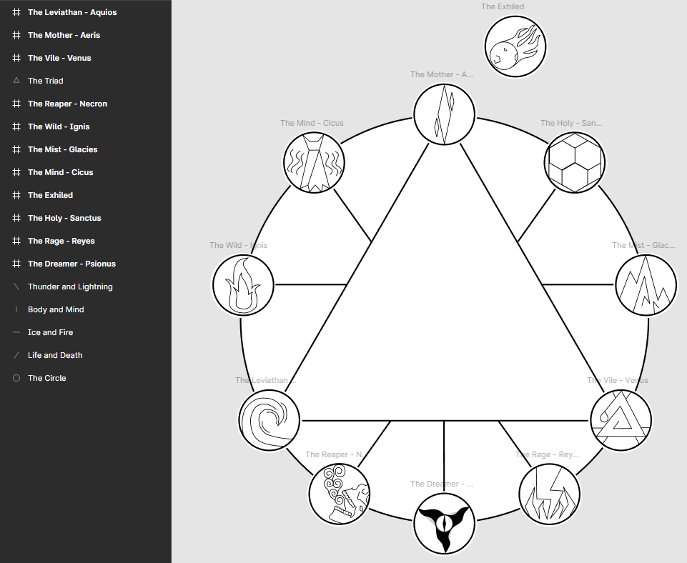

**Note**: These symbols can hold great power if one makes a deal with an Eidolon and their personality is aligned with what the Eidolon stands for. However, simply drawing a symbol has no effect. Such a symbol is only granted by an Eidolon.

## What **each** Eidolon stands for

Mother

- care, love, protection

Holy

- order, honor, truth

Mist

- secrets, stealth, agility

Vile

- deception, betrayal, malice

Rage

- aggression, rage, manipulation

Dreamer

- dreams, hallucinations, illusions

Reaper

- death, deals, research

Leviathan

- balance, justice, loyalty

Wild

- pride, freedom, independence

Mind

- knowledge, calmness, reason

# The Eidolon-touched

When huge amounts of stray / wild energy lingers in one place, the risk of an Eidolon-touched creature to appear increases. Any living creature that comes into contact with this energy can be fully changed and gain enormous power.

Most often, due to a lack of intellect, this causes great destruction and loss of innocent lives in the vicinity.

On the other hand, when a humanoid being willingly or not, receives great amounts of such energy, there is a possibility of a champion being created. These are the Eidolons’ right hand men and do their bidding on the worlds surface, increasing their influence and power.

# The Arcanists

Our motto is to put a stop to this vicious cycle. We strive to use the energy left by the Eidolons, but without the parts where the energy returns to them, they get more powerful and cause more mayhem by turning living beings into elemental monsters.

We do mercenary work and gather resources which we put to good use – research about understanding these natural energy flows. The final goal – absolute control of this energy by the hands of the people.

**Important note – Classified Organization Knowledge:** This knowledge and motivation is not and should not be shared with all members of the organization. Depending on their intellect, some of these things are kept secret and some members are kept on the edge of the organization, knowing little of these things and mostly doing mercenary work, without a specific reason except doing a good deed and getting paid.