EOG-Based Calculator
SC_08

2022170151 | SC | رشا عبد الخالق عبد الحميد ابو خليفه
2022170141 | SC | دارين حسام الدين علاء الدين الجندى
2022170148 | SC | رحمه احمد احمد عزت
2022170069 | SC | الحسن محمد مصطفى حامد
20201700525 | SC | عمر احمد محمود حسين

1. Project Overview
This project implements a Human-Computer Interface (HCI) driven entirely by Electrooculography (EOG) signals. Which measures the standing potential between the cornea and retina of the human eye as the eye moves . this potential changes and can be captured by electrodes placed around the eye. The recorded signals a horizontal channel (H) and a vertical channel (V) are processed , classified and mapped to calculator inputs allowing a user to operate a one-digit calculator using only eye movements and blinks.
The five supported eye-movement classes are:
- Up (Yukari) – upward gaze
- Down (Asagi) – downward gaze
- Right (Sag) – rightward gaze
- Left (Sol) – leftward gaze
- Blink (Kirp) – voluntary eye blink for selection

The signal acquisition was performed at a sampling frequency of 176 Hz.The classification pipeline compares three feature extraction strategies : Discrete Wavelet Transform (DWT), Autoregression (AR) coefficients andmorphological features then into a Support Vector Machine (SVM) classifier.

2. Data Preparation & Preprocessing

2.1 Dataset Structure
The dataset consists of text files named using the convention <movement><trial><channel>.txt (e.g., yukari1v.txt, yukari1h.txt). For each of the five classes . The files are loaded in matched pairs (H, V) to ensure channel alignment.

2.2 Train / Test Split
K-Fold cross-validation scheme with k = 5 folds is used. In each fold approximately 80 % of samples per class are used for training and 20 % for validation.

Split | Samples per Class | Percentage
Training | 16 | 80%
Validation | 4 | 20%

2.3 Preprocessing Pipeline
Each raw EOG signal is passed through a three-stage preprocessing pipeline before any feature extraction.

Stage 1 – DC Removal decision
A DC removal decision plot was generated comparing 4 versions of the same signal: raw, bandpass only, DC removal only, and DC removal followed by bandpass. Visual inspection showed that the bandpass-only output and the full pipeline output were virtually identical for both the vertical and horizontal channels. This confirms that the 0.5 Hz lower cutoff of the Butterworth bandpass filter already removes the DC component making a separate DC removal step redundant. DC removal was removed from the final preprocessing pipeline which consists of bandpass filtering only followed by the remaining stages.
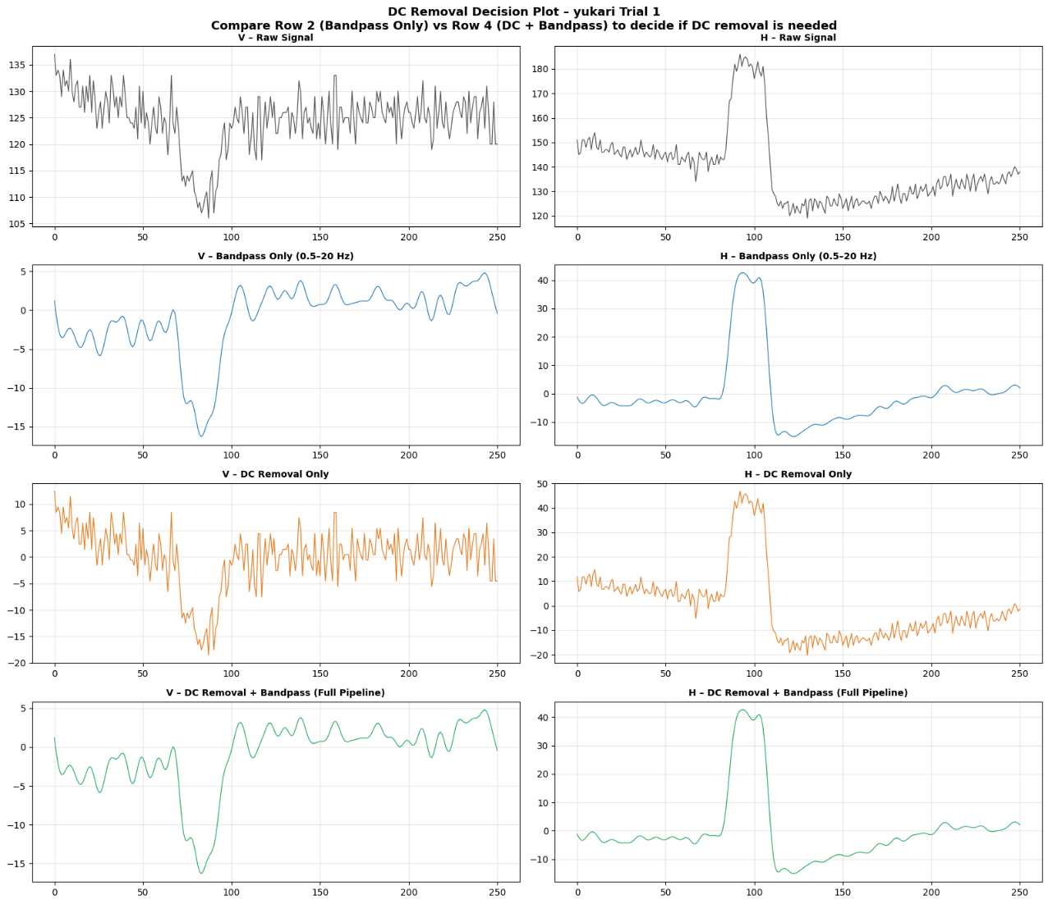

Figure 1 – DC removal decision

Stage 2 – Butterworth Bandpass Filter (0.5 – 20 Hz, order 4)
A 4th-order Butterworth bandpass filter with a passband of 0.5–20 Hz is applied.with cutoff (0.5 Hz) The upper cutoff (20 Hz) eliminates high-frequency noise such as EMG artefacts from facial muscles and environmental noise.
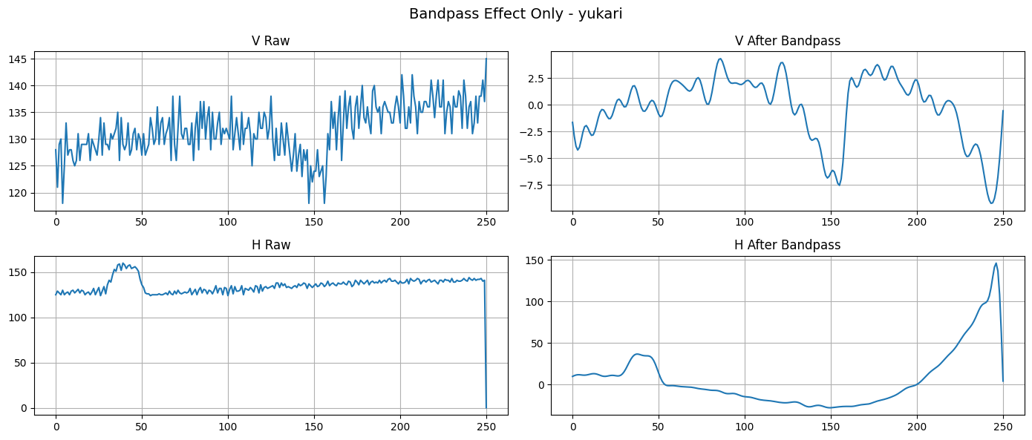
Figure 2 – before and after Bandpass[0.5,20]

Stage 3 – Signal-Type Selection (H or V)
For each of the five movement directions, a binary grid search is run separately on the horizontal (H) signal and the vertical (V) signal. The signal type that yields the higher positive-class F1-score for that direction is selected as the input to the final classifier. Each direction therefore uses only one channel — either H or V — not both.
.

3. Feature Extraction Methods
Three feature extraction methods are compared

3.1 Discrete Wavelet Transform (DWT) Features
DWT decomposes at A 4-level using three Daubechies wavelets — db1 (Haar), db2, and db4 — to allow a comparative evaluation of wavelet choice on classification accuracy.
Before applying DWT, an FFT analysis was performed on the preprocessed signals for all five classes. all meaningful signal energy is concentrated below 22 Hz across every class. This confirmed that the two highest-frequency sub-bands from the decomposition (cD1: 44–88 Hz and cD2: 22–44 Hz) contain no useful information after the 20 Hz bandpass filter and can be safely discarded leaving only cA4, cD4, and cD3 for feature extraction.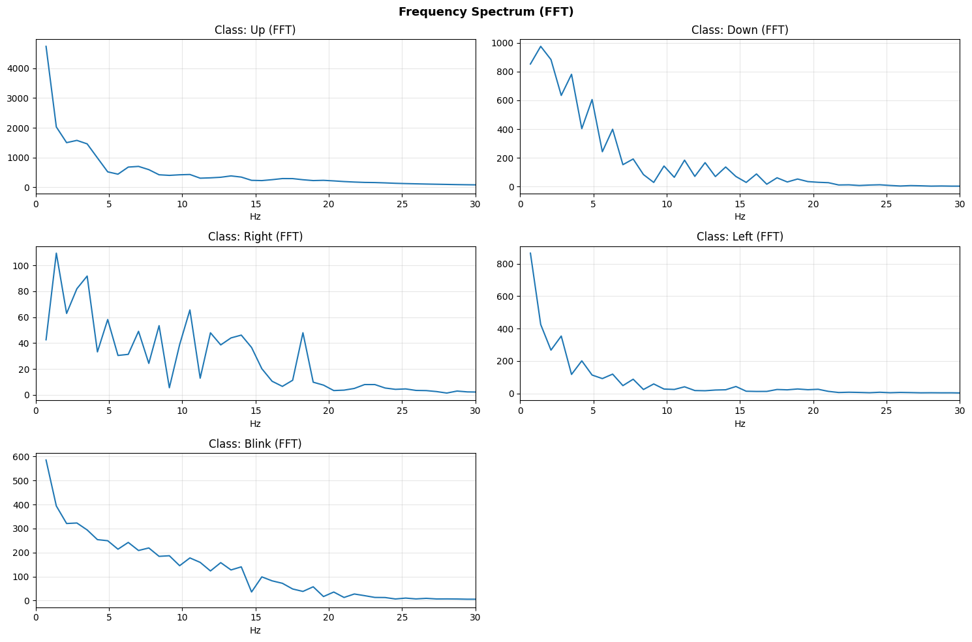
At a sampling frequency of 176 Hz, the four-level decomposition produces the following sub-bands:

Sub-band | Frequency Range (Hz)
cA4 (approximation) | 0 – 5.5
cD4 (detail level 4) | 5.5 – 11
cD3 (detail level 3) | 11 – 22
cD2 (detail level 2) | 22 – 44
cD1 (detail level 1) | 44 – 88
Table 2 – DWT at fs = 176 Hz
Only the three bands (cA4, cD4, cD3) are retained and 4 statistical features are extracted: energy (mean squared amplitude), mean, standard deviation, and maximum absolute value. This returned a 12-D feature vector per trial per wavelet.

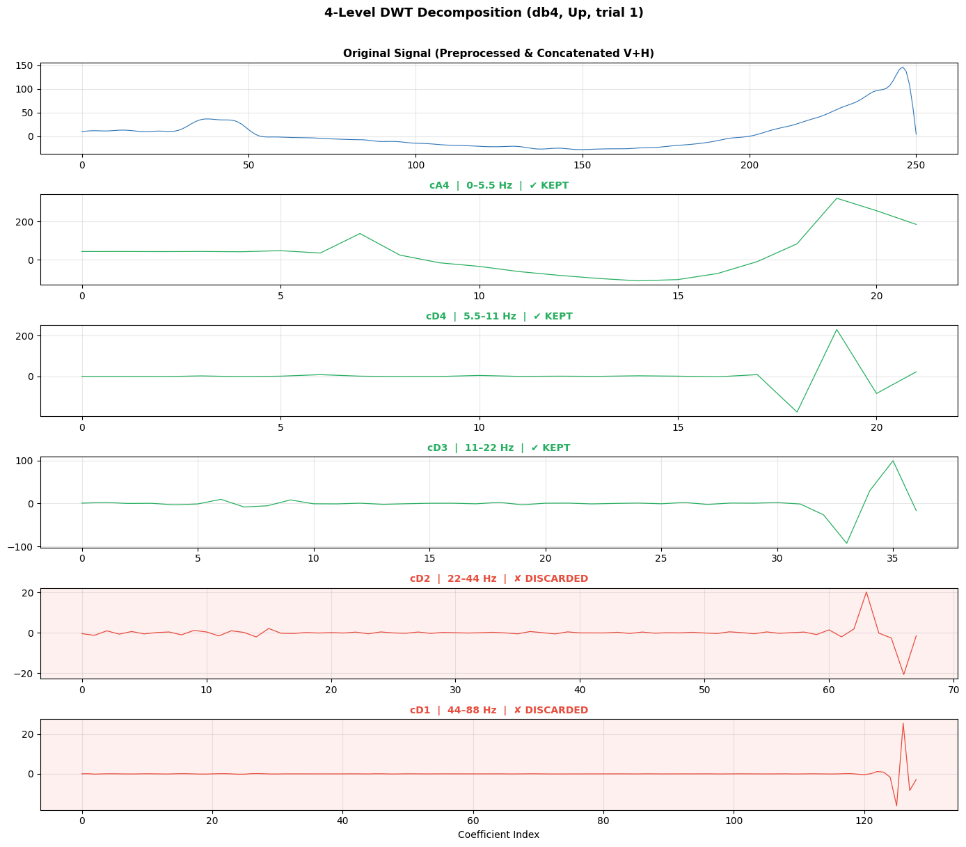
cD4 for db1 vs db2 vs db4 — shows how wavelet smoothness changes the representation
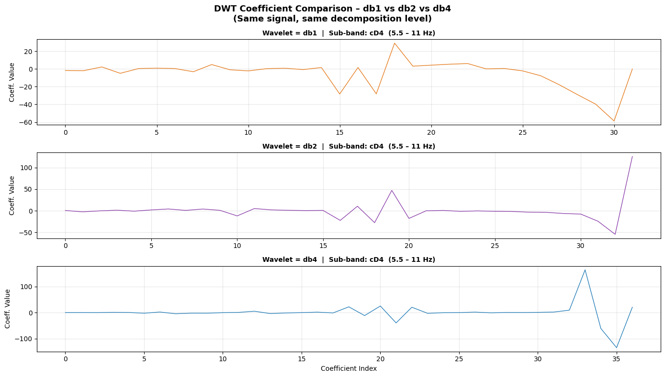

Autoregression (AR) Coefficient Features
To determine the appropriate model order, the Autocorrelation Function (ACF) was analyzed for all trials across all five classes.the plots indicate that 6 lags are sufficient to capture the temporal dependencies in the EOG signal so AR order 6 was selected.
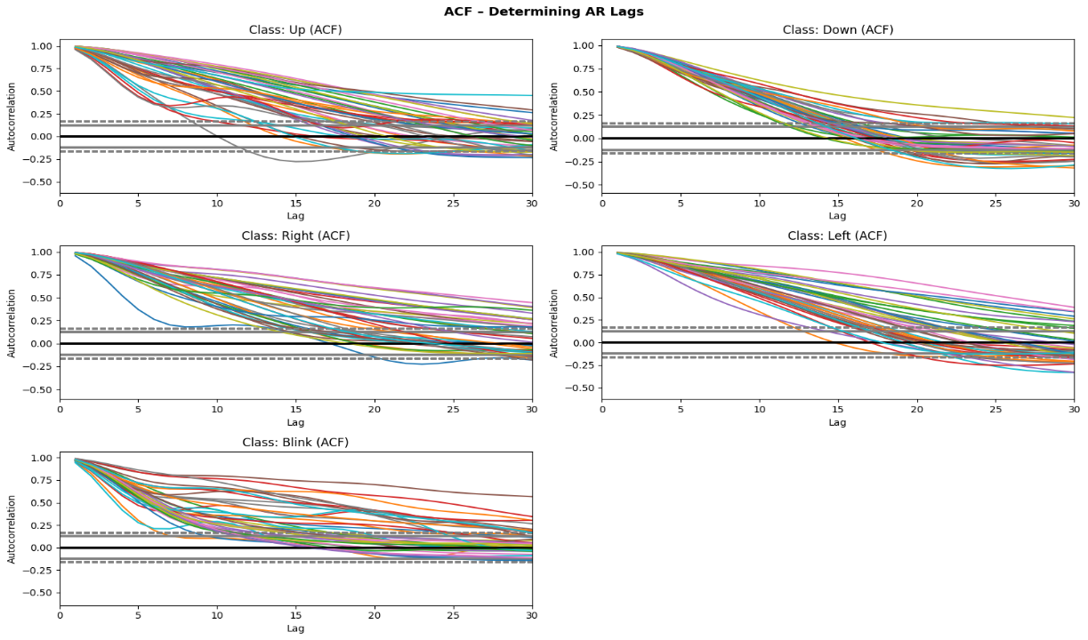
AR of order = 6 produced 7 output includes: 6 lag coefficients , 1 intercept.
The Autocorrelation Function (ACF) was analyzed to choose the AR at lag 6 .The reconstructed signal closely matched the original signal while the residuals were small and centered around zero . Each AR(6) model produced 7 features: 6 lag coefficients and 1 intercept.
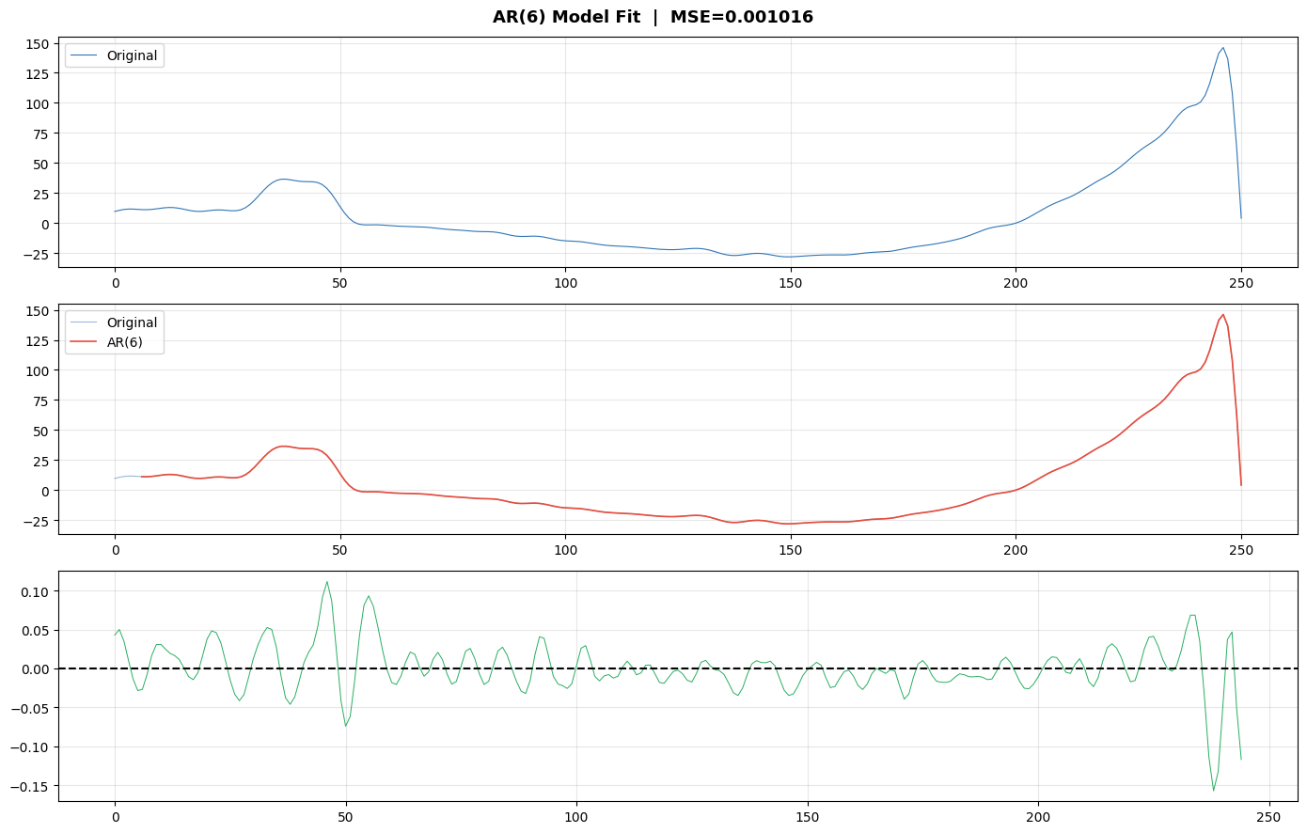

3.3 Raw Signal Samples
Both channels are concatenated each sample produces a feature vector of dimension 2 × N, where N is the signal length.
Method | Feature Dimension | Key Hyperparameter
DWT – db1 | 12 | Wavelet: db1 (Haar), Levels: 4
DWT – db2 | 12 | Wavelet: db2, Levels: 4
DWT – db4 | 12 | Wavelet: db4, Levels: 4
AR Coefficients | 7 | Model order (lags): 6
Raw Samples | 2N | None (N = signal length)
Table 3 – Summary of feature extraction

4. Classifier: Support Vector Machine (SVM)
Support Vector Machine with a one-vs-one multi-class
4.1 Hyperparameters Tested
A grid search was conducted over all combinations of kernel type, regularization constant C, and feature set. In total: 4 kernels × 5 C values × 19 feature combinations = 380 distinct experiments, each evaluated with 5-Fold
Hyperparameter | Values Tested | Notes
Kernel | linear, rbf, sigmoid, poly | Determines decision boundary shape
Regularization C | 0.01, 0.1, 0.5, 1, 5 | Controls margin width
Gamma (gamma) | scale (auto) | 1 / (n_features x Var(X)) with rbf/poly/sigmoid
Cross-Validation | k = 5 | Each fold 5 x 80/20 splits

4.2 Evaluation Metrics
Metric | Definition
Validation Accuracy | Correct predictions / Total predictions
Macro F1-Score | average of all F1-scores ($\frac{F1_{1}+F1_{2}+⋯+F1_{n}}{n}$)
Macro Precision | TP / (TP + FP) avg
Macro Recall | TP / (TP + FN) avg
Train–Val Gap | Train Accuracy - Validation Accuracy
Table 5 – Evaluation metrics recorded for every SVM configuration

5. Classification Results & Comparison

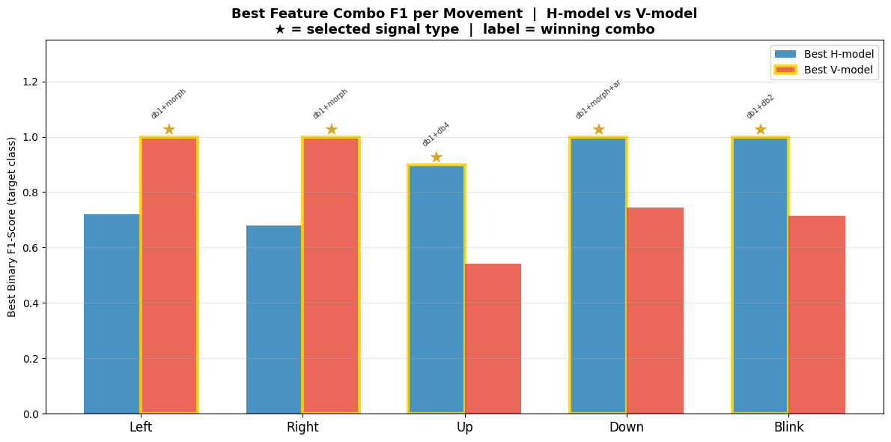
5.3 Key Findings
- For each of the five movement classes a one-vs-all SVM grid search was run separately on the horizontal (H) and vertical (V) signals across 380 configurations (20 feature combos × 4 kernels × 5 C values). The best combo and signal type per direction are:
- LEFT: The vertical channel achieved a perfect F1 of 100.0% using db1+morph (linear, C=0.1), far outperforming the horizontal channel's best of 72.0% (db1+db4, linear, C=5.0). → Selected: Vertical, db1+morph
- RIGHT: Again the vertical channel dominated with a perfect F1 of 100.0% using db1+morph (linear, C=1.0), versus the horizontal channel's 67.9% (db4+morph+ar, linear, C=0.1). → Selected: Vertical, db1+morph
- UP: Here the horizontal channel outperformed with 90.0% F1 using db1+db4 (linear, C=5.0), while the vertical channel only reached 54.0% (db1+db2, sigmoid, C=5.0). → Selected: Horizontal, db1+db4
- DOWN: The horizontal channel achieved a perfect F1 of 100.0% using db1+morph+ar (rbf, C=0.5), versus the vertical channel's 74.5% (db1+db2, linear, C=5.0). → Selected: Horizontal, db1+morph+ar
- BLINK: The horizontal channel achieved a perfect F1 of 100.0% using db1+db2 (rbf, C=5.0), versus the vertical channel's 71.4% (db2+ar, poly, C=1.0). → Selected: Horizontal, db1+db2
Direction | Selected Signal | Best Combo | H F1 | V F1 | Win F1
Left | Vertical | db1+morph | 72.0% | 100.0% | 100.0%
Right | Vertical | db1+morph | 67.9% | 100.0% | 100.0%
Up | Horizontal | db1+db4 | 90.0% | 54.0% | 90.0%
Down | Horizontal | db1+morph+ar | 100.0% | 74.5% | 100.0%
Blink | Horizontal | db1+db2 | 100.0% | 71.4% | 100.0%
Combo vote counts across movements:
The combo db1+morph was selected as the unified feature
Feature Combo | Votes | Avg Win F1 | Selected?
db1+morph | 2 | 100.0% | ✔ SELECTED
db1+db4 | 1 | 90.0%
db1+morph+ar | 1 | 100.0%
db1+db2 | 1 | 100.0%

5.4 Get Accuracy for each movement (H-V)
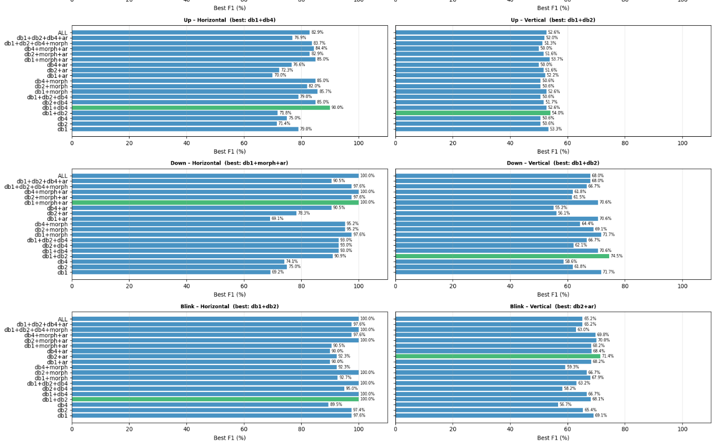

Per-fold accuracy breakdown:
 | Fold 1 | Fold 2 | Fold 3 | Fold 4 | Fold 5 | Mean
Train Acc | 100.00% | 100.00% | 100.00% | 100.00% | 98.75% | 99.75%
Val Acc | 95.00% | 90.00% | 85.00% | 90.00% | 95.00% | 91.00%

Conclusion
The preprocessing pipeline was refined through two experimental decisions: A visual decision plot confirmed that the 0.5 Hz lower cutoff of the Butterworth bandpass filter already removes the DC component making a separate DC removal step redundant. Second decision was normalization which maintains accuracy so it was kept , followed by per-direction signal-type selection (H or V).
DWT with the db4 wavelet achieved the highest standalone validation accuracy (65%),Raw samples performed the worst due to the very high dimensionality. AR coefficients produced compact 7-dimensional representations but with most DWT+AR combinations performing worse than their DWT+morphological.
The best overall validation accuracy of 92% was achieved by using db1+morph features with an rbf kernel and C=5 selected via majority vote across all five binary direction classifiers with the best-performing signal type (H or V) chosen per direction
The final deployed model uses db1+morph features with kernel =rbf and C= 5 achieved
Mean Train Acc = 99.75% & Mean Val Acc = 91.00% & Gap = 8.75%

6. Running Interface – EOG Calculator

6.1 Interface Design Principles
The calculator interface is divided into two panels. The left panel is the EOG Input panel, which displays the five detected EOG movement classes as labelled buttons (UP, DOWN, LEFT, RIGHT, and BLINK highlighted in the center) and provides a signal upload area for loading raw .txt signal files. The right panel is the Calculator panel, which contains the result display box at the top and the button grid below.
The button grid is organized into four quadrants separated by a central cursor indicator, each labeled by the gaze direction that activates it — LOOK UP, LOOK DOWN, LOOK LEFT, and LOOK RIGHT. Each quadrant holds a 2×2 arrangement of four buttons. This two-level layout guarantees that any button is reachable in exactly two eye movements: the first movement selects the quadrant, and the second movement selects the specific button within that quadrant. A voluntary blink then confirms the selection.
6.2 UI Elements
UI Element | Description
EOG Input panel (left) | Displays the five EOG classes as visual buttons also contains an upload area for loading .txt signal files
LOOK UP quadrant | Contains digits 7, 8, 4, 5 — activated by an upward gaze
LOOK RIGHT quadrant | Contains digits 9, 6 and operators /, × — activated by a rightward gaze
LOOK LEFT quadrant | Contains digits 1, 2, 0 and the C (Clear) button — activated by a leftward gaze
LOOK DOWN quadrant | Contains digit 3, operators −, + and the E (Exit) button — activated by a downward gaze
Central cursor dot | Yellow glowing indicator positioned at the intersection of the four quadrants
Result display box | Shows the computed result at the top of the calculator
Blink confirmation | A voluntary blink confirms the highlighted button as the user's choice
Table 8 –Ui elements description
6.3 Interaction Flow
The interaction follows a 2-movement + blink repeated three times to complete a full one-digit calculation:
- Movement 1 – Select quadrant: The user looks in the direction (Up / Down / Left / Right) corresponding to the quadrant containing the desired button.
- Movement 2 – Select button within quadrant: The user makes a second directional gaze to pinpoint the exact button within the chosen 2×2 quadrant.
- Blink – Confirm: A voluntary blink selects the highlighted button.
A full calculation proceeds as follows:
- Step 1 – First digit: The user performs the 2-movement sequence to reach a digit (0–9) and blinks to confirm. The digit appears in the expression display.
- Step 2 – Operator: The user navigates to an operator (+, −, ×, /) using the same two-movement sequence and blinks to confirm. The expression box updates (e.g., "7 +").
- Step 3 – Second digit: The user selects the second digit the same way and blinks. The result is computed and displayed in the result box (e.g., "15").
- Clear (C): Located in the LOOK LEFT quadrant to reset the calculator.
- Exit (E): Located in the LOOK DOWN quadrant to terminate the operation.

6.4 Interface Screenshots
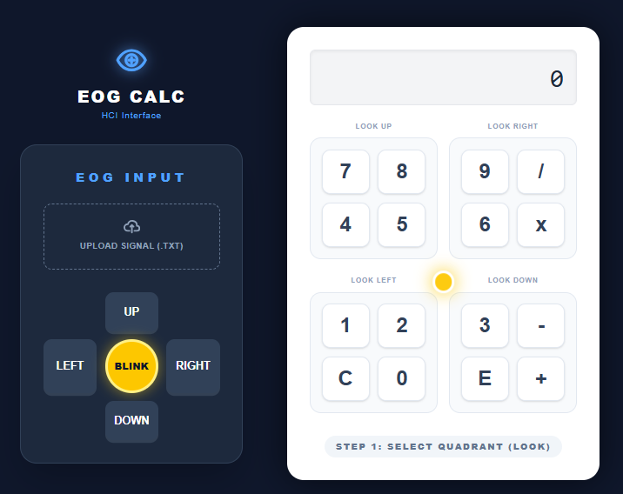
Figure 7 – EOG Calculator:idle state
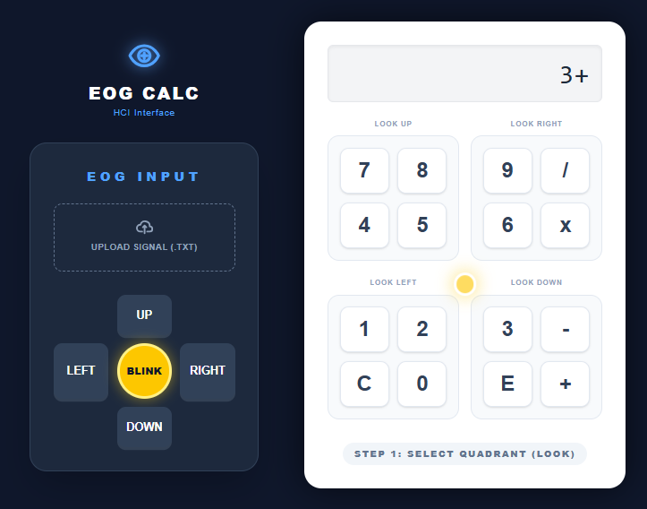
Figure 8 – EOG Calculator: after digit and operator selection (3+)
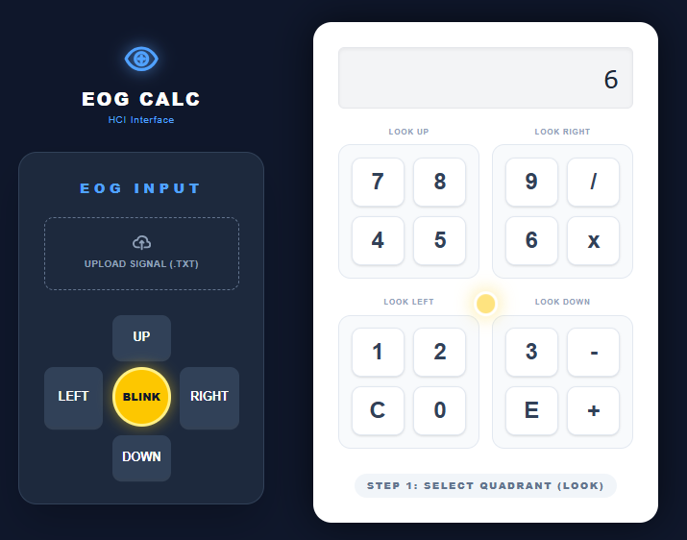
Figure 9 – EOG Calculator: final state with result display (3+3)

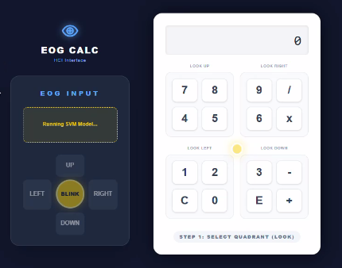
Figure 10 – Real-time EOG classification file showing predicted movement class

6.5 System Deployment
The EOG Calculator was deployed as a full-stack web application to enable real-time signal classification and calculator interaction through a browser interface.
Backend — FastAPI The trained SVM model was serialized using joblib and served through a FastAPI backend. The backend exposes a REST API endpoint that accepts a raw EOG signal file (.txt), applies the full preprocessing pipeline (DC removal, bandpass filtering, z-score normalization, and V+H concatenation), extracts the db1+db2+db4+morphological feature vector, and returns the predicted movement class (Up, Down, Left, Right, or Blink) as a JSON response.
Frontend — UI The frontend communicates with the FastAPI backend by sending the uploaded signal file to the prediction endpoint. The returned movement class is then mapped to a calculator action: directional movements navigate between quadrants and buttons and a blink confirmation triggers the selection. The expression and result are updated in real time on screen.
Deployment Flow:
User uploads .txt signal file → FastAPI receives file → Preprocessing pipeline applied → Feature extraction → SVM predicts class → Frontend receives prediction → Calculator UI updates.

