King Abdulaziz University  
 Faculty of Computing & Information Technology

Department of Computer Science

**CPCS 403 – Fall 2025**

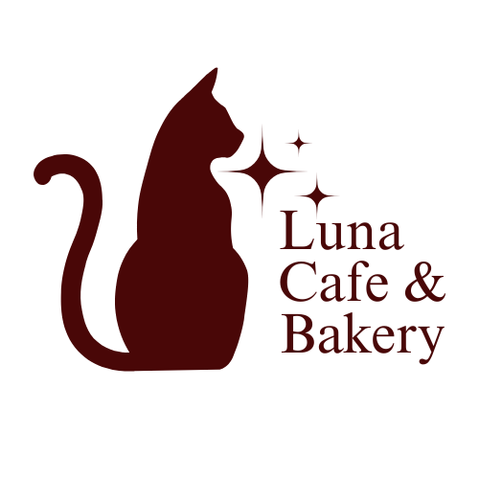

**Internet Application**

**Programming Assignment#1**

Group 16

**Prepared for:**

Dr. Samar Alkhuraiji

**Prepared by:**

|  |  |  |
| --- | --- | --- |
| **Name** | **ID** | **Section** |
| Njoud Naji Alahmadi | 2109470 | GAR |
| Dareen Hamed Alsulami | 2105810 | GAR |

Table of Contents

Introduction 3

Sitemap 4

Storyboard 5

Home’s storyboard 6

About’s Storyboard 7

Menu’s Storyboard 8

Services’s Storyboard 9

Feedback’s Storyboard 10

Working Hours’s Storyboard 10

**List of figures**

*Figure 1: Luna Cafe & Bakery Sitemap 4*

*Figure 2: Home page Storyboard 6*

*Figure 3: About Us page Storyboard 7*

*Figure 4: Menu page Storyboard 8*

*Figure 5: Services page Storyboard 9*

*Figure 6: Feedback page Stroyboard 10*

*Figure 7: Working Hours page Storyboard 10*

# **Introduction**

In this project we have developed a website for Luna Cafe and Bakery, a charming cafe known for its signature coffee and freshly baked goods. The goal of this project is to create an online platform that reflects the cafe’s identity and provides customers with an easy way to explore its offerings, learn about its story, and connect with the business. The website features six key pages: the Home Page, which highlights weekly offers and signature items; the Services Page, detailing the cafe’s offerings; the About Us Page, sharing the story and passion behind Luna; the Menu Page, showcasing the cafe’s drinks and baked goods; and the Working Hours Page, providing operating hours for customer convenience. Additionally, the Feedback Page allows customers to share their thoughts or reach out with inquiries. To host all of our work we created a domain for our project, [lunacafeandbakery.great-site.net](https://dash.infinityfree.com/accounts/if0_38576779/domains/lunacafeandbakery.great-site.net). This project demonstrates our ability to design a functional and user-friendly website while effectively communicating the essence of Luna Cafe and Bakery. Through this platform, we aim to enhance the cafe’s online presence and improve customer engagement.

# **validation**

To ensure the highest standards of web development and compliance with industry best practices, all pages of the Luna Cafe and Bakery website were rigorously tested using the W3C Markup Validation Service. After careful validation, the website achieved a clean result with no errors or warnings, confirming that the code is well-structured, semantically correct, and fully compliant with web standards.

# **Sitemap**

The website for Luna Cafe and Bakery is structured into six main pages, each designed to provide a seamless and intuitive user experience. The Home Page serves as the central hub, introducing visitors to the cafe’s weekly offers and signature items. The Services Page outlines the range of offerings available, while the About Us Page shares the story and values behind Luna. The Menu Page Showcases the cafe’s delicious drinks and baked goods, and the Working Hours Page provides clear information about operating hours. Finally, the Feedback Page enables customers to share their thoughts or get in touch with the cafe.

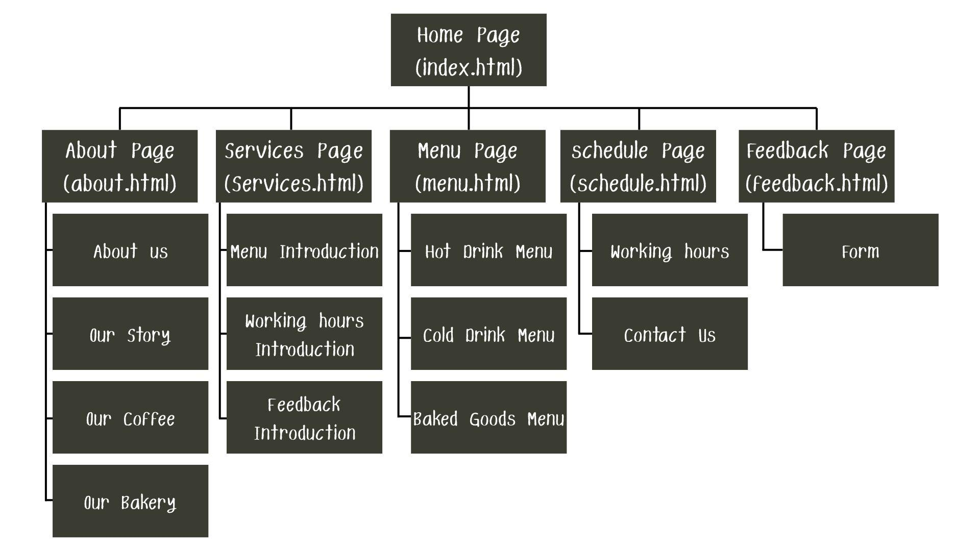

Figure 1: Luna Cafe & Bakery Sitemap

# **Storyboard**

The storyboard outlines the structure and layout of each page on the Luna Cafe and Bakery website, providing a visual and functional for the user experience. It details how the Home Page Introduces visitors to the cafe’s offerings, the Services Page highlights available services, and the About Us Page shares the cafe’s story. The Menu Page organizes the baked and drink options, while the Working Hours Page clearly displays operating hours. Lastly, the Feedback form Page Facilitates communication with customers.

**Home’s storyboard**

Figure 2: Home page Storyboard

## **About’s Storyboard**

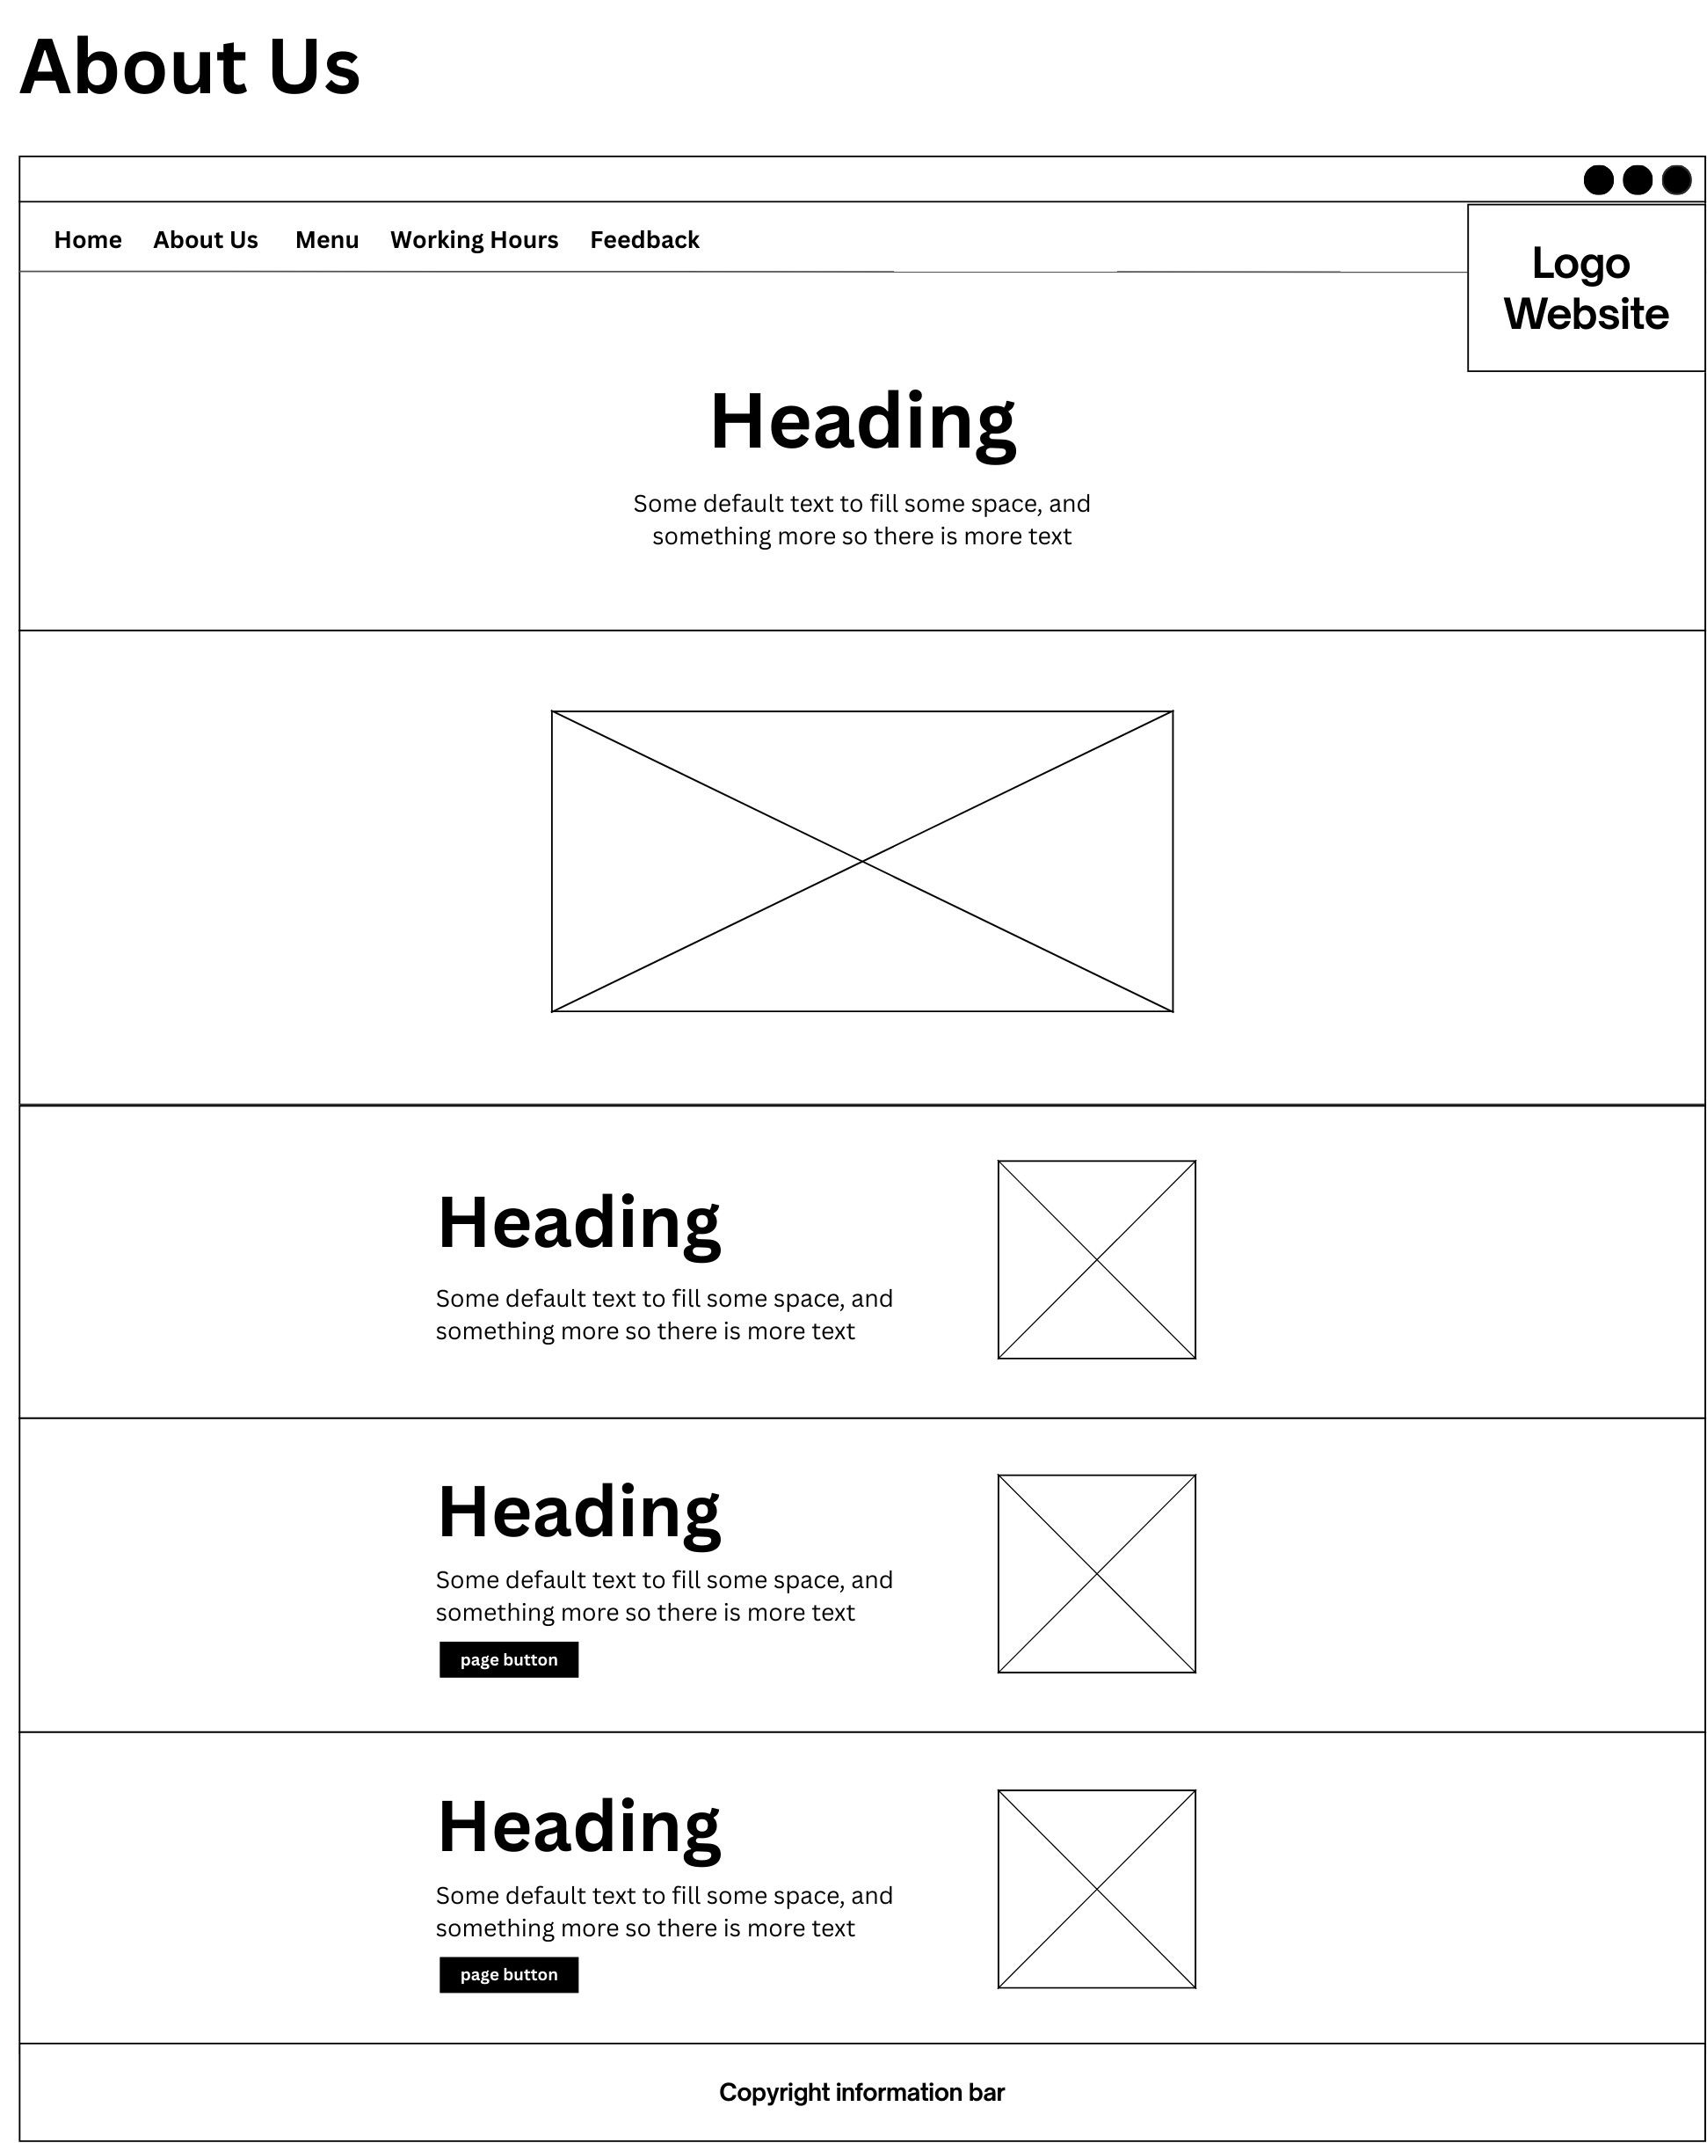

Figure 3: About Us page Storyboard

## **Menu’s Storyboard**

Figure 4: Menu page Storyboard

## 

## **Services’s Storyboard**

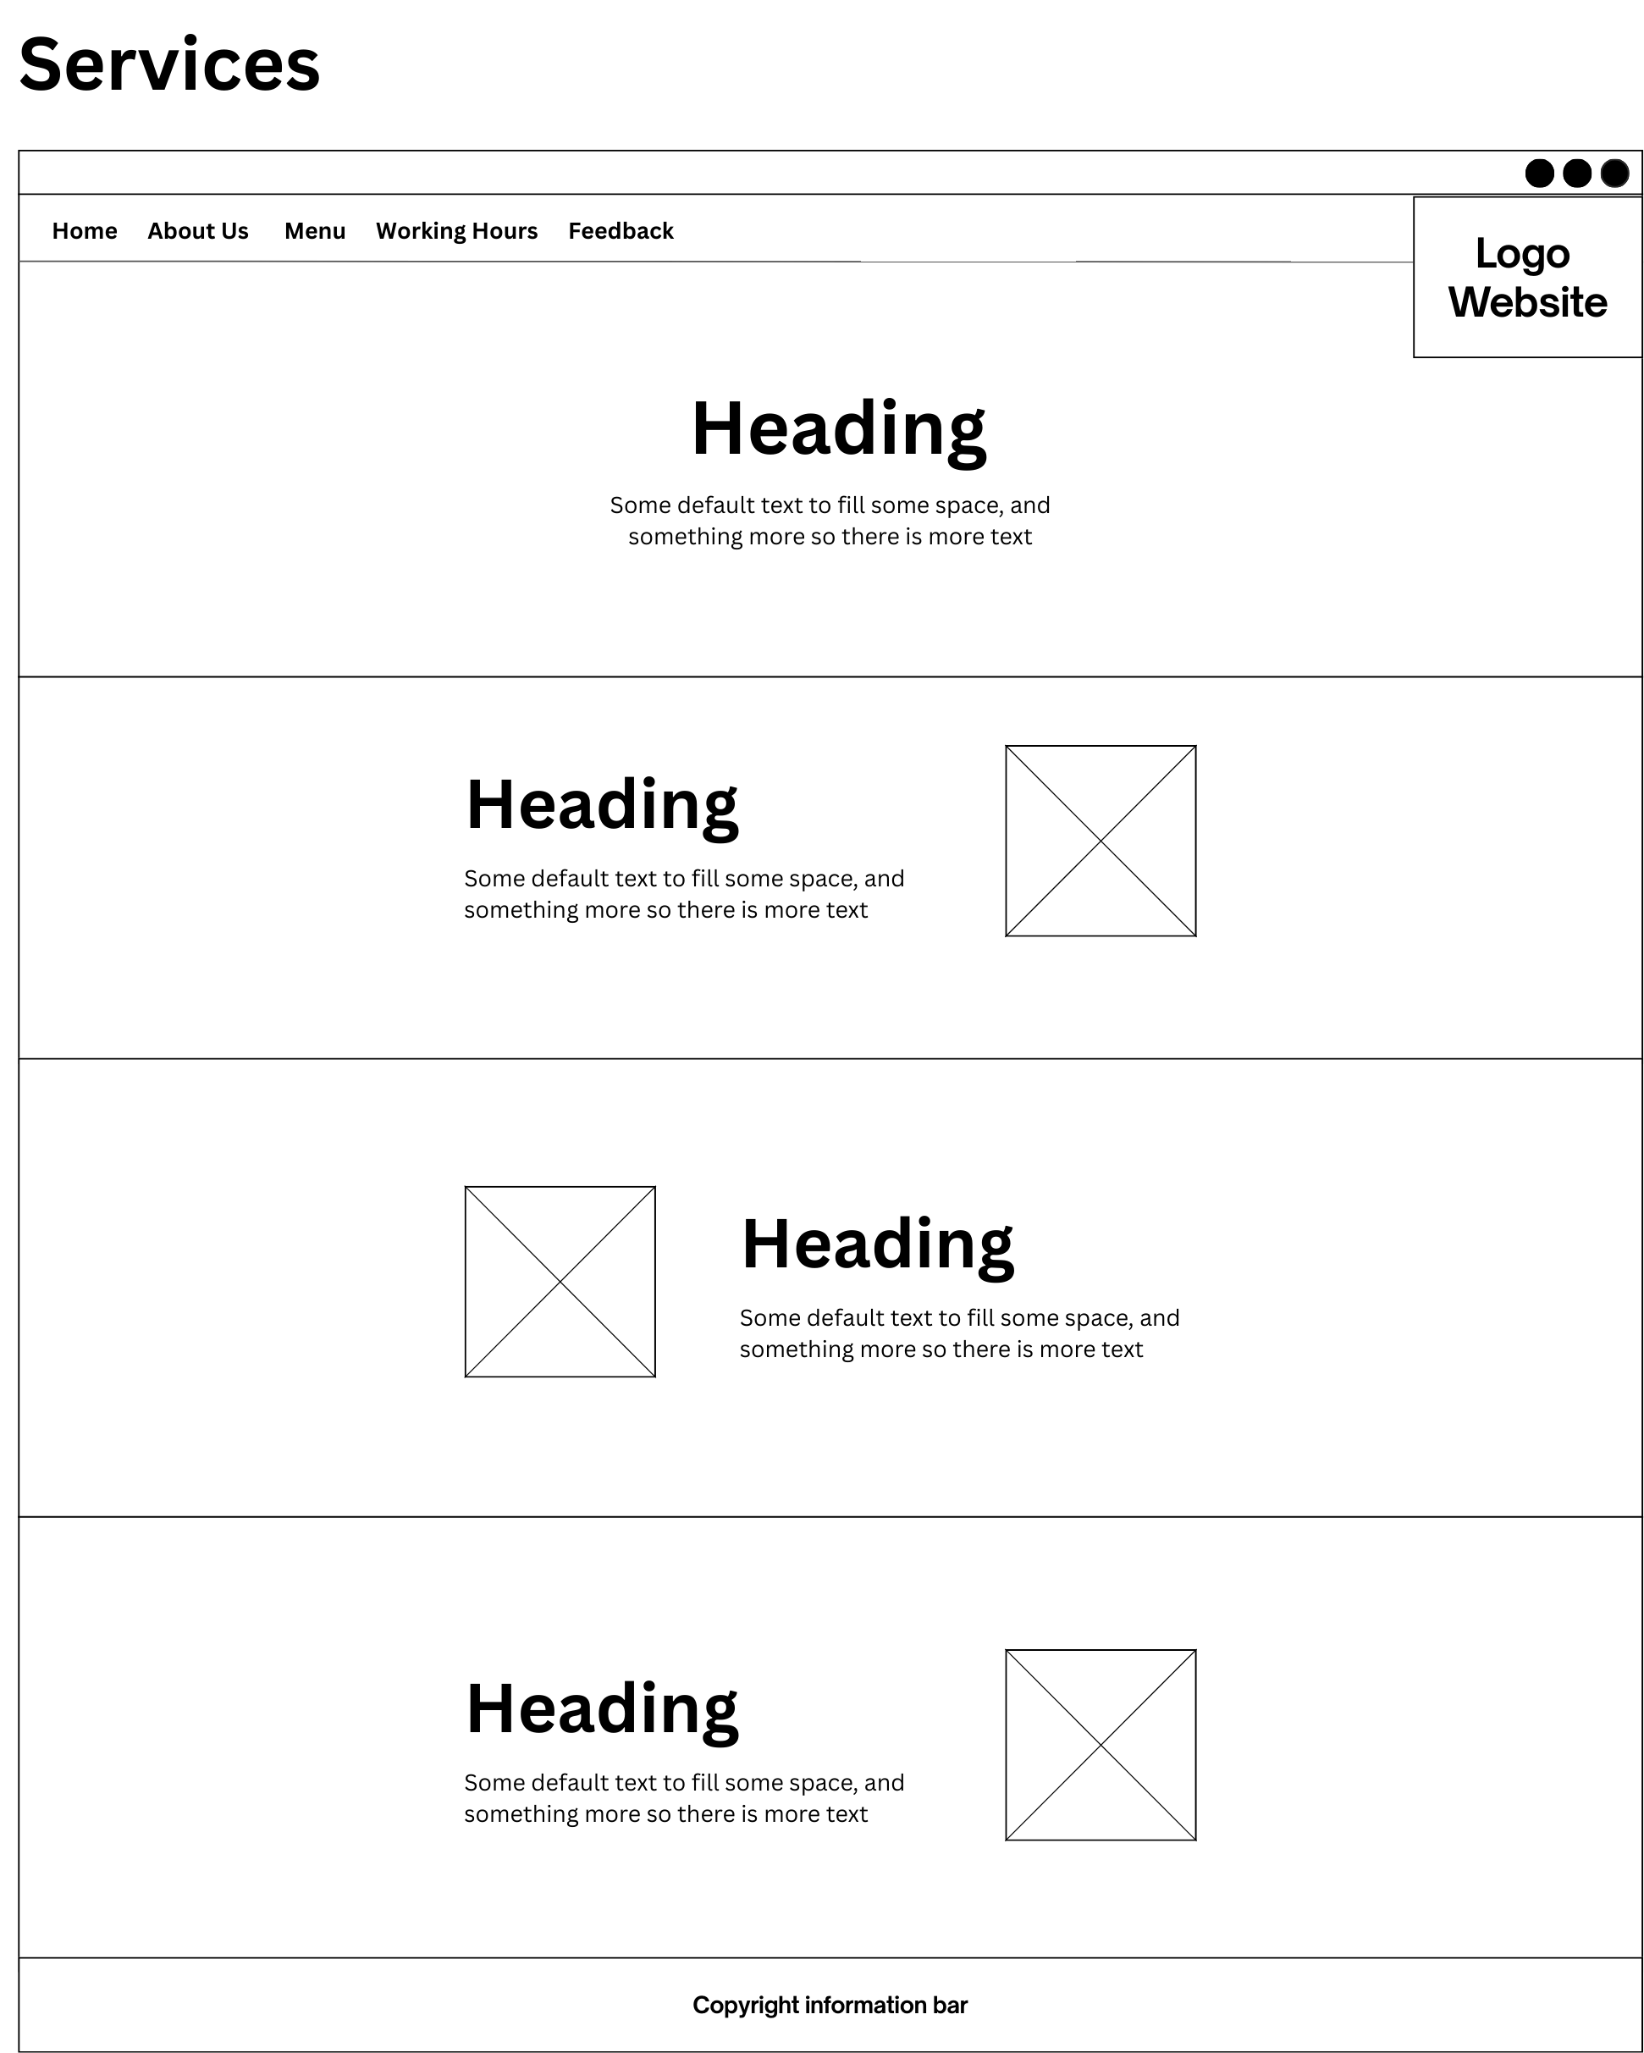

Figure 5: Services page Storyboard

## **Feedback’s Storyboard**

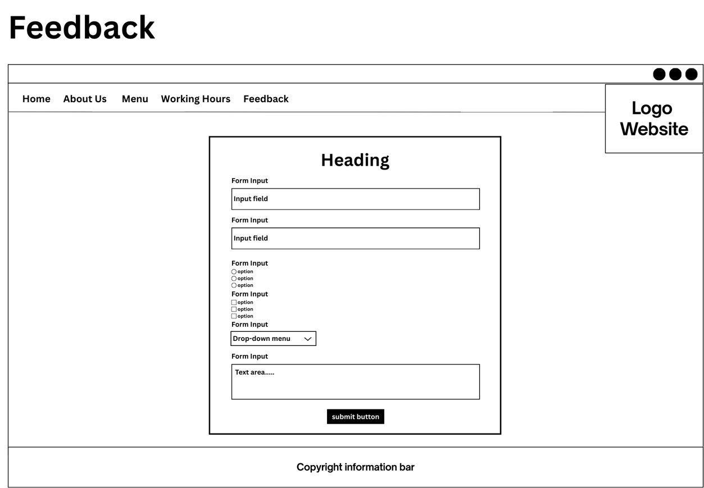

Figure 6: Feedback page Stroyboard

## **Working Hours’s Storyboard**

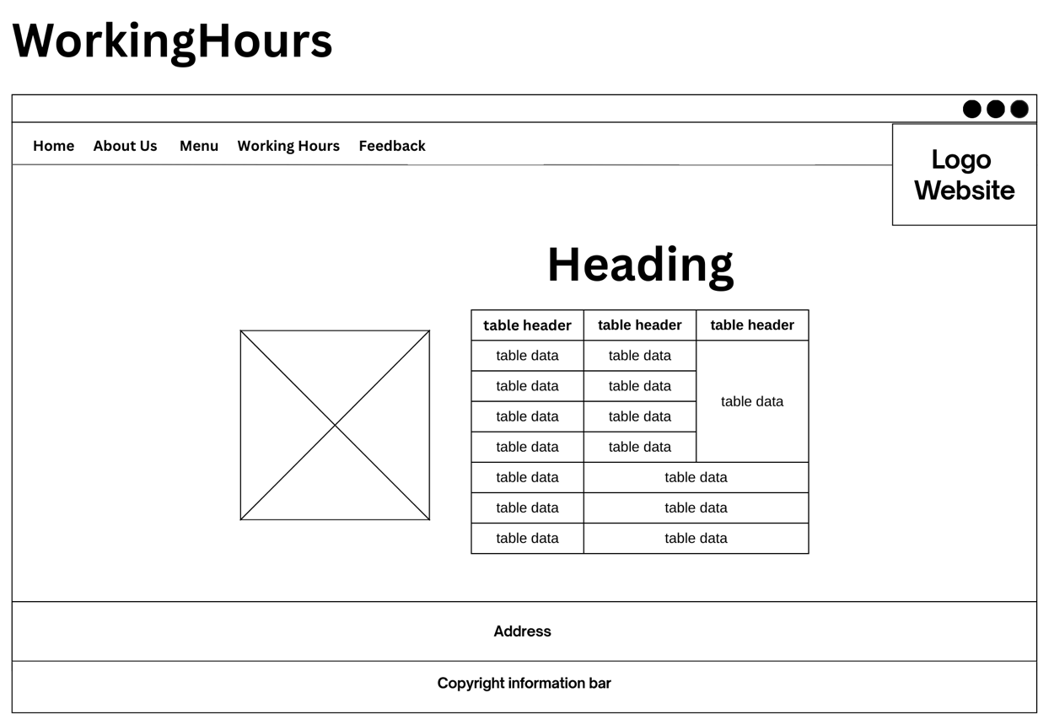

Figure 7: Working Hours page Storyboard