**Executive summary**

You are playing as the main character which is a bomb in a world full of enemies surrounding you and the game is very similar to Pac-Man. The main game mechanics is moving left, right, up, and down. The characters goal is to collect all the matches possible before the timer ends while avoiding the enemies. If the character loses all of his lives, he will lose the game and if the character does not collect all of the matches before the timer end, he will also lose. At a certain amount of points, the game will become much more difficult such as the enemies are faster.

 Bomb math

**User Interface Mock-up(s)**

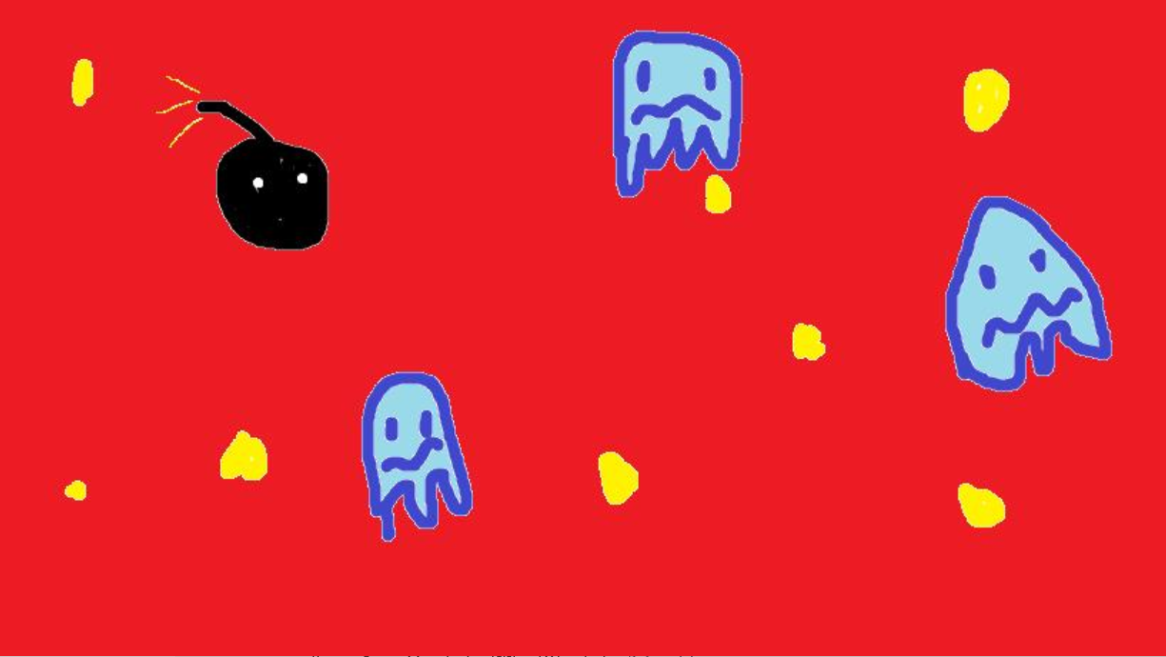

(May change)

**Controls**

The control inputs: Left, right, up, and down only. Allows the user to move around the map. User cannot go through the wall placed in the map. Every time the user touches a wall, he will have to move away from it.

**Developer roles**

Darel roles: Working on the mechanics of the main characters and working on the main game points for the win condition (collecting the matches).

Kofi roles: Working on the enemies (lose conditions and lives) and working on the timer for the game (lose condition)

Both: Visual representation.

(May change depending on how we do)

**Schedule of releases**

11 / 20: Prototype

11 / 25: First Playable

11 / 30: Pre-Alpha

12 / 06: Alpha

12 /10: Gold Master