Online Hardware Sales and Inventory with Credit Management System

A Capstone Project Proposal
Presented to the Faculty of the
Information and Communications Technology Program
STI College Balayan

In Partial Fulfilment
of the Requirements for the Degree
Bachelor of Science in Information Technology
Lito James G. Abenoja
Daren P. Ang
John Ian P. Brazas
Lance M. Tolentino

October, 2026

ENDORSEMENT FORM FOR ORAL DEFENSE
TITLE OF RESEARCH: Online Hardware Sales and Inventory with Credit Management System

NAME OF PROPONENTS: Lito James G. Abenoja
Daren P. Ang
John Ian P. Brazas
Lance M. Tolentino

In Partial Fulfilment of the Requirements
for the degree Bachelor of Science in Information Technology
has been examined and is recommended for Proposal Defense.

ENDORSED BY:

Mr. Ariane Milan M. Calupcupan
Capstone Project Adviser

APPROVED FOR PROPOSAL DEFENSE:

Ms. Terranya M. Tiamson
Capstone Project Coordinator

NOTED BY:

Ms. Terranya M. Tiamson
Program Head

OCTOBER, 2026

APPROVAL SHEET
This capstone project proposal titled Online Hardware Sales and Inventory with Credit Management System, prepared and submitted by Lito James G. Abenoja, Daren P. Ang, John Ian P. Brazas, and Lance M. Tolentino, in partial fulfillment of the requirements for the degree of Bachelor of Science in Information Technology, has been examined and is recommended for acceptance and approval.
Mr. Ariane Milan M. Calupcupan
Capstone Project Adviser
Accepted and approved by the Capstone Project Review Panel
in partial fulfillment of the requirements for the degree of
Bachelor of Science in Information Technology

Panel Member | Panel Member

Lead Panelist

Noted:
Ms. Terranya M. Tiamson
Capstone Project Coordinator/Program Head

October, 2026

ACKNOWLEDGEMENTS
First, the developers would like to thank the Capstone Project Coordinator and Program Head, Ms. Terranya M. Tiamson, for her guidance, coordination and support throughout the development of the project.
The developers are also grateful to their Capstone Project Adviser, Mr. Ariane Milan M. Calupcupan, for the valuable guidance, suggestions and recommendations that helped improve the system and the manuscript.
The developers thank the Capstone Project Review Panel for their constructive comments, suggestions and evaluations, which helped the developers enhance the quality of the project.
The developers give their sincere thanks to Ms. Lucelyn E. Palmaira, owner of Lucelyn Hardware, and to the staff of the store, for accepting the project, for sharing the processes and records of the store, and for testing the system.
The developers are thankful to their parents and guardians for their love, encouragement, financial support and understanding throughout the development of the project, and to their friends and classmates for their help and ideas.
Lastly, the developers thank everyone who contributed directly or indirectly to the completion of the system. Their support and assistance played an important role in making this project possible.

ABSTRACT
Title of research: Online Hardware Sales and Inventory with Credit Management System

Researchers: Lito James G. Abenoja
Daren P. Ang
John Ian P. Brazas
Lance M. Tolentino

Degree: Bachelor of Science in Information Technology

Date of Completion: October 2026

Keywords: sales and inventory system, credit management, point of sale, reorder point, hardware store

Lucelyn Hardware, a hardware store in Nasugbu, Batangas, kept its sales, inventory and customer records on paper. Records were lost and misplaced, searching was slow, stock was reordered only when it looked low, and balances owed by customers who bought were not monitored. This capstone project developed and implemented the Online Hardware Sales and Inventory with Credit Management System to solve these problems.
The developers followed the Spiral model and built the system with HTML, CSS, Bootstrap, JavaScript, Node.js, Express.js and MySQL, with GCash, PayMaya and bank transfer payments through PayMongo. The system has five roles, the System Administrator, Manager, Inventory Clerk, Cashier and Delivery Personnel, and eight modules: login, inventory management, sales, credit management, record maintenance, customer delivery, reporting and system maintenance. Every sale updates the stock, materials at or below their reorder point raise low-stock alerts, purchase orders are answered by suppliers through a QR code, and each customer's credit standing is computed from the balance and the age of the oldest unpaid sale, with part payments and late-payment penalties.
All 99 functions passed ten test runs each. The owner, Ms. Lucelyn E. Palmaira, accepted all twelve functions in user acceptance testing and issued a letter of acceptance on October 12, 2026.

TABLE OF CONTENTS
Title Page | i
Endorsement Form for Oral Defense | ii
Approval Sheet | iii
Acknowledgements | iv
Abstract | v
Table of Contents | vi
List of Figures | viii
List of Tables | xiii
List of Notations | xv
Introduction | 1
Project Context | 1
Purpose and Description | 3
Objectives | 4
Scope and Limitations | 6
Review of Related Literature/Studies/Systems | 18
Methodology | 24
Technical Background | 24
Requirements Analysis | 31
Requirements Documentation | 32
Design of Software, System, Product, and/or Processes | 39
Development | 158
Results and Discussion | 161
Testing | 161
Description of Prototype | 171
Implementation Plan | 171
Implementation Results | 175
Conclusion | 176
References | 178
Appendices | 182

LIST OF APPENDICES
Appendices 182
Appendix A Resource Persons 183
Appendix B Relevant Source Code 184
Appendix C Evaluation Tool/Test Documents 190
Appendix D Sample Input/Output/Reports 192
D-1 Sales Invoice 192
D-2 Purchase Order (PDF) 193
D-3 Supplier's Order Page on a Phone 194
D-4 Customer Credit and Payments 195
D-5 Sales Summary Report 196
Appendix E User's Guide 197
Appendix F Letter to the Beneficiary 223
Appendix G Transcript of Interview 224
Appendix H Sample Forms of the Beneficiary 228
H-1 Sales Invoice 228
H-2 Delivery Receipt 229
H-3 Inventory Record 230
H-4 Sales Record 231
Appendix I Letter of Acceptance 232
Appendix J Accomplishment Reports 233
Appendix K Personal Technical Vitae 236

LIST OF FIGURES
Figure 1. Hierarchical Diagram of the Online Hardware Sales and Inventory with Credit Management System | 32
Figure 2. Hierarchical Diagram of the Login Module | 32
Figure 3. Hierarchical Diagram of the Inventory Management Module | 33
Figure 4. Hierarchical Diagram of the Sales Module | 34
Figure 5. Hierarchical Diagram of the Credit Management Module | 35
Figure 6. Hierarchical Diagram of the Record Maintenance Module | 36
Figure 7. Hierarchical Diagram of the Customer Delivery Module | 37
Figure 8. Hierarchical Diagram of the Reporting Module | 37
Figure 9. Hierarchical Diagram of the System Maintenance Module | 38
Figure 10. Spiral Model | 39
Figure 11. Diagram of Employee Entity | 41
Figure 12. Diagram of User Entity | 41
Figure 13. Diagram of Category Entity | 42
Figure 14. Diagram of Unit Entity | 42
Figure 15. Diagram of Product Entity | 42
Figure 16. Diagram of Supplier Entity | 43
Figure 17. Diagram of Customer Entity | 43
Figure 18. Diagram of Sale Entity | 44
Figure 19. Diagram of Purchase Order Entity | 45
Figure 20. Diagram of Delivery Entity | 46
Figure 21. Diagram of Employee and User Relationship | 46
Figure 22. Diagram of Category and Product Relationship | 47
Figure 23. Diagram of Unit and Product Relationship | 47
Figure 24. Diagram of Supplier and Product Relationship | 47
Figure 25. Diagram of Supplier and Purchase Order Relationship | 48
Figure 26. Diagram of Employee and Purchase Order Relationship | 48
Figure 27. Diagram of Purchase Order and Product Relationship | 48
Figure 28. Diagram of Customer and Sale Relationship | 49
Figure 29. Diagram of Employee and Sale Relationship | 49
Figure 30. Diagram of Sale and Product Relationship | 49
Figure 31. Diagram of Sale and Delivery Relationship | 50
Figure 32. Diagram of Employee and Delivery Relationship | 50
Figure 33. Context Diagram of the Online Hardware Sales and Inventory with Credit Management System | 51
Figure 34. Data Flow Diagram for the System Administrator | 52
Figure 35. Data Flow Diagram for the Manager | 53
Figure 36. Data Flow Diagram for the Inventory Clerk | 54
Figure 37. Data Flow Diagram for the Cashier | 55
Figure 38. Data Flow Diagram for the Delivery Personnel | 56
Figure 39. Data Flow Diagram for the Supplier | 57
Figure 40. Login Page | 93
Figure 41. Forgot Password | 94
Figure 42. Choose Your Password Page | 95
Figure 43. Staff Directory (System Administrator) | 96
Figure 44. Create New Account | 97
Figure 45. Staff Account Card | 98
Figure 46. Archived Accounts | 99
Figure 47. Access Control | 100
Figure 48. Audit Logs | 101
Figure 49. Audit Log Entry | 102
Figure 50. Backup & Recovery | 103
Figure 51. Receipt Maintenance | 104
Figure 52. Point of Sale (Cashier) | 105
Figure 53. Payment Card with Credit and Part Payment | 106
Figure 54. Make a Delivery | 107
Figure 55. Sale Confirmation | 108
Figure 56. Sales Invoice | 109
Figure 57. Pay by QR | 110
Figure 58. Customers Record | 111
Figure 59. Customer Account Card | 112
Figure 60. Unpaid Sales of a Customer | 113
Figure 61. Credit Settlement | 114
Figure 62. Ask for a Higher Limit | 115
Figure 63. Refunds | 115
Figure 64. Deliveries (Cashier) | 116
Figure 65. Sales Report (Cashier) | 117
Figure 66. Request Void | 118
Figure 67. Material List (Inventory Clerk) | 119
Figure 68. Material Card | 119
Figure 69. Add New Product | 120
Figure 70. Stock Adjustment | 121
Figure 71. Adjustment History | 122
Figure 72. Reorder Point | 123
Figure 73. Purchase Orders (Inventory Clerk) | 124
Figure 74. New Purchase Order | 125
Figure 75. Receive Delivery | 126
Figure 76. Returned Items | 127
Figure 77. Sales Summary (Manager) | 128
Figure 78. Sales Transactions | 129
Figure 79. Sale Card with a Void Request | 130
Figure 80. Total Purchases | 131
Figure 81. Receivables | 132
Figure 82. Repeat Customers | 133
Figure 83. Activity Log | 134
Figure 84. Stocks Overview | 135
Figure 85. Product Card: Reorder Point | 135
Figure 86. Reorder Alerts | 136
Figure 87. Stock Movements | 137
Figure 88. Purchase Orders (Manager) | 138
Figure 89. Purchase Order Review | 138
Figure 90. Customer Credit | 139
Figure 91. Credit Account Card | 140
Figure 92. Extension Requests | 141
Figure 93. Extension Request | 142
Figure 94. Delivery History (Manager) | 143
Figure 95. Delivery Card | 143
Figure 96. Delivery Schedule | 144
Figure 97. Suppliers | 145
Figure 98. Customers | 146
Figure 99. Products | 147
Figure 100. Product Record: Price | 147
Figure 101. Categories | 148
Figure 102. Units | 148
Figure 103. Credit Maintenance | 149
Figure 104. Customer Data Terms | 150
Figure 105. Refund Policy | 151
Figure 106. Archives | 152
Figure 107. Pending Deliveries (Delivery Personnel) | 153
Figure 108. Delivery Card (Delivery Personnel) | 154
Figure 109. Payment at the Door | 155
Figure 110. Deliveries Handled | 156
Figure 111. Payments Collected | 157
Figure 112. Supplier's Order Page | 158
Figure 113. Network Layout of the Implementation Setup | 172

LIST OF TABLES
Table 1. Data Dictionary for roles | 57
Table 2. Data Dictionary for staff | 58
Table 3. Data Dictionary for users | 59
Table 4. Data Dictionary for password_resets | 60
Table 5. Data Dictionary for role_feature_permissions | 61
Table 6. Data Dictionary for user_sessions | 62
Table 7. Data Dictionary for account_drafts | 63
Table 8. Data Dictionary for audit_logs | 63
Table 9. Data Dictionary for categories | 64
Table 10. Data Dictionary for brands | 65
Table 11. Data Dictionary for units | 65
Table 12. Data Dictionary for suppliers | 66
Table 13. Data Dictionary for products | 67
Table 14. Data Dictionary for inventory | 68
Table 15. Data Dictionary for product_units | 69
Table 16. Data Dictionary for stock_adjustments | 70
Table 17. Data Dictionary for purchase_orders | 71
Table 18. Data Dictionary for purchase_order_items | 72
Table 19. Data Dictionary for purchase_order_ordered_items | 73
Table 20. Data Dictionary for customers | 74
Table 21. Data Dictionary for customer_credits | 75
Table 22. Data Dictionary for credit_requests | 76
Table 23. Data Dictionary for credit_payments | 77
Table 24. Data Dictionary for sales | 78
Table 25. Data Dictionary for sale_items | 80
Table 26. Data Dictionary for payment_details | 81
Table 27. Data Dictionary for qr_payments | 82
Table 28. Data Dictionary for qr_sim_intents | 83
Table 29. Data Dictionary for void_requests | 84
Table 30. Data Dictionary for returned_items | 85
Table 31. Data Dictionary for deliveries | 87
Table 32. Data Dictionary for notifications | 88
Table 33. Data Dictionary for store_settings | 89
Table 34. Data Dictionary for live_changes | 91
Table 35. Data Dictionary for backup_files | 91
Table 36. Data Dictionary for app_flags | 92
Table 37. Login Module Testing | 161
Table 38. Inventory Management Module Testing | 162
Table 39. Sales Module Testing | 164
Table 40. Credit Management Module Testing | 165
Table 41. Record Maintenance Module Testing | 166
Table 42. Customer Delivery Module Testing | 167
Table 43. Reporting Module Testing | 168
Table 44. System Maintenance Module Testing | 169
Table 45. Major tasks of the implementation | 173
Table 46. Resources needed for implementation | 174
Table 47. User Acceptance Test form | 190

LIST OF NOTATIONS
Notation | Meaning
API | Application Programming Interface
COD | Cash on Delivery
CSS | Cascading Style Sheets
CSV | Comma-Separated Values
DFD | Data Flow Diagram
ERD | Entity Relationship Diagram
HTML | HyperText Markup Language
HTTPS | Hypertext Transfer Protocol Secure
LAN | Local Area Network
MSME | Micro, Small and Medium Enterprise
NIST | National Institute of Standards and Technology
PDF | Portable Document Format
PO | Purchase Order
POS | Point of Sale
QR | Quick Response (code)
RA | Republic Act
ROP | Reorder Point
SKU | Stock Keeping Unit
SME | Small and Medium-sized Enterprise
SMTP | Simple Mail Transfer Protocol
SQL | Structured Query Language
TIN | Tax Identification Number
UAT | User Acceptance Testing
VAT | Value-Added Tax

INTRODUCTION

Project Context
The retail industry has steadily shifted away from manual, paper-based operations toward computerized and online sales and inventory systems as a means of improving accuracy, efficiency and profitability. For small and medium-sized enterprises such as hardware stores, which handle a large and varied assortment of fast- and slow-moving items, digital inventory and sales solutions have become an important factor in staying competitive and in reducing operational losses. Recent research shows that innovative inventory management practices and digital tools are consistently associated with better record-keeping, more reliable replenishment decisions and higher profitability among local SMEs, particularly where management skills and digital visibility remain limited (Rodríguez et al., 2025). An online sales and inventory system brings product information, sales transactions, supplier data and customer records into one platform, so that the owner can monitor stock movement, produce accurate reports and reduce the errors and losses that come with purely manual processing.
Lucelyn Hardware is a local hardware store in Nasugbu, Batangas that supplies a wide range of construction and home-improvement products, such as nails, paints, PVC fittings and pipes, plywood, metal roofing, deformed bars, cement, adhesives, light bulbs, hollow blocks, shovels and hammers. Before the project, the store ran all of its operations on paper. A full physical inventory was done only once a year, at the end of the year. Stock levels were monitored daily by reviewing the sales records and adding up the items sold by hand before subtracting them from the stock count. Reordering was not based on any computed figure: stocks were replenished only when they visibly looked low, and slow-moving items with low stock were not reordered right away. Sales were processed through manually issued official receipts, and customer records were kept as carbon copies of these receipts. Returns and exchanges, which the store allows for within three days of purchase, were written in a logbook and approved by the sales representative. To protect its data, the store kept the original receipts and wrote its inventory in a record book.

Based on the current process of the store, the following problems were identified:
- Loss and misplacement of paper records
Because all transactions, sales receipts, inventories and customer records were written and stored on paper, documents were often lost, damaged by water or misplaced. The owner named the loss of regular customer records and misplaced records of sales and inventory as concerns. Once a receipt, notebook entry or inventory sheet is misplaced, the information on it is effectively lost.
- Unorganized filing and slow retrieval of records
Finding a specific record among a large volume of paper was slow and labor-intensive. To verify a past sale or an earlier inventory figure, the owner and staff had to search through receipts, notebooks and record books by hand, which delayed decisions that depend on accurate and timely information.
- Understocking of products
The store did not compute reorder points and replenished stock only when it looked low. Without a set threshold for restocking, fast-moving items risked running out before they were reordered, while slow-moving items could be overlooked. This made purchasing decisions inconsistent and exposed the store to stockouts and delays in replenishment.
These problems are related, and together they show how vulnerable a hardware store becomes when it depends entirely on paper. Lost documents, slow retrieval of information, the absence of computed reorder points and unmonitored credit all weaken the store's ability to make informed and timely decisions and reduce the accuracy of its records. The developed Online Hardware Sales and Inventory with Credit Management System addresses these problems at their common source. It replaces scattered paper records with one centralized database, records every sale and stock movement as it happens, computes reorder points, keeps a credit ledger for each customer and produces accurate reports, giving Lucelyn Hardware a dependable basis for managing its inventory, sales, customers, suppliers and deliveries.

Purpose and Description
The purpose of the developed system is to replace the manual, paper-based operations of Lucelyn Hardware with an accurate, efficient and centralized digital solution. It responds directly to the difficulties of the store in safeguarding its records, retrieving information quickly, monitoring stock levels, controlling sales on credit and reconciling physical stock with sales data. By bringing product, sales, supplier, customer, credit and delivery information into one system, the project reduces human error, prevents the loss of records and supports the owner in deciding on restocking, pricing and the handling of customer accounts.
The developed system is a web-based application with five user roles, which are the System Administrator, the Manager, the Inventory Clerk, the Cashier and the Delivery Personnel. Each role signs in to its own dashboard and sees only the screens it is allowed to use. The Cashier rings up sales at the point of sale, prints a sales invoice with the tax lines of the store's registration, takes cash, cheque, GCash, PayMaya and bank transfer payments, the last three through PayMongo, sells on credit with part payment, creates deliveries, records refunds, takes payments on balances and asks the Manager to void a sale. The Inventory Clerk keeps the material list, opens records for new materials, adjusts stock with remarks, raises purchase orders and counts deliveries in, and adds returned items back to stock or discards them. The Manager sets prices and reorder points, approves purchase orders, decides credit limit and void requests, keeps the supplier records and the credit, customer data and refund policies, and reads the sales, stock, credit and delivery reports. The Delivery Personnel update each delivery and collect payment at the door. The System Administrator manages the user accounts, the screens each role can open, the audit trail, the backups and the store details printed on receipts. Suppliers do not sign in but they answer an approved purchase order through a QR code or link printed on the order.
The system is different from a general point-of-sale program because it was built around the practices of the store. It sells measured goods in fractions of a kilogram, meter or liter, sells the same product by the piece or in bigger sizes such as a box or a sack, and keeps the three-day replacement policy through its returns and refunds screens. It also joins inventory and sales with credit management: each customer has a credit limit, a standing of Good, Watch or Hold that the system computes from the actual balance and the age of the oldest unpaid sale, a thirty-day payment term and a late-payment penalty of one to three percent a month.

Objectives
The objective of the project is to develop and implement an Online Hardware Sales and Inventory with Credit Management System that improves the accuracy and efficiency of the sales, inventory and credit operations of Lucelyn Hardware by replacing its manual, paper-based processes with a centralized and reliable digital platform.
The specific objectives of the project are:
- To develop and implement a centralized digital record of inventory, sales, customer and supplier information
This objective addresses the loss and misplacement of paper records. Inventory, sales, customer, supplier, credit and delivery records are stored in one MySQL database that is backed up automatically every day and can be backed up by hand at any time, so the records no longer depend on paper that can be lost, damaged or misplaced.
- To develop and implement a searchable record management and retrieval feature
This objective addresses the slow retrieval of records. Every list in the system has a search box and filters, and each record opens to a card with its details and history, so that staff can find a transaction, a customer or an inventory figure in seconds instead of searching through receipts and record books.
- To develop and implement a reorder point monitoring with low-stock alerts
This objective addresses the absence of computed reorder points. Each material has a reorder point that the Manager sets for it, and the system compares the stock on hand with it after every sale, delivery, adjustment and return. Materials at or below their reorder point are listed in Reorder Alerts with a suggested order quantity, the clerk's screen warns how many materials are low or out of stock, and low-stock and out-of-stock alerts are raised for the Manager and the Inventory Clerk, so that stock is reordered before it runs out instead of only when it looks low.

The project is beneficial to the following:
Store Owner (Manager)
The project gives the owner accurate and readily available information on inventory, sales, suppliers and customer accounts. This supports better decisions on purchasing, pricing and credit while reducing losses from misplaced records, uncollected receivables and unnoticed low stock.
Cashier and Sales Representative
The project simplifies the work at the counter by computing every sale, printing the invoice, handling part payments on credit and recording returns and refunds, which reduces manual errors and lets transactions be processed faster.
Inventory Clerk and Delivery Personnel
The clerk sees the stock on hand and the materials that need ordering without counting by hand, and the delivery personnel see their deliveries and record the payments collected at the door on a phone.
Customers
Customers benefit from faster and more accurate transactions, clear invoices, a transparent record of their credit balance and payments, and the option to pay by GCash, PayMaya or bank transfer through a QR code.
STI College Balayan
The school benefits from a project that shows the practical use of information technology in solving a real business problem, and the study can serve as a reference for future students who will develop similar systems.
Developers
The developers gained experience in building a real system for a real client, which improved their skills in systems analysis, database design, programming, testing and deployment.
Future Researchers
Future researchers may use this study as a reference in developing sales, inventory and credit systems for hardware and other retail businesses.

Scope and Limitations

Scope
The project covers the sales, inventory, purchasing, customer credit, delivery, reporting and system maintenance operations of Lucelyn Hardware. The system is used by five roles: the System Administrator, the Manager (the store owner), the Inventory Clerk, the Cashier and the Delivery Personnel; suppliers answer purchase orders through a link without signing in. The system is organized into the eight modules below, and what each user can open depends on the role and on the screens the System Administrator has switched on for that role.

Login Module
This module controls access to the system. A user signs in with an email address and a password, and is taken to the dashboard of the user's role.
Sign In
The user signs in with the email address and password of the account. After three wrong passwords in a row, the account is held from signing in for fifteen minutes, and every failed attempt is written to the audit trail. A screen left idle is signed out after thirty minutes, and a sign-in lasts eight hours at most.
First Sign-in Password Change
Initial passwords are not typed by anyone. When an account is created, the system generates a fourteen-character temporary password, sends it to the user's email address and requires the user to choose a new password at the first sign-in. A password must have at least eight characters with an uppercase letter, a lowercase letter, a number and a symbol.
Forgot Password
A user who forgot the password asks for a six-digit code sent to the email address of the account. The code lasts fifteen minutes and five tries. When mail is not available, the System Administrator resets the password of the account, and the user chooses a new one at the next sign-in.
One Session per Account
Signing in ends every other session of the same account, so a till left signed in on another computer is signed out and told why.

Inventory Management Module
This module keeps the stock of the store accurate, from the stock on hand to the orders placed with suppliers and the items returned.
Stock Monitoring
The Material List shows every material with its supplier, unit price, quantity on hand and stock status, and the quantity changes by itself whenever a sale, delivery, adjustment or return is recorded. Each material also lists the bigger sizes it is sold in and the pack its supplier delivers it in. A warning at the top of the clerk's screen says how many materials are out of stock or low. The clerk opens the record of a new material, which starts with no price and no stock until the Manager sets its price.
Stock Adjustment
The Inventory Clerk corrects a stock figure when supplies arrive outside a purchase order, when a count differs or when items are damaged, and adds returned goods back to stock or discards them. Every adjustment records the quantity before, the change, the quantity after, the unit and the remarks, and a Reference list beside the form shows the received purchase orders and the returned items to check against.
Adjustment History
Every adjustment is kept in a permanent log that shows when, by whom and why each stock figure changed.
Reorder Point
The Manager sets the reorder point of each material from its card as a whole number. After every sale, delivery, adjustment or return, the system compares the stock on hand with the reorder point: the materials at or under it are listed in Reorder Alerts with a suggested order that brings the stock back to twice the reorder point, and a low-stock or out-of-stock alert is raised for the Manager and the clerk. The clerk sees each material's reorder point and stock level on the Reorder Point screen.
Purchase Order
The Inventory Clerk raises a purchase order for a supplier and its materials, and the order waits for the Manager, who approves or declines it with a reason. An approved order is printed as a PDF document with a QR code and a link, and is emailed to the supplier when mail is set up. The supplier opens the link to check the prices, correct a price that does not match, give a discount and a ship date, and accept or decline the order. When the goods arrive, the clerk counts them in against the order, the stock is updated, and the lines as they were ordered are kept so that the clerk can compare them with what arrived.
Returned Items
The Returned Items screen lists the items that the counter or the driver took back and the damage reports, with the quantity, the reason and where the goods went. The clerk adds a sellable item back to stock or writes off an unsellable one through Stock Adjustment, which closes the report.

Sales Module
This module is used by the Cashier to process sales at the counter and issue sales invoices.
Point of Sale
The Cashier presses products in the catalog to put them on the order, sets the quantities and proceeds to payment. A sale can be for a registered customer or for a walk-in. The system accepts six payment methods: Cash, Cheque, GCash, PayMaya, Bank Transfer and Credit. A cheque is recorded with its number, bank, branch, date, account name and account number, GCash and PayMaya are paid by QR code, and a bank transfer is paid and verified through PayMongo's online banking. The button on the payment card says what pressing it does, such as Complete Sale, Charge to Account, Pay by QR or Pay by Bank Transfer. The printed sales invoice shows the store's name, proprietor, address, TIN and tax registration, the items, the total items purchased, the amount received and the change, and the tax lines that match the store's registration: the vatable, VAT, VAT-exempt and zero-rated amounts for a VAT-registered store, or the sales subject to percentage tax for a non-VAT store.
Product Catalog and Selling Units
The catalog lists the products in stock with their category, brand, unit and price, and its search finds the typed letters anywhere in a name, category or brand. Measured goods such as nails by the kilogram or wire by the meter can be sold in fractions up to three decimal places, while counted goods such as bags of cement are sold in whole numbers. A product can also be sold in bigger sizes, such as a box or a sack, each with its own price, which supports the store's wholesale price for bundles.
QR Payments
With GCash or PayMaya chosen, the Cashier shows a QR code that the customer scans with a phone to pay through PayMongo, and with Bank Transfer chosen, the customer approves the transfer on the bank's own page. The till detects the payment within seconds and completes the sale, using PayMongo's payment number as the sale's reference. A payment that fails, is cancelled or expires records nothing.
Refunds
The Cashier picks a sale from the past three days and records the items taken back, with the quantity, the refund amount and a written reason. The goods are set aside until the Inventory Clerk adds them back to stock or discards them, and a refund on a credit sale comes off what the customer owes.
Sales Report and Daily Summary
The Cashier sees the cashier's own sales with their method and status, and a daily tally of what the till took for balancing the drawer.
Void Request
The Cashier cannot void a sale. From the invoice of a sale made the same day, the Cashier sends a request to void it with a reason, and the Manager approves the request, which voids the sale and puts its goods back on the shelf, or declines it with a note. The Cashier is told of the decision.

Credit Management Module
This module controls sales on credit and the collection of customer balances.
Credit Limit and Standing
Each customer account has a credit limit and a standing that the system computes every time the account is read. A new customer starts with no credit limit until the Manager approves a limit that the Cashier asks for. An account is on Hold if the balance is over the credit limit or the oldest unpaid sale is more than ninety days old. It is on Watch if the oldest unpaid sale is more than thirty days old or the balance reaches seventy-five percent of the limit. Otherwise it is Good, and every screen that shows the standing also shows the reason.
Credit Sales and Part Payment
When a customer is picked at the point of sale, the Cashier sees the credit rating, the credit limit, the balance and the available balance. A sale can be part paid: whatever is handed over is taken now and the rest is charged to the account, and the invoice shows both.
Credit Limit Extension Request
When a sale does not fit under the customer's available balance, the Cashier files a request for a higher limit from the customer's card. The Manager sees the request with the customer's balance and history and approves it, which raises the limit in the same transaction, or declines it with a required note.
Credit Settlement
From the customer's card, the Cashier sees every unpaid sale with its balance and due date, which is thirty days after the sale, and opens Credit Settlement to take a payment by cash, cheque, GCash, PayMaya or bank transfer, with quick-fill buttons for a quarter, half or the whole balance. Each payment is confirmed first and printed as a receipt, and a sale whose balance reaches zero is marked Paid. The customer list can be filtered to accounts that are overdue, due within the week, with a balance or with no balance.
Late-Payment Penalty
A credit sale not paid within thirty days is charged a penalty of one to three percent a month of the goods still unpaid, three percent by default. The Manager sets the store's rate in Credit Maintenance. The penalty is charged by the database every hour and is shown on the balance, the account card and the alerts.
Credit Terms and Customer Card
The Cashier and the Manager print the Credit Terms and Conditions page of a customer, with the credit limit, the due days and the late-payment rate, and a customer card to cut out, with the credit policy, the customer data terms and the refund policy on its back.

Record Maintenance Module
This module is used by the Manager to keep the master records of the store.
Supplier Records
The Manager adds and updates the suppliers with their contact person, contact number, email address and address, and sees the products each one supplies.
Customer Records
The customer records hold the name, phone number and address of each customer with their purchases, credit limit and balance. The Cashier adds and edits customers at the counter, with the address in parts, while the Manager reads them. The Repeat Customers report identifies loyal customers by the number of purchases and the total spent.
Product Records
The product records show every product with its category, brand, price and quantity on hand. New materials are opened by the Inventory Clerk, who alone edits a product, and the selling price is set by the Manager from the product's record.
Category Records
The Inventory Clerk adds and updates the product categories, such as Construction Materials, Electrical, Fasteners, Hand Tools and Paint and Finishes, and the records show the number of products and the total stock of each.
Unit Records
The Inventory Clerk adds and updates the units of measurement. A unit such as kilogram, meter, liter, foot or gallon is treated as measured, while every other unit is counted in whole numbers.
Policy Maintenance
The Manager writes the wording of the credit policy, the customer data terms and the refund policy, which are printed with every credit account and on the back of the customer card, and sees how the card will look as the text is typed.
Archives
Nothing in the system is deleted. Suppliers, customers, products, categories, units and staff accounts are archived with who archived them and when, and can be restored. A sale can be voided only on the day it was made, which puts its stock back. Materials with no stock and no movement for 180 days are archived automatically every night.

Customer Delivery Module
This module tracks the delivery of customer orders and the money collected on delivery.
Delivery Creation
The Cashier creates a delivery while completing a sale for a customer on record, with the recipient picked from the customers, the contact number, the address in parts, the preferred delivery date, the driver and remarks.
Delivery Tracking
Every delivery moves one step at a time through the statuses Pending, In Transit, Out for Delivery and Delivered, and a delivery that is out can be marked Delayed or Failed with a reason. A delivery is marked Delivered when its sale is fully paid.
Delivery Runs and Payment Collection
The Delivery Personnel see their active deliveries in one list, update the status with remarks and collect the balance of a Cash on Delivery order at the door by cash, cheque, GCash, PayMaya or bank transfer, the last three by QR code. The payment goes on the sale at once, and the Cashier and the Manager are told.
Refund at the Door
When a customer turns away an item at the door, the Delivery Personnel record a refund, and the item waits for the Inventory Clerk's inspection.
Delivery Schedule
The deliveries still to go out are grouped into Overdue, Today, Tomorrow and Later so that the store can plan the day's route. The schedule is the Manager's by default and can be switched on for any other role.

Reporting Module
This module gives the Manager the reports of the store. Every table can be exported as an Excel file or printed and saved as a PDF, and the server refuses export requests from the Cashier and the Inventory Clerk.
Sales Summary
This report shows the total sales and the number of transactions over any period, broken down by payment method into the number of sales and the billed, collected and outstanding amounts.
Sales Transactions
This report lists every sale with the date, customer, method, status and total, and opens each sale to its lines and payments, where the Manager also decides the void requests of the cashiers.
Purchase Report
This report shows the purchase orders for a month or a date range with the total purchases, the number of orders, the units ordered and the average order.
Receivables Report
This report lists every sale with money still owed, with its payment method, status, balance due and age.
Repeat Customers Report
This report lists the customers who bought more than once, with the number of purchases, the total spent and the balance due.
Stock Reports
Stocks Overview lists the whole inventory with the category, the quantity on hand and the status, Reorder Alerts lists the materials at or under their reorder point with the suggested order and the supplier, and Stock Movements lists the damage and return reports, adjustments and purchase orders.
Delivery Reports
The Delivery Personnel see the deliveries they handled and the payments they collected over a period.
Activity Log
This report lists everything the staff filed, such as damage reports, returns, adjustments and purchase orders, with who filed each and when.

System Maintenance Module
This module is used by the System Administrator for the accounts, security and upkeep of the system.
User Account Management
The System Administrator creates an account by entering the name, role, Philippine mobile number and email address, reads the details back and confirms them. The system then generates the password and emails it, or shows it once on the screen if mail is not set up. The administrator can edit, deactivate and reactivate accounts and reset passwords, and the Staff Directory shows whether each person is active, deactivated or online. The administrator can also switch on Account Management for the Manager, who can then create cashier, inventory clerk and delivery personnel accounts and lift their sign-in holds.
Access Control
Every screen of the system is listed by role with a check box. The administrator can switch a screen off for a role, such as Refunds for the cashiers, or grant any screen to any role, such as the Delivery Schedule for the clerk. The changes are read back before they are applied, they take effect at once without reloading, the server refuses the routes of a screen that is switched off, and every change is written to the audit trail.
Audit Logs
The audit trail records every important action with the user, the role held at the time, the IP address, the type of action and the values before and after the change, including failed sign-ins. It can be searched, filtered by role and period, and exported to Excel or PDF.
Backup and Recovery
The system backs up the whole database once a day at two in the morning and deletes the automatic backups older than thirty days. The administrator can run a backup at any time; these manual backups are kept until deleted, up to twenty. Every backup is a standard .sql file that opens in MySQL Workbench and can be downloaded or restored from the system.
Receipt Maintenance
The administrator keeps the store details printed on invoices and purchase orders: the registered name, proprietor, address, TIN, tax registration and VAT rate, and the layout of the receipt, with a live preview.
Account Archive
A deactivated account stays in the Staff Directory as Deactivated. It is archived by the administrator or by the system thirty days after it was deactivated, and an archived account is kept in the archive with its details and can be restored.
Alerts and Notifications
A bell on every dashboard holds the alerts for the role: low stock, out of stock, new products without a price, damage and refund reports, purchase orders, new deliveries, credit and void requests and late penalties. Each alert says what happened, who raised it and when, and new alerts also appear briefly at the corner of the screen.

Implementation
The system was built with Node.js and Express.js for the server, MySQL for the database, and HTML, CSS, Bootstrap and JavaScript for the pages. It runs on a computer in the store with the command npm start, where the staff and the delivery personnel open it through a web browser on the store's network, and it can also be hosted online on Vercel with the database on Aiven MySQL so that it can be reached from any network. Implementation includes the installation and configuration of the system, the encoding of the store's existing products, suppliers and customers, and the orientation of the Manager, the Inventory Clerk, the Cashier and the Delivery Personnel on the screens of their roles.

Limitations
The limitations of the project are as follows:
- Delivery status is updated by hand
The delivery module shows the progress of a delivery only as updated by the Delivery Personnel. It does not track vehicles by GPS, so the accuracy of the status depends on the driver updating it on time.
- Email depends on an outside mail server
Temporary passwords, reset codes and purchase orders are sent through an SMTP mail account. When mail is not set up or the mail server refuses a message, the password is shown once on the administrator's screen and purchase orders must be printed and sent by hand.
- No demand forecasting
The reorder point of each material is typed by the Manager. The system does not compute reorder points from past sales and does not forecast seasonal demand, price changes or construction surges.

Review of Related Literature/Studies/Systems

Inventory Management Concepts and Implementations
According to Munyaka and Yadavalli (2022), inventory is a central management function and a cornerstone of supply chain management and logistics in any material management system. Their systematic review in the South African Journal of Industrial Engineering stressed that controlling inventory is critical to operational success, and that demand is the key variable in inventory control because its characteristics decide how stock must be treated. The review divided demand into deterministic demand, which is known with certainty, and stochastic demand, which is known but uncertain, and showed that the certainty and the dependency of demand directly affect inventory decisions.
This foreign literature is relevant to the developed system because a hardware store sells products from bulk construction supplies to single fasteners, each with its own demand pattern. The developers agree that a digital system must track which items move quickly and which are slow, and this is why the developed system lets each product use either a computed (Dynamic) or a fixed (Manual) reorder point and raises an alert when stock reaches it.

Development of a Web-Based Inventory Management System for Small Businesses
According to Chukwumuanya et al. (2024), a web-based inventory management model built on MySQL for continuous data storage and quick retrieval improved inventory control over the manual practices of the unit where it was tested. Their system joined an Autoregressive Moving Average (ARMA) forecasting model, an economic order quantity model, and supplier and customer information in one database to support management decisions and continuous performance monitoring. The study showed that a small organization can benefit from a custom-built, task-specific web platform instead of an expensive enterprise system.
This foreign study is relevant to the developed system because it consolidates inventory, sales and supplier records into one web platform backed by MySQL, as the developed system does. Hardware stores that rely on handwritten stock cards face the same difficulty in tracking stock movement and producing timely reports that this study addressed.

Real-Time Inventory Management: Reducing Stockouts and Overstocks in Retail
According to Immadisetty (2025), real-time inventory management reduced both stockouts and overstocking across several retail industries. Before real-time systems were adopted, about 40 percent of consumers in the study reported regular stockouts; afterward the figure dropped to 15 percent. Stockout rates fell from 12 percent to an average of 7 percent, and overstock rates fell from 18 percent to 12 percent. The study credited these results to technologies that give retailers clear visibility of their stock and let them act on actual data rather than estimates.
This foreign study is relevant to the developed system because a missing bolt, pipe fitting or electrical part can stop a customer's project, while excess slow-moving stock ties up space and capital. The developed system updates stock with every sale, delivery and adjustment and sends low-stock alerts, which applies the study's finding that live inventory visibility improves stock outcomes.

Impact of Inventory Management on Financial Performance of MSMEs in Santiago City
According to Gaoat et al. (2023), inventory management had a strong positive relationship with operational efficiency (R² = 0.539, p = .001) and a moderate positive relationship with financial performance among MSMEs in Santiago City, Philippines. Efficient inventory practices lowered carrying costs, prevented excess stock and improved liquidity. The researchers observed that many Philippine MSMEs struggle with inventory not because they lack awareness but because they lack structured systems that enforce consistent monitoring and recording.
This local study is relevant to the developed system because Lucelyn Hardware also relied on experience and informal tracking. The developers agree that the gap is structural, and the developed system provides that structure by recording stock levels, purchases and sales in real time.

The Influence of Inventory Management Practices on Financial Performance among Retail Businesses
According to Toroba et al. (2025), the inventory practices of 116 retail businesses in Cateel, Davao Oriental, measured as order inventory, inventory storage, inventory control and warehouse management, all had significant positive relationships with sales growth, market growth and profit growth. Businesses with higher inventory control, those that updated records regularly, counted stock on schedule and followed structured reorder practices, outperformed those that managed stock reactively.
This local study is relevant to the developed system because its four dimensions match the modules of the system: purchase orders for ordering, the material list and stock adjustments for storage and control, and reorder points and alerts for replenishment. By supporting these practices digitally, the system gives the store the structure the study links to better performance.

Micro-Business Owners' Inventory Management Practices
According to Gaborno et al. (2025), the 287 micro-business owners they surveyed in Buenavista, Guimaras practiced inventory management at a high level overall (mean = 4.00), but mainly in behavior-based tasks such as keeping products available (M = 4.62), classifying products during physical counts (M = 4.48) and counting remaining items before buying (M = 4.33). Practices tied to tracking tools, digital record-keeping and technology scored lower. Education, income and capital affected the quality of the practices, so the researchers recommended technology-driven systems that are accessible and easy to use.
This local study is relevant to the developed system because it describes the same gap seen at Lucelyn Hardware: strong familiarity with stock tasks but no digital tools. The developed system was designed to need no technical background, with screens that show only what each role uses.

Development of a Web-Based Platform for Automating Inventory Management of a Small and Medium Enterprise
According to Agboola et al. (2022), manual record-keeping in SMEs in Nigeria caused inefficiency, high costs and frequent errors. Their computerized, modular system handled stock records, salaries and transactions on a MySQL database and was tested through a case study that showed better accuracy and efficiency. The authors concluded that such systems reduce stress, improve service delivery and simplify operations.
This foreign study is relevant to the developed system because it addresses the same manual record-keeping problems that the store described in the interview, and its modular design guided the division of the developed system into separate modules for inventory, sales, credit, delivery, reporting and maintenance.

Implementing an Automated Inventory Management System for Small and Medium-Sized Enterprises
According to Ghazi et al. (2023), Alfa Company, a medium-sized distributor of laboratory supplies in Iraq, moved from manual to automated inventory tracking and gained real-time stock monitoring, fewer stockouts and less excess stock, lower holding costs and better customer satisfaction. The study also recorded the difficulties of the transition: a complex setup that needed outside IT help and staff training that temporarily lowered productivity.
This foreign study is relevant to the developed system because it confirms the benefits of automation and warns about adoption. The developers took this into account by keeping the screens simple, giving every action a plain confirmation and preparing a user's guide and an orientation for each role.

An Advanced Inventory Management System Powered by IoT and AI for Real-Time Tracking and Optimization
According to Kamali et al. (2025), an inventory system that combined an ESP32-CAM module, QR code scanning, cloud storage and AI forecasting updated stock levels in real time without manual entry, produced movement reports and sent restocking notices when stock fell below set thresholds. The study named five problems of conventional systems: inaccurate records from manual entry, no real-time tracking, poor demand forecasting, high labor costs and poor integration with the supply chain.
This foreign study is relevant to the developed system because the same problems existed at the store. While the developed system does not use IoT sensors, every sale and delivery updates stock automatically and low-stock alerts are raised when reorder points are reached, which produces the same basic benefit of accurate and current stock data.

An Agile Approach to the Sales and Inventory System for Company A
According to Rosario et al. (2021), a web-based sales and inventory system developed for a footwear company improved the accuracy of stock counts and cut transaction processing time from 10 minutes to 15 seconds. It also produced reliable reports that helped managers decide. The study showed the value of iterative development and user feedback.
This study is relevant to the developed system because it shows that replacing manual records with a sales and inventory system saves time at the counter and improves reporting. The developers likewise asked for the beneficiary's feedback during development and revised the system accordingly.

Web-Based Inventory Management System
According to Tanaman et al. (2023), a multi-branch small business in Pagadian City, Zamboanga del Sur, that relied on paper request forms between its branches suffered from lost and torn forms, inaccurate records and slow, error-prone sales reports. The web-based system they developed recorded, processed and reported inventory in real time, let the owner manage inventory from anywhere and produced consolidated reports. Users rated it highly in functionality (4.34), maintainability (4.57) and compatibility (4.35).
This local study is relevant to the developed system because it closely mirrors the situation of Lucelyn Hardware: a small Philippine business with paper records that were lost and hard to consolidate. Its success supports the feasibility of the developed system and its emphasis on easy navigation and real-time reports.

Synthesis
The reviewed literature and studies support the development of the system by showing that manual inventory and sales records are slow, error-prone and easily lost, and that structured digital systems improve accuracy, efficiency and financial performance. The demand framework of Munyaka and Yadavalli (2022) explains why products need different reorder treatment, while Chukwumuanya et al. (2024) and Kamali et al. (2025) show how forecasting, reorder thresholds and alerts support replenishment. Local studies by Gaoat et al. (2023), Toroba et al. (2025) and Gaborno et al. (2025) agree that Philippine MSMEs share a common gap: strong awareness of inventory but weak adoption of systematic digital tools. Technical studies by Immadisetty (2025), Agboola et al. (2022), Ghazi et al. (2023), Rosario et al. (2021) and Tanaman et al. (2023) show that web-based and automated systems reduce errors, lower holding costs, give real-time stock visibility and speed up transactions in settings like a hardware store. A notable difference is that the reviewed systems focus on inventory and sales and do not cover customer credit, even though selling on account to regular customers and contractors is common in hardware retail. The developed system addresses this gap by joining inventory, point of sale and credit management, with computed account standing, credit limits, part payments and late-payment penalties, in one system built for Lucelyn Hardware.

METHODOLOGY

Technical Background

Technologies Used
The developers built the project as a web-based application so that the counter, the stockroom, the owner and the delivery personnel use one system through a web browser on a computer or a phone. Besides the usual web technologies described in Resources, the system depends on six technologies. First, the server runs on Node.js with the Express.js framework and every route checks the session and the role of the user against one access table before it answers, so a hidden button never grants access. Second, the data is kept in MySQL and every change to the data goes through one of the stored procedures, while the credit standing of each customer is computed by a database view every time it is read, so the till and the manager's screens cannot disagree. Third, passwords are stored as salted scrypt hashes using the crypto module built into Node.js, and new passwords and reset codes are generated from random bytes. Fourth, every open screen asks the server for changes every few seconds, so a sale at the till or a stock adjustment in the stockroom refreshes the figures on the other screens without reloading. Fifth, GCash, PayMaya and bank transfer payments go through the PayMongo payment gateway, and the server asks PayMongo to confirm a payment before it records it. Sixth, the system produces documents itself: purchase orders as PDF files with PDFKit, QR codes with the qrcode library, and spreadsheets with ExcelJS, and it sends email over SMTP. The same code runs on a computer in the store with npm start or online on Vercel with the database on Aiven MySQL.

Calendar of Activities
Proposal Planning
The developers researched possible projects individually, met to discuss the proposals and assessed which were the most feasible. They chose the final title and kept the other titles as backups.
Securing the Beneficiary
The developers sent a letter to Lucelyn Hardware asking permission for the store to be the beneficiary of the project and obtained the approval of the store owner, Ms. Lucelyn E. Palmaira.
Data Gathering
The developers prepared a set of questions and interviewed the store owner about the store's manual process, its problems, its products, suppliers, payment methods, receipts, credit and returns. They also collected samples of the store's sales invoice, delivery receipt, inventory record and sales record.
Proposal Document Development
The developers wrote the introduction, objectives, scope, review of related literature and methodology based on the interview, consulted the capstone adviser, and revised the document and the planned features after the proposal defense.
System Development
The developers built the system from the approved requirements and design, module by module: sign-in and accounts, inventory and purchase orders, the point of sale, credit management, deliveries, reports and system maintenance.
Testing
The developers tested every module as it was completed and then the system as a whole, through unit, integration and system testing. Each function was run ten times against the sample data of six months of trading, the errors found were corrected, and the functions were tested again before the system was presented to the beneficiary.
Implementation
The developers installed the system, set up the store details, accounts and records, and presented the system to the beneficiary.
System Revision
The developers corrected the errors found in testing and applied the changes requested by the beneficiary.
User Acceptance Testing
The owner of Lucelyn Hardware, Ms. Lucelyn E. Palmaira, tested the functions of the system with the developers using the User Acceptance Test form, accepted every function, and issued a letter of acceptance on October 12, 2026.
Manuscript Writing
The developers wrote this manuscript, which adds the design, the development standards, the results and the conclusion to the approved proposal.
Final Defense
The developers present the completed system and this manuscript to the panel.

Resources

Hardware
Laptop
According to Kirvan, P. (2023), a notebook computer, more often called a laptop, is a battery- or AC-powered personal computer, generally smaller than a briefcase, that can easily be carried and used in temporary spaces such as libraries, offices and meetings.
The developers used laptops to develop the system and the documentation, to run the local server and the MySQL database during development, and to test the system with the beneficiary.
Smartphone
According to Cassavoy, L. (2024), a modern smartphone comes with enough hardware and software to be the only computer most people need most of the time.
The developers used smartphones for communication within the group and to test the screens of the Delivery Personnel on a phone, the QR code payments through GCash and Maya, and the supplier's order page opened from a QR code.
Printer
According to Hall, C. (2026), printers convert digital images and text into physical copies by recreating them on the page as a series of minuscule dots.
The developers used a printer for the documentation and to test the printed sales invoices and purchase orders.

Software
Visual Studio Code
According to Dominykas, J. (2024), Visual Studio Code is a lightweight yet powerful source code editor designed and maintained by Microsoft that offers much of the functionality of an integrated development environment.
The developers used it as the main code editor for the whole development.
HyperText Markup Language
According to Hayes, A. (2025), HTML is a series of short codes, or tags, typed into a text file that a web browser reads and turns into a visible page.
The developers used HTML to build the sign-in page, the dashboards of the five roles and the supplier's order page.
Cascading Style Sheets
According to Jane, R. (2022), CSS is a style sheet language that describes how a document written in a markup language such as HTML is displayed.
The developers used CSS to give every page one consistent look and to turn tables into cards on phone screens.
JavaScript
According to Williams, M. (2024), JavaScript is a programming language used to create dynamic and interactive content for websites.
The developers used JavaScript for the logic of every page in the browser and for the server program.
Node.js
According to Boucheron, B. (2021), Node.js is a JavaScript runtime built on Chrome's V8 engine that lets programmers create fast, scalable back-end applications, and its asynchronous, event-driven nature suits servers that handle many connections at once.
The developers used Node.js as the runtime of the server that answers the requests of the pages, hashes passwords and sends email.
Express.js
According to Sinha, S. (2024), Express.js is a fast, unopinionated and minimalist web application framework for Node.js that provides routing, middleware and error handling.
The developers used Express.js version 5 to map each request to its route and to check the session and role of the user before the route answers.
MySQL
According to Metwalli, S. (2025), MySQL is an open-source relational database management system that is accessed with Structured Query Language and supported by many programming languages and platforms.
The developers used MySQL 8 to store all the records of the system in 36 tables, with 3 views and 37 stored procedures.
PayMongo
According to Shu, C. (2022), PayMongo is a payment gateway in the Philippines that lets merchants accept digital payments, such as cards and e-wallets, and is building disbursements, lending and recurring payments on its payments infrastructure.
The developers used PayMongo to take GCash and PayMaya payments by QR code and bank transfers through online banking, at the counter and at the door.
Bootstrap
According to Muhammad, A. (2025), Bootstrap is a free and open-source front-end framework built on pre-written HTML, CSS and JavaScript for building responsive, mobile-first websites, with a grid, ready-made components and JavaScript plugins.
The developers used Bootstrap and Bootstrap Icons for the layout, the pop-up cards and the icons of every page.
Git
According to Corbo, A. (2025), Git is a free and open-source distributed version control system that tracks the changes made to files, so that earlier versions can be recalled and several people can work on the same project without overwriting each other's work.
The developers used Git to keep the history of every change to the source code and to work on different modules at the same time.
GitHub
According to Lutkevich, B., and Courtemanche, M. (2024), GitHub is a web-based platform for version control and collaboration for software developers, built on Git.
The developers kept the repository of the system on GitHub, where the changes of each member were reviewed and merged.
PDFKit
According to Szymanowski, M. (2025), PDFKit is a JavaScript library for generating PDF documents in Node.js, drawing the text, tables and images of a page through code.
The developers used PDFKit to produce the printable purchase order with its QR code and the PDF export of the audit trail.
ExcelJS
According to Ng, W. F. (2025), ExcelJS is a JavaScript library for reading, manipulating and writing spreadsheet data and styles to XLSX files, in Node.js and in the browser.
The developers used ExcelJS to export the report tables and the audit trail as Excel files.
QRCode
According to Dhote, S. (2023), the qrcode package for Node.js generates a QR code from a text or a link as an image that can be shown on a web page or saved.
The developers used the qrcode library to print the QR code on every approved purchase order, which the supplier scans to open the order.
Aiven
According to Wauters, R. (2022), Aiven is a company based in Helsinki that provides managed open-source data technologies, such as databases, on all the major cloud platforms.
The developers prepared the system to run online with its MySQL database on Aiven.
Vercel
According to Parashar, G. (2025), Vercel is a cloud platform for deploying web applications, static sites and serverless functions.
The developers prepared the system to run online with the server on Vercel.
Windows 11
According to Solari, T. (2021), Windows 11 is Microsoft's operating system that succeeded Windows 10, with a simplified and modernized interface designed for productivity.
The development of the system was carried out on Windows 11.

Requirements Analysis
The people involved are the store owner, who acts as the manager, the cashier or sales representative, inventory clerk and the delivery personnel of Lucelyn Hardware, together with the suppliers and its customers. The business activities are selling at the counter, issuing receipts, monitoring stock, ordering from suppliers, receiving deliveries, delivering orders to customers, collecting payments, handling returns and preparing sales reports. The work takes place at the store in Nasugbu, Batangas, and at the customers' addresses for deliveries. Sales happen every day, stocks are monitored daily through the sales records, and a full inventory was taken only at the end of each year. In the old procedure, the cashier issued handwritten official receipts and kept their carbon copies as the customer records, stock was reordered when it looked low, suppliers either visited the store or supplies were ordered from online, returns were written in a logbook, and the owner reviewed sales reports prepared by hand. This caused lost and misplaced records, slow searching, stockouts of items nobody noticed were low, errors in the sales records and no control over balances owed. The developed system provides the computing solution: sales, stock, purchase orders, customer credit and deliveries are recorded in one database as they happen, stock levels are computed by the system and compared with the reorder point of each material, the credit standing of every customer is worked out from the actual balance, and reports and invoices are produced by the system, with access to each function depending on the role of the user.

Requirements Documentation
Figure 1: Hierarchical Diagram of the Online Hardware Sales and Inventory with Credit Management System
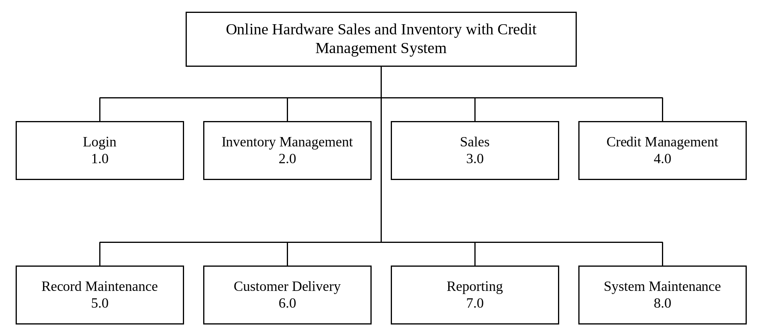
The figure above shows that the system has eight modules: Login (1.0), Inventory Management (2.0), Sales (3.0), Credit Management (4.0), Record Maintenance (5.0), Customer Delivery (6.0), Reporting (7.0) and System Maintenance (8.0).
Figure 2: Hierarchical Diagram of the Login Module
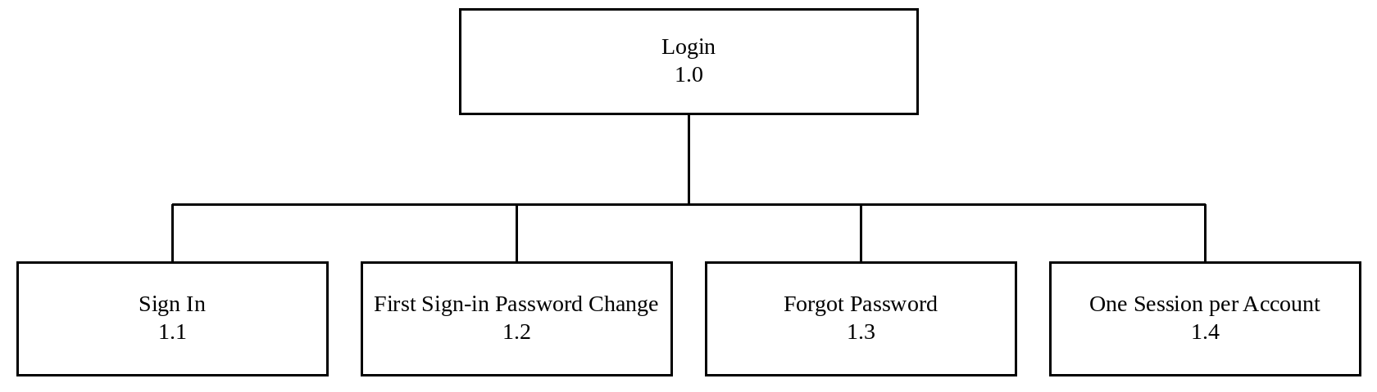
This module controls who can enter the system and keeps each account to one session.
1.1 Sign In
This section checks the email address and password and holds an account after three wrong passwords.
1.2 First Sign-in Password Change
This section makes a new user replace the generated temporary password.
1.3 Forgot Password
This section sends a six-digit code by email so that a user can set a new password.
1.4 One Session per Account
This section ends the other sessions of an account when it signs in again.
Figure 3: Hierarchical Diagram of the Inventory Management Module
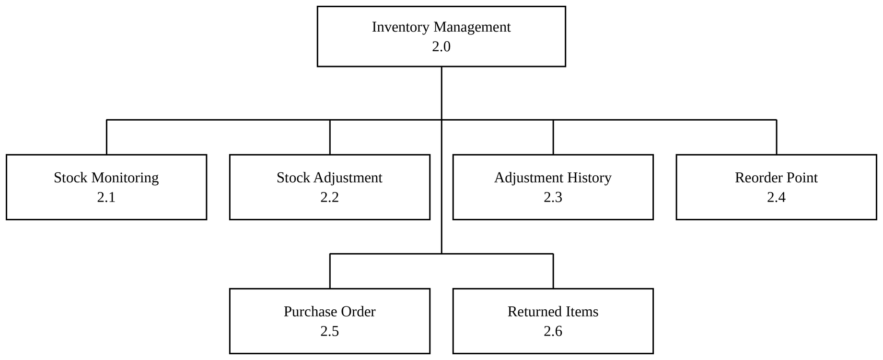
This module keeps the stock of the store accurate.
2.1 Stock Monitoring
This section shows the stock on hand of every material, updates it with every movement and opens the records of new materials.
2.2 Stock Adjustment
This section records manual corrections of stock with remarks, and adds returned goods back to stock or discards them.
2.3 Adjustment History
This section keeps the permanent log of stock corrections.
2.4 Reorder Point
This section keeps each material's reorder point, set by the Manager, and lists the materials at or below it.
2.5 Purchase Order
This section raises, approves, sends and receives orders to suppliers.
2.6 Returned Items
This section lists the returns, refunds and damage reports and where the goods went.
Figure 4: Hierarchical Diagram of the Sales Module
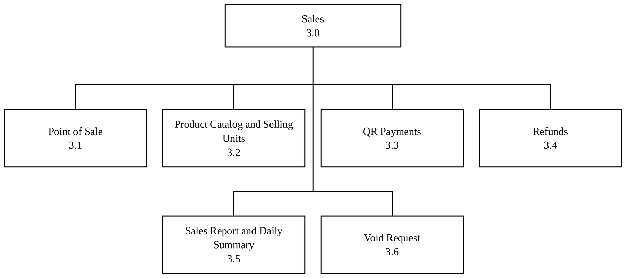
This module processes sales at the counter.
3.1 Point of Sale
This section rings up a sale, takes the payment and prints the sales invoice.
3.2 Product Catalog and Selling Units
This section lists the products and the sizes they are sold in.
3.3 QR Payments
This section takes GCash, PayMaya and bank transfer payments through PayMongo.
3.4 Refunds
This section records items taken back and refunded at the counter.
3.5 Sales Report and Daily Summary
This section shows the cashier's sales and the day's tally.
3.6 Void Request
This section sends a request to void a sale of the same day to the Manager.
Figure 5: Hierarchical Diagram of the Credit Management Module
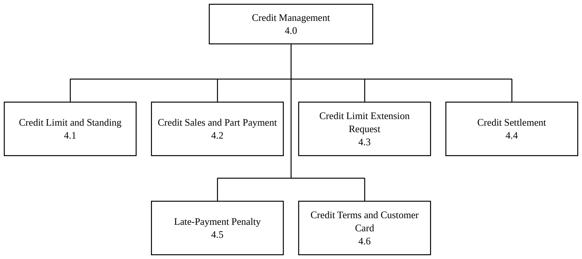
This module controls selling on account and collecting balances.
4.1 Credit Limit and Standing
This section keeps each account's credit limit and computes its standing.
4.2 Credit Sales and Part Payment
This section charges a sale, or the unpaid part of it, to the account.
4.3 Credit Limit Extension Request
This section sends a request for a higher limit to the Manager.
4.4 Credit Settlement
This section takes payments against unpaid sales and prints a receipt.
4.5 Late-Payment Penalty
This section charges a monthly penalty on overdue credit sales.
4.6 Credit Terms and Customer Card
This section prints the credit terms of a customer and the customer card.
Figure 6: Hierarchical Diagram of the Record Maintenance Module
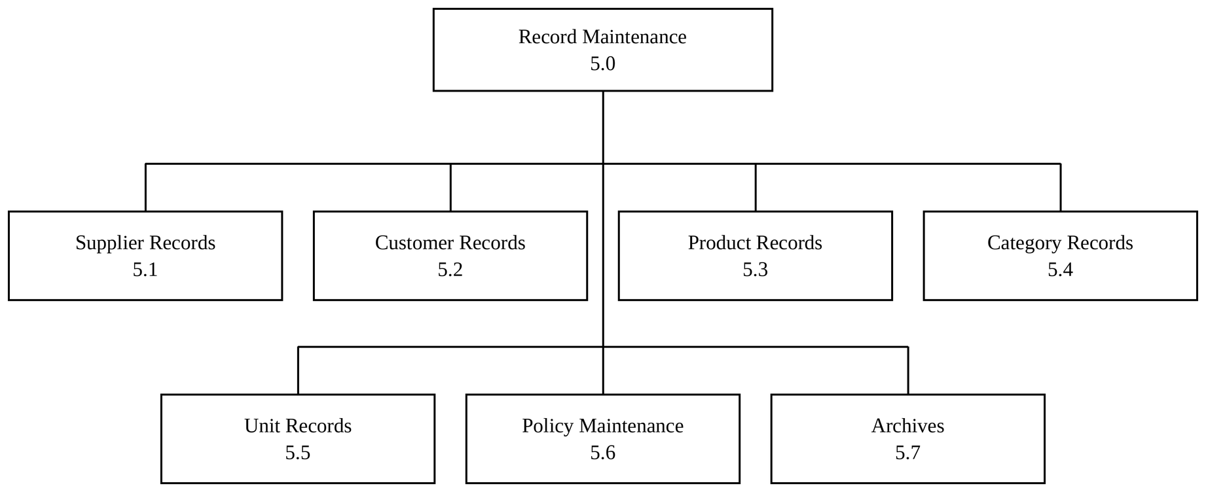
This module keeps the master records of the store.
5.1 Supplier Records
This section keeps the suppliers and their contact details.
5.2 Customer Records
This section keeps the customers and their accounts.
5.3 Product Records
This section keeps the products and their prices.
5.4 Category Records
This section keeps the product categories.
5.5 Unit Records
This section keeps the units of measurement.
5.6 Policy Maintenance
This section keeps the wording of the credit policy, the customer data terms and the refund policy.
5.7 Archives
This section keeps the archived records and restores them.
Figure 7: Hierarchical Diagram of the Customer Delivery Module
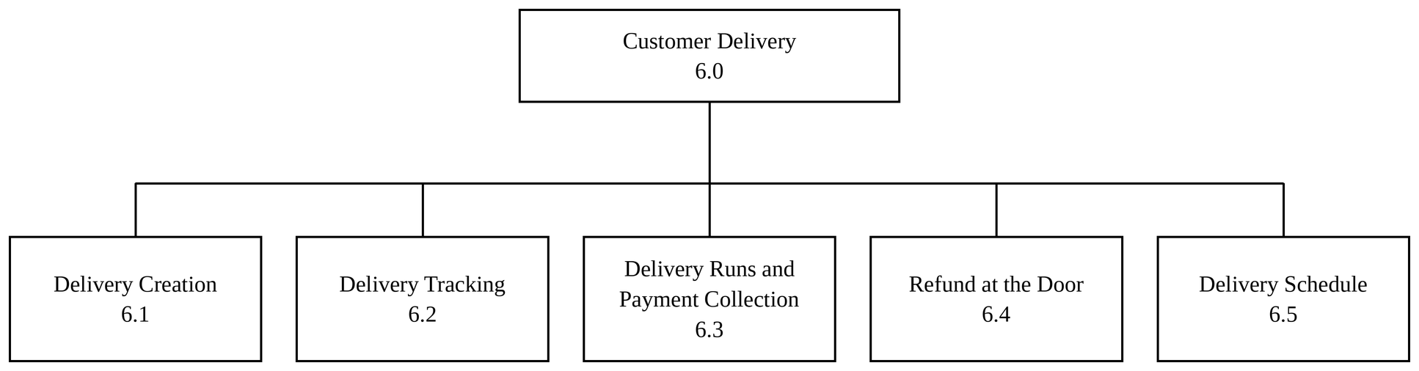
This module tracks deliveries and the money collected on them.
6.1 Delivery Creation
This section creates a delivery for a sale.
6.2 Delivery Tracking
This section follows each delivery through its statuses.
6.3 Delivery Runs and Payment Collection
This section gives the driver the list of deliveries and records the payment collected at the door.
6.4 Refund at the Door
This section records items refused by the customer at the door.
6.5 Delivery Schedule
This section groups the deliveries still to go out by day.
Figure 8: Hierarchical Diagram of the Reporting Module
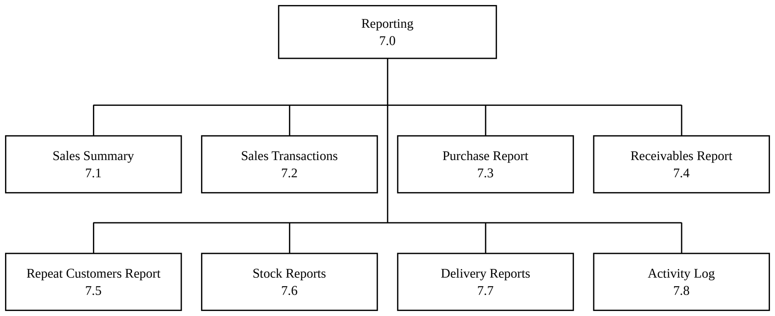
This module produces the reports of the store.
7.1 Sales Summary
This section summarizes the sales of a period by payment method.
7.2 Sales Transactions
This section lists every sale with its lines and payments.
7.3 Purchase Report
This section summarizes the purchase orders of a period.
7.4 Receivables Report
This section lists the sales with money still owed.
7.5 Repeat Customers Report
This section lists the customers who bought more than once.
7.6 Stock Reports
This section lists the stock, the reorder alerts and the stock movements.
7.7 Delivery Reports
This section shows each driver's deliveries and collections.
7.8 Activity Log
This section lists what the staff filed and when.
Figure 9: Hierarchical Diagram of the System Maintenance Module
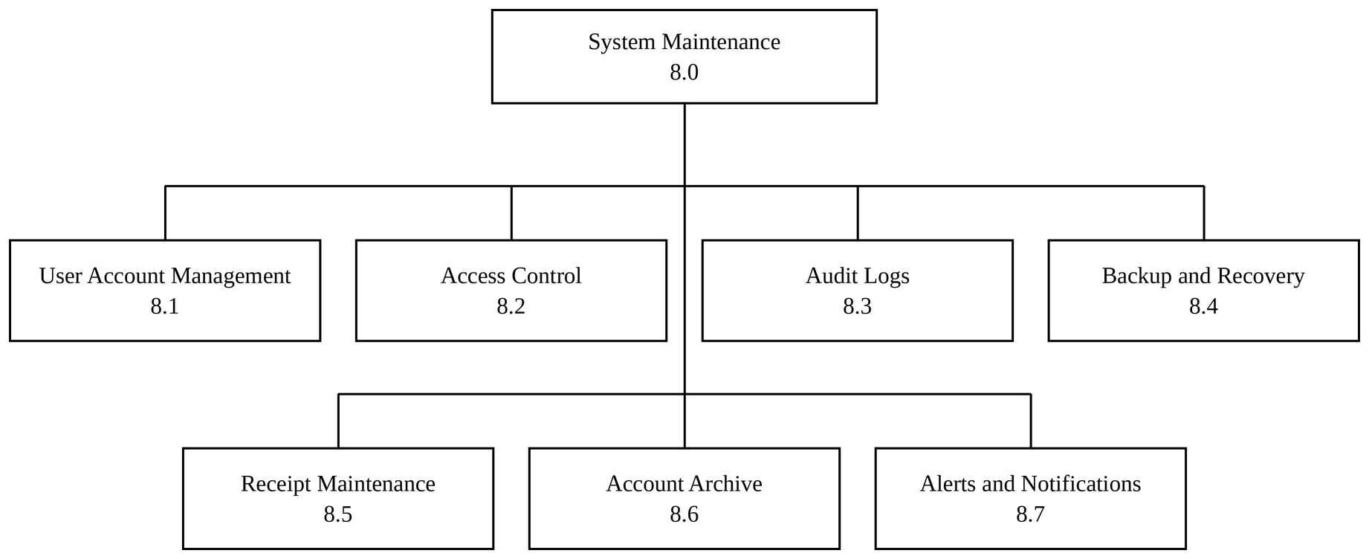
This module holds the tools for accounts, security and upkeep.
8.1 User Account Management
This section creates, edits, deactivates and resets staff accounts.
8.2 Access Control
This section switches the screens of each role on or off.
8.3 Audit Logs
This section shows the log of important actions.
8.4 Backup and Recovery
This section creates, downloads and restores backups.
8.5 Receipt Maintenance
This section keeps the store details and the layout of the receipt.
8.6 Account Archive
This section keeps the archived staff accounts.
8.7 Alerts and Notifications
This section shows the alerts of each role.

Design of Software, System, Product, and/or Processes
Figure 10: Spiral Model
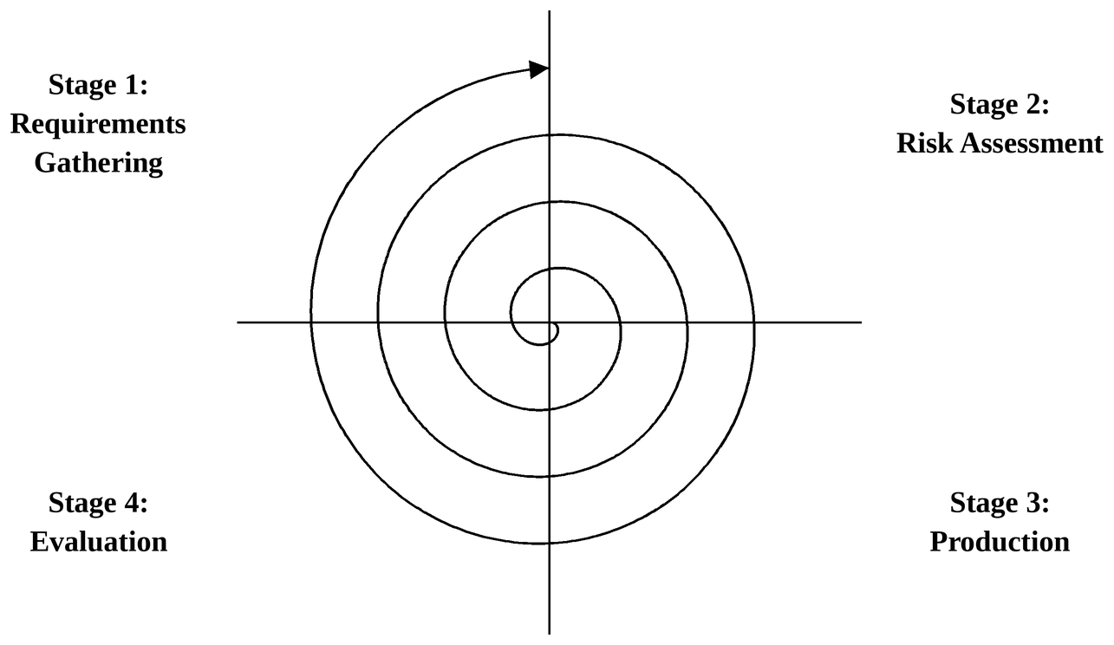
The developers followed the Spiral model, a risk-driven model in which the project passes through the same four stages again and again, and every loop of the spiral adds to the system until it is complete (Hashemi-Pour, 2025). The model suited the project because the requirements of the store were refined after every presentation to the beneficiary, and the riskiest parts, such as the payments, the credit rules and the stock figures, could be tried early and checked again in later loops.
Stage 1: Requirements Gathering
In this first quadrant of each loop, the developers worked closely with Lucelyn Hardware to gather and understand the requirements. The owner was interviewed about the manual processes of the store, its products, suppliers, receipts, credit and returns, and samples of its sales invoice, delivery receipt, inventory record and sales record were collected. The objectives of the loop were identified, the alternatives were explored, and the limitations were set.
Stage 2: Risk Assessment
In this quadrant, the possible solutions were explored and evaluated in order to select the best option. The risks of the selected option were identified and addressed, such as lost sales when a payment fails, wrong balances when two screens change the same record, and stock that goes negative. The developers reduced them with stored procedures that lock the rows they change, payments that are recorded only after PayMongo confirms them, and screens that ask before an action that cannot be taken back.
Stage 3: Production
In this quadrant, the developers built the part of the system planned for the loop, module by module: sign-in and accounts, inventory and purchase orders, the point of sale, credit management, deliveries, reports and system maintenance. The developers wrote the code together and tested each function as it was finished to make sure that the system meets the required standards and works as intended.
Stage 4: Evaluation
In this final quadrant, the developers presented the system to the owner of Lucelyn Hardware and gathered feedback on the screens and the processes. Based on the feedback, the system was evaluated and the developers returned to the earlier quadrants for another loop when changes were needed, until the owner accepted the system in user acceptance testing.

Entity Diagrams
Figure 11: Diagram of Employee Entity
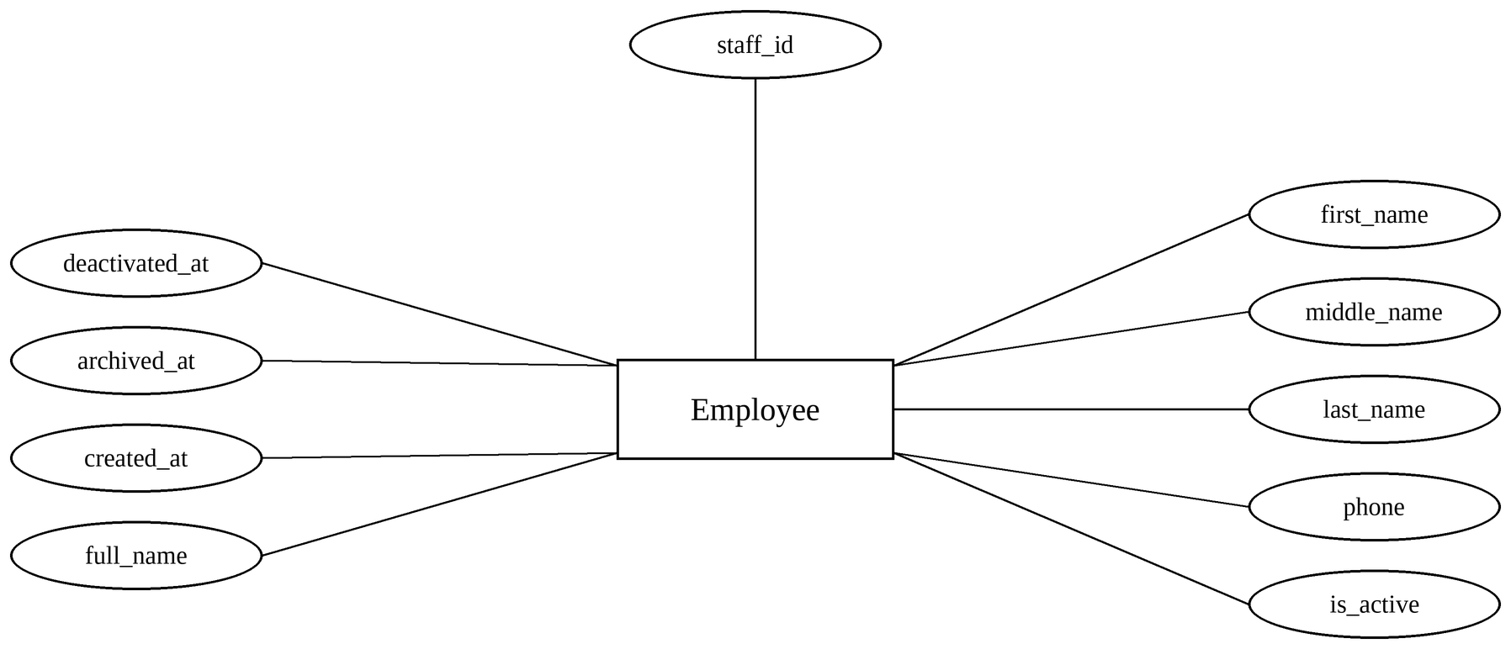
The figure above shows the Employee entity, which represents the staff members of the store. Employee attributes include staff_id, first_name, middle_name, last_name, phone, is_active, deactivated_at, archived_at, created_at, and full_name.
Figure 12: Diagram of User Entity
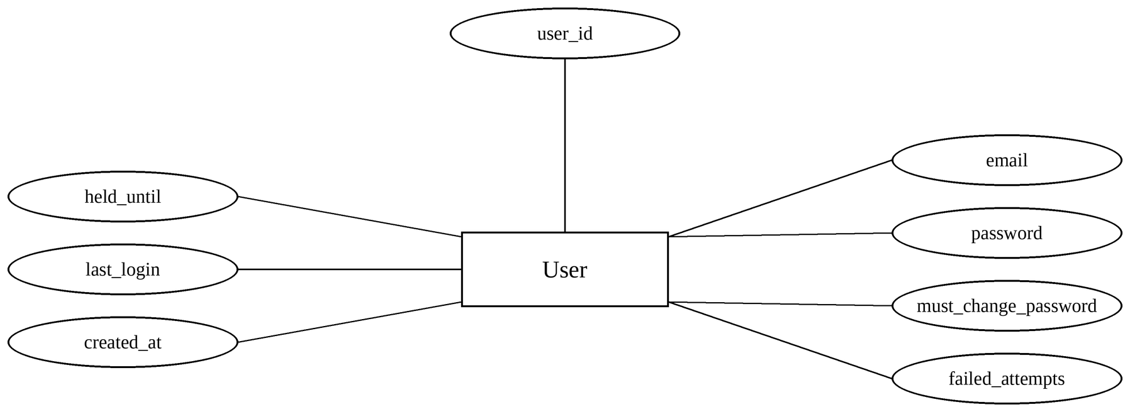
The figure above shows the User entity, which contains the login accounts of the staff members. Its attributes are user_id, email, password, must_change_password, failed_attempts, held_until, last_login, and created_at.
Figure 13: Diagram of Category Entity
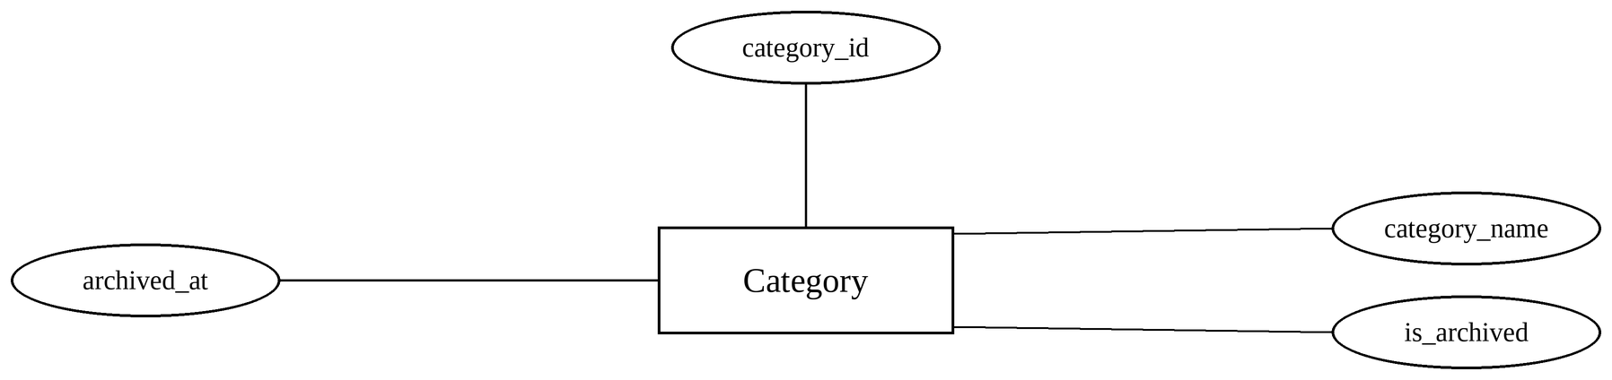
The figure above shows the Category entity, which contains the product categories. Its attributes are category_id, category_name, is_archived, and archived_at.
Figure 14: Diagram of Unit Entity
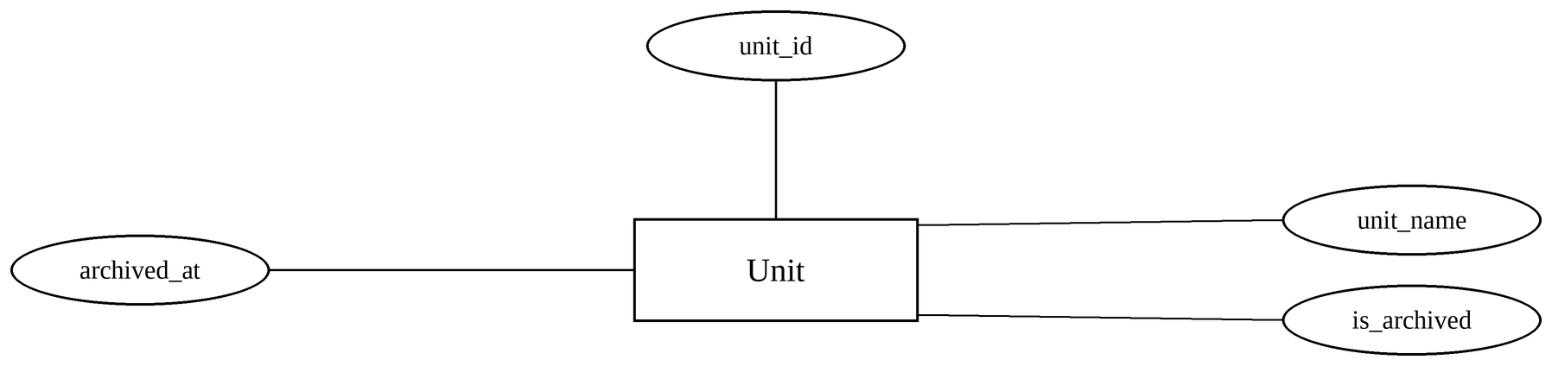
The figure above shows the Unit entity, which contains the units of measurement. Its attributes are unit_id, unit_name, is_archived, and archived_at.
Figure 15: Diagram of Product Entity
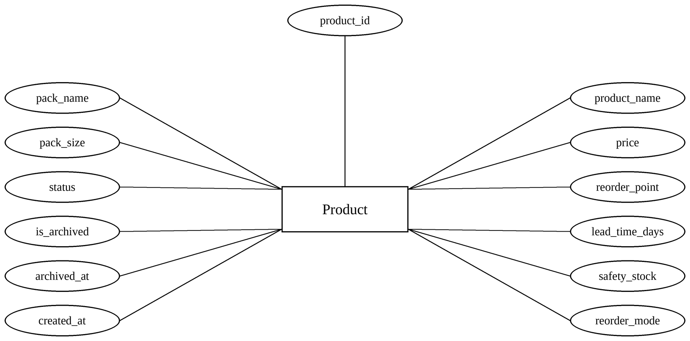
The figure above shows the Product entity, which contains the materials sold by the store. Its attributes are product_id, product_name, price, reorder_point, lead_time_days, safety_stock, reorder_mode, pack_name, pack_size, status, is_archived, archived_at, and created_at.
Figure 16: Diagram of Supplier Entity
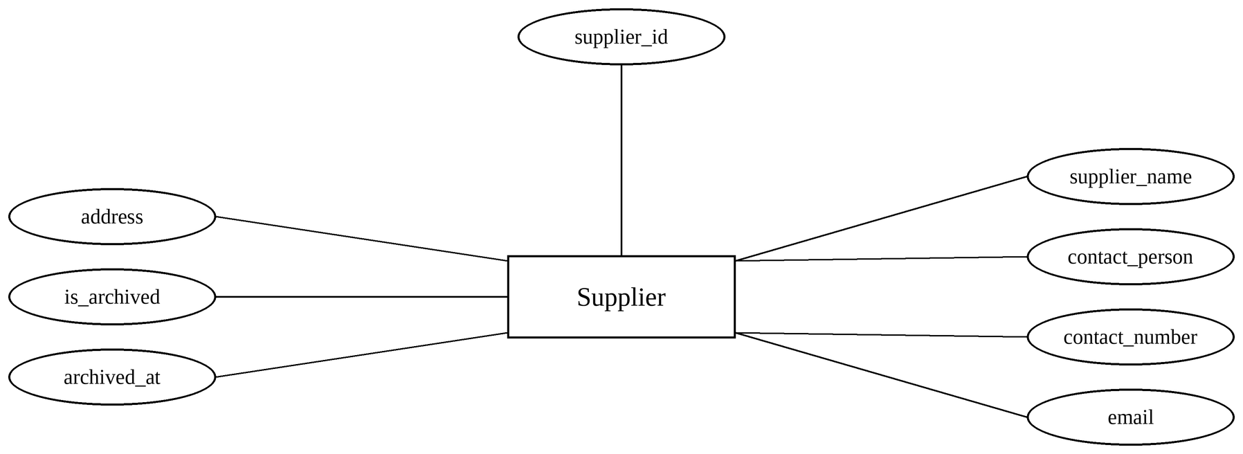
The figure above shows the Supplier entity, which contains the suppliers of the store. Its attributes are supplier_id, supplier_name, contact_person, contact_number, email, address, is_archived, and archived_at.
Figure 17: Diagram of Customer Entity
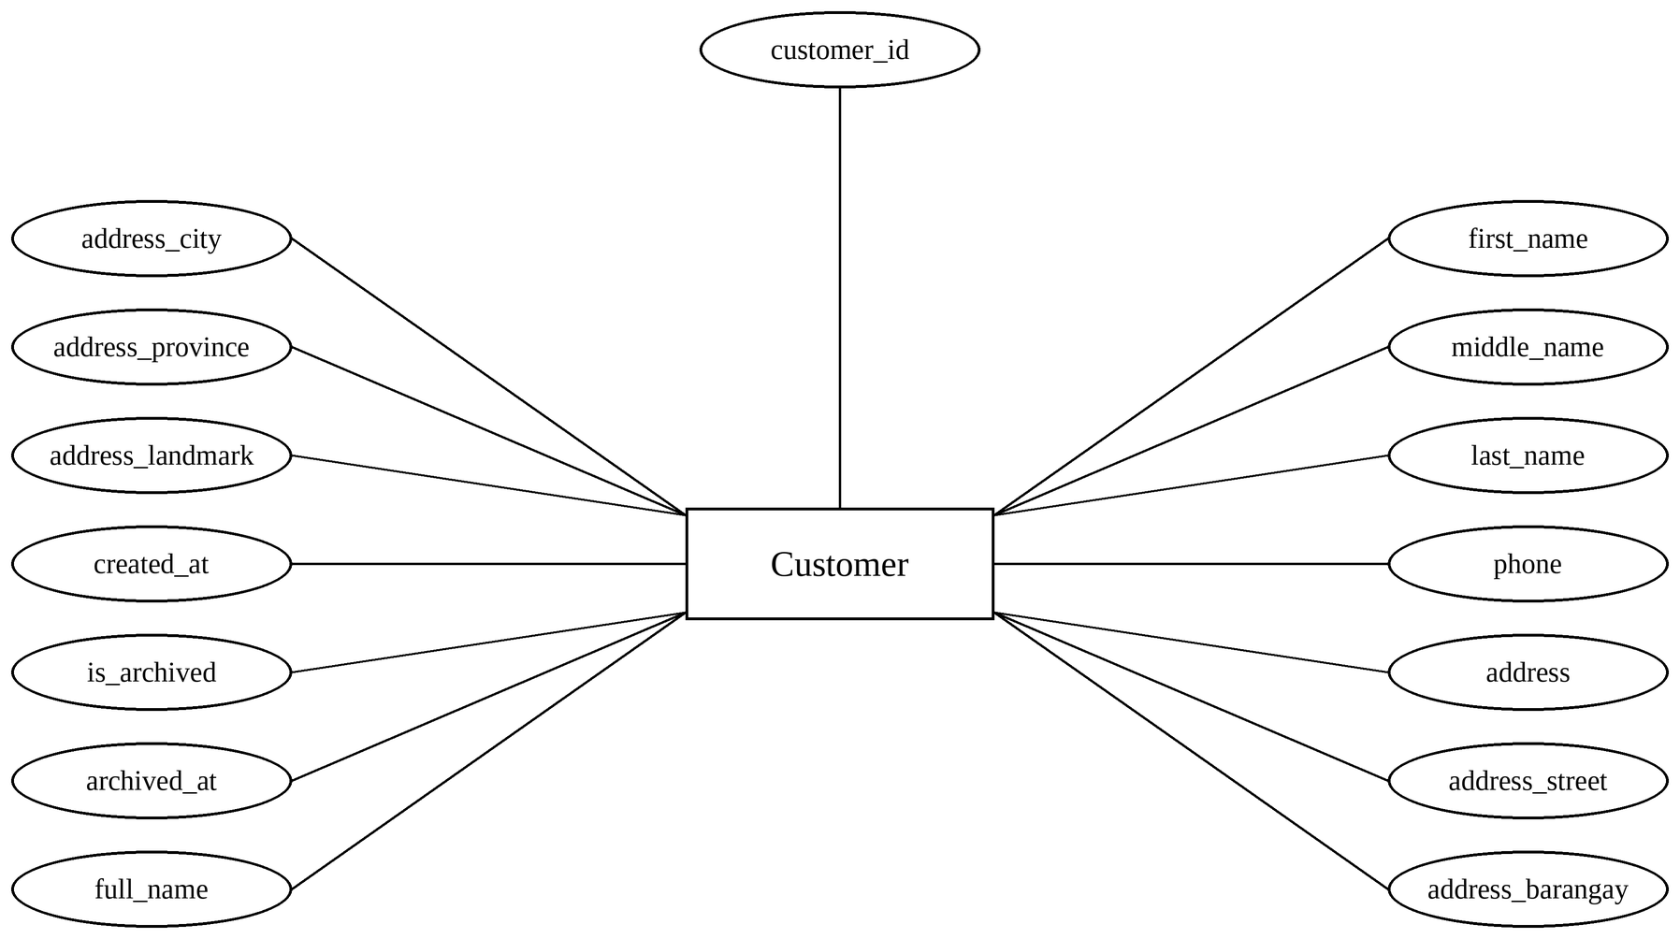
The figure above shows the Customer entity, which contains the customers of the store. Its attributes are customer_id, first_name, middle_name, last_name, phone, address, address_street, address_barangay, address_city, address_province, address_landmark, created_at, is_archived, archived_at, and full_name.
Figure 18: Diagram of Sale Entity
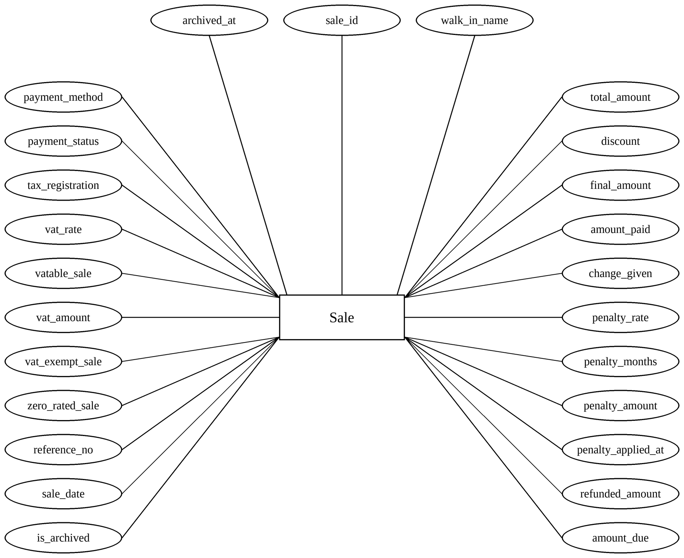
The figure above shows the Sale entity, which contains the sales rung up at the counter. Its attributes are sale_id, walk_in_name, total_amount, discount, final_amount, amount_paid, change_given, penalty_rate, penalty_months, penalty_amount, penalty_applied_at, refunded_amount, amount_due, payment_method, payment_status, tax_registration, vat_rate, vatable_sale, vat_amount, vat_exempt_sale, zero_rated_sale, reference_no, sale_date, is_archived, and archived_at.
Figure 19: Diagram of Purchase Order Entity
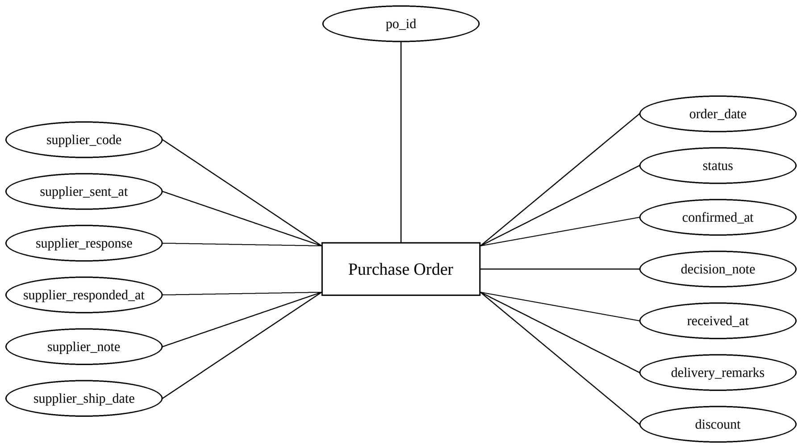
The figure above shows the Purchase Order entity, which contains the orders placed with the suppliers. Its attributes are po_id, order_date, status, confirmed_at, decision_note, received_at, delivery_remarks, discount, supplier_code, supplier_sent_at, supplier_response, supplier_responded_at, supplier_note, and supplier_ship_date.
Figure 20: Diagram of Delivery Entity
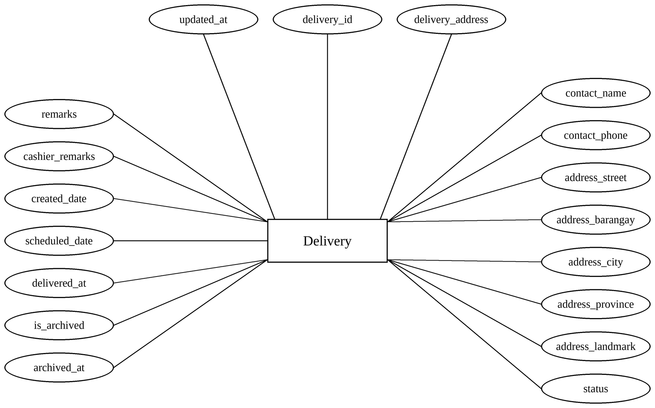
The figure above shows the Delivery entity, which contains the deliveries created with the sales. Its attributes are delivery_id, delivery_address, contact_name, contact_phone, address_street, address_barangay, address_city, address_province, address_landmark, status, remarks, cashier_remarks, created_date, scheduled_date, delivered_at, is_archived, archived_at, and updated_at.

Entity Relationship Diagrams
Figure 21: Diagram of Employee and User Relationship
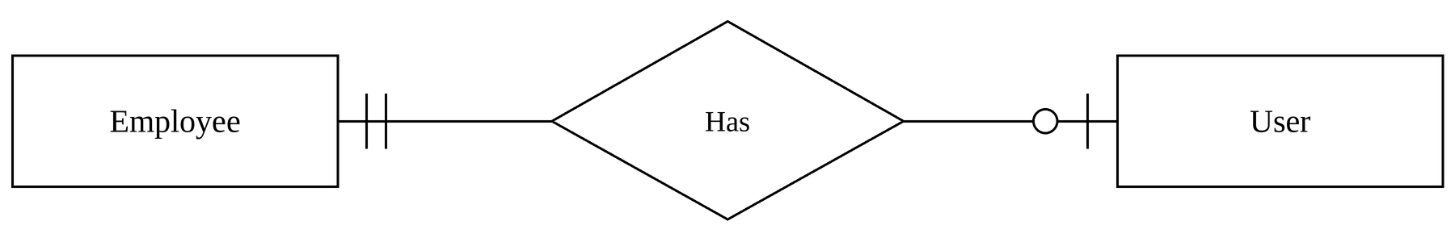
The figure above shows the relationship between Employee and User. It is a one-to-one relationship indicating that an employee has at most one user account, and each user account belongs to only one employee.
Figure 22: Diagram of Category and Product Relationship
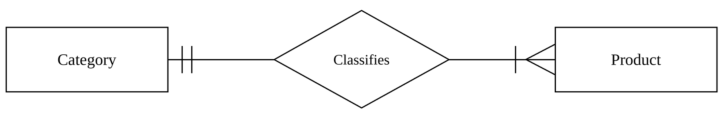
The figure above shows the relationship between Category and Product. It is a one-to-many relationship indicating that a category can classify many products, while each product belongs to only one category.
Figure 23: Diagram of Unit and Product Relationship
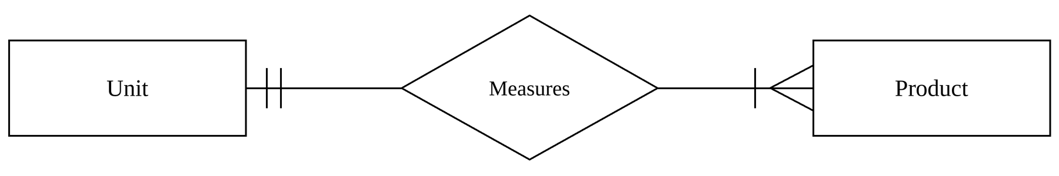
The figure above shows the relationship between Unit and Product. It is a one-to-many relationship indicating that a unit can measure many products, while each product has only one unit.
Figure 24: Diagram of Supplier and Product Relationship
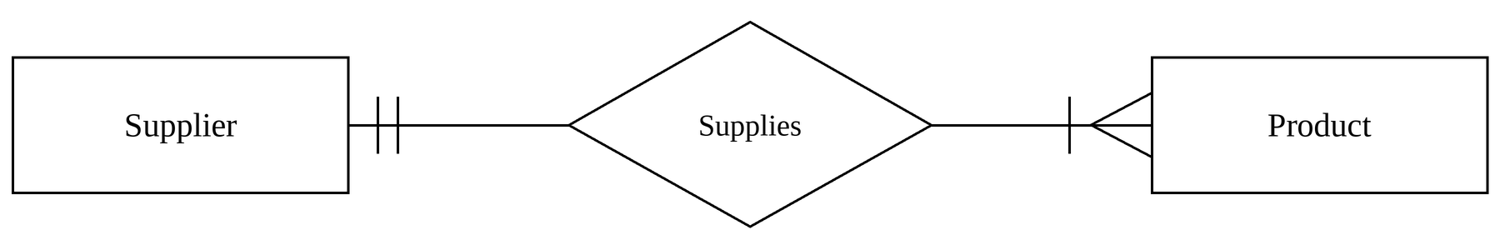
The figure above shows the relationship between Supplier and Product. It is a one-to-many relationship indicating that a supplier can supply many products, while each product has one usual supplier.
Figure 25: Diagram of Supplier and Purchase Order Relationship
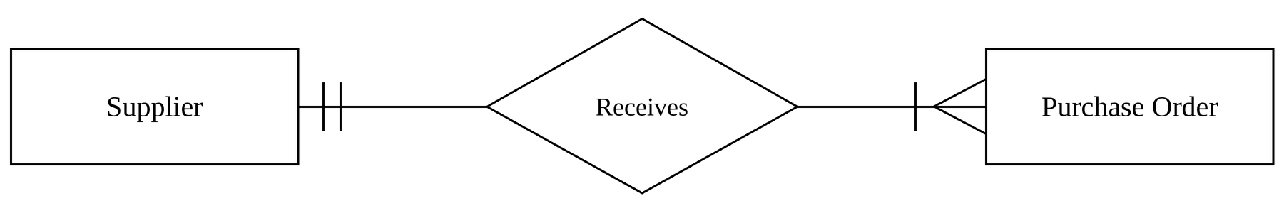
The figure above shows the relationship between Supplier and Purchase Order. It is a one-to-many relationship indicating that a supplier can receive many purchase orders, while each purchase order is placed with only one supplier.
Figure 26: Diagram of Employee and Purchase Order Relationship
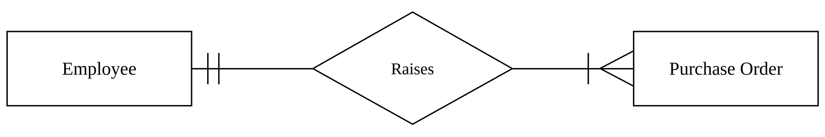
The figure above shows the relationship between Employee and Purchase Order. It is a one-to-many relationship indicating that an employee can raise many purchase orders, while each purchase order is raised by only one employee. A purchase order is also approved by one manager in the same way.
Figure 27: Diagram of Purchase Order and Product Relationship
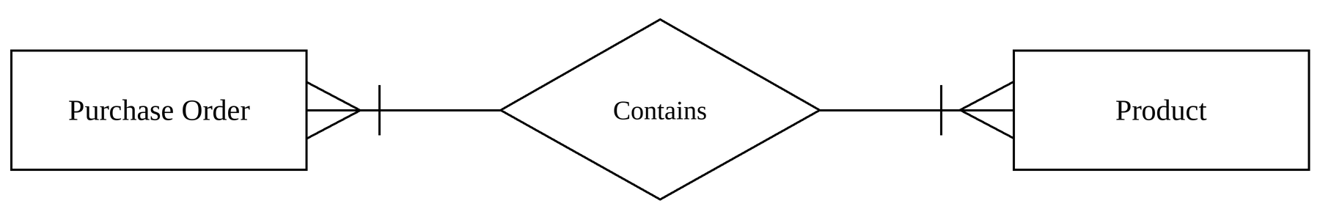
The figure above shows the relationship between Purchase Order and Product. It is a many-to-many relationship indicating that a purchase order can contain many products, while a product can be included in many purchase orders.
Figure 28: Diagram of Customer and Sale Relationship
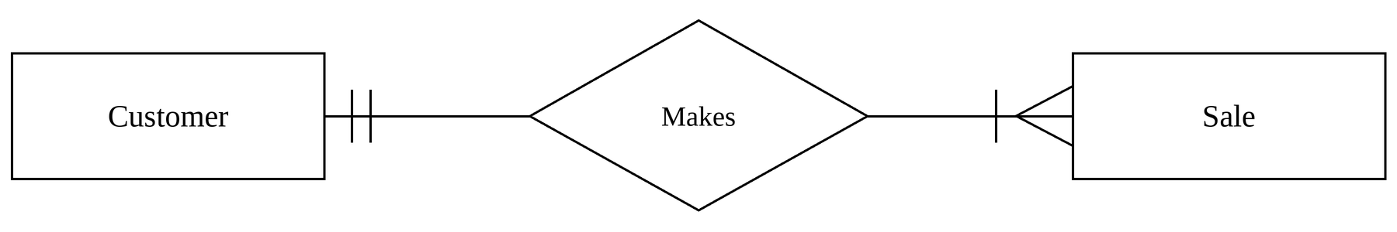
The figure above shows the relationship between Customer and Sale. It is a one-to-many relationship indicating that a customer can make many sales, while each sale on record belongs to only one customer. A walk-in sale has no customer.
Figure 29: Diagram of Employee and Sale Relationship
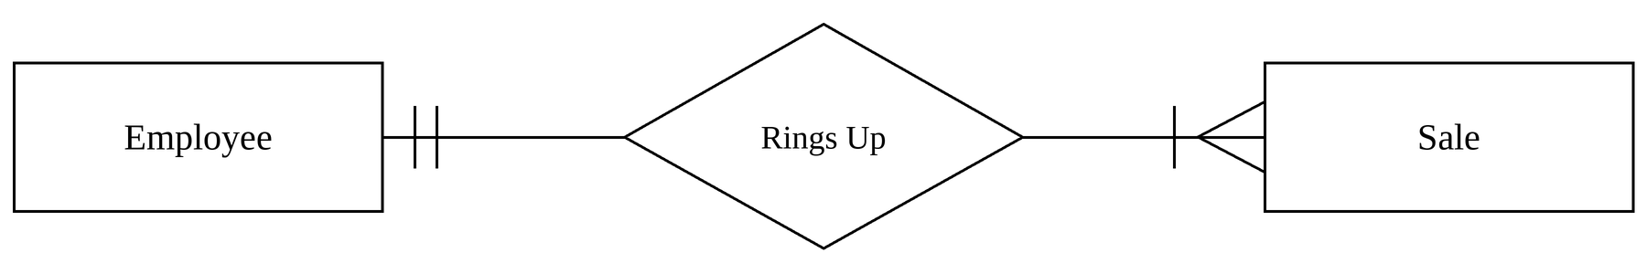
The figure above shows the relationship between Employee and Sale. It is a one-to-many relationship indicating that a cashier can ring up many sales, while each sale is rung up by only one cashier.
Figure 30: Diagram of Sale and Product Relationship
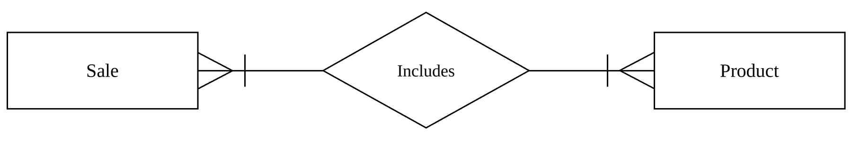
The figure above shows the relationship between Sale and Product. It is a many-to-many relationship indicating that a sale can include many products, while a product can be included in many sales.
Figure 31: Diagram of Sale and Delivery Relationship
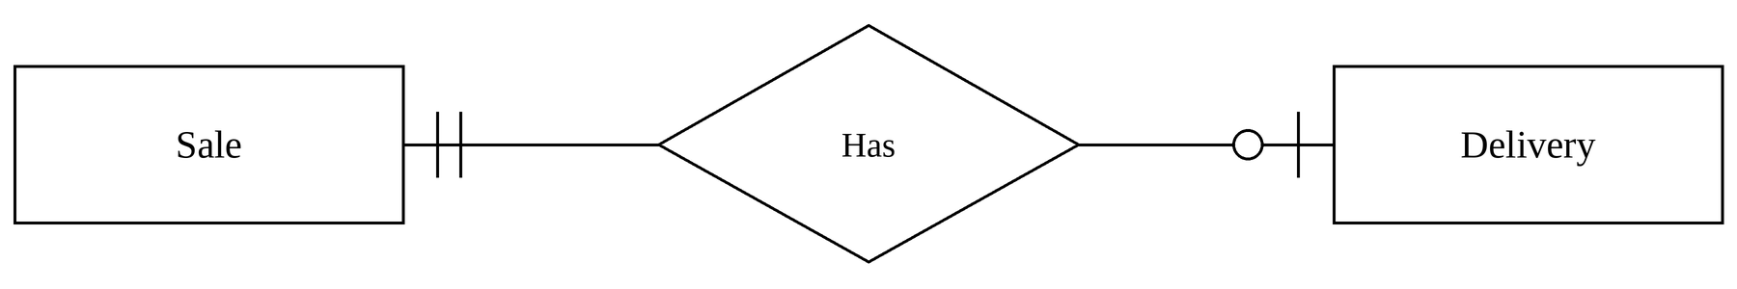
The figure above shows the relationship between Sale and Delivery. It is a one-to-one relationship indicating that a sale has at most one delivery, and each delivery is for only one sale.
Figure 32: Diagram of Employee and Delivery Relationship
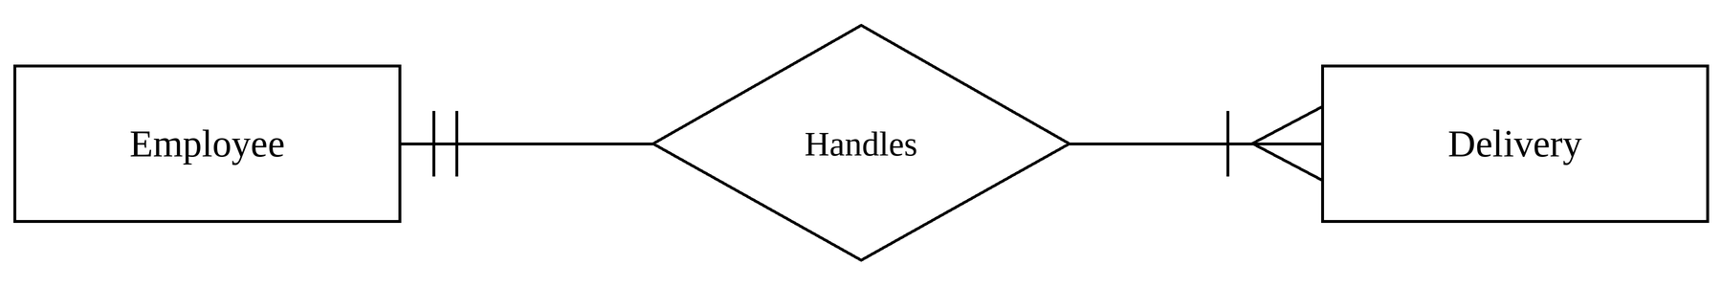
The figure above shows the relationship between Employee and Delivery. It is a one-to-many relationship indicating that a delivery personnel can handle many deliveries, while each delivery is assigned to only one delivery personnel.

Data Flow Diagram
Figure 33: Context Diagram of the Online Hardware Sales and Inventory with Credit Management System
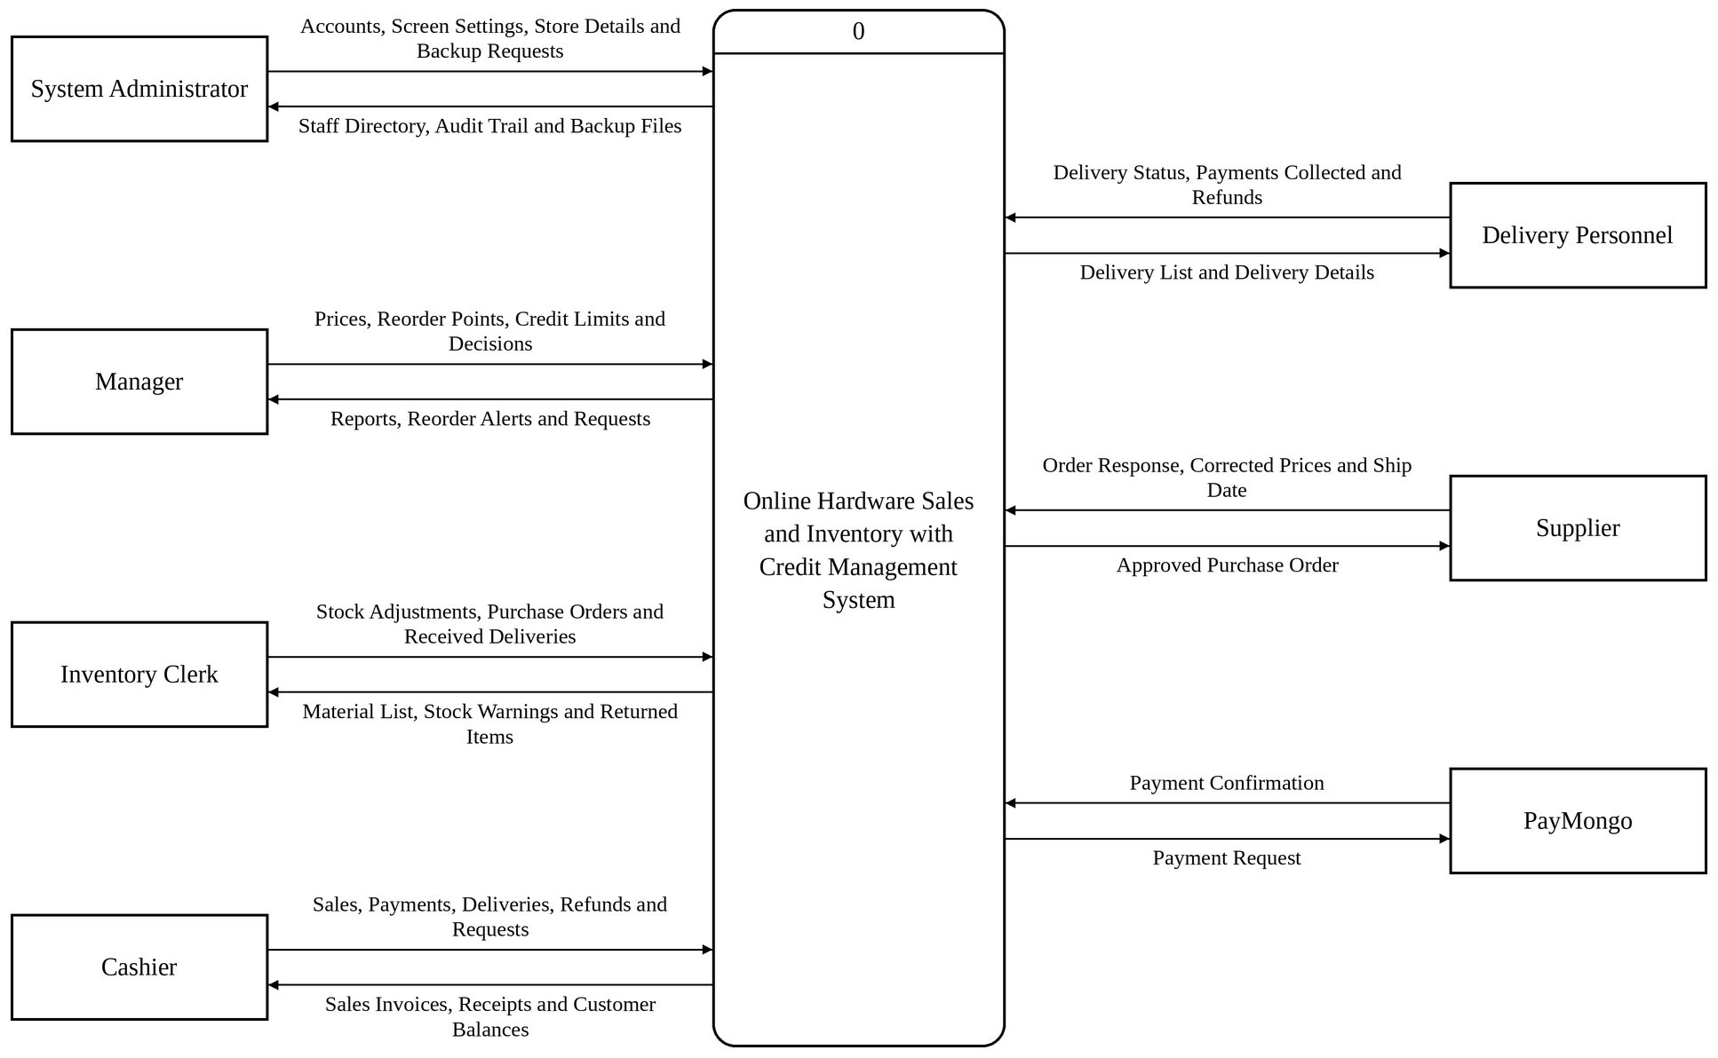
The context diagram above shows the whole system as a single process and every external entity that exchanges data with it: the System Administrator, the Manager, the Inventory Clerk, the Cashier, the Delivery Personnel, the suppliers, who answer purchase orders through a link, and PayMongo, which confirms the GCash, PayMaya and bank transfer payments.
Figure 34: Data Flow Diagram for the System Administrator
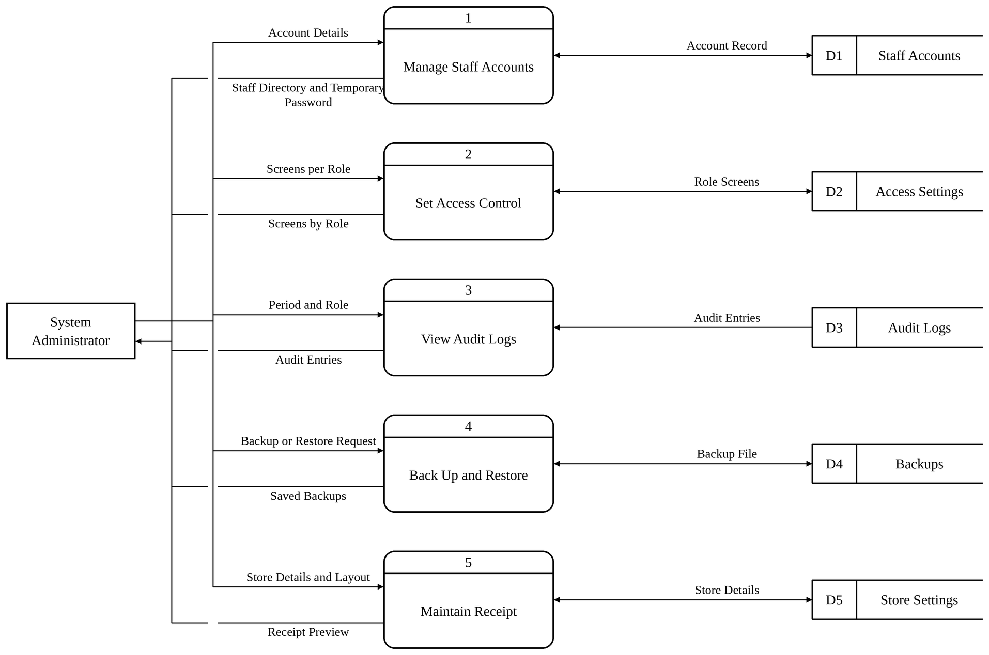
The System Administrator will be able to create, edit, deactivate and reset the staff accounts, switch the screens of each role on or off in Access Control, view the audit trail by period and role, back up and restore the database, and keep the store details and the layout of the receipt.
Figure 35: Data Flow Diagram for the Manager
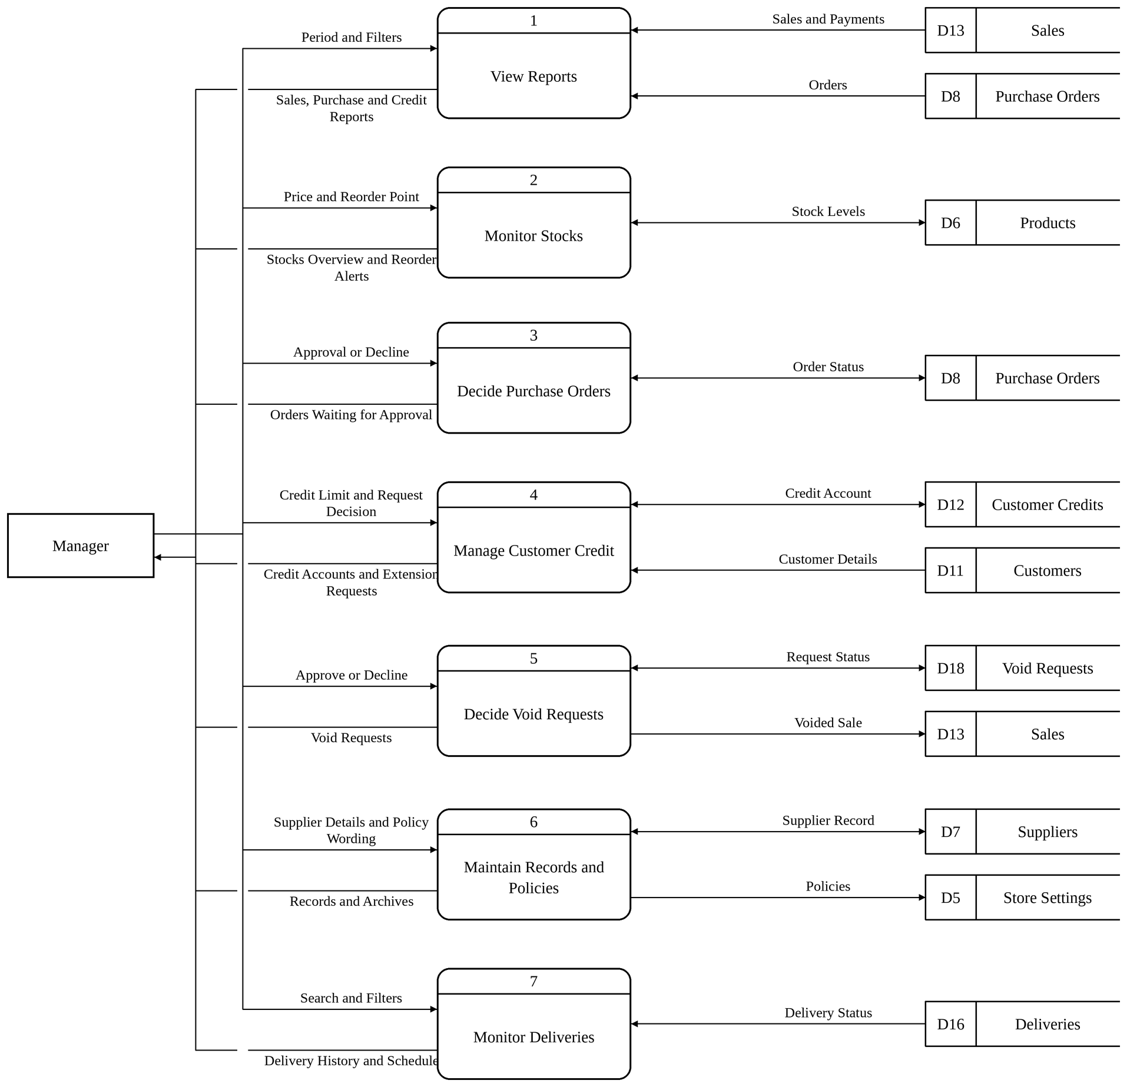
The Manager will be able to view the sales, purchase and credit reports, set the price and the reorder point of each material and watch the reorder alerts, approve or decline purchase orders, decide the credit limit extension requests and the void requests of the cashiers, keep the supplier records and the wording of the policies, and follow the deliveries.
Figure 36: Data Flow Diagram for the Inventory Clerk
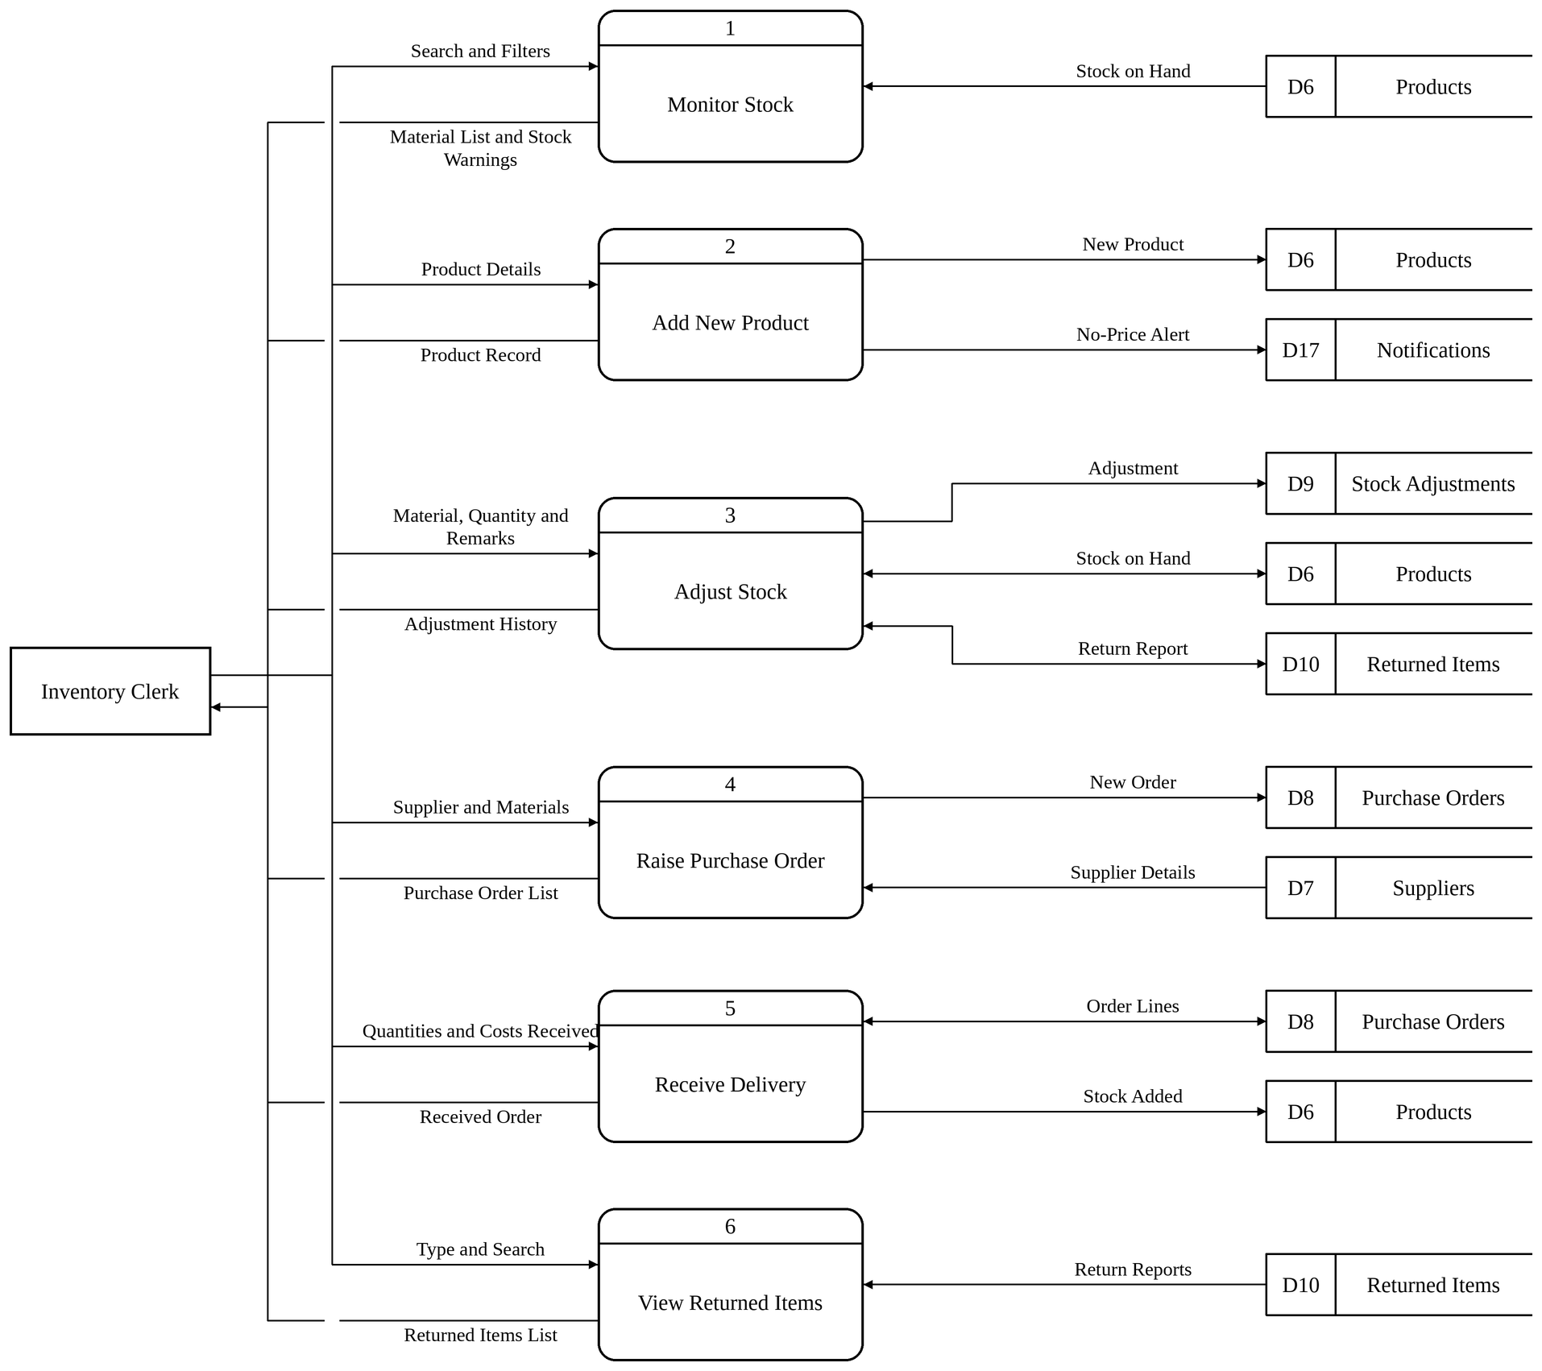
The Inventory Clerk will be able to monitor the stock on the material list, open the record of a new product, adjust the stock with remarks, including adding returned goods back or discarding them, raise purchase orders, receive the deliveries against them, and view the returned items.
Figure 37: Data Flow Diagram for the Cashier
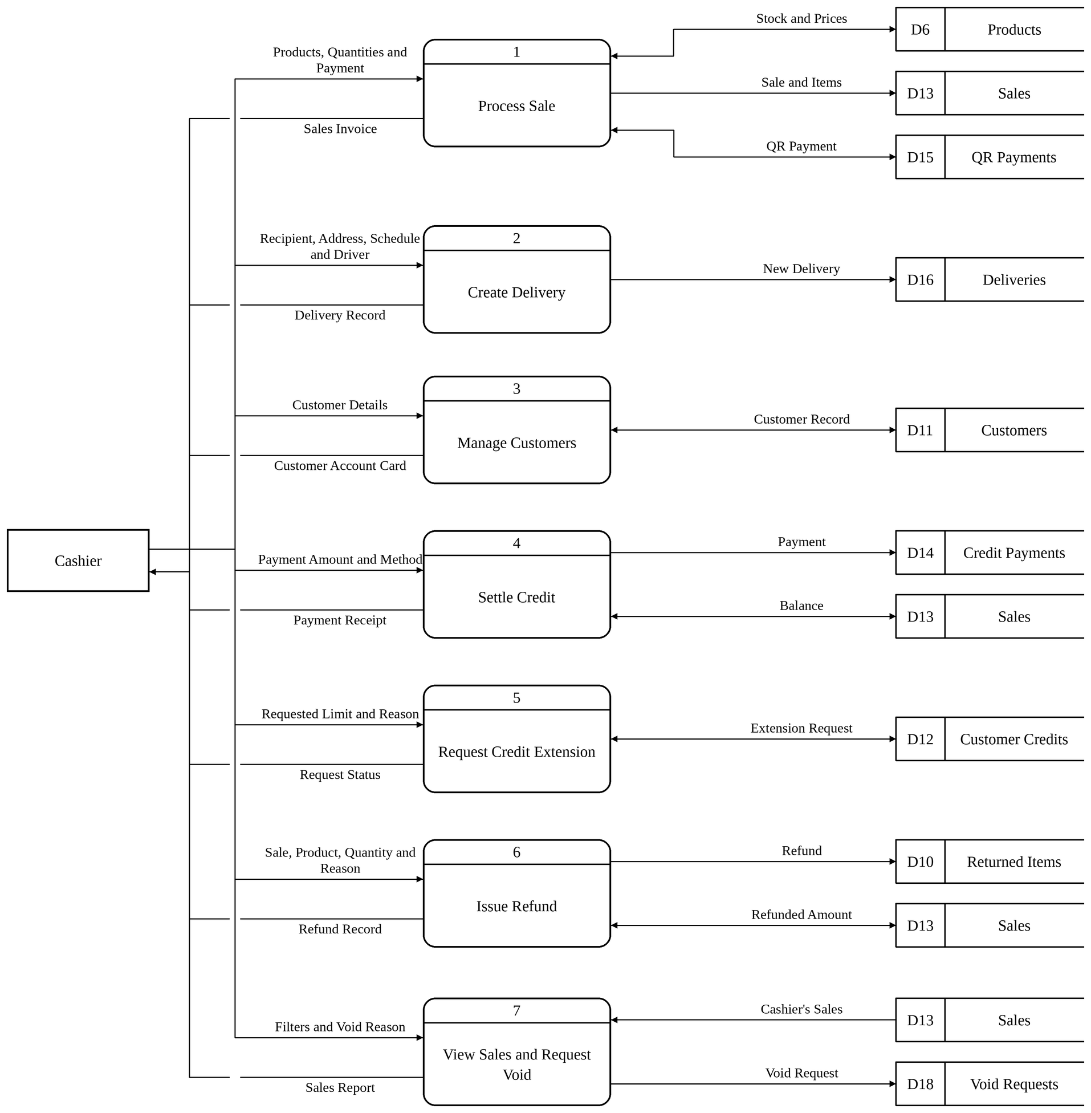
The Cashier will be able to ring up sales with cash, cheque, GCash, PayMaya, bank transfer or credit payments, create the delivery of a sale, add and edit customers, take payments on balances through Credit Settlement, ask for a higher credit limit, issue refunds, and view the sales report and request the void of a sale of the same day.
Figure 38: Data Flow Diagram for the Delivery Personnel
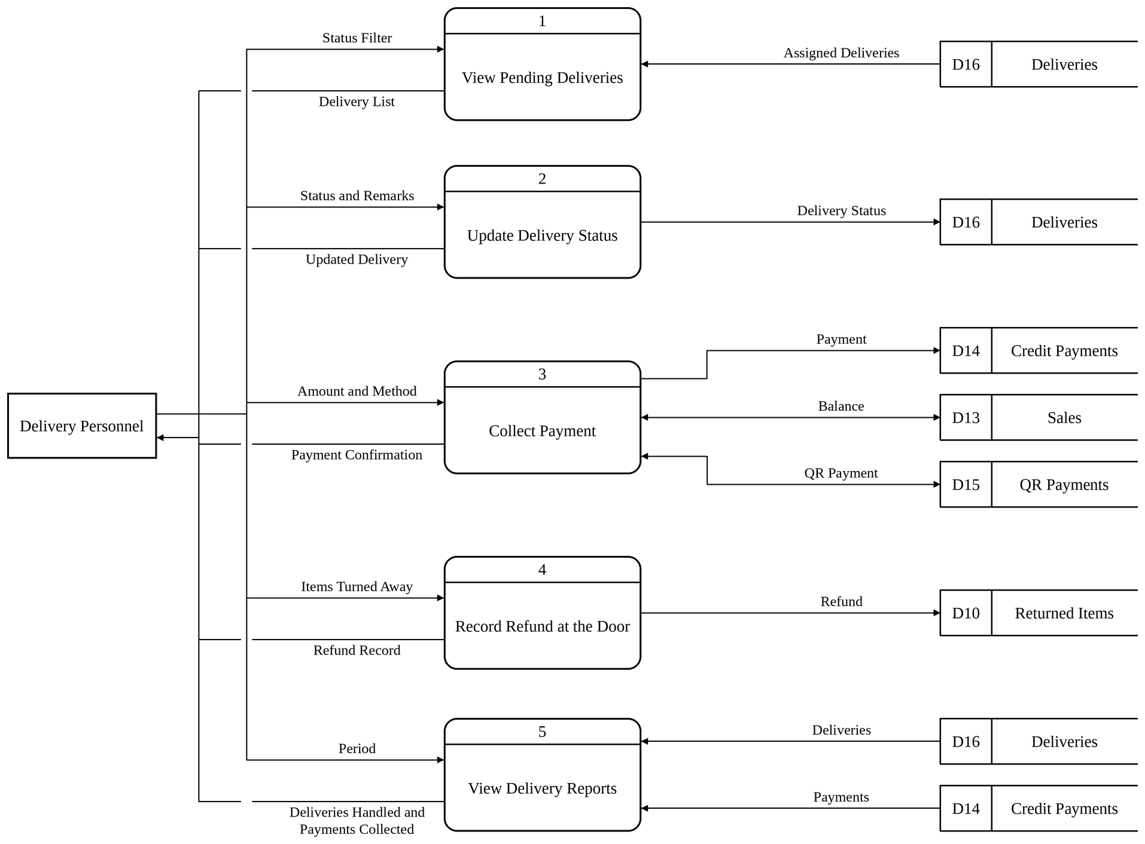
The Delivery Personnel will be able to view the pending deliveries assigned to them, update the status of each delivery, collect the payment of a Cash on Delivery order at the door, record a refund for items turned away, and view the deliveries handled and the payments collected over a period.
Figure 39: Data Flow Diagram for the Supplier
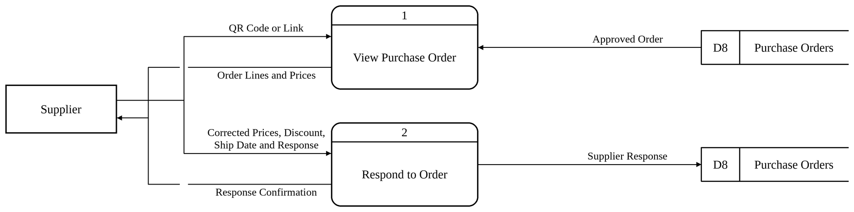
The supplier will be able to open an approved purchase order from its QR code or link without signing in, check the lines and prices, and accept the order with a ship date or decline it with a reason.

Data Dictionary
Table 1. Data Dictionary for roles
Name: | roles
Description: | It is the list of the five user roles of the system: System Administrator, Manager, Inventory Clerk, Cashier and Delivery Personnel.
Contents: | roles = (role_id + role_name)
 | Field Name | Data Type | Description
 | role_id | INT | Primary key. Unique number given automatically to each record.
 | role_name | VARCHAR(50) | Name of the role.
The table above describes roles. It is the list of the five user roles of the system: System Administrator, Manager, Inventory Clerk, Cashier and Delivery Personnel.
Table 2. Data Dictionary for staff
Name: | staff
Description: | It holds the personal record of every member of the staff, the role assigned to the person and whether the account is active, deactivated or archived.
Contents: | staff = (staff_id + first_name + middle_name + last_name + phone + role_id + is_active + deactivated_at + archived_at + archived_by_staff_id + created_at + full_name)
 | Field Name | Data Type | Description
 | staff_id | INT | Primary key. Unique number given automatically to each record.
 | first_name | VARCHAR(100) | First name of the staff member.
 | middle_name | VARCHAR(100) | Whole middle name of the staff member; only the initial is printed.
 | last_name | VARCHAR(100) | Last name of the staff member.
 | phone | VARCHAR(20) | Philippine mobile number, stored as +639XXXXXXXXX.
 | role_id | INT | Links the staff member to the roles table.
 | is_active | BOOLEAN | Shows whether the record is in use (1) or deactivated (0).
 | deactivated_at | TIMESTAMP | Date and time the account was deactivated; the account is archived 30 days later.
 | archived_at | TIMESTAMP | Date and time the record was archived.
 | archived_by_staff_id | INT | Links the record to the staff member who archived it.
 | created_at | TIMESTAMP | Date and time the record was created.
 | full_name | VARCHAR(220) | Name as printed everywhere, built from the first name, middle initial and last name. (computed)
The table above describes staff. It holds the personal record of every member of the staff, the role assigned to the person and whether the account is active, deactivated or archived.
Table 3. Data Dictionary for users
Name: | users
Description: | It holds the login account of each staff member: the email address used to sign in, the hashed password and the sign-in hold that follows repeated wrong passwords.
Contents: | users = (user_id + staff_id + email + password + must_change_password + failed_attempts + held_until + last_login + created_at)
 | Field Name | Data Type | Description
 | user_id | INT | Primary key. Unique number given automatically to each record.
 | staff_id | INT | Links the account to the staff table; one account for each staff member.
 | email | VARCHAR(100) | Email address used to sign in; must be unique.
 | password | VARCHAR(255) | Salted scrypt hash of the password; the password itself is never stored.
 | must_change_password | BOOLEAN | Shows that the user must choose a new password at the next sign-in.
 | failed_attempts | INT | Number of wrong passwords entered in a row.
 | held_until | TIMESTAMP | Date and time until which sign-in is held after too many wrong passwords.
 | last_login | TIMESTAMP | Date and time of the last successful sign-in.
 | created_at | TIMESTAMP | Date and time the record was created.
The table above describes users. It holds the login account of each staff member: the email address used to sign in, the hashed password and the sign-in hold that follows repeated wrong passwords.
Table 4. Data Dictionary for password_resets
Name: | password_resets
Description: | It records every six-digit code sent through "Forgot your password?", keeping only the hash of the code, its expiry and the number of tries.
Contents: | password_resets = (reset_id + user_id + code_hash + expires_at + attempts + used_at + requested_ip + created_at)
 | Field Name | Data Type | Description
 | reset_id | INT | Primary key. Unique number given automatically to each record.
 | user_id | INT | Links the code to the users table.
 | code_hash | VARCHAR(255) | Hash of the six-digit code sent by email.
 | expires_at | TIMESTAMP | Date and time the code stops working (15 minutes).
 | attempts | INT | Number of wrong tries of the code.
 | used_at | TIMESTAMP | Date and time the code was used or replaced.
 | requested_ip | VARCHAR(45) | IP address that asked for the code.
 | created_at | TIMESTAMP | Date and time the record was created.
The table above describes password_resets. It records every six-digit code sent through "Forgot your password?", keeping only the hash of the code, its expiry and the number of tries.
Table 5. Data Dictionary for role_feature_permissions
Name: | role_feature_permissions
Description: | It records the screens that the System Administrator switched on or off for a role in Access Control, beyond what the role holds by default.
Contents: | role_feature_permissions = (permission_id + role_id + feature_key + is_granted + note + granted_by_staff_id + granted_at + updated_at)
 | Field Name | Data Type | Description
 | permission_id | INT | Primary key. Unique number given automatically to each record.
 | role_id | INT | Links the setting to the roles table.
 | feature_key | VARCHAR(40) | Key of the screen in the screen catalogue, such as refunds or delivery-schedule.
 | is_granted | BOOLEAN | Shows whether the screen is switched on (1) or off (0) for the role.
 | note | VARCHAR(255) | Remark entered with the change.
 | granted_by_staff_id | INT | Links the setting to the administrator who made it.
 | granted_at | TIMESTAMP | Date and time the setting was made.
 | updated_at | TIMESTAMP | Date and time the record was last changed.
The table above describes role_feature_permissions. It records the screens that the System Administrator switched on or off for a role in Access Control, beyond what the role holds by default.
Table 6. Data Dictionary for user_sessions
Name: | user_sessions
Description: | It keeps the sign-ins that are open, so that the server can check every request and end the other sessions when the same account signs in again.
Contents: | user_sessions = (token_hash + staff_id + user_id + role_id + role_name + email + started_at + last_seen + expires_at + ended_reason + ended_at)
 | Field Name | Data Type | Description
 | token_hash | CHAR(64) | Primary key. SHA-256 hash of the session cookie.
 | staff_id | INT | Staff member who is signed in.
 | user_id | INT | Account that is signed in.
 | role_id | INT | Role of the account at sign-in.
 | role_name | VARCHAR(50) | Name of the role at sign-in.
 | email | VARCHAR(100) | Email address used to sign in.
 | started_at | BIGINT | Time the session started, in milliseconds.
 | last_seen | BIGINT | Time of the last request, in milliseconds.
 | expires_at | BIGINT | Time the session ends, in milliseconds.
 | ended_reason | VARCHAR(255) | Reason the session was ended, such as a sign-in on another device.
 | ended_at | BIGINT | Time the session was ended, in milliseconds.
The table above describes user_sessions. It keeps the sign-ins that are open, so that the server can check every request and end the other sessions when the same account signs in again.
Table 7. Data Dictionary for account_drafts
Name: | account_drafts
Description: | It holds a new account or a password reset that is waiting for the System Administrator to read it back and confirm it; a draft expires after ten minutes.
Contents: | account_drafts = (draft_hash + staff_id + kind + payload + expires_at)
 | Field Name | Data Type | Description
 | draft_hash | CHAR(64) | Primary key. Hash that identifies the draft.
 | staff_id | INT | Administrator who prepared the draft.
 | kind | VARCHAR(10) | Kind of draft: a new account or a reset.
 | payload | TEXT | Sealed details of the account waiting for confirmation.
 | expires_at | BIGINT | Time the draft expires, in milliseconds.
The table above describes account_drafts. It holds a new account or a password reset that is waiting for the System Administrator to read it back and confirm it; a draft expires after ten minutes.
Table 8. Data Dictionary for audit_logs
Name: | audit_logs
Description: | It records who did what and when: the user, the role held at the time, the IP address, the type of action and the values before and after the change.
Contents: | audit_logs = (log_id + staff_id + role_name + ip_address + action + action_type + details + metadata + created_at)
 | Field Name | Data Type | Description
 | log_id | INT | Primary key. Unique number given automatically to each record.
 | staff_id | INT | Links the entry to the staff member who did the action; empty for the system.
 | role_name | VARCHAR(50) | Role the person held at the time of the action.
 | ip_address | VARCHAR(45) | IP address the request came from.
 | action | VARCHAR(100) | Name of the action, such as CREATE_SALE or UPDATE_PRICE.
 | action_type | ENUM | Kind of action: create, update, delete, void, restore, backup, login, logout, login failure, security, payment, access or other.
 | details | TEXT | Description of the action.
 | metadata | TEXT | Values before and after the change.
 | created_at | TIMESTAMP | Date and time the record was created.
The table above describes audit_logs. It records who did what and when: the user, the role held at the time, the IP address, the type of action and the values before and after the change.
Table 9. Data Dictionary for categories
Name: | categories
Description: | It is the list of product categories, such as Construction Materials, Electrical, Fasteners and Paint and Finishes, which can be archived and restored.
Contents: | categories = (category_id + category_name + is_archived + archived_at + archived_by_staff_id)
 | Field Name | Data Type | Description
 | category_id | INT | Primary key. Unique number given automatically to each record.
 | category_name | VARCHAR(50) | Name of the category.
 | is_archived | BOOLEAN | Shows whether the record is archived (1) or in use (0).
 | archived_at | TIMESTAMP | Date and time the record was archived.
 | archived_by_staff_id | INT | Links the record to the staff member who archived it.
The table above describes categories. It is the list of product categories, such as Construction Materials, Electrical, Fasteners and Paint and Finishes, which can be archived and restored.
Table 10. Data Dictionary for brands
Name: | brands
Description: | It is the list of product brands, kept apart from the categories and units.
Contents: | brands = (brand_id + brand_name)
 | Field Name | Data Type | Description
 | brand_id | INT | Primary key. Unique number given automatically to each record.
 | brand_name | VARCHAR(100) | Name of the brand.
The table above describes brands. It is the list of product brands, kept apart from the categories and units.
Table 11. Data Dictionary for units
Name: | units
Description: | It is the list of units of measurement; a unit such as kilogram or meter is measured and every other unit is counted.
Contents: | units = (unit_id + unit_name + is_archived + archived_at + archived_by_staff_id)
 | Field Name | Data Type | Description
 | unit_id | INT | Primary key. Unique number given automatically to each record.
 | unit_name | VARCHAR(20) | Name of the unit of measurement.
 | is_archived | BOOLEAN | Shows whether the record is archived (1) or in use (0).
 | archived_at | TIMESTAMP | Date and time the record was archived.
 | archived_by_staff_id | INT | Links the record to the staff member who archived it.
The table above describes units. It is the list of units of measurement; a unit such as kilogram or meter is measured and every other unit is counted.
Table 12. Data Dictionary for suppliers
Name: | suppliers
Description: | It holds the suppliers of the store with their contact person, contact number, email address and address.
Contents: | suppliers = (supplier_id + supplier_name + contact_person + contact_number + email + address + is_archived + archived_at + archived_by_staff_id)
 | Field Name | Data Type | Description
 | supplier_id | INT | Primary key. Unique number given automatically to each record.
 | supplier_name | VARCHAR(100) | Name of the supplier company.
 | contact_person | VARCHAR(100) | Name of the supplier's contact person.
 | contact_number | VARCHAR(20) | Contact number of the supplier.
 | email | VARCHAR(100) | Email address where approved purchase orders are sent.
 | address | TEXT | Address of the supplier.
 | is_archived | BOOLEAN | Shows whether the record is archived (1) or in use (0).
 | archived_at | TIMESTAMP | Date and time the record was archived.
 | archived_by_staff_id | INT | Links the record to the staff member who archived it.
The table above describes suppliers. It holds the suppliers of the store with their contact person, contact number, email address and address.
Table 13. Data Dictionary for products
Name: | products
Description: | It is the main record of every material the store sells: its name, brand, category, unit, selling price, supplier, reorder settings and status.
Contents: | products = (product_id + product_name + brand_id + category_id + unit_id + price + reorder_point + lead_time_days + safety_stock + reorder_mode + pack_name + pack_size + status + supplier_id + is_archived + archived_at + archived_by_staff_id + created_at)
 | Field Name | Data Type | Description
 | product_id | INT | Primary key. Unique number given automatically to each record.
 | product_name | VARCHAR(150) | Name of the product, such as Portland Cement 40kg.
 | brand_id | INT | Links the product to the brands table.
 | category_id | INT | Links the product to the categories table.
 | unit_id | INT | Links the product to the units table.
 | price | DECIMAL(10,2) | Selling price of one unit, set by the manager.
 | reorder_point | INT | Stock level, typed by the manager, at or below which the material is listed in Reorder Alerts.
 | lead_time_days | INT | Days the supplier takes to deliver, kept for reference.
 | safety_stock | INT | Extra stock kept for reference; the reorder point is typed by the manager.
 | reorder_mode | ENUM | Kept as Manual: every material reorders at the figure typed for it.
 | pack_name | VARCHAR(20) | Name of the pack the supplier delivers in, such as box.
 | pack_size | DECIMAL(12,3) | Number of units in one pack.
 | status | ENUM | Active or Inactive.
 | supplier_id | INT | Links the product to the suppliers table.
 | is_archived | BOOLEAN | Shows whether the record has been archived (1) or is in use (0).
 | archived_at | TIMESTAMP | Date and time the record was archived.
 | archived_by_staff_id | INT | Links the record to the staff member who archived it.
 | created_at | TIMESTAMP | Date and time the record was created.
The table above describes products. It is the main record of every material the store sells: its name, brand, category, unit, selling price, supplier, reorder settings and status.
Table 14. Data Dictionary for inventory
Name: | inventory
Description: | It holds the quantity on hand of each product, which goes down with every sale and up with every delivery received or item restocked.
Contents: | inventory = (inventory_id + product_id + quantity_in_stock + last_updated)
 | Field Name | Data Type | Description
 | inventory_id | INT | Primary key. Unique number given automatically to each record.
 | product_id | INT | Links the stock record to the products table; one record for each product.
 | quantity_in_stock | DECIMAL(12,3) | Quantity on hand, up to three decimal places for measured goods.
 | last_updated | TIMESTAMP | Date and time the quantity last changed.
The table above describes inventory. It holds the quantity on hand of each product, which goes down with every sale and up with every delivery received or item restocked.
Table 15. Data Dictionary for product_units
Name: | product_units
Description: | It lists the bigger sizes a product is also sold in, such as a box or a sack, with how many of the product's own unit each size holds and its price.
Contents: | product_units = (product_unit_id + product_id + unit_name + units_per + price + created_at)
 | Field Name | Data Type | Description
 | product_unit_id | INT | Primary key. Unique number given automatically to each record.
 | product_id | INT | Links the size to the products table.
 | unit_name | VARCHAR(20) | Name of the selling size, such as box or sack.
 | units_per | DECIMAL(12,3) | Number of the product's own unit in one size.
 | price | DECIMAL(10,2) | Price of one size; empty means the unit price times the count.
 | created_at | TIMESTAMP | Date and time the record was created.
The table above describes product_units. It lists the bigger sizes a product is also sold in, such as a box or a sack, with how many of the product's own unit each size holds and its price.
Table 16. Data Dictionary for stock_adjustments
Name: | stock_adjustments
Description: | It is the permanent log of every manual change to a stock figure, with the quantity before, the change, the quantity after and the reason.
Contents: | stock_adjustments = (adjustment_id + product_id + adjustment_type + quantity_before + quantity_change + quantity_after + unit_name + reason + adjusted_by_staff_id + created_at)
 | Field Name | Data Type | Description
 | adjustment_id | INT | Primary key. Unique number given automatically to each record.
 | product_id | INT | Links the entry to the products table.
 | adjustment_type | ENUM | Add, Remove or Recount.
 | quantity_before | DECIMAL(12,3) | Quantity before the adjustment.
 | quantity_change | DECIMAL(12,3) | Quantity added or removed.
 | quantity_after | DECIMAL(12,3) | Quantity after the adjustment.
 | unit_name | VARCHAR(20) | Unit the quantity was counted in at the time.
 | reason | VARCHAR(255) | Written reason for the adjustment; required.
 | adjusted_by_staff_id | INT | Links the entry to the staff member who made it.
 | created_at | TIMESTAMP | Date and time the record was created.
The table above describes stock_adjustments. It is the permanent log of every manual change to a stock figure, with the quantity before, the change, the quantity after and the reason.
Table 17. Data Dictionary for purchase_orders
Name: | purchase_orders
Description: | It holds every order placed with a supplier, from the clerk's request and the manager's approval to the supplier's answer and the receiving of the goods.
Contents: | purchase_orders = (po_id + supplier_id + order_date + status + raised_by_staff_id + confirmed_by_staff_id + confirmed_at + decision_note + received_at + delivery_remarks + discount + supplier_code + supplier_sent_at + supplier_response + supplier_responded_at + supplier_note + supplier_ship_date)
 | Field Name | Data Type | Description
 | po_id | INT | Primary key. Unique number given automatically to each record.
 | supplier_id | INT | Links the order to the suppliers table.
 | order_date | TIMESTAMP | Date and time the order was raised.
 | status | ENUM | For Approval, Pending (approved and sent), Received or Cancelled.
 | raised_by_staff_id | INT | Staff member who raised the order.
 | confirmed_by_staff_id | INT | Manager who approved or declined the order.
 | confirmed_at | TIMESTAMP | Date and time of the decision.
 | decision_note | VARCHAR(255) | Reason given when the order was declined.
 | received_at | TIMESTAMP | Date and time the delivery of the order was received.
 | delivery_remarks | VARCHAR(255) | Remarks written by the clerk when the delivery was received.
 | discount | DECIMAL(12,2) | Discount given by the supplier on the whole order.
 | supplier_code | VARCHAR(64) | Secret code in the QR link that lets the supplier answer the order.
 | supplier_sent_at | TIMESTAMP | Date and time the order was sent to the supplier.
 | supplier_response | ENUM | Supplier's answer: Accepted or Declined.
 | supplier_responded_at | TIMESTAMP | Date and time of the supplier's answer.
 | supplier_note | VARCHAR(255) | Note written by the supplier.
 | supplier_ship_date | DATE | Date the supplier will ship the order.
The table above describes purchase_orders. It holds every order placed with a supplier, from the clerk's request and the manager's approval to the supplier's answer and the receiving of the goods.
Table 18. Data Dictionary for purchase_order_items
Name: | purchase_order_items
Description: | It lists the materials, quantities and unit costs of each purchase order.
Contents: | purchase_order_items = (po_item_id + po_id + product_id + quantity + unit_cost + line_cost + pack_name + pack_size + pack_count + original_unit_cost)
 | Field Name | Data Type | Description
 | po_item_id | INT | Primary key. Unique number given automatically to each record.
 | po_id | INT | Links the line to the purchase_orders table.
 | product_id | INT | Links the line to the products table.
 | quantity | INT | Quantity ordered in the product's own unit.
 | unit_cost | DECIMAL(10,2) | Cost of one unit.
 | line_cost | DECIMAL(12,2) | Quantity times unit cost, computed by the database.
 | pack_name | VARCHAR(20) | Pack the line was ordered in.
 | pack_size | DECIMAL(12,3) | Units in one pack.
 | pack_count | DECIMAL(12,3) | Number of packs ordered.
 | original_unit_cost | DECIMAL(10,2) | Unit cost before the supplier corrected it.
The table above describes purchase_order_items. It lists the materials, quantities and unit costs of each purchase order.
Table 19. Data Dictionary for purchase_order_ordered_items
Name: | purchase_order_ordered_items
Description: | It keeps the lines of a purchase order as they were ordered, so that what arrived can be checked against what was ordered after the order is received.
Contents: | purchase_order_ordered_items = (ordered_item_id + po_id + product_id + quantity + pack_name + pack_size + pack_count)
 | Field Name | Data Type | Description
 | ordered_item_id | INT | Primary key. Unique number given automatically to each record.
 | po_id | INT | Links the line to the purchase_orders table.
 | product_id | INT | Links the line to the products table.
 | quantity | INT | Quantity ordered, in the product's own unit.
 | pack_name | VARCHAR(20) | Name of the pack the supplier delivers in, such as box or sack.
 | pack_size | DECIMAL(12,3) | How many of the product's unit one pack holds.
 | pack_count | DECIMAL(12,3) | Number of packs ordered.
The table above describes purchase_order_ordered_items. It keeps the lines of a purchase order as they were ordered, so that what arrived can be checked against what was ordered after the order is received.
Table 20. Data Dictionary for customers
Name: | customers
Description: | It holds the customers of the store with their name, phone number and address in parts.
Contents: | customers = (customer_id + first_name + middle_name + last_name + phone + address + address_street + address_barangay + address_city + address_province + address_landmark + created_at + is_archived + archived_at + archived_by_staff_id + full_name)
 | Field Name | Data Type | Description
 | customer_id | INT | Primary key. Unique number given automatically to each record.
 | first_name | VARCHAR(100) | First name of the customer.
 | middle_name | VARCHAR(100) | Whole middle name of the customer; only the initial is printed.
 | last_name | VARCHAR(100) | Last name of the customer.
 | phone | VARCHAR(20) | Philippine mobile number of the customer.
 | address | TEXT | Address of the customer, also used for deliveries.
 | address_street | VARCHAR(150) | House number and street of the address.
 | address_barangay | VARCHAR(100) | Barangay of the address.
 | address_city | VARCHAR(100) | Town or city of the address.
 | address_province | VARCHAR(100) | Province of the address.
 | address_landmark | VARCHAR(150) | Landmark near the address.
 | created_at | TIMESTAMP | Date and time the record was created.
 | is_archived | BOOLEAN | Shows whether the record is archived (1) or in use (0).
 | archived_at | TIMESTAMP | Date and time the record was archived.
 | archived_by_staff_id | INT | Links the record to the staff member who archived it.
 | full_name | VARCHAR(220) | Name as printed everywhere, built from the first name, middle initial and last name. (computed)
The table above describes customers. It holds the customers of the store with their name, phone number and address in parts.
Table 21. Data Dictionary for customer_credits
Name: | customer_credits
Description: | It holds the credit terms of a customer: the credit limit, the standing override set by the manager and the late-payment rate of the account.
Contents: | customer_credits = (credit_id + customer_id + credit_limit + standing + penalty_rate + notes + updated_at + updated_by_staff_id)
 | Field Name | Data Type | Description
 | credit_id | INT | Primary key. Unique number given automatically to each record.
 | customer_id | INT | Links the terms to the customers table; one record for each customer.
 | credit_limit | DECIMAL(12,2) | Most that the customer may owe.
 | standing | ENUM | Manager's override: Good (let the figures decide), Watch or Hold.
 | penalty_rate | DECIMAL(5,2) | Late-payment rate of this account, 1 to 3 percent a month; empty means the store's rate.
 | notes | VARCHAR(255) | Reason for the limit or the standing.
 | updated_at | TIMESTAMP | Date and time the record was last changed.
 | updated_by_staff_id | INT | Manager who last changed the terms.
The table above describes customer_credits. It holds the credit terms of a customer: the credit limit, the standing override set by the manager and the late-payment rate of the account.
Table 22. Data Dictionary for credit_requests
Name: | credit_requests
Description: | It holds the credit limit extension requests filed by the cashier and the manager's decision on each.
Contents: | credit_requests = (request_id + customer_id + previous_limit + requested_limit + reason + status + requested_by_staff_id + decided_by_staff_id + decision_note + decided_at + created_at)
 | Field Name | Data Type | Description
 | request_id | INT | Primary key. Unique number given automatically to each record.
 | customer_id | INT | Links the request to the customers table.
 | previous_limit | DECIMAL(12,2) | Credit limit at the time of the request.
 | requested_limit | DECIMAL(12,2) | Credit limit asked for.
 | reason | VARCHAR(255) | Reason given by the cashier.
 | status | ENUM | Pending, Approved or Declined.
 | requested_by_staff_id | INT | Cashier who filed the request.
 | decided_by_staff_id | INT | Manager who decided.
 | decision_note | VARCHAR(255) | Manager's note; required when declining.
 | decided_at | TIMESTAMP | Date and time of the decision.
 | created_at | TIMESTAMP | Date and time the record was created.
The table above describes credit_requests. It holds the credit limit extension requests filed by the cashier and the manager's decision on each.
Table 23. Data Dictionary for credit_payments
Name: | credit_payments
Description: | It records every payment made against a sale, whether at the counter, on delivery or later against a credit balance.
Contents: | credit_payments = (payment_id + customer_id + sale_id + amount + payment_method + reference_no + received_by_staff_id + payment_date)
 | Field Name | Data Type | Description
 | payment_id | INT | Primary key. Unique number given automatically to each record.
 | customer_id | INT | Links the payment to the customers table; empty for a walk-in sale.
 | sale_id | INT | Sale the payment is for.
 | amount | DECIMAL(12,2) | Amount paid.
 | payment_method | ENUM | Cash, Cheque, GCash, PayMaya or Bank Transfer.
 | reference_no | VARCHAR(60) | Cheque, transfer or e-wallet reference number.
 | received_by_staff_id | INT | Staff member who received the payment.
 | payment_date | TIMESTAMP | Date and time of the payment.
The table above describes credit_payments. It records every payment made against a sale, whether at the counter, on delivery or later against a credit balance.
Table 24. Data Dictionary for sales
Name: | sales
Description: | It is the main record of every sale: the customer, the cashier, the amounts, the payment method and status, the VAT breakdown and the late-payment penalty.
Contents: | sales = (sale_id + customer_id + walk_in_name + cashier_staff_id + total_amount + discount + final_amount + amount_paid + change_given + penalty_rate + penalty_months + penalty_amount + penalty_applied_at + refunded_amount + amount_due + payment_method + payment_status + tax_registration + vat_rate + vatable_sale + vat_amount + vat_exempt_sale + zero_rated_sale + reference_no + sale_date + is_archived + archived_at + archived_by_staff_id)
 | Field Name | Data Type | Description
 | sale_id | INT | Primary key. Unique number given automatically to each record.
 | customer_id | INT | Links the sale to the customers table; empty for a walk-in.
 | walk_in_name | VARCHAR(150) | Name of a walk-in customer, when given.
 | cashier_staff_id | INT | Cashier who rang up the sale.
 | total_amount | DECIMAL(12,2) | Total of the sale lines.
 | discount | DECIMAL(10,2) | Discount on the sale.
 | final_amount | DECIMAL(12,2) | Total less discount, computed by the database.
 | amount_paid | DECIMAL(12,2) | Amount paid so far.
 | change_given | DECIMAL(12,2) | Change returned to the customer, computed by the database.
 | penalty_rate | DECIMAL(5,2) | Late-payment rate last charged.
 | penalty_months | INT | Number of months charged a penalty.
 | penalty_amount | DECIMAL(12,2) | Total late-payment penalty charged.
 | penalty_applied_at | TIMESTAMP | Date and time the last penalty was charged.
 | refunded_amount | DECIMAL(12,2) | Part of the refunds taken off what the customer owes.
 | amount_due | DECIMAL(12,2) | Final amount plus penalties less refunds, computed by the database.
 | payment_method | ENUM | Cash, Cheque, GCash, PayMaya, Bank Transfer or Credit at the counter; COD for an older Cash on Delivery order.
 | payment_status | ENUM | Paid, Partial or Unpaid.
 | tax_registration | ENUM | VAT or NON-VAT at the time of the sale.
 | vat_rate | DECIMAL(5,2) | VAT rate at the time of the sale.
 | vatable_sale | DECIMAL(12,2) | Vatable sales amount.
 | vat_amount | DECIMAL(12,2) | VAT amount.
 | vat_exempt_sale | DECIMAL(12,2) | VAT-exempt sales amount.
 | zero_rated_sale | DECIMAL(12,2) | Zero-rated sales amount.
 | reference_no | VARCHAR(60) | Payment reference number.
 | sale_date | TIMESTAMP | Date and time of the sale.
 | is_archived | BOOLEAN | Shows whether the record has been archived (1) or is in use (0).
 | archived_at | TIMESTAMP | Date and time the record was archived.
 | archived_by_staff_id | INT | Links the record to the staff member who archived it.
The table above describes sales. It is the main record of every sale: the customer, the cashier, the amounts, the payment method and status, the VAT breakdown and the late-payment penalty.
Table 25. Data Dictionary for sale_items
Name: | sale_items
Description: | It lists the products, quantities, selling units and prices of each sale.
Contents: | sale_items = (sale_item_id + sale_id + product_id + quantity + sold_unit + sold_quantity + unit_price + subtotal)
 | Field Name | Data Type | Description
 | sale_item_id | INT | Primary key. Unique number given automatically to each record.
 | sale_id | INT | Links the line to the sales table.
 | product_id | INT | Links the line to the products table.
 | quantity | DECIMAL(12,3) | Quantity taken off the shelf, in the product's own unit.
 | sold_unit | VARCHAR(20) | Selling size charged, such as sack; empty for the product's own unit.
 | sold_quantity | DECIMAL(12,3) | Number of selling sizes charged.
 | unit_price | DECIMAL(10,2) | Price of one unit or size at the time of sale.
 | subtotal | DECIMAL(12,2) | Quantity times unit price, computed by the database.
The table above describes sale_items. It lists the products, quantities, selling units and prices of each sale.
Table 26. Data Dictionary for payment_details
Name: | payment_details
Description: | It holds the bank and account behind a cheque or a bank transfer, saved in the same transaction as the money.
Contents: | payment_details = (detail_id + sale_id + payment_id + method + account_name + account_number + bank_name + branch + cheque_date + qr_payment_id + created_by_staff_id + created_at)
 | Field Name | Data Type | Description
 | detail_id | INT | Primary key. Unique number given automatically to each record.
 | sale_id | INT | Links the details to the sales table.
 | payment_id | INT | Links the details to the credit_payments table when the money was a payment on an account.
 | method | ENUM | Kind of payment: Cheque or Bank Transfer.
 | account_name | VARCHAR(100) | Name on the account the money comes from.
 | account_number | VARCHAR(30) | Number of the account the money comes from.
 | bank_name | VARCHAR(80) | Bank the cheque is drawn on or the transfer comes from.
 | branch | VARCHAR(80) | Branch of the bank, for a cheque.
 | cheque_date | DATE | Date written on the cheque.
 | qr_payment_id | INT | Links a bank transfer to the qr_payments table.
 | created_by_staff_id | INT | Links the record to the staff member who took the payment.
 | created_at | TIMESTAMP | Date and time the record was created.
The table above describes payment_details. It holds the bank and account behind a cheque or a bank transfer, saved in the same transaction as the money.
Table 27. Data Dictionary for qr_payments
Name: | qr_payments
Description: | It records every GCash or Maya payment attempted by QR code and how it ended: paid, failed, expired or cancelled.
Contents: | qr_payments = (qr_payment_id + provider + mode + provider_intent_id + provider_payment_id + amount + wallet + bank_code + bank_name + account_name + account_number + purpose + status + error_message + sale_id + created_by_staff_id + created_at + expires_at + paid_at + closed_at)
 | Field Name | Data Type | Description
 | qr_payment_id | INT | Primary key. Unique number given automatically to each record.
 | provider | ENUM | Who took the payment: paymongo or sim (simulation).
 | mode | ENUM | test or live money.
 | provider_intent_id | VARCHAR(80) | Payment intent number from the provider.
 | provider_payment_id | VARCHAR(80) | Payment number from the provider; used as the sale reference.
 | amount | DECIMAL(12,2) | Amount to pay.
 | wallet | ENUM | GCash or PayMaya.
 | bank_code | VARCHAR(20) | Code of the bank chosen for a bank transfer through PayMongo.
 | bank_name | VARCHAR(80) | Name of the bank chosen for a bank transfer.
 | account_name | VARCHAR(100) | Account name of the customer's bank account.
 | account_number | VARCHAR(30) | Account number of the customer's bank account.
 | purpose | ENUM | A new sale or a payment on a balance.
 | status | ENUM | pending, paid, failed, expired or cancelled.
 | error_message | VARCHAR(255) | Reason a payment failed or was not saved.
 | sale_id | INT | Sale the payment was recorded on.
 | created_by_staff_id | INT | Cashier who made the code.
 | created_at | TIMESTAMP | Date and time the record was created.
 | expires_at | TIMESTAMP | Date and time the code expires (10 minutes).
 | paid_at | TIMESTAMP | Date and time it was paid.
 | closed_at | TIMESTAMP | Date and time the attempt was closed.
The table above describes qr_payments. It records every GCash or Maya payment attempted by QR code and how it ended: paid, failed, expired or cancelled.
Table 28. Data Dictionary for qr_sim_intents
Name: | qr_sim_intents
Description: | It holds the payment codes of the offline payment simulator used for demonstrations without internet access.
Contents: | qr_sim_intents = (intent_id + token + amount + wallet + bank_name + description + return_url + status + payment_id + error_message + created_at)
 | Field Name | Data Type | Description
 | intent_id | VARCHAR(40) | Primary key. Code of the simulated payment.
 | token | VARCHAR(40) | Secret token in the simulated payment page link.
 | amount | DECIMAL(12,2) | Amount to pay.
 | wallet | VARCHAR(20) | GCash or PayMaya.
 | bank_name | VARCHAR(80) | Name of the bank of a simulated bank transfer.
 | description | VARCHAR(255) | Description of the payment.
 | return_url | VARCHAR(500) | Page to return to after paying.
 | status | VARCHAR(10) | Status of the simulated payment.
 | payment_id | VARCHAR(40) | Simulated payment number.
 | error_message | VARCHAR(255) | Reason a simulated payment failed.
 | created_at | BIGINT | Time the code was made, in milliseconds.
The table above describes qr_sim_intents. It holds the payment codes of the offline payment simulator used for demonstrations without internet access.
Table 29. Data Dictionary for void_requests
Name: | void_requests
Description: | It records a cashier's request to void a sale of the same day and the manager's decision on it.
Contents: | void_requests = (request_id + sale_id + reason + status + requested_by_staff_id + requested_at + decided_by_staff_id + decided_at + decision_note)
 | Field Name | Data Type | Description
 | request_id | INT | Primary key. Unique number given automatically to each record.
 | sale_id | INT | Links the request to the sales table.
 | reason | VARCHAR(255) | Reason the cashier gave for voiding the sale.
 | status | ENUM | State of the request: Pending, Approved or Declined.
 | requested_by_staff_id | INT | Links the request to the cashier who asked.
 | requested_at | TIMESTAMP | Date and time the request was made.
 | decided_by_staff_id | INT | Links the request to the manager who decided it.
 | decided_at | TIMESTAMP | Date and time the request was decided.
 | decision_note | VARCHAR(255) | Note the manager wrote with the decision.
The table above describes void_requests. It records a cashier's request to void a sale of the same day and the manager's decision on it.
Table 30. Data Dictionary for returned_items
Name: | returned_items
Description: | It holds the returns, refunds and damage reports, with the reason and where the goods went after the clerk added them back to stock or discarded them.
Contents: | returned_items = (return_id + product_id + sale_id + po_id + report_type + quantity + reason + disposition + refund_amount + restocked + status + reported_by_staff_id + inspected_by_staff_id + inspected_at + inspection_note + return_date)
 | Field Name | Data Type | Description
 | return_id | INT | Primary key. Unique number given automatically to each record.
 | product_id | INT | Links the report to the products table.
 | sale_id | INT | Sale the item came from, when known.
 | po_id | INT | Links a report of goods missing from a delivery to the purchase_orders table.
 | report_type | ENUM | Return, Damaged or Refunded.
 | quantity | DECIMAL(12,3) | Quantity returned or damaged.
 | reason | TEXT | Written account of what happened; required.
 | disposition | ENUM | Where the goods went: back to stock or written off through Stock Adjustment.
 | refund_amount | DECIMAL(12,2) | Amount refunded to the customer.
 | restocked | BOOLEAN | Shows whether the item went back on the shelf.
 | status | ENUM | Open or Resolved.
 | reported_by_staff_id | INT | Staff member who filed the report.
 | inspected_by_staff_id | INT | Clerk who added the goods back to stock or discarded them.
 | inspected_at | TIMESTAMP | Date and time the goods were added back or discarded.
 | inspection_note | VARCHAR(255) | What the clerk found.
 | return_date | TIMESTAMP | Date and time the report was filed.
The table above describes returned_items. It holds the returns, refunds and damage reports, with the reason and where the goods went after the clerk added them back to stock or discarded them.
Table 31. Data Dictionary for deliveries
Name: | deliveries
Description: | It holds the deliveries created with the sales: the recipient, the drop-off address in parts, the driver, the schedule and the status.
Contents: | deliveries = (delivery_id + sale_id + delivery_staff_id + delivery_address + contact_name + contact_phone + address_street + address_barangay + address_city + address_province + address_landmark + status + remarks + cashier_remarks + created_date + scheduled_date + delivered_at + is_archived + archived_at + archived_by_staff_id + updated_at)
 | Field Name | Data Type | Description
 | delivery_id | INT | Primary key. Unique number given automatically to each record.
 | sale_id | INT | Links the delivery to the sales table.
 | delivery_staff_id | INT | Driver assigned to the delivery.
 | delivery_address | TEXT | Drop-off address.
 | contact_name | VARCHAR(150) | Person to look for at the address.
 | contact_phone | VARCHAR(30) | Contact number at the address.
 | address_street | VARCHAR(150) | House number and street of the drop-off address.
 | address_barangay | VARCHAR(100) | Barangay of the drop-off address.
 | address_city | VARCHAR(100) | Town or city of the drop-off address.
 | address_province | VARCHAR(100) | Province of the drop-off address.
 | address_landmark | VARCHAR(150) | Landmark near the drop-off address.
 | status | ENUM | Pending, In Transit, Out for Delivery, Delivered, Delayed or Failed.
 | remarks | TEXT | Latest note from the driver or the manager.
 | cashier_remarks | TEXT | Note written by the cashier when the delivery was created.
 | created_date | DATE | Date and time the delivery was created with the sale.
 | scheduled_date | DATETIME | Date and time the delivery should arrive.
 | delivered_at | TIMESTAMP | Date and time it was delivered.
 | is_archived | BOOLEAN | Shows whether the record has been archived (1) or is in use (0).
 | archived_at | TIMESTAMP | Date and time the record was archived.
 | archived_by_staff_id | INT | Links the record to the staff member who archived it.
 | updated_at | TIMESTAMP | Date and time the record was last changed.
The table above describes deliveries. It holds the deliveries created with the sales: the recipient, the drop-off address in parts, the driver, the schedule and the status.
Table 32. Data Dictionary for notifications
Name: | notifications
Description: | It holds the alerts shown in the bell menu of each role, such as low stock, damage reports, purchase orders, deliveries and credit requests.
Contents: | notifications = (notification_id + target_role_id + notif_type + title + message + product_id + created_by_staff_id + is_read + created_at)
 | Field Name | Data Type | Description
 | notification_id | INT | Primary key. Unique number given automatically to each record.
 | target_role_id | INT | Role that sees the alert.
 | notif_type | ENUM | Kind of alert: Low Stock, Out of Stock, Damage Report, Refund Report, Purchase Order, Stock Adjustment, Delivery, Credit Request or Late Penalty.
 | title | VARCHAR(150) | Title of the alert.
 | message | TEXT | Text of the alert.
 | product_id | INT | Product the alert is about, if any.
 | created_by_staff_id | INT | Staff member who caused the alert; empty for the system.
 | is_read | BOOLEAN | Shows whether the alert has been read.
 | created_at | TIMESTAMP | Date and time the record was created.
The table above describes notifications. It holds the alerts shown in the bell menu of each role, such as low stock, damage reports, purchase orders, deliveries and credit requests.
Table 33. Data Dictionary for store_settings
Name: | store_settings
Description: | It holds the store details printed on invoices and purchase orders, the receipt layout, the late-payment rate and the wording of the credit, customer data and refund policies.
Contents: | store_settings = (setting_id + store_name + proprietor + address + tin + registration_type + vat_rate + invoice_note + penalty_rate + bank_name + bank_account_name + bank_account_number + receipt_layout + credit_terms + data_terms + refund_policy + updated_at + updated_by_staff_id)
 | Field Name | Data Type | Description
 | setting_id | INT | Primary key. Always 1; the table has one row.
 | store_name | VARCHAR(150) | Registered name of the store.
 | proprietor | VARCHAR(150) | Owner printed as "Prop." on invoices.
 | address | VARCHAR(255) | Business address.
 | tin | VARCHAR(30) | Taxpayer Identification Number.
 | registration_type | ENUM | VAT or NON-VAT.
 | vat_rate | DECIMAL(5,2) | VAT rate in percent.
 | invoice_note | VARCHAR(255) | Note printed at the bottom of invoices.
 | penalty_rate | DECIMAL(5,2) | Store's late-payment rate, 1 to 3 percent a month.
 | bank_name | VARCHAR(100) | Bank of the store account for transfers; kept from earlier versions and no longer shown on the receipt.
 | bank_account_name | VARCHAR(150) | Name on the bank account.
 | bank_account_number | VARCHAR(50) | Bank account number.
 | receipt_layout | TEXT | Receipt layout settings: paper width, text size, title and what is shown.
 | credit_terms | TEXT | Wording of the credit policy printed with every credit account and on the customer card.
 | data_terms | TEXT | Wording of the terms on how the store keeps and uses a customer's personal data.
 | refund_policy | TEXT | Wording of the store's refund policy printed on the customer card.
 | updated_at | TIMESTAMP | Date and time the record was last changed.
 | updated_by_staff_id | INT | Administrator who last changed the settings.
The table above describes store_settings. It holds the store details printed on invoices and purchase orders, the receipt layout, the late-payment rate and the wording of the credit, customer data and refund policies.
Table 34. Data Dictionary for live_changes
Name: | live_changes
Description: | It is the log of changes that tells every open screen that the data it shows has changed, so that it can be refreshed.
Contents: | live_changes = (change_id + scope + detail + origin + created_at)
 | Field Name | Data Type | Description
 | change_id | BIGINT | Primary key. Version number of the change.
 | scope | VARCHAR(30) | Area that changed, such as inventory or sales.
 | detail | VARCHAR(255) | Short description of the change.
 | origin | VARCHAR(64) | Screen that made the change.
 | created_at | BIGINT | Time of the change, in milliseconds.
The table above describes live_changes. It is the log of changes that tells every open screen that the data it shows has changed, so that it can be refreshed.
Table 35. Data Dictionary for backup_files
Name: | backup_files
Description: | It keeps the backup files inside the database when the system runs on a host with no lasting disk, such as Vercel.
Contents: | backup_files = (file_name + bytes + created_at + content)
 | Field Name | Data Type | Description
 | file_name | VARCHAR(100) | Primary key. Name of the backup file.
 | bytes | INT | Size of the file.
 | created_at | BIGINT | Time the backup was made, in milliseconds.
 | content | LONGBLOB | Compressed contents of the backup.
The table above describes backup_files. It keeps the backup files inside the database when the system runs on a host with no lasting disk, such as Vercel.
Table 36. Data Dictionary for app_flags
Name: | app_flags
Description: | It holds small system switches, such as whether the automatic daily backup is on.
Contents: | app_flags = (flag_key + flag_value + updated_at)
 | Field Name | Data Type | Description
 | flag_key | VARCHAR(50) | Primary key. Name of the switch.
 | flag_value | VARCHAR(255) | Value of the switch.
 | updated_at | BIGINT | Time the switch was changed, in milliseconds.
The table above describes app_flags. It holds small system switches, such as whether the automatic daily backup is on.

Prototype Design
The figures below show the pages of the developed system, captured from the running system with its sample data of six months of trading. The pages are grouped by the role that uses them.
Figure 40: Login Page
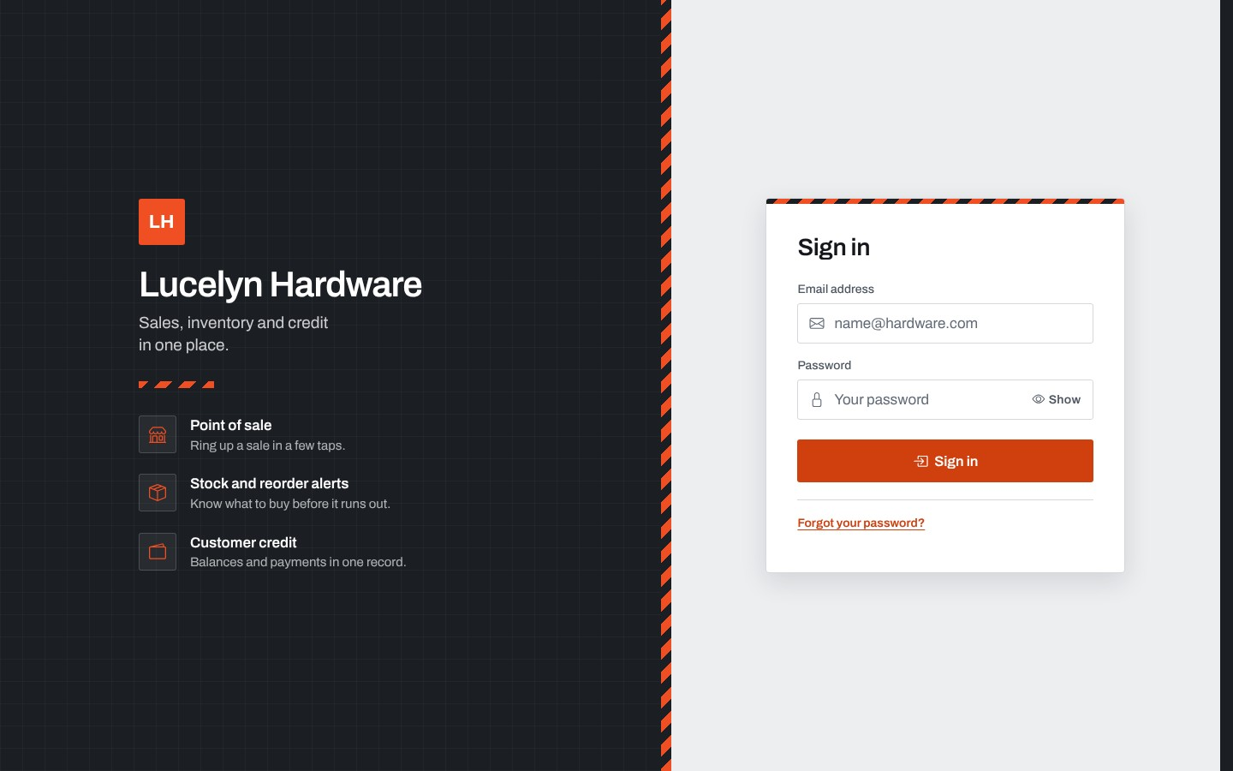
The login page asks for the email address and the password of the account. After three wrong passwords in a row, the account is held for fifteen minutes. The page also has the link for a forgotten password.
Figure 41: Forgot Password
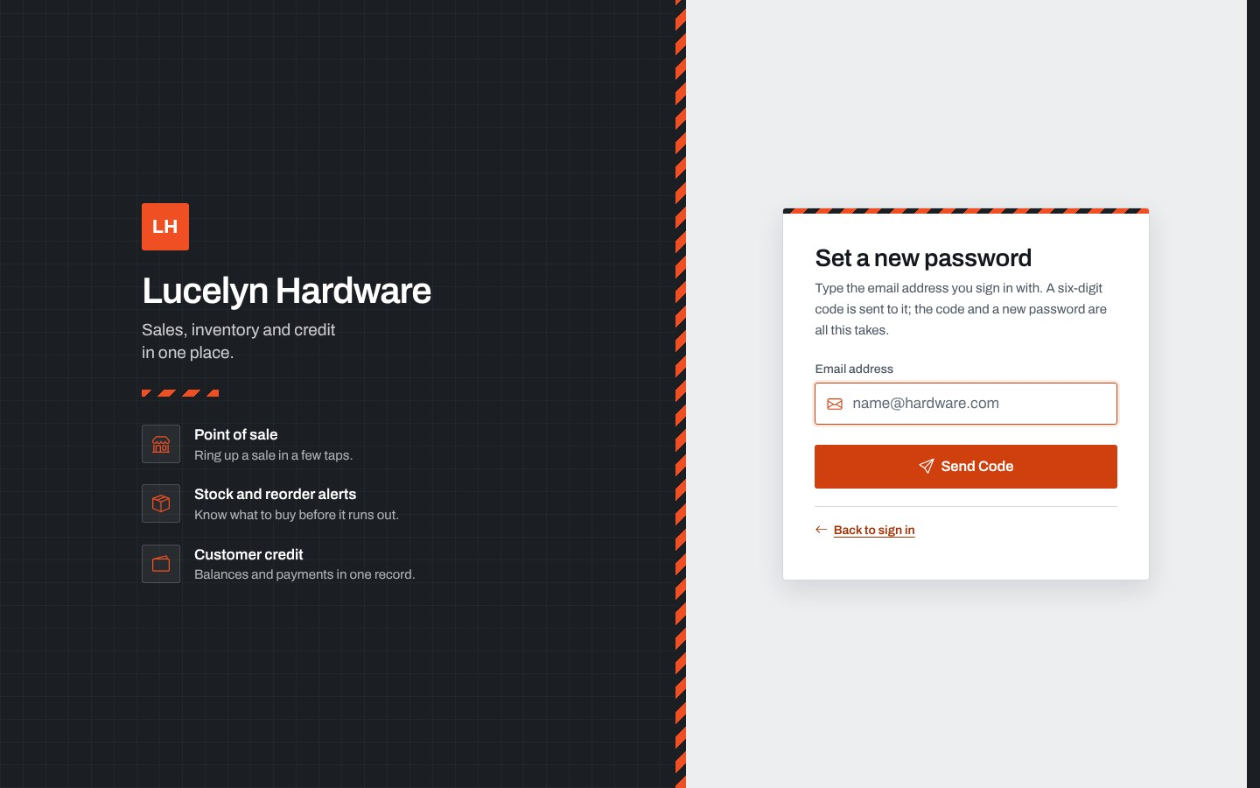
This card sends a six-digit code to the email address of the account. The user then types the code and a new password of the user's own choosing.
Figure 42: Choose Your Password Page
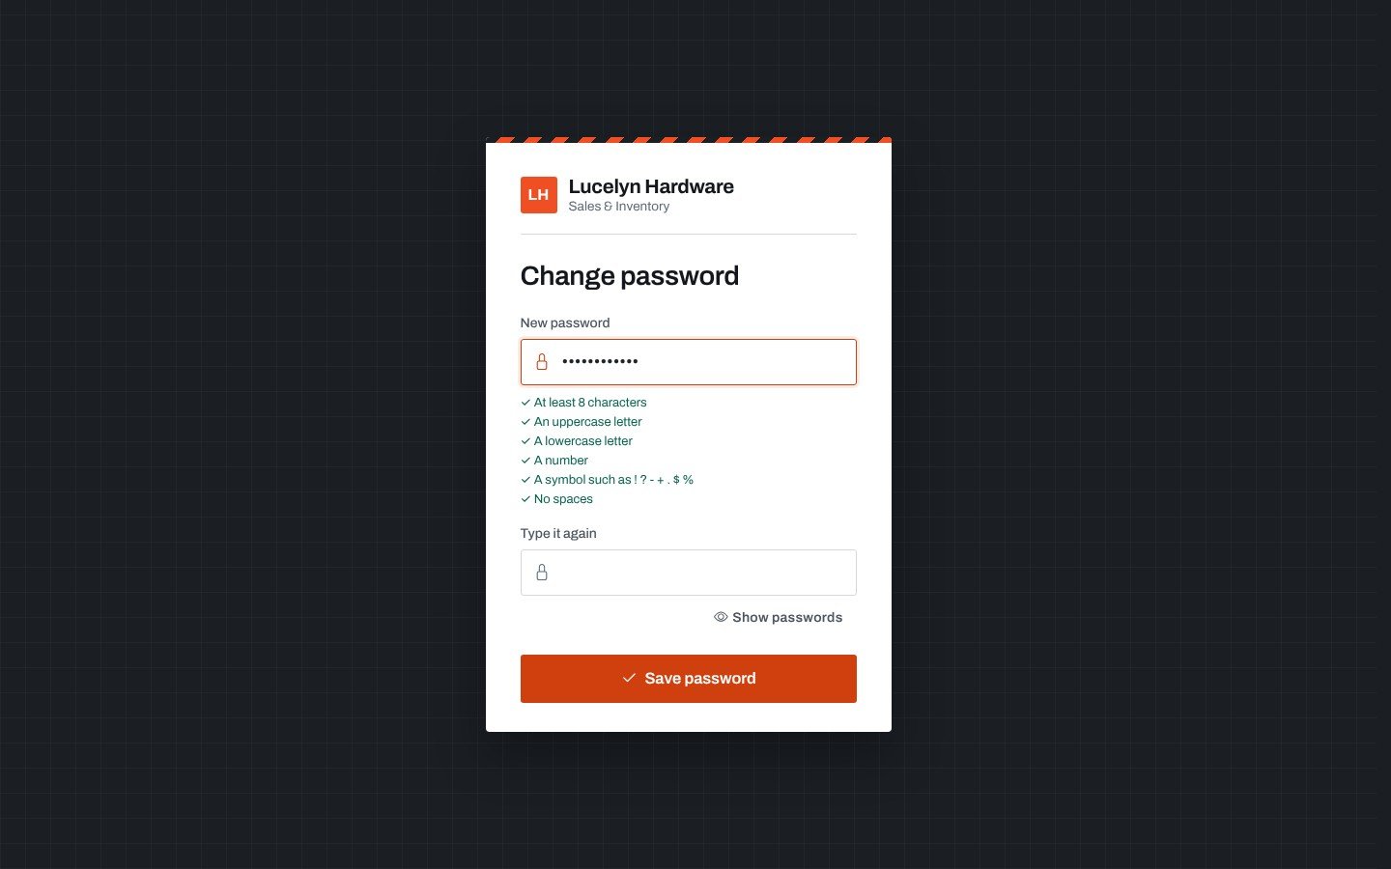
A new user, or a user whose password was reset, must choose a new password at the first sign-in. The rules are listed under the box and are checked as the password is typed.
Figure 43: Staff Directory (System Administrator)
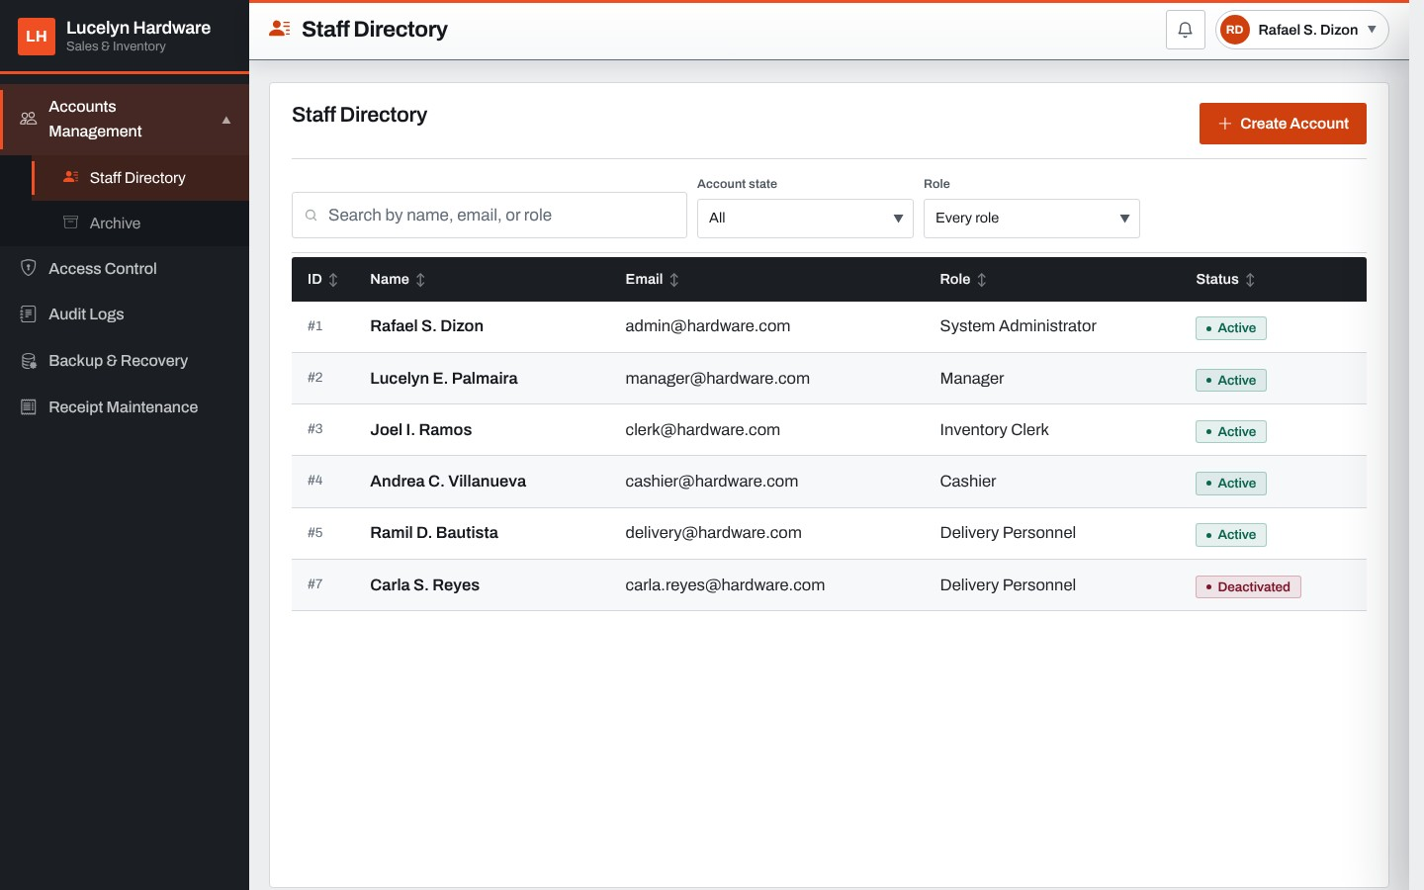
The Staff Directory lists every account with its name, email address, role and status, Active or Deactivated. It loads when the administrator presses Load Data or searches for a name, and it can be filtered by account state and role. Create Account opens the form for a new account.
Figure 44: Create New Account
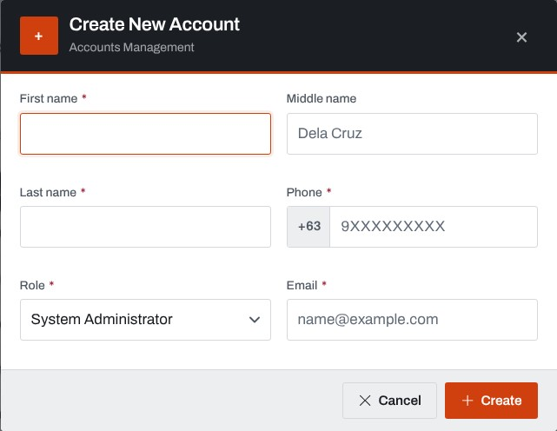
The administrator enters the first, middle and last name, the role, the Philippine mobile number and the email address. The details are read back before the account is created, and the system generates the temporary password and emails it.
Figure 45: Staff Account Card
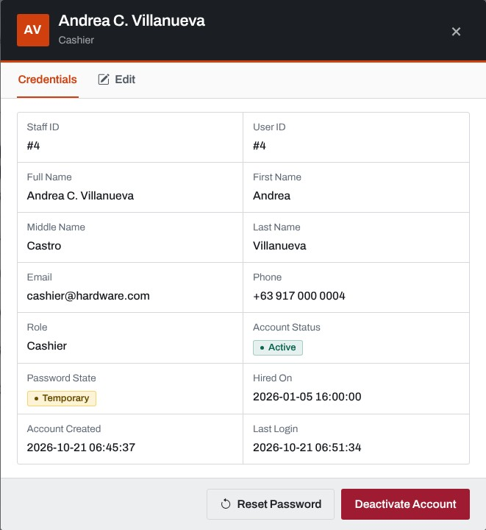
Opening an account shows everything the system holds about the person, with buttons to reset the password and to deactivate the account. The Edit tab changes the name, phone and role.
Figure 46: Archived Accounts
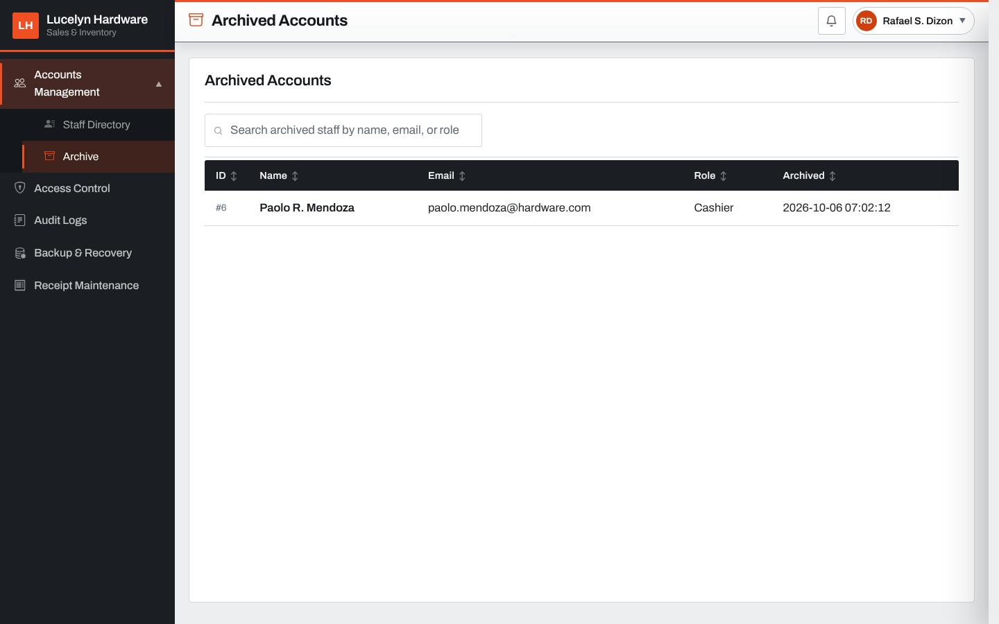
The archive lists the staff accounts that were archived by the administrator or thirty days after they were deactivated, with the date each was archived. An account opens to a card with the button to restore it.
Figure 47: Access Control
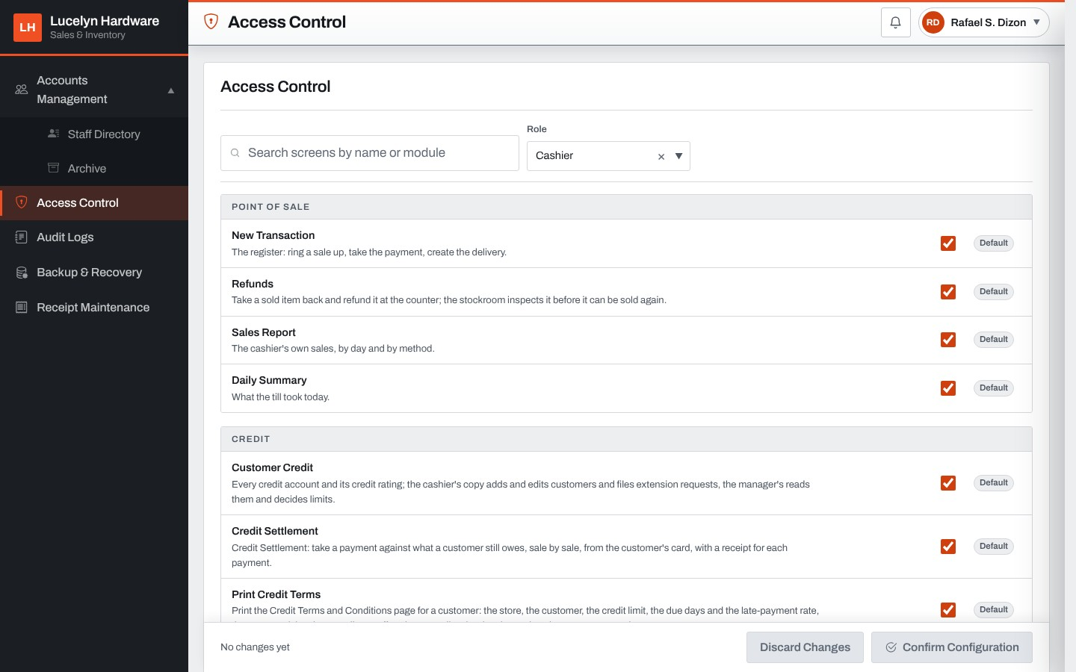
Access Control lists every screen of the chosen role with a check box, grouped by module, and marks the screens the role holds by default. Confirm Configuration reads the changes back before applying them, and the menus of the users follow at once.
Figure 48: Audit Logs
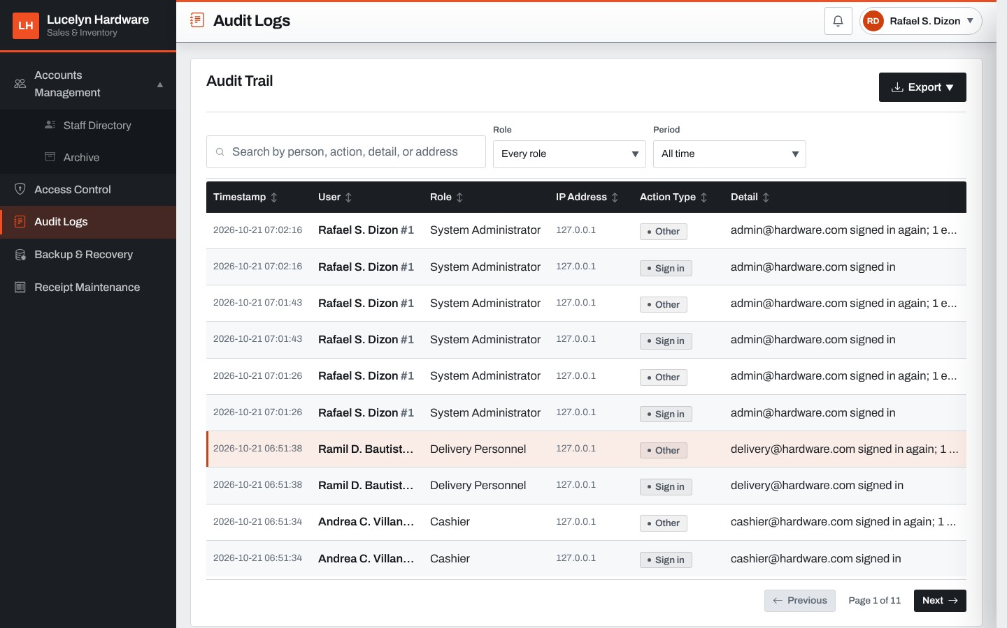
The audit trail lists every important action with the time, the user, the role, the IP address, the action type and the details. It can be searched, filtered by role and period, and exported to Excel or PDF.
Figure 49: Audit Log Entry
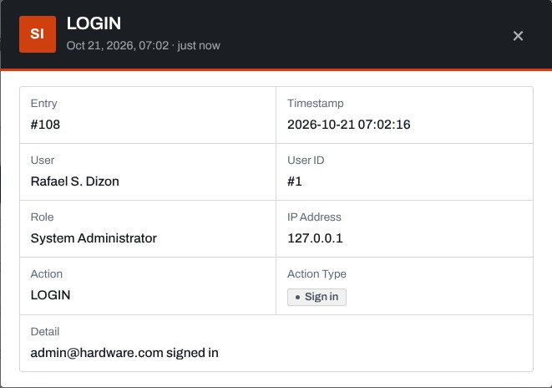
Opening an entry shows the full record of the action, including the values before and after a change.
Figure 50: Backup & Recovery
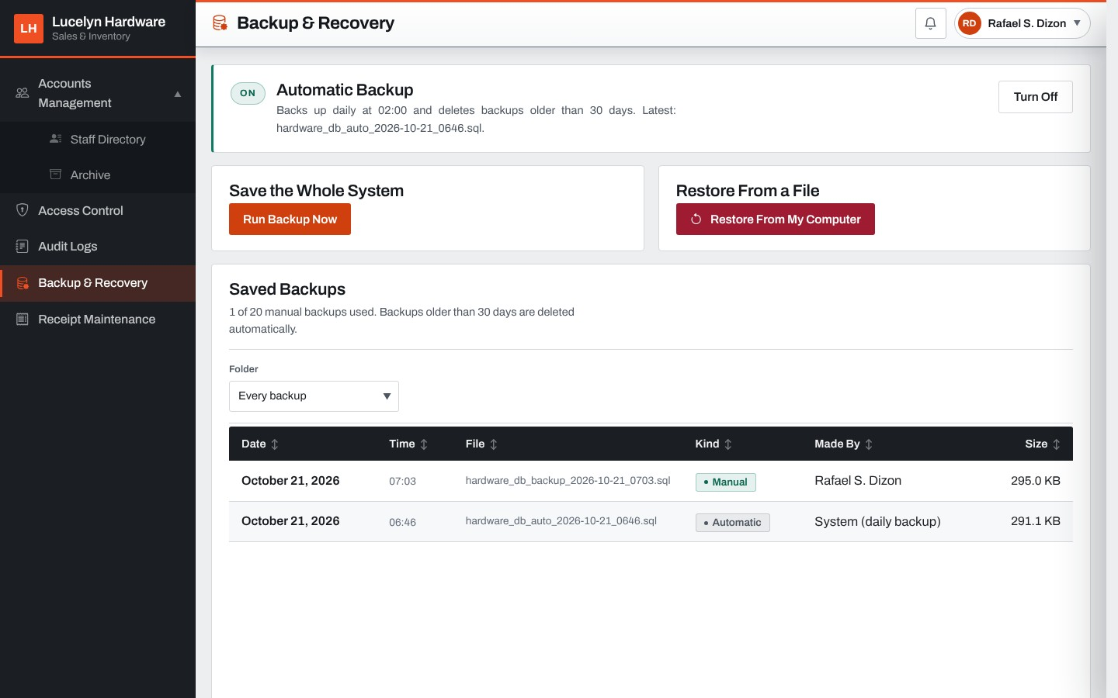
This page shows whether the automatic daily backup is on and when it runs, has the buttons to run a backup now and to restore from a file, and lists the saved backups with their kind, who made them and their size.
Figure 51: Receipt Maintenance
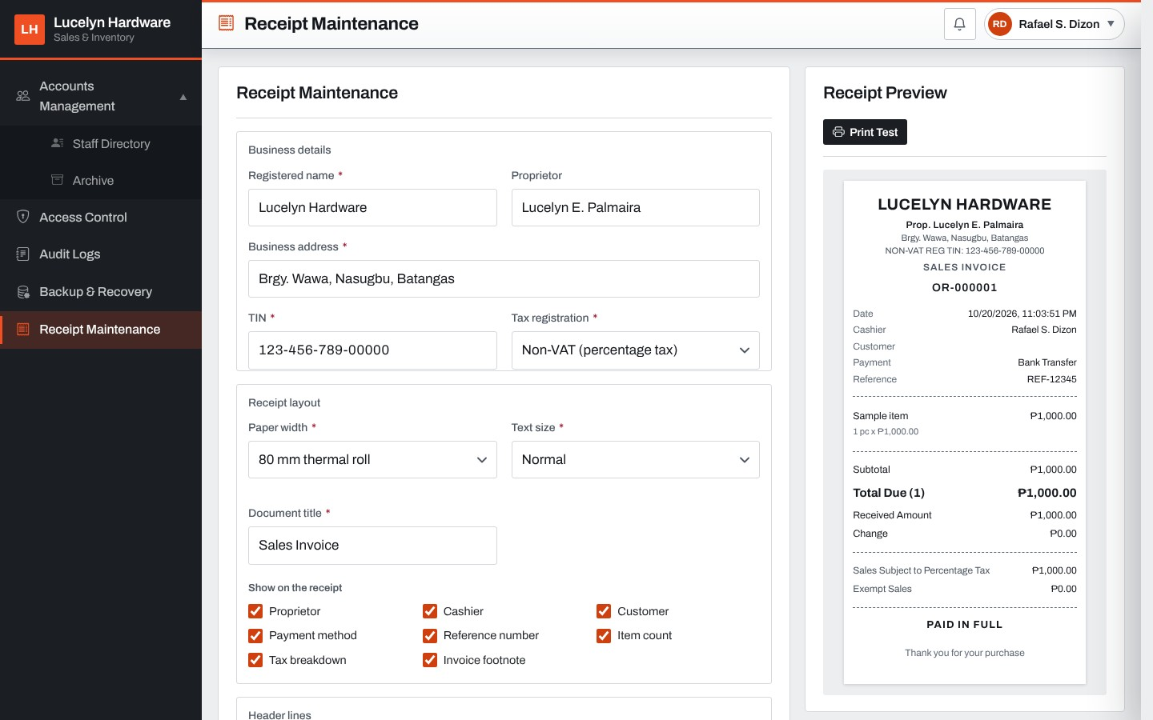
The administrator keeps the store details printed on invoices: the registered name, proprietor, address, TIN and tax registration, and the layout of the receipt. The receipt preview on the right changes as the details are typed.
Figure 52: Point of Sale (Cashier)
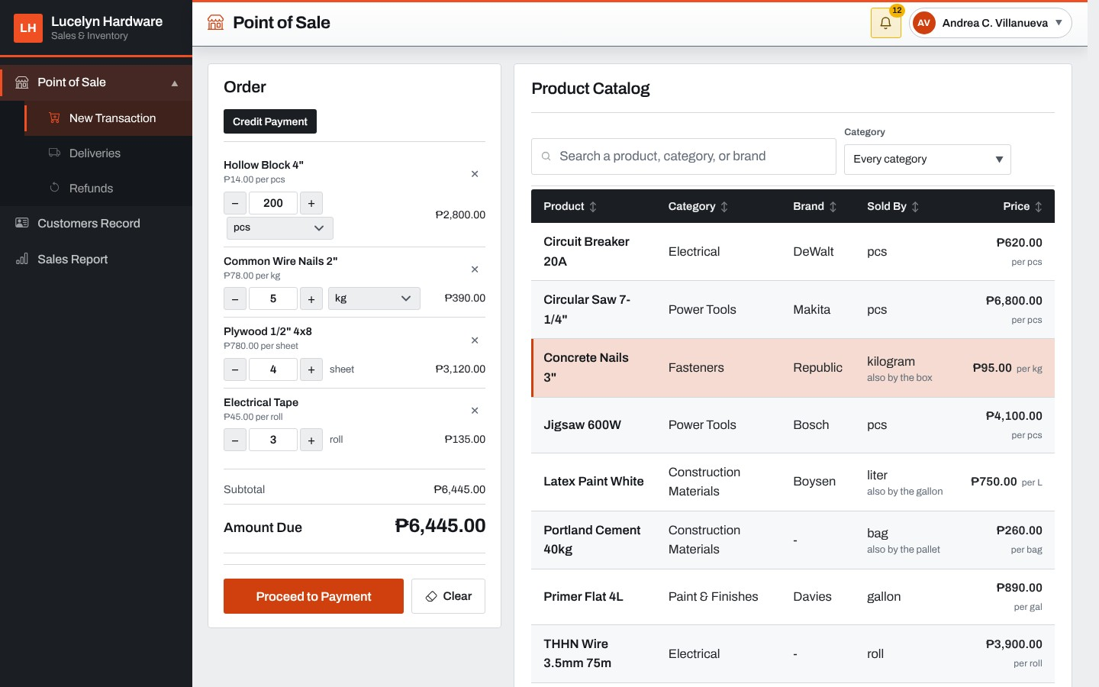
The cashier presses a product in the catalog to put it on the order and sets the quantity, which can be a fraction for measured goods. The order on the left shows the subtotal and the amount due, and a product sold in bigger sizes has a unit picker on its line.
Figure 53: Payment Card with Credit and Part Payment
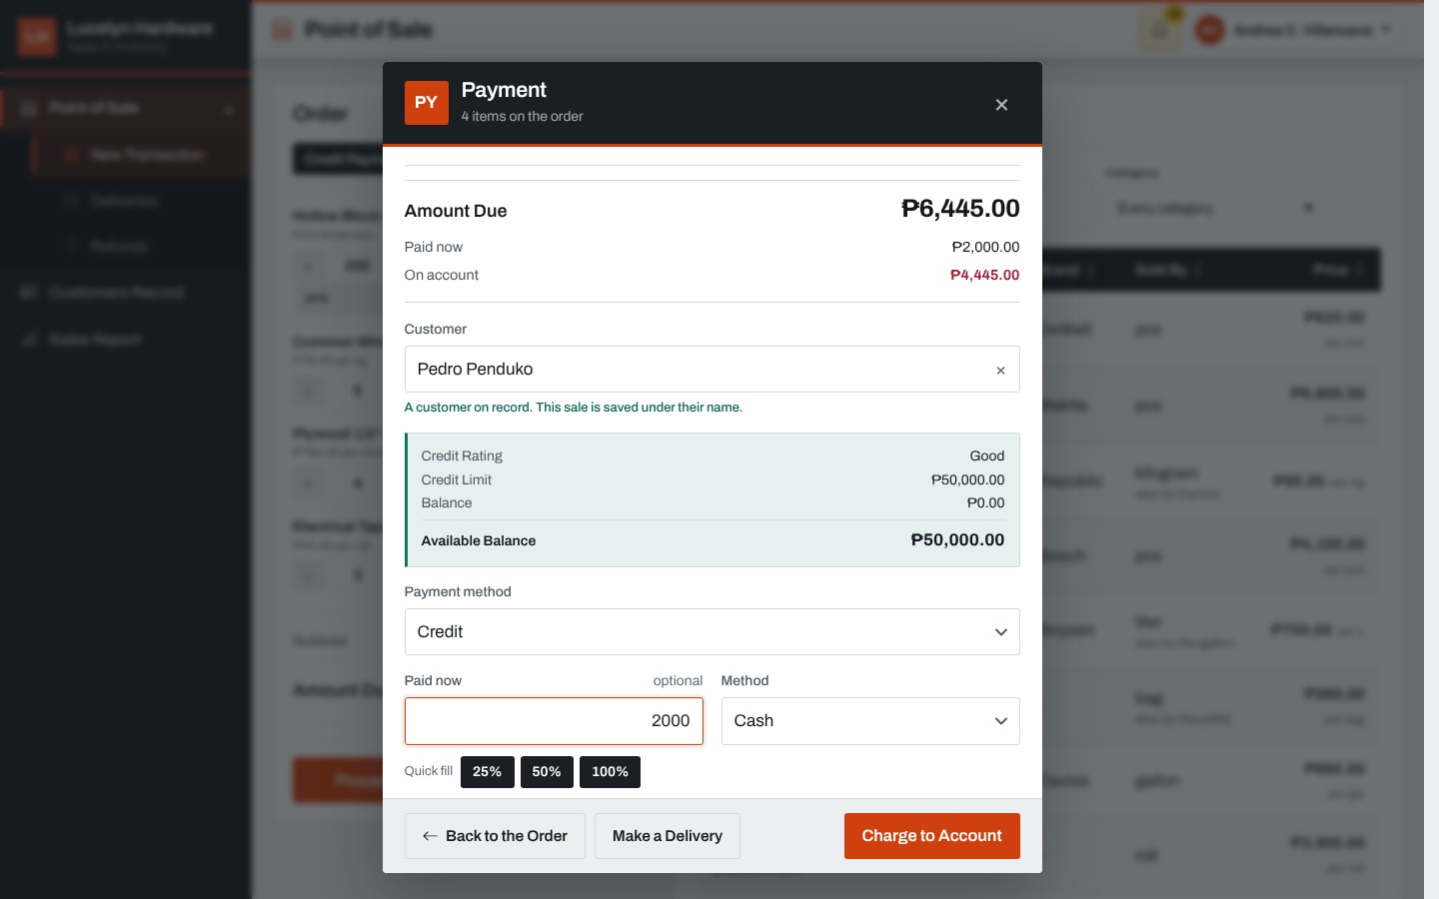
The payment card asks for the customer, empty for a walk-in, and the payment method. When a customer is picked, the card shows the credit rating, the credit limit, the balance and the available balance. On a Credit sale, the cashier enters what is paid now and its method, and the line at the bottom says what goes on the account.
Figure 54: Make a Delivery
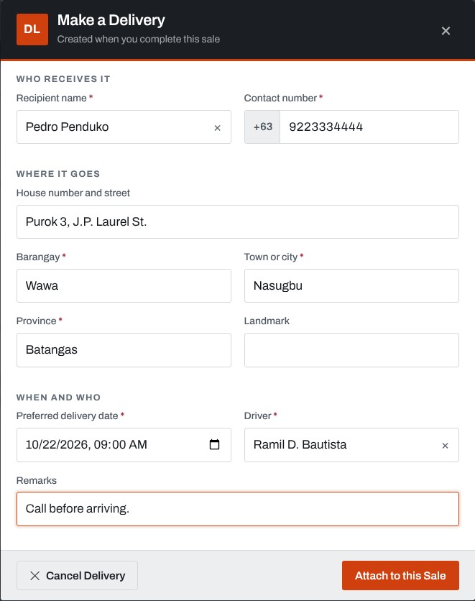
The cashier creates a delivery with the sale: the recipient picked from the customers, the contact number, the address in parts, the preferred delivery date, the driver and remarks.
Figure 55: Sale Confirmation
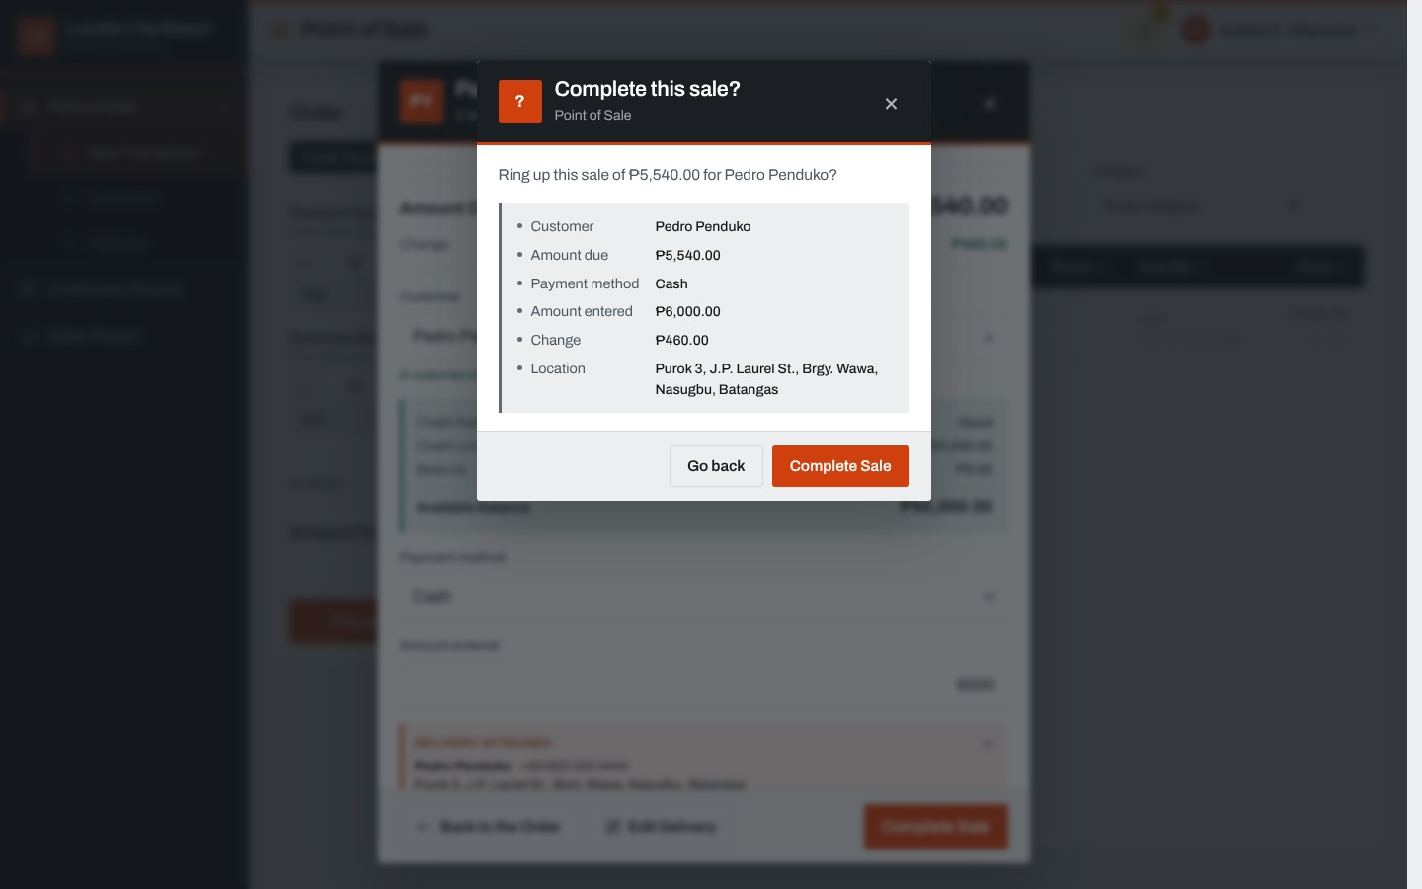
Before a sale is rung up, the system asks first and lists the customer, the amount due, the payment method, the amount entered, the change and the delivery location.
Figure 56: Sales Invoice
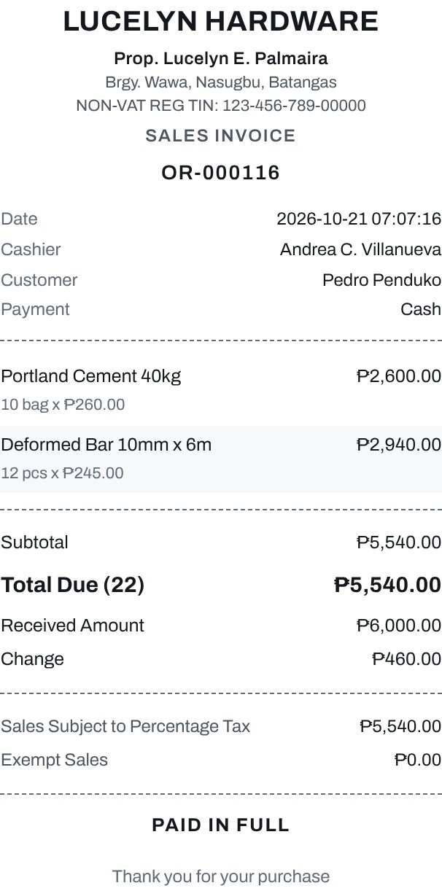
The sales invoice shows the store details, the invoice number, the date, the cashier, the customer and the payment method, the items, the total items purchased, the amount received and the change, and the tax lines of the store's registration: vatable sales, VAT, VAT-exempt and zero-rated sales for a VAT-registered store, or sales subject to percentage tax and exempt sales for a non-VAT store such as Lucelyn Hardware. It can be printed from the card.
Figure 57: Pay by QR
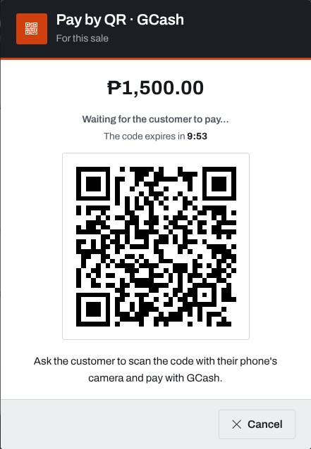
With GCash or PayMaya chosen, the cashier shows this QR code to the customer, who scans it and pays from the phone. The card counts down the ten minutes the code lasts and completes the sale when the payment is confirmed.
Figure 58: Customers Record
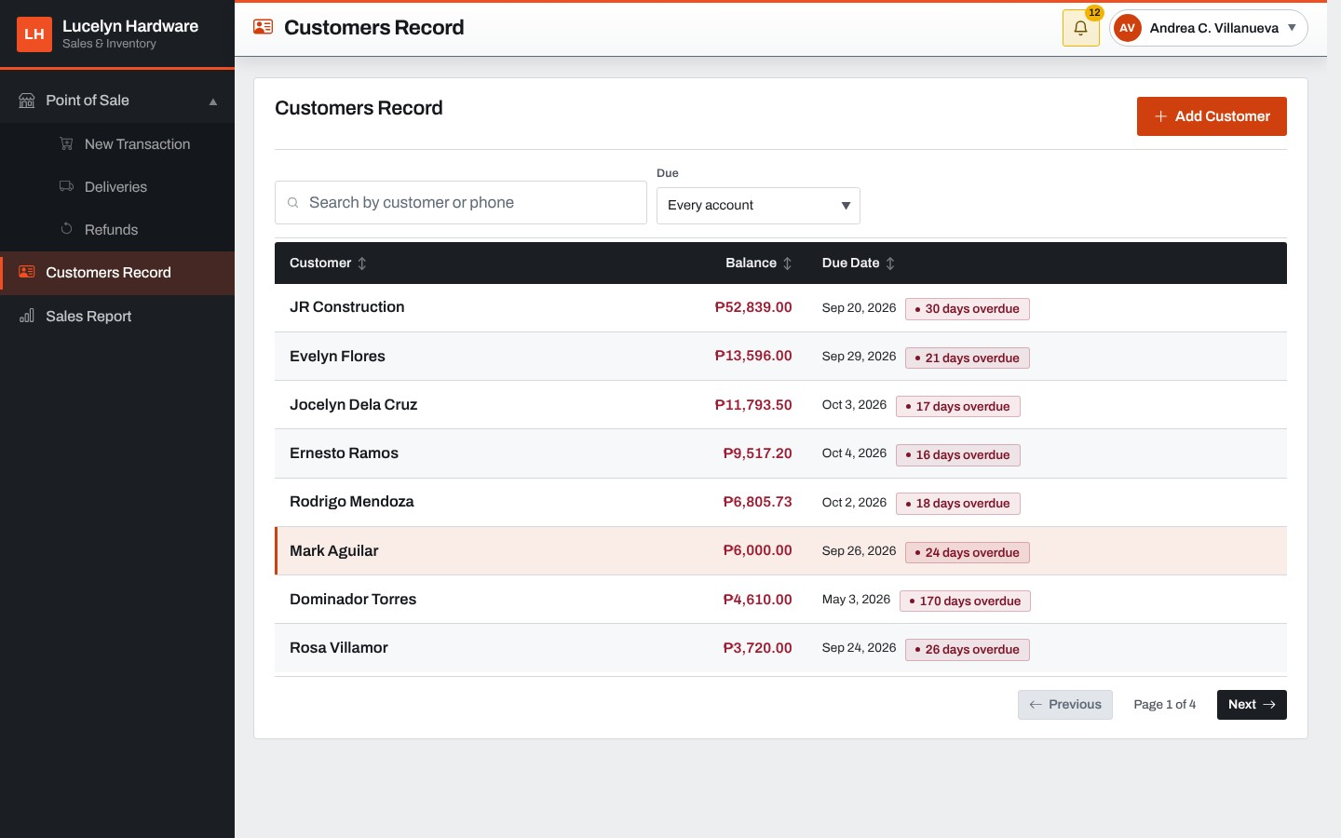
The cashier's customer list shows each customer's balance and due date, with how many days the account is overdue. It can be filtered to overdue accounts, accounts due within the week, with a balance or with no balance, and Add Customer opens the form for a new customer.
Figure 59: Customer Account Card
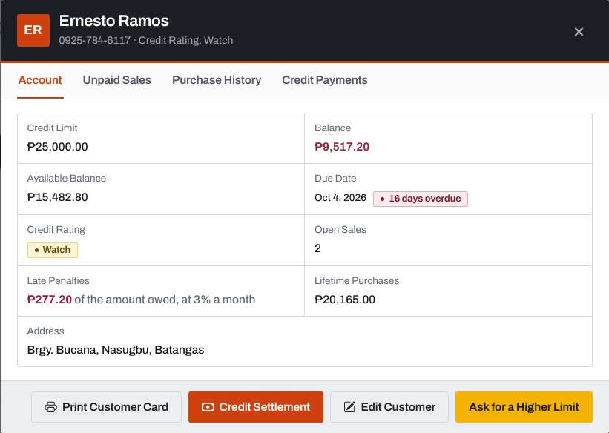
Opening a customer shows the credit limit, balance, available balance, due date, credit rating, open sales, late penalties, lifetime purchases and address. The buttons print the customer card, open Credit Settlement, edit the customer or ask the Manager for a higher limit.
Figure 60: Unpaid Sales of a Customer
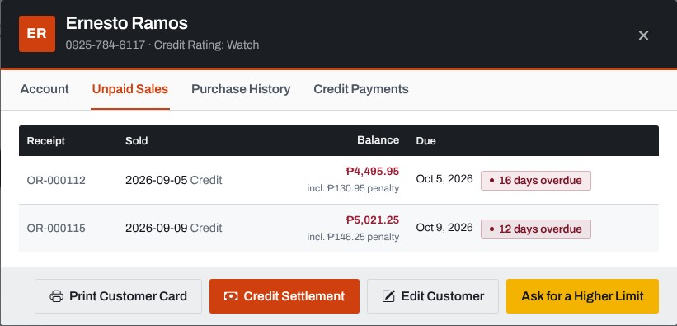
The Unpaid Sales tab lists every sale that still has a balance, oldest first, with the penalty included, the due date and how overdue it is.
Figure 61: Credit Settlement
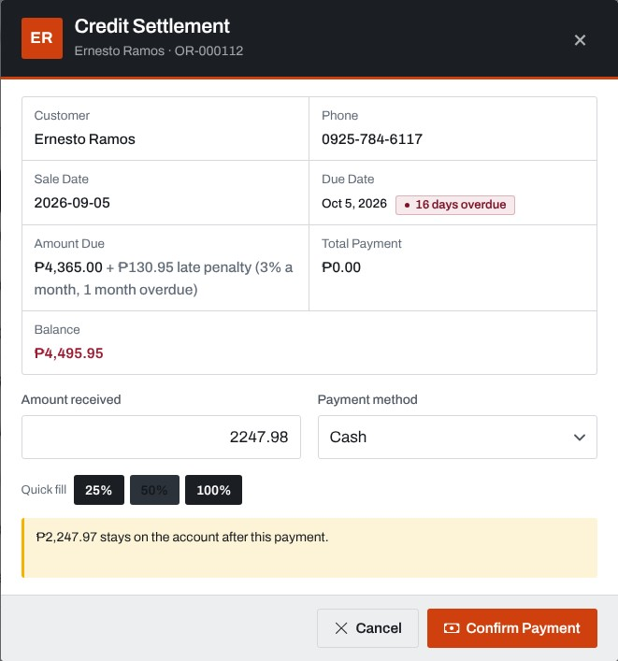
The cashier records a payment against one sale. Quick-fill buttons offer a quarter, half or the whole balance, the line at the bottom says what stays on the account, and Confirm Payment asks first and then prints the payment receipt.
Figure 62: Ask for a Higher Limit
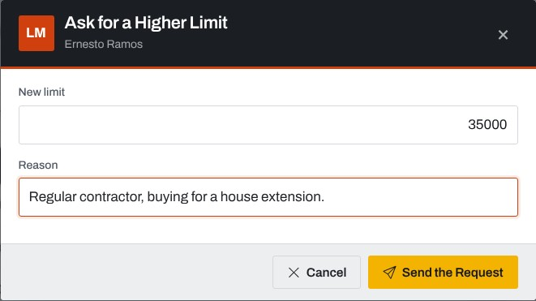
The cashier types the new limit and the reason, and the request is sent to the Manager.
Figure 63: Refunds
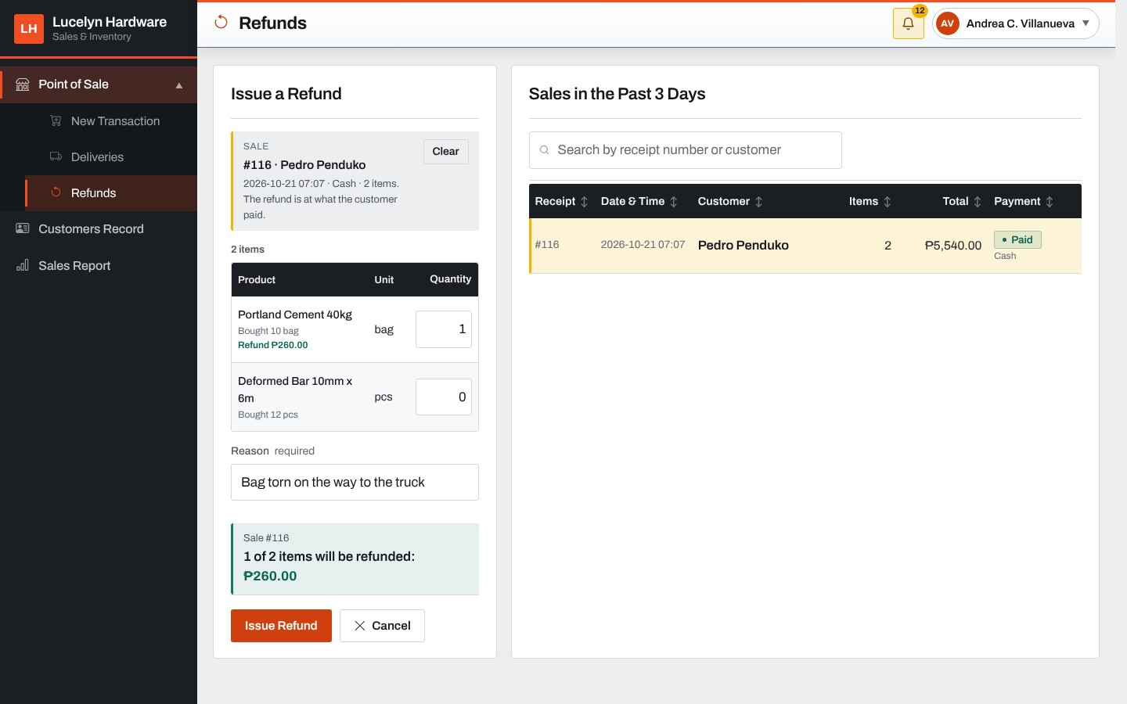
The cashier picks a sale from the past three days on the right, and the items of the sale fill the refund form with the quantity to refund of each. The reason is required, and Issue Refund records the refund.
Figure 64: Deliveries (Cashier)
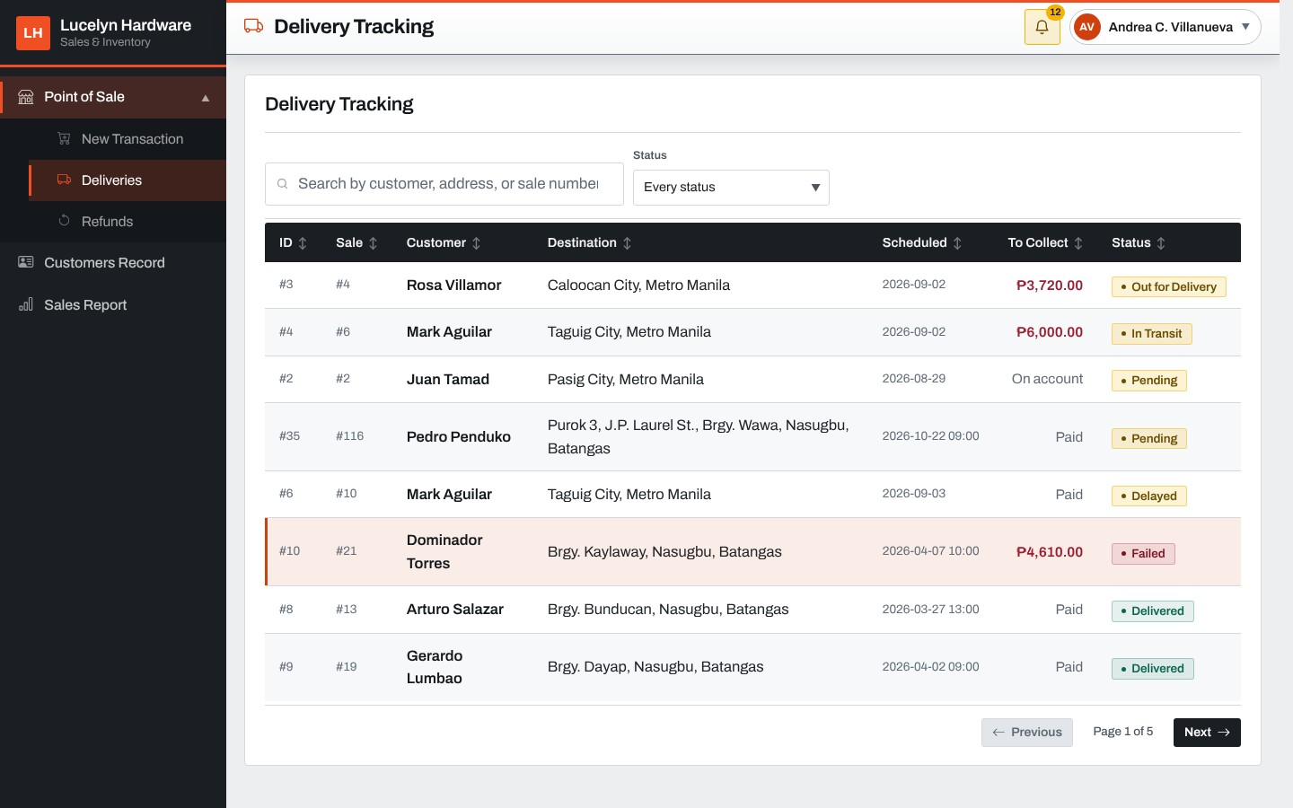
The cashier sees every delivery with its customer, destination, schedule, amount to collect and status.
Figure 65: Sales Report (Cashier)
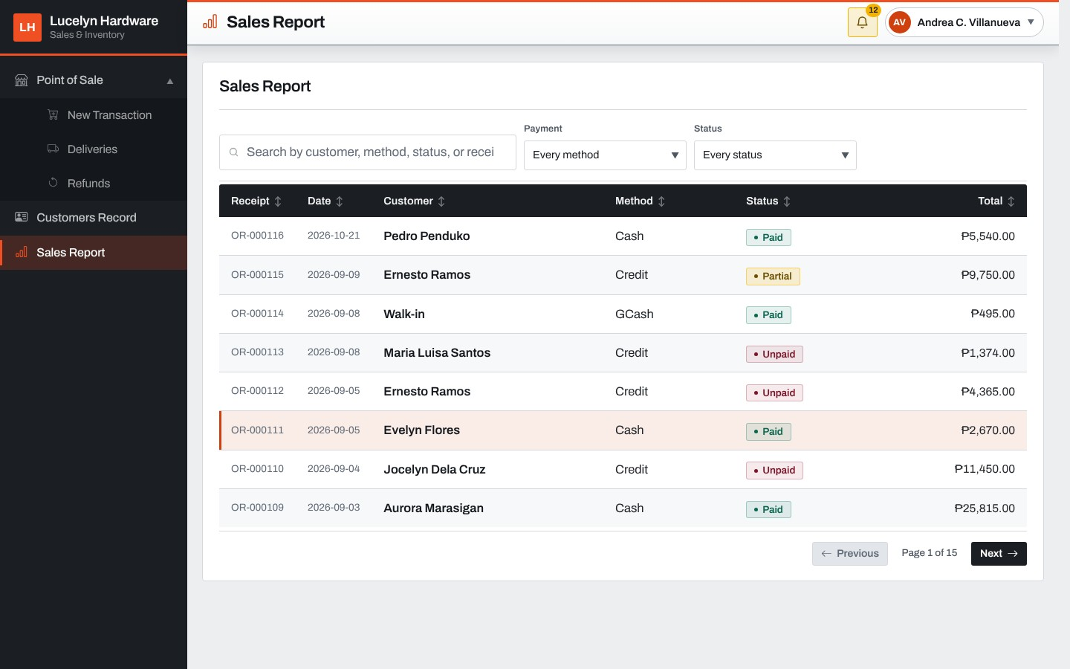
The cashier's sales report lists the receipts with the date, customer, method, status and total, and can be filtered by payment method and status.
Figure 66: Request Void
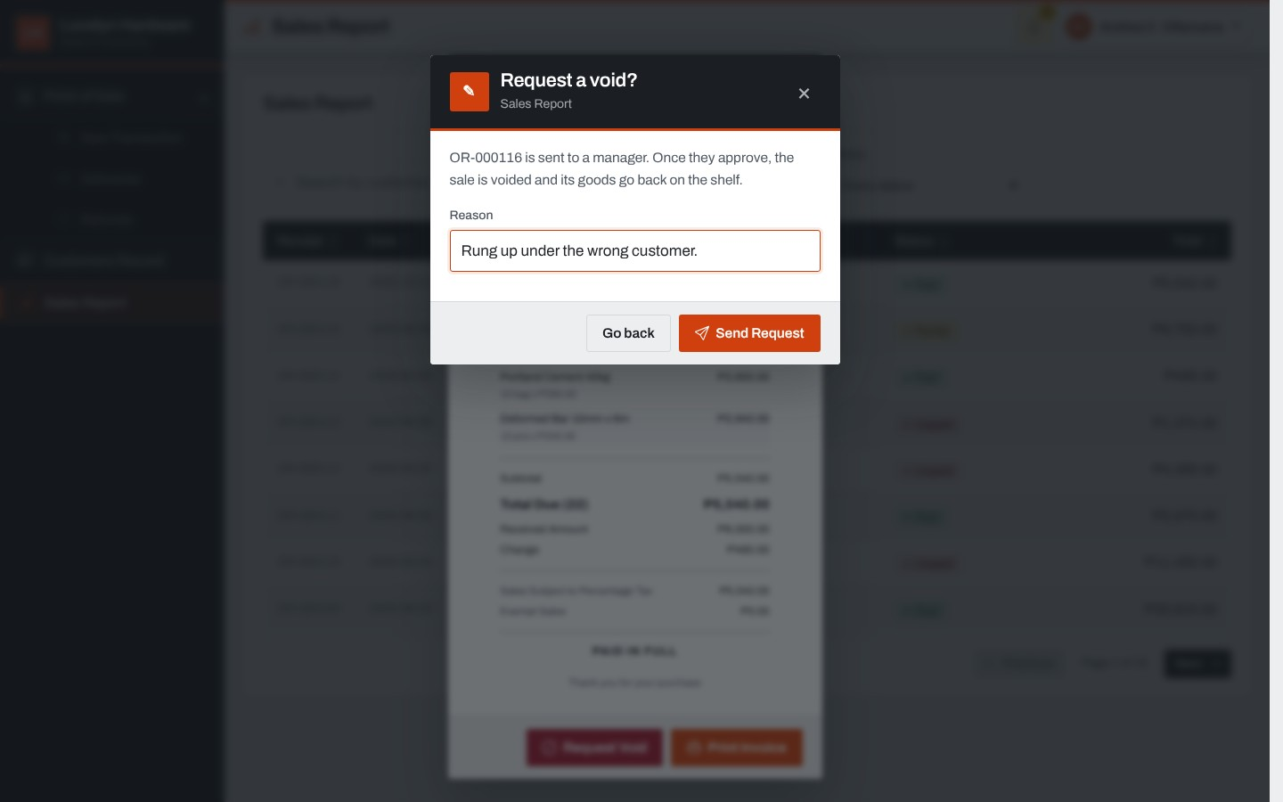
From the invoice of a sale made today, the cashier presses Request Void and gives the reason. The request is sent to the Manager, who approves or declines it.
Figure 67: Material List (Inventory Clerk)
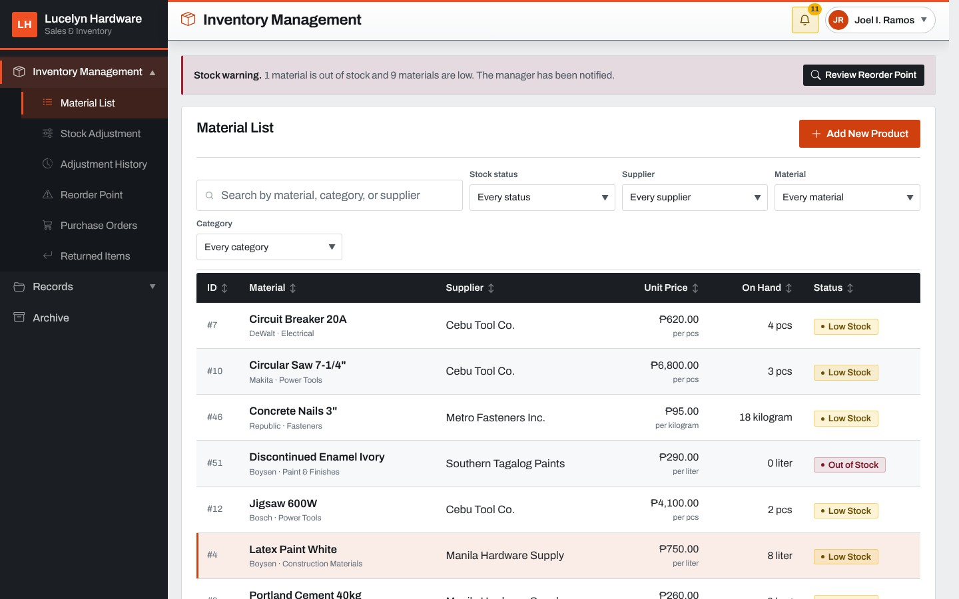
The material list shows every material with its supplier, unit price, quantity on hand and stock status, and can be filtered by stock status, supplier, material and category. The warning at the top says how many materials are out of stock or low.
Figure 68: Material Card
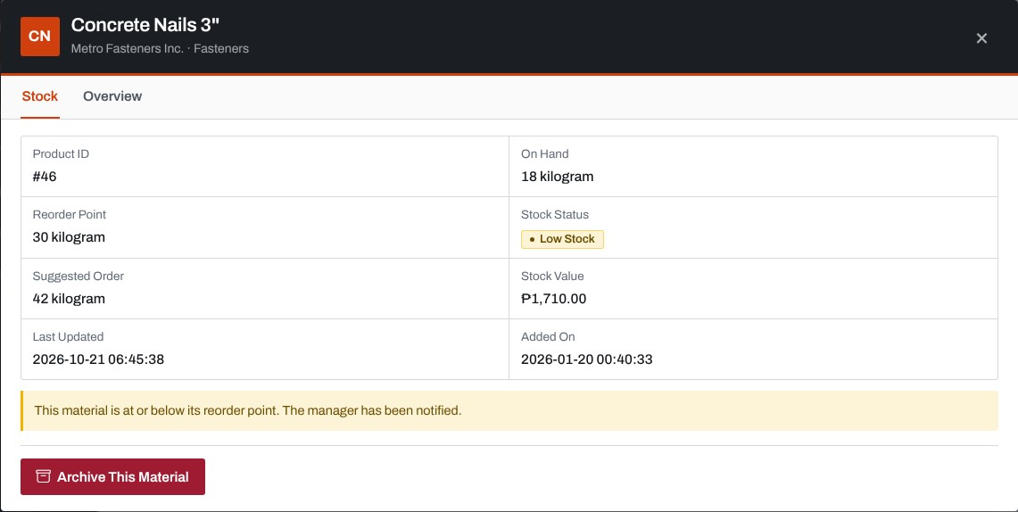
Opening a material shows its stock, reorder point, suggested order and stock value, the sizes it is sold in and the pack it is delivered in, and the button to archive it.
Figure 69: Add New Product
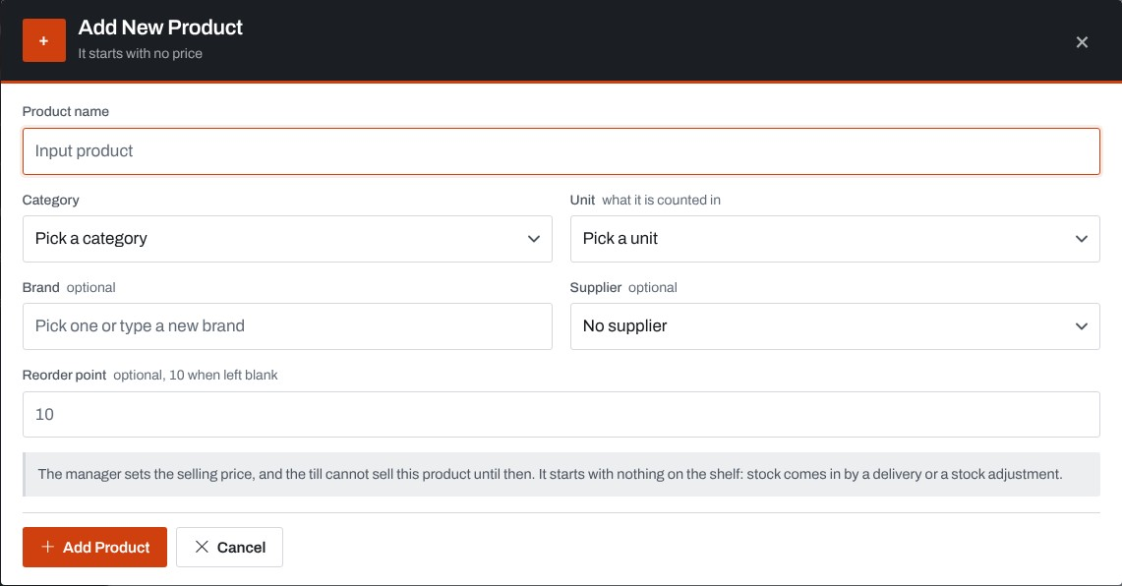
The clerk opens the record of a product the store has never stocked, with its name, category, unit, brand, supplier and reorder point. It starts with no price, and the Manager is told to set one.
Figure 70: Stock Adjustment
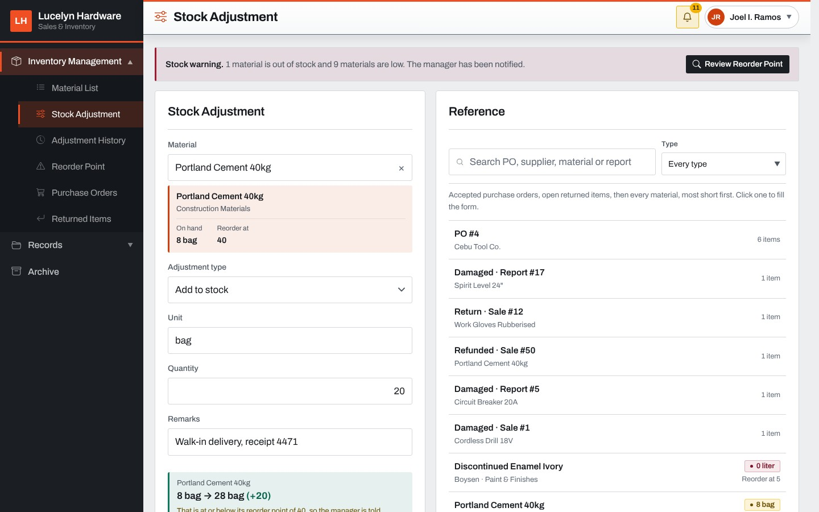
The clerk picks a material, the adjustment type, the unit and the quantity, and writes the remarks. The Reference list on the right shows the received purchase orders, the returned items and the materials that need attention, to check against.
Figure 71: Adjustment History
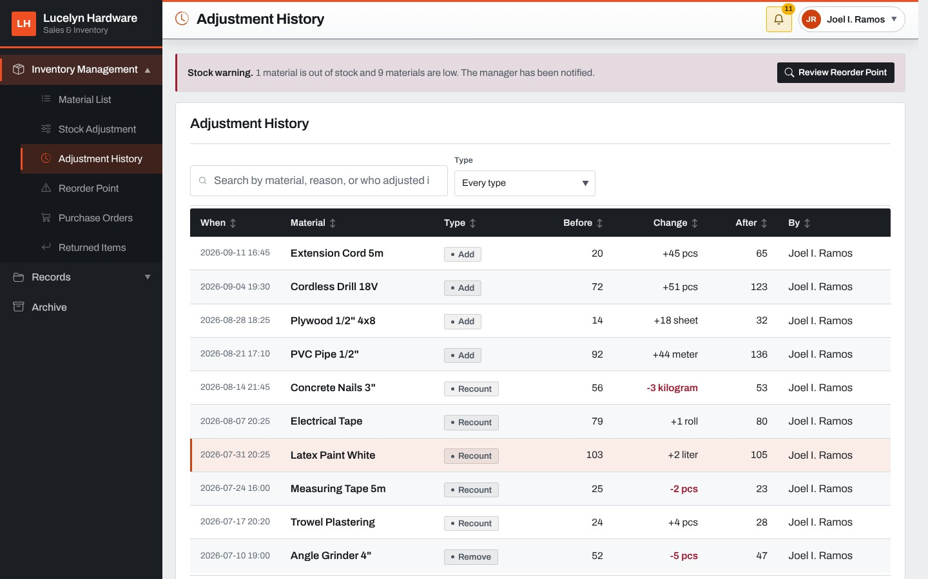
Every adjustment is listed with the date, material, type, the quantity before, the change, the quantity after and who made it.
Figure 72: Reorder Point
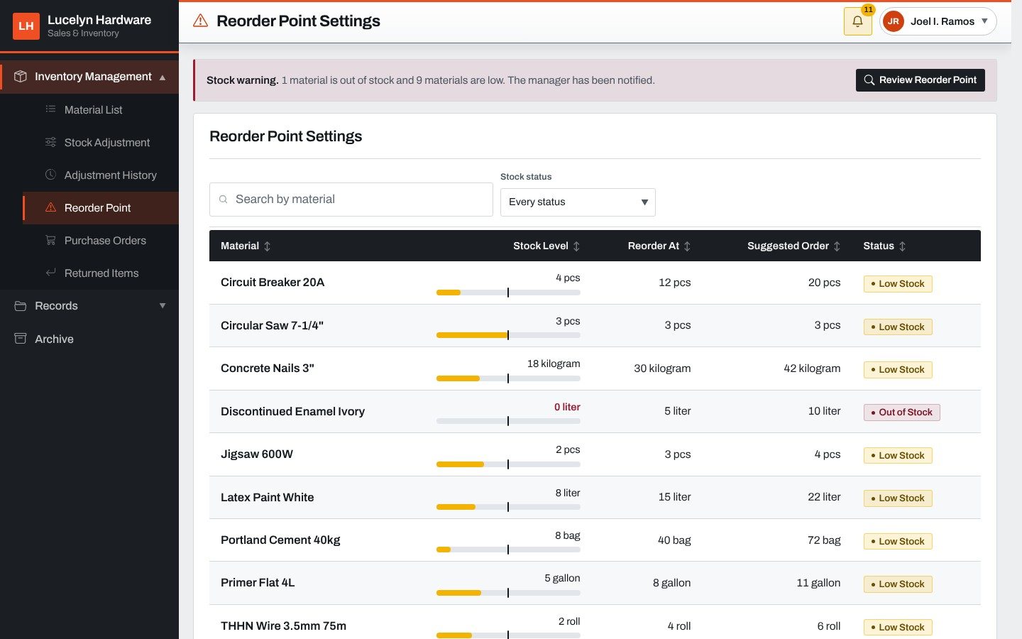
The clerk's Reorder Point screen shows each material's stock level against its reorder point, the suggested order and its status. The reorder points are set by the Manager.
Figure 73: Purchase Orders (Inventory Clerk)
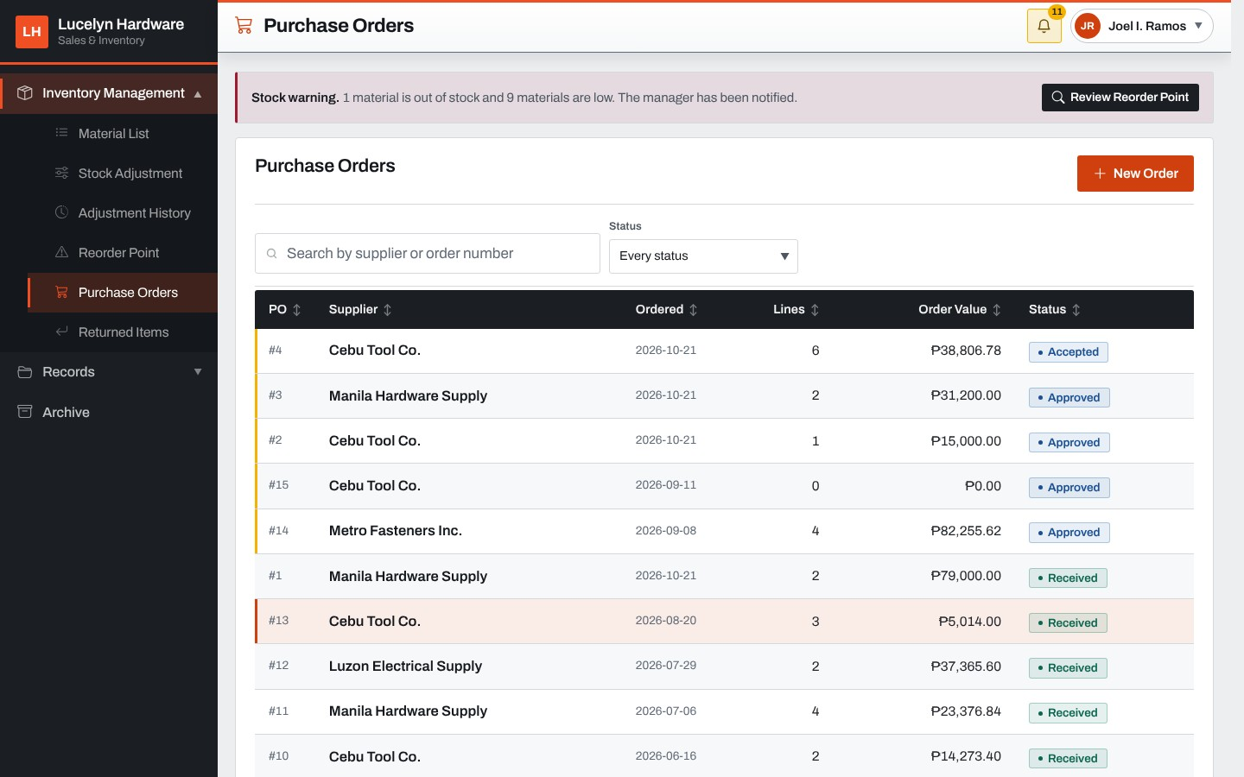
The clerk's purchase orders list every order with its supplier, date, number of lines, value and status, from waiting for the manager's approval to received.
Figure 74: New Purchase Order
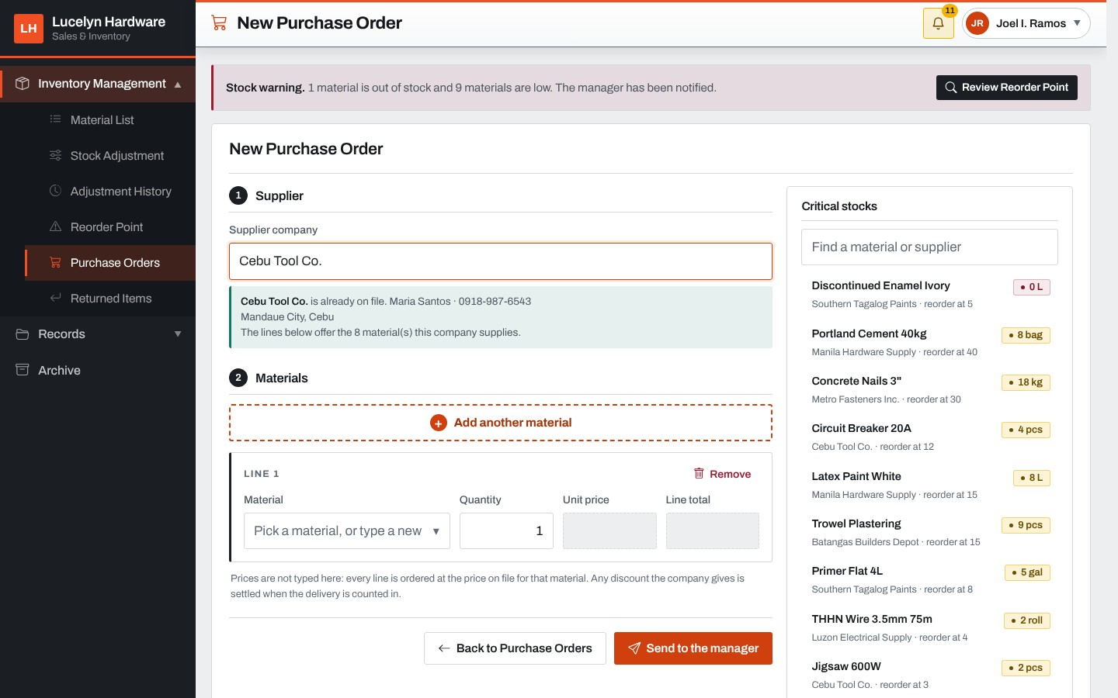
The clerk names the supplier company, from the list or by typing a new one, and adds the materials to order. The Critical Stocks list on the right shows the materials that are out of stock or low, and the order is sent to the Manager.
Figure 75: Receive Delivery
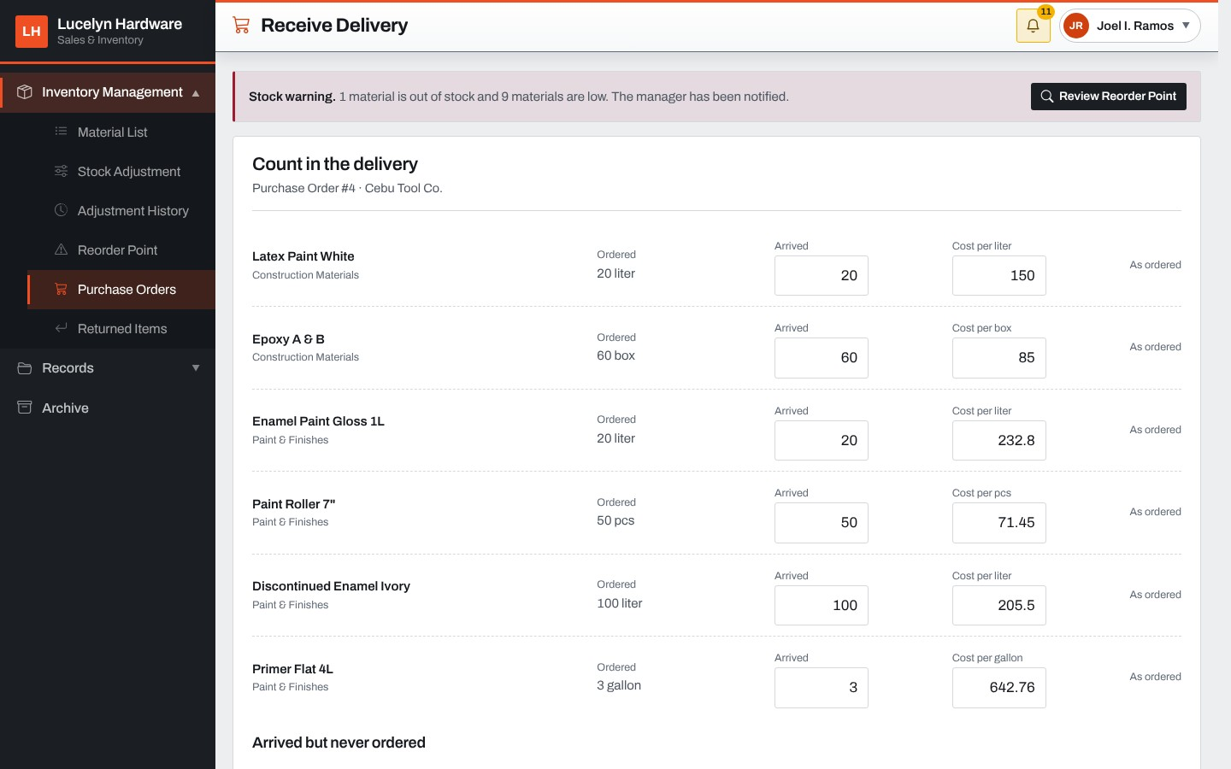
When an accepted order arrives, the clerk enters what arrived and the cost of each line, adds anything that arrived but was not ordered, and receives the delivery into stock.
Figure 76: Returned Items
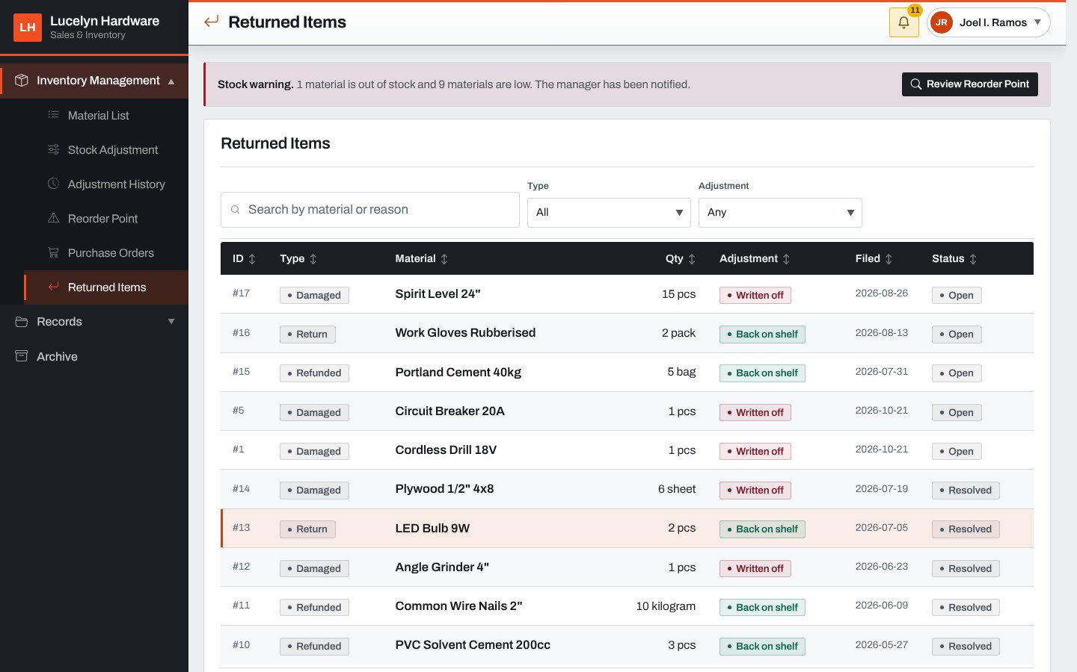
The returned items screen lists the returns, damage reports and refunds with the quantity, what happened to the goods, the date filed and the status. It can be filtered by type and adjustment.
Figure 77: Sales Summary (Manager)
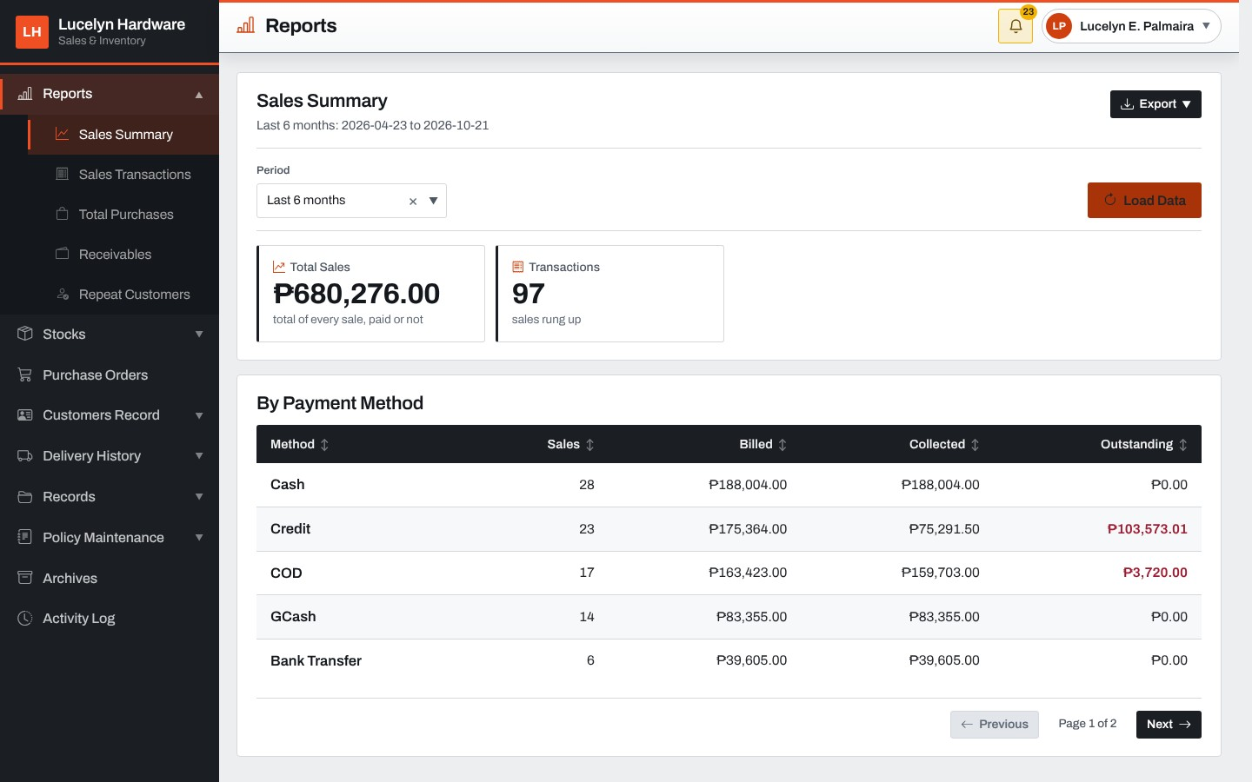
The Sales Summary shows the total sales and the number of transactions for the chosen period, and a table by payment method with the sales and what was billed, collected and still outstanding. The report can be exported to Excel or printed as a PDF.
Figure 78: Sales Transactions
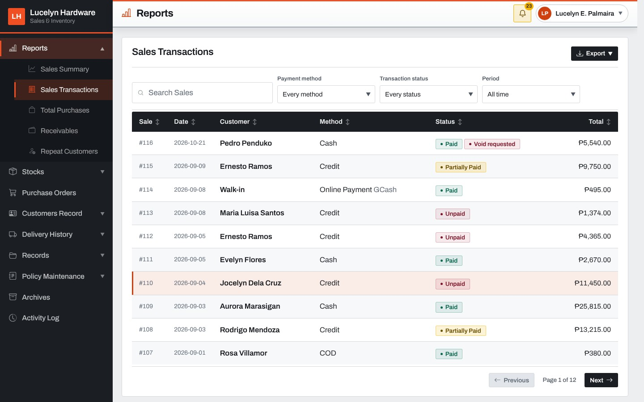
This report lists every sale with the date, customer, method, status and total, and can be filtered by method, status and period. A sale with a void request waiting is marked Void requested.
Figure 79: Sale Card with a Void Request
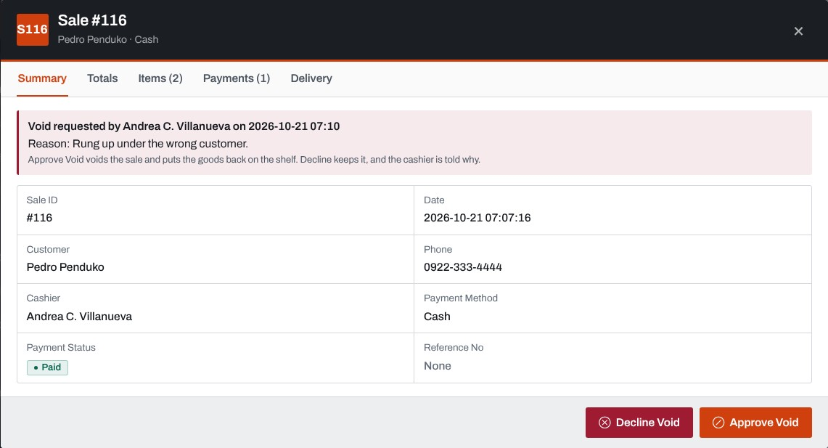
Opening a sale shows its summary, totals, items, payments and delivery. When the cashier asked for it to be voided, the card shows the request and its reason, and the Manager approves or declines it.
Figure 80: Total Purchases
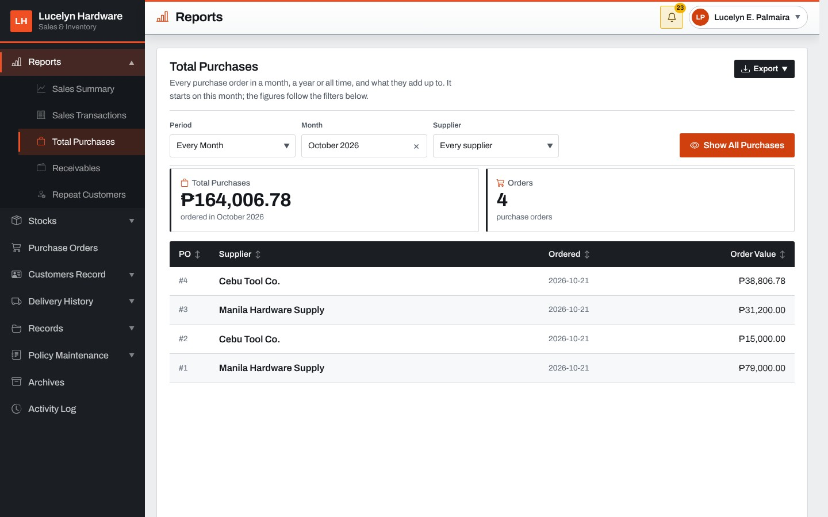
This report shows the purchase orders of a month, a year or a date range, with the total purchases and the number of orders, and can be filtered by supplier.
Figure 81: Receivables
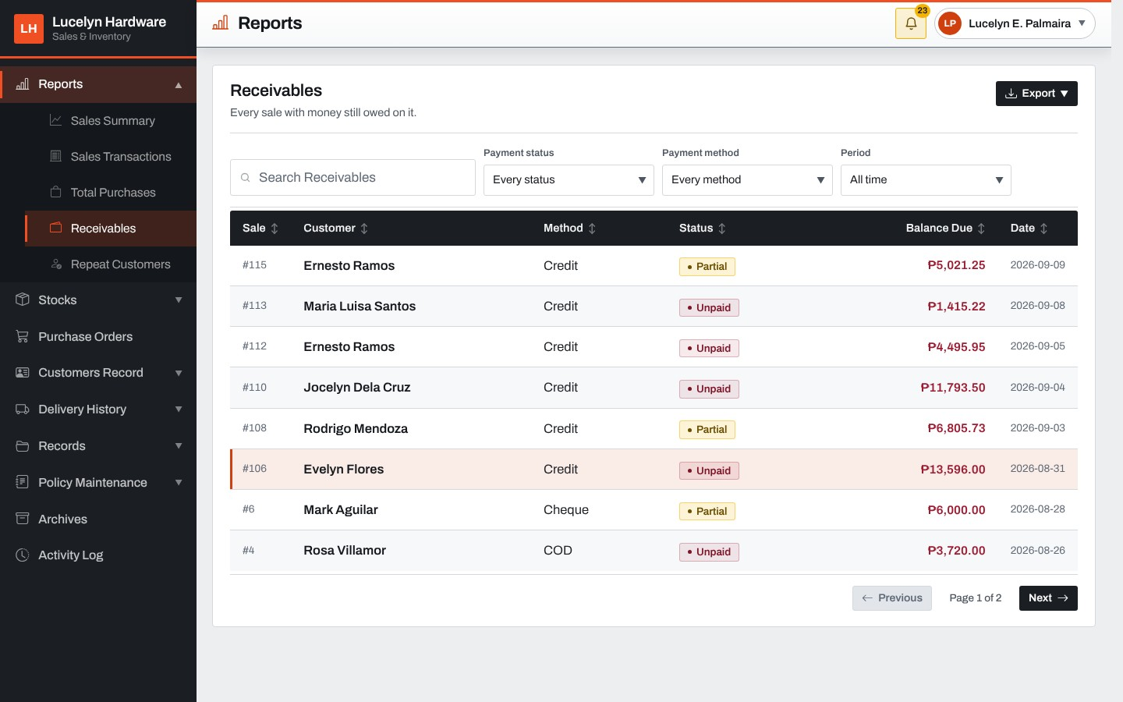
This report lists every sale with money still owed, with its method, status, balance due and date, and can be filtered by payment status, method and period.
Figure 82: Repeat Customers
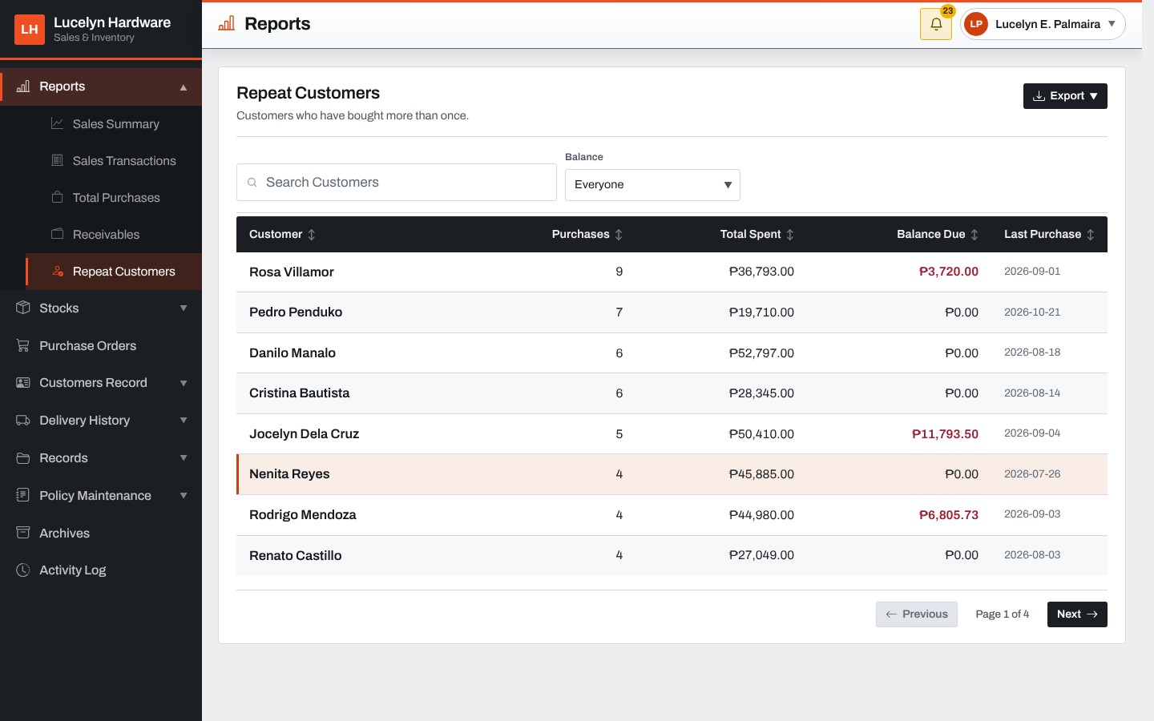
This report lists the customers who bought more than once, with the number of purchases, total spent, balance due and last purchase.
Figure 83: Activity Log
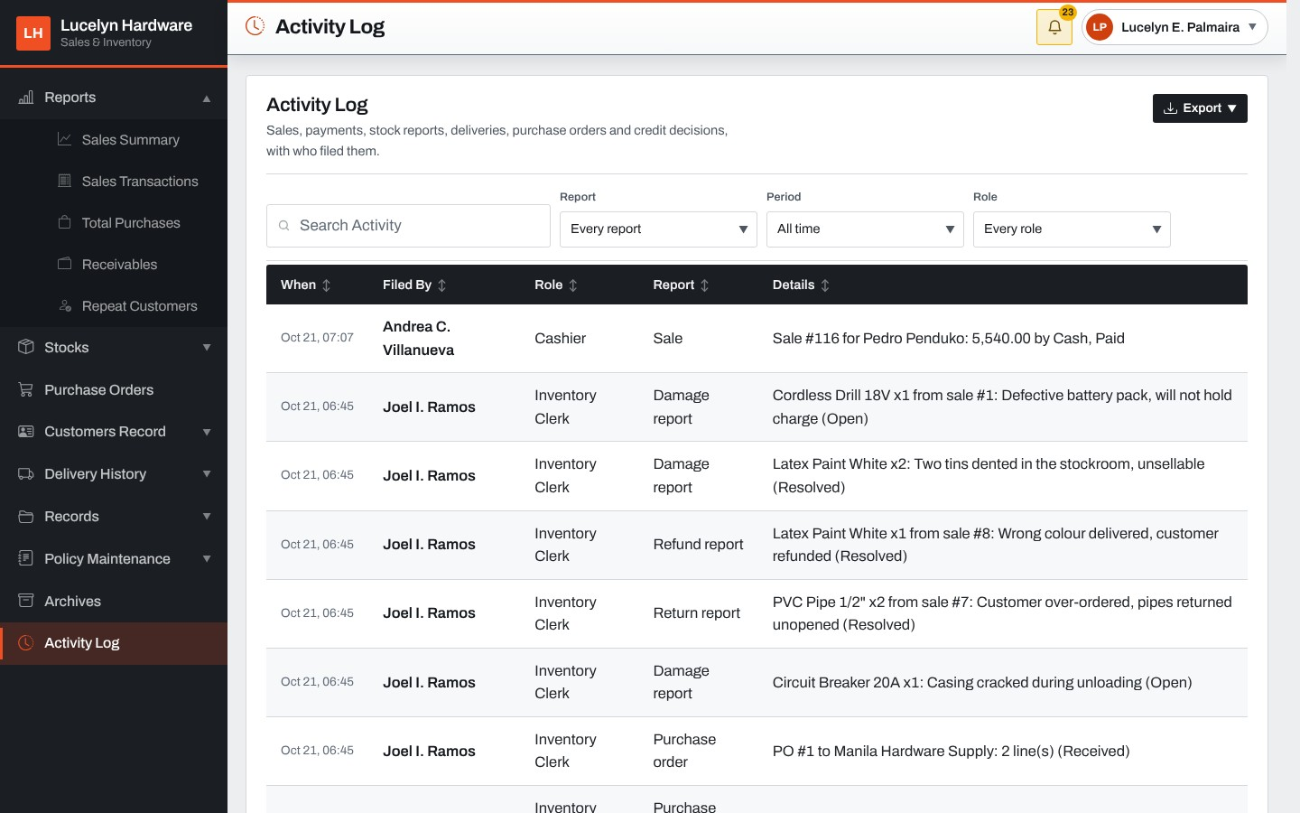
The activity log lists the sales, payments, stock reports, deliveries, purchase orders and credit decisions filed by the staff, with who filed each and when.
Figure 84: Stocks Overview
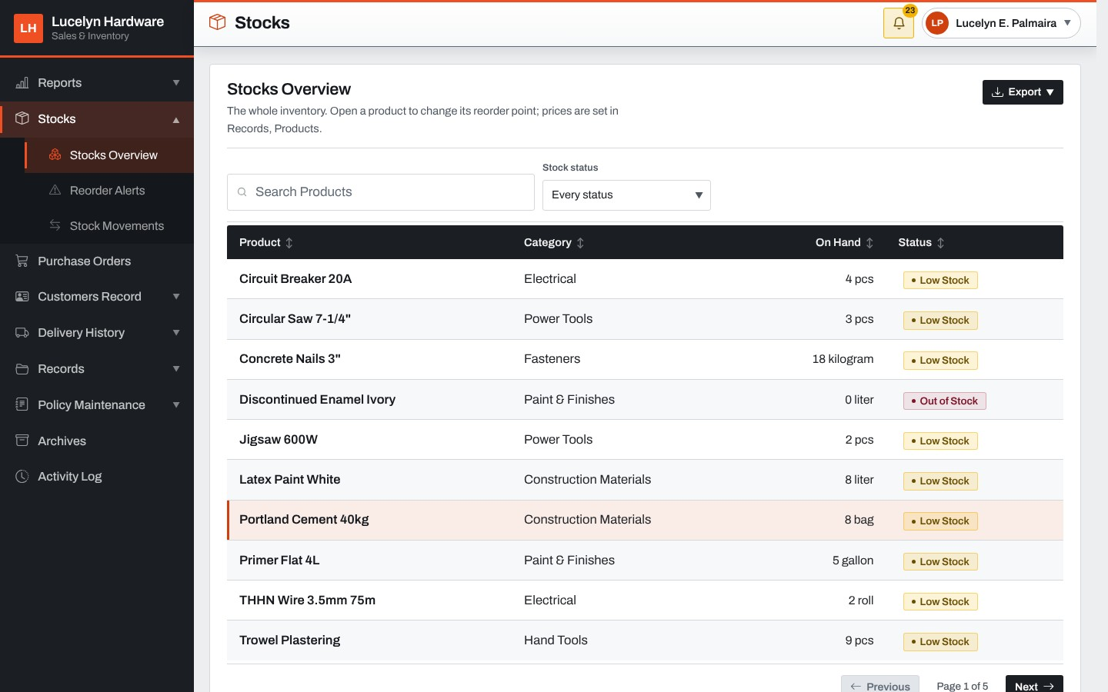
Stocks Overview lists the whole inventory with the category, the quantity on hand and the status, and can be filtered by stock status. Opening a product shows its card.
Figure 85: Product Card: Reorder Point
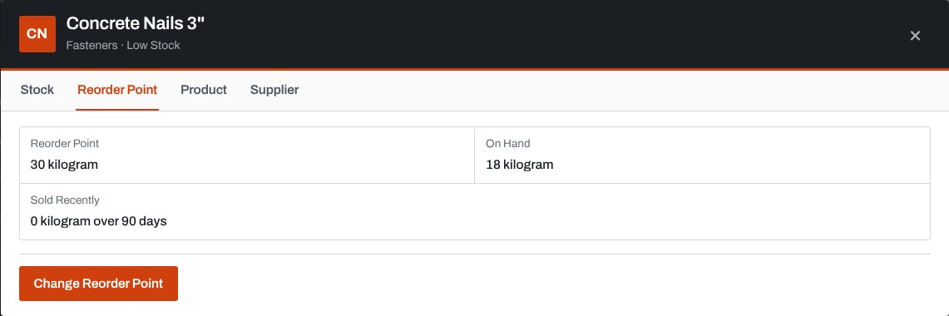
The Reorder Point tab of a product's card shows its reorder point, the stock on hand and what was sold in the last ninety days. Change Reorder Point sets the new figure.
Figure 86: Reorder Alerts
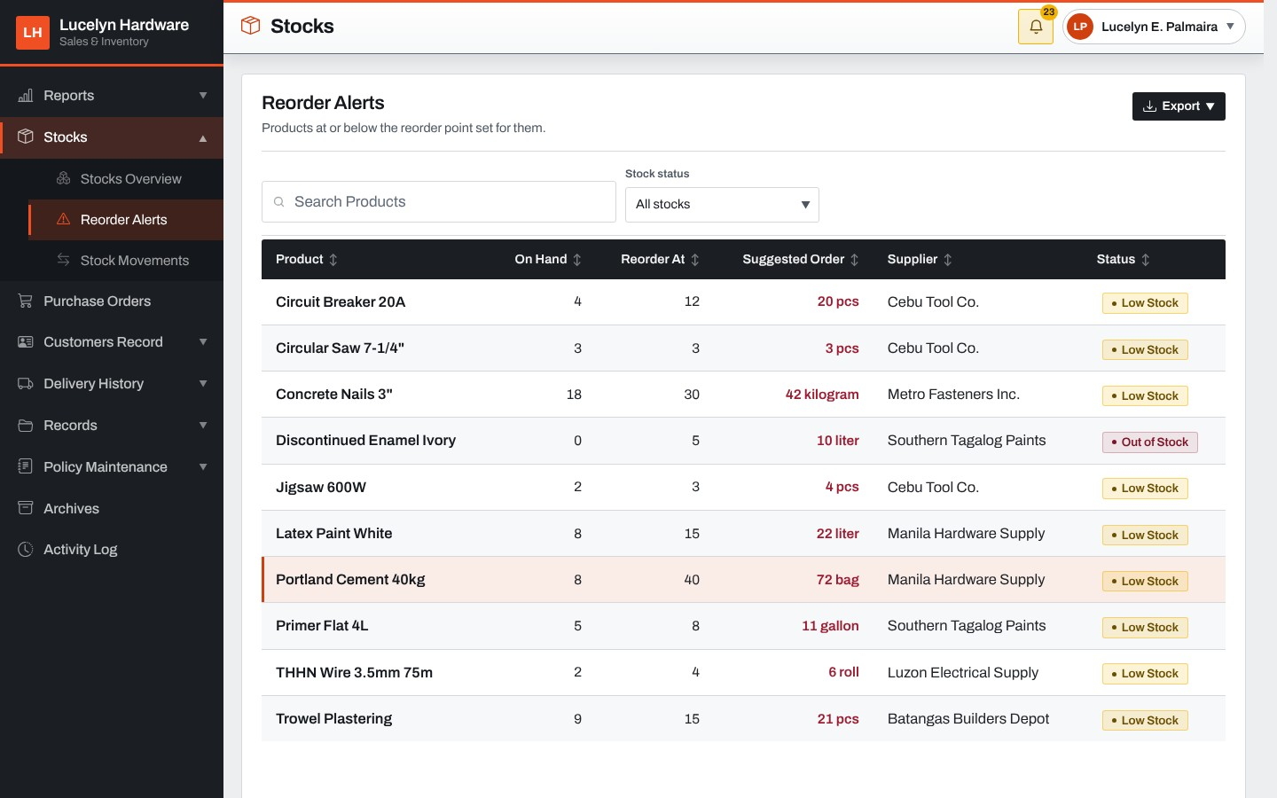
Reorder Alerts lists the materials at or under their reorder point, with the quantity on hand, the reorder point, the suggested order and the supplier.
Figure 87: Stock Movements
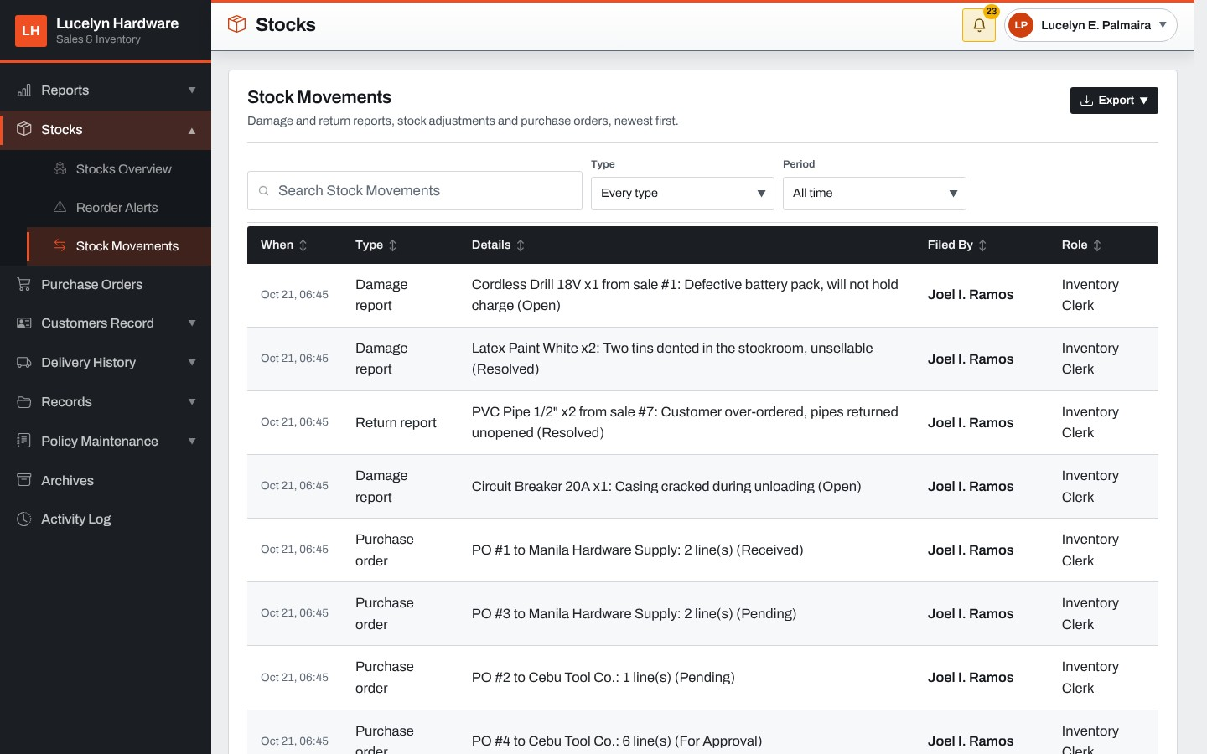
This report lists the damage reports, returns, adjustments and purchase orders that moved stock, with the details and who filed each.
Figure 88: Purchase Orders (Manager)
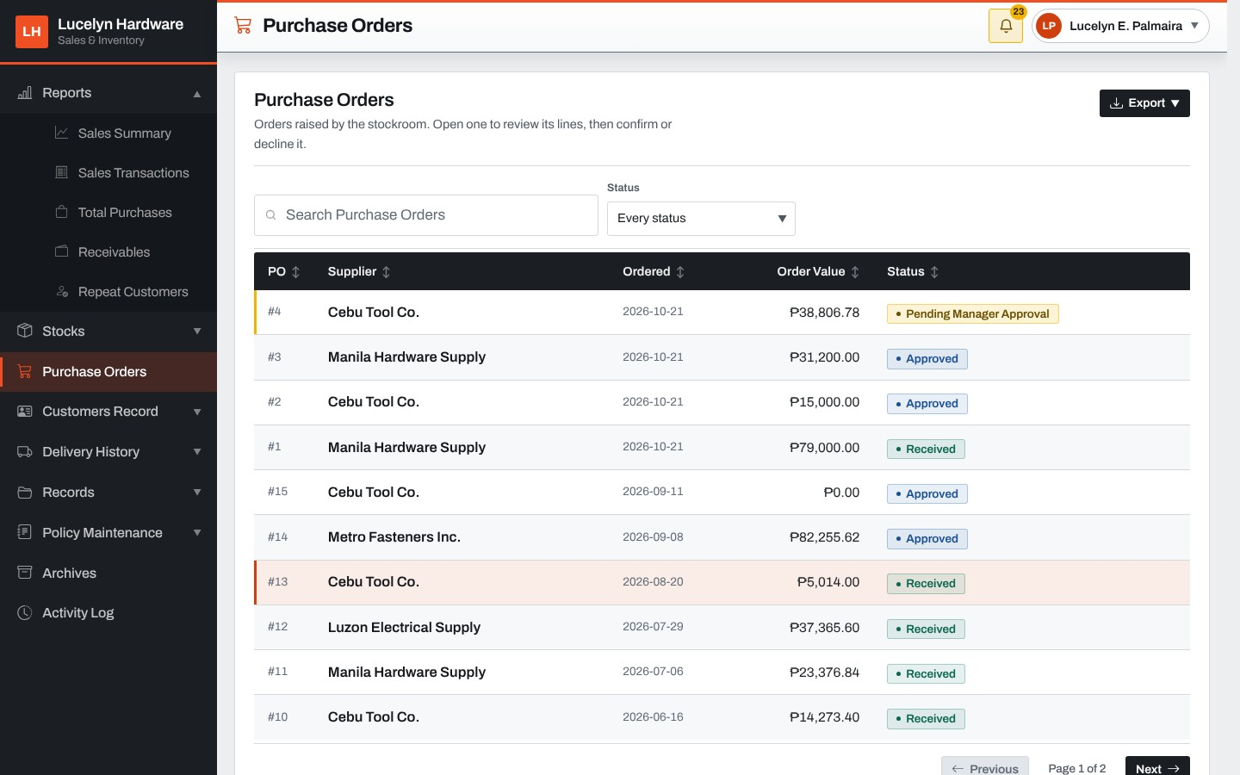
The Manager's purchase order list shows every order and its status, with the orders waiting for the manager's approval on top.
Figure 89: Purchase Order Review
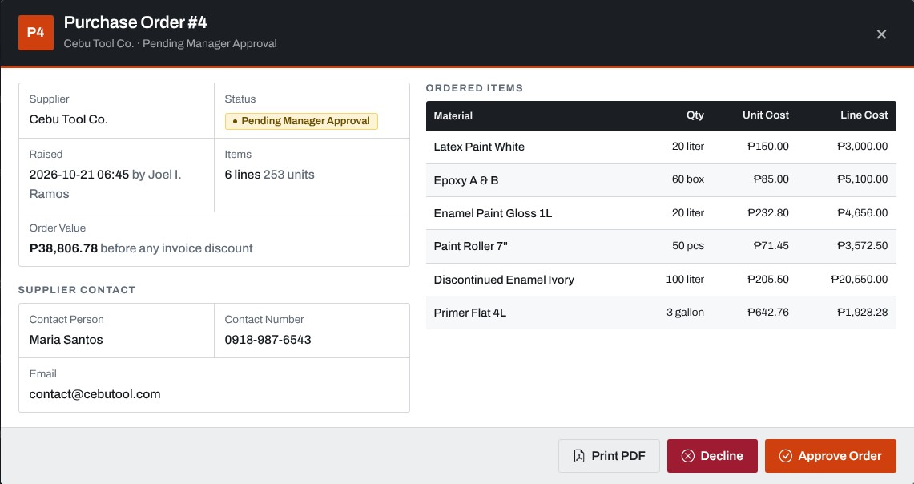
Opening an order waiting for approval shows the supplier, the materials, quantities and costs. The Manager approves it or declines it with a reason, and can print it as a PDF.
Figure 90: Customer Credit
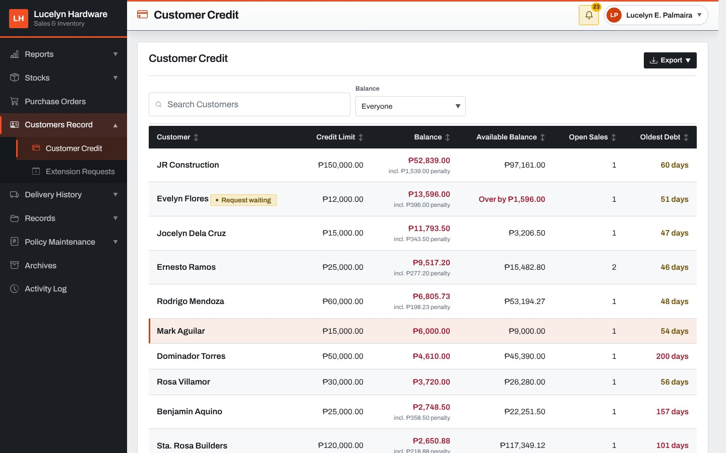
The Manager's credit book lists every account with its credit limit, balance, available balance, open sales and oldest debt, with the accounts that have a request waiting marked.
Figure 91: Credit Account Card
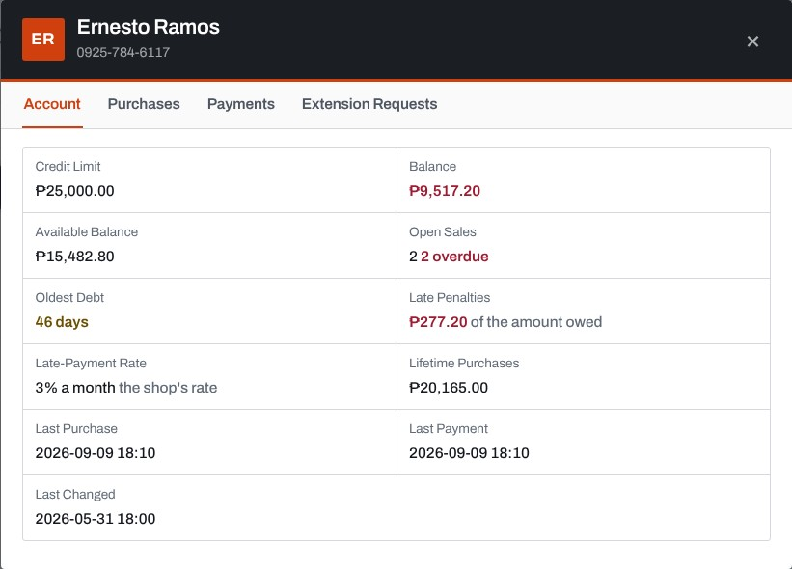
The account card shows the figures behind the standing: the credit limit, balance, available balance, open and overdue sales, oldest debt, late penalties, late-payment rate and lifetime purchases, with tabs for the purchases, payments and extension requests.
Figure 92: Extension Requests
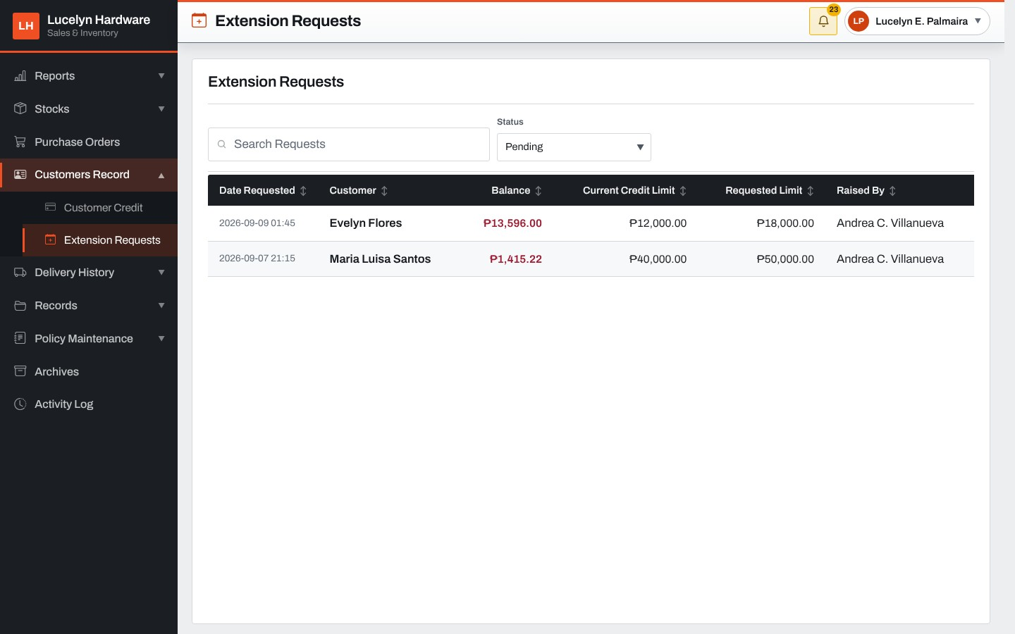
This screen lists the requests for a higher limit with the date, customer, balance, current and requested limits and the cashier who asked.
Figure 93: Extension Request
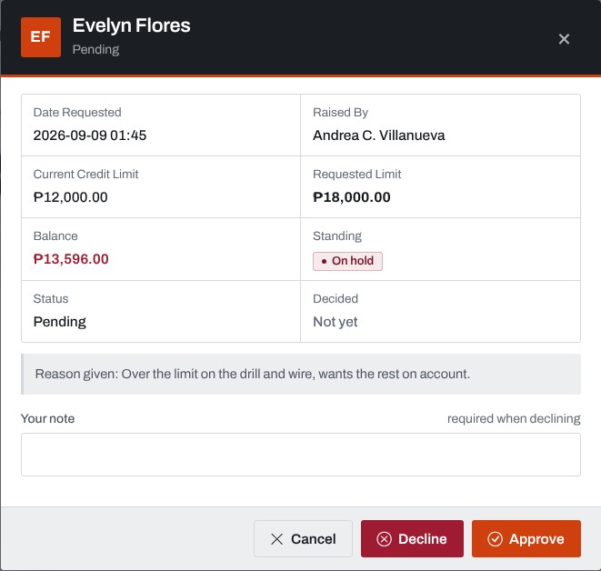
A request shows the current and requested limits, the balance, the standing and the cashier's reason. The Manager approves it or declines it with a required note.
Figure 94: Delivery History (Manager)
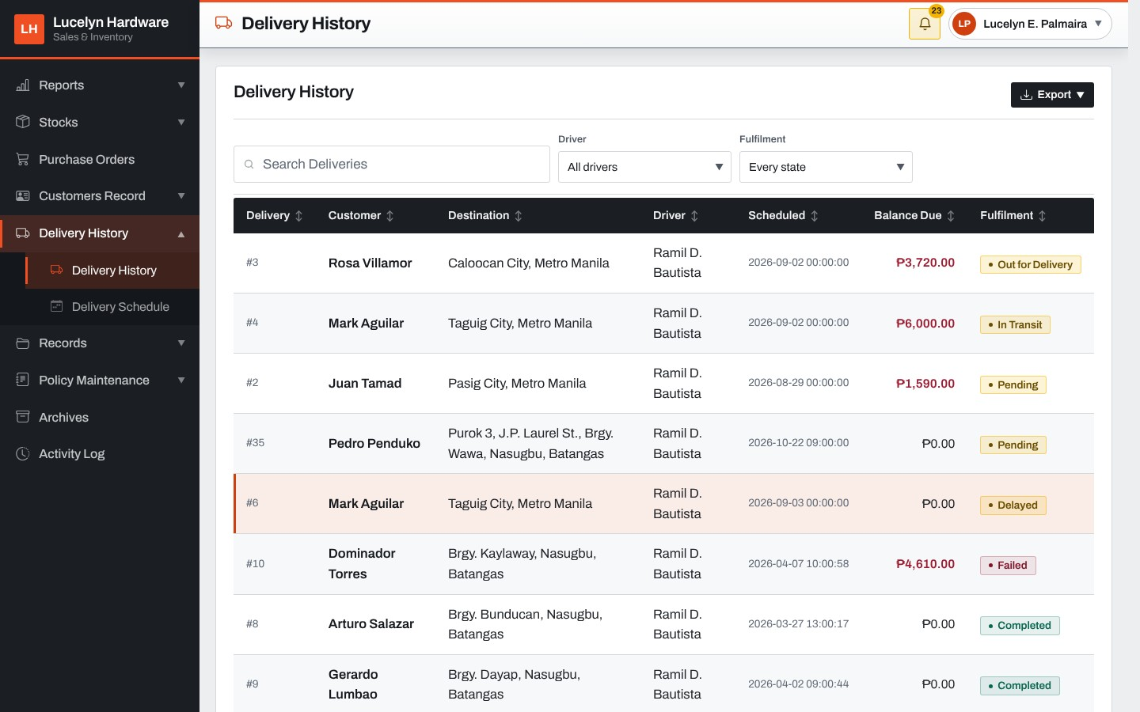
The Manager sees every delivery with its customer, destination, driver, schedule, balance due and fulfillment, and can filter them by driver and state.
Figure 95: Delivery Card
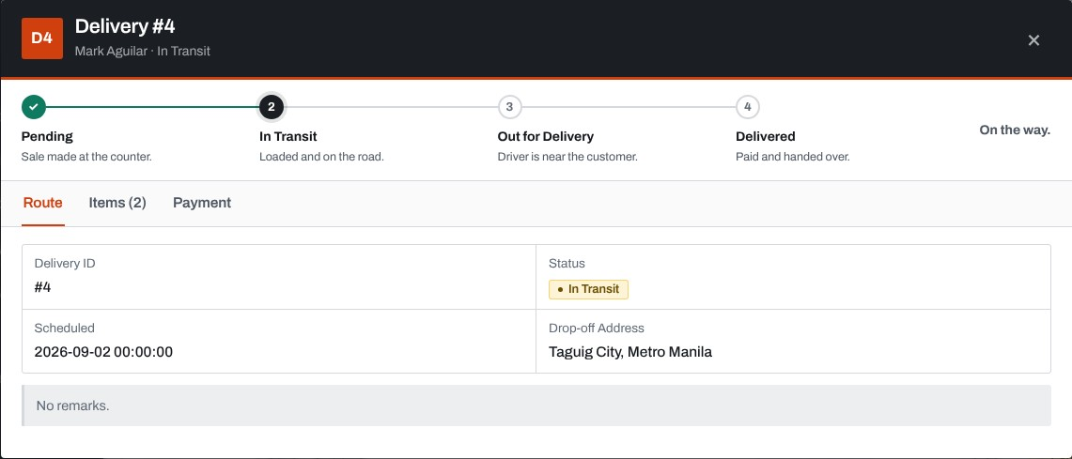
Opening a delivery shows its progress through Pending, In Transit, Out for Delivery and Delivered, its route, items and payment.
Figure 96: Delivery Schedule
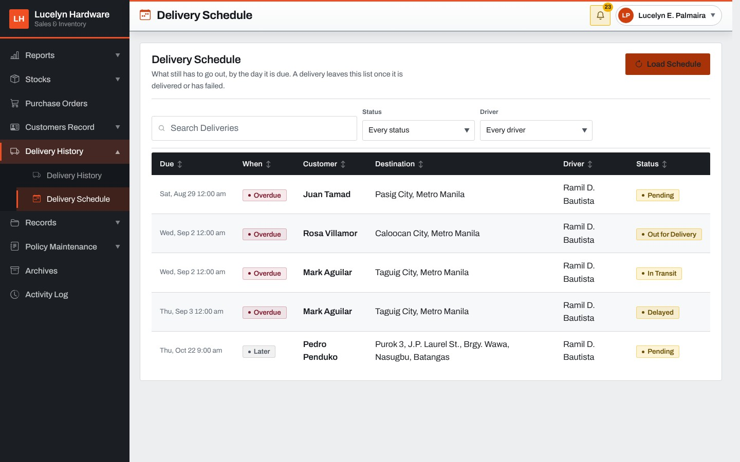
The delivery schedule lists the deliveries still to go out with when they are due, Overdue, Today, Tomorrow or Later.
Figure 97: Suppliers
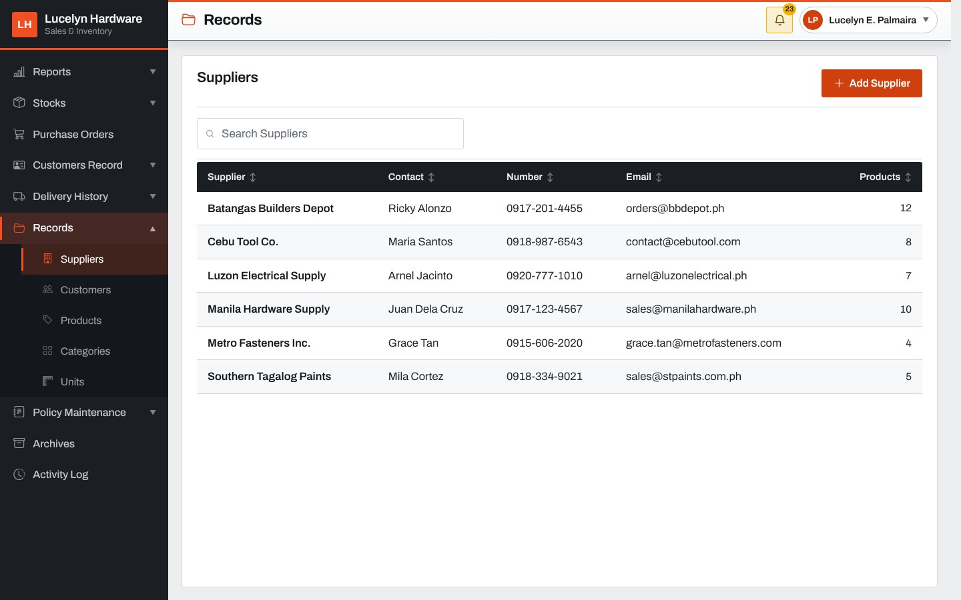
The supplier records list each supplier with the contact person, number, email address and the number of products supplied.
Figure 98: Customers
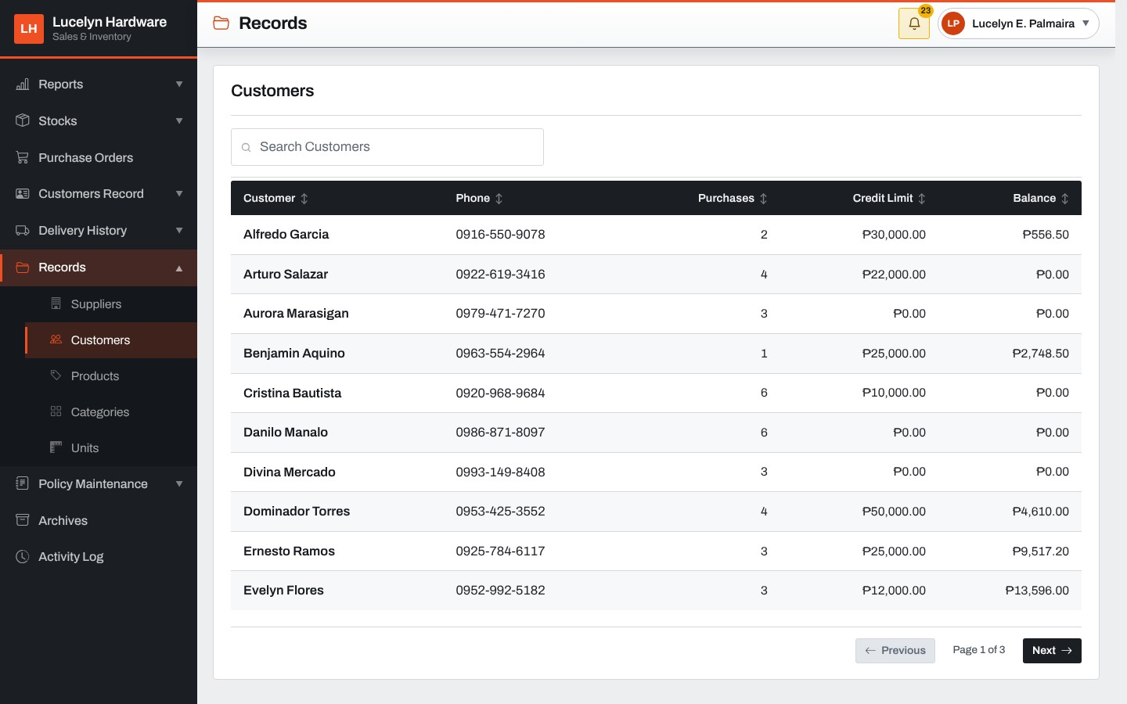
The customer records list each customer with the phone number, purchases, credit limit and balance.
Figure 99: Products
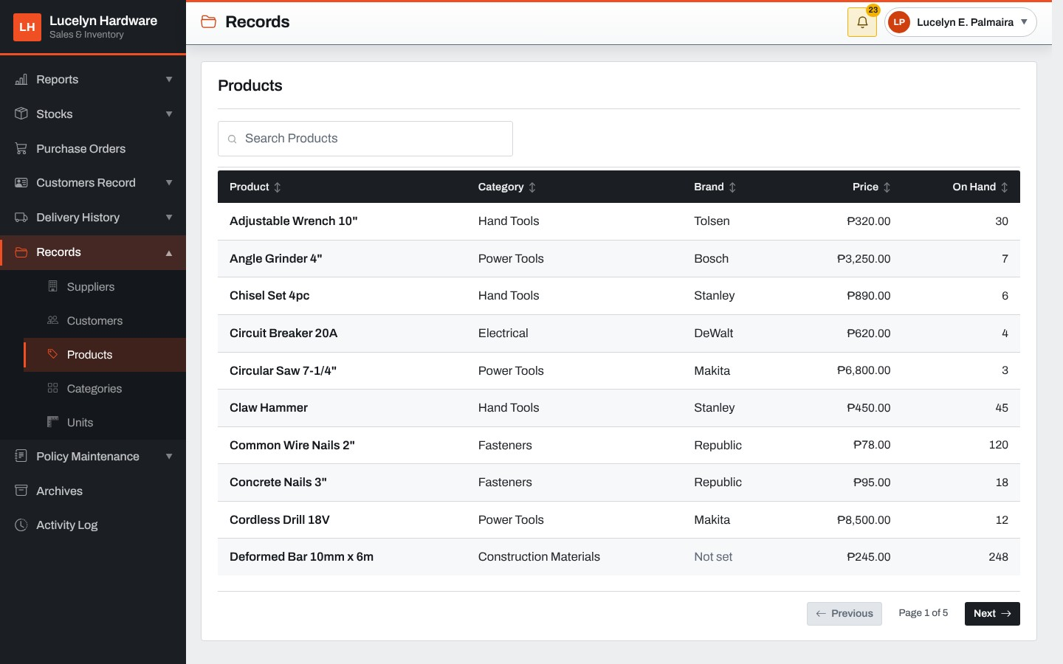
The product records list each product with its category, brand, price and quantity on hand.
Figure 100: Product Record: Price
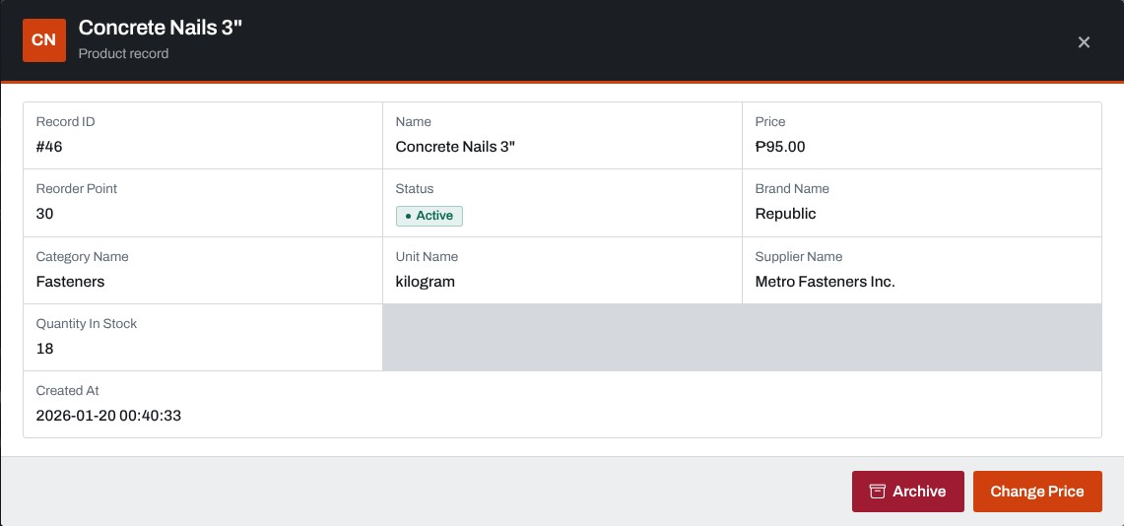
Opening a product record shows its details, with the buttons to archive it and to change its selling price.
Figure 101: Categories
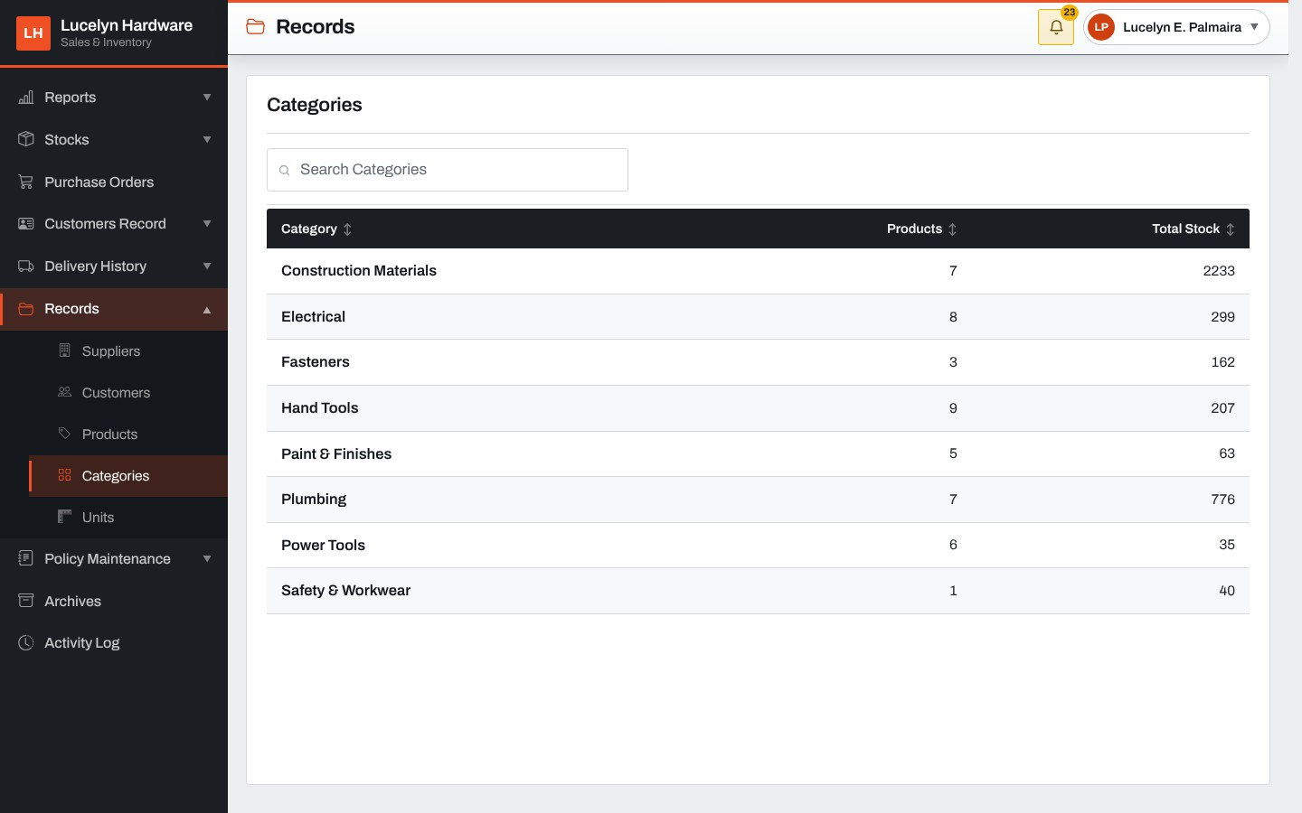
The category records list each category with the number of products and the total stock.
Figure 102: Units
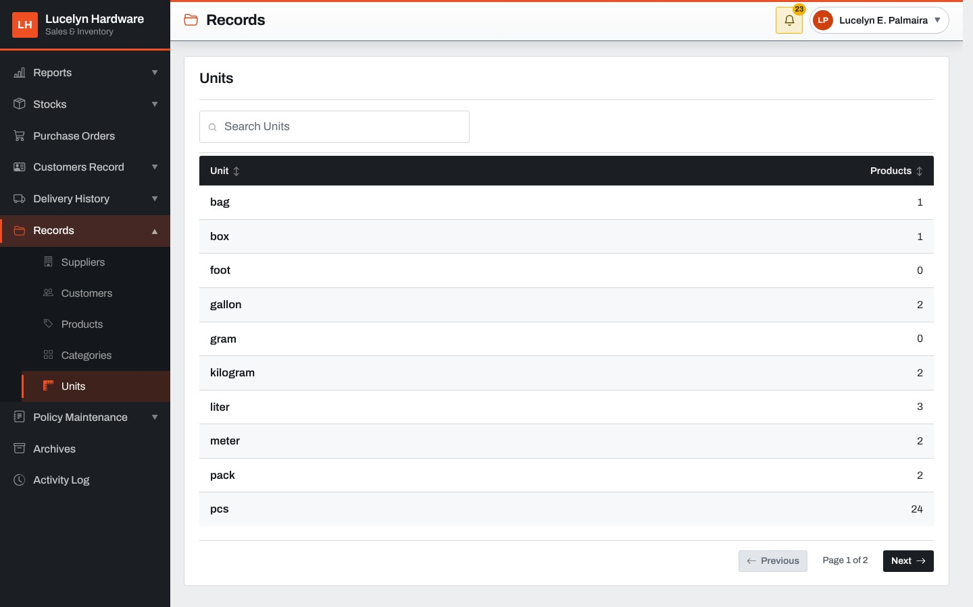
The unit records list the units of measurement with the number of products that use each.
Figure 103: Credit Maintenance
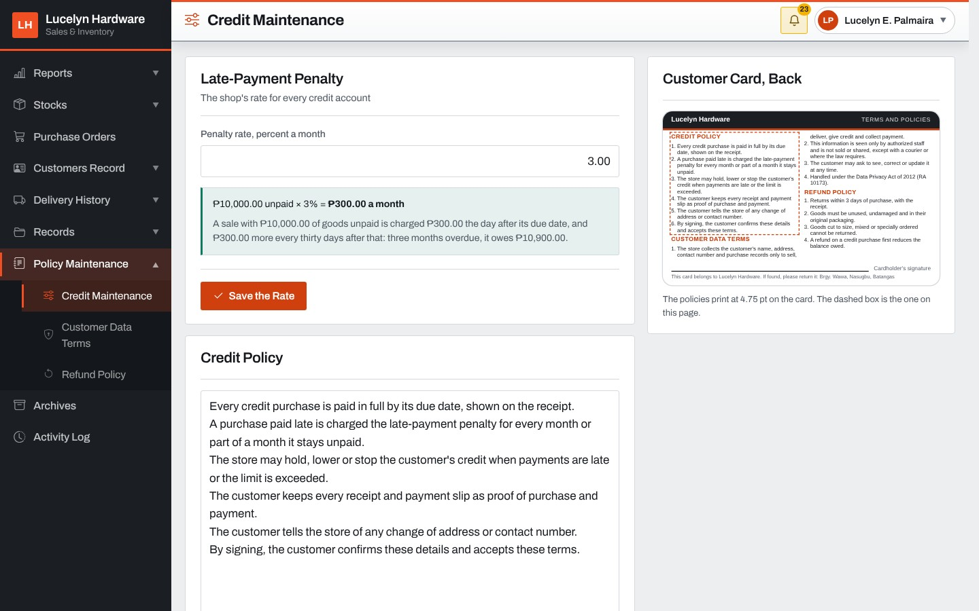
Credit Maintenance sets the store's late-payment rate, one to three percent a month, with an example of what it charges, and holds the wording of the credit policy. The back of the customer card is previewed on the right.
Figure 104: Customer Data Terms
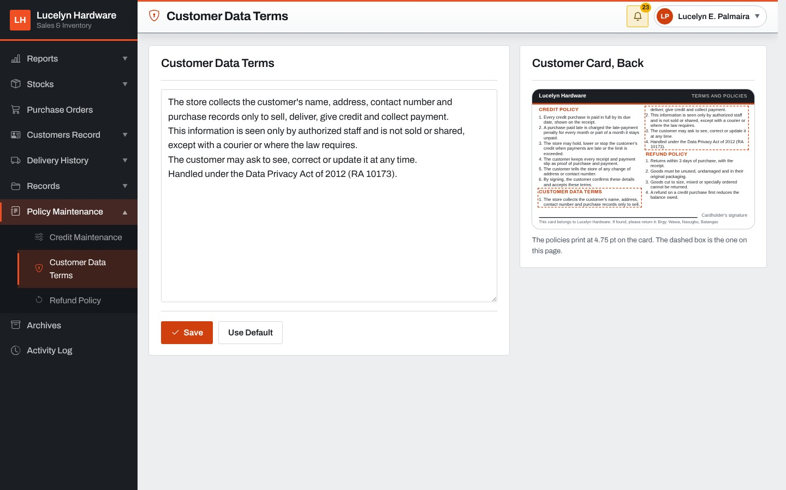
The Manager writes the terms on how the store collects, keeps and uses a customer's personal data, which are printed on the back of the customer card.
Figure 105: Refund Policy
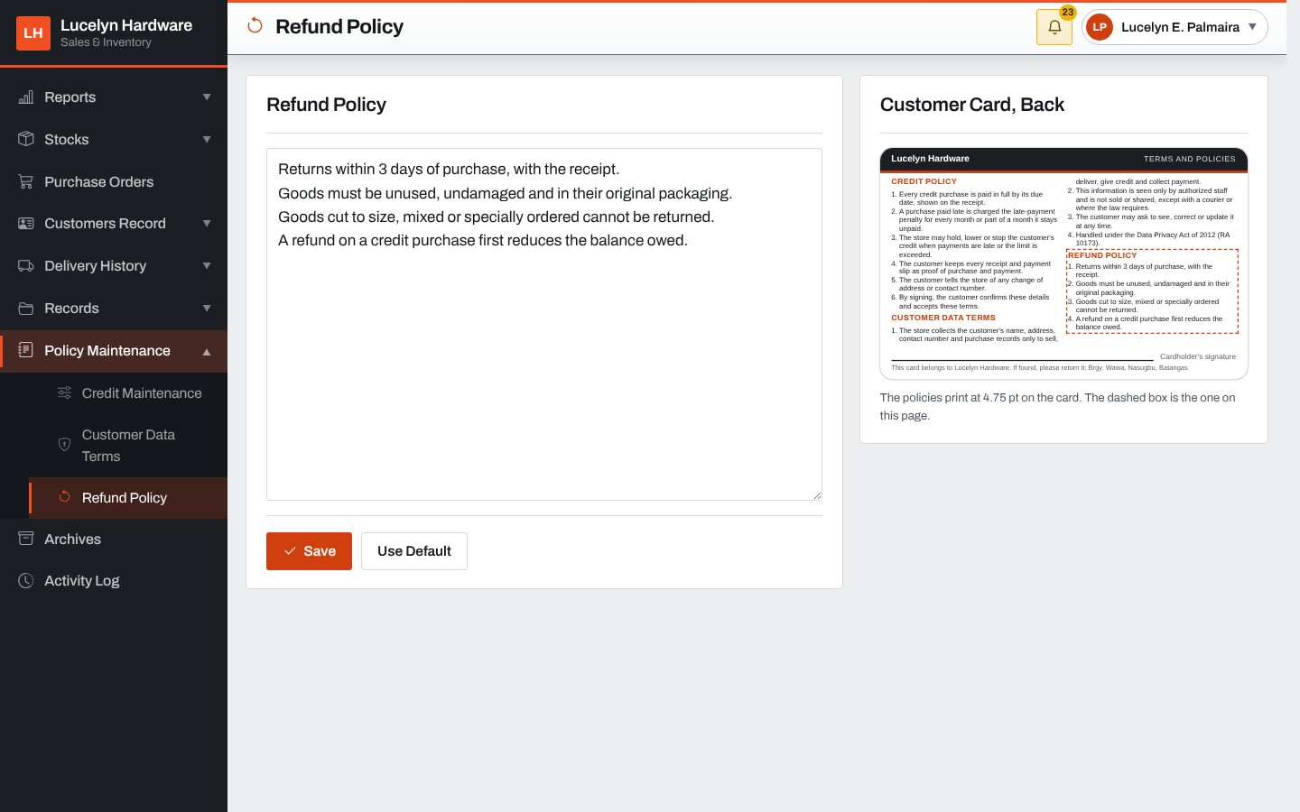
The Manager writes the store's refund policy, which is printed on the back of the customer card.
Figure 106: Archives
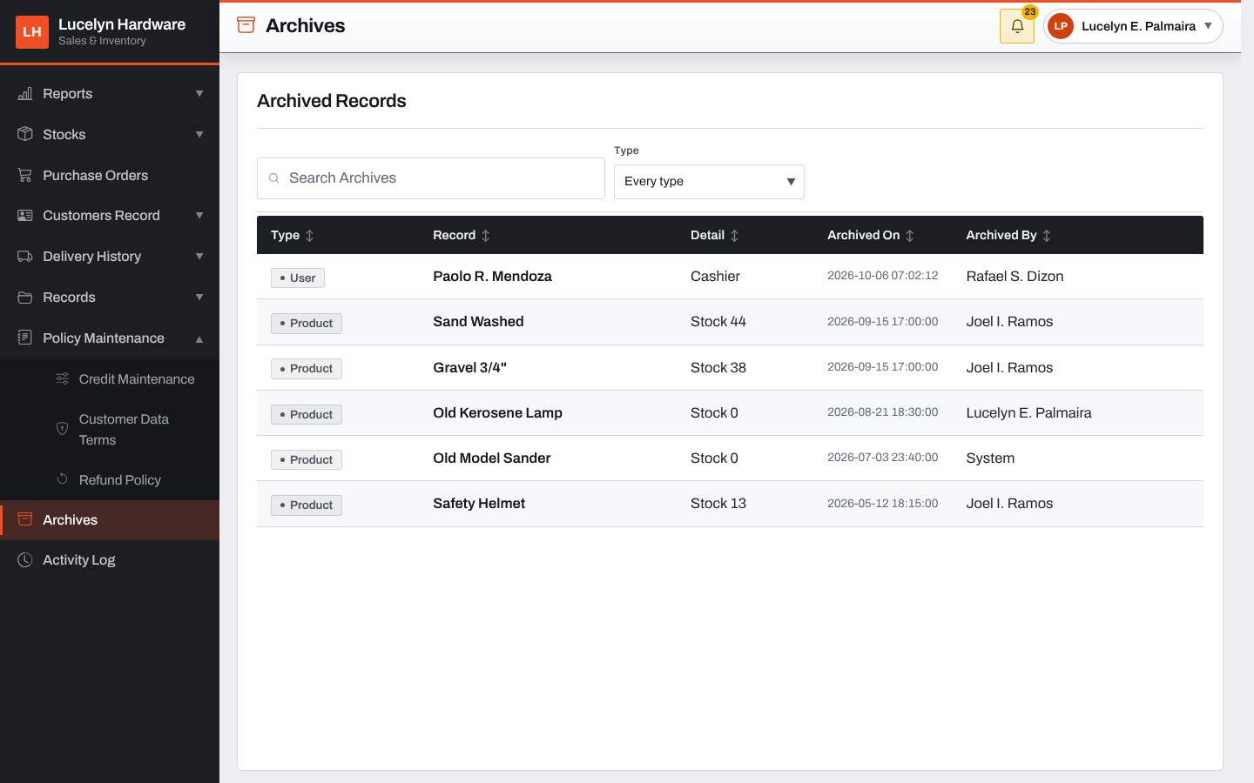
The Archives screen lists the archived records by type, with the date and who archived each. A record opens to a card with the button to restore it.
Figure 107: Pending Deliveries (Delivery Personnel)
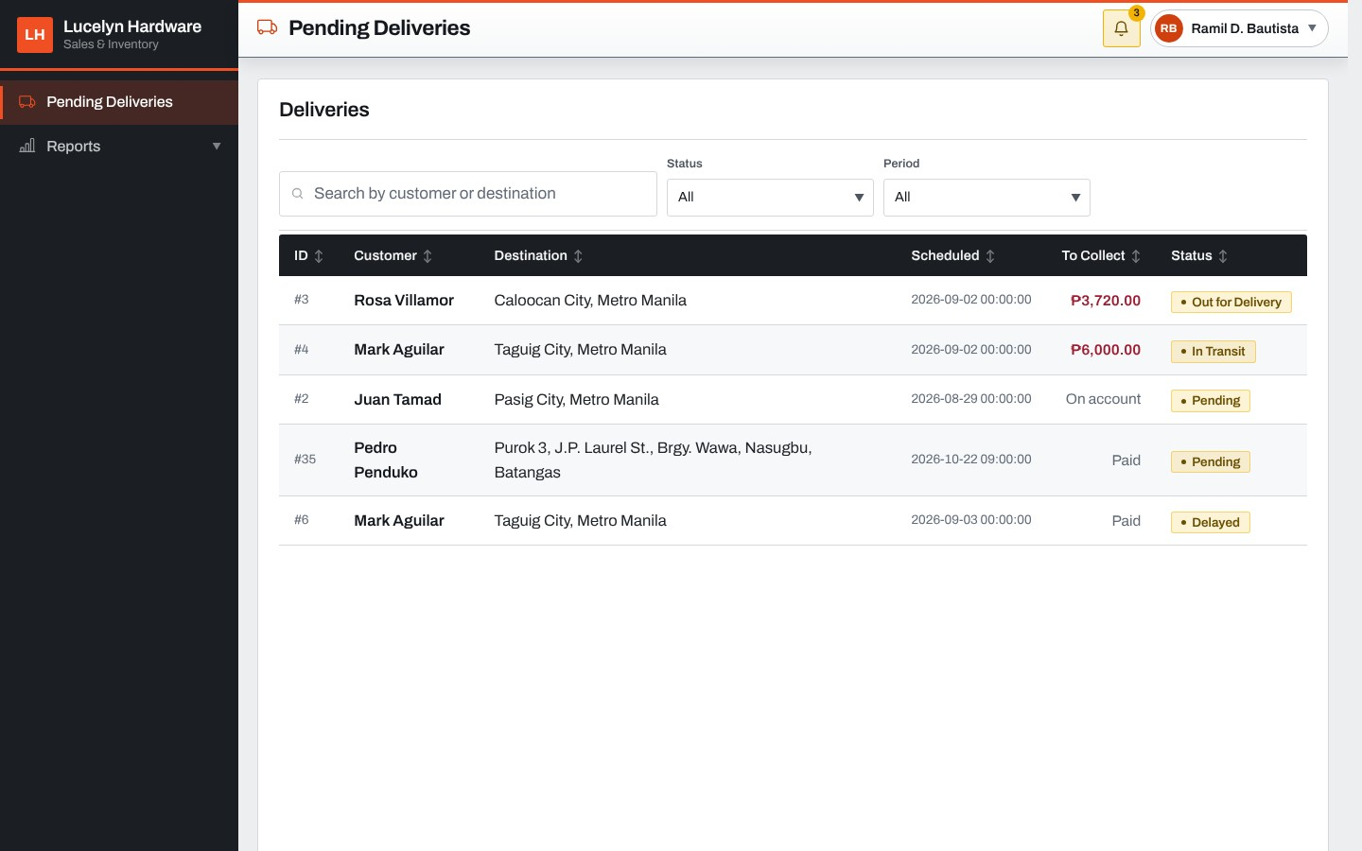
The driver's list shows the active deliveries with the customer, destination, schedule, amount to collect and status.
Figure 108: Delivery Card (Delivery Personnel)
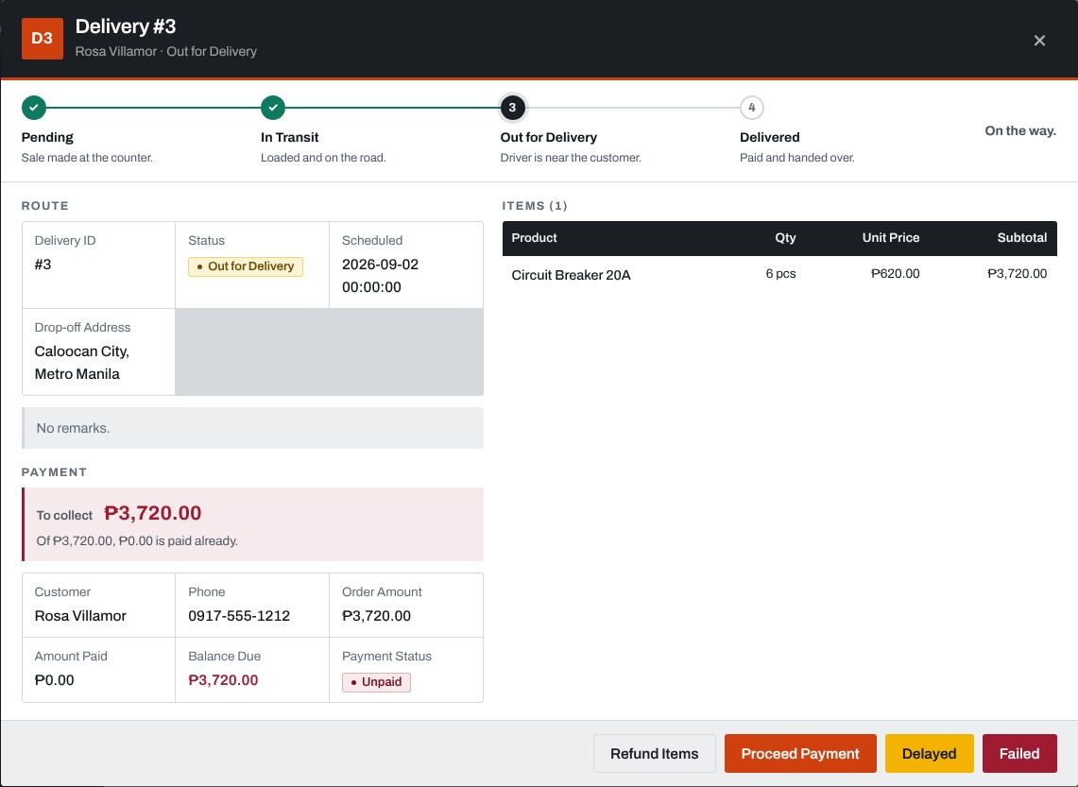
Opening a delivery shows its progress, route, items and payment. The driver moves it to the next status, refunds items turned away at the door, takes the payment, and marks it delayed or failed.
Figure 109: Payment at the Door
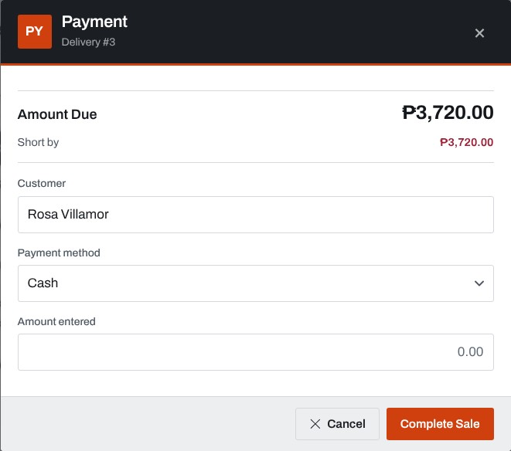
The driver records the payment of a Cash on Delivery order with the method and the amount. GCash, PayMaya and bank transfers are paid by QR code.
Figure 110: Deliveries Handled
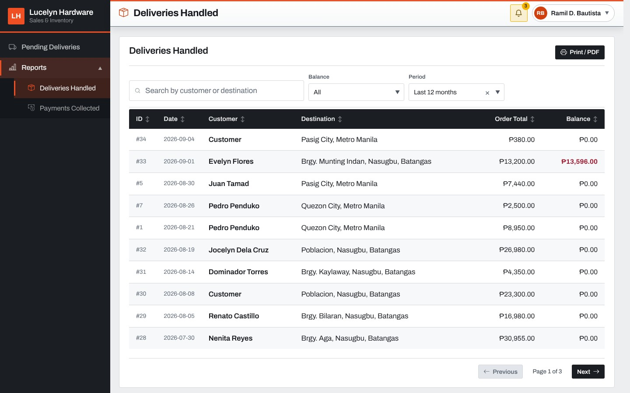
The driver's report lists the deliveries handled over a period with the customer, destination, order total and balance.
Figure 111: Payments Collected
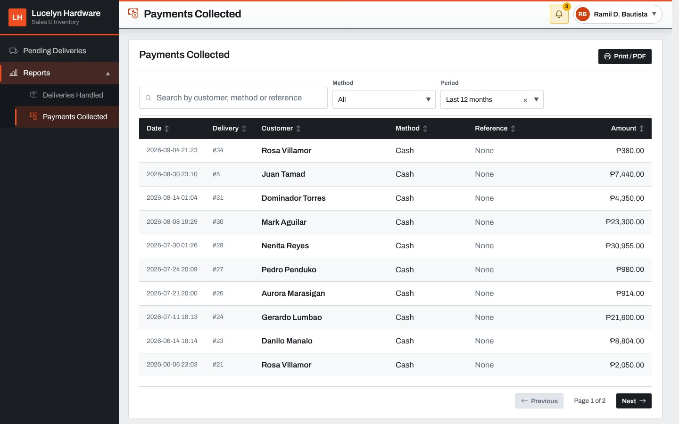
The driver's report lists the payments collected at the door over a period with the delivery, customer, method, reference and amount.
Figure 112: Supplier's Order Page
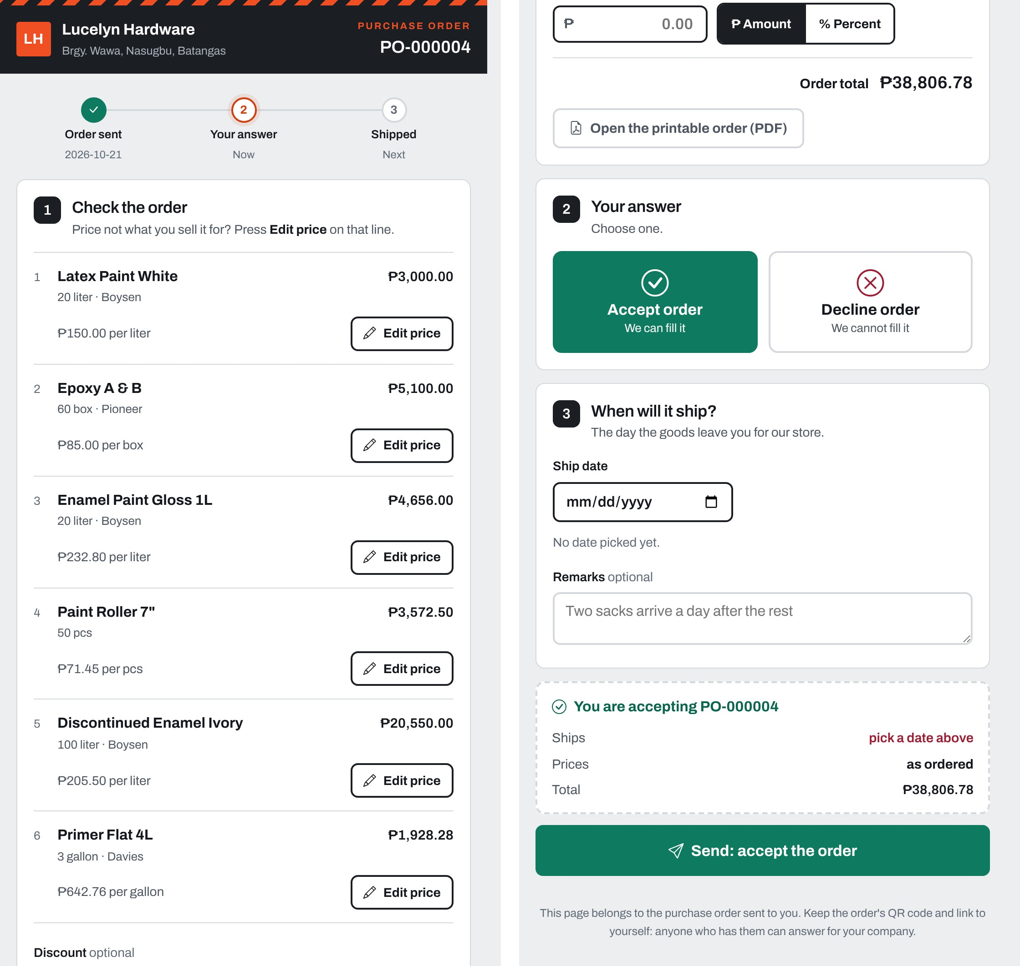
The supplier opens this page from the QR code or link on the purchase order, without signing in. The supplier checks each line, corrects a price that does not match, gives a discount, and accepts or declines the order with a ship date or a reason.

Development
The developers wrote the system in JavaScript on both the server and the browser. The server program, public/backend/server.js, sets up the sessions, the access table, the audit trail and the live updates; the routes of each role are kept in their own files under public/backend/routes, and the calls to the stored procedures under public/backend/database/procedures. The pages are plain HTML files under public/frontend with their own style sheets, the screen code of each role is kept under public/frontend/scripts, and the code shared by every page, such as tables, pop-up cards, menus and alerts, under public/frontend/scripts/shared. The database structure, the demonstration data and six months of sample trading are kept in one SQL file, and the views and stored procedures in a second file, so that the database can be rebuilt on any computer; the server also upgrades an older database by itself when it starts. Every change to the data goes through a stored procedure, and every important action is written to the audit trail. The developers kept the source code in a Git repository on GitHub. Selected source code is in Appendix B. The developers followed the standards below in developing the system.

Legal and Ethical Standards
Data privacy
The developers complied with Republic Act No. 10173, known as the Data Privacy Act of 2012, in collecting, using, keeping and disposing of the personal data gathered from the beneficiary and processed by the system. The system collects only the personal data the store needs: the names, phone numbers and addresses of customers, suppliers and staff. Each user can open only the screens allowed for the user's role, the server checks the role on every request, passwords and reset codes are stored only as hashes, and the audit trail records who changed records and when. The information gathered in the interview was used only for this project.
Anti-plagiarism
The developers wrote the manuscript in their own words and gave a correct and complete citation for every idea, definition and finding taken from another author, following the reference format required by STI College.
Copyright
The developers respected Republic Act No. 8293, known as the Intellectual Property Code of the Philippines. They designed the pages of the system themselves. The open-source libraries used in the system, such as Bootstrap, Bootstrap Icons, Express.js, PDFKit, ExcelJS and node-qrcode, are used under their licenses, and the license notices are kept with the source code.
Professional ethics
The developers followed the principles of the ACM Code of Ethics and Professional Conduct (Association for Computing Machinery, 2018), in particular to avoid harm, to be honest and trustworthy, to respect privacy and to honor confidentiality. They told the beneficiary what the system can and cannot do, and they handled the store's data with care.

Cybersecurity Standard
The developers aligned the handling of passwords and sign-in with the Digital Identity Guidelines of the National Institute of Standards and Technology, NIST Special Publication 800-63B (Grassi et al., 2017). In line with the guideline, the system requires passwords of at least eight characters, stores them only as salted one-way scrypt hashes, generates temporary passwords and reset codes from a secure random source, limits repeated wrong attempts by holding the account for fifteen minutes after three failures, gives the same answer for an unknown email address and a wrong password so that accounts cannot be discovered, and does not force users to change passwords on a fixed schedule. A temporary password works for one sign-in only, and changing or resetting a password ends every session of the account. The system also signs out idle sessions after thirty minutes, allows one session per account, stores only a hash of the session cookie, checks the role of the user on the server for every request, and records failed sign-ins in the audit trail.

RESULTS AND DISCUSSION

Testing
The developers tested the system at three levels. In unit testing, each function of every module was checked on its own. In integration testing, the records written by one module were checked in the next, such as a sale lowering the stock, a received purchase order raising it, and a payment at the door lowering the balance of the sale. In system testing, complete scenarios were run from the counter to the reports, as each role would use them. Every function was run ten times on the system with its sample data of six months of trading. The tables below list the functions tested in each module, what was expected, and the results.
Table 37. Login Module Testing
Functionality | Expected Outcome | No. of times tested | Result
Functionality | Expected Outcome | No. of times tested | Pass | Fail
Sign in | A user with the right email address and password is signed in with the role of the account | 10 | 10 | 0
Refuse a wrong password | The sign-in is refused with a message | 10 | 10 | 0
Refuse an unknown email address | The same message as for a wrong password is shown | 10 | 10 | 0
Hold after three wrong passwords | The account is held from signing in | 10 | 10 | 0
Release a held account | The administrator lets a held account sign in again | 10 | 10 | 0
First sign-in password change | A new account must choose its own password before using the system | 10 | 10 | 0
Refuse a weak password | A password without an uppercase letter, a lowercase letter, a number and a symbol is refused | 10 | 10 | 0
Forgot password | A request for a reset code gets the same answer for a known and an unknown email address | 10 | 10 | 0
Refuse a wrong reset code | A code that was not sent is refused | 10 | 10 | 0
One session per account | Signing in on another device ends the first session | 10 | 10 | 0
Sign out | The session ends and the screens can no longer be opened | 10 | 10 | 0
Screens of the role only | A cashier is refused the administrator's and manager's routes | 10 | 10 | 0
The table above shows the testing of the Login module. All 12 functions passed in every one of their ten runs.
Table 38. Inventory Management Module Testing
Functionality | Expected Outcome | No. of times tested | Result
Functionality | Expected Outcome | No. of times tested | Pass | Fail
View the material list | Every material is listed with its supplier, price, stock on hand and status | 10 | 10 | 0
Add a new product | The product is opened with no price and no stock | 10 | 10 | 0
Add to stock | The stock goes up by the quantity and the adjustment is kept with its remarks | 10 | 10 | 0
Remove from stock | The stock goes down by the quantity | 10 | 10 | 0
Refuse an adjustment without remarks | The adjustment is refused and the stock does not change | 10 | 10 | 0
Refuse removing more than on hand | An adjustment that would make the stock negative is refused | 10 | 10 | 0
View the adjustment history | Every adjustment is listed with the quantity before, the change, the quantity after and who made it | 10 | 10 | 0
Set the reorder point | The manager types the reorder point and the material is listed in Reorder Alerts when stock reaches it | 10 | 10 | 0
Refuse a wrong reorder point | A reorder point that is not a whole number of zero or more is refused | 10 | 10 | 0
Raise a purchase order | The order is saved and waits for the manager's approval | 10 | 10 | 0
Approve a purchase order | The order is approved and gets its QR code and link for the supplier | 10 | 10 | 0
Decline a purchase order | The order is declined with the manager's reason | 10 | 10 | 0
Supplier answers the order | The supplier opens the order from its link and accepts it with a ship date | 10 | 10 | 0
Receive a delivery | The clerk counts the goods in against the order and the stock goes up | 10 | 10 | 0
Print the purchase order | The approved order prints as a PDF document with its QR code | 10 | 10 | 0
View the returned items | The returns, refunds and damage reports are listed with what happened to the goods | 10 | 10 | 0
Low-stock alert | A material that falls to its reorder point raises a low-stock alert for the manager and the clerk | 10 | 10 | 0
The table above shows the testing of the Inventory Management module. All 17 functions passed in every one of their ten runs.
Table 39. Sales Module Testing
Functionality | Expected Outcome | No. of times tested | Result
Functionality | Expected Outcome | No. of times tested | Pass | Fail
Ring up a cash sale | The sale is saved, the change is computed and the stock goes down | 10 | 10 | 0
Refuse a short cash payment | A sale paid with less than the amount due is refused | 10 | 10 | 0
Sell measured goods in fractions | A product sold by the kilogram is sold in a quantity such as 2.5 | 10 | 10 | 0
Sell counted goods in whole numbers | A fraction typed for a product counted in pieces is brought down to a whole number at the till | 10 | 10 | 0
Sell in a bigger size | A product is sold by the box at the price of the box and the stock goes down in its own unit | 10 | 10 | 0
Refuse selling more than in stock | A sale for more than the stock on hand is refused | 10 | 10 | 0
Take a cheque | A cheque sale needs the cheque number, bank, branch, date and account; with them it is saved | 10 | 10 | 0
Pay by QR code | A GCash or Maya QR code is made for the amount and can be cancelled before it is paid | 10 | 10 | 0
Print the sales invoice | The sale is read back with its items, payment and tax lines for the invoice | 10 | 10 | 0
Issue a refund | The item taken back is recorded with the amount and reason and waits for the stockroom | 10 | 10 | 0
Refuse a refund over the sale | A refund for more items than were bought is refused | 10 | 10 | 0
View the sales report | The cashier's sales are listed with the method, status and total | 10 | 10 | 0
View the daily summary | What the till took today is shown by method | 10 | 10 | 0
Request a void | A sale of today is sent to the manager to void, once | 10 | 10 | 0
Approve a void | The manager approves the request, the sale is voided and the goods go back on the shelf | 10 | 10 | 0
Decline a void | The manager declines the request with a note and the sale stays | 10 | 10 | 0
The table above shows the testing of the Sales module. All 16 functions passed in every one of their ten runs.
Table 40. Credit Management Module Testing
Functionality | Expected Outcome | No. of times tested | Result
Functionality | Expected Outcome | No. of times tested | Pass | Fail
Charge a sale to an account | A credit sale within the available balance is saved as unpaid and the balance goes up | 10 | 10 | 0
Take a part payment | What is handed over is taken now and the rest is charged to the account | 10 | 10 | 0
Refuse a sale over the limit | A credit sale that does not fit under the available balance is refused | 10 | 10 | 0
Refuse credit for a walk-in | A credit sale needs a customer on record | 10 | 10 | 0
Compute the standing | The account reads Good, Watch or Hold from the balance and the oldest unpaid sale, with the reason | 10 | 10 | 0
Ask for a higher limit | The cashier's request goes to the manager with the reason | 10 | 10 | 0
Approve a higher limit | The manager approves the request and the limit is raised | 10 | 10 | 0
Decline a higher limit | Declining needs a note and leaves the limit as it was | 10 | 10 | 0
Credit settlement | A payment against an unpaid sale lowers its balance | 10 | 10 | 0
Refuse a payment over the balance | A payment larger than what is owed is refused | 10 | 10 | 0
Mark a sale paid | A sale whose balance reaches zero is marked Paid | 10 | 10 | 0
Set the late-payment rate | The manager sets a rate of one to three percent a month; a rate outside it is refused | 10 | 10 | 0
Charge the late penalty | An overdue credit sale carries the penalty in its balance | 10 | 10 | 0
Print the credit terms | The credit terms page of a customer is produced | 10 | 10 | 0
The table above shows the testing of the Credit Management module. All 14 functions passed in every one of their ten runs.
Table 41. Record Maintenance Module Testing
Functionality | Expected Outcome | No. of times tested | Result
Functionality | Expected Outcome | No. of times tested | Pass | Fail
Add a supplier | The supplier is saved with its contact person, number, email and address | 10 | 10 | 0
Edit a supplier | The changed details are saved | 10 | 10 | 0
Add a customer | The cashier adds a customer with the name, phone and address | 10 | 10 | 0
Refuse an incomplete address | A customer without a barangay, town or province is refused | 10 | 10 | 0
Add a category | The clerk adds a category, and a name already used is refused | 10 | 10 | 0
Add a unit | The clerk adds a unit of measurement | 10 | 10 | 0
Set the selling price | The manager changes the selling price of a product | 10 | 10 | 0
Archive and restore a record | An archived record leaves the lists and comes back when restored | 10 | 10 | 0
Save a policy | The refund policy wording is saved | 10 | 10 | 0
The table above shows the testing of the Record Maintenance module. All 9 functions passed in every one of their ten runs.
Table 42. Customer Delivery Module Testing
Functionality | Expected Outcome | No. of times tested | Result
Functionality | Expected Outcome | No. of times tested | Pass | Fail
Create a delivery | A delivery is created for the sale with the recipient, address, schedule and driver | 10 | 10 | 0
Refuse a delivery without a driver | A delivery needs a driver and a date | 10 | 10 | 0
List the driver's deliveries | The driver sees the active deliveries assigned to the driver | 10 | 10 | 0
Move a delivery along | The status moves from Pending to In Transit to Out for Delivery | 10 | 10 | 0
Mark a delivery delivered | A delivery that is fully paid is marked Delivered | 10 | 10 | 0
Mark a delivery delayed or failed | A delivery on the road is marked Delayed or Failed with a reason of at least five characters | 10 | 10 | 0
Refuse a status out of order | A delivery cannot skip a step, such as going from Pending to Delivered | 10 | 10 | 0
Collect payment at the door | The driver records the money collected on a Cash on Delivery order and it goes on the sale | 10 | 10 | 0
Refund at the door | An item the customer turns away at the door is recorded as a refund for the stockroom | 10 | 10 | 0
View the delivery schedule | The deliveries still to go out are listed by the day they are due | 10 | 10 | 0
The table above shows the testing of the Customer Delivery module. All 10 functions passed in every one of their ten runs.
Table 43. Reporting Module Testing
Functionality | Expected Outcome | No. of times tested | Result
Functionality | Expected Outcome | No. of times tested | Pass | Fail
Sales summary | The total sales and transactions of the period are shown by payment method | 10 | 10 | 0
Sales transactions | Every sale of the period is listed with the customer, method, status and total | 10 | 10 | 0
Total purchases | The purchase orders of the period are listed with their value | 10 | 10 | 0
Receivables and repeat customers | The sales with money owed and the customers who bought more than once are listed | 10 | 10 | 0
Stocks overview and reorder alerts | The inventory is listed with the stock on hand, the reorder point and the status | 10 | 10 | 0
Activity log and stock movements | Everything the staff filed is listed with who filed it and when | 10 | 10 | 0
Export to Excel | A report table is saved as an Excel file | 10 | 10 | 0
Refuse exports for the cashier | The server refuses an export asked by the cashier | 10 | 10 | 0
Delivery reports | The driver sees the deliveries handled and the payments collected over a period | 10 | 10 | 0
The table above shows the testing of the Reporting module. All 9 functions passed in every one of their ten runs.
Table 44. System Maintenance Module Testing
Functionality | Expected Outcome | No. of times tested | Result
Functionality | Expected Outcome | No. of times tested | Pass | Fail
Create an account | The details are read back first, then the account is created and its password is generated | 10 | 10 | 0
Refuse a duplicate email address | An email address already used by another account is refused | 10 | 10 | 0
Edit an account | The name, phone and role of an account are changed | 10 | 10 | 0
Deactivate and reactivate | The account is marked deactivated, then active again | 10 | 10 | 0
Reset a password | A new temporary password is made and must be changed at the next sign-in | 10 | 10 | 0
Switch a screen off for a role | The server refuses the routes of a screen switched off, and allows them again when switched on | 10 | 10 | 0
View the audit logs | Every important action is listed with the user, role, IP address, action type and details | 10 | 10 | 0
Export the audit logs | The audit trail is exported to Excel or PDF | 10 | 10 | 0
Run a backup | A backup of the whole database is saved as a .sql file and listed | 10 | 10 | 0
Download a backup | A saved backup is downloaded as a .sql file | 10 | 10 | 0
Keep the store details | The store details and receipt layout are saved | 10 | 10 | 0
Alerts and notifications | The alerts of the role are listed and can be marked read | 10 | 10 | 0
The table above shows the testing of the System Maintenance module. All 12 functions passed in every one of their ten runs.
User acceptance testing
User acceptance testing was conducted with the owner of Lucelyn Hardware, Ms. Lucelyn E. Palmaira, who tested the functions of the system with the developers. The functions checked are listed in the User Acceptance Test form in Appendix C (Table 47). The owner accepted all twelve functions: signing in with screens limited by role; ringing up a sale, taking the payment and printing the sales invoice; selling measured goods in fractions and products in bigger sizes; recording GCash and Maya payments by QR code; lowering the stock with every sale and raising it with every delivery received; listing the materials at or below their reorder point with alerts; raising, approving, sending and receiving purchase orders; recording credit sales, part payments and payments on balances; computing the late penalty of each customer; recording deliveries and the cash collected on delivery; producing reports with the correct figures that can be exported or printed; and creating and restoring backups.
On October 12, 2026, the owner issued a letter of acceptance, found in Appendix I, certifying that the system was presented to and tested by Lucelyn Hardware, that it meets the requirements the store gave to the developers and addresses the problems in its manual recording of sales, inventory and customer credit, and that the store accepts the system and finds it ready for implementation in the store.

Description of Prototype
System requirements
The server needs a computer with Node.js version 20 or newer and MySQL version 8.0 or newer, or an account on Vercel with a MySQL database on Aiven. The staff need a computer or phone with a current web browser on the same network as the server, or with an internet connection when the system is hosted online. A receipt printer and a printer for purchase orders are optional. An email account that allows SMTP is needed to send passwords, reset codes and purchase orders, and a PayMongo account is needed for GCash, PayMaya and bank transfer payments.
Design
The prototype is a web application with five dashboards that share one database, as shown in the hierarchical diagrams and the prototype design in the Methodology. The menu on the left holds the modules of the role, and the strip at the top holds the screens of the open module. Colors mean the same thing everywhere: orange for buttons to press, green for what is fine, amber for what needs a look, and crimson for what stops something or money owed, and every color is paired with a word. Tables load when asked, show ten rows at a time and turn into cards on a phone. Actions that cannot be taken back, such as voiding a sale, writing off stock or restoring a backup, ask first and list what will happen.
Evaluation and testing
The prototype was evaluated through the module tests in Tables 37 to 44 and through the user acceptance test of the beneficiary. Each of the 99 functions tested passed in all of its ten runs, for 990 runs in all. The owner of Lucelyn Hardware accepted all twelve functions in the User Acceptance Test form and accepted the system as a whole in the letter of acceptance.

Implementation Plan
The Online Hardware Sales and Inventory with Credit Management System for Lucelyn Hardware in Nasugbu, Batangas runs on one computer in the store, which holds the Node.js server and the MySQL database, and the staff open it through a web browser on the store's network. The Cashier uses the computer at the counter with a receipt printer, the Manager and the System Administrator use the computer in the office, the Inventory Clerk uses a computer in the stockroom, and the Delivery Personnel use a phone. The system can also be hosted online on Vercel with the database on Aiven MySQL, so that it can be reached from any network. The network layout of the implementation setup is shown in the figure below.
Figure 113: Network Layout of the Implementation Setup
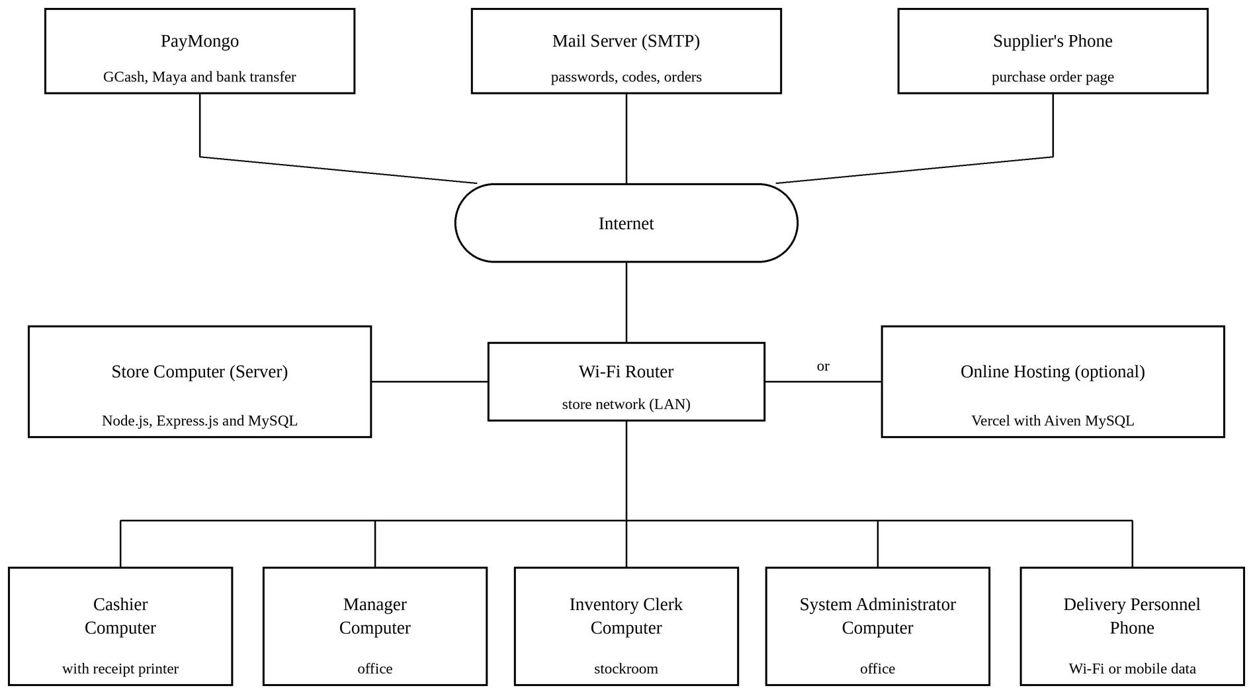
The figure above shows the store computer that runs the server and the database, connected through the Wi-Fi router to the computers of the Cashier, the Manager, the Inventory Clerk and the System Administrator and to the phone of the Delivery Personnel. Through the internet, the system reaches PayMongo for the GCash, PayMaya and bank transfer payments and the mail server for passwords, reset codes and purchase orders, and the suppliers open their purchase orders on their phones.
Implementation type
The developers will use the parallel implementation approach. For an agreed trial period of two weeks, the system will run side by side with the store's current manual process instead of replacing it at once. During this period, the Cashier will ring up every sale in the system while the handwritten receipts are still issued, the Inventory Clerk will record the deliveries, adjustments and returns in the system and in the record book, and the credit sales and payments of the customers will be recorded both in the system and on the carbon copies. At the end of each day, the Manager will compare the two records: the sales of the day by payment method, the stock of the materials that moved, and the balances of the customers who bought on credit or paid. Any difference will be checked to find whether it came from the system or from the manual record, and errors in the system will be corrected before the trial ends.
Running both processes at the same time keeps the risk low, because the manual process remains as a fallback if the computer, the network or the printer fails, and the results of the system can be checked against a known process before the store relies on it. Its drawback is the extra work for the staff, who must keep two records during the trial. Once the two records match consistently and the staff are comfortable with the system, the owner will decide when to stop the manual process and use the system on its own.
The major tasks of the implementation are listed in the table below, followed by the resources needed.
Table 45. Major tasks of the implementation
Task | Description | Person in charge
Install the software | Install Node.js and MySQL on the store computer, copy the system, install its packages and create the database from the two SQL files. | Developers
Set up the system | Set the store details, tax registration and receipt layout, the late-payment rate and the policies, and connect the mail account and the PayMongo account. | Developers and System Administrator
Create the accounts | Create the accounts of the Manager, Inventory Clerk, Cashier and Delivery Personnel, and set the screens of each role. | System Administrator
Encode the records | Enter the store's products with their prices and reorder points, the suppliers, and the customers with their credit limits and balances. | Developers, Manager and Inventory Clerk
Train the users | Orient each role on the screens it uses, with the user's guide in Appendix E. | Developers
Run the parallel trial | Use the system beside the manual records for two weeks and compare the two at the end of each day. | All users and Manager
Correct and back up | Correct the errors found in the trial, take a backup, and stop the manual process when the owner decides. | Developers and System Administrator
The table above lists the major tasks of the implementation in the order they are done, with the people in charge of each.
Table 46. Resources needed for implementation
Resource | Specification | Quantity
Store computer (server) | Windows 10 or 11, 8 GB of memory, with Node.js 20 or newer and MySQL 8.0 or newer | 1
Computers for the staff | Any computer with a current web browser (Chrome, Edge or Firefox) on the store network | 3
Phone of the Delivery Personnel | Android or iPhone with a current web browser and Wi-Fi or mobile data | 1
Wi-Fi router and internet connection | Connects the computers and the phone, and reaches PayMongo and the mail server | 1
Receipt printer and document printer | For the sales invoices and the purchase orders (optional) | 1 each
Email account with SMTP | Sends temporary passwords, reset codes and purchase orders | 1
PayMongo account | Takes GCash, PayMaya and bank transfer payments; live payments need the store's activated account | 1
System Administrator | A staff member who manages the accounts, access control and backups | 1
The table above lists the hardware, software and people needed to run the system in the store.

Implementation Results
The implementation phase produced a working system installed on the store computer. The developers installed Node.js and MySQL, created the database from the two SQL files, set the store details, the tax registration and the receipt layout, created the accounts of the staff, and set up the records of the store. On the installed system, the owner and the developers went through the main tasks of each role: ringing up cash, credit and QR sales with printed invoices, adjusting stock and receiving purchase orders, approving purchase orders that the supplier answered from a phone, taking payments on balances, creating and following deliveries, reading the reports, and running and restoring a backup.
The GCash, PayMaya and bank transfer payments were tried in PayMongo's test mode, since live payments need the store's own activated PayMongo account. The owner accepted the system through the User Acceptance Test form and the letter of acceptance dated October 12, 2026, and the store will run the system side by side with its paper records during the parallel trial described in the implementation plan.

CONCLUSION
The project developed and implemented the Online Hardware Sales and Inventory with Credit Management System for Lucelyn Hardware. The system replaced the handwritten official receipts, carbon copies, logbook and record book of the store with one web-based system in which every sale, stock movement, purchase order, customer balance and delivery is recorded as it happens, stock levels and credit standings are computed by the system, and invoices and reports are produced by the system. Each of the 99 functions of the eight modules passed all ten of its test runs, and in user acceptance testing the owner of Lucelyn Hardware accepted all twelve functions in the User Acceptance Test form and issued a letter of acceptance stating that the system meets the requirements of the store and is ready for implementation.
Based on the results, the developers conclude the following. First, the centralized database, with its daily and manual backups, keeps the store's inventory, sales, customer and supplier records safe from the loss, damage and misplacement that came with paper, which agrees with Tanaman et al. (2023), who found that a web-based system solved the lost and torn paper forms of a Philippine small business. Second, the search and filters on every list and the record cards let the staff find a sale, a customer or a stock figure in seconds, which supports Rosario et al. (2021), who found that a sales and inventory system shortened transaction time and improved reporting. Third, the reorder point set for each material and the low-stock alerts replaced reordering by sight, so that materials are ordered before they run out, which applies the finding of Immadisetty (2025) that real-time inventory visibility reduces stockouts. Fourth, the credit management feature, with credit limits, a computed standing, part payments, extension requests and late-payment penalties, gives the store control over sales on account, which the reviewed inventory systems did not cover. The objectives of the project were therefore met.
The developers recommend the following to future researchers and developers who will enhance the system:
- Add demand forecasting.
Reorder points are typed by the Manager. A forecasting model, such as the time series model used by Chukwumuanya et al. (2024), could compute them from past sales and anticipate seasonal and project-based demand.
- Track deliveries by GPS.
The delivery status depends on the driver updating it. A mobile application with location tracking would show where each delivery is.
- Connect more payment channels.
Cheques are still confirmed by hand when they clear, and live GCash, PayMaya and bank transfer payments need the store's own activated PayMongo account. Future work may record cheque clearing and add card payments through the payment gateway.

REFERENCES
Agboola, F. F., Malgwi, Y. M., Mahmud, M. A., & Oguntoye, J. P. (2022). Development of a web-based platform for automating inventory management of a small and medium enterprise. FUDMA Journal of Sciences, 6(5), 57–65. https://doi.org/10.33003/fjs-2022-0605-1064

Association for Computing Machinery. (2018). ACM code of ethics and professional conduct. https://www.acm.org/code-of-ethics

Boucheron, B. (2021). What is Node.js? DigitalOcean. https://www.digitalocean.com/community/tutorials/what-is-node-js

Cassavoy, L. (2024). Why today's smartphones are the ultimate personal computers. Lifewire. https://www.lifewire.com/what-makes-a-smartphone-smart-8734282

Chukwumuanya, O. E., Onwurah, U. O., & Ihueze, C. C. (2024). Development of a web-based inventory management system for small businesses. International Journal of Industrial and Production Engineering, 2(2), 53–67. https://journals.unizik.edu.ng/ijipe/article/view/4096

Corbo, A. (2025). What is Git? (Definition, commands and uses). Built In. https://builtin.com/software-engineering-perspectives/git

Dhote, S. (2023). A guide to generate QR code using NodeJS. CloudThat. https://www.cloudthat.com/resources/blog/a-guide-to-generate-qr-code-using-nodejs

Dominykas, J. (2024). What is VS Code: An overview of the popular code editor and its features. Hostinger. https://www.hostinger.com/ph/tutorials/what-is-vs-code

Gaborno, J. A. B., Ernal, J. G. G., Gange, M. S. R. L., Mucho, J. G. P., Cariaga, K. G., Ibieza, D. B., Egael, L. J. J., & Gentapanan, R. G. (2025). Micro-business owners' inventory management practices. International Journal of Research and Innovation in Social Science, 9(9), 4550–4559. https://doi.org/10.47772/IJRISS

Gaoat, M. G., Cabungcal, C., Enriques, C., Medios, Z., Ruiz, H. R., Villanueva, J. L., & Gacrama, B. (2023). Impact of inventory management on financial performance of MSMEs in Santiago City. American Journal of Economics and Business Innovation, 2(3), 11–24. https://doi.org/10.54536/ajebi.v2i3.1839

Ghazi, M., Salih, H. S., & Al Janabi, M. (2023). Implementing an automated inventory management system for small and medium-sized enterprises. Iraqi Journal for Computer Science and Mathematics, 4(2), 238–244. https://doi.org/10.52866/ijcsm.2023.02.02.021

Grassi, P. A., Fenton, J. L., Newton, E. M., Perlner, R. A., Regenscheid, A. R., Burr, W. E., et al. (2017). Digital identity guidelines: Authentication and lifecycle management (NIST Special Publication 800-63B). National Institute of Standards and Technology. https://doi.org/10.6028/NIST.SP.800-63b

Hall, C. (2026). How does a printer work? Printerbase. https://www.printerbase.co.uk/news/how-does-a-printer-work/

Hashemi-Pour, C. (2025). What is the spiral model and how is it used? TechTarget. https://www.techtarget.com/searchsoftwarequality/definition/spiral-model

Hayes, A. (2025). What is HTML? Understanding HyperText Markup Language basics. Investopedia. https://www.investopedia.com/terms/h/html.asp

Immadisetty, A. (2025). Real-time inventory management: Reducing stockouts and overstocks in retail. Journal of Recent Trends in Computer Science and Engineering, 13(1), 77–88. https://doi.org/10.70589/JRTCSE.2025.13.1.10

Jane, R. (2022). What is CSS and how does it work? TechRadar. https://www.techradar.com/features/what-is-css-and-how-does-it-work

Kamali, R., Ganesan, R. T., Dhanush Raja, M., Jeisurya, S., & Kamala Kannan, N. G. (2025). An advanced inventory management system powered by IoT and AI for real-time tracking and optimization. International Journal for Research Trends and Innovation, 10(4), 173–178. https://ijrti.org/papers/IJRTI2504022.pdf

Kirvan, P. (2023). Notebook computer. TechTarget SearchMobileComputing. https://www.techtarget.com/searchmobilecomputing/definition/notebook-computer

Lutkevich, B., & Courtemanche, M. (2024). What is GitHub? TechTarget. https://www.techtarget.com/searchitoperations/definition/GitHub

Metwalli, S. (2025). What is MySQL? Built In. https://builtin.com/data-science/mysql

Muhammad, A. (2025). What is Bootstrap? The complete front-end framework guide. Hostinger. https://www.hostinger.com/tutorials/what-is-bootstrap/

Munyaka, J.-C. B., & Yadavalli, V. S. S. (2022). Inventory management concepts and implementations: A systematic review. The South African Journal of Industrial Engineering, 33(2), 15–36. https://doi.org/10.7166/33-2-2527

Ng, W. F. (2025). Guide to ExcelJS: An Excel workbook manager. Built In. https://builtin.com/software-engineering-perspectives/exceljs

Parashar, G. (2025). Vercel: What you need to know about this popular deployment platform. Jobaaj Learnings. https://www.jobaajlearnings.com/blog/vercel-what-you-need-to-know-about-this-popular-deployment-platform

Republic Act No. 10173. (2012). Data Privacy Act of 2012. https://privacy.gov.ph/data-privacy-act/

Republic Act No. 8293. (1997). Intellectual Property Code of the Philippines. https://www.officialgazette.gov.ph/1997/06/06/republic-act-no-8293/

Rodríguez, V. H. P., López, R. D. T., & Vera, W. R. G. (2025). Innovations in inventory management to improve the profitability of local SMEs. F1000Research, 14, 853. https://doi.org/10.12688/f1000research.168900.3

Rosario, J., Perez, M., & Trinidad, A. (2021). An agile approach to the sales and inventory system for Company A. Zenodo. https://zenodo.org/record/8069150

Shu, C. (2022, February 20). Philippines payment gateway PayMongo gets $31M Series B, will explore regional expansion. TechCrunch. https://techcrunch.com/2022/02/20/philippines-payment-gateway-paymongo-gets-31m-series-b-will-explore-regional-expansion/

Sinha, S. (2024). What is Express.js? Scaler. https://www.scaler.com/topics/expressjs-tutorial/what-is-express-js/

Solari, T. (2021). Windows 11: A new era. KMTech. https://kmtech.com.au/information-centre/windows-11/

Szymanowski, M. (2025). PDFKit Node.js tutorial: Generate PDFs programmatically. PDFBolt. https://pdfbolt.com/blog/generate-pdf-pdfkit-nodejs

Tanaman, M. T., Baylosis, J. L. A., Abiles, B. J. A., Catungal, M. L. P., & Encarnacion, P. C. (2023). Web-based inventory management system. International Journal of Science and Applied Information Technology, 12(5), 44–48. https://doi.org/10.30534/ijsait/2023/021252023

Toroba, A. O., Gregori, R. A., Baraas, C. V., Impas, C. B., Martinez, D. J., & Cervantes, J. S. (2025). The influence of inventory management practices on financial performance among retail businesses. South Asian Journal of Social Studies and Economics, 22(8), 24–43. https://doi.org/10.9734/sajsse/2025/v22i81099

Wauters, R. (2022, May 11). Finnish open source software champion Aiven raises $210 million, landing a $3 billion valuation. Tech.eu. https://tech.eu/2022/05/11/finnish-open-source-software-champion-aiven-raises-210-million-landing-a-3-billion-valuation/

Williams, M. (2024). What is JavaScript used for? ComputerScience.org. https://www.computerscience.org/bootcamps/guides/javascript-uses/

APPENDICES

APPENDIX A. RESOURCE PERSONS
Name: Lucelyn E. Palmaira
Position: Store Owner
Company: Lucelyn Hardware
Contact Number: 09152718688
Email: lucelynpalmaira@gmail.com

APPENDIX B. RELEVANT SOURCE CODE
This appendix shows selected parts of the source code of the system: how the credit standing of a customer is worked out, how a credit sale is checked against the limit, how the reorder alerts are listed, how every request is checked against the role and the screens of the user, how passwords are stored, and how a void request is approved. The full source code is kept in the project repository.
B-1. Credit standing of a customer (database view)
File: public/database/2-RUN-SECOND-stored-procedures.sql, lines 99 to 151.
-- ==========================================
-- WHAT "STANDING" MEANS
--
-- HOLD over the credit limit, oldest unpaid sale over 90 days, or a
-- manager put the account on hold
-- WATCH oldest unpaid sale over 30 days, balance 75% or more of the
-- limit, or a manager flagged the account
-- GOOD none of the above
--
-- The manager's word (customer_credits.standing) only makes it stricter;
-- Good means "let the figures decide". The thresholds are written twice
-- (tier and reason) in the same order, so the two cannot disagree.
-- ==========================================
CREATE VIEW vw_customer_credit AS
SELECT
f.*,

-- the tier the figures alone would give, before the manager's word
CASE
WHEN f.credit_limit > 0 AND f.current_credit > f.credit_limit THEN 'Hold'
WHEN f.oldest_debt_days > 90 THEN 'Hold'
WHEN f.oldest_debt_days > 30 THEN 'Watch'
WHEN f.credit_limit > 0 AND f.current_credit >= f.credit_limit * 0.75 THEN 'Watch'
ELSE 'Good'
END AS computed_standing,

-- the tier in force: the stricter of the figures and the manager's word
CASE
WHEN f.manual_standing = 'Hold' THEN 'Hold'
WHEN f.credit_limit > 0 AND f.current_credit > f.credit_limit THEN 'Hold'
WHEN f.oldest_debt_days > 90 THEN 'Hold'
WHEN f.manual_standing = 'Watch' THEN 'Watch'
WHEN f.oldest_debt_days > 30 THEN 'Watch'
WHEN f.credit_limit > 0 AND f.current_credit >= f.credit_limit * 0.75 THEN 'Watch'
ELSE 'Good'
END AS standing,

-- why, in words, for the screen that shows the badge
CASE
WHEN f.manual_standing = 'Hold' THEN
CONCAT('Put on hold by a manager',
IF(f.credit_notes IS NULL OR f.credit_notes = '', '', CONCAT(': ', f.credit_notes)))
WHEN f.credit_limit > 0 AND f.current_credit > f.credit_limit THEN
CONCAT('Over the limit by ', FORMAT(f.current_credit - f.credit_limit, 2))
WHEN f.oldest_debt_days > 90 THEN
CONCAT('Oldest unpaid sale is ', f.oldest_debt_days, ' days old; the limit is 90')
WHEN f.manual_standing = 'Watch' THEN
CONCAT('Flagged by a manager',
IF(f.credit_notes IS NULL OR f.credit_notes = '', '', CONCAT(': ', f.credit_notes)))
WHEN f.oldest_debt_days > 30 THEN
CONCAT('Oldest unpaid sale is ', f.oldest_debt_days, ' days old; watched past 30')
WHEN f.credit_limit > 0 AND f.current_credit >= f.credit_limit * 0.75 THEN
CONCAT('Owes ', ROUND(f.current_credit / f.credit_limit * 100), '% of the limit; watched from 75%')

B-2. Credit limit check when a sale is rung up (stored procedure)
File: public/database/2-RUN-SECOND-stored-procedures.sql, lines 910 to 972.
SET v_new_exposure = v_final_amount - v_amount_paid;

-- The account is locked before the limit is checked, in the same
-- transaction as the shelf rows above, so two Credit sales for the
-- same customer take their turn: the second waits here until the
-- first has committed or rolled back. The limit and the balance are
-- then read FOR UPDATE as well, because a plain read in this
-- transaction would still see the snapshot taken before the wait
-- and miss the sale that just went on account.
SELECT c.customer_id, COALESCE(cc.credit_limit, 0.00)
INTO v_locked_customer_id, v_credit_limit
FROM customers c
LEFT JOIN customer_credits cc ON cc.customer_id = c.customer_id
WHERE c.customer_id = p_customer_id
FOR UPDATE;

-- the same sum as vw_customer_credit.current_credit, read locked
SELECT COALESCE(SUM(s.amount_due - s.amount_paid), 0.00)
INTO v_current_credit
FROM sales s
WHERE s.customer_id = p_customer_id
AND s.is_archived = FALSE
AND s.payment_status <> 'Paid'
FOR UPDATE;

-- the tier is still the view's word: a manager's hold or an aged
-- debt, neither of which another sale in flight can change
SELECT standing
INTO v_standing
FROM vw_customer_credit
WHERE customer_id = p_customer_id;

-- checked before the limit: "on hold" is a more useful refusal than "300 over"
IF v_standing = 'Hold' AND v_new_exposure > 0 THEN
ROLLBACK;
SET p_status_code = 403;
IF v_on_credit THEN
SET p_message = CONCAT('This account is on hold and cannot take new credit. ',
'Take the full ', FORMAT(v_final_amount, 2),
' now, or ask a manager to lift the hold.');
ELSE
SET p_message = CONCAT('This account is on hold, so a COD order cannot be placed. ',
'Take the full ', FORMAT(v_final_amount, 2),
' now, or ask a manager to lift the hold.');
END IF;
DROP TEMPORARY TABLE IF EXISTS tmp_sale_needed;
LEAVE PROC_BODY;
END IF;

IF v_current_credit + v_new_exposure > v_credit_limit THEN
ROLLBACK;
SET p_status_code = 400;
IF v_on_credit THEN
SET p_message = CONCAT('Credit limit exceeded. Remaining credit: ',
FORMAT(GREATEST(v_credit_limit - v_current_credit, 0), 2),
'. Take a down payment of at least ',
FORMAT(GREATEST(v_new_exposure - (v_credit_limit - v_current_credit), 0), 2),
', or raise an extension request.');
ELSE
SET p_message = CONCAT('Credit limit exceeded. Remaining credit: ',
FORMAT(GREATEST(v_credit_limit - v_current_credit, 0), 2),
'. This COD order is for ', FORMAT(v_final_amount, 2),
'. Take payment now, or raise an extension request.');

B-3. Reorder alerts and the suggested order
File: public/backend/routes/manager.js, lines 1708 to 1756.
app.get("/api/stocks", async function (request, response) {
try {
const rowsResult = await db.query(
"WITH window_days AS ( " +
"SELECT GREATEST( " +
"LEAST(?, COALESCE(DATEDIFF(CURDATE(), DATE(MIN(sale_date))) + 1, ?)), " +
"1) AS days " +
"FROM sales " +
"WHERE is_archived = FALSE " +
"), " +
"recent AS ( " +
"SELECT si.product_id, COALESCE(SUM(si.quantity), 0) AS units " +
"FROM sale_items si " +
"JOIN sales s ON s.sale_id = si.sale_id " +
"WHERE s.is_archived = FALSE " +
"AND s.sale_date >= DATE_SUB(CURDATE(), INTERVAL ? DAY) " +
"GROUP BY si.product_id " +
") " +
"SELECT p.product_id, p.product_name, p.price, p.reorder_point, p.status, " +
"p.lead_time_days, p.safety_stock, " +
"COALESCE(i.quantity_in_stock, 0) AS quantity_in_stock, " +
"i.last_updated, " +
"c.category_name, b.brand_name, u.unit_name, " +
"sup.supplier_name, sup.contact_person, sup.contact_number, " +
"(COALESCE(i.quantity_in_stock, 0) * p.price) AS stock_value, " +
"w.days AS window_days, " +
"COALESCE(rc.units, 0) AS units_sold_window, " +
"p.reorder_point AS effective_rop, " +
"CASE " +
"WHEN COALESCE(i.quantity_in_stock, 0) = 0 THEN 'Out of Stock' " +
"WHEN COALESCE(i.quantity_in_stock, 0) <= p.reorder_point " +
"THEN 'Low Stock' " +
"ELSE 'In Stock' " +
"END AS stock_status, " +
"-- order back up to twice the reorder point, so the next order is\n" +
"-- not due the week after this one arrives\n" +
"GREATEST(p.reorder_point * 2 - COALESCE(i.quantity_in_stock, 0), 0) AS suggested_order " +
"FROM products p " +
"CROSS JOIN window_days w " +
"LEFT JOIN recent rc ON rc.product_id = p.product_id " +
"LEFT JOIN inventory i ON i.product_id = p.product_id " +
"LEFT JOIN categories c ON c.category_id = p.category_id " +
"LEFT JOIN brands b ON b.brand_id = p.brand_id " +
"LEFT JOIN units u ON u.unit_id = p.unit_id " +
"LEFT JOIN suppliers sup ON sup.supplier_id = p.supplier_id " +
"WHERE p.is_archived = FALSE " +
"ORDER BY (COALESCE(i.quantity_in_stock, 0) <= p.reorder_point) DESC, " +
"p.product_name",
[SALES_WINDOW_DAYS, SALES_WINDOW_DAYS, SALES_WINDOW_DAYS]

B-4. Checking the role and the screens of every request
File: public/backend/access-control.js, lines 313 to 345.
// The check every request goes through (server.js: app.use(accessHook)). It
// applies the table above and the screens by role, and announces each write.
async function accessHook(request, response, next) {
// A path like /API/backups is still an API call, so the check below must
// not be skipped just because the letters are in a different case. Only the
// exact lowercase /api/ is real; any other case is refused outright. Only
// the first five letters are compared: the rest of the path may have capital
// letters (a supplier-order code is mixed case).
const lower = request.path.toLowerCase();
if (lower.startsWith("/api/") && !request.path.startsWith("/api/")) return response.status(404).json({ error: "Not found" });
if (!lower.startsWith("/api/")) return next();

const allowed = findRule(request.method, request.path);

if (allowed === null) {
return response.status(403).json({ error: "This feature is not available." });
}

// With no procedures, reads still work and writes cannot: writes are stopped
// here with the sentence that names the fix. Sign-in is exempt.
const isWrite = request.method !== "GET" && request.method !== "HEAD";
const isSignIn = request.path === "/api/login" || request.path === "/api/logout" ||
request.path === "/api/heartbeat" ||
request.path.startsWith("/api/password-reset/");

if (isWrite && !isSignIn && (await proceduresAreMissing())) {
console.error("Refused " + request.method + " " + request.path + ": " +
proceduresLoadedCount() + " of " + EXPECTED_PROCEDURES + " stored procedures are loaded.");
return response.status(503).json({ error: procedureAdvice() });
}

if (allowed === PUBLIC) return next();

B-5. Password hashing and generated passwords
File: public/backend/services/passwords.js, lines 10 to 56.
// ==========================================
// PASSWORDS -- stored as scrypt hashes, format scrypt$<salt>$<hash>
// ==========================================
// crypto.scrypt normally uses a callback; promisify lets us use it with "await"
const util = require("util");
const scrypt = util.promisify(crypto.scrypt);
const SCRYPT_KEYLEN = 64;
const SCRYPT_PARAMS = { N: 16384, r: 8, p: 1, maxmem: 64 * 1024 * 1024 };

async function hashPassword(plainText) {
const salt = crypto.randomBytes(16).toString("hex");
const derived = await scrypt(plainText, salt, SCRYPT_KEYLEN, SCRYPT_PARAMS);
return "scrypt$" + salt + "$" + derived.toString("hex");
}

function isHashed(stored) {
return typeof stored === "string" && stored.startsWith("scrypt$");
}

const PASSWORD_ALPHABET =
"ACDEFGHJKLMNPQRTUVWXY" + // no B, I, O, S, Z
"acdefghjkmnpqrtuvwxy" + // no b, i, l, o, s, z
"34679" + // no 0, 1, 2, 5, 8
"!?-+.$%";
const PASSWORD_LENGTH = 14;

function generatePassword() {
// randomInt is uniform; a modulo over a random byte is not
let password = "";
while (password.length < PASSWORD_LENGTH) {
password += PASSWORD_ALPHABET[crypto.randomInt(PASSWORD_ALPHABET.length)];
}

// It must follow the same password rules a person's own password must
// (passwordComplaint in validation.js): a small letter, a capital letter, a
// digit and a symbol, and no spaces (the alphabet has none).
// If one is missing, simply make a new password and check again.
const hasLower = /[a-z]/.test(password);
const hasUpper = /[A-Z]/.test(password);
const hasDigit = /[0-9]/.test(password);
const hasSymbol = /[^A-Za-z0-9]/.test(password);
if (!hasLower || !hasUpper || !hasDigit || !hasSymbol) {
return generatePassword();
}
return password;
}

B-6. The manager approves a void request
File: public/backend/routes/void-requests.js, lines 146 to 186.
app.post("/api/void-requests/:requestId/approve", async function (request, response) {
const requestId = Number(request.params.requestId);
const note = typeof request.body.note === "string" ? request.body.note.trim().slice(0, 255) : "";
try {
const found = await waitingRequest(requestId);
if (found.error) return response.status(found.status).json({ error: found.error });
const row = found.row;

// taken first, so two managers cannot both act on it
const taken = await db.query(
"UPDATE void_requests SET status = 'Approved', decided_by_staff_id = ?, decided_at = NOW(),\n" +
" decision_note = ? WHERE request_id = ? AND status = 'Pending'",
[getActorId(request), note || null, requestId]
);
if (!taken[0].affectedRows) {
return response.status(409).json({ error: "Another manager has just decided this request." });
}

// the void itself, with its own rules (same day, not out for delivery)
let output;
try {
output = await sharedProcedures.archiveRecord(["Sales", row.sale_id, getActorId(request)]);
} catch (error) {
output = { status_code: 500, message: "Unable to void the sale" };
console.error("Void sale failed:", error.message);
}
if (output.status_code !== 200) {
// the sale stays as it was, so the request waits again
await db.query(
"UPDATE void_requests SET status = 'Pending', decided_by_staff_id = NULL, decided_at = NULL,\n" +
" decision_note = NULL WHERE request_id = ?", [requestId]);
return response.status(output.status_code).json({ error: output.message });
}

await tellCashiers(request, "Void approved for " + receiptNo(row.sale_id),
receiptNo(row.sale_id) + " is voided, as " + (row.requested_by || "the cashier") + " asked." +
(note ? " Manager's note: " + note : ""));
announce(request, "void approved " + row.sale_id);
publishChange("inventory", "void approved " + row.sale_id, request.headers["x-client-id"] || null);
publishChange("deliveries", "void approved " + row.sale_id, request.headers["x-client-id"] || null);
response.json({ message: output.message || (receiptNo(row.sale_id) + " is voided.") });

APPENDIX C. EVALUATION TOOL/TEST DOCUMENTS
The table below is the User Acceptance Test form used by the owner of Lucelyn Hardware to check the functions of the system. The letter of acceptance is in Appendix I.
Table 47. User Acceptance Test form
Function checked by the beneficiary | Accepted (Yes/No) | Remarks
Users sign in with their own accounts and see only the screens of their roles. | Yes
The cashier can ring up a sale, take the payment and print the sales invoice. | Yes
Measured goods can be sold in fractions and products can be sold in bigger sizes. | Yes
GCash and Maya payments by QR code are recorded on the sale. | Yes
Stock goes down with every sale and up with every delivery received. | Yes
Materials at or below their reorder point are shown and alerts are raised. | Yes
Purchase orders can be raised, approved, sent to the supplier and received. | Yes
Credit sales, part payments and payments on balances are recorded correctly. | Yes
The late penalty of each customer is correct. | Yes
Deliveries and the cash collected on delivery are recorded. | Yes
Reports show the correct figures and can be exported or printed. | Yes
Backups can be created and restored. | Yes

Tested by:
Ms. Lucelyn E. Palmaira
Owner, Lucelyn Hardware
Date tested: October 12, 2026

APPENDIX D. SAMPLE INPUT/OUTPUT/REPORTS
Appendix D-1. Sales Invoice
Appendix D-2. Purchase Order (PDF)
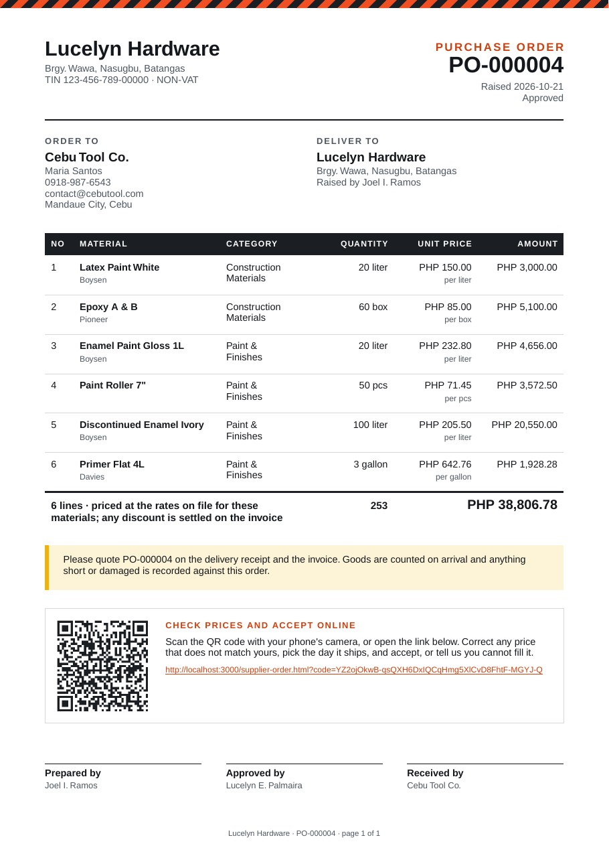
Appendix D-3. Supplier's Order Page on a Phone
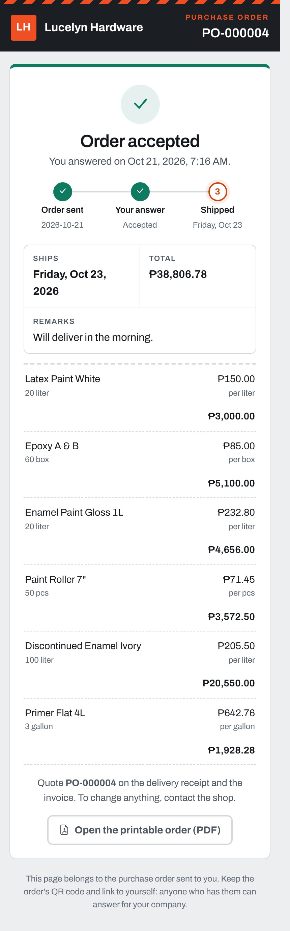
Appendix D-4. Customer Credit and Payments
Appendix D-5. Sales Summary Report

APPENDIX E. USER'S GUIDE

User Manual
For all users
1. Open the address of the system and sign in with your email address and password.
Figure 40
2. If you forget your password, press Forgot your password? to receive a code by email, or ask the System Administrator to reset it.
Figure 41
3. On the first sign-in, choose your own password following the rules shown.
Figure 42
4. Use the bell at the top right for your alerts, and the menu beside it to view your details or to log out.
For the System Administrator
1. Open Staff Directory under Accounts Management and press Load Data to see the accounts.
Figure 43
2. Press Create Account, fill in the name, role, phone number and email address, check the details read back, and create the account. The password is emailed or shown once.
Figure 44
3. Open an account to reset its password or to deactivate it. The Edit tab changes the name, phone and role.
Figure 45
4. Use Access Control to switch the screens of a role on or off, then press Confirm Configuration.
Figure 47
5. Use Audit Logs to review the actions in the system, and Export to save them to Excel or PDF.
Figure 48
6. Use Backup & Recovery to run, download or restore backups.
Figure 50
7. Keep the store details, tax registration and receipt layout in Receipt Maintenance, and press Save.
Figure 51
For the Cashier
1. In New Transaction, press the products to put them on the order, set the quantities and press Proceed to Payment.
Figure 52
2. Pick the customer, or leave it empty for a walk-in, choose the payment method and enter the amount. On a Credit sale, enter what is paid now.
Figure 53
3. Press Make a Delivery when the order is to be delivered, and fill in the recipient, address, date and driver.
Figure 54
4. Press the button at the bottom of the card, check the details read back, and confirm. Print the invoice that comes up.
Figure 56
5. For GCash or PayMaya, press Pay by QR and let the customer scan the code.
Figure 57
6. In Customers Record, open a customer to see the account, the unpaid sales and the payments.
Figure 59
7. Press Credit Settlement to take a payment against an unpaid sale, then Confirm Payment and print the receipt.
Figure 61
8. Press Ask for a Higher Limit to send a request to the Manager.
Figure 62
9. In Refunds, pick the sale, type the quantity of each item taken back and the reason, and press Issue Refund.
Figure 63
10. In Sales Report, open a sale of today and press Request Void to ask the Manager to void it.
Figure 66
For the Inventory Clerk
1. Check the stock in Material List, and press Add New Product to open the record of a new material.
Figure 67
2. Use Stock Adjustment to correct a figure with remarks, or to add returned goods back to stock or discard them.
Figure 70
3. See every correction in Adjustment History and the reorder point of each material in Reorder Point.
Figure 72
4. In Purchase Orders, press New Order, name the supplier, add the materials and send the order to the Manager.
Figure 74
5. When an accepted order arrives, open it, enter what arrived and receive the delivery.
Figure 75
6. Check the items taken back in Returned Items.
Figure 76
For the Manager
1. Read the reports under Reports, choose the period and press Load Data. Use Export to save a table to Excel or PDF.
Figure 77
2. Open a sale in Sales Transactions to approve or decline a void request.
Figure 79
3. Check Reorder Alerts and Stocks Overview under Stocks, and change the reorder point from a product's card.
Figure 85
4. Open an order waiting for approval in Purchase Orders and approve it or decline it with a reason.
Figure 89
5. Read the accounts in Customer Credit, and decide the requests in Extension Requests.
Figure 93
6. Follow the deliveries in Delivery History and Delivery Schedule.
Figure 94
7. Keep the suppliers under Records, and set the selling price of a product from its record.
Figure 100
8. Set the late-payment rate and the policies under Policy Maintenance.
Figure 103
For the Delivery Personnel
1. Open Pending Deliveries to see your deliveries, and open one to move it to the next status with remarks.
Figure 108
2. On a Cash on Delivery order, press Proceed Payment to record the payment collected.
Figure 109
3. Use Refund Items for an item turned away at the door, and Delayed or Failed with a reason when the delivery cannot go on.
4. See your deliveries and collections under Reports.
Figure 110
For suppliers
1. Scan the QR code or open the link on the purchase order. Check each line, press Edit price for a price that does not match, add a discount if any, then accept the order with the ship date or decline it with the reason, and press Send.
Figure 112

APPENDIX F. LETTER TO THE BENEFICIARY


APPENDIX G. TRANSCRIPT OF INTERVIEW

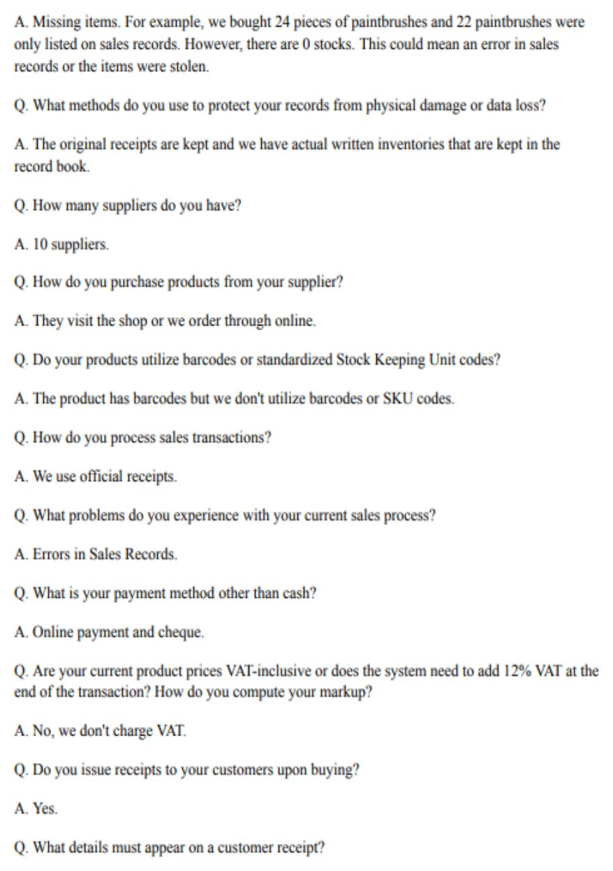
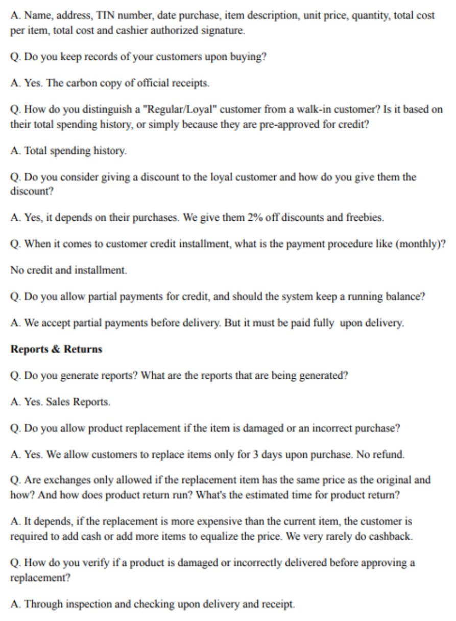
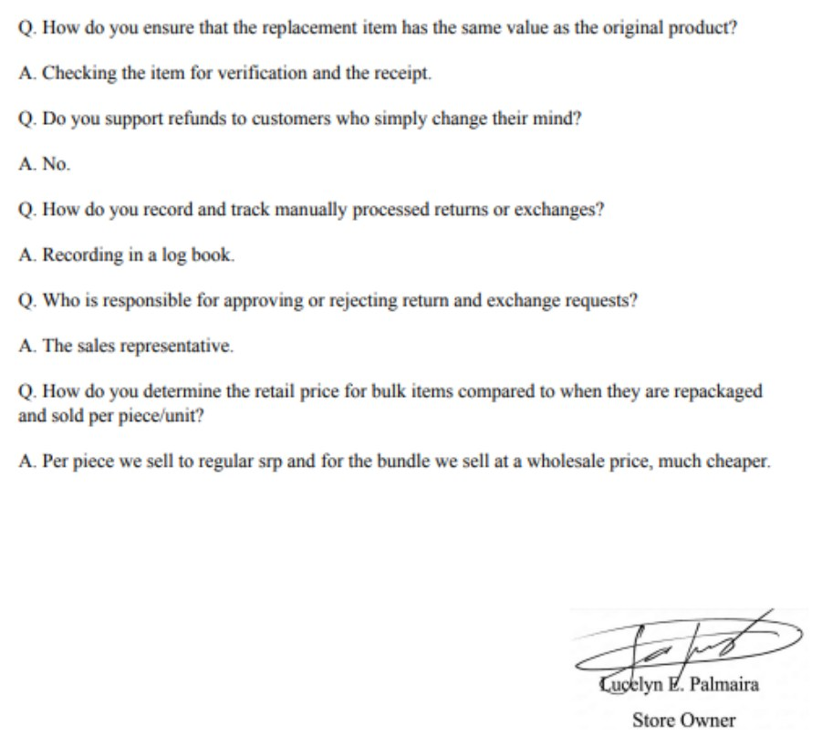

APPENDIX H. SAMPLE FORMS OF THE BENEFICIARY
Appendix H-1. Sales Invoice
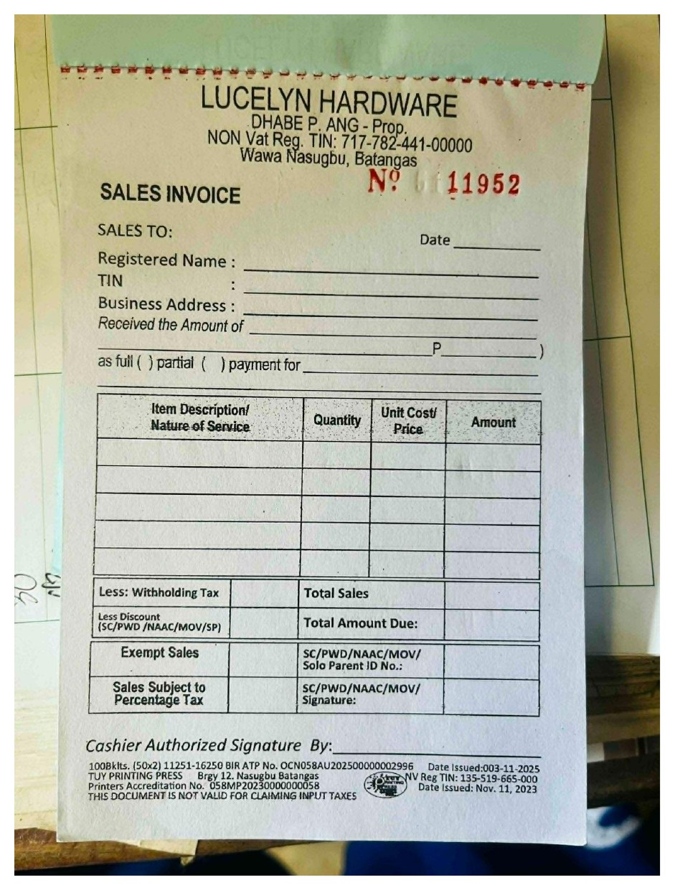
Appendix H-2. Delivery Receipt
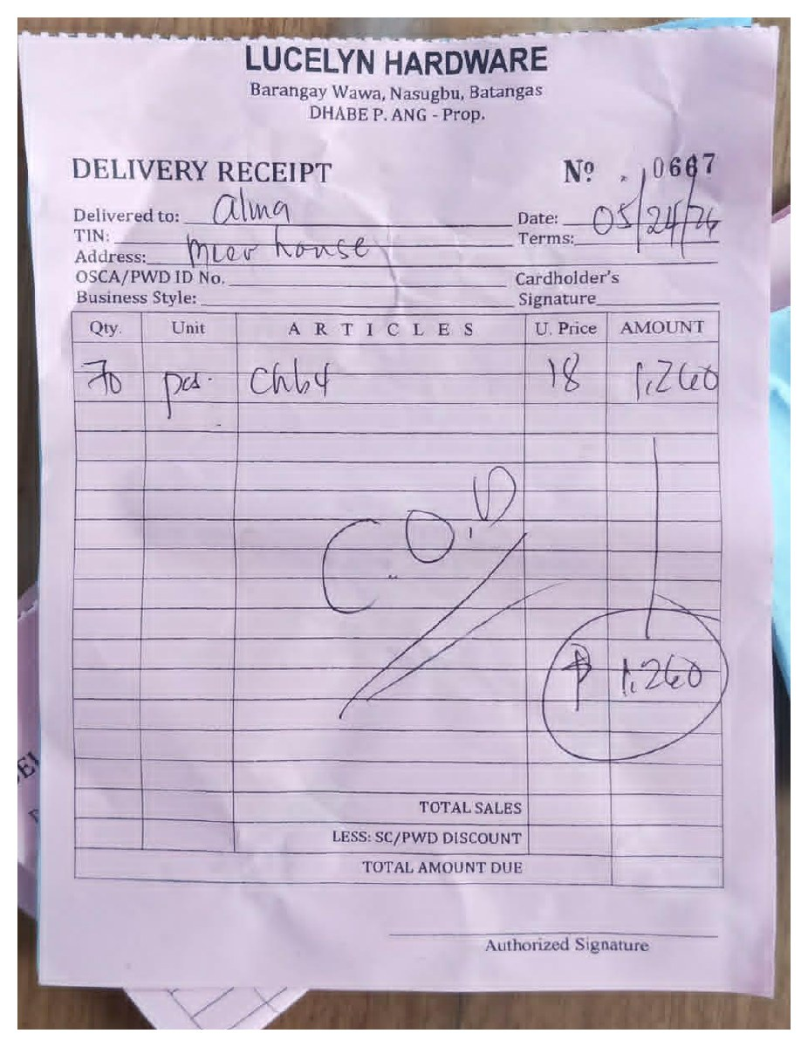
Appendix H-3. Inventory Record
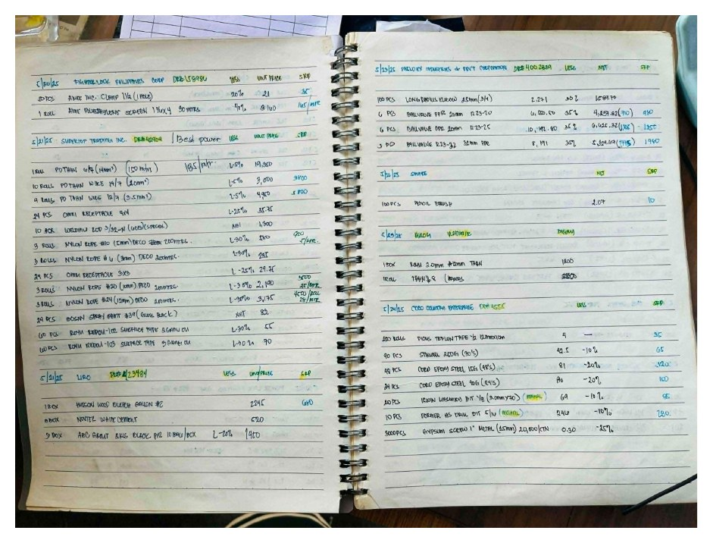
Appendix H-4. Sales Record
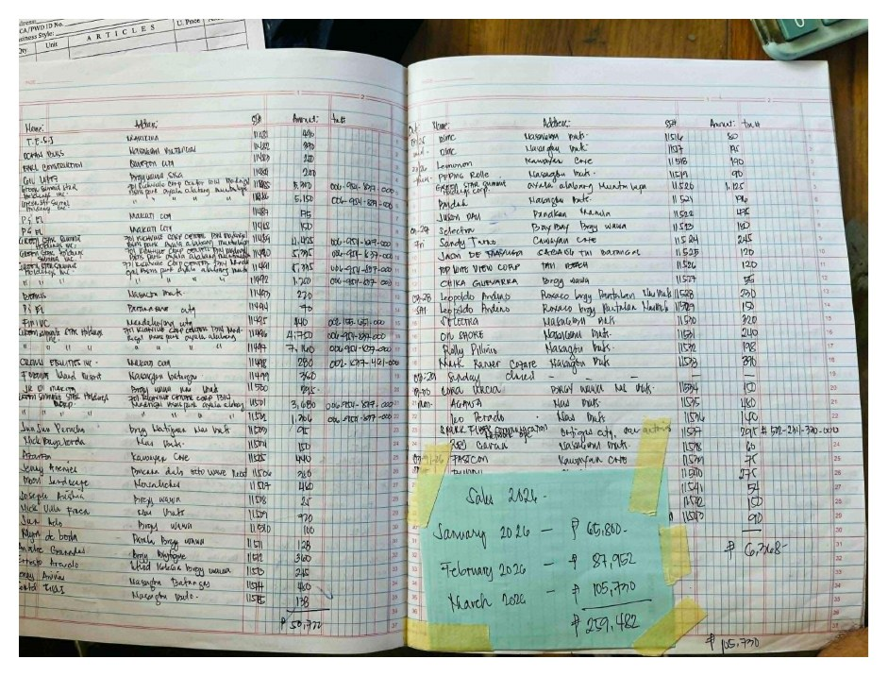

APPENDIX I. LETTER OF ACCEPTANCE
LUCELYN HARDWARE
Brgy. Wawa, Nasugbu, Batangas
LETTER OF ACCEPTANCE
Date: October 12, 2026
Ms. Terranya M. Tiamson
Capstone Project Coordinator
STI College Balayan
Balayan, Batangas
Dear Ms. Tiamson:
Greetings!
This is to certify that the capstone project titled “Online Hardware Sales and Inventory with Credit Management System,” developed by Lito James G. Abenoja, Daren P. Ang, John Ian P. Brazas, and Lance M. Tolentino, students of the Bachelor of Science in Information Technology program of STI College Balayan, Inc., was presented to and tested by Lucelyn Hardware, Nasugbu, Batangas.
The developers demonstrated the system to us, and we tested its functions. These include the processing of sales at the counter with cash, e-wallet, bank, and credit payments, the monitoring of inventory with reorder points and stock adjustments, the creation, approval, and receiving of purchase orders, the management of customer credit with limits, balances, and late-payment penalties, the scheduling and tracking of deliveries, the processing of refunds and returned items, the user accounts with access limited by role, and the reports. Based on our evaluation, the system meets the requirements we gave to the developers and addresses the problems in our manual recording of sales, inventory, and customer credit.
In view of this, we accept the system and find it ready for implementation in our store.
This letter is issued upon the request of the developers for the requirements of their capstone project.
Respectfully yours,
Ms. Lucelyn E. Palmaira
Owner
Lucelyn Hardware

APPENDIX J. ACCOMPLISHMENT REPORTS
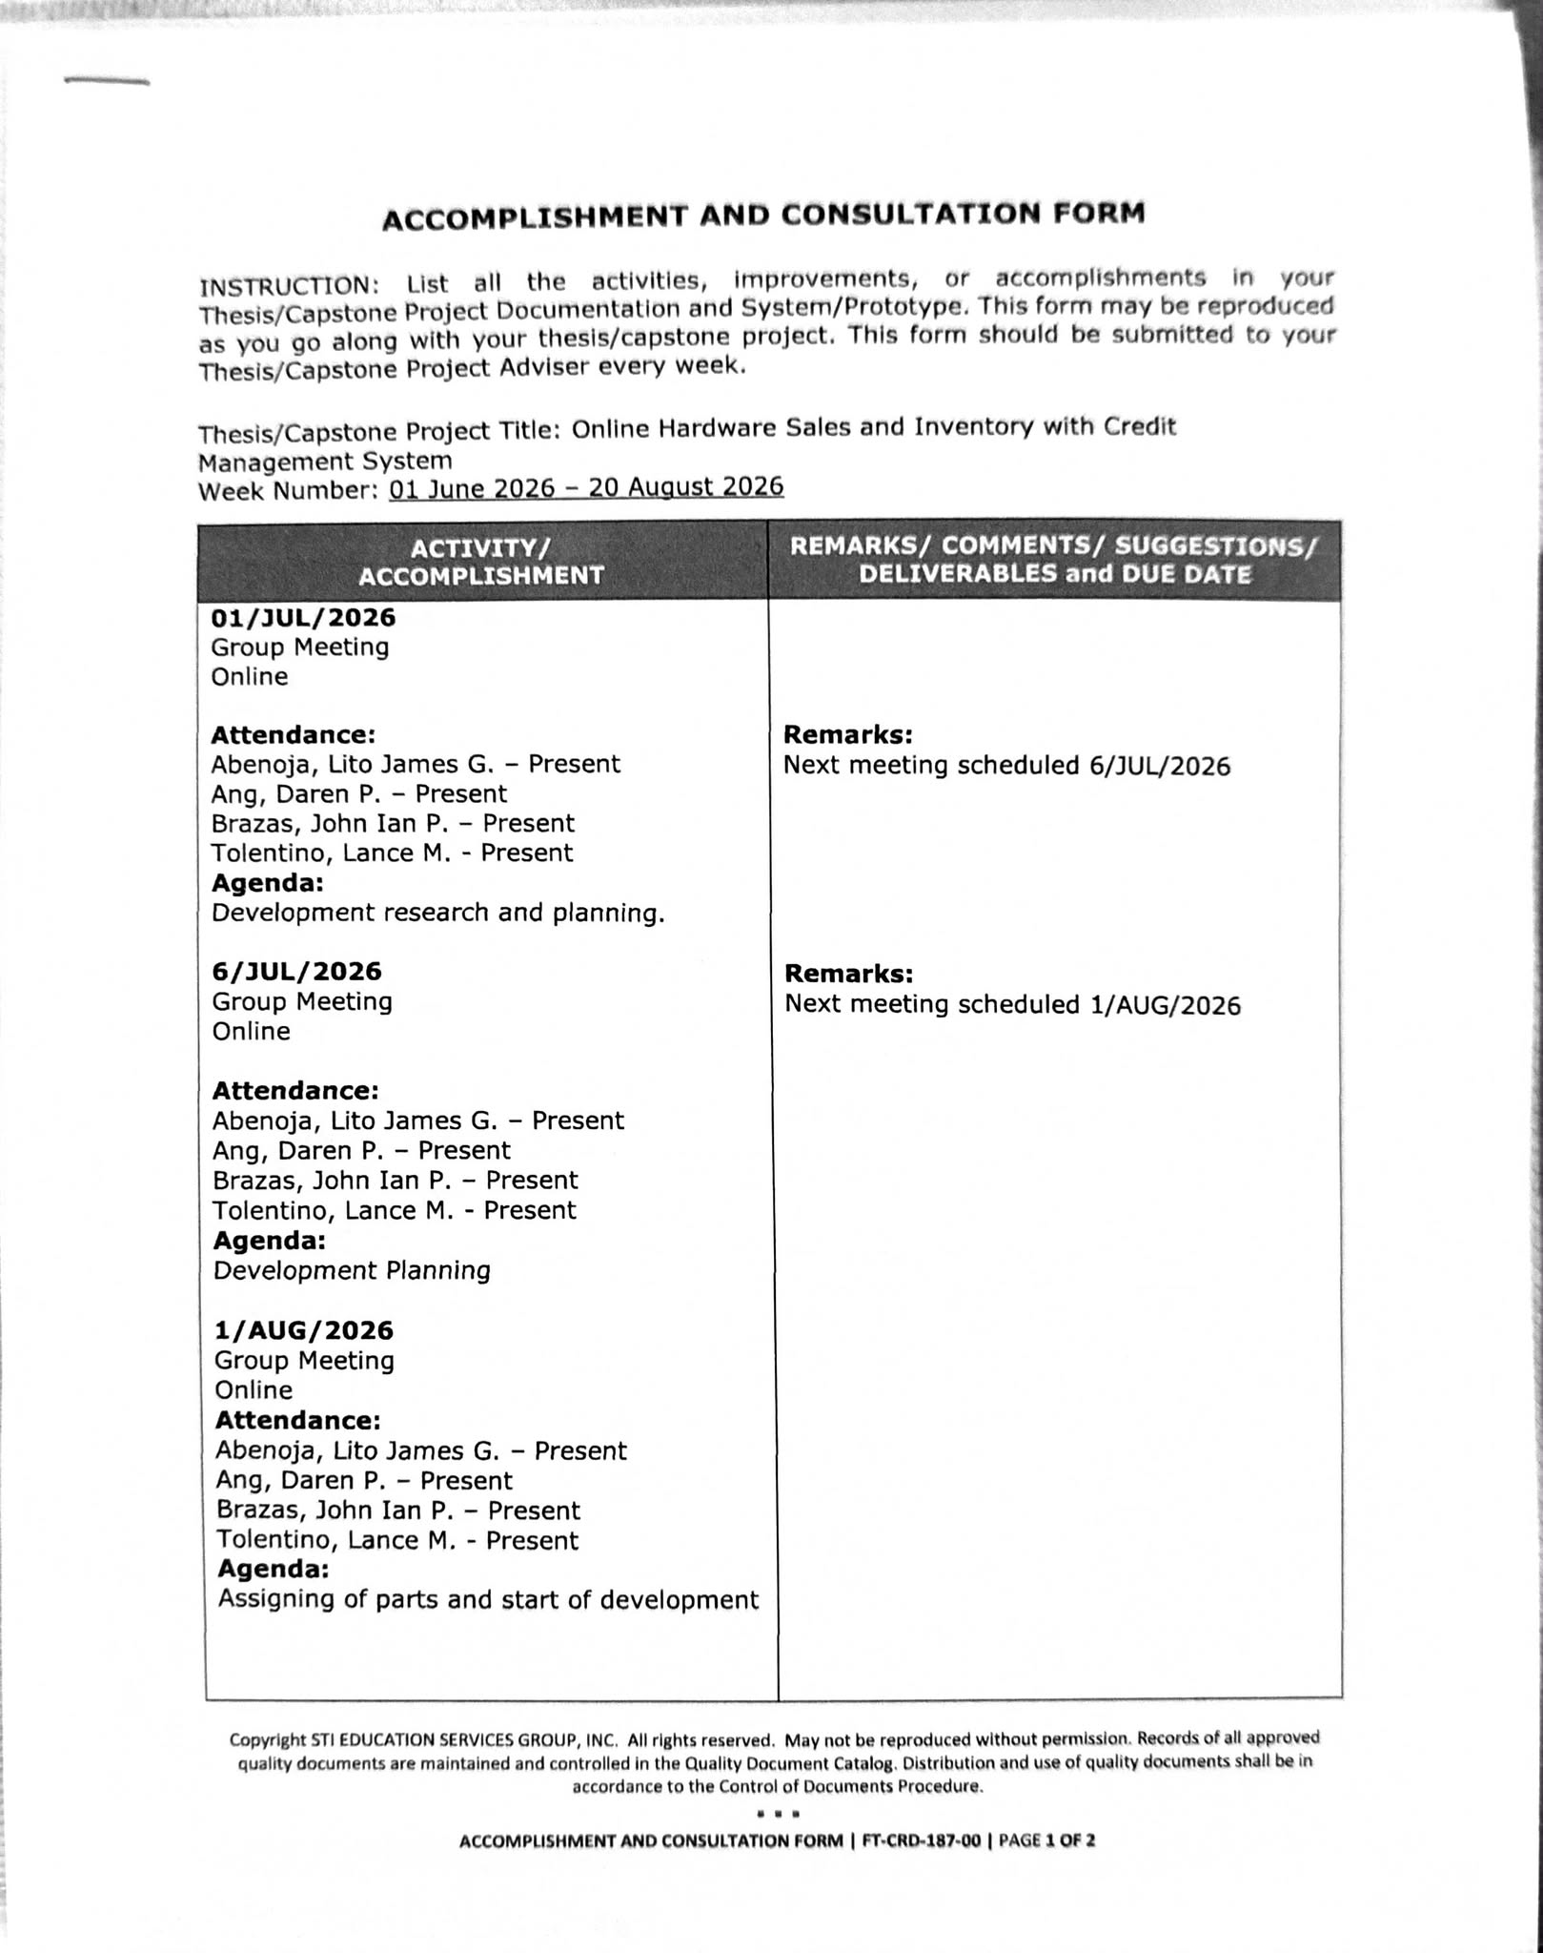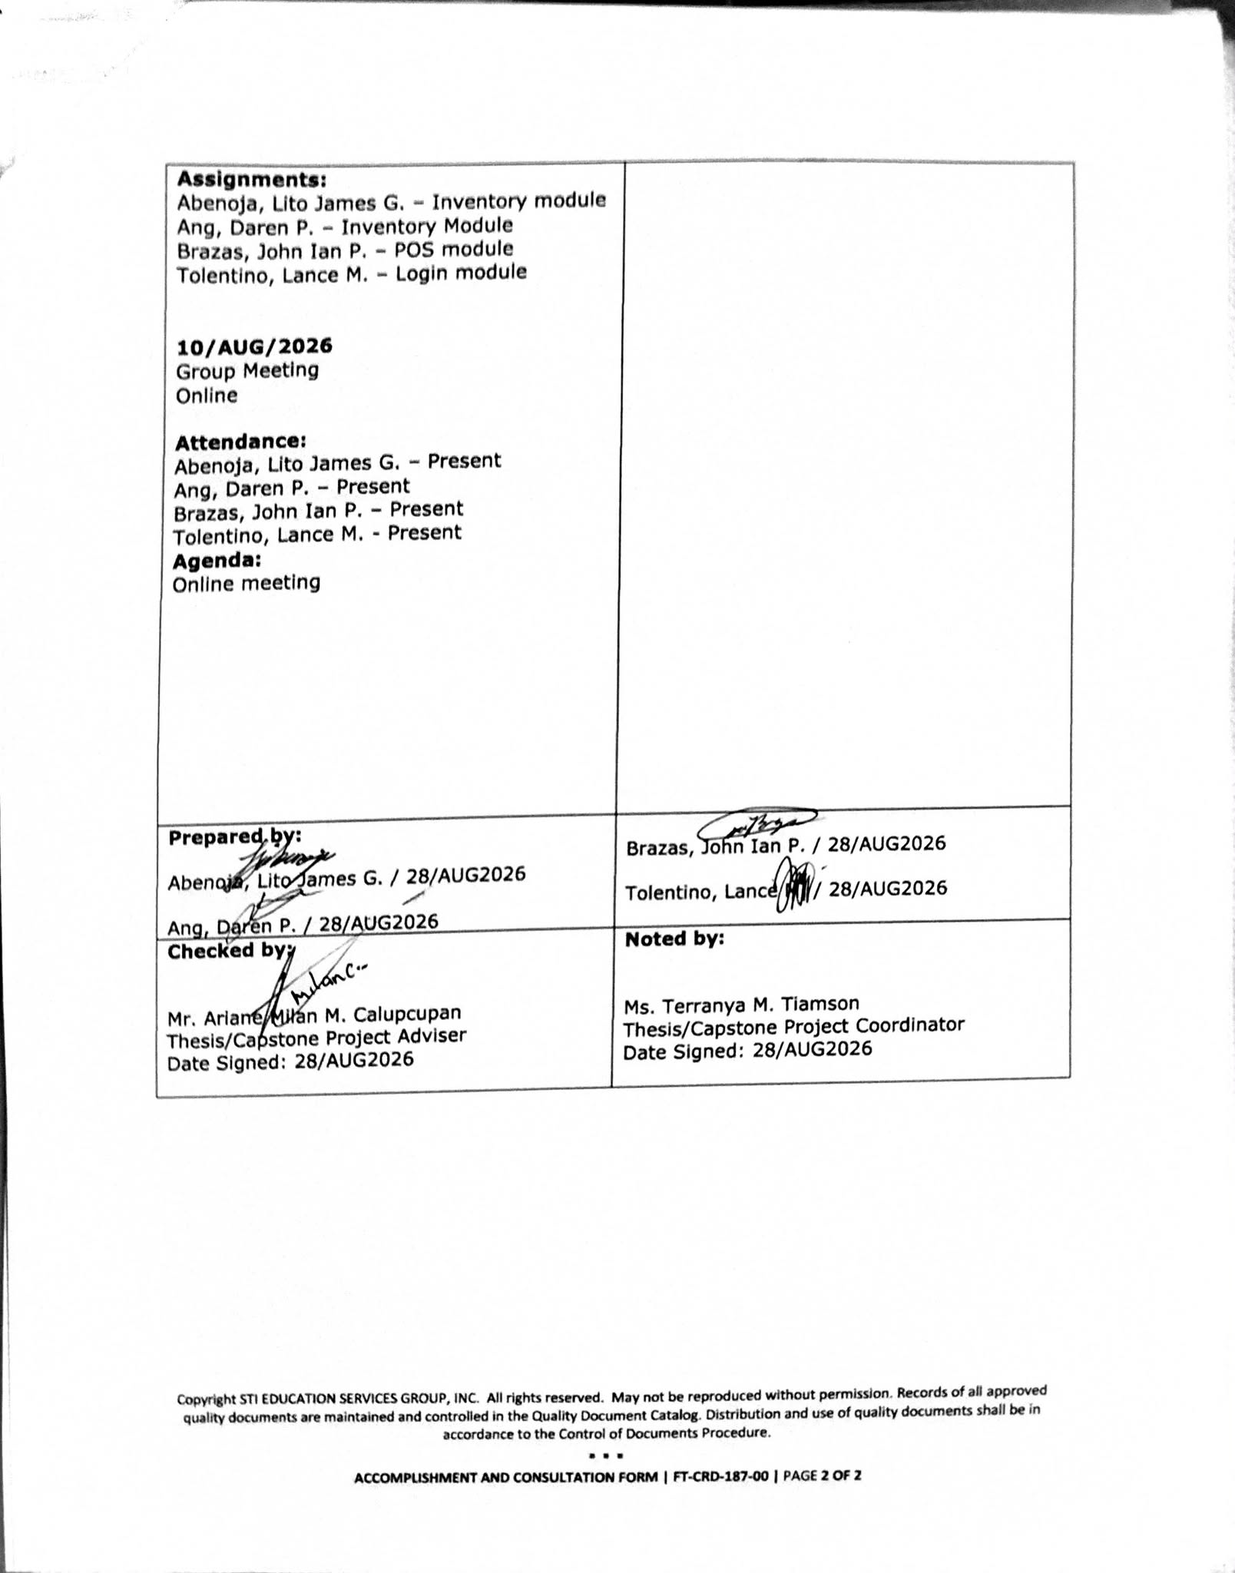

APPENDIX K. PERSONAL TECHNICAL VITAE





