Joe Bartocci

1. Three.
2. 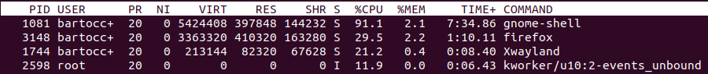



1. 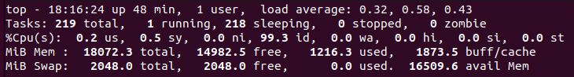



1. 

Gnome-shell



1. 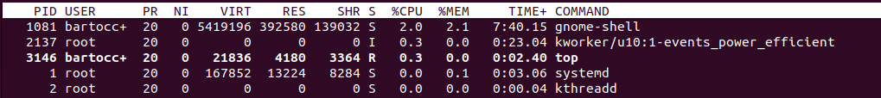

Gnome shell uses the most of each type of memory.

1. Apt-get: APT stands for Advanced Packaging Tool. Apt-get is used to manage Debian based linux distributions such as ubuntu which we are using right now.

Yum: Similar to apt-get but for red-hat distributions of linux.

Wget: used to download files from the internet.

Gzip: Used as a compression/decompression tool to reduce file size.

Tar: Tool used to create and extract archives through command-line.

Rar: Similar to tar except it is a commercial software used for similar purposes, except it creates files that can only be used by this software.

1. 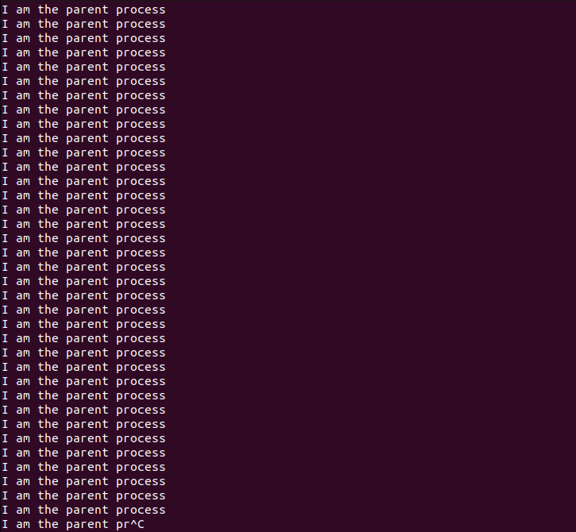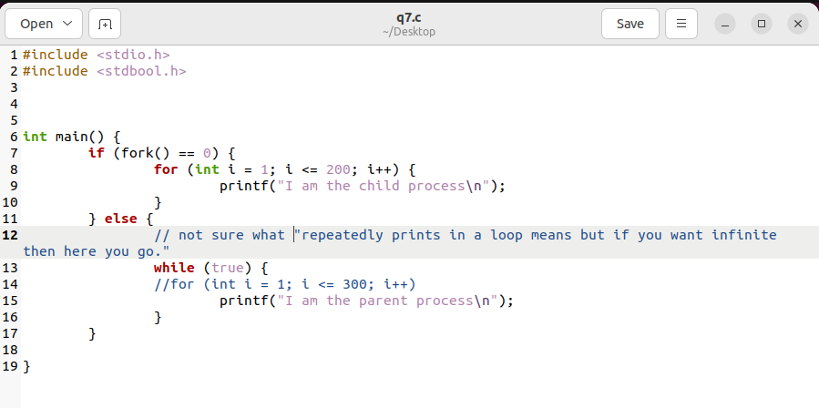
2. 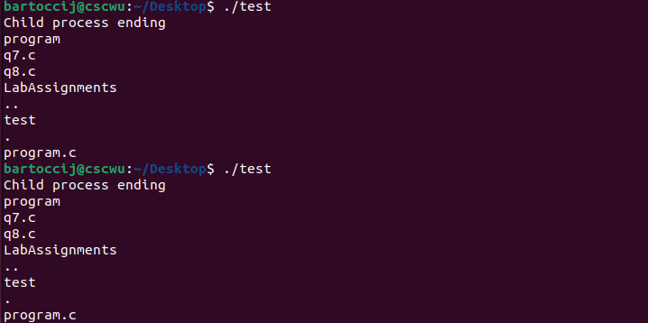

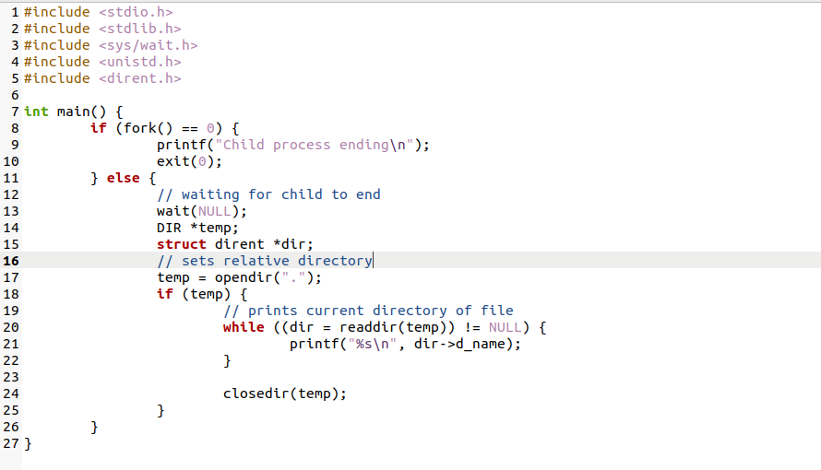

1. 

