1. Create a table to show which data conversions are possible and which are not.

|  |  |  |  |  |  |  |  |  |  |  |  |  |
| --- | --- | --- | --- | --- | --- | --- | --- | --- | --- | --- | --- | --- |
|  | **Integer** | **Float** | **Complex** | **Bool** | **List** | **Tuple** | **Range** | **String** | **Dictionary** | **Set** | **Frozen**  **Set** | **None** |
| **Integer** | True | True | True | True | False | False | True | True | False | False | False | False |
| **Float** | True | True | True | True | False | False | False | True | False | False | False | False |
| **Complex** | False | False | True | True | False | False | False | True | False | False | False | False |
| **Bool** | True | True | True | True | False | False | True | True | False | False | False | False |
| **List** | False | False | False | True | True | True | False | True | False | True | True | False |
| **Tuple** | False | False | False | True | True | True | False | True | False | True | True | False |
| **Range** | False | False | False | True | True | True | False | True | False | True | True | False |
| **String** | False | False | False | True | True | True | False | True | False | True | True | False |
| **Dictionary** | False | False | False | True | True | True |  | True | True | True | True | False |
| **Set** | False | False | False | True | True | True | True | False | True | False | True | False |
| **Frozen**  **Set** | False | False | False | True | True | True | True | False | True | False | True | False |
| **None** | False | False | False | True | False | False |  | True | False | False | False | False |

1. Research how to convert a positive integer to binary format. Vice versa also.

Converting a positive integer to binary format:

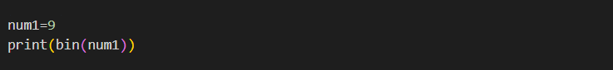

Output:

0b1001

Converting a binary to positive integer:

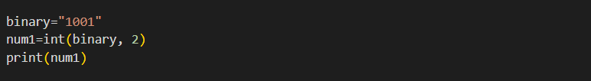

Output:

9