**SQL EXERCISE**

*Practice and practice we can improve our skills.*

Retrieve the required information using SQL language.

**Part I.** Give a database schema for a library management system as the following picture.

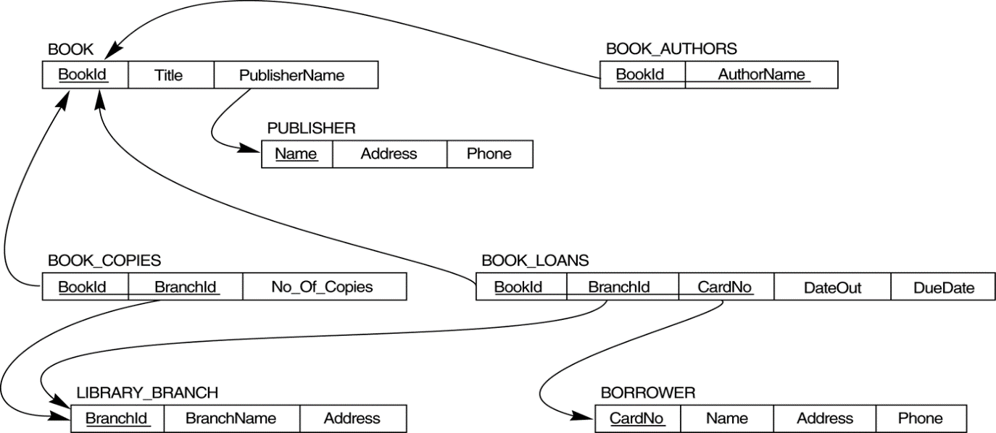

1. How many copies of the book titled The Lost Tribe are owned by the library branch whose name is "Sharpstown"?

SELECT SUM(n.No_Of_Copies)

FROM (SELECT b.tilte, bookId, bc.branchId, bc.No_Of_Copies

FROM book AS b

JOIN book_copies AS bc

ON b.bookId = bc.bookId

WHERE b.title = ‘The Lost Tribe’

) AS n

JOIN library_branches AS lb

ON lb.branchId = n.branchId

GROUP BY bl.branchName

HAVING bl,branchName = ‘Sharpstown’;

1. How many copies of the book titled The Lost Tribe are owned by each library branch?

SELECT SUM(n.No_Of_Copies)

FROM (SELECT b.tilte, bookId, bc.branchId, bc.No_Of_Copies

FROM book AS b

JOIN book_copies AS bc

ON b.bookId = bc.bookId

WHERE b.title = ‘The Lost Tribe’

) AS n

JOIN library_branches AS lb

ON lb.branchId = n.branchId

GROUP BY bl.branchName;

1. Retrieve the names of all borrowers who do not have any books checked out .

SELECT b.name

FROM borrowers AS b

LEFT JOIN book_loans AS bl

ON b.cardNo = bl.cardNo

WHERE DateOut IS NULL;

1. For each book that is loaned out from the "Sharpstown" branch and whose DueDate is today, retrieve the book title, the borrower's name, and the borrower's address.

SELECT bo.title, n.name, n.address

FROM ( SELECT bl.DueDate, b.name, b.address,lb.branch_name, bl.bookId

FROM borrower AS b

JOIN book_loans AS bl

ON b.cardNo = bl.cardNo

WHERE DueDate = CURDATE()

JOIN library_branch AS lb

ON bl.BranchId = lb.BranchId

WHERE DueDate = now() and branch_name = ‘Sharpstown’

) AS n

JOIN book AS bo

ON bo.bookId = n.bookId;

1. For each library branch, retrieve the branch name and the total number of books loaned out from that branch.

SELECT lb.branch_name , count(bl.bookId)

FROM library_branch AS lb

JOIN book_loans AS bl

ON lb.branchId = bl.branchId

GROUP BY lb.branch_name;

1. Retrieve the names, addresses, and number of books checked out for all borrowers who have more than five books checked out.

SELECT b.name,b.address, COUNT(bl.bookId) AS num_books

FROM borrower AS b

JOIN book_loans AS bl

ON b.cardNo = bl.cardNo

GROUP BY b.name

HAVING num_books > 5;

1. For each book authored (or co-authored) by "Stephen King", retrieve the title and the number of copies owned by the library branch whose name is "Central"

SELECT n.title, n.No_of_coppies

FROM ( SELECT b.title , bookId, ba.autor_name, b.publisher, bc.branchId, bc.No_of_coppies

FROM book AS b

JOIN book_autors AS ba

ON ba.bookId = b.bookId

JOIN book_copies AS bc

ON bc.bookId = b.bookId

WHERE ba.autor_name = ‘Stephen King’ OR b.publisher = ‘Stephen King’

) AS n

JOIN library_branch AS lb

ON n.branchId = lb.branchId

WHERE branch_name = ‘Central’;