Practical Work No. 11
Methods for Joining Row Sets. Approaches to Query Optimization in PostgreSQL

Objective: to study row-set join methods in PostgreSQL, obtain query execution plans using EXPLAIN ANALYZE, analyze the join and sorting methods selected by the planner, and verify memory usage during Hash Join operations.
https://postgrespro.ru/community/demodbDatabase used: Postgres Pro demonstration database “Air Transportation” — https://postgrespro.ru/community/demodb
https://edu.postgrespro.ru/qpt-13/qpt_02_query.htmlhttps://postgrespro.ru/education/books/sqlprimerMethodological materials: https://edu.postgrespro.ru/qpt-13/qpt_02_query.html; https://postgrespro.ru/education/books/sqlprimer
Execution environment: PostgreSQL, pgAdmin, bookings schema.

Work Progress and Results

Screenshot 1. Preparing the Working Environment
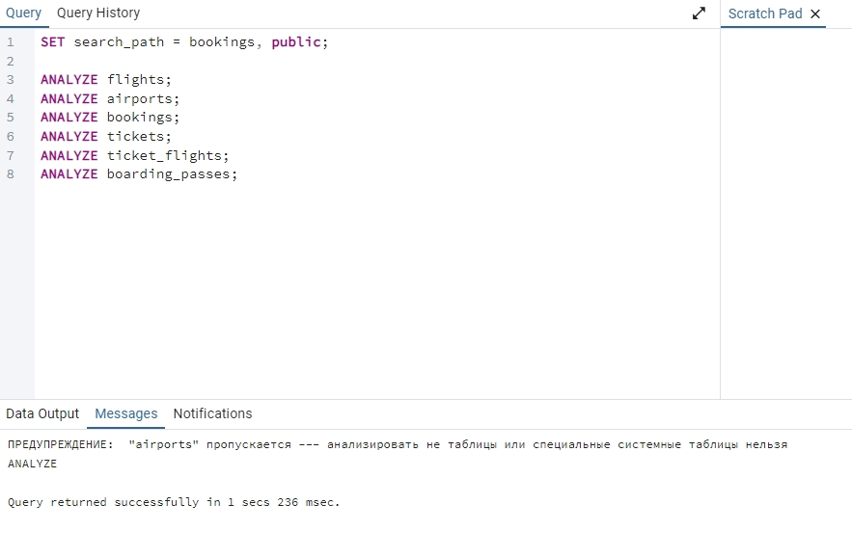
The bookings schema was set in search_path, and statistics for the main tables were updated using ANALYZE. The warning for airports appears because airports is a view, while statistics are collected for the underlying base tables.

Screenshot 2. Task 1. Index and Flights to Moscow
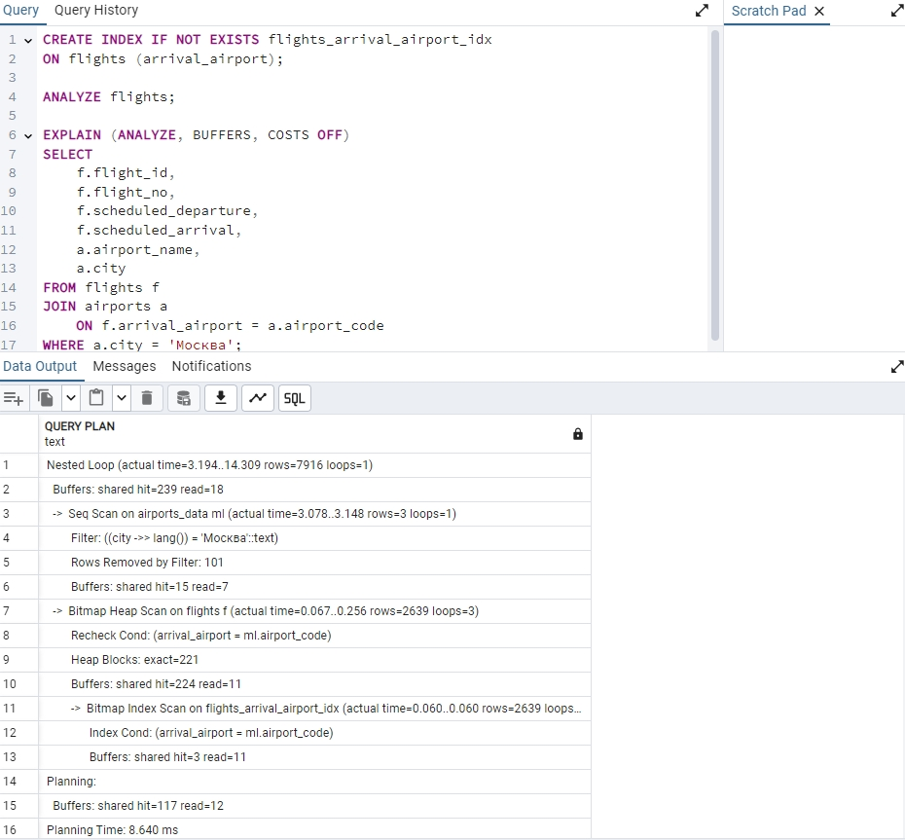
An index was created on flights.arrival_airport. The plan shows a Nested Loop: the outer set consists of filtered Moscow airports, while the inner set contains flights retrieved through an index/bitmap scan.

Screenshot 3. Task 2. Cartesian Product
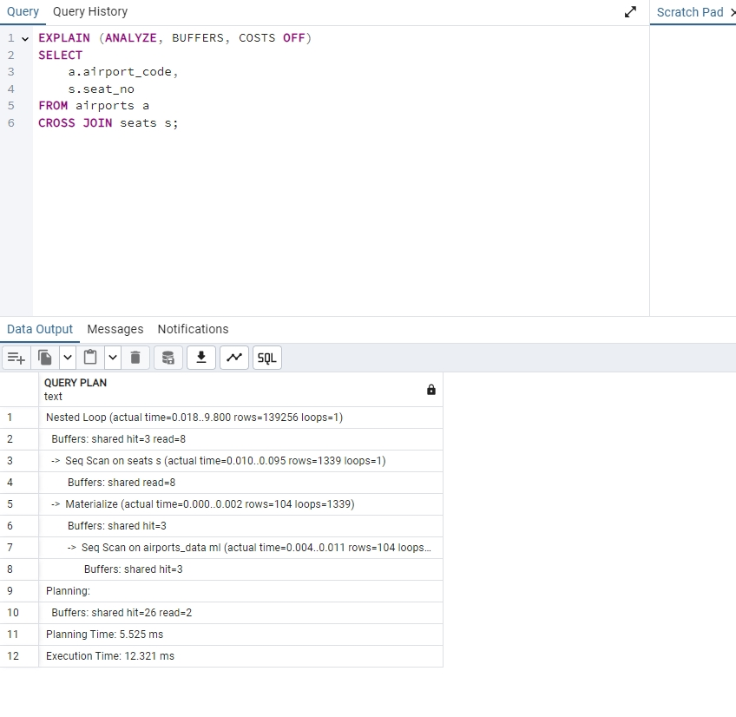
For CROSS JOIN, the planner selected Nested Loop with Materialize. This plan is appropriate because each row of the first table is matched with all rows of the second table.

Screenshot 4. Task 3. Departure and Arrival Airports
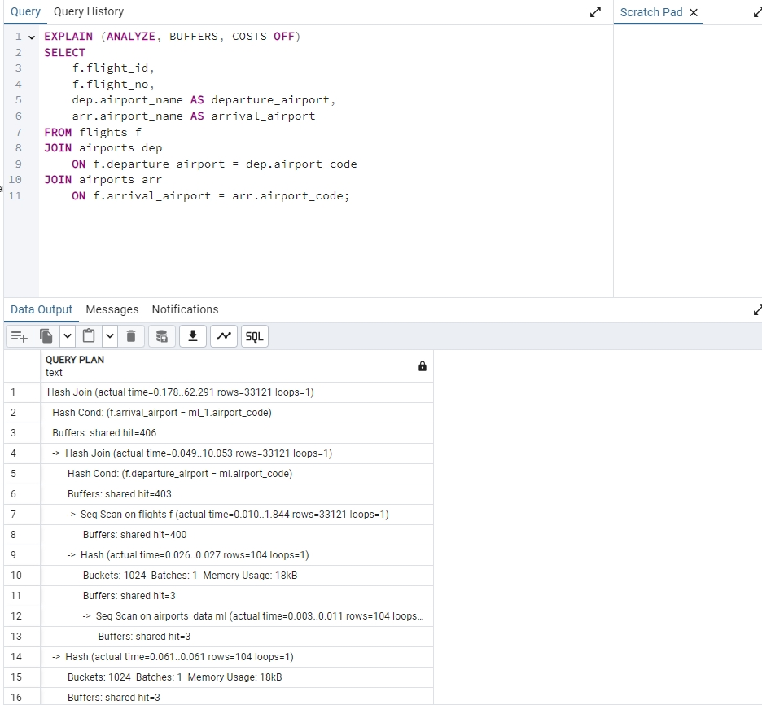
The query joins flights with airports twice: once for the departure airport and once for the arrival airport. The plan shows joins by airport_code and hash operations for the relatively small airport reference data.

Screenshot 5. Task 3. Memory Check
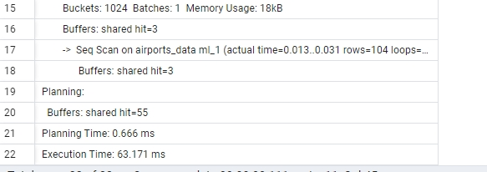
The plan includes the Memory Usage indicator for the hash table. The memory footprint is small, so the hash table fits into RAM.

Screenshot 6. Task 4. Number of Occupied Seats
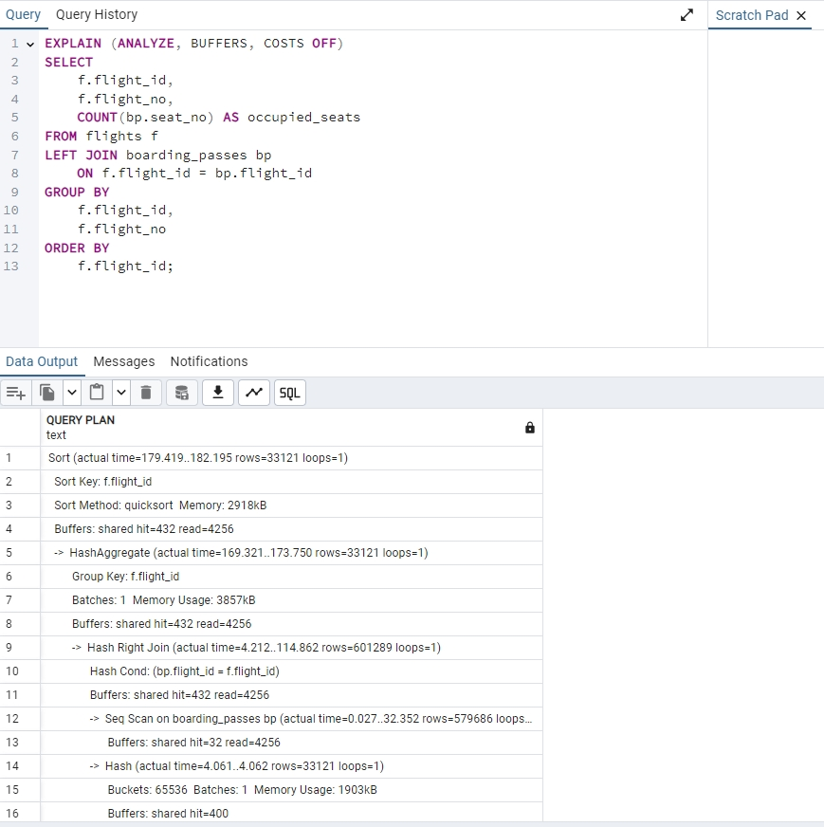
Flights are joined with boarding passes using LEFT JOIN, followed by grouping by flight. This query makes it possible to display the number of occupied seats even for flights without boarding passes.

Screenshot 7. Task 4. Completion of the Plan
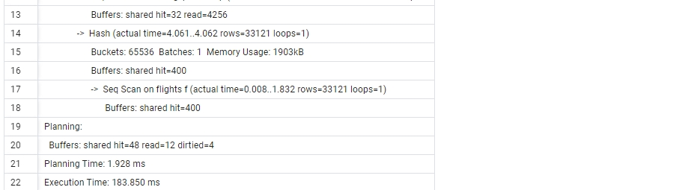
The lower part of the plan shows the final planning and execution time. The query was completed successfully, and the data was aggregated for all flights.

Screenshot 8. Task 5. Joining Four Tables
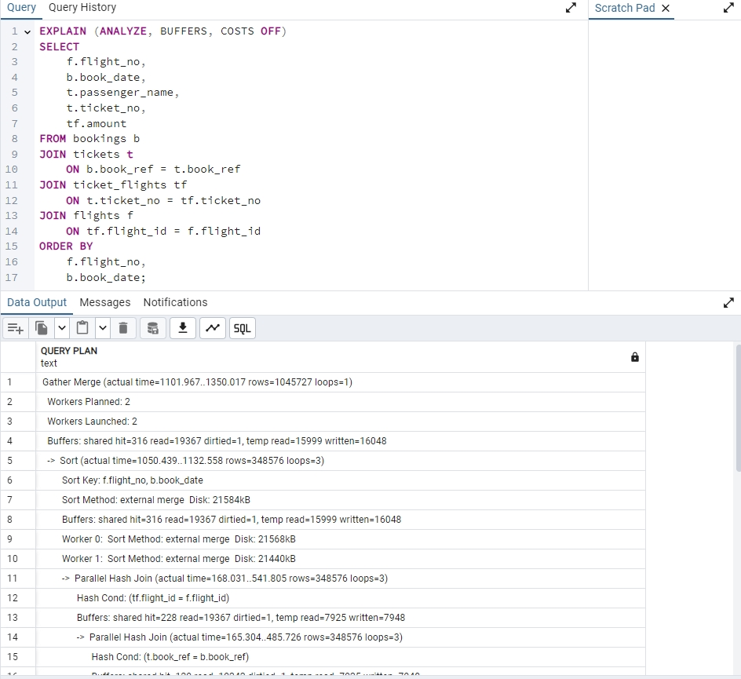
The query links bookings, tickets, ticket_flights, and flights, and then sorts the result by flight number and booking date.

Screenshot 9. Task 5. Execution Plan
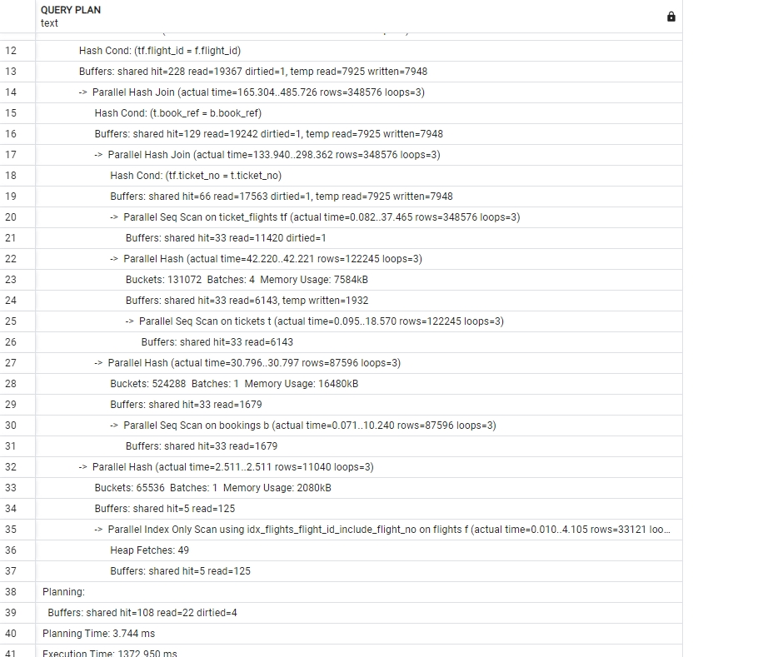
The plan shows the sequential execution of joins: intermediate sets are built first, then combined and sorted. For large tables, the planner uses more efficient join methods than a simple nested loop.

Screenshot 10. Task 6. tickets, ticket_flights, and boarding_passes
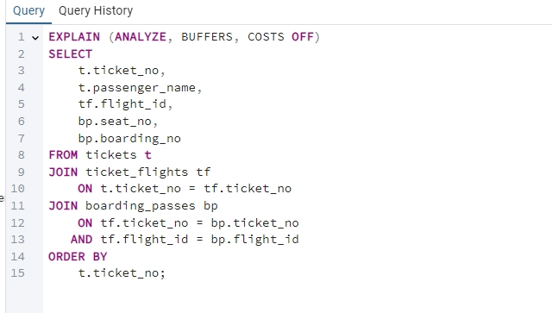
The query joins tickets, flight segments, and boarding passes, and the result is sorted by ticket_no.

Screenshot 11. Task 6. Execution Plan
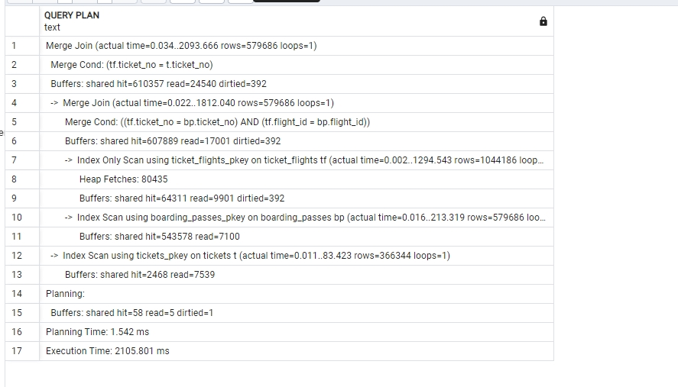
The plan shows joins by the ticket_no and flight_id keys. Since the result is sorted by ticket number, the planner uses the data order and Merge Join/Sort operations where beneficial.

Screenshot 12. Task 7. Sorting by Flight Number
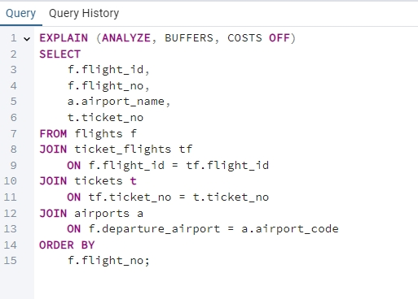
The first sorting option is performed by flight_no. This makes it possible to identify which sort node is added to the plan after joining the tables.

Screenshot 13. Task 7. Sorting Plan by flight_no
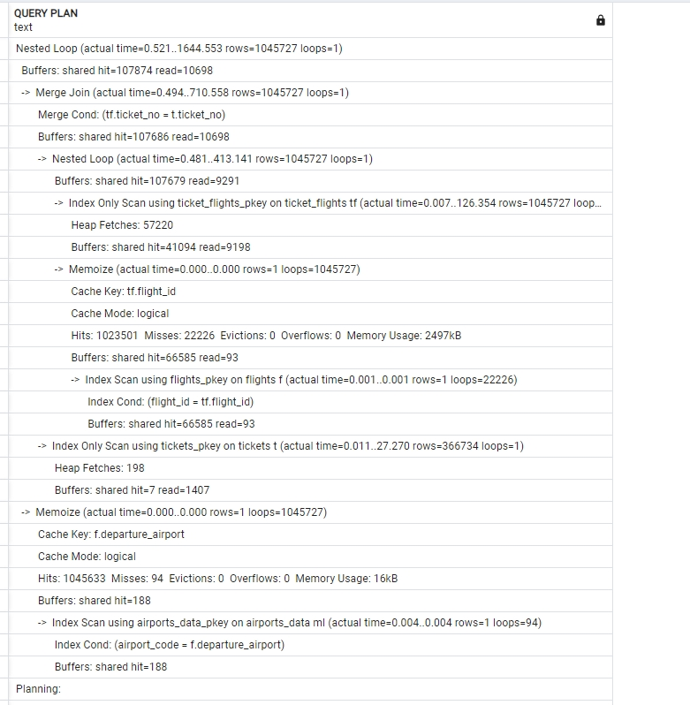
The plan contains a Sort Key for the selected column. The sorting method depends on the result size and the available work_mem.

Screenshot 14. Task 7. Results of the First Sorting Plan
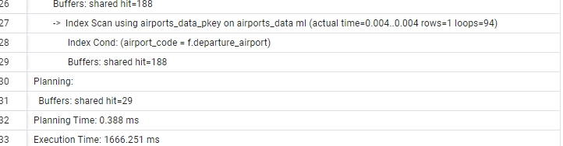
The lower part of the plan records buffers, planning time, and execution time. This is useful for comparing different ORDER BY variants.

Screenshot 15. Task 7. Sorting by Multiple Columns
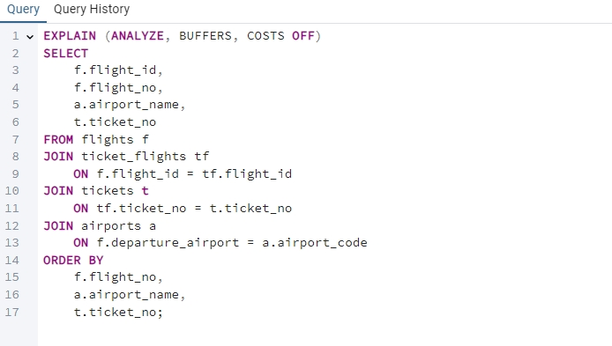
The third option sorts the result by flight_no, airport_name, and ticket_no at the same time. Such an ORDER BY clause requires a more complex sort than sorting by a single field.

Screenshot 16. Task 7. Sorting Plan by Multiple Columns
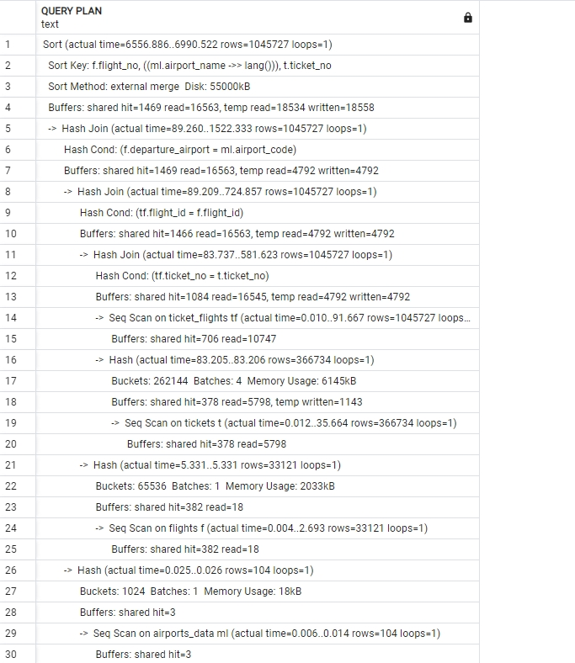
The plan shows the construction of the combined result through table joins followed by sorting by a composite key.

Screenshot 17. Task 7. Results of the Second Sorting Plan
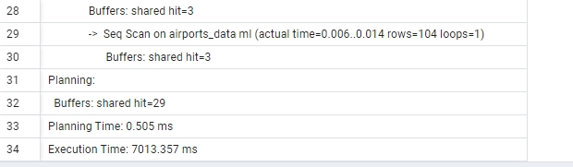
Execution time and buffer usage make it possible to compare how different sets of sorting fields affect the query cost.

Screenshot 18. Additional Hash Join Check
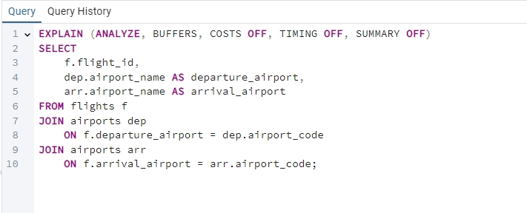
The query was intentionally executed with TIMING OFF and SUMMARY OFF to display the plan and hash join indicators in a compact form.

Screenshot 19. Additional Hash Join Memory Check
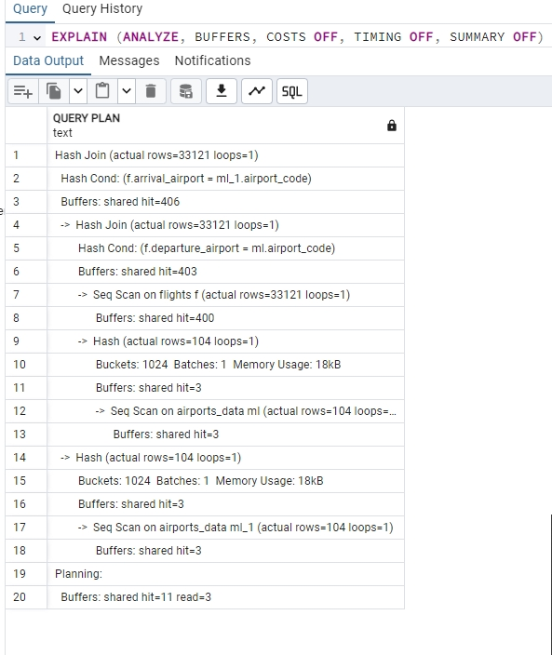
The Hash lines display Buckets, Batches, and Memory Usage. If Batches = 1, the hash table fully fits into memory.

SQL Code Used in the Work
The SQL blocks below were used to obtain execution plans and verify the results. Screenshots are not included in this section so that the code can be copied conveniently into PostgreSQL.

Preparation
SET search_path = bookings, public;
ANALYZE flights;
ANALYZE airports;
ANALYZE bookings;
ANALYZE tickets;
ANALYZE ticket_flights;
ANALYZE boarding_passes;

Task 1. Index on Arrival Airport and Flights to Moscow
CREATE INDEX IF NOT EXISTS flights_arrival_airport_idx
ON flights (arrival_airport);
ANALYZE flights;
EXPLAIN (ANALYZE, BUFFERS, COSTS OFF)
SELECT
f.flight_id,
f.flight_no,
f.scheduled_departure,
f.scheduled_arrival,
a.airport_name,
a.city
FROM flights f
JOIN airports a
ON f.arrival_airport = a.airport_code
WHERE a.city = 'Москва';

Task 2. Cartesian Product of Two Tables
EXPLAIN (ANALYZE, BUFFERS, COSTS OFF)
SELECT
a.airport_code,
s.seat_no
FROM airports a
CROSS JOIN seats s;

Task 3. Departure and Arrival Airports for All Flights
EXPLAIN (ANALYZE, BUFFERS, COSTS OFF)
SELECT
f.flight_id,
f.flight_no,
dep.airport_name AS departure_airport,
arr.airport_name AS arrival_airport
FROM flights f
JOIN airports dep
ON f.departure_airport = dep.airport_code
JOIN airports arr
ON f.arrival_airport = arr.airport_code;

Task 4. Total Number of Occupied Seats for All Flights
EXPLAIN (ANALYZE, BUFFERS, COSTS OFF)
SELECT
f.flight_id,
f.flight_no,
COUNT(bp.seat_no) AS occupied_seats
FROM flights f
LEFT JOIN boarding_passes bp
ON f.flight_id = bp.flight_id
GROUP BY
f.flight_id,
f.flight_no
ORDER BY
f.flight_id;

Task 5. Booking Date, Passenger, Ticket, Fare, and Flight Number
EXPLAIN (ANALYZE, BUFFERS, COSTS OFF)
SELECT
f.flight_no,
b.book_date,
t.passenger_name,
t.ticket_no,
tf.amount
FROM bookings b
JOIN tickets t
ON b.book_ref = t.book_ref
JOIN ticket_flights tf
ON t.ticket_no = tf.ticket_no
JOIN flights f
ON tf.flight_id = f.flight_id
ORDER BY
f.flight_no,
b.book_date;

Task 6. Joining tickets, ticket_flights, and boarding_passes with Sorting by Ticket Number
EXPLAIN (ANALYZE, BUFFERS, COSTS OFF)
SELECT
t.ticket_no,
t.passenger_name,
tf.flight_id,
bp.seat_no,
bp.boarding_no
FROM tickets t
JOIN ticket_flights tf
ON t.ticket_no = tf.ticket_no
JOIN boarding_passes bp
ON tf.ticket_no = bp.ticket_no
AND tf.flight_id = bp.flight_id
ORDER BY
t.ticket_no;

Task 7. Sorting by Flight Number
EXPLAIN (ANALYZE, BUFFERS, COSTS OFF)
SELECT
f.flight_id,
f.flight_no,
a.airport_name,
t.ticket_no
FROM flights f
JOIN ticket_flights tf
ON f.flight_id = tf.flight_id
JOIN tickets t
ON tf.ticket_no = t.ticket_no
JOIN airports a
ON f.departure_airport = a.airport_code
ORDER BY
f.flight_no;

Task 7. Sorting by Ticket Number
EXPLAIN (ANALYZE, BUFFERS, COSTS OFF)
SELECT
f.flight_id,
f.flight_no,
a.airport_name,
t.ticket_no
FROM flights f
JOIN ticket_flights tf
ON f.flight_id = tf.flight_id
JOIN tickets t
ON tf.ticket_no = t.ticket_no
JOIN airports a
ON f.departure_airport = a.airport_code
ORDER BY
t.ticket_no;

Task 7. Sorting by All Selected Columns
EXPLAIN (ANALYZE, BUFFERS, COSTS OFF)
SELECT
f.flight_id,
f.flight_no,
a.airport_name,
t.ticket_no
FROM flights f
JOIN ticket_flights tf
ON f.flight_id = tf.flight_id
JOIN tickets t
ON tf.ticket_no = t.ticket_no
JOIN airports a
ON f.departure_airport = a.airport_code
ORDER BY
f.flight_no,
a.airport_name,
t.ticket_no;

Additional Task. Memory Check for Hash Join
EXPLAIN (ANALYZE, BUFFERS, COSTS OFF, TIMING OFF, SUMMARY OFF)
SELECT
f.flight_id,
dep.airport_name AS departure_airport,
arr.airport_name AS arrival_airport
FROM flights f
JOIN airports dep
ON f.departure_airport = dep.airport_code
JOIN airports arr
ON f.arrival_airport = arr.airport_code;

Conclusion
During the practical work, query execution plans were built and analyzed for different join types: Nested Loop, Hash Join, and Merge Join, as well as for result sorting. EXPLAIN ANALYZE showed that the choice of join method depends on data volume, join conditions, indexes, and whether sorting is required. For hash joins, the Buckets, Batches, and Memory Usage indicators were additionally checked to evaluate whether enough RAM was available to store the hash table.

